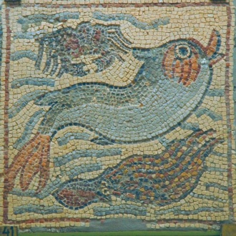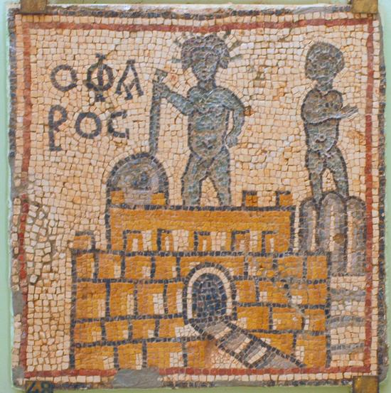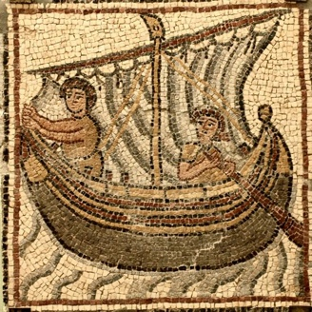
Byzantium: Empire of the Sea

21st Biennial Conference of the Australasian Association for Byzantine Studies

University of Queensland, 2-5 June 2023

Registration Form/Tax Invoice

ABN 68 068 565 011

Please fill out this form and email it, with payment information (direct deposit), to the address below by 8 May 2023 for early bird rates, or by 2 June 2023 for standard registration.

PERSONAL INFORMATION

Title:
Name:
Institutional affiliation (if any):
Address:
Email:
Please mark the type of registration you desire. Registration includes the conference from June 2-5, with morning and afternoon teas on June 4-5, and the opening reception on the evening of 2 June.

Student $165
AABS Full member (early bird by 8 May 2023) $200
AABS Full member (from 9 May to 2 June 2023) $230
Single day registration $90

Conference dinner (with drinks)
I will attend the conference dinner (AU$75) Yes/No
Any dietary requirements Yes/No If yes, attach details

Summary of Registration Fees

Conference registration: _________
Conference dinner (optional): ________

Total: _________

Payment: direct deposit

(1) Please email this completed form by 8 May 2023 for early bird rates (or for registration by 2 June 2023) to:
Janet Wade, AABS Treasurer
treasurer@aabs.org.au (and CC. janet.wade@mq.edu.au)

Please note that no refunds can be made for cancellations after 21 May 2023.
(2) Payment to be made by direct deposit to:
Australian Association for Byzantine Studies
Commonwealth Bank of Australia
Account 10443686, BSB 063-238
Please note: if you pay by direct deposit please note your surname and ‘AABS23’ with your online payment, and also complete and email this form to the emails listed above.

