Source Data Mapping Approach to CDMV5.4
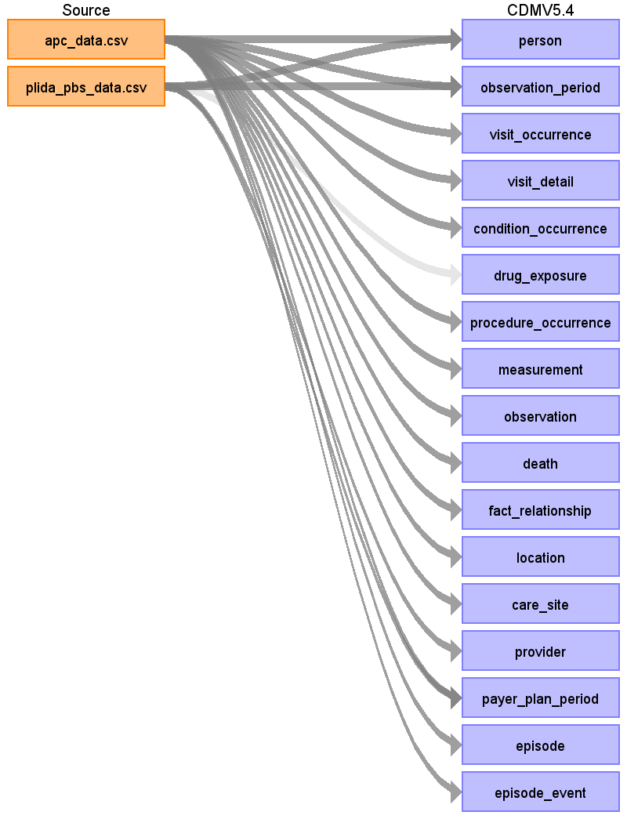
Table name: person
Reading from apc_data.csv
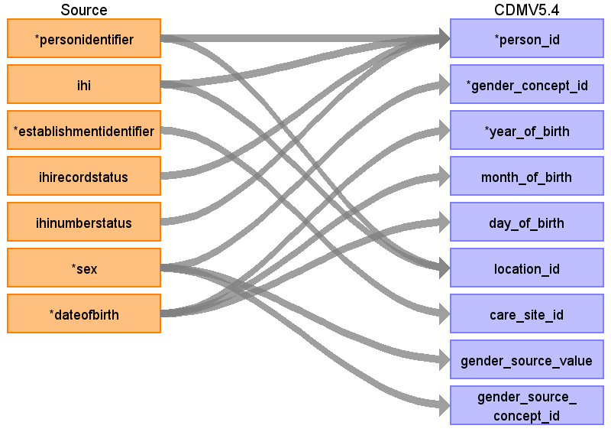
Destination Field | Source Field | Logic | Comment
person_id | personidentifier  ihi  ihirecordstatus  ihinumberstatus
gender_concept_id | sex
year_of_birth | dateofbirth
month_of_birth | dateofbirth
day_of_birth | dateofbirth
birth_datetime
race_concept_id
ethnicity_concept_id
location_id | personidentifier  ihi
provider_id
care_site_id | establishmentidentifier
person_source_value
gender_source_value | sex
gender_source_concept_id | sex
race_source_value
race_source_concept_id
ethnicity_source_value
ethnicity_source_concept_id
Reading from plida_pbs_data.csv
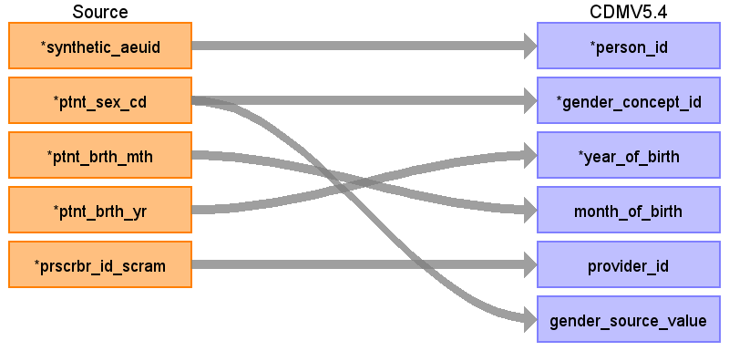
Destination Field | Source Field | Logic | Comment
person_id | synthetic_aeuid
gender_concept_id | ptnt_sex_cd
year_of_birth | ptnt_brth_yr
month_of_birth | ptnt_brth_mth
day_of_birth
birth_datetime
race_concept_id
ethnicity_concept_id
location_id
provider_id | prscrbr_id_scram
care_site_id
person_source_value
gender_source_value | ptnt_sex_cd
gender_source_concept_id
race_source_value
race_source_concept_id
ethnicity_source_value
ethnicity_source_concept_id
Table name: observation_period
Reading from apc_data.csv
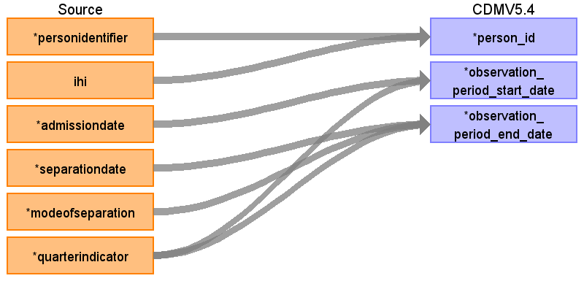
Destination Field | Source Field | Logic | Comment
observation_period_id
person_id | personidentifier  ihi
observation_period_start_date | admissiondate  quarterindicator
observation_period_end_date | separationdate  modeofseparation  quarterindicator
period_type_concept_id |  |  | 32810 Claim
Reading from plida_pbs_data.csv
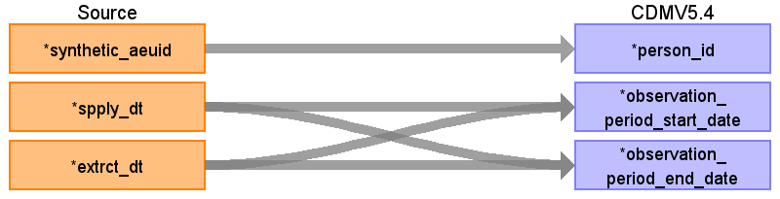
Destination Field | Source Field | Logic | Comment
observation_period_id
person_id | synthetic_aeuid
observation_period_start_date | spply_dt  extrct_dt
observation_period_end_date | spply_dt  extrct_dt
period_type_concept_id |  |  | 32810 Claim
Table name: visit_occurrence
Reading from apc_data.csv
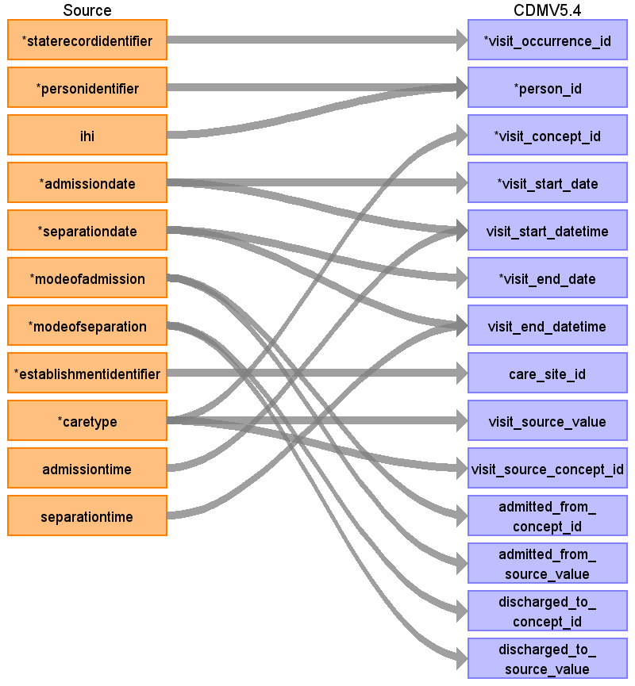
Destination Field | Source Field | Logic | Comment
visit_occurrence_id | staterecordidentifier
person_id | personidentifier  ihi
visit_concept_id | caretype
visit_start_date | admissiondate
visit_start_datetime | admissiondate  admissiontime
visit_end_date | separationdate
visit_end_datetime | separationdate  separationtime
visit_type_concept_id |  |  | 32843 External CDM instance
provider_id
care_site_id | establishmentidentifier
visit_source_value | caretype
visit_source_concept_id | caretype
admitted_from_concept_id | modeofadmission
admitted_from_source_value | modeofadmission
discharged_to_concept_id | modeofseparation
discharged_to_source_value | modeofseparation
preceding_visit_occurrence_id
Table name: visit_detail
Reading from apc_data.csv
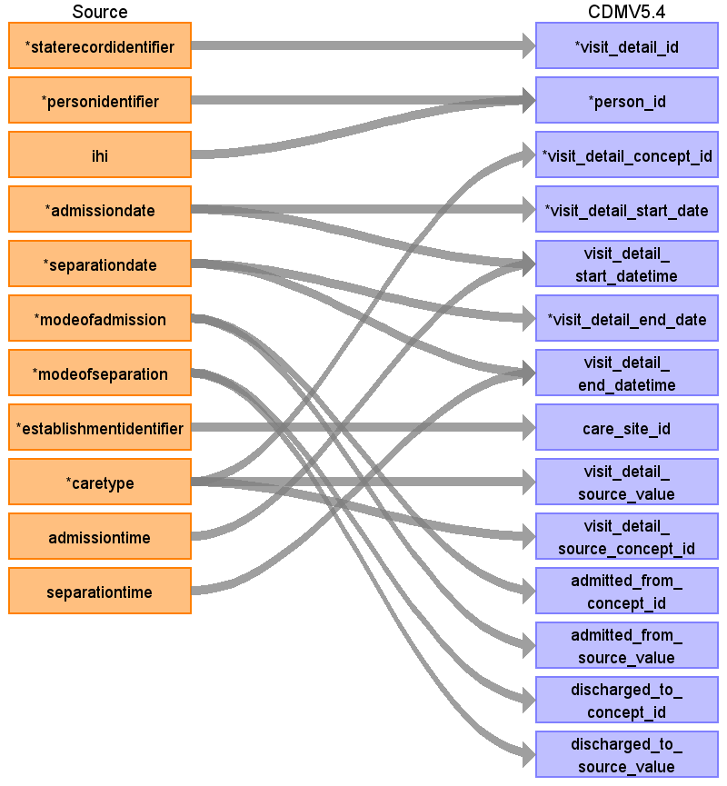
Destination Field | Source Field | Logic | Comment
visit_detail_id | staterecordidentifier
person_id | personidentifier  ihi
visit_detail_concept_id | caretype
visit_detail_start_date | admissiondate
visit_detail_start_datetime | admissiondate  admissiontime
visit_detail_end_date | separationdate
visit_detail_end_datetime | separationdate  separationtime
visit_detail_type_concept_id
provider_id
care_site_id | establishmentidentifier
visit_detail_source_value | caretype
visit_detail_source_concept_id | caretype
admitted_from_concept_id | modeofadmission
admitted_from_source_value | modeofadmission
discharged_to_concept_id | modeofseparation
discharged_to_source_value | modeofseparation
preceding_visit_detail_id
parent_visit_detail_id
visit_occurrence_id
Table name: condition_occurrence
Reading from apc_data.csv
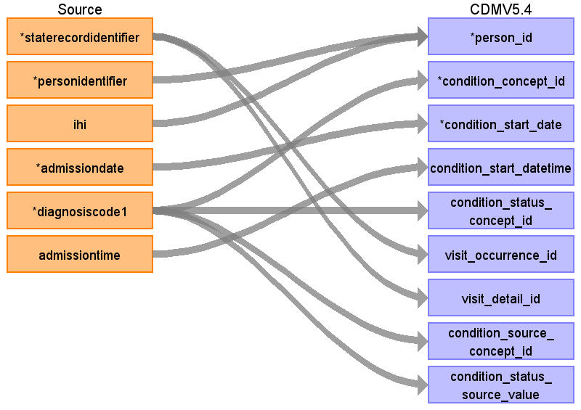
Destination Field | Source Field | Logic | Comment
condition_occurrence_id
person_id | personidentifier  ihi
condition_concept_id | diagnosiscode1
condition_start_date | admissiondate
condition_start_datetime | admissiontime
condition_end_date
condition_end_datetime
condition_type_concept_id |  |  | 32843 External CDM instance
condition_status_concept_id | diagnosiscode1
stop_reason
provider_id
visit_occurrence_id | staterecordidentifier
visit_detail_id | staterecordidentifier
condition_source_value
condition_source_concept_id | diagnosiscode1
condition_status_source_value | diagnosiscode1
Table name: drug_exposure
Reading from plida_pbs_data.csv
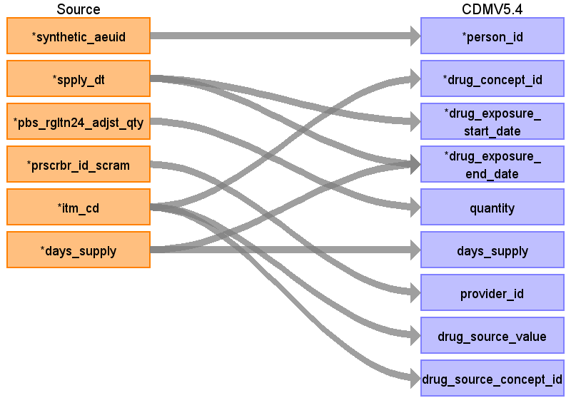
Destination Field | Source Field | Logic | Comment
drug_exposure_id
person_id | synthetic_aeuid
drug_concept_id | itm_cd
drug_exposure_start_date | spply_dt
drug_exposure_start_datetime
drug_exposure_end_date | spply_dt  days_supply
drug_exposure_end_datetime
verbatim_end_date
drug_type_concept_id |  |  | 32810 Claim
stop_reason
refills
quantity | pbs_rgltn24_adjst_qty
days_supply | days_supply
sig
route_concept_id
lot_number
provider_id | prscrbr_id_scram
visit_occurrence_id
visit_detail_id
drug_source_value | itm_cd
drug_source_concept_id | itm_cd
route_source_value
dose_unit_source_value
Table name: procedure_occurrence
Reading from apc_data.csv
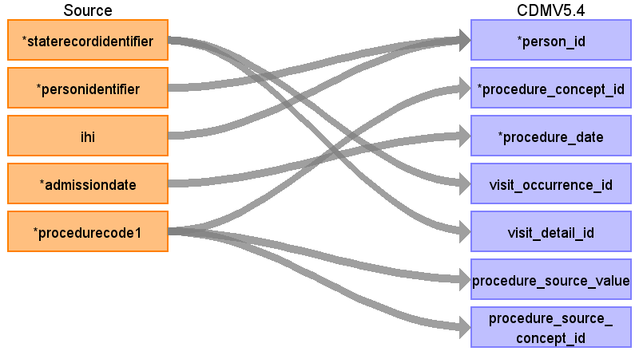
Destination Field | Source Field | Logic | Comment
procedure_occurrence_id
person_id | personidentifier  ihi
procedure_concept_id | procedurecode1
procedure_date | admissiondate
procedure_datetime
procedure_end_date
procedure_end_datetime
procedure_type_concept_id |  |  | 32843 External CDM instance
modifier_concept_id
quantity
provider_id
visit_occurrence_id | staterecordidentifier
visit_detail_id | staterecordidentifier
procedure_source_value | procedurecode1
procedure_source_concept_id | procedurecode1
modifier_source_value
Table name: device_exposure
Table name: measurement
Reading from apc_data.csv
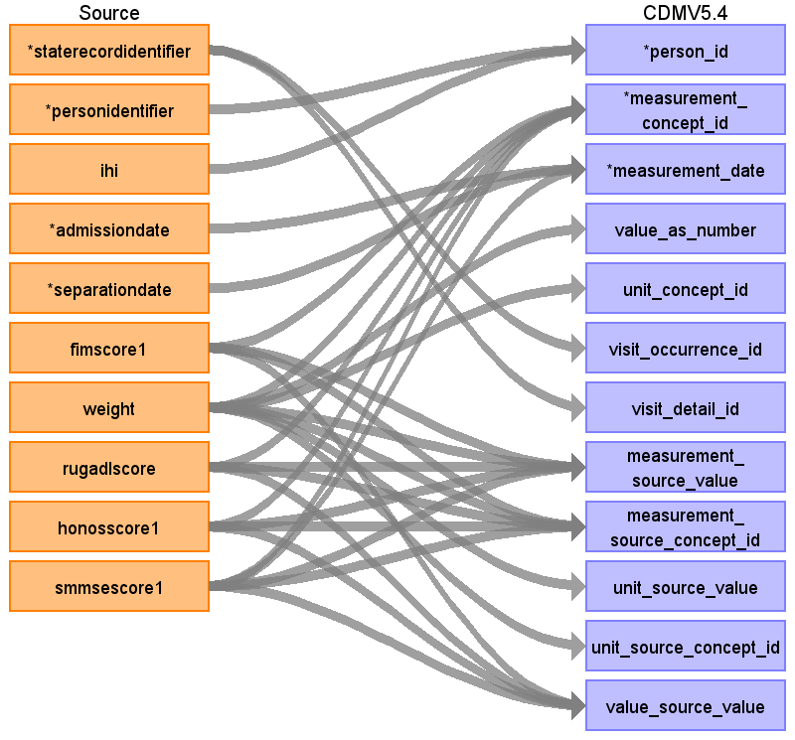
Destination Field | Source Field | Logic | Comment
measurement_id
person_id | personidentifier  ihi
measurement_concept_id | weight  fimscore1  rugadlscore  smmsescore1  honosscore1
measurement_date | admissiondate  smmsescore1  separationdate
measurement_datetime
measurement_time
measurement_type_concept_id |  |  | 32843 External CDM instance
operator_concept_id |  |  | 4172703
value_as_number | weight
value_as_concept_id
unit_concept_id | weight
range_low
range_high
provider_id
visit_occurrence_id | staterecordidentifier
visit_detail_id | staterecordidentifier
measurement_source_value | weight  fimscore1  rugadlscore  honosscore1  smmsescore1
measurement_source_concept_id | weight  fimscore1  rugadlscore  honosscore1  smmsescore1
unit_source_value | weight
unit_source_concept_id | weight
value_source_value | fimscore1  rugadlscore  honosscore1  smmsescore1
measurement_event_id
meas_event_field_concept_id
Table name: observation
Reading from apc_data.csv
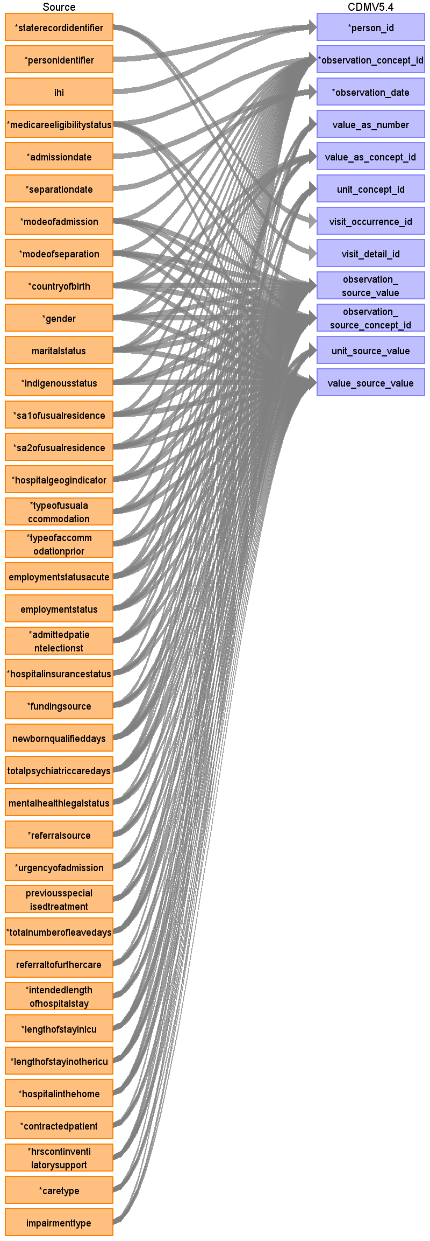
Destination Field | Source Field | Logic | Comment
observation_id
person_id | personidentifier  ihi
observation_concept_id | countryofbirth  gender  maritalstatus  indigenousstatus  sa2ofusualresidence  typeofusualaccommodation  typeofaccommodationprior  employmentstatusacute  employmentstatus  admittedpatientelectionst  hospitalinsurancestatus  modeofadmission  modeofseparation  fundingsource  newbornqualifieddays  totalpsychiatriccaredays  mentalhealthlegalstatus  referralsource  urgencyofadmission  previousspecialisedtreatment  totalnumberofleavedays  referraltofurthercare  intendedlengthofhospitalstay  lengthofstayinicu  hospitalinthehome  hrscontinventilatorysupport  sa1ofusualresidence  medicareeligibilitystatus  contractedpatient  lengthofstayinothericu  impairmenttype  hospitalgeogindicator  caretype
observation_date | admissiondate  separationdate
observation_datetime
observation_type_concept_id |  |  | 32843 External CDM instance
value_as_number | totalpsychiatriccaredays  newbornqualifieddays  totalnumberofleavedays  lengthofstayinicu  hospitalinthehome  hrscontinventilatorysupport  lengthofstayinothericu
value_as_string
value_as_concept_id | countryofbirth  gender  maritalstatus  employmentstatusacute  employmentstatus  admittedpatientelectionst
qualifier_concept_id
unit_concept_id | newbornqualifieddays  totalpsychiatriccaredays  totalnumberofleavedays  lengthofstayinicu  hospitalinthehome  hrscontinventilatorysupport  lengthofstayinothericu
provider_id
visit_occurrence_id | staterecordidentifier
visit_detail_id | staterecordidentifier
observation_source_value | gender  countryofbirth  maritalstatus  indigenousstatus  sa2ofusualresidence  typeofusualaccommodation  typeofaccommodationprior  employmentstatusacute  employmentstatus  admittedpatientelectionst  hospitalinsurancestatus  modeofadmission  modeofseparation  fundingsource  newbornqualifieddays  totalpsychiatriccaredays  mentalhealthlegalstatus  referralsource  urgencyofadmission  previousspecialisedtreatment  totalnumberofleavedays  referraltofurthercare  intendedlengthofhospitalstay  lengthofstayinicu  hospitalinthehome  hrscontinventilatorysupport  sa1ofusualresidence  medicareeligibilitystatus  contractedpatient  lengthofstayinothericu  impairmenttype  hospitalgeogindicator  caretype
observation_source_concept_id | gender  countryofbirth  maritalstatus  indigenousstatus  sa2ofusualresidence  typeofusualaccommodation  typeofaccommodationprior  employmentstatusacute  employmentstatus  admittedpatientelectionst  hospitalinsurancestatus  modeofadmission  modeofseparation  fundingsource  newbornqualifieddays  totalpsychiatriccaredays  mentalhealthlegalstatus  referralsource  urgencyofadmission  previousspecialisedtreatment  totalnumberofleavedays  referraltofurthercare  intendedlengthofhospitalstay  lengthofstayinicu  hospitalinthehome  hrscontinventilatorysupport  sa1ofusualresidence  medicareeligibilitystatus  contractedpatient  lengthofstayinothericu  impairmenttype  hospitalgeogindicator  caretype
unit_source_value | newbornqualifieddays  totalpsychiatriccaredays  totalnumberofleavedays  lengthofstayinicu  hospitalinthehome  hrscontinventilatorysupport  lengthofstayinothericu
qualifier_source_value
value_source_value | countryofbirth  gender  maritalstatus  employmentstatusacute  employmentstatus  admittedpatientelectionst  indigenousstatus  sa2ofusualresidence  typeofusualaccommodation  typeofaccommodationprior  hospitalinsurancestatus  modeofadmission  modeofseparation  fundingsource  newbornqualifieddays  totalpsychiatriccaredays  mentalhealthlegalstatus  referralsource  urgencyofadmission  previousspecialisedtreatment  totalnumberofleavedays  referraltofurthercare  intendedlengthofhospitalstay  lengthofstayinicu  hospitalinthehome  hrscontinventilatorysupport  sa1ofusualresidence  medicareeligibilitystatus  contractedpatient  lengthofstayinothericu  impairmenttype  hospitalgeogindicator  caretype
observation_event_id
obs_event_field_concept_id
Table name: death
Reading from apc_data.csv
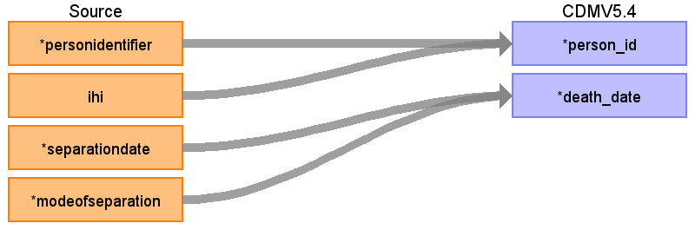
Destination Field | Source Field | Logic | Comment
person_id | personidentifier  ihi
death_date | modeofseparation  separationdate
death_datetime
death_type_concept_id
cause_concept_id
cause_source_value
cause_source_concept_id
Table name: note
Table name: note_nlp
Table name: specimen
Table name: fact_relationship
Reading from apc_data.csv
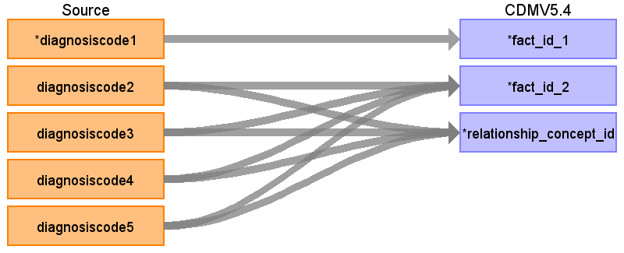
Destination Field | Source Field | Logic | Comment
domain_concept_id_1
fact_id_1 | diagnosiscode1
domain_concept_id_2
fact_id_2 | diagnosiscode2  diagnosiscode3  diagnosiscode4  diagnosiscode5
relationship_concept_id | diagnosiscode2  diagnosiscode3  diagnosiscode4  diagnosiscode5
Table name: location
Reading from apc_data.csv
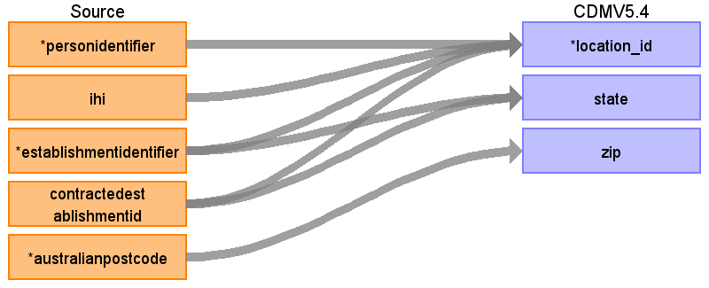
Destination Field | Source Field | Logic | Comment
location_id | establishmentidentifier  personidentifier  ihi  contractedestablishmentid
address_1
address_2
city
state | establishmentidentifier  contractedestablishmentid
zip | australianpostcode
county
location_source_value
country_concept_id |  |  | 41881315 Australia
country_source_value |  |  | Australia
latitude
longitude
Table name: care_site
Reading from apc_data.csv
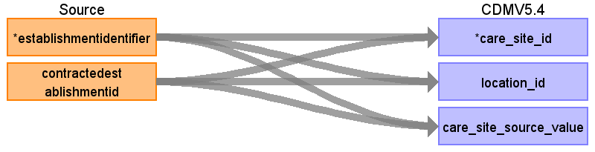
Destination Field | Source Field | Logic | Comment
care_site_id | establishmentidentifier  contractedestablishmentid
care_site_name
place_of_service_concept_id
location_id | establishmentidentifier  contractedestablishmentid
care_site_source_value | establishmentidentifier  contractedestablishmentid
place_of_service_source_value
Table name: provider
Reading from plida_pbs_data.csv
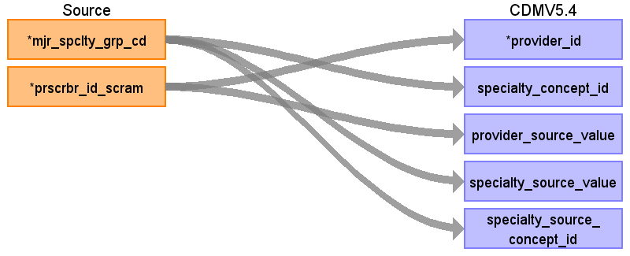
Destination Field | Source Field | Logic | Comment
provider_id | prscrbr_id_scram
provider_name
npi
dea
specialty_concept_id | mjr_spclty_grp_cd
care_site_id
year_of_birth
gender_concept_id
provider_source_value | prscrbr_id_scram
specialty_source_value | mjr_spclty_grp_cd
specialty_source_concept_id | mjr_spclty_grp_cd
gender_source_value
gender_source_concept_id
Table name: payer_plan_period
Reading from apc_data.csv
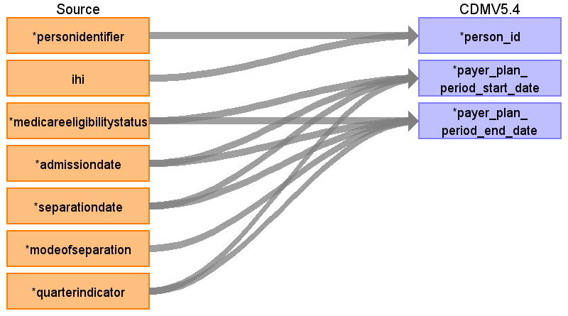
Destination Field | Source Field | Logic | Comment
payer_plan_period_id
person_id | personidentifier  ihi
payer_plan_period_start_date | medicareeligibilitystatus  admissiondate  separationdate  quarterindicator
payer_plan_period_end_date | medicareeligibilitystatus  admissiondate  separationdate  modeofseparation  quarterindicator
payer_concept_id
payer_source_value
payer_source_concept_id
plan_concept_id
plan_source_value
plan_source_concept_id
sponsor_concept_id
sponsor_source_value
sponsor_source_concept_id
family_source_value
stop_reason_concept_id
stop_reason_source_value
stop_reason_source_concept_id
Reading from plida_pbs_data.csv
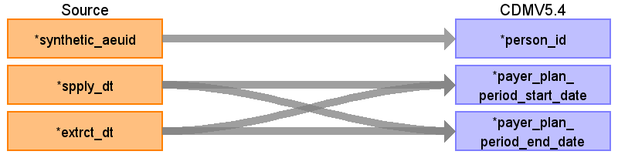
Destination Field | Source Field | Logic | Comment
payer_plan_period_id
person_id | synthetic_aeuid
payer_plan_period_start_date | spply_dt  extrct_dt
payer_plan_period_end_date | spply_dt  extrct_dt
payer_concept_id
payer_source_value
payer_source_concept_id
plan_concept_id
plan_source_value
plan_source_concept_id
sponsor_concept_id
sponsor_source_value
sponsor_source_concept_id
family_source_value
stop_reason_concept_id
stop_reason_source_value
stop_reason_source_concept_id
Table name: episode
Reading from apc_data.csv
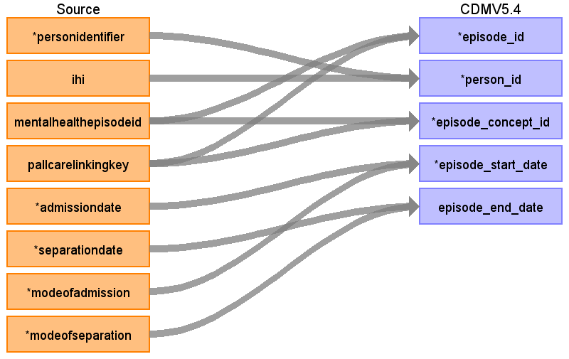
Destination Field | Source Field | Logic | Comment
episode_id | mentalhealthepisodeid  pallcarelinkingkey
person_id | personidentifier  ihi
episode_concept_id | mentalhealthepisodeid  pallcarelinkingkey
episode_start_date | admissiondate  modeofadmission
episode_start_datetime
episode_end_date | separationdate  modeofseparation
episode_end_datetime
episode_parent_id
episode_number
episode_object_concept_id
episode_type_concept_id
episode_source_value
episode_source_concept_id
Table name: episode_event
Reading from apc_data.csv
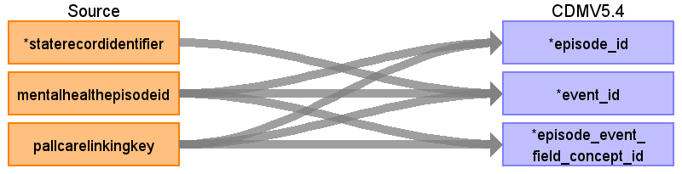
Destination Field | Source Field | Logic | Comment
episode_id | mentalhealthepisodeid  pallcarelinkingkey
event_id | staterecordidentifier  mentalhealthepisodeid  pallcarelinkingkey
episode_event_field_concept_id | mentalhealthepisodeid  pallcarelinkingkey
Table name: cost
Table name: drug_era
Table name: dose_era
Table name: condition_era
Table name: metadata
Table name: cdm_source
Table name: cohort
Table name: cohort_definition
Appendix: source tables
Table: apc_data.csv
Field | Type | Most freq. value | Comment
staterecordidentifier | VARCHAR
personidentifier | VARCHAR | PID-216715876-106402655
ihi | INT
mentalhealthepisodeid | VARCHAR
pallcarelinkingkey | VARCHAR
medicareeligibilitystatus | INT | 1
admissiondate | INT | 12072024
separationdate | INT | 30062025
modeofadmission | INT | 2
modeofseparation | INT | 01
quarterindicator | VARCHAR | JUN2025
establishmentidentifier | INT | 313554764
contractedestablishmentid | EMPTY
australianpostcode | INT | 0097
diagnosiscode1 | VARCHAR | 2Z49.1
diagnosiscode2 | VARCHAR
diagnosiscode3 | VARCHAR
diagnosiscode4 | VARCHAR
diagnosiscode5 | VARCHAR
countryofbirth | INT | 1079
gender | INT | 2
maritalstatus | INT | 5
indigenousstatus | INT | 4
sa1ofusualresidence | VARCHAR | ZZZZZZZZZZZ
sa2ofusualresidence | VARCHAR | ZZZZZZZZZ
hospitalgeogindicator | INT | 5
typeofusualaccommodation | INT | 0
typeofaccommodationprior | INT | 1
employmentstatusacute | INT | 2
employmentstatus | INT | 3
admittedpatientelectionst | INT | 1
hospitalinsurancestatus | INT | 2
fundingsource | INT | 03
newbornqualifieddays | INT
totalpsychiatriccaredays | INT
mentalhealthlegalstatus | INT
referralsource | INT | 05
urgencyofadmission | INT | 9
previousspecialisedtreatment | INT
totalnumberofleavedays | INT | 0
referraltofurthercare | INT
intendedlengthofhospitalstay | INT | 1
lengthofstayinicu | INT | 0
lengthofstayinothericu | INT | 0
hospitalinthehome | INT | 10
contractedpatient | INT | 3
hrscontinventilatorysupport | INT | 0
caretype | INT | 1
impairmenttype | REAL
managingwaitlistestabid | EMPTY
electivesurgerywaitingtimes1 | EMPTY
nwau23 | REAL | 0.4269
nwau24 | REAL | 0.6042
nwau25 | REAL | 0.5257
fimscore1 | INT
weight | INT
rugadlscore | INT
honosscore1 | INT
smmsescore1 | INT
ihirecordstatus | INT | 1
ihinumberstatus | INT | 1
sex | REAL | 2.0
dateofbirth | INT | 05102009
admissiontime | INT
separationtime | INT
electivesurgerywaitingtimes2 | EMPTY
electivesurgerywaitingtimes3 | EMPTY
electivesurgerywaitingtimes4 | EMPTY
electivesurgerywaitingtimes5 | EMPTY
procedurecode1 | VARCHAR | 13100-00
procedurecode2 | VARCHAR
procedurecode3 | VARCHAR
procedurecode4 | VARCHAR
procedurecode5 | VARCHAR
procedurecode6 | VARCHAR
procedurecode7 | EMPTY
procedurecode8 | EMPTY
procedurecode9 | EMPTY
procedurecode10 | EMPTY
procedurecode11 | EMPTY
procedurecode12 | EMPTY
procedurecode13 | EMPTY
procedurecode14 | EMPTY
procedurecode15 | EMPTY
procedurecode16 | EMPTY
procedurecode17 | EMPTY
procedurecode18 | EMPTY
procedurecode19 | EMPTY
procedurecode20 | EMPTY
procedurecode21 | EMPTY
procedurecode22 | EMPTY
procedurecode23 | EMPTY
procedurecode24 | EMPTY
procedurecode25 | EMPTY
procedurecode26 | EMPTY
procedurecode27 | EMPTY
procedurecode28 | EMPTY
procedurecode29 | EMPTY
procedurecode30 | EMPTY
procedurecode31 | EMPTY
procedurecode32 | EMPTY
procedurecode33 | EMPTY
procedurecode34 | EMPTY
procedurecode35 | EMPTY
procedurecode36 | EMPTY
procedurecode37 | EMPTY
procedurecode38 | EMPTY
procedurecode39 | EMPTY
procedurecode40 | EMPTY
procedurecode41 | EMPTY
procedurecode42 | EMPTY
procedurecode43 | EMPTY
procedurecode44 | EMPTY
procedurecode45 | EMPTY
procedurecode46 | EMPTY
procedurecode47 | EMPTY
procedurecode48 | EMPTY
procedurecode49 | EMPTY
procedurecode50 | EMPTY
diagnosiscode6 | VARCHAR
diagnosiscode7 | VARCHAR
diagnosiscode8 | VARCHAR
diagnosiscode9 | EMPTY
diagnosiscode10 | EMPTY
diagnosiscode11 | EMPTY
diagnosiscode12 | EMPTY
diagnosiscode13 | EMPTY
diagnosiscode14 | EMPTY
diagnosiscode15 | EMPTY
diagnosiscode16 | EMPTY
diagnosiscode17 | EMPTY
diagnosiscode18 | EMPTY
diagnosiscode19 | EMPTY
diagnosiscode20 | EMPTY
diagnosiscode21 | EMPTY
diagnosiscode22 | EMPTY
diagnosiscode23 | EMPTY
diagnosiscode24 | EMPTY
diagnosiscode25 | EMPTY
diagnosiscode26 | EMPTY
diagnosiscode27 | EMPTY
diagnosiscode28 | EMPTY
diagnosiscode29 | EMPTY
diagnosiscode30 | EMPTY
diagnosiscode31 | EMPTY
diagnosiscode32 | EMPTY
diagnosiscode33 | EMPTY
diagnosiscode34 | EMPTY
diagnosiscode35 | EMPTY
diagnosiscode36 | EMPTY
diagnosiscode37 | EMPTY
diagnosiscode38 | EMPTY
diagnosiscode39 | EMPTY
diagnosiscode40 | EMPTY
diagnosiscode41 | EMPTY
diagnosiscode42 | EMPTY
diagnosiscode43 | EMPTY
diagnosiscode44 | EMPTY
diagnosiscode45 | EMPTY
diagnosiscode46 | EMPTY
diagnosiscode47 | EMPTY
diagnosiscode48 | EMPTY
diagnosiscode49 | EMPTY
diagnosiscode50 | EMPTY
diagnosiscode51 | EMPTY
diagnosiscode52 | EMPTY
diagnosiscode53 | EMPTY
diagnosiscode54 | EMPTY
diagnosiscode55 | EMPTY
diagnosiscode56 | EMPTY
diagnosiscode57 | EMPTY
diagnosiscode58 | EMPTY
diagnosiscode59 | EMPTY
diagnosiscode60 | EMPTY
diagnosiscode61 | EMPTY
diagnosiscode62 | EMPTY
diagnosiscode63 | EMPTY
diagnosiscode64 | EMPTY
diagnosiscode65 | EMPTY
diagnosiscode66 | EMPTY
diagnosiscode67 | EMPTY
diagnosiscode68 | EMPTY
diagnosiscode69 | EMPTY
diagnosiscode70 | EMPTY
diagnosiscode71 | EMPTY
diagnosiscode72 | EMPTY
diagnosiscode73 | EMPTY
diagnosiscode74 | EMPTY
diagnosiscode75 | EMPTY
diagnosiscode76 | EMPTY
diagnosiscode77 | EMPTY
diagnosiscode78 | EMPTY
diagnosiscode79 | EMPTY
diagnosiscode80 | EMPTY
diagnosiscode81 | EMPTY
diagnosiscode82 | EMPTY
diagnosiscode83 | EMPTY
diagnosiscode84 | EMPTY
diagnosiscode85 | EMPTY
diagnosiscode86 | EMPTY
diagnosiscode87 | EMPTY
diagnosiscode88 | EMPTY
diagnosiscode89 | EMPTY
diagnosiscode90 | EMPTY
diagnosiscode91 | EMPTY
diagnosiscode93 | EMPTY
diagnosiscode92 | EMPTY
diagnosiscode94 | EMPTY
diagnosiscode95 | EMPTY
diagnosiscode96 | EMPTY
diagnosiscode97 | EMPTY
diagnosiscode98 | EMPTY
diagnosiscode99 | EMPTY
diagnosiscode100 | EMPTY
fimscore2 | INT
fimscore3 | INT
fimscore4 | INT
fimscore5 | INT
fimscore6 | INT
fimscore7 | INT
fimscore8 | INT
fimscore9 | INT
fimscore10 | INT
fimscore11 | INT
fimscore12 | INT
fimscore13 | INT
fimscore14 | INT
fimscore15 | INT
fimscore16 | INT
fimscore17 | INT
fimscore18 | INT
honosscore2 | INT
honosscore3 | INT
honosscore4 | INT
honosscore5 | INT
honosscore6 | INT
honosscore7 | INT
honosscore8 | INT
honosscore9 | INT
honosscore10 | INT
honosscore11 | INT
honosscore12 | INT
smmsescore2 | INT
smmsescore3 | INT
smmsescore4 | INT
smmsescore5 | INT
smmsescore6 | INT
smmsescore7 | INT
smmsescore8 | INT
smmsescore9 | INT
smmsescore10 | INT
smmsescore11 | INT
smmsescore12 | INT
Table: plida_pbs_data.csv
Field | Type | Most freq. value | Comment
synthetic_aeuid | INT | 18
ptnt_sex_cd | VARCHAR | F
ptnt_brth_mth | INT | 1
ptnt_brth_yr | INT | 1935
spply_dt | VARCHAR | 20-Apr-20
extrct_dt | VARCHAR | 1/03/2023
prscrb_dt | VARCHAR | 16/12/2019
mjr_spclty_grp_cd | INT | 0101
pbs_rgltn24_adjst_qty | INT | 30
rgltn24_ind | VARCHAR | N
prscrbr_id_scram | INT | 408030
itm_cd | VARCHAR | 02089Y
drug_name | VARCHAR | PARACETAMOL
form_strength | VARCHAR | Tablet 10 mg
atc5_code | VARCHAR | N02BE01
days_supply | INT | 35
amt | EMPTY
 | VARCHAR | 1/01/2018

