

Maia 384 Users Guide
Real-time SXRF Trace Element Imaging and Analysis

The Maia 384 detector array and imaging system
R. Kirkham¹, D.P. Siddons², P.A. Dunn¹, A. Kuczewski², C.G. Ryan^{3,6}, G.F. Moorhead^{3,6}, G. De Geronimo⁴, M. Jensen¹, R. Beuttenmuller⁴, D. Pinelli⁴, M. Pfeffer², P. Davey¹ and R. Dodanwela¹
Beamline integration at the X-ray Fluorescence Microprobe beamline
D. Paterson⁵, M.D. de Jonge⁵, D. Howard⁵, M. Küsel⁵ and J. McKinlay⁵

¹ CSIRO Materials Science and Engineering, Clayton VIC, Australia
² National Synchrotron Light Source, Brookhaven National Laboratory, NY, USA
³ CSIRO Mineral Resources, Clayton VIC, Australia
⁴ Instrumentation Division, Brookhaven National Laboratory, Brookhaven NY, USA
⁵ Australian Synchrotron, Clayton, VIC, Australia
⁶ School of Physics, University of Melbourne, Parkville VIC, Australia

Table of Contents
Maia 384 Users Guide 1
Table of Contents 2
Overview 4
Installation Notes 5
HYMOD: 5
Beamline GUI computer: 6
blogd file server 7
Preliminary Safe Operating Procedures 8
Cautions 8
Emergency Shutdown 8
Detector Set-up 8
Detector Operation 9
Pulse capture in Maia 11
Detector Array 11
HERMES Pre-amplifier, Shaper 11
SCEPTER Pulse Capture 11
ADCs 12
Data processing Pipeline 12
Event correction 13
ET event buffering 14
DA and ROI imaging 14
ET Spectra 14
Group Spectra 14
Energy-Time Histogram 14
Activity 15
Maia Control User Interface 15
Maia Control Windows 16
Maia Detector Setup window 25
Enable 25
HERMES 26
SCEPTER 26
HYMOD 29
Summary 30
Groups 31
Imaging 32
Controls 33
Layout 34
Pulser / Tests 34
Debug 35
Maia Pipeline Set-up 37
Setting Thresholds 37
Thresh 37
Trim 37
Detector Linearization 37
Running “step-cal” 38
Executing Linearization plug-in 38
Linearization using X-ray standard spectra 41
Linearization using Peak Offsets in Fit 43
Gain Trimming 43
Running the “gain-trim” pulser 44
Executing the Gain Trimming Plug-in 45
Gain-trim adjustment after minor TRIM or THRESH changes 47
Gain-trim using a dual X-ray source 47
Gain Trim Adjustment using a source 49
Pile-up Rejection 50
Energy Calibration 51
A single energy cal for all 51
Individual energy calibrations 51
Rough Initial energy calibration 52
Detector Energy Resolution 53
Acquire spectra 53
Fit spectra & display FWHM 53
Relative Noise Width 55
Acquire spectra 55
Fit spectra & display FWHM 55
Using Throttle to Control Data-rates 57
Representative Spectrum 58
Enabling Throttle in Maia 58
Maia Data Analysis 59

This guide is an initial draft to cover set-up and operation of the Maia detector system. It provides a basic overview of the detector hardware and software; for details please consult the detailed detector documentation.

GeoPIXE
This guide is a supplement to the GeoPIXE manual to cater for Maia-384 SXRF image data. More up to data worked examples relating to Maia calibration can be found in the “GeoPIXE Worked Example Notes.pdf” in the “geopixe/Help” directory.

Overview
The figure below provides an overview of the major Maia system components. The Safe Operating Procedures section provides brief notes of system set-up and operating rules. This is followed by more detailed notes on the data processing pipeline and the use of the Maia Control program.

Modules in the detector head (orange boxes):
- Maia: the detector array
- DAM (detector analogue module): is the board in the Maia vacuum chamber carrying the pulse processing ASICs HERMES (32 channel pre-amp quasi-Gaussian shapers) and SCEPTER (32 channel pulse capture, derandomizer). It receives signals from the Maia array for pulse amplitude, related to energy (E), and time-over-threshold (T).
- DDM (digital detector module): is the board in the Maia detector module carrying the ADCs for digitizing the E and T signals and an FPGA to package them for transmission to the HYMOD processor through an optic fibre link.
- DBPM (Detector Bias-Peltier Module): is the board in the Maia detector module carrying the Peltier cooling and bias drivers.

Modules in the Maia processing rack (located outside the hutch and connected via an optical link to the detector head; yellow boxes):
- HYMOD: the FPGA based real-time processing board that executes the data-flow pipeline.
- Kandinski: the Maia supervisor program that runs in the HYMOD coprocessor. It provides a socket interface for EPICS control and read-back via the Maia Control GUI.
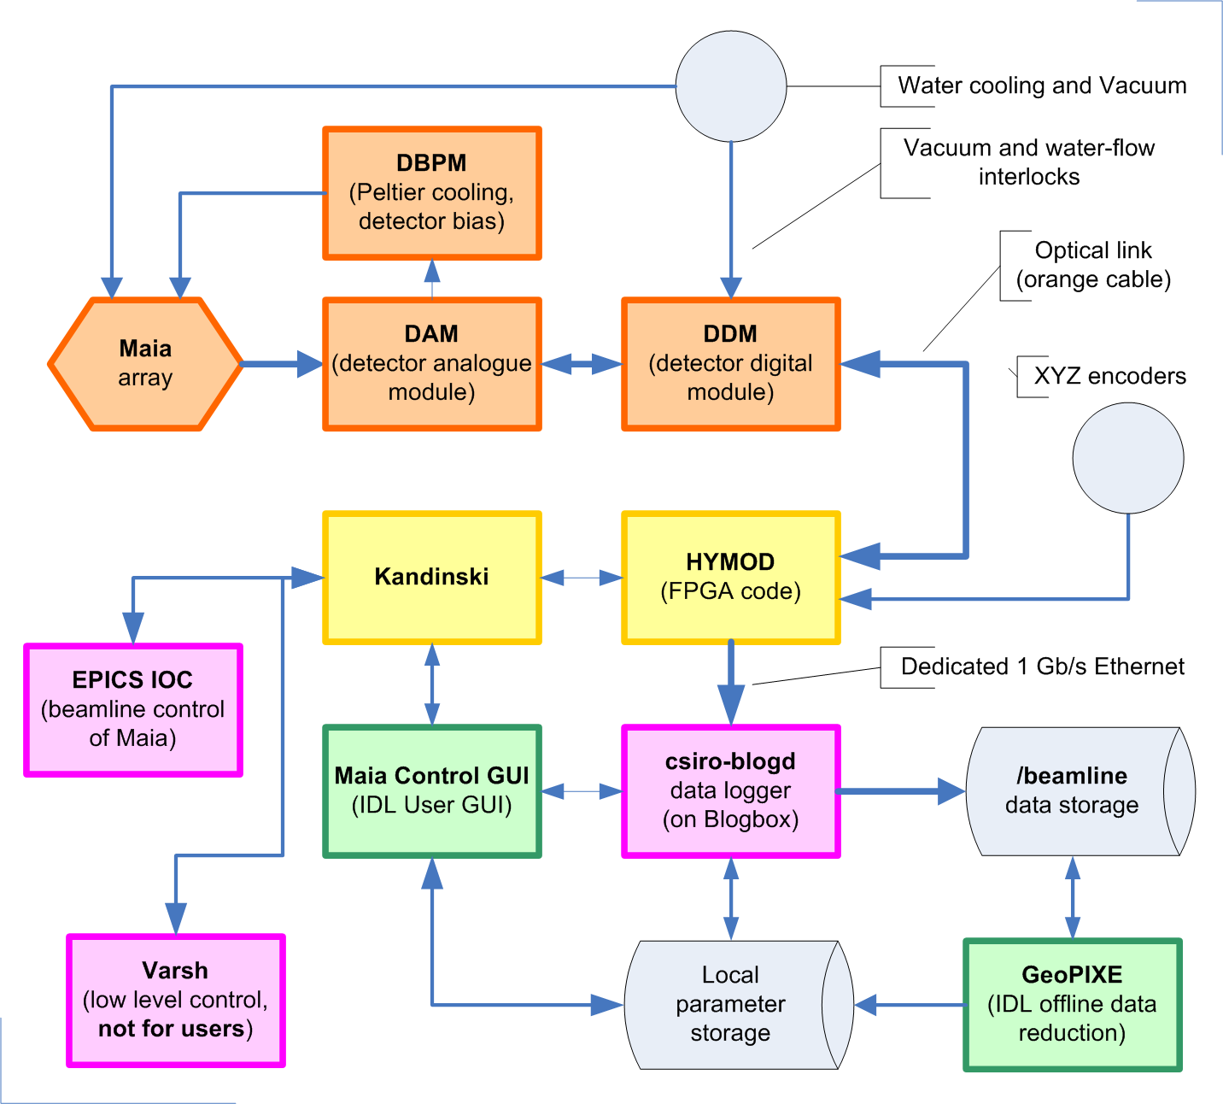
Overview of the Maia system (this diagram is also available on the “System Layout” tab of the Maia Detector Setup window of the Maia Control GUI). Some systems will implement an alternative to the Epics IOC (e.g. Tango, Spec) to push/pull parameters into/from the Kandinski socket interface.

Software modules residing on the beamline or file server Linux workstations (pink boxes):
- csiro-blogd: A logging server that writes data records to disk and serves out data records on request to clients (e.g. the Maia Control GUI).
- EPICS IOC: Control IOC running on the beamline EPICS system to control Maia and provide Maia with parameters it needs for pixellation of images during scanning. Some systems will implement an alternative to the Epics IOC (e.g. Tango, Spec) to push/pull parameters into/from the Kandinski socket interface.
- varsh: A low level command driven control program. This is NOT FOR USERS; users should use the Maia Control GUI. It is used by beamline personnel for direct access to Maia registers. Direct access to Maia via varsh may cause damage to the detector and should not be used by users.

Software modules running on a beamline computer (Windows or Linux):
- Maia Control GUI: IDL program that provides the main user interface for setting up Maia and for monitoring Maia operation.
- GeoPIXE: IDL program for off-line data reduction and occasional generation of calibration parameter files for input into Maia Control.

Installation Notes
These notes provide a basic check-list indicating the interconnected components. See the Maia documentation for details.

The entire Maia system pictured above is accommodated across 2 or 3 nodes.

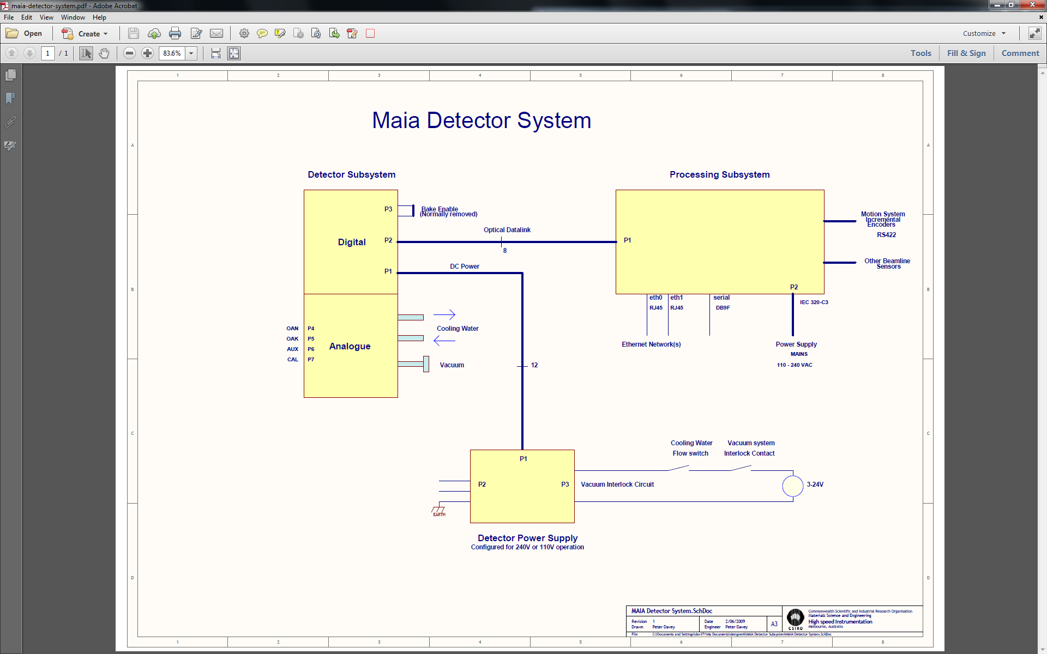

HYMOD:
  - The HYMOD FPGA processor has a coprocessor running Linux. HYMOD has two Ethernet ports: (i) eth0 typically connects to the beamline network and is used for client traffic, and (ii) eth1 provides an optional dedicated Ethernet link between the HYMOD Linux coprocessor and the file server running the blogd event logging daemon. The main service running on the HYMOD Linux processor is:

  - Kandinski:
    - Kandinski runs to handle Maia control and service requests via a socket connection from clients running on other nodes. These clients include: (i) Maia Control, which provides a GUI interface to Kandinski and Maia, (ii) varsh, which provides a low-level access to internal Kandinski variables via a command driven console, and (iii) an EPICS or Tango IOC. Kandinski maintains a copy of all variables reflecting: (i) DAM parameters for the ASICS HERMES and SCEPTER, (ii) DBPM parameters for Peltier and bias, (iii) DDM parameters for ADC control and (iv) parameters for the FPGA processing pipeline.

Beamline GUI computer:
  - One of the beamline computers can act as a host for clients to access Maia. These include:

  - Maia Control:
    - An IDL GUI program providing a real-time view of Maia parameters, event data (such as spectra and images) and methods for set-up and calibration of the processing pipeline. Multiple Maia Control clients can be run on various Linux or Windows computers on the local beamline network. However, avoid running two instances of Maia Control on one node connected to a single Maia. This GUI is used by beamline staff for Maia set-up and calibration, and by users for some operations, such as establishing Throttle vectors or setting a refined DA real-time imaging matrix.
    - On startup, Maia Control will select from any config files it finds (extension: “.Maia.conf”) in the user’s home .geopixe directory. This file specifies the IP/Port for the Maia (Kandinski) socket to HYMOD and the IP/Port for the blogger data logging process.
    - An example of lines in a .Maia.conf file …

# Maia 384/96 real-time detector set-up (only needed with a Maia detector)
#
# defaults
#
default detectors 384 # actual: config.channels
default version 1 # actual: config.ps.version
default spectra 12 # actual: config.spectrum.number
default DA 32 # actual: config.da.number
#
# shared memory for images
#
# DA image pixels will be compressed to fit into this physical range
#
default X 1000 # memory DA image X size
default Y 1000 # memory DA image Y size
#
# Kandinski socket
#
maia ip 11.22.33.44 # IP address of Maia HYMOD
maia name Maia_256 # name (max 8 chars, alphanumeric + “_”)
maia port 9001
maia device MAIA_DEVICE
maia enable 1 # Maia socket on/off
#
# Blog server
#
blog ip 22.33.44.55 # blogger host node
blog port 9000
blog enable 1 # blog on/off

  - varsh:
    - A low-level command driven console providing direct access to internal Kandinski variables. This console should be used only be experienced beamline and controls staff.
    - Run varsh by supplying the IP address of the Maia socket as the first argument.
  - EPICS IOC:
    - An EPICS IOC and MEDM panel (or equivalent) can be established (see XFM beamline example from the Australian Synchrotron) to provide the ability to (i) set selected Kandinski variables associated with a scan (e.g. scan XYZ origin, pixel size, scan range) and metadata destined to be logged with the data (e.g. beam energy, sample type and other details, etc.), and (ii) to read back status information from Maia (e.g. count rates, run number, data volume logged, etc.).
    - An equivalent Tango IOC and panel have been developed at the P06 beamline at DESY, Hamburg.

blogd file server
  - Data is logged over the dedicated eth1 Ethernet link to a file server. Initially this may be the same local computer used for GUI clients, etc. Later you may want to connect this Ethernet port over a dedicated link to a file server for the beamline or sector. Ideally, this will continue to use a dedicated Ethernet link of at least full 1 Gb/s capacity (if not shared) or a higher bandwidth if shared in any way. The service logging data is:

  - csiro-blogd:
    - blogd usually runs as a service daemon to service requests for socket connections from (i) Kandinski in HYMOD for logging event data, and (ii) from clients to request copies of selected requested event records as they pass by (e.g. ET records or Rates). blogd also adds record time stamps and records providing status information.

Typically, the HYMOD (Maia processing 19” rack unit) uses a dedicated Ethernet link (eth1) to the blogd server to handle raw data flow. Typically eth1 uses a fixed IP address. This can be changed by running the “hymod_netconf” utility on HYMOD, which allows DHCP and IP settings to be made to both Ethernet ports; “reboot” HYMOD when done. Typically, eth0 uses DHCP (or relevant beamline conventions) for connection to the beamline net.

Kandinski uses a config file (/Hymod/apps/kandinski-options), which typically has a single line, e.g.

--config kandinski_io25 –dam 384B5

which indicates the name of the executable (Kandinski_io25) and the name of the Maia detector module (in this case 384 series B unit 5. In later systems, the number is read from an ID chip in the DAM and should not be set here, as in ...

--config kandinski_io25 –dam 384D

Kandinski should start on reboot. If not, Kandinski is started with the command (as root):

appctl start Kandinski_io25

and stopped using:

appctl stop kandinskl_io25

The blogd daemon on the file server should be located and run from the /etc/inet.d list. If you need to start it use (as root):

service csiro-blogd start

Maia Control on start-up will search the local users home .geopixe dir (“~/.geopixe”) for any “*.Maia.conf” files, which can specify the IP address and port for the Kandinski socket and the blogd daemon. The key lines in this file are:

maia ip 192.168.2.123 # Kandinski socket
maia port 9001 # Kandinski port
maia name Maia_123 # a unique name stub for shared memory, etc.
maia enable 1 # enabled, else do not open port
maia device MAIA_DEVICE
maia timeout 30. # timeout for background processes

blog ip 192.168.2.254 # blogd file server IP
blog port 9000 # blogd port
blog enable 1 # enabled, else do not open the port

Preliminary Safe Operating Procedures
These notes provide a quick start-up checklist. Use this only after becoming familiar with the details of Maia internal workings and operation, as provided in the later sections of this manual and the documents providing the technical description of the detector system.

Cautions
- Do not touch the beryllium window on detector unit face, to avoid personal toxic contamination, vacuum failure and detector damage.
- Never apply Peltier cooling current without cooling water flow. Never exceed 0.5 A (Maia 96) or 2.8 A (Maia 384B) or 1.7 A (Maia 384C, Maia 384D).
- Never exceed a temperature of 65 °C on the DDM FPGA or MOSFET drive. Processor warnings may appear in the syslog, and the red LED on the HYMOD front panel may flash, if the board or CPU temperature exceeds a preset.
  - A large pop-up warning will appear if temperatures exceed: 60 °C on the detector (during baking), 40 °C water, 65 °C MOSFET, or 75 °C on the CPU or FPGAs.
- Never apply Bias without vacuum below 1.0e-5 mbar, and only change bias in 10V intervals or less. For Maia 96 never exceed 75 V, and for Maia 384 never exceed 150 V. Later Maia 384 models have a maximum of 85-90 V.
- Never run the detector biased without a valid vacuum interlock.
  - Test the interlock by observing its status during pump down. It should show Fail (Red LED on Maia-Control panel) while the vacuum is above 10⁻⁵ mbar typically, and then become Good (Green LED on Maia-Control) only after the vacuum has fallen into the 10⁻⁶ mbar range.

This is extremely important! A vacuum failure with bias applied will cause extreme damage to the detector, which cannot be repaired.

Emergency Shutdown
- In the event of an emergency, power to the detector (power supply, computers, cooling water, and vacuum pump) can be switched off (directly or as a result of loss of local power) without harm to personnel or the equipment.

Detector Set-up
The detector needs the following for safe operation: (i) adequate vacuum, (ii) cooling water flow, (iii) connection to the control processor via an optical link (orange cable).

Vacuum
- Vacuum provided by an oil-free pumping system with base vacuum below 1.0e-5 mbar. A turbomolecular pump can be used for initial pump-down; once stable in low 10⁻⁷ mbar range, an ion pump may also be used in place of the turbo.
  - However, make sure a valid interlock signal is prepared, to reflect good vacuum and water flow, and sent to the Maia power-supply interlock connector.
- It must have a vacuum gauge to measure vacuum in the manifold to be connected to the detector.

Cooling water
- The detector is connected to a chiller to provide chilled water flow (-5 ºC to +10 ºC typically and to +20 ºC for conditioning) via flexible tubing to the ¼ inch copper cooling tubes on the side of the detector housing.
- Use the supplied push-on connectors, which adapt from ¼” to 8 mm tubing. Be gentle when connecting or removing these push-on connectors to avoid damage to Maia.
- The detector requires minimal water flow, monitored directly in the connecting tubing.

Take extreme care with cooling line connections, as these are fragile. Do not twist, push or pull the cooling pipes where they enter the detector, as this may break internal solder joints.

Computer and ancillary connections
- A low-voltage power-supply cable (thick blue cable) connects the detector housing to the 19” rack form-factor power-supply unit.
- A single 12-core optical cable (orange) connects the detector to the HYMOD processing rack located outside the hutch.

Maia detector indicator LEDs
Status LEDs on the Maia detector housing (from top):
- Link status (green): optic fibre link to HYMOD is operational.
  - Flickering of this lamp, especially when manipulating the optic fibre cable or connector itself (at either end), probably indicates poor alignment or contamination of the plug in the optic fibre transceiver (socket).
- Error (red): indicates failure of fibre optic link and other errors.
  - A single blink indicates interlock down.
  - Two blinks indicate an optic fibre transceiver problem. Typically, this is loss of optical carrier, and in this case the green LINK LED will probably be extinguished.
  - Three blinks indicate the Digital Analogue Module (DAM) power is disabled manually, through setting Kandinskil variable ‘dam.power.enable’ to 0.
  - Four blinks indicate the Digital Analogue Module (DAM) power is disabled because the DAM's thermal cut-out has operated. The latter will occur if the detector cooling water is not flowing. This condition latches, so will remain until power to the entire detector subsystem is cycled at the detector power supply, or remotely using the Kandinski variable ‘dam.power.enable’ (set to 0, then back to 1).
- Poll (green): “heart beat” flashes at 1 Hz in the Kandinski program is running and in control of the detector module.
- Refresh (green): flashes once with the Poll lamp when Kandinski refreshes the DDM after initialisation, link loss, interlock trip, etc.
- Power (amber): indicates power on.

Detector Operation
These notes provide a quick start-up checklist. Use this only after becoming familiar with the details of Maia internal workings and operation, as provided in the later sections of this manual and the documents providing the technical description of the detector system.

Cool down and applying bias
- Start the cooling water and the Maia Control program, if it is not running.
- Open the Maia “Rates” window (click on “Rates” on Maia Control “Maia Detector System” main window) to monitor count rates. Select the “Detector Rate Map” panel, which shows rate per detector element. Multiple copies of Maia Rates can be opened to show different things.
- Open the “ET Spectra” windows and click on “Full” to show all channels. Click on “Select” to open the spectrum selection window. Click on “All” to display all E spectra. Click on “Clear” in the main window periodically to clear all spectra. (The “R” button can be used to display 32 channels at random across the array.)
- After vacuum has reached 1.0e-5 mbar, start the Peltier cooler. Overnight pumping or much longer before cooling is recommended.
- Open the “Setup” window by clicking on the “Maia” button under “Setup”. The detector controls are on the “Controls” tab. Here you’ll find the detector Temperature and Leakage read-back fields on the left under “Monitor”, and Peltier and Bias controls under “Controls”. Increment the control sliders by clicking to the right of the ‘handles’ to increase by 10 or use the arrows at the ends of the slider to change by 5. Under Linux, click on the knob and use the arrows keys on the keyboard, or simple type a desired target value in the box.
- The bias should be set to a preset minimum of around 15 V. Once the detector temperature has cooled to about 10 ºC above the water temperature, increment the Peltier to 0.2 A (Maia 96) or 0.5 A (Maia 384) and increment the bias to 50 V.
- Over the course of the next hour, increment the Peltier up to 0.4 A (Maia 96) or 2.5 A (Maia 384B) or 1.0 A (Maia 384C, Maia 384D) and the bias up to 60 V (Maia 96) or 70 V (Maia 384C,D or 100 V for 384B). At each step make sure the temperature continues to fall (to around -15 ºC or lower) and that leakage remains less than 5 µA. If the spectra show a large jump in counts that spread to high energies, back off the bias by 5-10V.
- If the detector has been in routine use, after 10-20 minutes the count rates in all detectors should fall below a few counts per second (with no beam). Note that a couple of channels may be disabled. A couple of channels may be ‘hot’; these will need to be disabled if they do not recover as the system stabilises.
- If the detector has been off or vented, then it will take more time to settle, and quite a few channels may still be noisy once cooled and up to 80 V bias (Maia 384C,D). Maia may require conditioning for some days. Please consult CSIRO for guidance or assistance. After conditioning it should be ‘quiet’ with few noisy pixels.
- Finally, increment to a working Peltier of 0.5 A (Maia 96) or 2.6-2.7 A (Maia 384B) or 1.0-1.1 A (Maia 384C, Maia 384D) and bias of 75 V (Maia 96), 150 V (Maia 384B) and 80-85V (Maia 384C, Maia 384D).
- The detector is ready for signal.

Pulse capture in Maia
Maia uses a 384 planar silicon detector array and dedicated pulse processing application specific integrated circuits (ASICs), one channel per detector. Pulses are amplified, shaped and sampled by the HERMES and SCEPTER ASICs and digitized by synchronous ADCs. Data from the ADCs, along with the associated detector address, are packaged and transmitted over a dedicated optical link to the HYMOD processing sub-system.

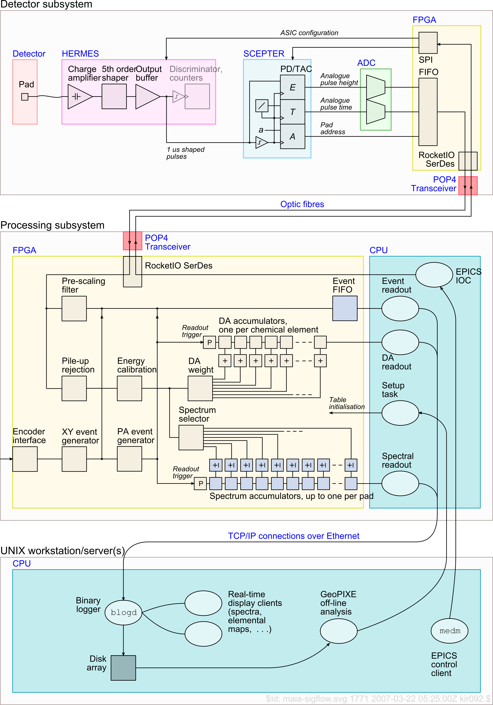

Detector Array
The Maia sensor array comprises a 20 x 20 array of 1 x 1 mm² Si planar diodes with a grid of 4 x 4 removed on the central axis for the beam. The result is a 384 detector array. Connectivity to each detector pad is provided by a 100 x 100 µm² aluminium bond pad deposited on top of the larger implanted detector pad. Detector bond pads are wire-bonded to dedicated pre-amplifier channels on the HERMES analogue pre-amplifier, shaping ASICs.

The sensor array is cooled to -10 to -25 °C using Peltier cooling elements mounted on a water-propylene-glycol cooled copper heat-sink that also cools the front-end ASICs. In the case of the 384-element array, the silicon extends about 8 mm beyond the active area in order to accommodate the Peltier cooling elements.

HERMES Pre-amplifier, Shaper
Each HERMES analogue signal conditioning ASIC provides 32 channels, each with a low-noise preamplifier, a high-order shaper and baseline stabilizer. The 384 detector array uses 12 HERMES chips. The analogue processing chain has an adjustable peaking time (0.5 µs, 1 µs, 2 µs, 4 µs), and gain (750 mV/fC, 1500 mV/fC). Control parameters for HERMES include:

- ech HERMES disable parameter ECH (ECH=1 to disable)
- time HERMES peaking time (0=1.0, 1=0.5, 2=4.0, 3=2.0 µs)
- gain HERMES gain parameter (0=1500 mV/fC , 1=750 mV/fC)
- eblk HERMES input bias leakage simulator (0=disabled)

SCEPTER Pulse Capture
SCEPTER, provides readout of two analogue signals, proportional respectively to the pulse-height and time-over-threshold (ToT). A sample-and-hold and analogue FIFO action is used for both signals allowing SCEPTER to multiplex the analogue levels to separate synchrotron ADC channels, one for E and one for T. It can cope with up to 8 simultaneous events on the 32 input channels without event loss (when the trk and trke modes are enabled). SCEPTER control parameters include:

- tdm SCEPTER timing mode (0=time-of-occurrence, 1=rise, 2=fall, 3=ToT)
- tds SCEPTER TAC slope (0=64, 1=32, 2=16, 3=8, 4=4, 5=3, 6=2, 7=1 µs/V)
- tos SCEPTER TAC timeout (0=64, 1=32, 2=16, 3=8, 4=4, 5=3, 6=2, 7=1 µs/V)
- thresh SCEPTER threshold voltage (V)
- clock SCEPTER and ADC read clock (MHz)
- trk SCEPTER simultaneous event catching (1=On)
- trke SCEPTER enhanced simultaneous event catching (1=On)
- trim SCEPTER individual channel threshold trim (V offset below thresh)
- filt SCEPTER optional input filtering (1=On)
- tcm SCEPTER comparator multifire suppression (0=0ns, 1=100ns, 2=µs, 3=2µs)
- thpd SCEPTER threshold adjust (V offset below thresh)

The SCEPTER timing function (tdm) used in Maia is the measurement of time-over-threshold (ToT) intended for pile-up rejection. For a given pulse shape with no pile-up, a well defined relation between amplitude and ToT exists. The Threshold is set by the parameter Thresh. Considering the characteristic equation of a 5th order complex poles shaper and plotting the ToT normalized to the peaking time versus the amplitude for a threshold equal to 0.5V the curve below labelled “singles” is obtained [10]. The scale of ToT is set by the time-to-analogue converter (TAC) slope parameter (tds). TAC timeout (tos) should be set somewhat longer than tds.
Time-over-threshold (ToT) as a function of pulse amplitude without pile-up (“singles”) and with pile-up and varying relative time between pulses (“piled-up”). ToT enables pile-up to be discriminated.

The relation between ToT and amplitude in pile-up events is also shown, considering two pulses of equal amplitude with an increasing relative delay. When the delay is negligible (A) the two pulses sum and the resulting signal cannot be distinguished from a single pulse of twice the amplitude. Increasing the delay the amplitude of the resulting signal decreases and the ToT increases until the shape presents a double peak (B). Further increase in the delay results in a constant peak amplitude (SCEPTER acquires the first peak) and in an increased ToT (C). The signal path allows one to distinguish, inside the biparametric scatter plot plane ToT vs. Peak Amplitude, the regions associated to single pulses from those associated to pile-up events. Thus, it allows discrimination against pile-up.

ADCs
SCEPTER chips have tri-state outputs allowing several to be ganged together for input into a single pair of dedicated synchrotron ADCs. In the 384 detector, 3 SCEPTERs share a pair of ADCs, one for E and one for T. The ADCs reads the output E and T at a fixed rate set by the SCEPTER clock parameter. If data is present on the read, it is passed by the DDM over the optical link to the HYMOD processing pipeline.

Data processing Pipeline
Real-time correction of detected signal data, pile-up rejection and image accumulation are done in the HYMOD processor FPGA code, written using the CSIRO developed 3PL language. Data is advanced through the pipeline on each clock cycle (approx. 50 MHz); HYMOD is able to accept new data events at this rate.

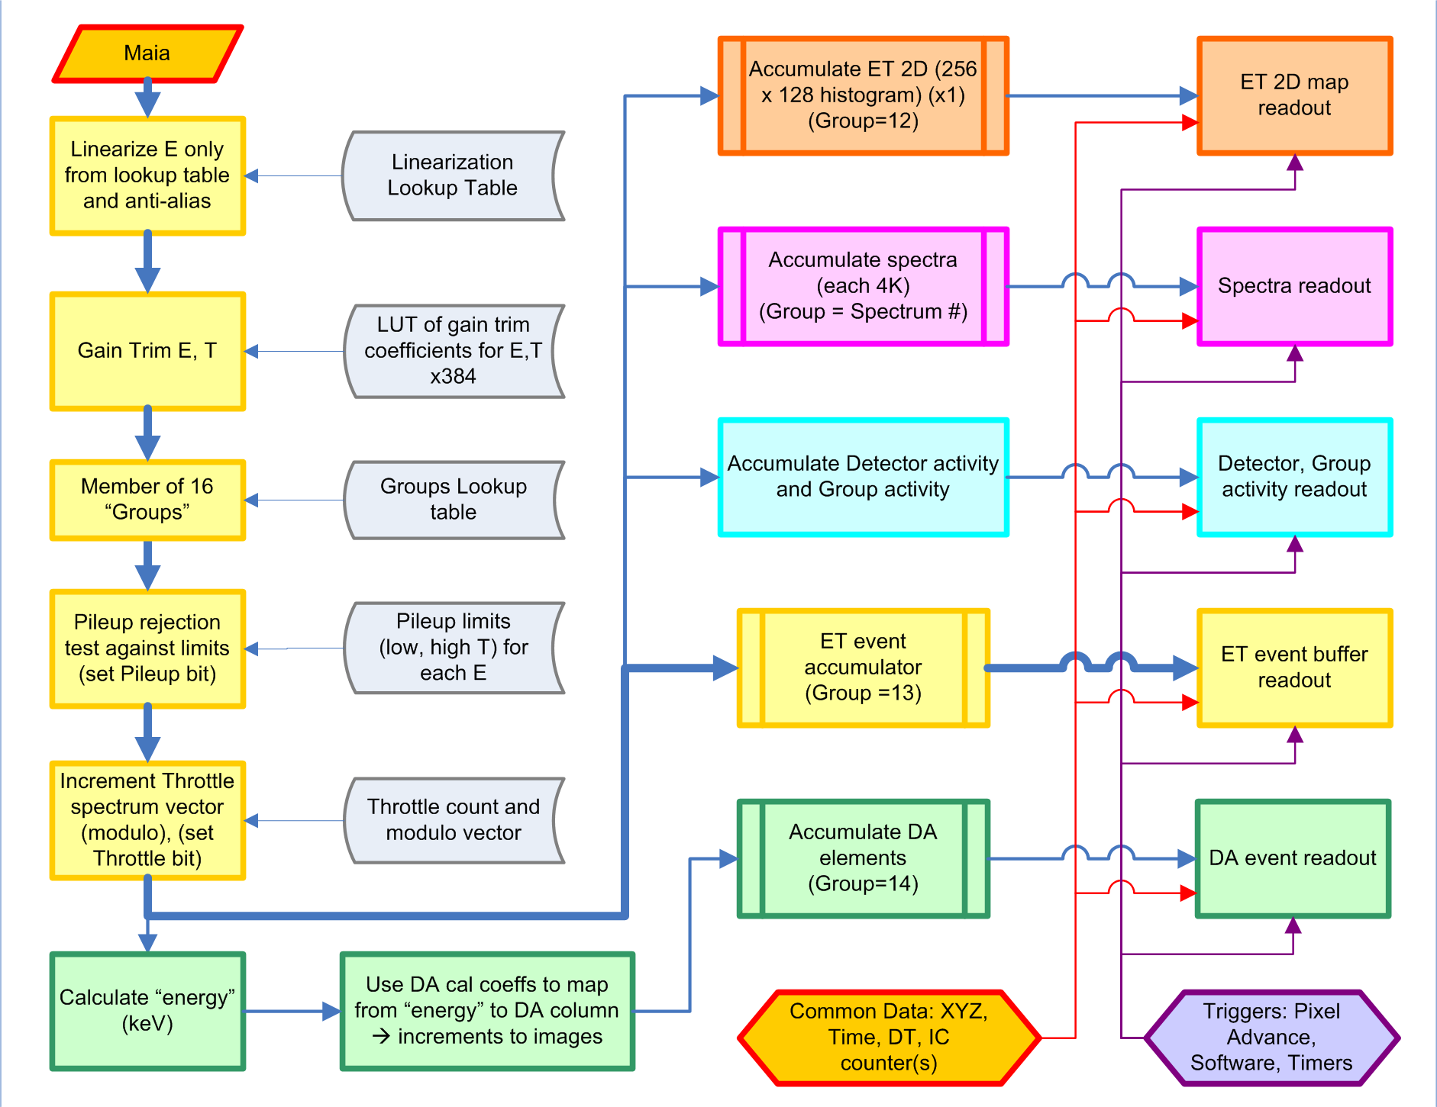
Data flow through the real-time HYMOD processor. Events are corrected in real-time in the first few modules and then collected in various accumulators and output when triggered on pixel advance, timer trigger, etc. The readout record contains the accumulator data as well as a number of common variables, such as counter values (used for ion chamber counters), dead-time data and encoder values (XYZ, etc.).

Event correction
The main data flow (yellow boxes) is through modules for data correction and filtering and then buffered for output as ET events (data words that encode E, T and detector number n within a single 32 bit word):
- Linearization: Used to use a lookup table to correct for a small degree of non-linearity in Maia response with energy. Now it implements a polynomial correction. It also implements anti-aliasing for this and the gain-trim module.
- Gain trim: Uses a linear mapping (2 coefficients per channel for each of E and T) to match all E detector channels to the same calibration; same for all T channels. The result is that all E and T channels should have peaks in the same position as the first active channel.
- Member of Groups: Flags if the current event is a member of up to 16 groups. Groups are defined to select detectors for the following accumulators:
  - 0-11: Up to 12 spectra histogram accumulators (4 spectra in initial implementation)
  - 12: Activity accumulator
  - 13: ET event buffer.
  - 14: Dynamic Analysis (DA) accumulator (also implements ROI in the current version)
  - 15: Dead-time statistics accumulator
Each group has a 384 bit field to enable any combination of detectors for the group. Groups can be defined arbitrarily, for example based on ASIC number, radial distance from axis, etc. This is discussed later in the Maia Control GUI notes.
- Pileup rejection: Tests whether the T value of the current event falls outside the T bounds set for the current E. If so, the pileup bit on that event is set. The pileup table is a lookup table of lower and upper T limits for each E. Group definitions specify whether a group will reject events if the pileup bit is set. Typically, the DA accumulator will reject pileup (so we avoid pileup artefacts in images) and the ET accumulator will not (so we log all events for later re-processing, including a new pileup rejection field if necessary). Spectra groups may reject pileup or not, to be able to contrast pileup effects.
- Throttle sub-sampling: All events for certain intense spectral features do not need to be saved to disk. The “Throttle” mechanism defines a modulo counter for selected channels so that only the n’th event in these channels is logged to disk. The modulo counter is incremented for each event based on E, and the Throttle bit on that event is reset only when the counter wraps around at the desired modulo count. Throttle settings are also set-up through the Group definitions. The Throttle modulo factors are 4 bit, restricted in the range 1-15 for now.

ET event buffering
The main data flow (yellow boxes) finishes with buffering of ET events for output (data words that encode E, T and detector number n within a single 32 bit word):
- ET event accumulator: Buffers selected ET event words (those that pass the pileup and throttle tests, if these modes are enabled for ET group 13) in the HYMOD output buffer. When full, it is written to the blogd server and written to disk. They are also available for clients to blogd, such as the Maia Control GUI. The ET event accumulator, like all accumulators, can accept or reject events based on their group, pileup or throttle bits. In parallel, it accumulates counts from the two flux inputs.
- ET event readout: When the buffer is full, or after a timeout to ensure that data is kept in HYMOD for a limited time, the buffer is written over the network to the blogd server and logged to disk (if logging is enabled). A header is added during readout, containing a time-stamp and other details of the record, such as a unique sequence counter. Accumulators are double-buffered, and so during readout no events are lost.

DA and ROI imaging
The DA extension to the data-flow (green boxes) is intended for real-time imaging using the DA method or simple ROI and has these processing modules. ROIs are handled as a trivial sub-class of DA. The DA accumulator uses Group 14.
- Calculate energy: The energy of each event (after linearization and gain-trimming) is determined from E using a lookup table of individual linear energy calibrations for each detector channel.
- DA Matrix Column: The column of the DA matrix is calculated using the energy calibration associated with the DA matrix. The column contains the increments to make to each element at the current pixel address.
- DA Accumulator: The increments are accumulated in an array of accumulators, one for each element.
- DA readout: On readout trigger, which is generated on pixel advance when the encoder show that the stage has moved into the next pixel address, the DA accumulators are read out and cleared. The output record is tagged with dwell time in the pixel, pixel XYZ… address and the flux counter 0 and 1 values. Accumulators are double-buffered, and so during readout no events are lost.

ET Spectra
Diagnostic spectra are extracted from ET events into one E and one T spectrum per channel. This is done in a Maia Control background process, which may not keep up with data rates. Hence, these spectra will not contain all events, but enable examination of every detector channel during data acquisition.

Group Spectra
Diagnostic spectra can also be accumulated in real-time using a number of spectra accumulators in Maia. These make use of the flexibility of “Groups” to accumulate any combination of detector channels, with or without pileup rejection or Throttling. Spectra accumulators can operate up to the full count rates of Maia (>50 M/s).
- Accumulate spectra: If the event satisfies the Group mask for a spectrum accumulator, and the pileup and throttle settings, it is added into the spectrum.
- Spectra readout: On readout trigger, which is commonly generated on a timer trigger, the Spectra accumulators are read out and cleared. Accumulators are double-buffered, and so during readout no events are lost.

This feature has not been completely implemented. As a result, only the first group spectrum #0 is working properly. It provides a simple way to obtain a single spectrum for all channels (mapped into a single energy calibration).

Energy-Time Histogram
A 2D histogram (256 x 128) that shows E-T relationships is accumulated in the ET 2D accumulator as Group 12.
- ET 2D accumulator: If the event satisfies the Group mask for the ET 2D accumulator, and the pileup and throttle settings, it is scaled and added into the 2D histogram.
- ET 2D readout: On readout trigger, which is commonly generated on a timer trigger, the ET 2D accumulator is read out and cleared. Accumulators are double-buffered, and so during readout no events are lost.

The 2D ET histogram accumulator is not used at present; a 2D ET display is emulated using extraction from the ET event stream by a Maia Control process. Hence, the 2D ET display will not contain all events, but enable examination of the trend during data acquisition.

Activity
Arrays that track count rates by detector channel and Group are accumulated in the Activity accumulator (no Group, pileup or throttle filters).
- Activity accumulator: increments registers based on detector channel and Group ID, for all groups that the event may be part of.
- Activity readout: On readout trigger, which is commonly generated on a timer trigger, the ET 2D accumulator is read out and cleared. Accumulators are double-buffered, and so during readout no events are lost.

Maia Control User Interface
The Maia Control GUI is started on a Windows PC or beamline Linux workstation to monitor and control the detector. It uses a configuration file “…Maia.conf” located in a user’s home .geopixe directory (if multiple files are available, you will be presented with a file selector). The conf file contains the IP addresses of the HYMOD processor, which is needed to connect to the Kandinski socket, and the blog server, which is needed to connect as a client to the blogd server. Lines can be commented out using the “#” character.

NOTE: Initially, if no Maia.conf file is found, a template will be copied to your home .geopixe directory. Edit this for your system configuration.

The left of the window has a panel of status LEDs that indicate the status of:
- Maia socket: Indicates whether Maia Control managed to connect to a running Kandinski (green). Red indicates a failed connection, or that Kandinski is not running.
- DDM link: Indicates a functioning optical link between the DDM unit in the detector head and the HYMOD crate (green).
- Maia to Blog: Indicates that Kandinski has successfully opened a connection to blogd (green) for data logging on the file server.
- Blog clients: Indicates that Maia Control has opened its background processes (green) connected to blogd as clients for read-back of event records.
- Interlock: Indicates that Maia hardware interlocks are OK (green).
- Bakeout: Indicates (red) that the Bakeout plug is connected and the Peltier controls can be used to either Cool or Bake the detector – selected via the COOL/BAKE droplist. Do not heat the array beyond ~50 °C. Also ensure that no other temperatures (e.g. Hermes, MOSFET, FPGA) exceed 65 °C.

The central part of the window has a group of fields:
- Maia, Reset, ET spectra, ET 2D, rates, Groups, Image, Multi, Browse buttons: These open various windows as indicated below under Maia Control Windows.
- Text display field for (i) context-sensitive help (just move the cursor over a widget to get help on it), and (ii) updates of detector bias, temperature and leakage current.

The right of the window has a group of Control buttons and status:
- Newrun/ Endrun button: “Newrun” can start data collection and logging to a new blog run (normally this is done via Epics/Tango). The button changes to “Endrun” when it is running, which can be used to manually stop data collection. This can be used during set-up and testing. A Newrun increments the run number.
- Clear: Clears shared memory buffers for ET spectra and DA real-time images. This does not clear data stored in the blog data files.
- Run, Rate, Project/Group: shows the status of the blog run number, data rate to disk and the “Project”, which is the parent directory for blog data logging, and “Group”, which is a user selectable sub-dir for grouping data as collected. It also shows an estimate of free disk space. Click on this row to set a Group. It is better to do this via beamline GUI controls.

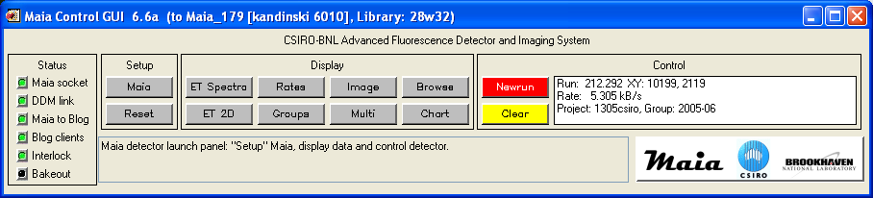
Maia Control GUI showing version number and Kandinski version, which is running on the Maia coprocessor.

Maia Control Windows
The main control panel has launch buttons for all main functions. Notes on each can be viewed in the help box by passing the cursor over each.
- Maia: Opens the Maia Setup window, which is used to set-up and view Maia parameters and control cooling and bias (see section below).
- Reset: Resets some hardware settings and background processes reading event records, etc. Also rewrites parameters to the detector head.
- ET Spectra: Opens 2 Spectrum Display windows, one for E spectra and one for T spectra. Use the “Select” button to open Spectrum Select windows to control detector selection and colours (see the GeoPIXE manual for details). These spectra are built up from ET event records obtained from blogd. At very high rates, some blocks may be lost (lost block rates can be checked in the Rates window).

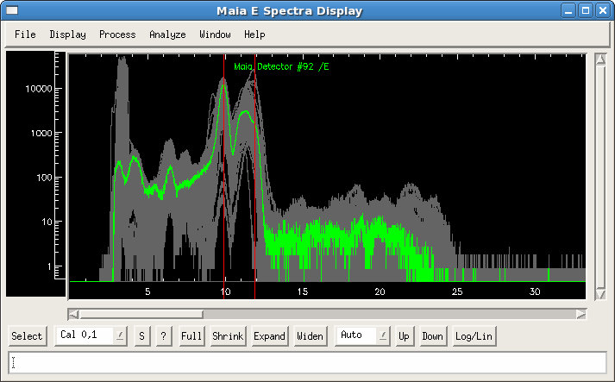
The “ET Spectra” button opens 2 windows, one for E spectra and one for T. This figure shows all 384 E spectra in “Highlight” mode with detector 92 selected (green), selected using the Select window

- Groups: Opens another Spectrum Display window, which displays the spectra collected in real-time in HYMOD, which reflect the Groups detector selections for the first few Groups. These do not suffer from lost blocks at any count rate up to the maximum (>50 M/s).

Groups spectra display, which shows the real-time spectra accumulated in HYMOD, specified as the first few Groups. Most controls behave as in GeoPIXE. See the GeoPIXE manual for details of the Spectrum Display window. Click on “Select” to select spectra to display using the Spectrum Select window (see GeoPIXE manual).

- Image: Opens a GeoPIXE Image window to display real-time DA (or ROI) images. The Image window is pretty high on resources due to the functionality that it provides.

It is best to not open too many on 32-bit systems, especially for high-definition Maia images. Use the Multi-Image display window instead for multiple images. Similarly, avoid zooming in by clicking on “+” more than about once. An RGB Image window can also be opened to monitor real-time imagery by using the Windows menu on the Image window.

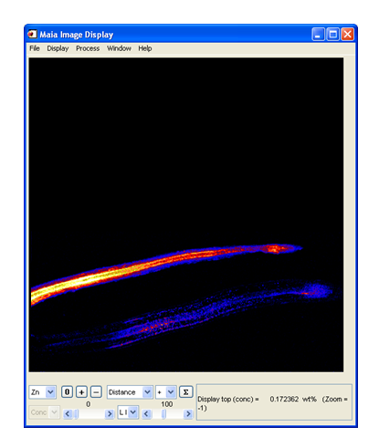
Image window display, used to display real-time DA (or ROI) images. See GeoPIXE manual for details.

- Multi: Opens a single window that enables the display of up to 25 element images from DA or ROI real-time acquisition in HYMOD. Left-click and drag out a selection rectangle in the top left window to zoom in all other windows. Right click (top left) to clear the zoom region.

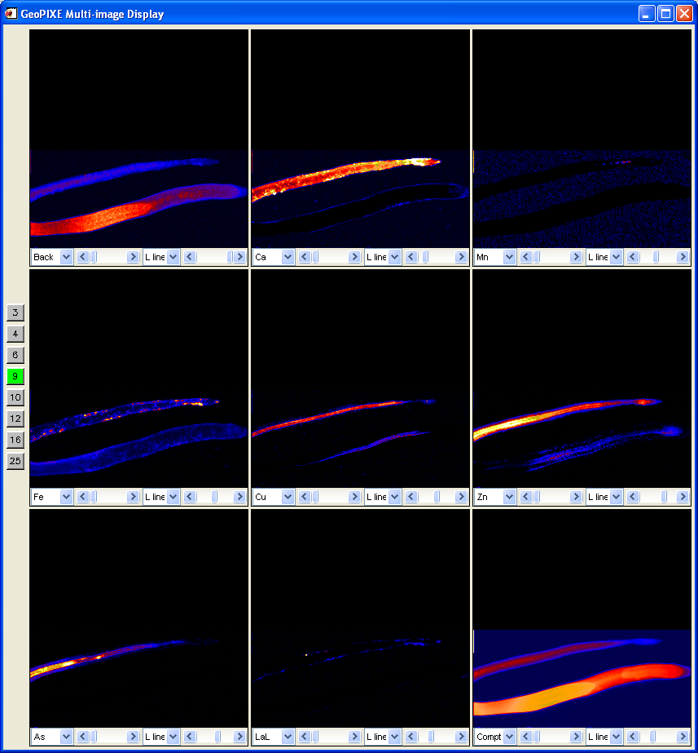
Multi-image display showing a 9 image selection. Change image number using the buttons on the left, and change image size by resizing the window. Each element window has a sub-set of GeoPIXE Image window controls for minimum and maximum concentration display, Z axis scale (linear, Sqrt, Log) and element selection drop-lists.

- Rates: Opens a window with three panels to display count rates and process resource usage:
  - Count rates: Shows a histogram of count rates by detector number within a selected quadrant, HERMES chip or the whole detector.
  - Detector rate map: Displays count rate as a colour-map overlaid on a mimic display of the detector array.
  - Process load: Shows a histogram of process % CPU busy and % lost buffer estimates.

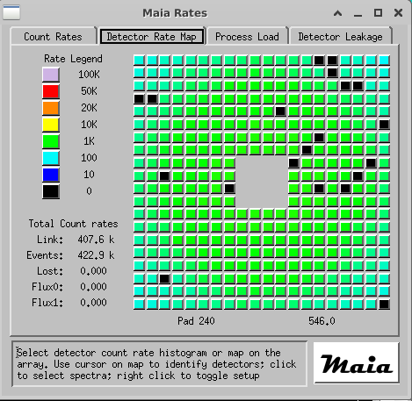
Maia detector count rate map for the 384 detector array. Also displays total count rates and flux counter rates. Pass the cursor over detector pads to view the detector number and view updating count rates for that pad in the text fields. Click on a pad to switch E and T spectra display to this pad.

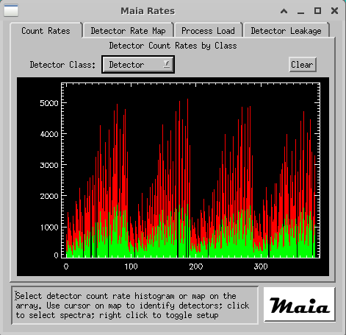
Maia detector count rate histogram, with “All” detector channels selected. The Red histogram shows the maximum rates obtained per channel. Use “Clear” to reset the maximum rate display.

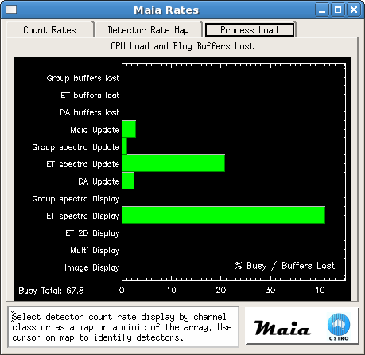
Maia detector rate display under the “Process” tab, which shows estimates of processor load and missed buffer rates. This display shows the high processor load when all 384 E spectra are selected (as shown above). Select fewer spectra for lower processor load.

- ET 2D: Opens a window to display the Energy-Time histogram, collected in real-time in HYMOD, as a 2D histogram colour map. Adjust the minimum and maximum histogram levels using the two sliders. Zoom into a region with a left-click and drag manoeuvre to select a rectangular zoom region. Right click to reset this.

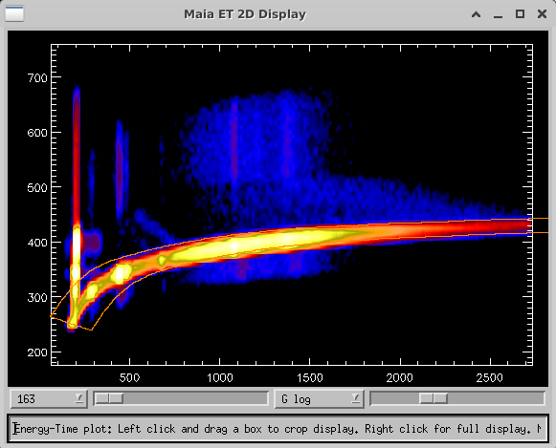
ET 2D histogram showing all or a selected detector channel(s) logged in ET event (select channels using the droplist). This shows E versus T after gain-trimming to match E and T spectra gains and offsets so they follow a single trend

- Browse: Opens a window like BlogBrowser to sample the event stream (not all events of a selected type will necessarily be captured).
  - Click on “Start” to start adding selected events to the list view, “Stop” top stop and “Clear” to clear the list. Up to 300 records are added.
  - Click on “Select Record Tags” to open a window to select which Blog records to display.
  - Click on records to see more information or pop-up plots.

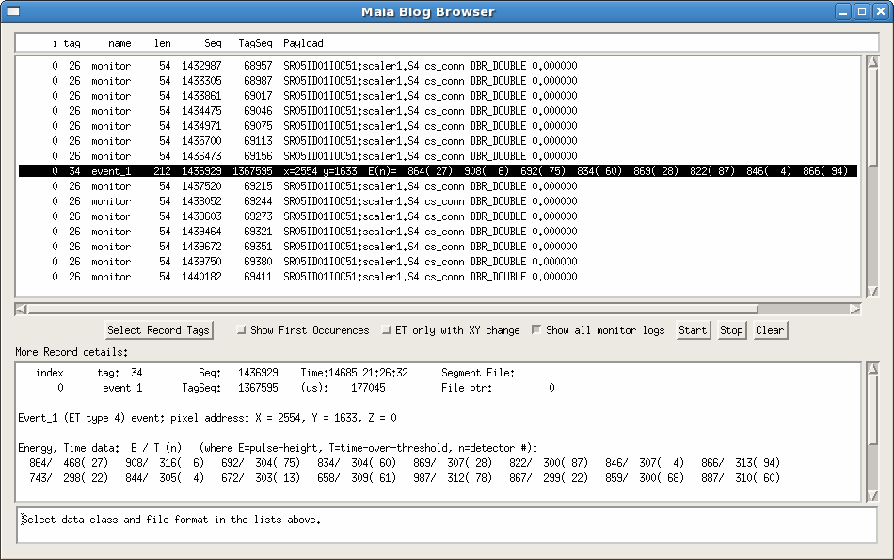
BlogBrower window for real-time sampling of the event stream. Not all selected event types can be displayed; only a sub-sampling is provided for very high-volume record types, such as the main ET event records.

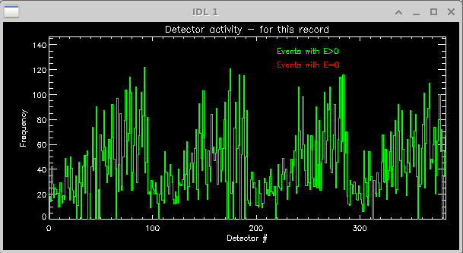
Detector rates from an ET event

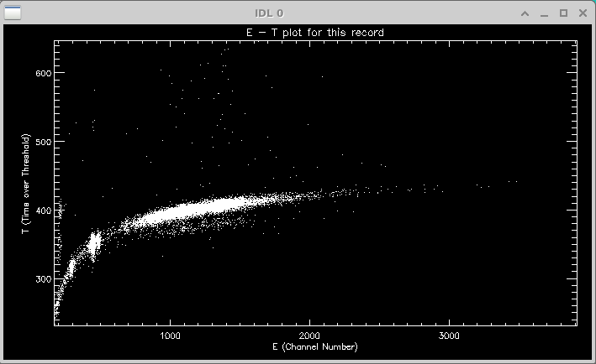
E-T plot for a selected ET record

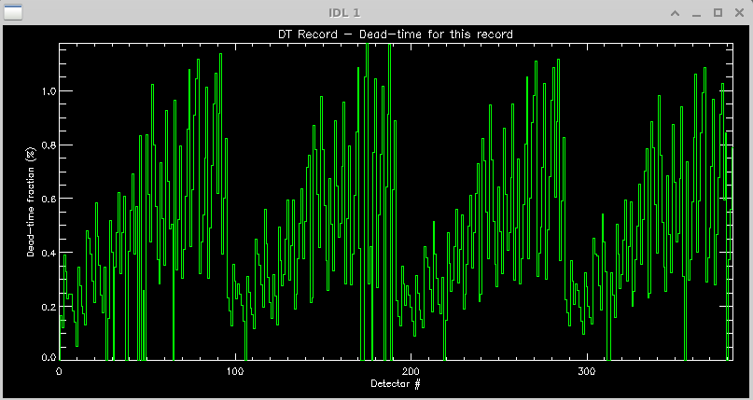
Dead-time rate from a DT record

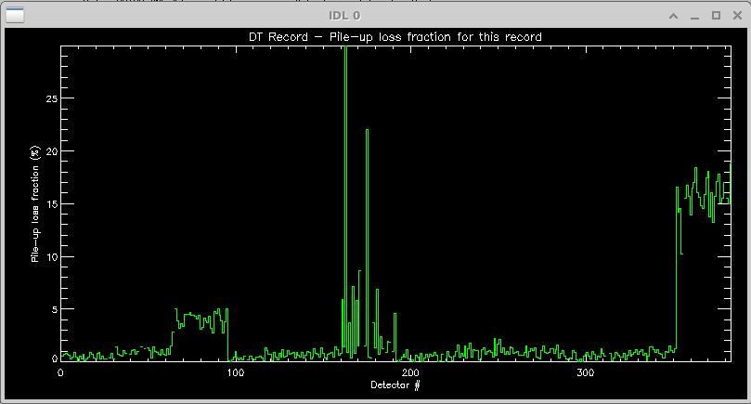
DT record showing pile-up losses for a time period

- Chart: Opens the Chart window to display logged detector parameters versus time. This is disabled by default. Enable it from the Setup “Enable” tab. Use the Select button to open a Spectrum Select window to control which parameters are plotted (and see colour legend). Parameters are logged versus time (UTC time relative to Jan 1, 1970) to the file “Maia_384xx_log.csv” (set via …Maia.conf file).

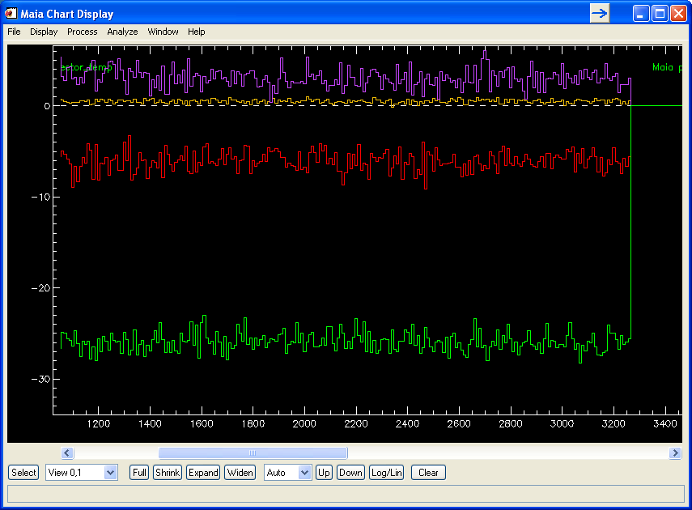
Maia Chart display showing selected parameters as a function of time, sampled every few seconds. The colour legend is provided by the 2nd column of the Spectrum Select window for parameters selected for display.

Maia Detector Setup window
The purpose of the Maia Setup window is to set-up the real-time processing pipeline for routine data collection. In its raw state, spectra from each detector will have different gain and offset and a small non-linearity. These need to be characterized to set-up lookup tables and linear mappings to correct this before routine analysis. It is expected that these tables for (i) Linearization, (ii) gain-trimming, and (iii) pile-up rejection will be set-up and enabled for routine analysis.

Maia parameters are set-up and viewed using this window, which is divided into 3 areas: (i) the left panel has a series of tabs to select groups of Maia parameters and panels for detector control and debugging; (ii) the right panel normally shows a mimic display of the detector that is used to select detector pads for selective application of parameters or to display parameters across the array. It also has tabs on the right to switch the display to diagrams showing detector layout, data-flow organization and system layout; and (iii) the bottom strip, which has Save and Load buttons for global parameters and controls for the mimic display. Normally, the mimic display is used to select groups of detectors for application of parameters or to set up Groups, for example. The grouping of detector pads for selection is controlled using the “Selection Class” droplist. It can also be used to display parameters across the array as a colour map (by enabling “Show Parameters”).

Enable
This panel is used to (i) disable detector channels that are not functioning correctly (top box; used with mimic display), (ii) enable Maia readout by quadrant and clock phase (used to select SCEPTERs within a quadrant; middle box), and (iii) enable various phases of the real-time processing pipeline (lower box); details of the pipeline are set-up elsewhere (HYMOD, Groups and Imaging tabs).

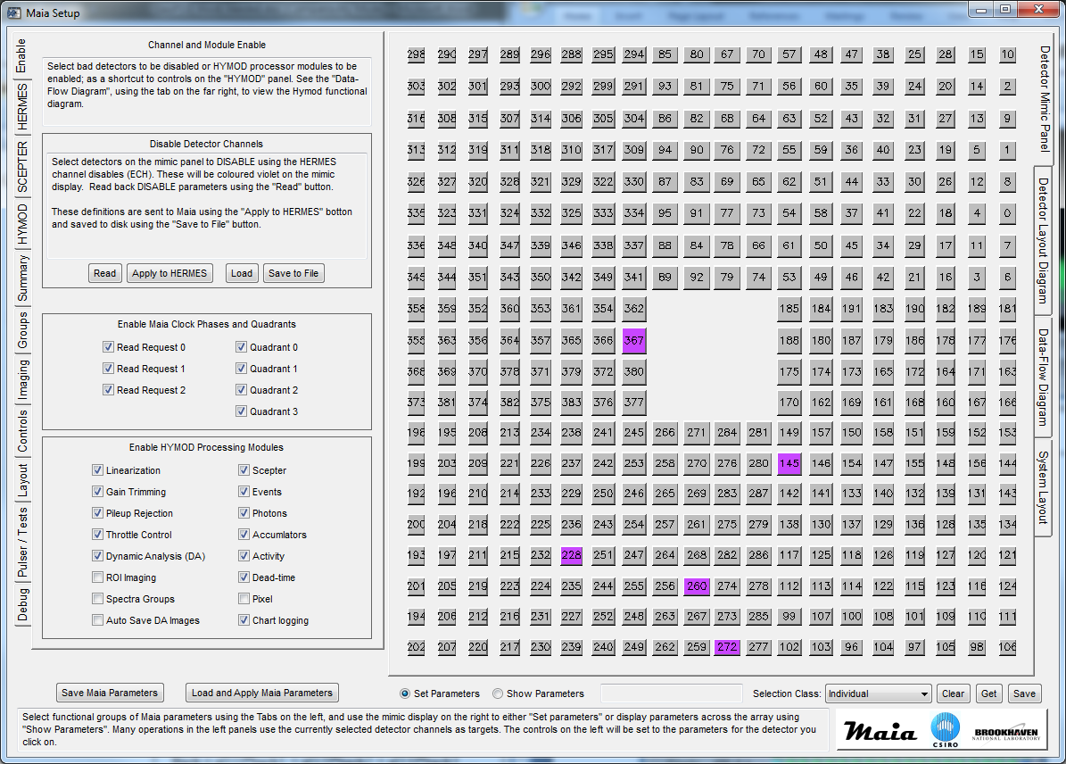
Maia Detector Setup window showing the first tab panel for enabling and disabling detector channels. The right panel shows the mimic display and the disabled detector channels. The tabs at the right can be used to show the system layout and processing pipeline diagrams as shown in the Overview above.

If spectrum quality indicates a bad detector channel, or the count rate of one channel indicates a lot of noise (see Rates window elsewhere), then those channels can be disabled here. The mimic display shows the channels disabled currently (shown in violet; actually, on entry to the “Enable” panel). To update this display, press “Read”. Set the selection class to “individual”. Toggle channels to disable/enable them on the mimic display., and then “Apply to HERMES”. This sets the HERMES ASIC disable parameter (ECH). All HERMES and SCEPTER parameters can be viewed in the table on the Summary tab. Also, these selections can be Loaded from or Saved to a file.

The lower boxes of the Enable tab panel are immediate, i.e. they send settings instantly to Maia via Kandinski. Most other panels (and the Disable function above) have explicit “Apply” buttons to send data to Maia. These enable check-boxes are short-hands for switching this pipeline modules on and off. The “Auto Save DA Images” check-box enables the saving of the real-time DA images to disk after each run. Remember to set up the parameters on the HYMOD, Groups and Imaging tabs first.

HERMES
This panel is used to set parameters for the HERMES pre-amp, quasi-Gaussian pulse shaper ASICs. Most parameters are set at the chip level, and so the “Selection Class” is set to “Chip”. Click on any detector pad within a desired Chip to toggle the selection, or normally set the selection class to “All” to set all HERMES chips. Now set the check box to the left of the parameter group you wish to change and set the new value from the droplists and sliders. On “Apply to HERMES” this change is sent to the selected HERMES chips.

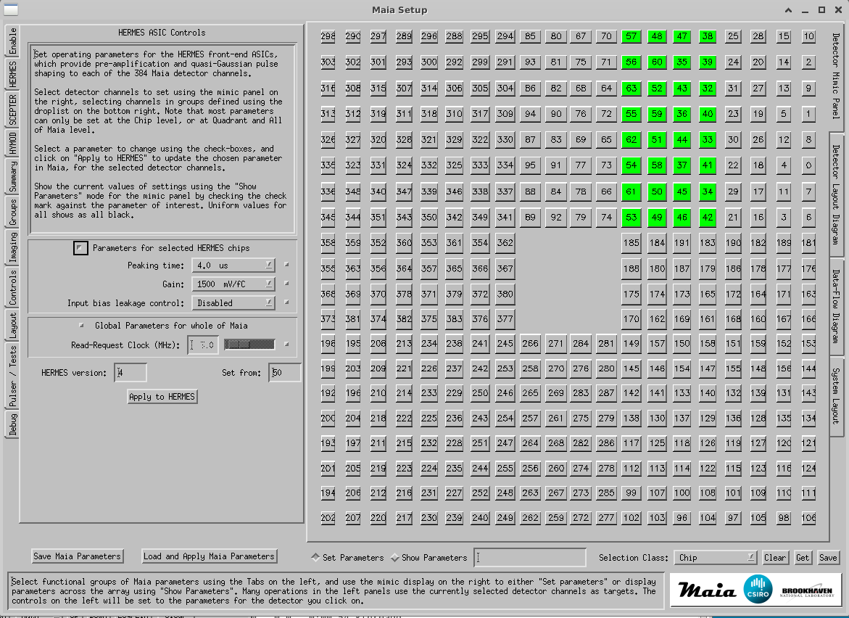

The check-boxes also double as a way to display parameters as a colour map across the array. Set the toggle below the mimic display to “Show Parameters”. Now check a desired parameter on this panel (or the SCEPTER or Summary tabs), using the small checkbox on the right of each, to see how it’s set across all chips.

HERMES, along with SCEPTER and HYMOD parameters, are saved to disk using the “Save Maia Parameters” button at the bottom of the window. The exception is the Disable (ECH) parameters, which are saved separately on the Enable tab panel.

In “Show Parameters” mode, click on the small check-box to the right of an item to display its values across the mimic display of the Maia array.

SCEPTER
This panel is used to set parameters for the SCEPTER pulse-capture, sample and hold and derandomizer ASICs. Most parameters are set at the chip level, and so the “Selection Class” is set to “Chip”. Click on any detector pad within a desired Chip to toggle the selection, or normally set the selection class to “All” to set all SCEPTER chips. Now set the check box to the left of the parameter group you wish to change and set the new value from the droplists and sliders. On “Apply to SCEPTER” this change is sent to the selected SCEPTER chips.

The Threshold parameters provide a chip-by-chip adjustment to Threshold. These can bet set in two ways: (i) select chips and set a value in the slider for the Threshold, or (ii) use the Up and Down arrows to shift the Threshold values of selected chips by +0.005V or -0.005V, respectively. These maintain differences between Threshold values on each chip and increment/decrement them together. Then apply this value to all selected channels.

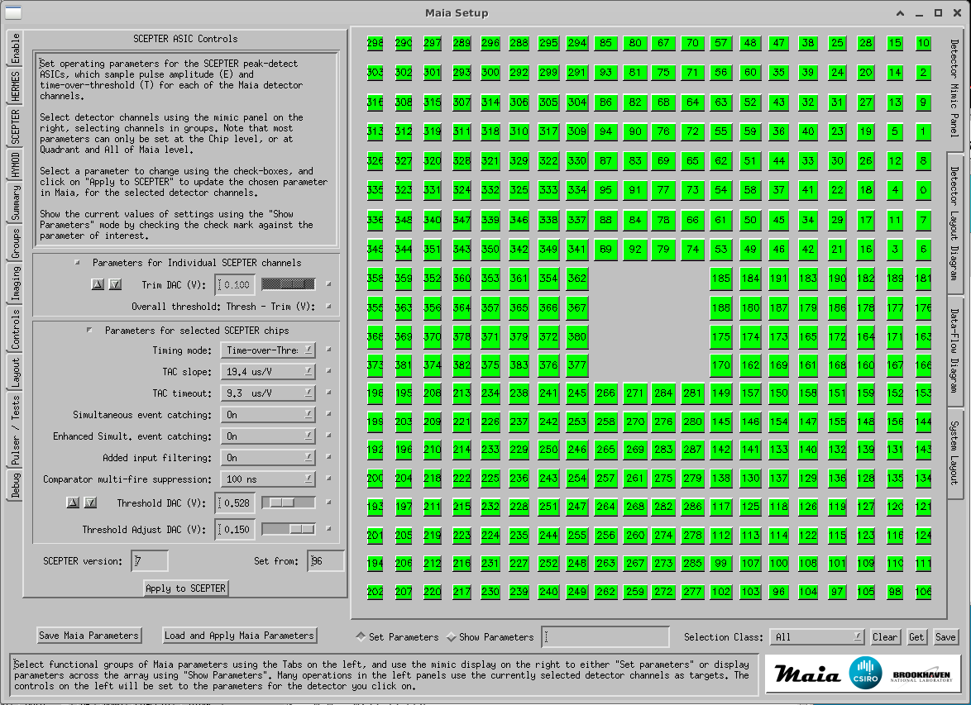

The Trim parameters provide a channel-by-channel adjustment, which is combined with Threshold (actually subtracted from it). These can bet set in two ways: (i) select channels and set a value in the slider for the Trim, or (ii) use the Up and Down arrows to shift the Trim values by +0.005V or -0.005V, respectively. These maintain differences between Trim values across channels and increment/decrement them together. Remember to “Apply to SCEPTER” these changes to selected channels.

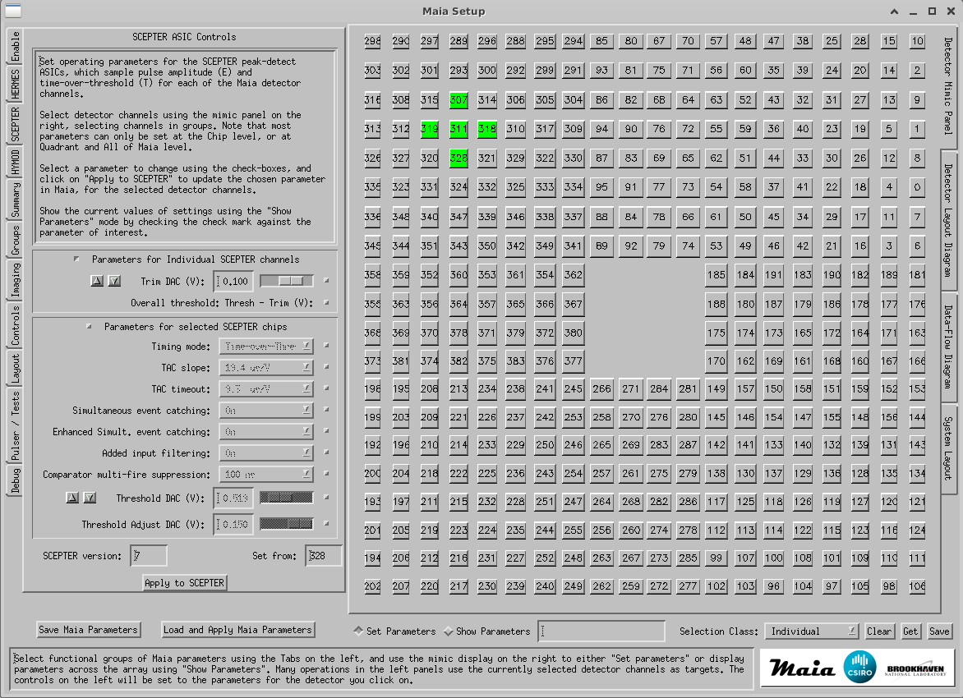

HERMES, along with SCEPTER and HYMOD parameters, are saved to disk using the “Save Maia Parameters” button at the bottom of the window. The exception is the Disable (ECH) parameters, which are saved separately on the Enable tab panel.

The check-boxes on the right also double as a way to display parameters as a colour map across the array. Set the toggle below the mimic display to “Show Parameters”. Now check a desired parameter on this panel (or the HERMES or Summary tabs, etc.) to see how it’s set across all chips.

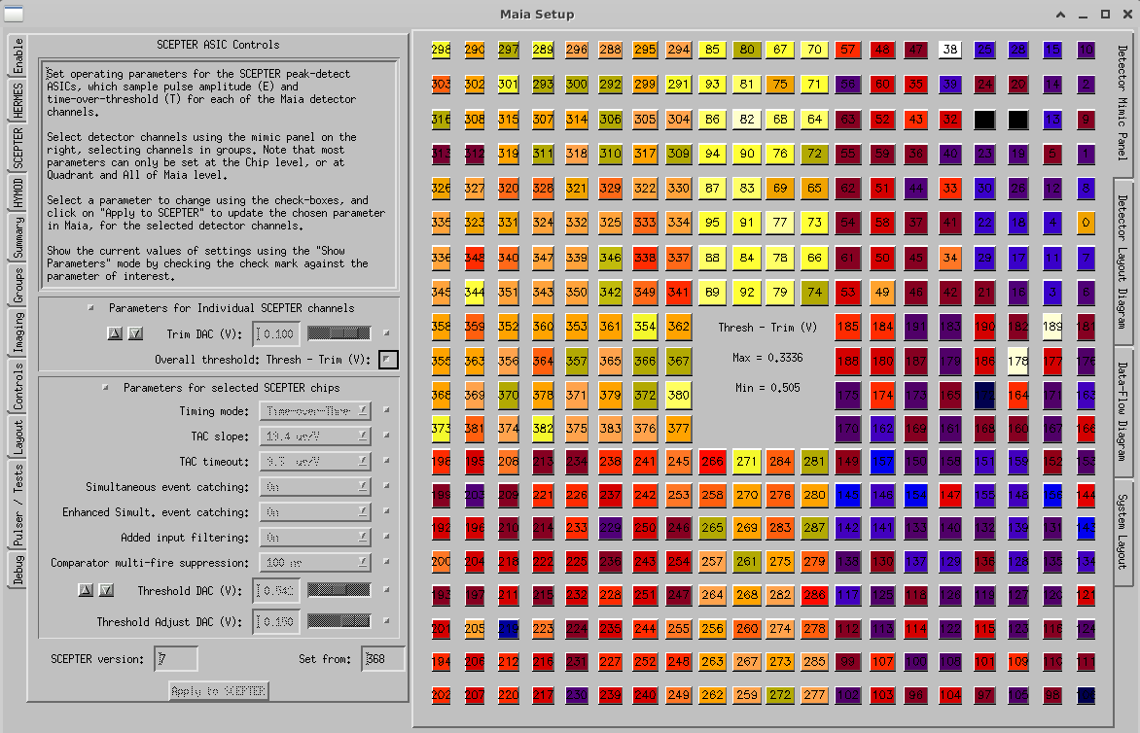
“Show Parameters” with “Overall Threshold-Trim” selected

HYMOD
Parameters and lookup tables for the real-time processing pipeline in HYMOD are constructed elsewhere (e.g. using tools in Spectra and Image windows, here or in GeoPIXE, using GeoPIXE procedures – see section “Maia Pipeline Set-up” p.37). In the HYMOD tab panel, these lookup table files are loaded and enabled/disabled. To send lookup table and enable settings to HYMOD, click on “Apply to HYMOD”.

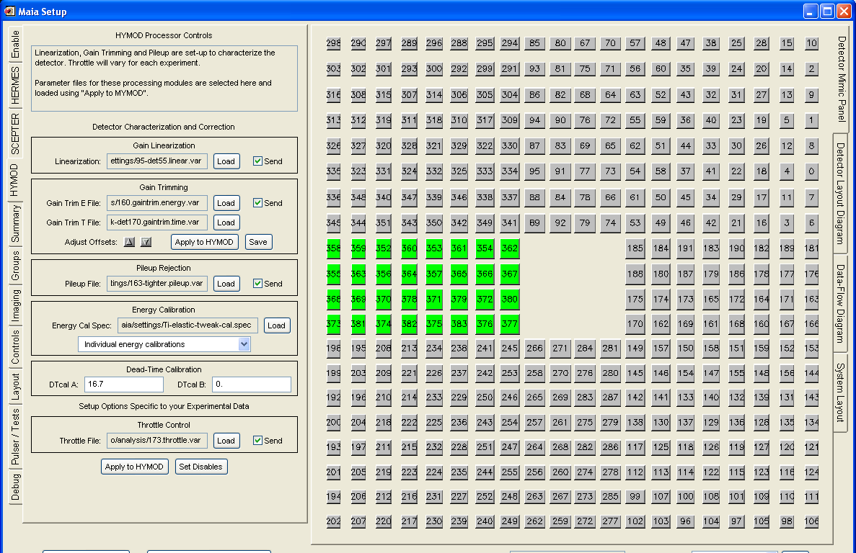

Most HYMOD tables and pipeline settings apply to all data collected by HYMOD. Linearization, gain-trimming, pile-up rejection, dead-time and energy calibration apply to all experiments.

In contrast, Throttle settings and lookup table are very specific to a sample, its major element lines and intensities, and to the beam energy, and its scatter peaks. These are not set globally, using the “Save Maia Parameters” and “Load and Apply Maia Parameters”. Set and enable these manually here, if needed to reduce data rates to disk for this experiment.

TIP: Once Throttle settings are established here, they can be turned on and off on the “Enable” tab.

The up, down “Adjust Offsets” arrow buttons in the Gain-trim group can be used to adjust the T Gain-trim offsets by +10, -10, respectively. These can be used to move the E-T field (in T direction) for selected individual channels into the correct position within the Pileup field (e.g. after a change of Trim). Click on “Apply to HYMOD” next these arrows to apply these changes to HYMOD.

TIP: To only see detector channels that you wish to adjust using the T Gain-trim arrow buttons, select these channels in the ET2D window using the droplist on the left.

After data has been Applied to HYMOD, the mimic display will show the channels that have been included. Click on “Set Disables” to disable those channels that have NOT been selected. During energy calibration procedures, delete any spectra not wanted. Hence, the loaded energy calibration SPEC file should only contain good channels.

Summary
The Summary tab displays a table of HERMES and SCEPTER parameters. It also contains columns for energy calibration and gain trimming parameters as well as array layout parameters for effective pad width and height, and layout indices for each pad based on Chip, Quadrant, Column and Row in the array. Click on a column heading to sort the table based on this column in ascending order.

The first column “Indx” is the index of the pad in the layout CSV file. For the 384 detector array, this index runs from top left across rows in the array and in rows from top to bottom. The next column “Det” is the detector channel number. The columns are:
- Indx CSV detector layout table index
- Det detector channel or pad number
- ech HERMES disable parameter ECH (ECH=1 to disable)
- time HERMES peaking time (0=1.0, 1=0.5, 2=4.0, 3=2.0 µs)
- gain HERMES gain parameter (0=1500 mV/fC , 1=750 mV/fC)
- tdm SCEPTER timing mode (0=time-of-occurrence, 1=rise, 2=fall, 3=ToT)
- tds SCEPTER TAC slope (0=64, 1=32, 2=16, 3=8, 4=4, 5=3, 6=2, 7=1 µs/V)
- tos SCEPTER TAC timeout (0=64, 1=32, 2=16, 3=8, 4=4, 5=3, 6=2, 7=1 µs/V)
- thresh SCEPTER threshold voltage (V)
- thpd SCEPTER threshold adjust (V offset below thresh)
- trim SCEPTER individual channel threshold trim (V offset below thresh)
- clock SCEPTER and ADC read clock (MHz)
- eblk HERMES input bias leakage simulator (0=disabled)
- tcm SCEPTER comparator multifire suppression (0=0ns, 1=100ns, 2=µs, 3=2µs)
- filt SCEPTER optional input filtering (1=On)
- trk SCEPTER simultaneous event catching (1=On)
- trke SCEPTER enhanced simultaneous event catching (1=On)
- CalA energy calibration gain (keV/bin)
- CalB energy calibration offset (keV)
- TrimEa gain trimming gain for E
- TrimEb gain trimming offset for E
- TrimTa gain trimming gain for T
- TrimTb gain trimming offset for T
- X X coordinate of pad centre (detector geometry comes from .csv file)
- Y Y coordinate of pad centre
- Width effective width of detector pad (after masking)
- Height effective height of detector pad (after masking)
- Tilt tilt (degrees) of pad from planar (towards array centre)
- FWHM FWHM of channel (eV) (optional)
- Chip index to HERMES-SCEPTER pair for this pad
- Quad index to the quadrant for this pad
- Radial index to the radial group for this pad (see Layout tab panel)
- Col index to the column for this pad
- Row index to the row for this pad

Detector layout details come from the “Maia_384#.csv” file, where “#” indicates the Maia generation (“A”, “B”, “C”, “D”, “G”).

Groups
Assignment of detector channels to each “Group”, as well as whether pileup is rejected for a Group of Throttling is applied, is set in the Group tab panel. Groups are defined to select detectors for the following accumulators:
- 0-11 Up to 12 spectra histogram accumulators (only 4 in current implementation ; 4K each)
- 12 E-T 2D histogram accumulator (256 x 128)
- 13 ET event buffer (32K buffer)
- 14 Dynamic Analysis (DA) accumulator (also implements ROI as a special case)
- 15 Dead-time statistics accumulator

NOTE: Groups spectra have not been fully implemented at this time. However, the settings for ET, DA are in use.

Each group has a 384 bit field to enable any combination of detectors for the group. Groups can be defined arbitrarily. Use the Selection Class droplist to group detectors and click on detector to toggle the selection state of this detector as part of a Selection Class. Click on “Read” to read back the current detector selection from Maia.

To set-up a Spectrum accumulator, click on the row and select detector channels on the mimic panel to the right. Then click on “SET” in the row for this Spectrum. The Title can be edited in the “Edit Title” field below the table – remember to hit <return> to make the change to the current row. Pileup rejection can be enabled for this accumulator by toggling the setting in the “PU Rej” column. Similarly, Throttling can be set in the “Throt” column.

Some rows are predefined for other accumulators (as listed above). Row 12 can be set-up for the E-T 2D histogram accumulator, using a similar approach to the Spectra Groups. There is only one E-T 2D histogram, so you might vary this from time to time to monitor specific detectors, or a bank of channels attached to one SCEPTER, for example. (ET 2D is disabled at present)

Setting the detector channels for row 13 selects detector channels for ET data records written to disk (and available to Maia Control as a client for individual detector Spectra display and the ET2D plot). Normally, this would select all detector channels (excluding those Disabled) and it may have Throttling enabled to conserve disk space.

Row 14 is used to select detector channels for DA imaging. This would normally use all detector channels and have Pileup rejection enabled, but it would not need to use Throttling as HYMOD can easily process all events in real-time.

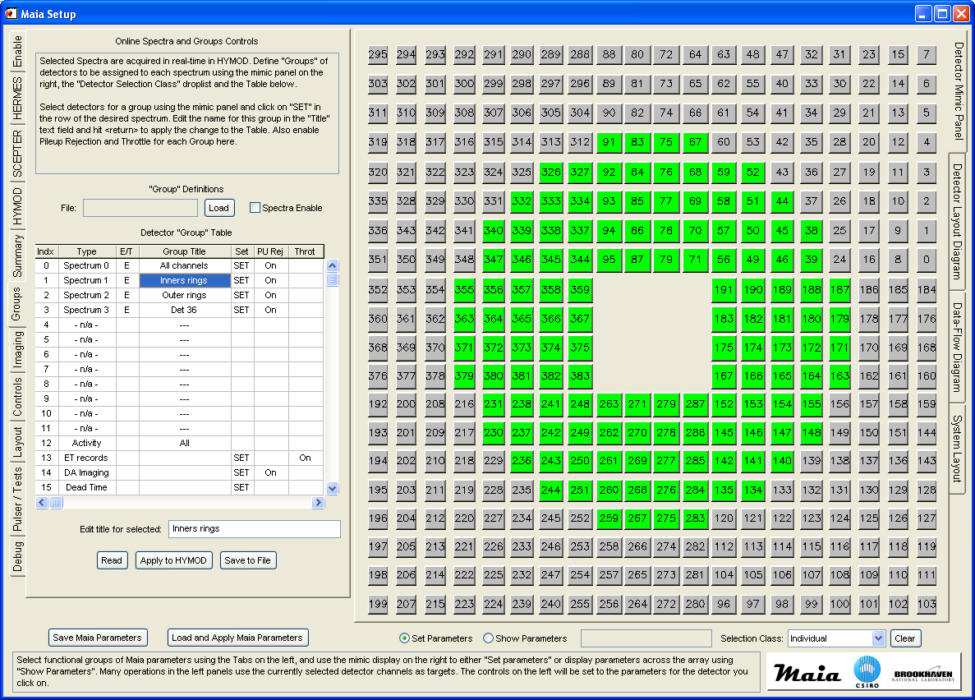

Set parameters and lookup tables for Groups in Maia by clicking on “Apply to HYMOD”. Note that Group settings are not loaded and saved using the buttons at the bottom of the window.

Imaging
The Imaging tab panel is used to select a pre-calculated Dynamic Analysis (DA) matrix file for real-time imaging, or a CUTs file to be used for ROI definition. In the present version of Maia, only one of DA or ROI can be in use at one time. ROI is implemented as a special case of DA, where matrix rows are preset to achieve the same result as a ROI, optionally with local background subtraction.

NOTE: ROI are provided for completeness. However, using DA is easier to set-up, unfolds element and peak overlaps and produces quantitative maps that can be directly interrogated; hence it is preferred for quantitative imaging.

A DA matrix is set-up using the normal GeoPIXE procedures. See the GeoPIXE manual, or the GeoPIXE workshop examples (see “geopixe/Help” dir), and the section on Data Analysis later in this manual. Select a DA matrix by using the “Load” button and selecting the DA file. Click “enable” and “Apply to Hymod” to transfer the matrix to Maia.

Before applying to Hymod, you will also need to select the Epics/Tango PV used for flux measurement (if this is not set remotely via metadata control from the Maia IOC) and a conversion factor from flux to “charge” for quantification. These are set-up in a similar way to off-line analysis in GeoPIXE, with one exception. The “Scan data for PVs” button will prompt for some existing Maia raw ‘blog’ data files (although this is seldom needed if rich metadata is supplied to blogd from the beamline Epics/Tango environment). These will be scanned for Epics/Tango PVs to populate the “IC Scaler channel” droplist. Choose recent files that contain all necessary PVs. Metadata control from the beamline system to the Maia Epics/Tango IOC obviates the need for much of this set-up and the correct values are usually set already.

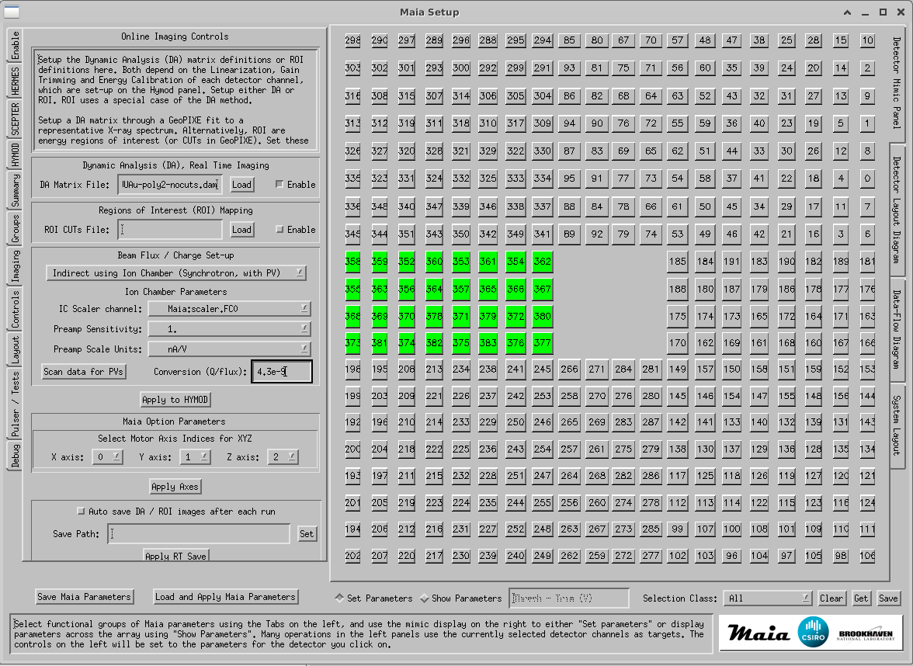

A CUTs file, used for ROI, is set-up using the Cut Setup Window (opened from the Spectra Display window in GeoPIXE or the Group Spectra or ET Spectra windows in Maia Control). It enables the definition of simple ROI as CUTs defined using the two View markers, or ones that enable local background subtraction using the X0-X5 markers to define a left background (X0-X1) the peak of interest (X2-X3) and a right background (X4-X5) region of the spectrum. Click on “Σ” in the Spectrum Display window to use the current position of the View or X markers, and then edit the title field for this CUT in the Cut Setup window.

Controls
The Controls tab panel displays the current state of detector operation parameters (bias read-back, leakage and temperature), various temperatures in the DDM and DAM modules, the DDM supply voltage Vcc and allows the control of detector Bias, Peltier cooling current and Guard ring voltage (in a later version).

The detector Temperature and Leakage read-back fields are on the left under “Monitor”, and Peltier and Bias controls under “Controls” on the right. Increment the control sliders by clicking to the right of the ‘handles’ to increase by 10 or use the arrows at the ends of the slider to change by 5. Never increase the bias or Peltier in increments larger than 10, and preferably by 5 as you approach the final settings (see the Safe Operation section under cool down). Avoid holding and dragging the controls to avoid wild swings. Alternatively, just type in the new value in the box.

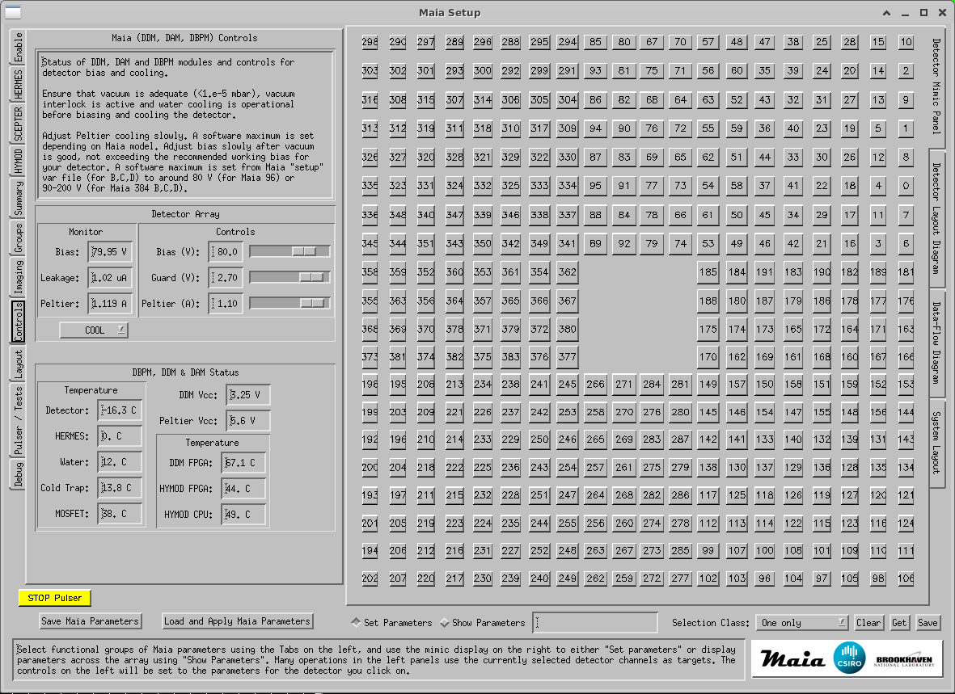

Layout
The Layout tab panel allows the definition, or correction, of pad number assignments across the array (see notes at top of window), and also the assignment of pads to various groupings based on:
- Chip connection to a specified HERMES-SCEPTER pair
- Quadrant member of a quadrant of the array
- Radial member of a radial group, number out from the centre (see below)
- Column member of a column, numbered from left
- Row member of a row, numbered from the top

The values for these classes are updated when a pad is clicked on the mimic display on the right.

It is unlikely that users or beamline scientists will need to change any of these assignments.

End users, however, may wish to change the Radial classes. These can be set automatically, based on a pitch value (mm). The “Set Radial Classes” button will use detector pad XY position and bin these into bins of width “pitch” based on radial distance from the centre of the array. Remember to save the layout after doing this.

Pulser / Tests
Note that the built-in pulser is only available on the full Maia 384 detector system with the new back-end DDM. In the case of Maia 96, the only pulser that is available is the simple “synth” simulator.

The Pulser tab panel provides a number of real and synthesized pulser functions selected using the top droplist:
- Pulse selected channels, which will generate a single pulser peak in selected channels. Take care not to select more that 7 detector pads on each chip, as this will overload SCEPTER (typically, select only one per chip). Select the pulser amplitude and count rate and click on “Enable pulser” to start the pulser.
- Run “step-cal” procedure, which will generate a series of evenly spaced pulser peaks across the E spectra of selected detector channels to be used to test and correct for non-linearity (also used to define the pileup field). Set-up the “Low” and “High” pulser amplitude and “Count”, which is the number of peaks to generate between Low and High, and “Time”, which is the counting time on each peak, and a count “Rate” of about 1000. Run it by clicking on “Execute step-cal”, which will generate a script of commands that are listed below and tracked during execution.
- Run “gain-trim” procedure, which will generate two pulser peaks in the E and T spectra of selected detector channels. This is used to build gain-trimming calibration lookup tables. Set-up the “Low” and “High” pulser amplitude for the two peaks and “Time”, which is the counting time on each peak, and a count “Rate” of about 1000. Run it by clicking on “Execute gain-trim”, which will generate a script of commands that are listed below and tracked during execution. Also used for the FWHM test procedure (using Low=High).
- Synth pulser, which simply injects the desired E and T values into the front-end of HYMOD for the selected channels, bypassing the analogue electronics.
- Leakage mapping, which uses the HERMES ELK mechanism to probe leakage current in each channel in turn and produce a map of leakage across the detector. The map is displayed on the “Detector Leakage Map” panel of the Maia Rates window and as a parameter map for ELK on the Maia Setup window.
- Baseling mapping, which uses a Maia ADC to probe the average DC level on each HERMES output as a probe of baseline using the EAN selection mechanism and the OAN output.
- Run “step-cal ALL” procedure, which will perform the “step-cal” procedure, but now sequentially for all channels. This can be used to investigate linearity across the array.

If any pulser/test function is left active, a Red “STOP Pulser” button will appear on the Maia Setup window to indicate the fact, and to provide a simple way to switch it off prior to normal data collection.

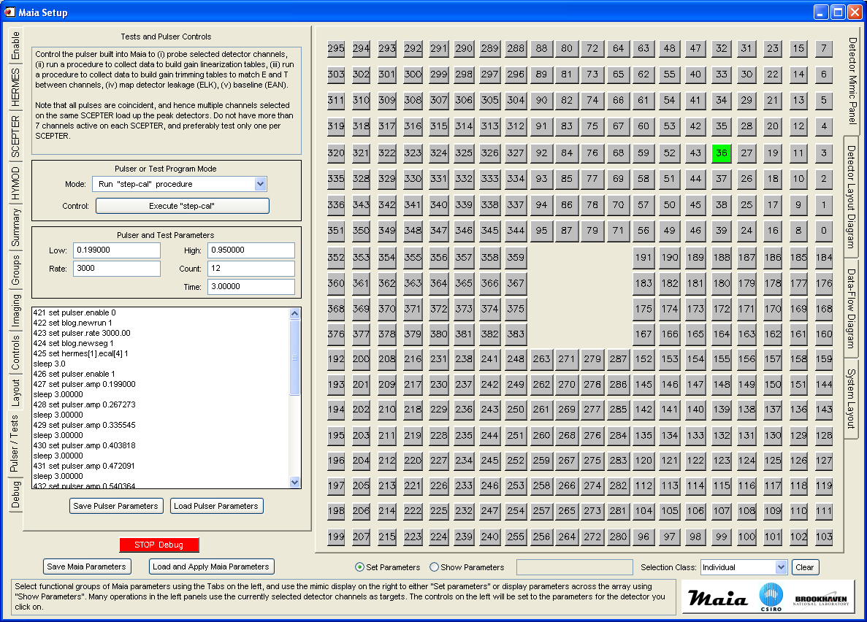

Debug
The Debug tab panel is used to select a single channel of HERMES or SCEPTER output and route it to the Lemo connector on the detector housing.

The top panel can select a single detector channel HERMES pulse output to route to the OAN Lemo output connector (Lemo #2 on the detector body).

The next panel can select a single detector channel SCEPTER output to route to the AUX Lemo output connector (Lemo #1 on the detector body). If this is enabled, SCEPTER multi-channel arbitration is disabled and only a single channel is routed to this output.

If any debug functions are left active, a Red “STOP Debug” button will appear on the Maia Setup window to indicate the fact, and to provide a simple way to switch it off prior to normal data collection.

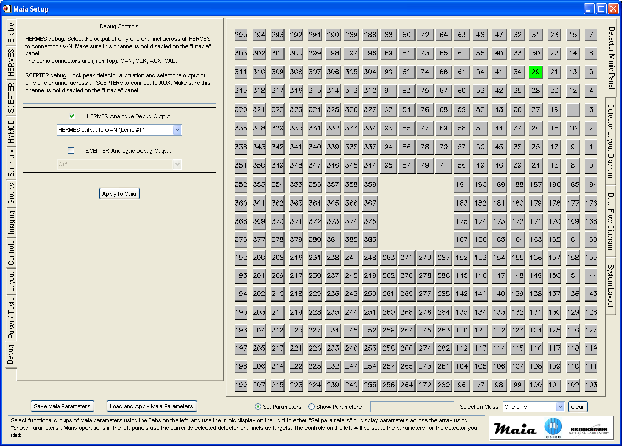

Maia Pipeline Set-up
Set-up of the Maia processing pipeline can be divided into 3 groups: (i) fundamental detector response characterization and set-up that is done only occasionally and should cater for a wide range of experiments and data (Linearization, Gain trimming, Energy Calibration, Dead-time calibration and Pile-up Rejection), (ii) set-up for diagnostic monitoring of a measurement (e.g. Groups, Spectra and ET 2D histograms), and (iii) set-up that is more specific to a particular experiment, beam energy and sample suite (Throttling, DA or ROI imaging) and will need to be reconsidered for each experiment or sample.

Preliminary analysis and pipeline set-up are carried out using the Maia Control windows, using on-line data directly, or the equivalent windows in GeoPIXE, using off-line analysis of data saved as spectra files or logged to blogd.

Setting Thresholds
Note: Initial values for Thresh (and Trim) may have been provided with your Maia detector.

Thresh
Initially Maia may show various patters of noise rates across the array. We can use this noise to adjust all threshold parameters (THRESH and TRIM) to even out differences between channels. These parameters have probably been setup before you received your Maia detector. To view them, use the “Show Parameters” mode and click on the selector check-box to the right of “Trim”, “Thresh-Trim” or “Thresh” on the SCEPTER tab.

To start again and set these from scratch, first, select the main parameter group on SCEPTER tab and start by setting all THRESH high (e.g. 0.7 V) and reduce them all down in 0.03 V steps until you see noise rates on several chips. You could set class to “All” and click on one channel to toggle it and all channels ON (displayed green).

Select just these noisy chips and use the up arrow next to THRESH to increase the THRESH for these chips by 1-2 clicks (hit “Apply to SCEPTER”). This will raise the THRESH for these chips and reduce their noise. Repeat this for other noisy chips. Now lower the THRESH for all chips again by 1-2 clicks (using arrow button with all channels selected) to increase noise rates on all. Repeat this procedure until all chips have a similar general noise rate. Lower all THRESH so that the colours generally span blue through to orange.

Trim
Now select the TRIM group of parameters on the SCEPTER tab. Focus attention on one chip or quadrant, and select all pads that show higher rates (yellow, orange, red, violet) and use the up arrow button next to TRIM to increase the overall thresholds for these (THRESH combined with TRIM). Do this until all become blue or green. Repeat for all chips.

Now return to the first chips again and select all pads that show black or occasional dark-blue rates and adjust down arrow to lower their combined thresholds. Many of these will start to show rates. A few may not respond – they could be dead or with very low noise. In this way you start to even out the noise in all channels.

Finally, increase the THRESH on all channels by about 4 clicks, which should silence all channels and provide some latitude above noise. Save all parameters using the “Save Maia Parameters” button to a directory used for Maia config (e.g. “config/<detector>/setup”, where <detector> is the Maia name code, such as “384D21”).

Detector Linearization
Non-linearity of the detector response with energy is probed and characterized using the built-in test pulser and the “step-cal” procedure, which produces a series of pulser peaks in a selected spectrum at equally spaces intervals across the full energy range. The linearization analysis and correction is aimed at refining a correction function that removes errors in centroid position so that these peaks have the same separation across the spectrum.

The main aim of linearization correction is to build a correction for a module in the FPGA pipeline, so that linearity is removed in E data produced by Maia. Once linear, we do not need any further corrections. However, it can also be used to build a correction as a fine adjustment to linearity, to handle any residual non-linearity that remains, and used in GeoPIXE processing. The example below “Linearization using X-ray standard spectra” is such a second order further refinement to linearity that gets used in GeoPIXE.

Running “step-cal”
Open the Maia Setup window and go to the “Pulser” tab page. Select the “Step-cal” pulser mode. “Step-cal” will generate a series of evenly spaced pulser peaks across the E spectra of selected detector channels to be used to test and correct for non-linearity. Set-up the full E range using the “Low” and “High” pulser amplitudes and set “Count”, which is the number of peaks to generate between Low and High; a value of ~20-50 or more works well if you choose detector channels with good resolution (make sure the peaks are clearly separated). Set “Time”, which is the counting time on each peak. See the example window view above under “Pulser”.

Typically, settings for this step-cal procedure will be stored in file “maia/Maia-384-linearity.pulser.csv” in the geopixe directory, or your local laboratory Config directory (“config/<detector>/setup/”). Use the “Load Pulser Parameters” button to load these settings. The script uses some arbitrary channel selections on each HERMES chip. If necessary, if for example one of these is a disabled channel, you can change these by toggling the channel selection on the detector mimic display.

Now disable both “linearization” and “Gain trimming” on the “Enable” tab page of Maia Setup. Run the step-cal procedure by clicking on “Execute step-cal”, which will generate a script of commands and step through them. The commands are listed in the list-view on the Pulser tab page and tracked through during execution. A new blog run will be started (note this blog #) and data will be logged there. See the current run number in the Control display frame.

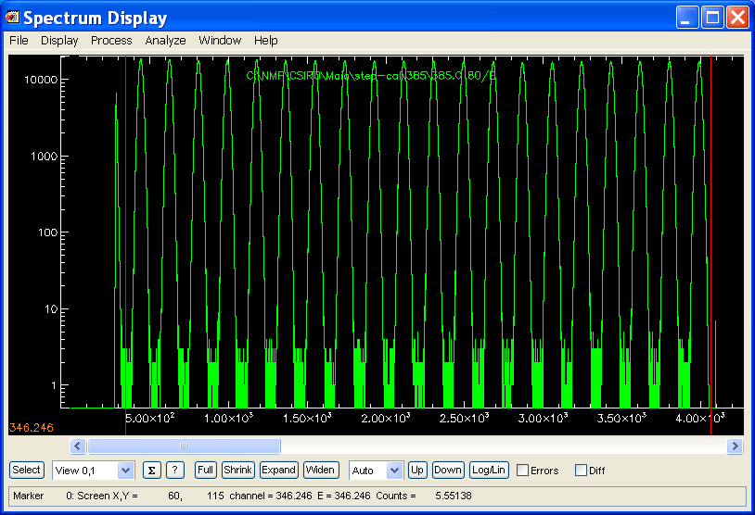
A “step-cal’” spectrum (count=24) generated for detector #80 (actually one detector on each SCEPTER was enabled). Make sure the “Low” value starts near or below the lower threshold and the “High” value starts near or extends off the top of the spectrum range. A larger value of “Count” would have been better in this case.

Executing Linearization plug-in
There are two approaches to analyze the linearization data in GeoPIXE, either using saved spectra or extracting spectra from blog event data.

GeoPIXE – blog data
Import spectra from the blog run file using the “fileImport Spectra” menu in the Spectrum Display window by selecting a few blog data files. Select just one of the E spectra for just one of the channels (use the Spectrum Select window, “Select” button, click on a row in the table of spectra, and click “One”).

GeoPIXE – saved spectra
Save the spectra from Maia Control (“Maia E Spectra Display” window) into a local SPEC file. Load these into GeoPIXE’s Spectrum Display window. Select just one of the E spectra for just one of the channels (use the Spectrum Select window, “Select” button, click on a row in the table of spectra, and click “One”).

In Spectrum Display, set the View markers to bracket all WHOLE peaks (see figure above – click to set Right View marker first, then click to set Left one). Do not include a partial peak at the ends (as in the spectrum above at both ends). Now run the linearity plug-in (“Build Linearize2 by Chip”) in the Spectrum Display “ProcessUser Plugins” menu. A pop-up enables the selection of either (i) a single polynomial function fit to linearity, or (ii) a two component fit, and the path to the output file (put this in your config area used for Maia calibration files).

For the two component model, the plug-in analyses just one spectrum, and determines the centroids of all peaks and fits two functions in two passes: (i) an exponential function that targets any small non-linearity at low energies, and (ii) an polynomial function to pick up any residual. The one component model just uses the polynomial model. The one component model works well for all new Maia C, D units.

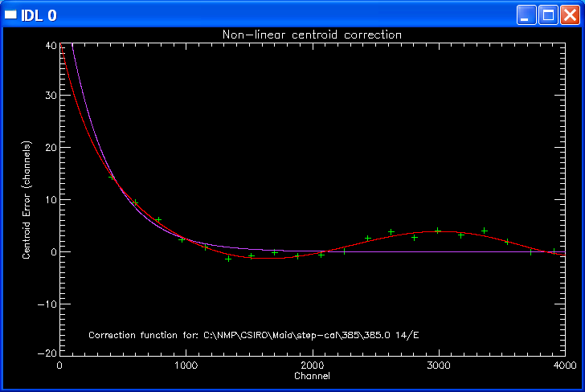
Detector #14 after one pass (violet) and 2 passes (red), an example from the Maia 96 prototype.

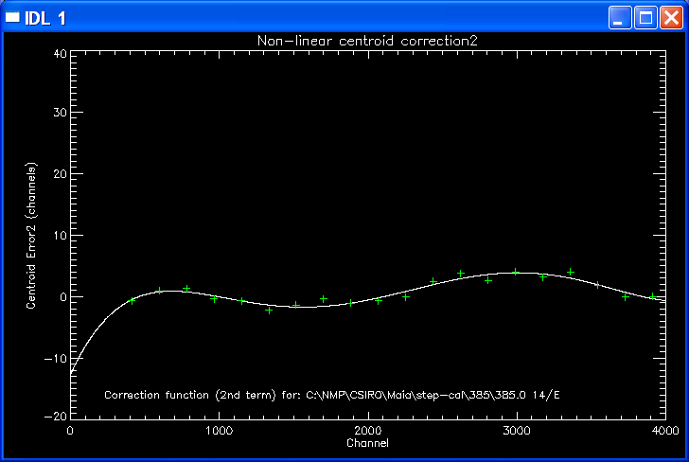
Detector #14 showing fit to residual in 2nd pass.

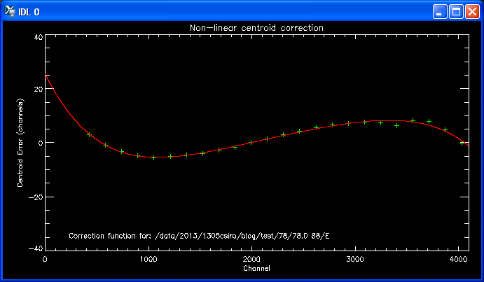
Single component fit to a channel from a Maia 384B detector array

The Linearization plug-in writes a file with the same name as the spectrum file, but with the extension “.linear.var”. Save this file in a central Config location agreed for your laboratory for Maia detector parameters and calibrations (e.g. “config/<detector>/linear/”).

The new Linearize2 plugin performs the fitting to data from each chip, so you end up with 12 plots showing the residual non-linearity and the fit to it. The new output file (extension “.linear.var” in varsh format) contains parameters for a linearization correction for each chip. This requires Kandinski version 9542, or later. Typically, save the Linearity correction to a file in your local laboratory Config directory (“config/<detector>/linear/”).

This linearization file can be selected using the Linearization “load” button on the HYMOD tab page of Maia Control. Make sure the “Send” checkbox is set. On “Apply to HYMOD” a lookup table will be loaded into HYMOD to perform real-time linearization. This will enable “Linearization” in the FPGA as well.

Now on the “Enable” tab page, check that “Linearization” is enabled. If you like, you can repeat the linearization script to collect a new run and then the analysis using the plugin. The result should now show a flat curve indicating little residual non-linearity.

Linearization using X-ray standard spectra
A new plugin (“Build Linearize using Cut named Energies”) can be used to fit a linearity correction based on clearly resolved X-ray peaks and their centroids calculated using CUTs.

It is typically used to construct a second iteration linearization correction in post processing to correct for residual non-linear behaviour. This can be used in post-processing in GeoPIXE and selected in the “Linearize” file fields for importing spectra or sorting images in Sort EVT to provide a second order correction to linearization.

Peaks are selected by creating a CUTs file (see below) with each named to indicate the element label and the centroid energy for the line (group), separated by a space. In the example “S 2.31” is used to label the cut and set its energy to 2.31 keV for the linearization. Labels can also simply use the energy alone (e.g. “2.31”).

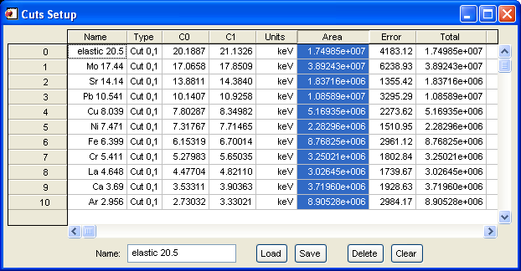

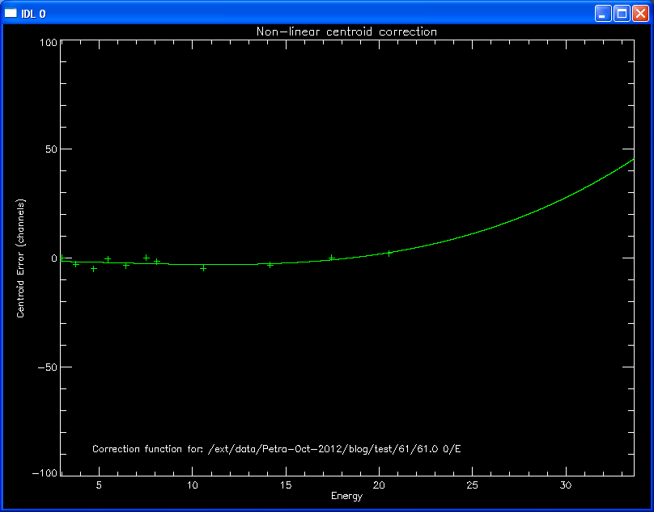
Executing the plugin we get this correction to linearization.

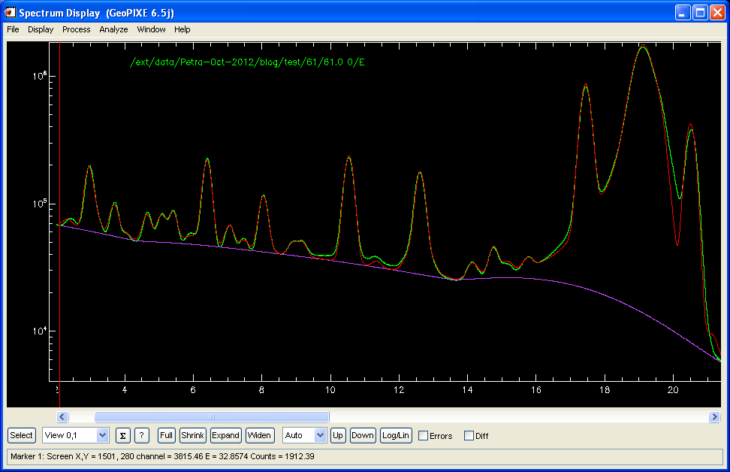
Initial spectrum and fit, showing some residual non-linearity

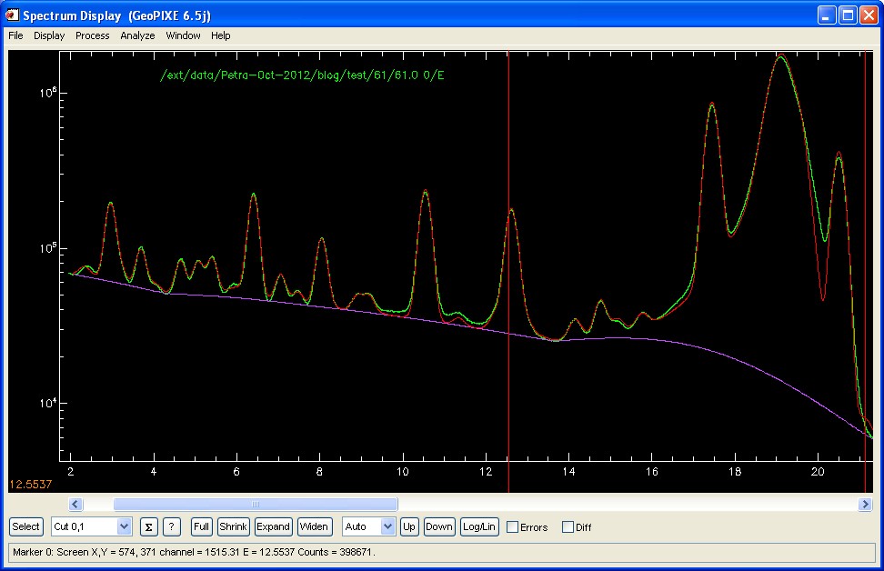
Re-fitted after application of the Linearization above (use “Apply linearization” spectrum plugin)

To use this Linearization adjustment
This linearization assumes that the data has been linearized originally (in Maia), and then this linearization is applied as a second order correction during off-line processing, for both Import of spectra and Sorting of Images, as a fine adjustment. For import, select the option “with linearization”. For Image sorting, fill in the “Linearize” field on the Files tab.

Linearization using Peak Offsets in Fit
A new plugin (“Build Linearize using peak offsets in fit”) can be used to fit a linearity correction based on the differences between peaks in a spectrum and the same peaks in the fit to the spectrum.

It is normally used to construct a second iteration linearization correction in post processing to correct for residual non-linear behaviour. This can be used in post-processing in GeoPIXE and selected in the “Linearize” file fields for importing spectra or sorting images in Sort EVT to provide a second order correction to linearization.

Firstly, fit a spectrum with nicely spaced peaks that cover as much of the useful energy range as possible. This is important, as the linearity correction polynomial will probably diverge outside this energy range and quickly become meaningless. Fit the spectrum in GeoPIXE Xray Spectrum Fit and set CUTs on all clear peaks to use in the analysis. Unlike the method above, this does not need special rules for naming each CUT. Save the CUTs to a file, then call the spectrum plugin “Build Linearize using peak offsets in Fit”, which will prompt for the CUTs file and then plot the correction (just a single correction for all chips).

To use this Linearization adjustment
This linearization assumes that the data has been linearized originally (in Maia), and then this linearization is applied as a second order correction during off-line processing, for both Import of spectra and Sorting of Images, as a fine adjustment. For import, select the option “with linearization”. For Image sorting, fill in the “Linearize” field on the Files tab.

Gain Trimming
Gain trimming is designed to correct for the small gain and offset differences between detector channels. NOTE: This will be needed after any changes of SCEPTER Threshold, Trim or HERMES Gain, Time, or to Linearity, which all effect peak positions. Once corrected, both E and T spectra from all detectors should have similar gain and offset and can be overlaid and added together. The latter is essential for the Pileup correction approach, the ET2D display and the Groups Spectra to provide a useful sum of selected detector spectra.

Differences in gain and offset are characterized using the built-in test pulser and the “gain-trim” procedure, which produces a pair of pulser peaks (a “low” and “High” peak) in both E and T in all detector channels in turn. The method uses a pair of peaks, at both ends of the E and T range, and the algorithm determines a linear mapping for all channels to match these peaks to those in the average detector channel.

NOTE: Gain-trimming should be done AFTER Linearization has been completed and the Linearization module is set-up and enabled in the FPGA (after “Apply to HYMOD” on the HYMOD tab and enabled on “Enable” tab). THEN collect data to be used to define gain trimming.

To accommodate drift, adjustment to gain-trimming can be performed from time to time. This can be done using the “Gain trim Adjustment” procedure described below.

Running the “gain-trim” pulser
Open the Maia Setup window and go to the “Pulser” tab page. Select the “gain-trim” pulser mode. “Gain-trim” will generate a pair of pulser peaks in the E and T spectra of selected detector channels. Set-up the pair of peaks to span the full E range using the “Low” and “High” pulser amplitudes. Set “Time”, which is the counting time on each peak. It’s a good idea to save the pulser set-up in a file for next time.

Typically, settings for this gain-trim procedure will be stored in file “Maia-384-gaintrim2.pulser.csv” in the “local laboratory Config directory (an initial one can be found in “geopixe/maia”). Use the “Load Pulser Parameters” button to load these settings. The script will step through all channels, so there is no need to play with channel selection on the detector mimic display.

Now disable “Gain trimming” on the “Enable tab page of Maia Setup (make sure that “Linearization” remains enabled, and that a valid linearization file has been loaded, as described earlier). Run the procedure by clicking on “Execute gain-trim”, which will generate a script of commands and step through them. The commands are listed in the list-view on the Pulser tab page and tracked through during execution. A new blog run will be started, and data will be logged there. See the current run number in the Control display frame.

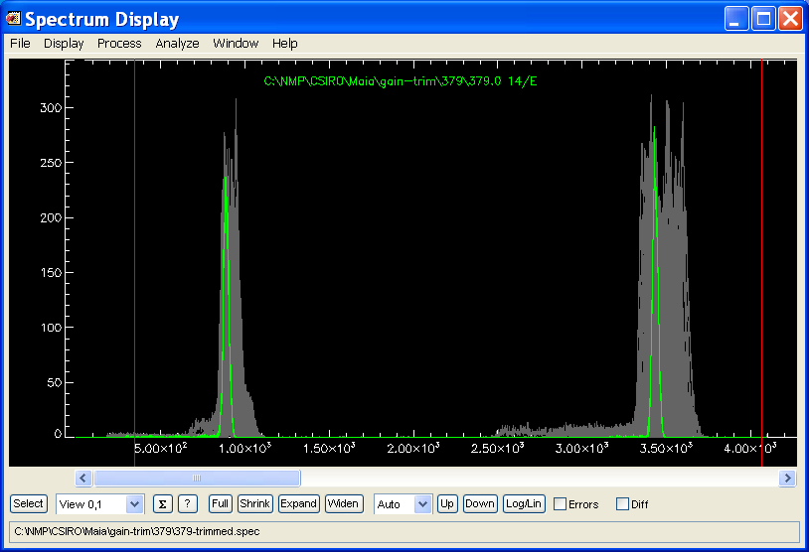
Overlay of 96 E spectra from the Maia prototype showing pairs of pulser peaks from the “gain-trim” procedure, displayed in “Highlight” mode with detector #14 selected (in green).

Executing the Gain Trimming Plug-in
There are two approaches to analyze the gain-trim data. Either use, either using saved spectra or extracting spectra from blog event data.

GeoPIXE – blog data
Import spectra from the blog run file using the “fileImport Spectra” menu in the Spectrum Display window by selecting a few blog data files. Select just one of the E spectra for just one of the channels (use the Spectrum Select window, “Select” button, and click “All”).

GeoPIXE – saved spectra
Save the spectra from Maia Control (“Maia E Spectra Display” window) into a local SPEC file. Load these into GeoPIXE’s Spectrum Display window. Select just one of the E spectra for just one of the channels (use the Spectrum Select window, “Select” button, and click “All”).

This will display all E spectra for determining the E gain-trims. You will also need to repeat the steps below for all T spectra (by deleting all XYE spectra) to determine T gain-trims.

Now in GeoPIXE, select all E spectra and place View markers around both peaks in all detector channels (see spectra above). Make sure there is no existing energy calibration set (use the “DisplayClear ALL Energy Cals” menu).

Now run the gain-trim plug-in (“* Build Gain Trim Plug-in”; the “*” indicates that this plug-in processes all selected spectra) under the “ProcessUser Plugins” menu in the Maia E Spectra Display (online in Maia Control) or Spectrum Display (off line in GeoPIXE) window. A pop-up window allows setting some parameters for the Gain-trim plugin. These set (i) the output file name and path, (ii) the maximum ratio of peak intensity relative to the largest peak (a value of 0.3 is adequate here), (iii) the level below the maximum to use in each peak to determine centroid (use values like 0.3-0.6), and (iv) the pre-smoothing to apply to each spectrum first to smooth out local minima due to noise (values of 10 for E and 2-3 for T spectra work well). The default settings generally work well.

Gain-trim will adjust the energy calibration of all E spectra to match the peaks to the average. The Gain-trim plug-in writes a file with the same name as the spectrum file, but with the extension “.energy.gaintrim.var”.

Save this file in a central Config location agreed for your laboratory for Maia detector parameters and calibrations. Typically, save the gain-trim correction coefficients to a file in your local laboratory Config directory (“config/<detector>/setup/”).

Repeat the above procedure (select all T spectra, the run gain-trim plugin) for all T spectra. Gain-trim will adjust the energy calibration of all T spectra to match the peaks to the average. The Gain-trim plug-in writes a file with the same name as the spectrum file, but with the extension “.time.gaintrim.var”. Save this file in a central Config location agreed for your laboratory for Maia detector parameters and calibrations.

If some channels of the T spectra fail to fit correctly, you can use the Cal window to manually calibrate those channels to match all other channels. In this case, then save the spectra from the Spectrum Window to a SPEC file and use that file for T gain-trimming.

The E gain-trim file can be selected using the “Gain Trim E File” “load” button on the HYMOD tab page of Maia Control. The T E gain-trim file can be selected using the “Gain Trim T File” “load” button (either the .gaintrim..time.var or .spec file). Make sure the “Send” checkbox is set. On “Apply to HYMOD” the gain-trim tables will be loaded into HYMOD to perform real-time gain-trimming. This should also enable “Gain trimming” on the Enable” tab.

Now on the “Enable” tab page, check that “Gain trimming” is enabled. If you like, you can repeat the gain-trim script and plugin (but do not disable the gain-trim module). The result should now show spectra peaks for all E spectra overlapping indicating good trimming, and similarly for all T spectra.

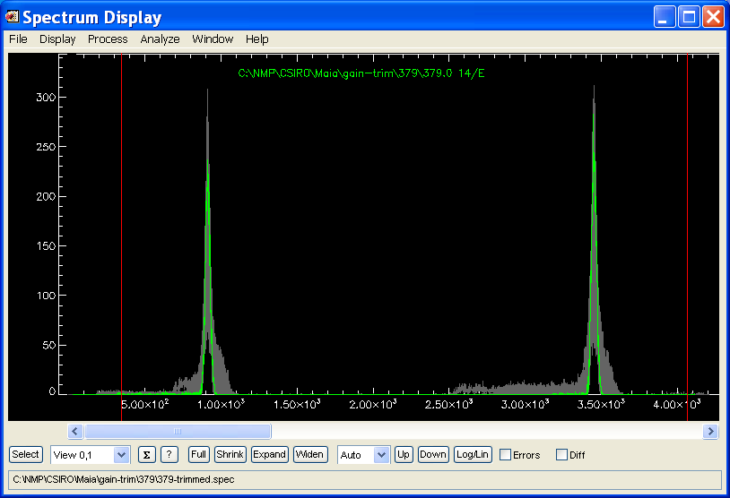
Overlay of 96 E spectra from the Maia prototype showing pairs of pulser peaks after application of the “gain-trim” procedure off-line in GeoPIXE.

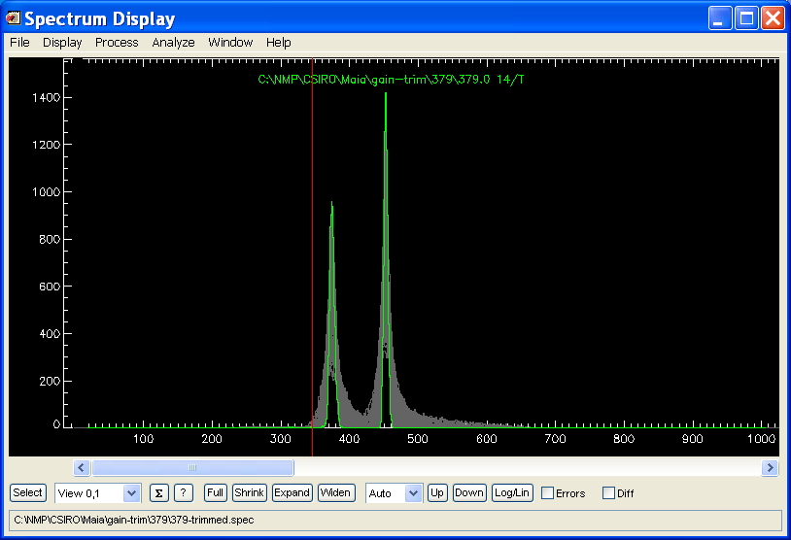
Overlay of 96 T spectra from the Maia prototype showing pairs of pulser peaks after application of the “gain-trim” procedure off-line in GeoPIXE. This was done simultaneously with the E spectra shown above in a single pass.

Gain-trim adjustment after minor TRIM or THRESH changes
Changes to SCEPTER values for individual (TRIM) or per chip thresholds (THRESH) will move peaks in T spectra. The solution is to either repeat the full Gain-trim procedure using the pulser, or for small changes (few channels corrected), the following method can be used.

After making changes to TRIM for a few channels, run the pulser for a fixed amplitude and display T spectra showing all changed channels, plus a reference good channel that was not changed. Use the Spectrum Select window to select channels (e.g. using the “Array …” pop-up window). For each adjusted channel, select it in the T spectrum (e.g. use “Highlight” mode and click on this detector in the Spectrum Select table) and then use the Arrow buttons on the HYMOD tab of the Maia Setup” window to adjust the T gain trim offset. The arrows are labelled “Adjust T Offsets” and are located below “Gain Trim T File” field under “Gain Trimming”. Select the desired channel on the detector mimic panel on the right (use “Individual” selection mode). Then, while the pulser is still running, click on the Up arrow once and hit “Apply”. Observe which way the peak moves in the T spectrum and use more “Up” clicks or go for “Down” instead. Repeat adjustments (click “Clear” in between) until the adjusted channel T peak matches the reference channel and repeat for other channels.

Once changes have been made, click on “Save”, which will prompt for a file-name ( .gaintrim.time.var) for the new T gain-trim parameters. This name will also be set in the “Gain Trim T File” field. Remember to “Save Maia Parameters” to capture these new SCEPTER and gain-trim parameters to file.

Gain-trim using a dual X-ray source
An X-ray source that produces at least 2 well separated X-rays lines can also be used to define the gain-trim linear mapping. This can be a little tricky as the source lines may have very different intensity and may require attention to detail. The following is an example of using combined ⁵⁵Fe (Mn K X-rays) and ¹⁰⁹Cd (Ag K X-rays) sources.

NOTE: This is not the usual approach to gain trimming. To avoid some of the complications mentioned here, use the pulser gain-trim method followed by the method described below for individual channel energy calibration.

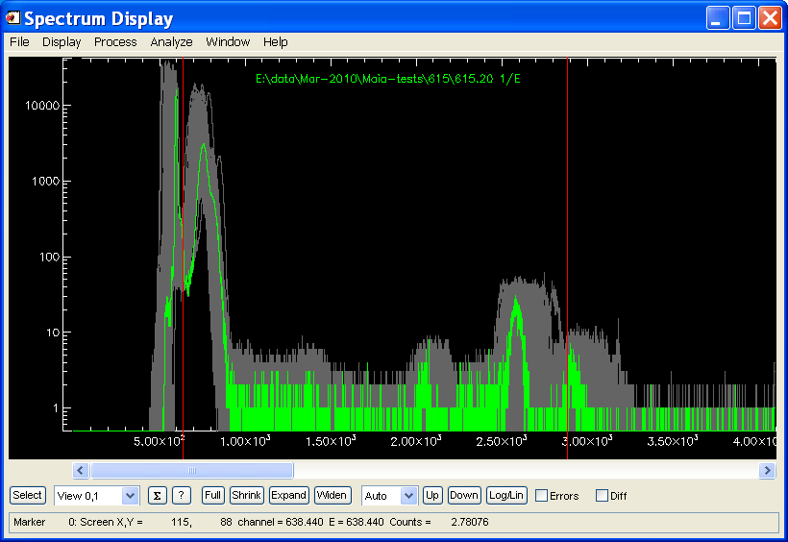
Uncalibrated, un-gain trimmed E spectra using combined ⁵⁵Fe (Mn K X-rays) and ¹⁰⁹Cd (Ag K X-rays) sources. Linearization was applied during extraction in GeoPIXE using file “306-det-14-36-80.linear”.

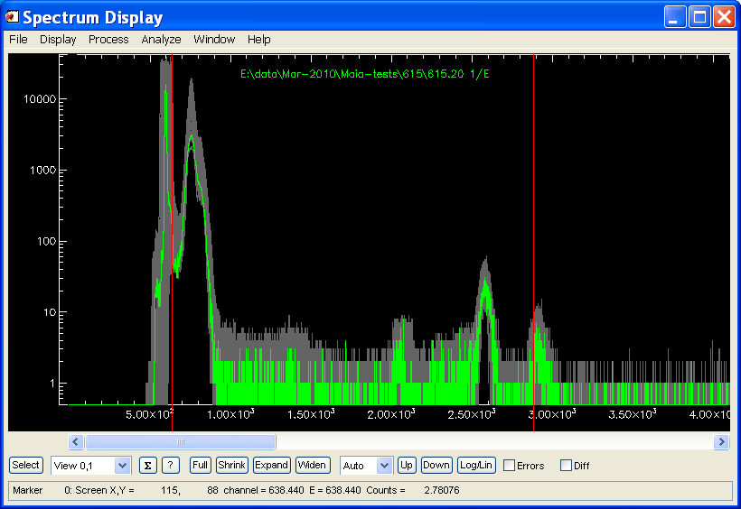
The same spectra after successfully applying the “* Build gain trim” plugin. Note the placement of the View markers to exclude the odd channel artefacts.

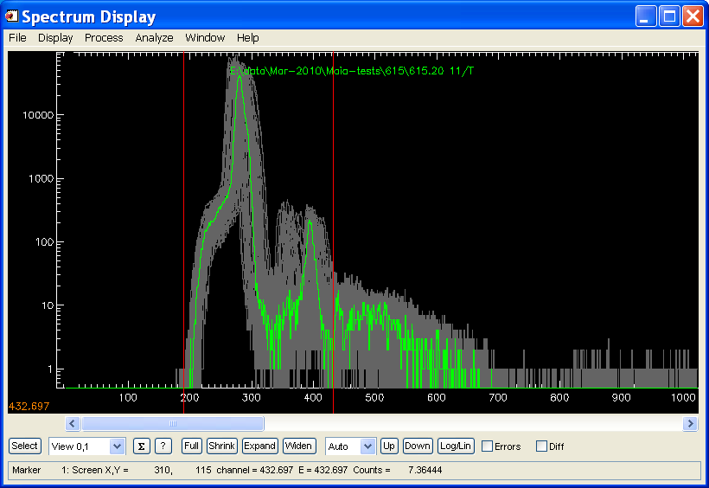
Un-gain trimmed T spectra using combined ⁵⁵Fe (Mn K X-rays) and ¹⁰⁹Cd (Ag K X-rays) sources.

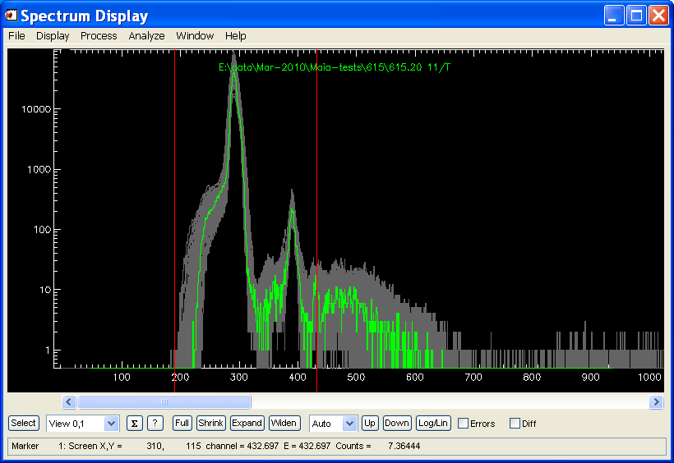
The same T spectra after successfully applying the “* Build gain trim” plugin.

Gain Trim Adjustment using a source
Once gain-trimming for E and T has been established using the pulser, and uploaded and enabled in Maia, it can be adjusted using the following procedure. Small differences between pulser input to each detector channel produce some variance in peak position, which means that adjustment is a good idea to remove the effect of these differences on gain-trimming. This is best done using dual element fluorescence lines (not scatter peaks) or multiple peaks from a source (⁵⁵Fe [Mn K lines] alone is not adequate; use ⁵⁵Fe together with ¹⁰⁹Cd [Ag K lines], for example). For this adjustment, leave Gain-Trimming enabled in Maia and collect data from this source, or dual element fluorescence lines.

NOTE: This is not the usual approach to gain trimming. To avoid some of the complications mentioned here, use the pulser gain-trim method followed by the method described below for individual channel energy calibration.

This approach uses the “Gain Trim Xcuts” spectrum plugin, on the Spectrum Display “ProcessPlugin” menu. First, clear all energy calibration using the Display menu. Position X markers around the two dominant peaks you intent to use, starting from the right with X5. Click and position the marker, then proceed to position the next marker (lower number) by clicking to the left (well away from the first) and dragging the marker into position. This procedure works for both T and E spectra. For T, make sure the peaks are well separated.

Then apply the “Gain Trim Xcuts” spectrum plugin. This should change energy calibration to make the peaks for all detectors fall at the same position on the spectrum display. If not, you may need to manually correct channels in error. This can be tricky to get right.

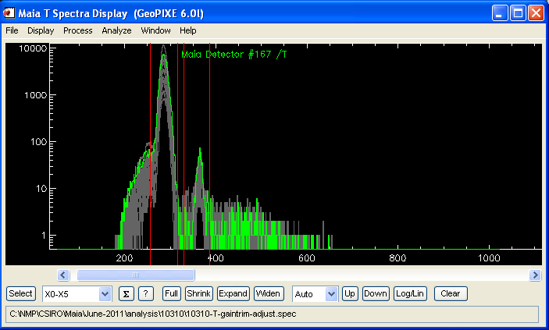
T spectrum after T gain-trimming adjustment. X markers for the Gain_trim_Xcuts spectrum plugin are shown. Unity energy cal for T needs to be set back manually after gain-trim plugin is used.

Now we need to apply this new calibration to correct the original gain-trimming calibration that you have loaded in Maia. To do this, use the “Gain Trim Adjust” spectrum plugin, on the Spectrum Display “ProcessPlugin” menu. It will prompt for the file-names for the original Gain-trimming calibration spec file and the new adjustment spec file, and then for an output file-name for a new corrected gain-trimming spec file. This becomes the new file to upload into Maia (Hymod panel on Maia Setup). Repeat this for both E and T spectra cases. To test that this new gain-trimming works, clear all energy cals again and collect more data from the source. The peaks from all detectors should now line up.

Pile-up Rejection
Without pile-up, time-over-threshold T follows a curve as a function of E, which reflects the width of each pulse at a fixed threshold. Pile-up causes the T value to exceed this curve. Pile-up rejection relies on selecting a field that encloses all good events and rejects all the longer T pile-up events. At present, this is done using the Time Amplitude window in GeoPIXE (see the Windows menu in the Spectrum Display window). Use the File menu to drag-select a range of recent raw blog files to scan for E and T. By default, the first 100k events are plotted on an E-T scatter plot for all detectors. Selected detectors can also be displayed, and more events can be scanned by entering the number of events in the Events field. Reload the blog data if this is changed.

The Time Amplitude window can also be used to overlay the pile-up limits defined in a pile-up file (see “Display” menu). This is a useful check to perform regularly to make sure that the current pileup limits are still correct for new data.

To define the pile-up acceptance field, position the mouse cursor on the start of the curve at low E-T (e.g. at about [400,200] in the example below) and then click and drag out a straight line up to the top of the curve (e.g. [3500,368]). Try to extend your field to the top of the spectrum (works best using a higher energy beam to provide events and pileup right up the spectral range).This line has control points along the centre-line that can be used to drag it into a spline curve shape to follow the curve. This takes some care, and usually benefits from a closer spacing of control points at lower E end in order to follow the sharper curvature at lower E, as shown below. Once the shape is defined, the width can be adjusted using the two handles on the sides (top and bottom adjacent to the middle control points) of the red box. The final field can be saved using the File menu for use in Maia Setup to define pile-up rejection. Typically, save the pileup definition to a file in your local laboratory Config directory (“config/<detector>/pileup/”).

NOTE: Pile-up rejection set-up should follow AFTER both linearization and Gain-Trimming have been completed and the Linearization and Gain-trimming modules are set-up and active (enabled) in Maia. THEN collect data to be used to define the pile-up acceptance field.

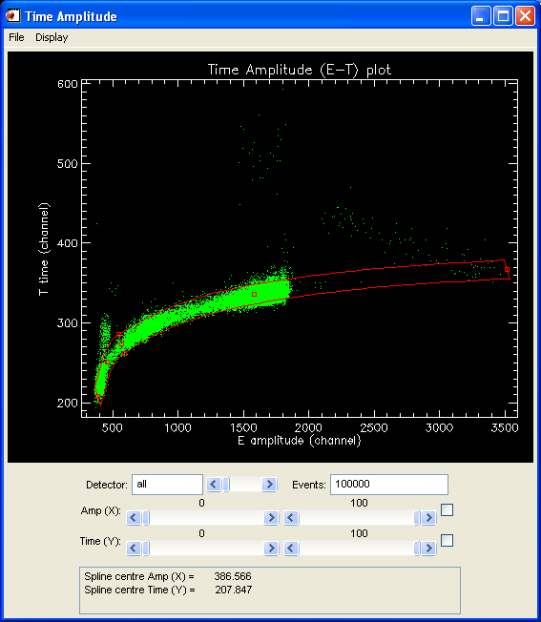
Time Amplitude display (GeoPIXE Spectrum Display Windows menu) for all detector channels extracted from raw Maia blog data files for 100k events. The red spline field selects the range of T as a function of E that will be accepted; all other events will be rejected as pile-up events.

Energy Calibration

A single energy cal for all
Ideally, after linearization and gain-trimming you only really need a single energy calibration for all detector channel E spectra. A single representative spectrum can now be calibrated for energy. There are two approaches:

- Fit the spectra recorded for this detector (with the Linearization and Gain trimming modules set-up and enabled) using X-ray Spectrum Fit.
- Mark peaks manually and use the “Display->Calibrate Energy” menu function.

The fitting method produces the most accurate calibration and is well worth the effort (see the notes below).

Individual energy calibrations
It is not known how long gain-trimming calibration will remain valid before discernible differences in calibration between detector channels will become apparent. Indeed, small differences between channels (pulser feed-in capacitance) makes doing an individual channel energy calibration essential right from the start.

The spectra for all detectors can be extracted using the “Display->Import” menu function in Spectrum Display or saved from Maia Control’s Maia E Spectra window. If linearization correction has been performed in real-time by HYMOD, then no further linearization correction should be needed. The extracted spectra can now be calibrated for energy using a fit to all spectra recorded for each detector using X-ray Spectrum Fit.

Once a good fit is obtained to one detector spectra with Cal parameters free to vary, use the “Fit: All” button to fit all detector channels. This assumes that the energy calibrations are reasonable now and you see peaks lining up from detectors across the array when displayed overlaid together in the GeoPIXE Spectrum Display window (or the Maia Control E Spectrum window). But initially, the energy calibrations may be quite different and “Fit All” may struggle. In this case, use the “Rough Initial Calibration” approach below.

There are some points of caution and care that need to be addressed for this to be successful.

- If possible, avoid including the scatter peaks in the fit. The energy of these may be in error, and the width and skew of the Compton peak can bias the fit of energy calibration.
- Use spectrum Cuts to remove problem regions from spectra, such as the odd-channel artefacts in the Maia prototypes, or severe pileup peaks and tails.
- Make sure the lower View range is above any rapid fall-off of the spectrum or the ‘glitch’ peaks.
- Disable fitting of Tail parameters.

Once all spectra have been fitted, view the results to detect any problems. Individual spectra may need re-fitting, or bad channels with broad peaks may need to be deleted from the spectra list. There are two ways to view the results:

- Open the Fit Results window (using the Spectrum Display “Window->Fit Results” menu) and look at the “Fitting” results using the droplist. Scan down to see any channels with un-usually large RMS fitting error. View these in Spectrum Display (use Spectrum Select to toggle the Display status for selected detectors) to see what the problem is and re-fit.
- Step through all spectra fits in Spectrum Display (use Spectrum Select to step through using “Next”) to see what the problem is and re-fit.

Tip: If you display all detector channels a poor fitted channel may stand out. Use “Highlight” mode in Spectrum Select and click on the odd spectrum to identify it.

To re-fit spectra, you may need to fix parameters such as FWHM or set FWHM manually (use the “Advanced” “Widths” tab and enter or adjust Mn K FWHM). You may need to move the lower View marker and click on “Use View” in X-ray Spectrum Fit, and then re-fit. If the energy calibration is well out, you may need to use the Energy Calibration window to adjust it to match the peaks to expected energies.

If all else fails, disable the detector channel by deleting its spectrum from the list.

Once spectra are fitted successfully, or deleted, save the remaining good spectra to a file (include “cal” in the name for future reference, e.g. “999-cal.spec”). Typically, save the energy calibrations to a file in your local laboratory Config directory (“config/<detector>/energy/”). This file can be used with the Maia Control Energy Calibration Load on the HYMOD panel, or in GeoPIXE with the “Get” button in Sort EVT, with the “Get ALL Energy Cals” menu in Spectrum Display (see above). Missing detector channels (spectra deleted as bad fits or broad peaks) will then be disabled in further analysis.

Tip: Acquire spectra from metal foils that produce nicely space X-ray lines, and the use the “Add by Detector” spectrum plugin to add these spectra channel by channel to produce composite spectra with the combined lines. These are ideal for fitting and refining the energy calibrations.

Rough Initial energy calibration
If the energy calibrations are quite bad, and peaks do no line up making “Fit All” fail to converge on the correct element peaks, then we need to roughly align them first. One approach uses the spectrum plugin “Cal by X marker range centroids (2)”. The idea is to select two, well separated peaks in the spectrum and place X markers around them. Start setting the far-right X marker first, to the right of a prominent peak, and then click to the left of the peak (if you pick up the first marker again, try clicking further to the left for a new marker) to set the next X marker. Then proceed to click further left and position a marker to the right of the other prominent peak at lower energy. Then click to position the final X marker left of the lower energy peak. You should have 4 markers set around 2 peaks.

Now run the spectrum plugin “Cal by X marker range centroids (2)”, which will prompt for the energy of the first and second peaks and then refine the energy calibration of all selected detector channels to align the centroids of these peaks. If the initial cal was quite far off, you might do well to repeat this plugin, perhaps with the X markers tighter around the peaks. When the rough energy calibrations look better, then “Fit All” may succeed.

Detector Energy Resolution
Energy resolution can be measured using a radioactive source, such as ⁵⁵Fe, or using a test target with a well resolved prominent X-ray line or group. The following illustrates measuring energy resolution using the Mn K lines from ⁵⁵Fe source spectra.

Acquire spectra
Acquire spectra from ⁵⁵Fe with the source positioned near the optimum Z distance, near ~2.0-2.5 mm from front face of Maia. This will ensure that all detector pads are illuminated. Or run beam on a simple standard, such as the NIST alloy (take care as high count-rates will degrade energy resolution). Save the spectra to a file, from the Maia E Spectrum window.

Fit spectra & display FWHM
Load these spectra into GeoPIXE and perform these steps on it, using the indicated plugins:

- Import spectra: Use the “FileImportSpectra” menu to select raw blog files. Once loaded delete the T, X, Y spectra using the Spectrum Select window.
- “Peak Mn Centre” plugin: First set the View markers around the Mn K lines, and then run this plugin, which will set a starting energy calibration for all spectra, using a constant Gain (Cal A) term. If there is a reasonable existing energy calibration, then you can skip this step.

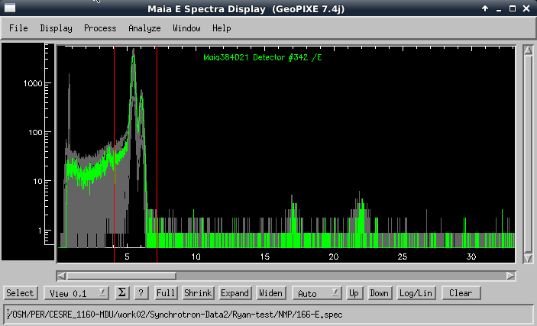

- Fit spectra: Load the PCM “dummy-Fe-55.pcm” into the X-ray Spectrum Fit window, which establishes a simple fit setup and a dummy yield file. Then use “Fit: ALL” to fit all spectra. If using the NIST on Maia Mapper, you might use a PCM for it, such as “standards/24100eV/NIST_1243_384D19_24100eV-basic-for-cal.pcm”.
- Fit results: Open the Fit Results window. You can see the FWHM (Mn) as fitted by selecting “Spectra” on the droplist. Save results to a PFR file.
- “Fit file Peak FWHM” plugin: This plugin opens a window – select the above PFR file as the “Fit Results File”. Click OK to show the FWHM map, which displays these FWHM values on a detector mimic display.

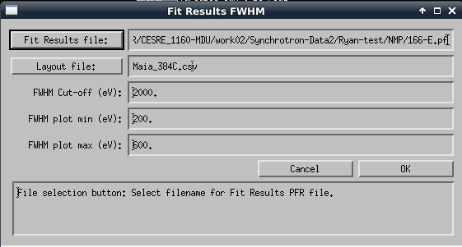

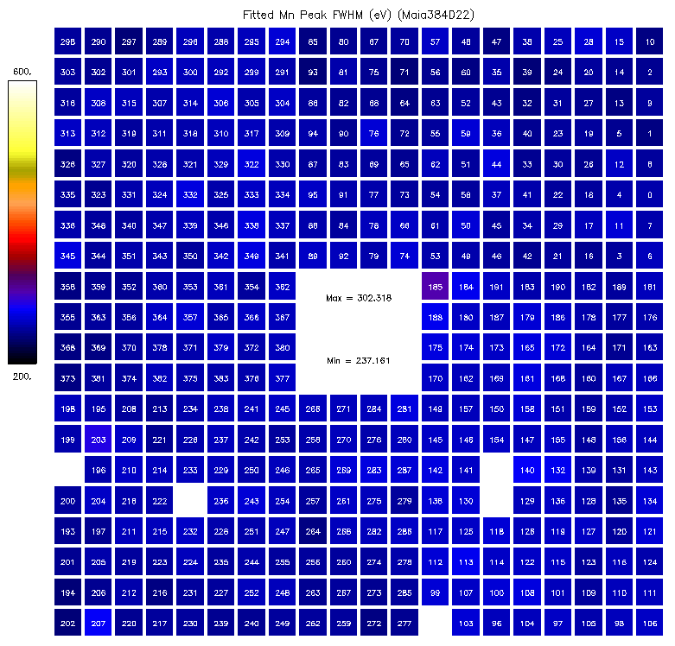
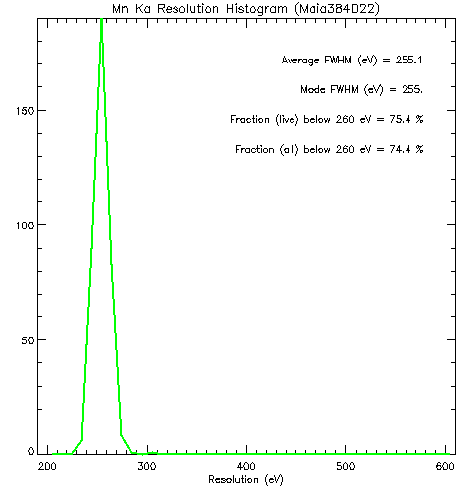

Relative Noise Width
Relative noise width can be measured using the built-in pulser.

Acquire spectra
Acquire spectra using the pulser. The Gain-Trim script can be used, with Low=High to produce just a single peak in each detector channel. Save the spectra to a file, from the Maia E Spectrum window.

Fit spectra & display FWHM
Load these spectra into GeoPIXE and perform these steps on it, using the indicated plugin:

“Plot Pulser FWHM map” plugin: First set the View markers around all the pulser peaks, and then run this plugin, which will determine FWHM based on a given energy calibration dispersion (eV/ch).

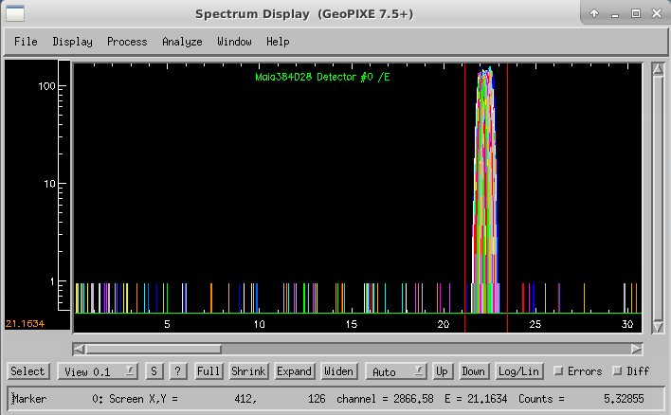

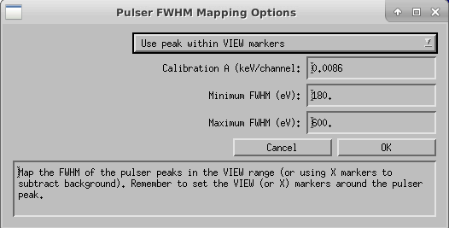

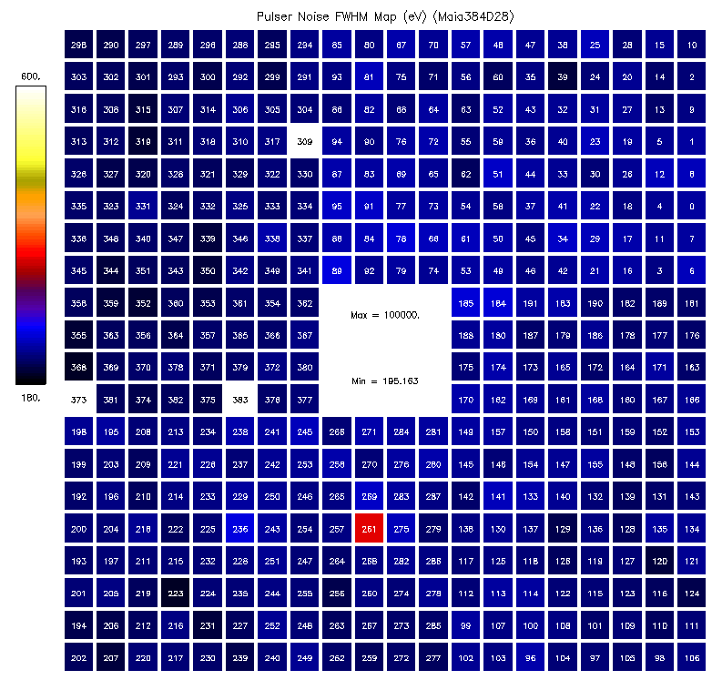

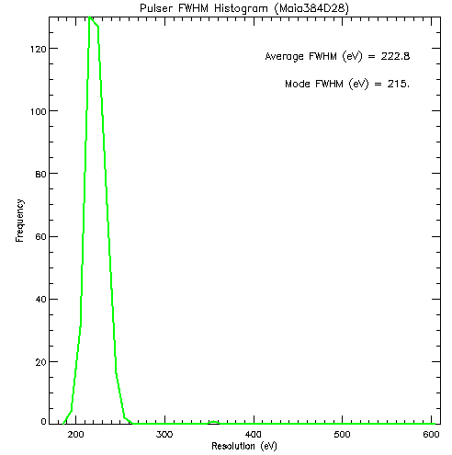

Using Throttle to Control Data-rates
Data rates are often dominated by a major element (e.g. Fe in iron oxides) or the scatter peaks (e.g. for biological material). The data for these energies is excessive and superfluous. It can be reduced prior to storage in the blog files without loss of significant image detail for these element/features using the “Throttle” mechanism described here.

Throttle scales down certain parts of the spectrum from all detectors, effectively accepting every n’th event at these energies. The factors ‘n’ can vary across the spectrum. Important areas of the spectrum are kept at ‘1’ to avoid any Throttling. . Set-up involves developing this spectrum of scaling factors.

Representative Spectrum
Load (or Import) some representative spectral data, such as a total spectrum for one detector over a representative scan area. Use the Spectrum Display menu “AnalyzeThrottle”. This brings up a panel where you enter the factor to reduce count-rate by, integrated over the range between the View markers. Move the markers to surround a strong peak and then click on “Throttle” to throttle that selected part of the spectrum. This procedure can be repeated for other parts of the spectrum by moving the View markers and entering a new throttle factor and clicking on “Throttle”.

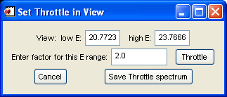

Generally, attack the largest peaks in the spectrum or ones of little importance (e.g. scatter). The red spectrum overlay shows the result. The purple spectrum is the vector of throttle scaling factors. These are limited by Hymod firmware implementation (4 bits) to not exceed 15.

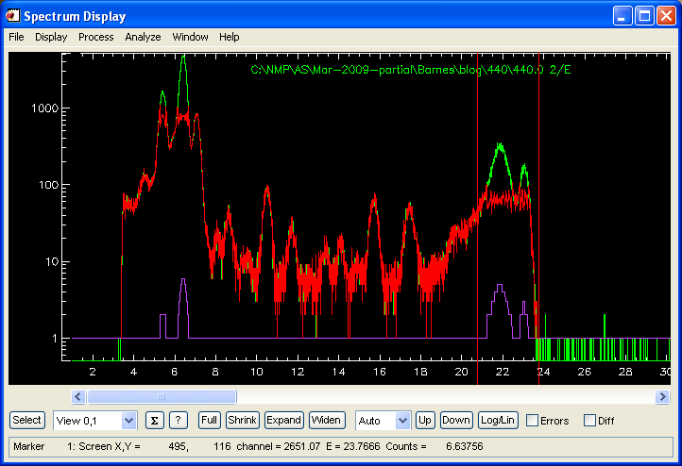

The red spectrum is the result after Throttling and the violet spectrum is the vector of Throttle Factors. If data with Throttling active is read-back from disk (e.g. Import spectra or Sort EVT in GeoPIXE), these throttle factors are re-applied to correct spectral data. Typically, save the Throttle vector to a file in your local laboratory Config directory (“config/<detector>/throttle/”).

Enabling Throttle in Maia
On the HYMOD tab page on Maia Setup window, Load the Throttle file, “enable throttle” to make sure that Throttle is switched on and press “Apply to HYMOD”. Since Throttle is intended to reduce data rates to disk, on the Groups tab page make sure that Throttle is enabled for ET Events (Group 13).

Maia Data Analysis
It is recommended to use the worked examples in the Workshop notes (see “geopixe/Help” directory) that contain more up to date examples of Maia data analysis.

See the file “GeoPIXE Worked Example Notes.pdf”.

