**Project: Isolating box for self-noise measurement mar2018**

# Construction

Regufoam® 150+ damping material

Außen Maß

512x512x812mm (ohne Räder)

vcc

vcc

Äußere Box

2Stk. 512x512

4Stk. 716x494

4Stk. 494x60

Innere Box

1Stk. 366x366mm

4Stk. 318x600mm

12Stk. 100x100mm

1Stk. SR28 366x336mm

MDF ca.1m²,

Bitumen ca.2m²ca.

Gewicht 30Kg

c

MDF 18mm

vcc

Bitumenplatte ca.15mm

# Computation of damping material



# pictures

|  |  |
| --- | --- |
|  |  |
|  |  |

# Results

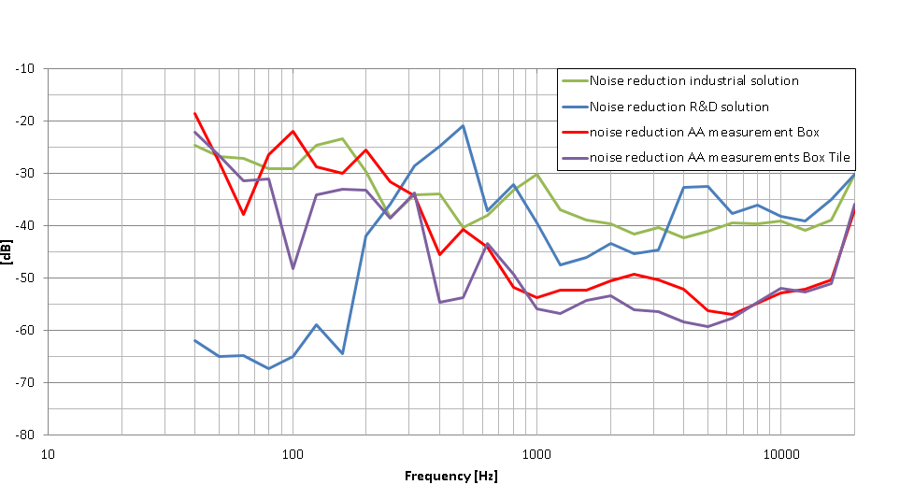

Purple our improved box with tiles outside

Red our first try

Green fore AKG expensive solution

Blue home brew AKG solution