Video about what this is: https://youtu.be/uA70TDW96uE

Basically, we needed to stress test some audio cables for a prototyping project and we had to get going with this before our industrial grade machine arrived. Our engineering staff knocked this tester together in the course of a day. The Servo motor came from either an RC plane or car.

“Trumeter 7000” Digital Counter - 28€
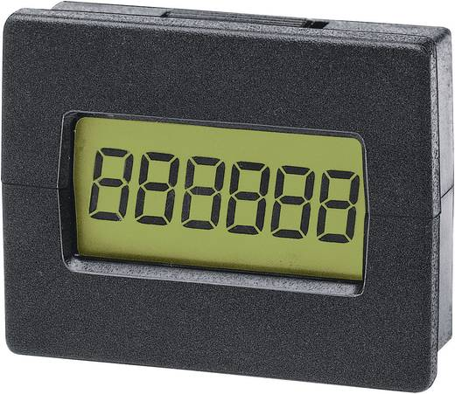
https://www.conrad.at/de/trumeter-7000-elektronischer-miniaturimpulszaehler-einbaumasse-294-x-22-mm-127419.html

Arduino Uno 22-25€

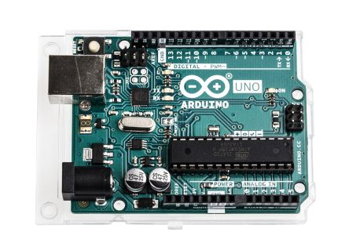

https://at.rs-online.com/web/p/products/7154081/?grossPrice=Y&cm_mmc=AT-PLA-DS3A-_-google-_-PLA_AT_DE_Halbleiter-_-Entwicklungskits%7CEntwicklungskits_Prozessor_And_Mikrocontroller-_-PRODUCT+GROUP&matchtype=&gclid=EAIaIQobChMI38nLreGb2wIVC54bCh0npg4iEAQYASABEgLsw_D_BwE&gclsrc=aw.ds

DS-8203 MG Digital-Servo
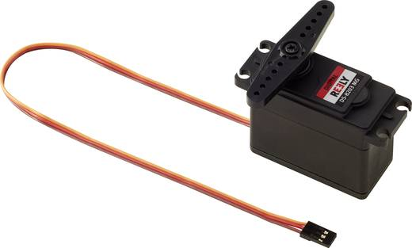

https://www.conrad.at/de/reely-spezial-servo-ds-8203-mg-digital-servo-getriebe-material-metall-stecksystem-jr-1365553.html

Austrian Audio Engineering Staff – (Priceless They wanted me to write that!)

Oh, yeah: Source Code

/* Sweep
by RIRO & DAWO & ALKA

V6
ADC Schwellwert = Kabelbruch
Zeigt ADC Wert bei 0°, 180°
Meldung bei Kabelbruch
Läuft weiter bei Kabel = OK
Pause bei 90° (kein Kabelknick)
Zeigt Pausenzeit

*/

#include <Servo.h>
#include <SPI.h>
#include <SD.h>

Servo myservo; // create servo object to control a servo

enum e_State {
IDLE = 0, PAUSE, RUN, BROKEN
} myState;

const int chipSelect = 4;
int ledPin = 13; // LED connected to digital pin 13
int countPin = 4; // count output is pin 4
int buttonPin = 2; // button connected to pin 2
int buttonval = 0; // variable to store the read value
int pos = 0; // variable to store the servo position
int sensorPin = A0;
int sensorValue = 1023;
int threshold = 10; // ADC Values 0-1023 (1023 = 5VDC) => with 1k pull up => threshold 10 = 10R
int timecount = 0; // Pause time

void cableBroken() {
Serial.println("");
Serial.print(" - !!!Kabel gebrochen!!! - A0 ADC Wert: ");
Serial.println(sensorValue);
Serial.println("");
}

void countUp() {
static unsigned long counter = 1; // 32bit only positive
digitalWrite(countPin, HIGH);
delay (5); // 5ms High signal
digitalWrite(countPin, LOW);
Serial.print("Counter: ");
Serial.println(counter++);
}

void ADCValue() {
Serial.print(" A0 ADC Wert: ");
Serial.println(sensorValue); // ADC value
}

void servopos(int endpos) {
bool changed = false;
if (pos < endpos) {
for (; pos < endpos; pos += 3) { // counts up in 3° steps (speed = 180°/3°*20ms = 1.2sec)
myservo.write(pos); // tell servo to go to position in variable 'pos'
delay(20); // 20ms delay for every 3° step (20ms according to Servo Spec)
}
changed = true;
}
if (pos > endpos) {
for (; pos > endpos; pos -= 3) {
myservo.write(pos);
delay(20);
}
changed = true;
}

if (changed == true) {
Serial.print(pos);
Serial.print("°");
if (pos == 90) {
Serial.print(" - Pause - ");
}
}
}

void setup() {
pinMode(ledPin, OUTPUT); // sets the digital ledPin as output
pinMode(countPin, OUTPUT); // sets the countPin as output
pinMode(buttonPin, INPUT); // button pin set as input
digitalWrite(countPin, LOW);
myservo.attach(9, 650, 2400); // attaches the servo signal on pin 9, min, max = shortest, longest pulse with (µs) = physical end position for 0°, 180°
Serial.begin(9600) ;
Serial.println("Hello World");
myState = e_State::RUN;
}

void loop() {

switch (myState) {

case e_State::IDLE:
sensorValue = analogRead(sensorPin);// A0 einlesen
if (sensorValue <= threshold) { // Wenn Kabel ok => Servobewegung
myState = e_State::RUN;
}
break;

case e_State::BROKEN:
cableBroken();
myState = e_State::IDLE;
break;

case e_State::RUN:
buttonval = digitalRead(buttonPin);
if (buttonval == HIGH) {
myState = e_State::PAUSE;
break;
}
servopos(180);
sensorValue = analogRead(sensorPin);// A0 einlesen
ADCValue(); // Wert ausgeben
if (sensorValue > threshold) { // Wenn Kabel ok => Servobewegung
myState = e_State::BROKEN;
break;
}
servopos(0);
sensorValue = analogRead(sensorPin);
ADCValue();
if (sensorValue > threshold) {
myState = e_State::BROKEN;
break;
}
countUp();
break;

case e_State::PAUSE:
servopos(90);
delay(1000);
timecount++;
buttonval = digitalRead(buttonPin);
if (buttonval == LOW) {
Serial.print("Dauer: ");
Serial.print(timecount);
Serial.println("s");
Serial.println("");
timecount = 0;
myState = e_State::RUN;
}
break;
}
}

Schematics: I dunno. The Engineers sent me two sets… :D

Hoff Equipped
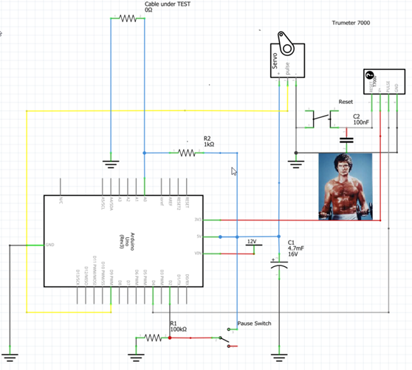

The following one actually works:
