https://www.petfinder.com/dog/snow-kitty-41310144/ca/point-richmond/the-milo-foundation-ca387/

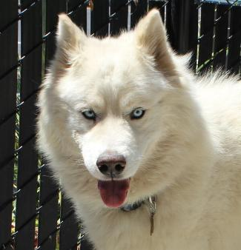

# SNOW KITTY

## Samoyed,Siberian Husky - M - Adult - L - undefined

This is the Animal Description Header
Kitty is a social and playful boy, but he is a confident guy and can be possessive over toys/food etc so he would need to be in an adult only home that would work respect his quirks and work with him on this. He stands up on his back feet and does an adorable little dance with his feet when he sees someone that he knows approaching. He has a good heart and is a very intelligent guy. He is going to be just a fantastic dog for a bight confident and dog savvy person.; Original Bio: One big furry fluff ball! Snow Kitty needs someone who is familiar with Nordic breeds and can give him the space, exercise, training, and leadership he needs. He is very dog-friendly and does not appear to be outwardly cat-aggressive, though we believe he'd be best in a no cat and no kid home! He is stubborn, willful and possessive and he doesn?t take to being restrained. Snow Kitty had a stuffed animal and was very possessive and unwilling to let it go. He is a bit of a touchy fellow and needs adults who can allow him the space he needs - and also provide friendship and activity - he does really like playing with other dogs - males or females.Snow Kitty also had the name Griffin which is a bit more regal -- but this is not a joker, rather he has an independent streak, he is prideful and dominant in that he feels secure in himself and his right to have what he wants and do what he wants and really doesn't want a person telling him otherwise or demanding of such... he can get angry and takes some time to let him calm down - thus a savvy adult home is what he needs.; If interested please email us at sanctuary@milofoundation.orgThis is the Animal Description Footer
7/20/18 12:17 PM