
DAILY USE GUIDE

TourClicks
  - Punches, timeline, calculators, leave, FMLA, reports, and backup
Record the day. Review the result. Protect the record.
Purpose: Use this guide after initial setup. Follow one worked example from Begin Tour through reporting and backup.

Prepared from TourClicks 1.0.0 interface and project documentation
Guide date: August 2026

START HERE

How to use this guide
Use the chapters in order for your first complete day. Later, use each chapter as a quick reference for one screen.
After a change, wait for Saved locally before closing the app. Local means the active app or browser storage, not automatic cloud sync.
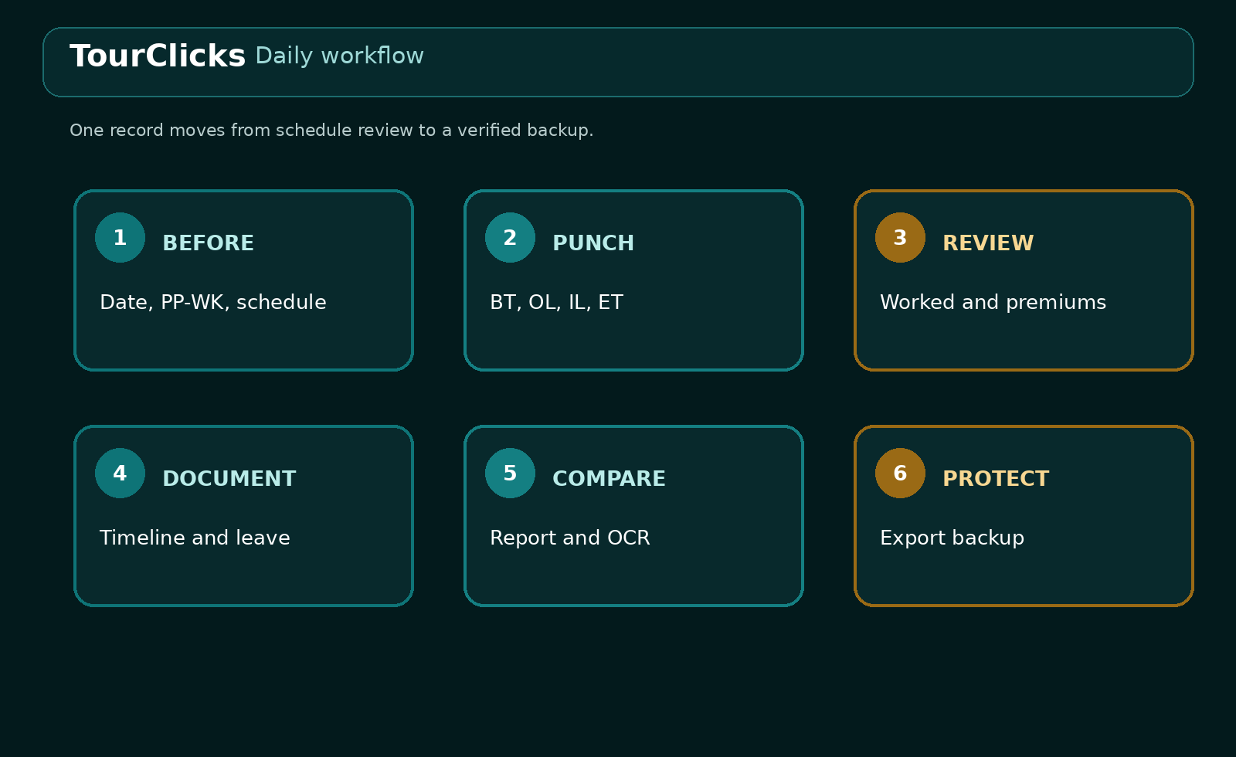
Figure 1. Daily workflow: review, punch, calculate, document, compare, and back up.

Screen map
Screen | Use it for
Today | Date, schedule, BT, OL, IL, ET, daily totals, premium estimates, and timers
Calendar | Pay-period context, holidays, dates with work, leave, FMLA, notes, or attachments
Timeline | Timestamped facts, instructions, equipment or safety notes, images, and day export
Calculator | USPS hundredths conversion and late, lunch, or makeup scenarios
Leave/FMLA | Multi-date leave, FMLA cases, holiday records, and balance projections
Reports | Range summary, daily details, CSV, PDF, OCR comparison, and saved review history
Settings | Full backup, restore, and occasional configuration changes

PART 1

Today: record the workday

Before Begin Tour
- Open Today and confirm the Date field.
- Read the PP-WK label and 14-day pay-period range.
- Expand Schedule and day status.
- Confirm Scheduled workday, Nonscheduled day, Training schedule, or Changed schedule.
- If the date differs from the regular template, edit that date. Do not change the weekly template for a one-day exception.
- Return to the punch panels and check that BT is the first missing punch.
Status | Use it when | Calculation effect
Scheduled workday | Normal assignment | First 8 worked hours estimate as straight time
Nonscheduled day | Regular day off | First 8 worked hours estimate as overtime
Training schedule | Training changed the day's schedule | Uses scheduled-day daily estimates
Changed schedule | Temporary approved schedule change | Uses scheduled-day daily estimates

Existing dates: A later change to the weekly template does not silently rewrite an existing daily record. Choose Use weekly schedule on that date if you intend to refresh it.

Enter BT, OL, IL, and ET
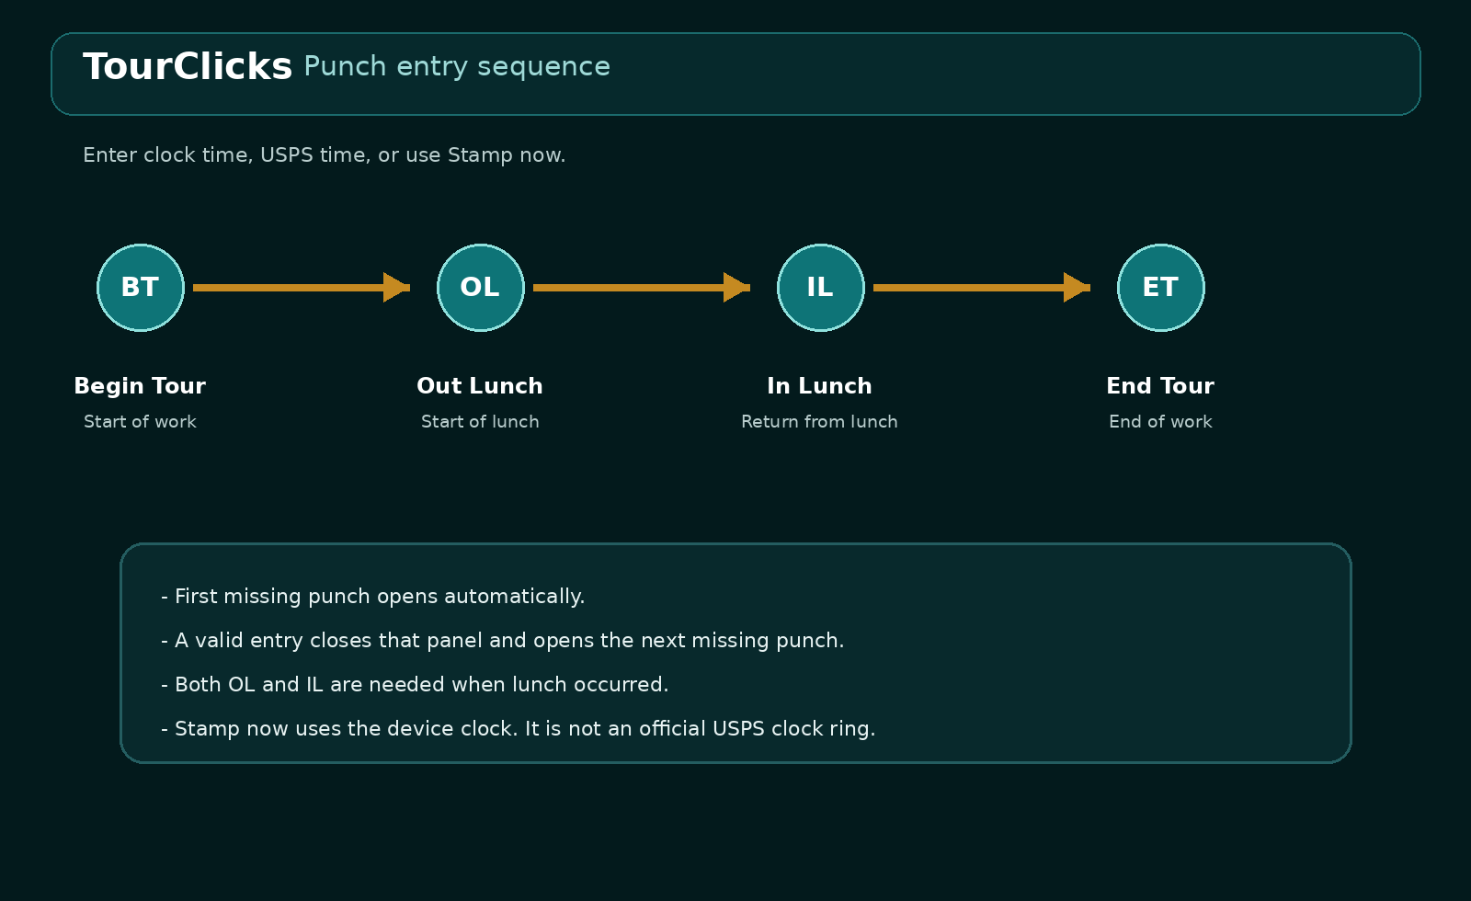
Figure 2. A completed punch advances to the next missing punch.
Code | Meaning | Record it when
BT | Begin Tour | Work begins
OL | Out Lunch | Lunch begins
IL | In Lunch | Work resumes after lunch
ET | End Tour | Work ends

- Open the punch panel.
- Type a regular clock value, type a USPS hundredths value, or select Stamp now.
- Press Enter, Go, or Done after a direct entry when needed.
- Confirm that the panel summary shows both regular clock and USPS formats.
- Continue to the next missing punch.

Accepted time formats
Input type | Examples | How TourClicks reads it
Clock with AM/PM | 5:27 AM, 1:30 PM | 12-hour clock
24-hour clock | 05:27, 13:30 | AM or PM is not needed
Clock with seconds | 05:27:00 | Keeps second-level precision
Compact clock | 0527 | Reads as 05:27
USPS hundredths | 05.27, 11.77, 13.44 | Decimal portion is a fraction of an hour

USPS hundredths reference
Hundredths | Minutes | Seconds
0.01 | 0.6 | 36
0.10 | 6 | 360
0.25 | 15 | 900
0.50 | 30 | 1,800
0.75 | 45 | 2,700
1.00 | 60 | 3,600

Common mistake: 05.27 does not mean 5:27 AM. It means 5 hours plus 27 hundredths, which equals 5:16:12 AM.

Worked daily example
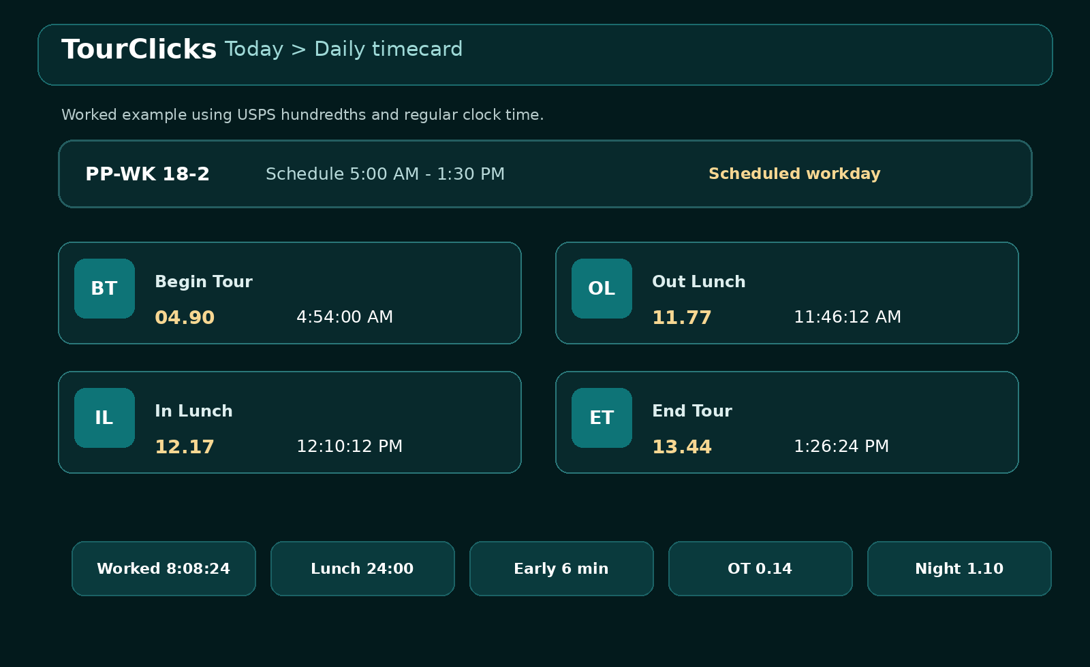
Figure 3. Fictional scheduled-day example.
Punch | USPS | Regular clock
BT | 04.90 | 4:54:00 AM
OL | 11.77 | 11:46:12 AM
IL | 12.17 | 12:10:12 PM
ET | 13.44 | 1:26:24 PM

TourClicks removes the 24-minute lunch interval. Worked time is 8 hours, 8 minutes, 24 seconds. Begin Tour is 6 minutes early. Daily estimates are 8.00 straight hours, about 0.14 overtime hour, 0.00 penalty overtime, and 1.10 night-differential hours.

Read every Today result
Result | What it means | What to check
Worked | BT-to-ET time minus a complete OL-to-IL lunch | Both lunch punches when lunch occurred
Lunch | Elapsed time from OL to IL | Missing or reversed lunch punches
Start variance | Actual BT compared with scheduled BT | Correct date-specific schedule
Straight time | Daily straight-time estimate | Day status and worked duration
Overtime | Daily overtime estimate | Scheduled versus nonscheduled day
Penalty OT | Eligible daily time beyond the threshold | Exclusion dates and eligibility
Night differential | Worked time from midnight-6 AM and 6 PM-midnight | Lunch is excluded

Missing lunch pair: If OL and IL are not both present, TourClicks treats BT through ET as one continuous interval. Complete both punches when lunch occurred.

Scheduled and nonscheduled premium estimates
Day type | Straight | Overtime | Penalty OT
Scheduled, training, or changed | First 8 hours | Hours over 8 through 10 | Eligible hours over 10
Nonscheduled | 0 | First 8 worked hours | Eligible hours over 8

Manual premium override
Turn on Manually override calculated premium hours only when you have a known value that the punch-only estimate cannot represent. Enter overtime, penalty overtime, and night hours. Add a Timeline note explaining the source or instruction.
[ ] I confirmed the date and day status.
[ ] I checked all four punches and lunch.
[ ] I have a clear reason for the override.
[ ] I added a note that explains the source of the value.
[ ] I compared the result with the official record when available.

Live timers
- Tour timer and Lunch timer run independently.
- Start, Stop, and Reset affect only the timer.
- Timers never write BT, OL, IL, or ET.
- Browser timers catch up from saved timestamps when the page returns.
- Android can provide persistent timer notifications when permission is allowed.
Timer use: Use a timer as a reminder or personal reference. Record each required punch separately.

PART 2

Timeline and Calendar

Add a timestamped timeline entry
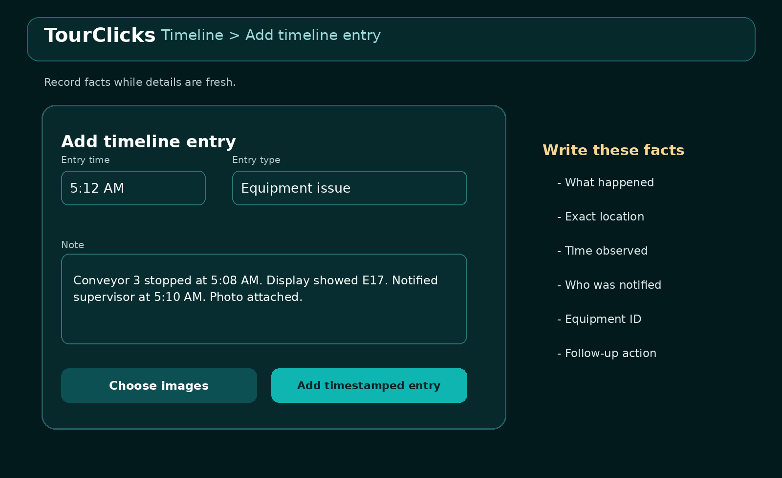
Figure 4. A factual note records what happened, when, where, and who was notified.
- Open Timeline and confirm the selected date.
- Set Entry time to the time connected with the event.
- Choose Work note, Instruction received, Equipment issue, Safety observation, Leave request, Schedule change, or Other.
- Write observable facts and identify any follow-up.
- Attach JPG, PNG, WebP, or GIF images when useful.
- Select Add timestamped entry and wait for Saved locally.
Two timestamps: Entry time describes when the event occurred. Creation time records when the entry was saved.

Write useful documentation
Include | Example
Event | Conveyor stopped during startup
Time | Observed at 5:08 AM
Location or equipment | Conveyor 3, display E17
Notification | Supervisor notified at 5:10 AM
Action | Unit isolated and maintenance contacted
Evidence | Two photos attached

Images and daily export
- TourClicks compresses stored images and limits the longest side to about 1600 pixels.
- HEIC and HEIF are not supported by the current browser image workflow.
- Tap an attachment to view, fit, save, or share it where supported.
- Export day creates a date-specific JSON with that daily record, timeline entries, and leave entries.
- Export day is not a complete-app restore backup.

Use Calendar for review
Calendar groups dates by USPS-style pay periods and gives a quick view of work, late starts, leave, FMLA, notes, attachments, holidays, paydays, and nonscheduled days.
Calendar mark | Meaning
Green dot | Worked record
Red dot | Late start
Blue dot | Leave
Purple dot | FMLA or renewal date
Gray-blue dot | Timeline note or attachment
NS | Regular nonscheduled day
Diagonal shading | Unavailable or on vacation
PP badge | First Saturday of a pay period
PAY | Calculated payday

- Open Calendar and move to the needed month.
- Select a marked date.
- Review punches, totals, leave, holiday information, and note count in the date dialog.
- Select Open daily record to return to Today for that date.
PART 3

Calculator
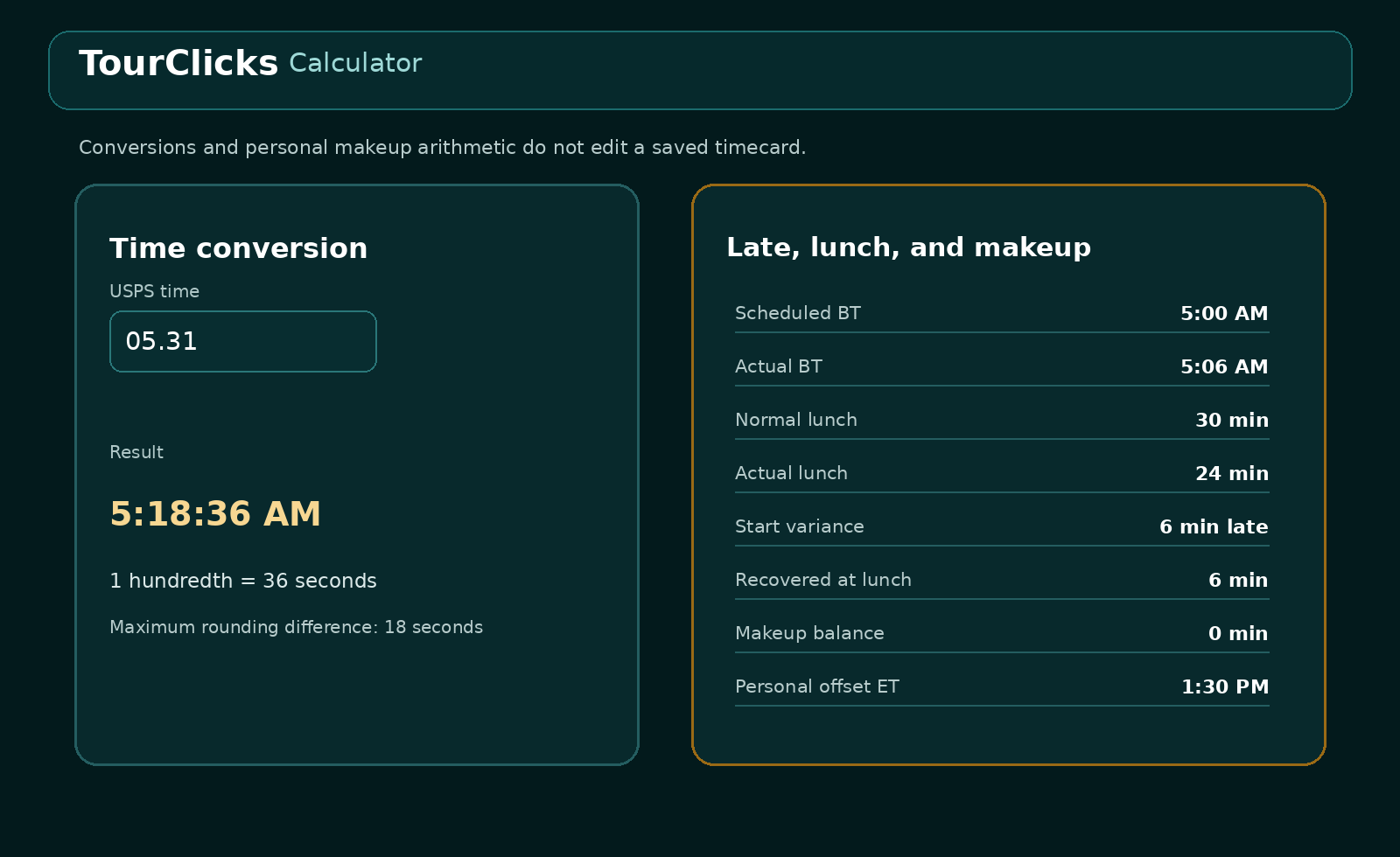
Figure 5. Calculator results are separate from saved timecards.

Convert USPS time
- Open Calculator.
- Enter a value such as 05.31 under USPS hundredths to regular clock time.
- Read the result, 5:18:36 AM.
- For the reverse conversion, enter a clock time such as 5:18:36 AM.
- Read the nearest USPS hundredth. Maximum rounding difference is 18 seconds.

Use a saved day as a calculator starting point
- Choose a source Date or keep the shared selected date.
- Select Use selected day.
- Choose Regular clock time or USPS hundredths as the input format.
- Edit Scheduled BT, Actual BT, Scheduled ET, normal lunch, OL, or IL for the scenario.
- Read Start variance, Lunch used, Recovered at lunch, Makeup balance, Standard ET, Personal offset ET, and Adjusted USPS punch.
- Return to Today if you need to edit the real daily record. Calculator changes do not do that.

Makeup example
Input | Value
Scheduled BT | 5:00 AM
Actual BT | 5:06 AM
Scheduled ET | 1:30 PM
Normal lunch | 30 minutes
OL | 11:46 AM
IL | 12:10 PM

Result | Value
Start variance | 6 minutes late
Lunch used | 24 minutes
Recovered at lunch | 6 minutes
Makeup balance | 0 minutes
Standard ET | 1:30 PM
Personal offset ET | 1:30 PM

Interpretation: Personal offset ET is arithmetic for planning. Schedule changes, short lunches, makeup arrangements, and alternate end times require the applicable approval or instruction.

PART 4

Leave and FMLA

Create an FMLA case first when needed
- Open Leave/FMLA and find FMLA case and renewal alert.
- Enter a neutral Case label.
- Choose Own condition or Dependent care.
- Enter expiration and renewal-warning days from the official case information.
- Enter the reference number only when useful.
- Record approved frequency or case details without unnecessary medical information.
- Select Save FMLA case.
Case field | Example
Case label | Own condition - Case A
Category | Own condition
Expiration | 12/31/2026
Renewal warning | 30 days
Frequency details | Up to 2 episodes per month, up to 8 hours each

FMLA alert: A saved case can show a warning on Today when it enters the configured renewal period or expires.

Enter multi-date leave
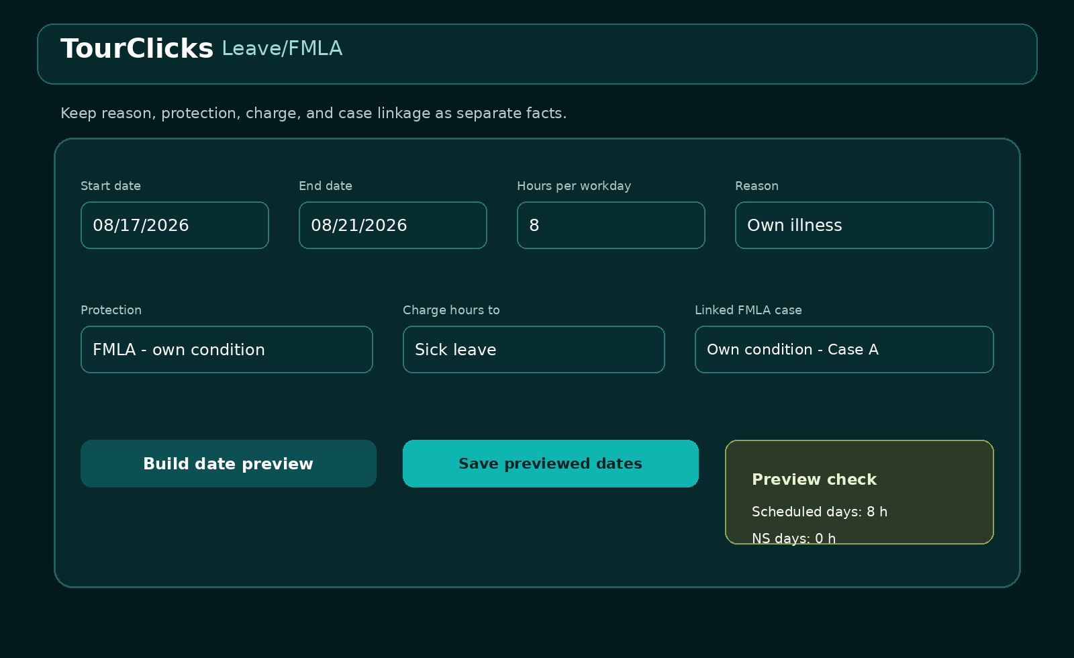
Figure 6. Reason, protection, charge, and linked case describe different parts of the absence.
- Choose Start date and End date.
- Enter Default hours per scheduled day.
- Choose Reason.
- Choose Protection or designation.
- Choose Charge hours to.
- Link the saved FMLA case when FMLA protection is selected.
- Review or edit the suggested pay or timekeeping code.
- Choose whether nonscheduled days should be marked unavailable with zero leave hours.
- Add a short note or approval reference.
- Select Build date preview.

Review the date preview before saving
Preview item | What to verify
Date and weekday | Every intended date is present
Scheduled status | Regular schedule or date-specific change is correct
Scheduled hours | Expected work hours for that date
Leave hours | Full or partial amount is correct
Unavailable | Nonscheduled dates are marked only when intended

For a scheduled date, TourClicks suggests the smaller of the default requested hours or the scheduled hours remaining after recorded work. If four hours were already worked on an eight-hour day, the preview can suggest four leave hours.
- Edit any partial-day leave hours.
- Keep nonscheduled leave hours at zero.
- Confirm the unavailable checkboxes.
- Select Save previewed dates.
- Review Annual Leave and Sick Leave current and projected balances.
- Open Calendar to confirm leave, FMLA, and unavailable indicators.
Negative estimate: If the request projects annual or sick leave below zero, TourClicks asks before saving. A red value is a local projection, not an approval decision.

Reason, protection, and charge examples
Situation | Reason | Protection | Charge
Vacation | Vacation or personal | None | Annual leave
Own illness with FMLA | Own illness or medical | FMLA - own condition | Sick leave, AL, or LWOP as applicable
Dependent care with FMLA | Dependent care | FMLA - dependent care | SL, AL, or LWOP as applicable
Dependent care without FMLA | Dependent care | Dependent care - non-FMLA | Applicable leave category
Unavailable only | Applicable reason | Applicable designation | No leave hours - unavailable only

Common suggested codes
Charge | Suggested editable code
Annual leave | 055
Sick leave | 056
LWOP | 060
Union official - LWOP | 060
Holiday leave | 058
Administrative leave | 086

Holiday record
Use the same screen to record the actual holiday date, confirmed designated holiday, whether it was worked, annual-leave-in-lieu election, credit, code, assignment status, notification times, and factual evidence.
PART 5

Reports and comparison
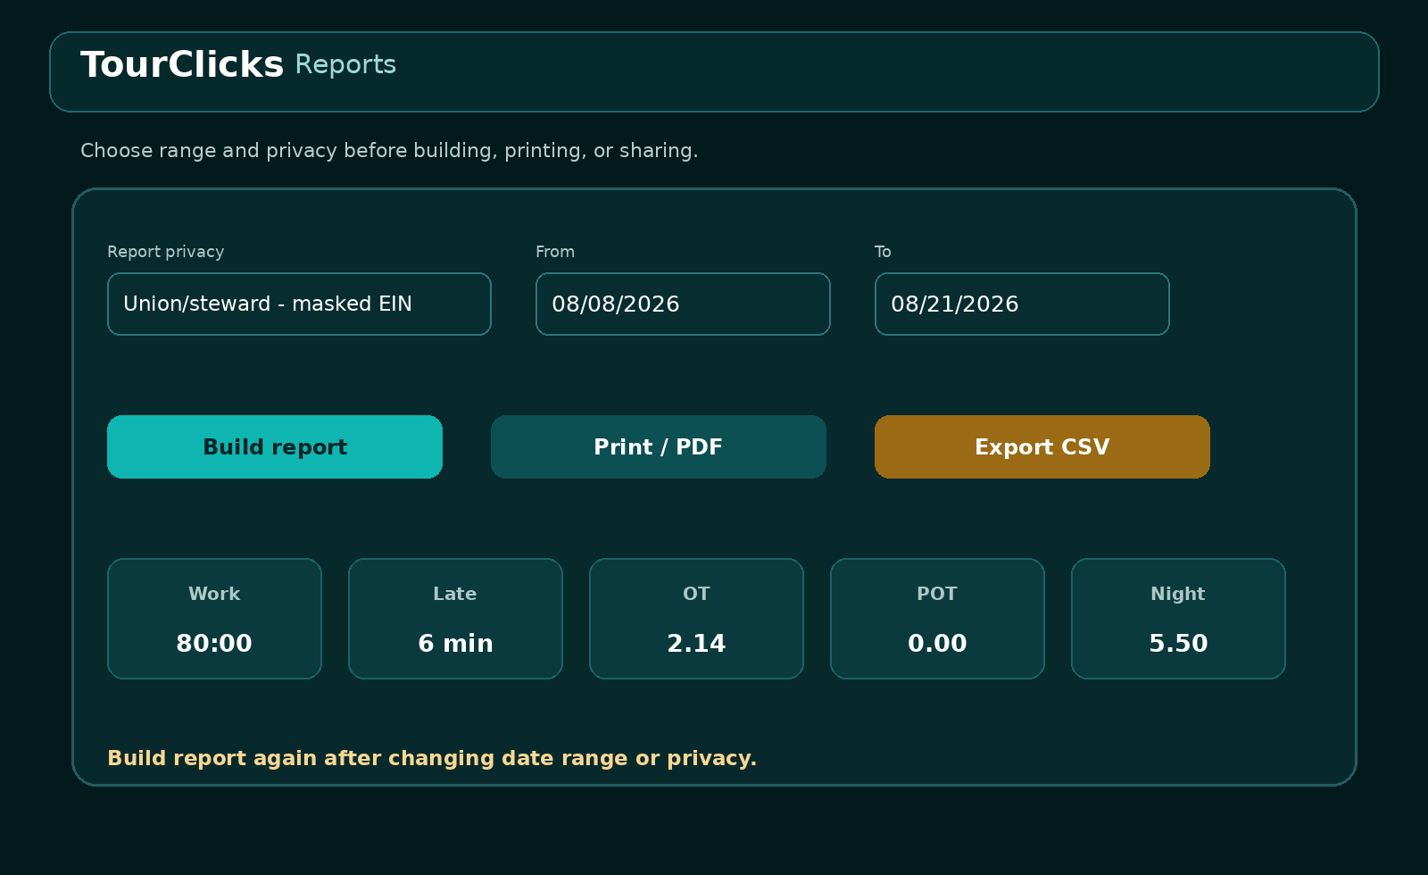
Figure 7. Choose privacy and date range before building a report.

Build a report
- Open Reports.
- Choose Private - full profile, Union/steward - masked EIN, or Shareable - omit EIN.
- Select From and To dates.
- Choose Build report.
- Review employee header, summary totals, daily records, and missing punches.
- Choose Print / PDF or Export CSV only after reviewing privacy and range.
Privacy mode | EIN behavior | Typical use
Private | Full EIN when saved | Personal full record
Union/steward | Masked, final four visible when available | Review with a representative
Shareable | Omitted | Broader sharing or tutorial examples

Read report output
Section | Contents
Employee and installation | Profile fields allowed by the privacy mode and regular schedule
Summary | Work, late, overtime, penalty overtime, night, leave, notes, and record count
Daily details | Date, PP-WK, punches, worked duration, late minutes, and premiums
CSV | One row for every calendar date in the selected range
Print / PDF | Rendered report for printing or saving

Restoration: CSV and PDF are report outputs. They cannot restore app state. Use Export backup in Settings for restoration.

Quick pay-period review
[ ] Date range covers the complete pay period.
[ ] Every worked date has expected punches.
[ ] Missing OL or IL is intentional or corrected.
[ ] Late, OT, penalty OT, and night totals were reviewed.
[ ] Leave totals match the intended dates and hours.
[ ] Privacy mode fits the recipient.

Compare a screenshot
- Choose Virtual Timecard or ePayroll.
- Choose the comparison date.
- Select a JPG, PNG, or WebP screenshot.
- Crop with Left, Top, Right, and Bottom percentages. Rotate if needed.
- On Android, use Automatic OCR. On Web, paste recognized text manually.
- Read and correct the recognized text.
- Select Extract values from reviewed text.
- Correct Date, BT, OL, IL, ET, regular, OT, penalty, night, and leave fields as needed.
- Select Compare with TourClicks.
- Investigate each match, small clock variance, difference, or missing OCR value.
- Save the reviewed comparison if it should remain in history and Timeline.
Comparison state | Meaning
Match | Values agree within the app's comparison tolerance
Small clock variance | Punch difference is 90 seconds or less
Difference | Values differ beyond the tolerance
OCR value missing | No reviewed external value is available

No overwrite: Saving a reviewed comparison does not change punches, premium hours, or leave entries.

PART 6

Backup, restore, and transfer
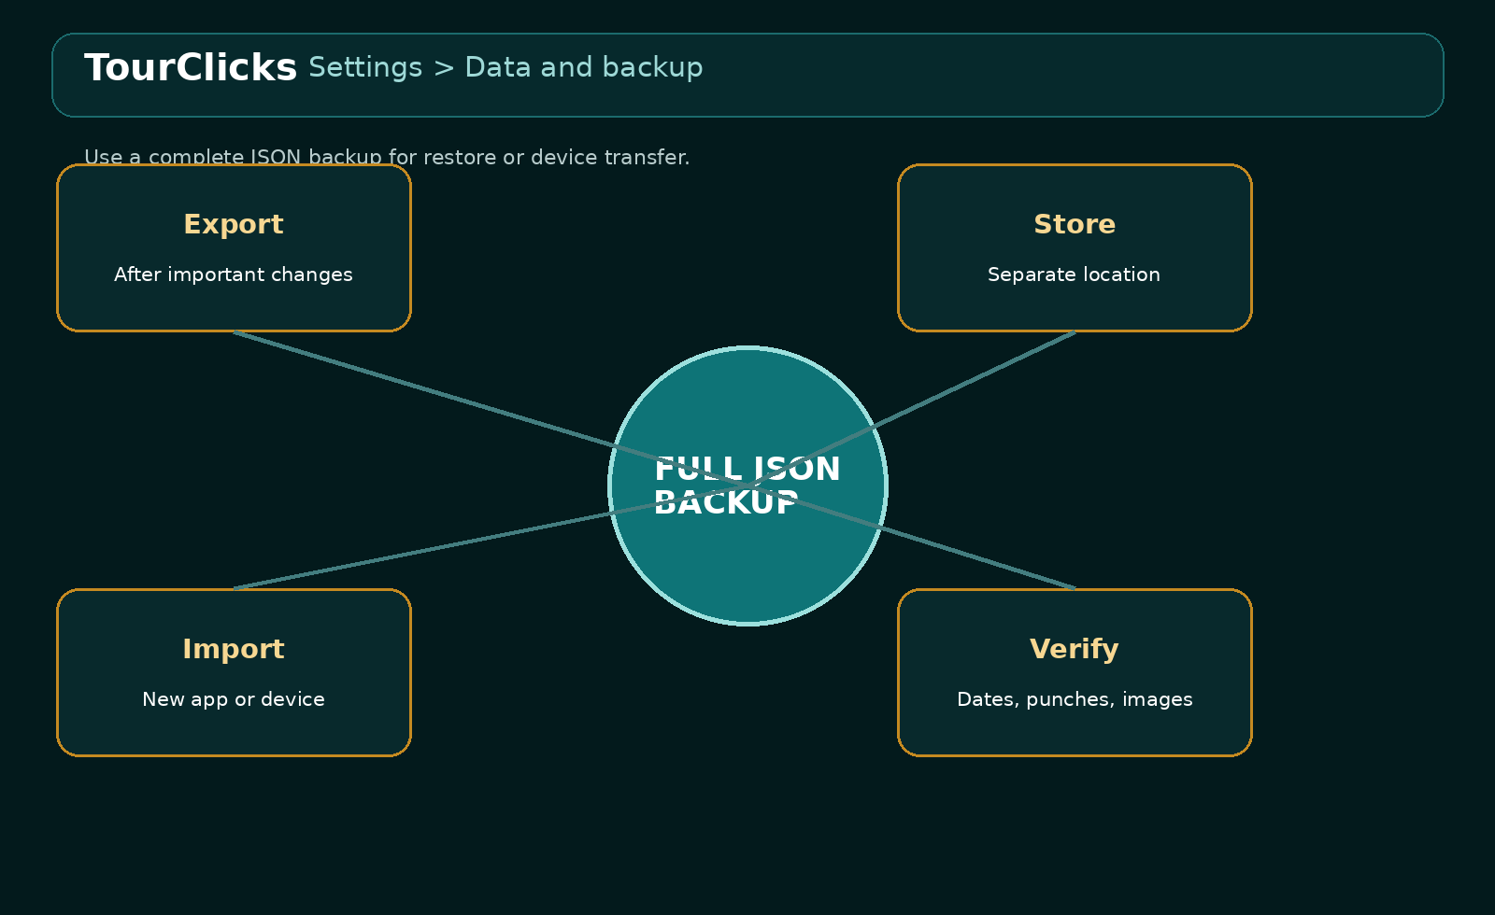
Figure 8. A backup is complete only after it is stored separately and can be verified.

Export a complete backup
- Wait for Saved locally.
- Open Settings and expand Data and backup.
- Choose Export backup.
- Save the tourclicks-backup-date.json file in a location separate from the app.
- Keep at least one older known-good export before replacing it.
File or output | Contains | Can restore full app
Full backup JSON | Settings, daily records, Timeline, leave, FMLA, holidays, timers, comparisons, and stored images | Yes
Export day JSON | One date's daily record, Timeline, and leave | No
Report CSV | Tabular date-range report | No
Printed PDF | Rendered report | No

Restore or move to another device
- Open or install TourClicks on the destination device or browser.
- Open Settings, then Data and backup.
- Choose Import backup and select the trusted JSON file.
- After import, review several known dates in Today and Calendar.
- Review Timeline images, leave entries, FMLA cases, report settings, and weekly schedule.
- Export a new backup from the destination after verification.
Import effect: Import replaces the active local app state with the imported state, then fills newer default fields where needed. Export the current state before importing.

Backup schedule
When | Action
After each important day | Export if notes, images, leave, or corrected punches would be hard to recreate
At each pay-period review | Export after report comparison and corrections
Before import or update | Keep a fresh backup and an older known-good copy
Before changing device or browser | Export and copy the file to the destination
After successful restore | Create a new destination backup

PART 7

Daily checklist

Before work
[ ] Correct date
[ ] Correct PP-WK
[ ] Correct schedule and day status
[ ] BT panel ready

During work
[ ] BT entered
[ ] OL entered
[ ] IL entered
[ ] Timeline facts or images added when useful

At End Tour
[ ] ET entered
[ ] Worked time reviewed
[ ] Lunch reviewed
[ ] Start variance reviewed
[ ] Straight, OT, penalty OT, and night reviewed
[ ] Any override explained in Timeline
[ ] Saved locally displayed

After official records post
[ ] Report range built
[ ] Privacy checked
[ ] Important dates compared
[ ] Differences investigated
[ ] Backup exported

Troubleshooting
Problem | Likely cause | Action
Worked time includes lunch | OL or IL is missing | Enter both lunch punches
05.27 displays 5:16:12 | USPS value was read as clock minutes | Use 05:27 for clock time or accept the hundredths conversion
Wrong overtime pattern | Day status is wrong | Review Scheduled versus Nonscheduled
Schedule changed on one date | Date-specific record differs from template | Use weekly schedule only if you want to reset that date
Calculator result did not change Today | Calculator is isolated | Edit the actual date in Today
FMLA leave will not save | No linked case | Create and select the required FMLA case
Leave preview is lower than expected | Worked hours reduce remaining scheduled hours | Review that day's punches and partial-day amount
OCR button disabled on Web | Automatic OCR is Android-only | Paste recognized text manually, then extract and review
PDF or CSV will not restore | Report output is not a backup | Import a full backup JSON
Records missing on another browser | No automatic sync | Export from the source and import on the destination

APPENDIX

Sources and product links
TourClicks live web app
https://ausuba3d.github.io/TourClicks/
TourClicks public repository
https://github.com/Ausuba3D/TourClicks
USPS Virtual Timecard overview
https://news.usps.com/2019/10/23/its-about-time/
USPS ePayroll overview
https://news.usps.com/2019/10/29/show-me-the-money/

Scope
TourClicks is independent Ausuba3D software. It supports personal recordkeeping and comparison. It does not connect to LiteBlue, submit leave or FMLA, replace official records, or determine final pay or contractual entitlement.

