
SETUP AND FIRST USE GUIDE

TourClicks
  - Schedule, pay periods, leave balances, verification, and backup
Start small. Verify each section. Keep an export.
Purpose: This guide helps a new user set up TourClicks without filling uncertain fields. It separates the minimum setup from optional payroll and leave projections.

Prepared from the TourClicks web app, public repository, and official USPS references
Guide date: August 2026

START HERE

How to use this guide
TourClicks can look complex because it combines daily time records, leave projections, FMLA references, reports, images, and backup tools. You do not need to configure every feature before using the daily timecard.
Best approach: Complete the Quick Start first. Add verified leave information only after you have one finalized ePayroll statement.

Two setup paths
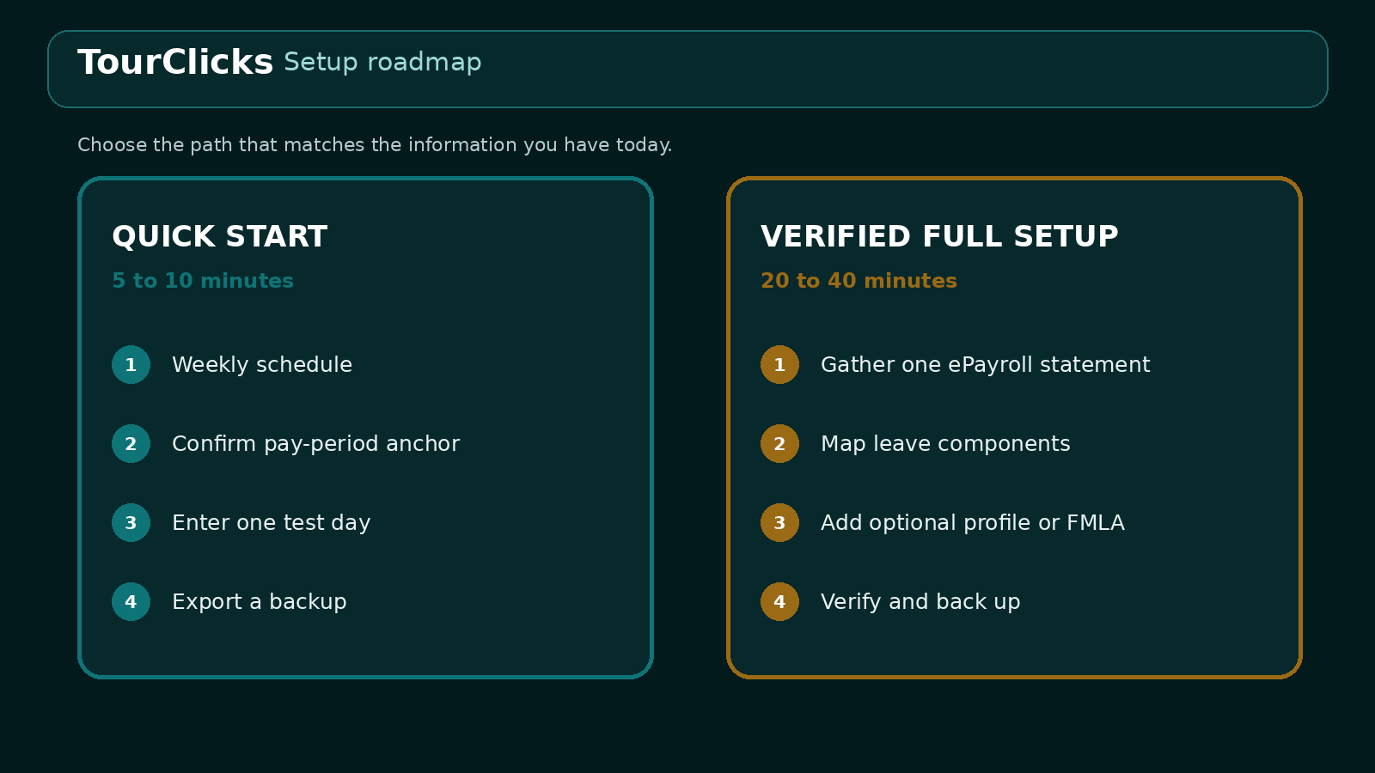
Figure 1. Quick Start gets the app usable. Full Setup adds verified records later.

Guide sections
Section | Purpose
Parts 1-2 | Gather sources and complete the Quick Start
Parts 3-4 | Add verified leave and optional settings
Part 5 + appendices | Verify, troubleshoot, use tables, and complete the worksheet

PART 1

Gather your setup information
You can complete the schedule and pay-period setup with two sources. The remaining documents support leave projections, reporting, and optional records.
Information | Where to find it | TourClicks section | Priority
Regular schedule | Posted schedule, bid assignment, or current local instruction | Weekly schedule | Needed now
Pay-period calendar | USPS Postal Bulletin pay dates and leave-year chart | Pay-period anchors | Verify now
Leave values | One finalized ePayroll statement, Leave section | Leave accrual and balances | Useful later
Clock rings | LiteBlue Virtual Timecard | Daily comparison or screenshot review | Useful later
Position details | PS Form 50 or eOPF | Employee profile | Optional
FMLA limits | Official designation or approval notice | FMLA case | If applicable
Holiday details | Official calendar plus posted schedule or local instruction | Holiday record | If applicable
Penalty exclusion | Official notice, agreement, or trusted guidance | Premium settings | If applicable
Existing data | Trusted TourClicks or Janus JSON export | Import backup | For restore

Prepare before entering leave
- Use one finalized ePayroll statement for every starting leave component.
- Record the pay period number and its Friday end date.
- Redact your EIN and other personal values from any tutorial images.
- Do not collect or enter a LiteBlue password in TourClicks.
- If a value is uncertain, leave it for later instead of estimating it.
[ ] I have my normal Begin Tour, End Tour, lunch, and nonscheduled days.
[ ] I have the official pay-period chart for the year I am setting up.
[ ] I have one finalized ePayroll statement, or I will skip leave setup for now.
[ ] I know where I will store the first export backup.
PART 2

Quick Start
This path makes TourClicks usable in about 5 to 10 minutes. It avoids optional fields that require official records.

Step 1. First launch
- Open TourClicks. Read the local-storage and independent-app explanation.
- Choose Continue to configure the weekly schedule.
- At the optional starting leave page, choose Skip for now if you are starting mid-year or do not have verified components.
- Open Settings later when you are ready to add detailed leave information.
Mid-year accuracy: The simplified onboarding asks for current balances, but TourClicks also calculates leave earned from the leave-year start. A mid-year current balance can be counted with those calculated accruals. Skip that step and use the detailed Settings fields when accuracy matters.

Step 2. Build the regular weekly template
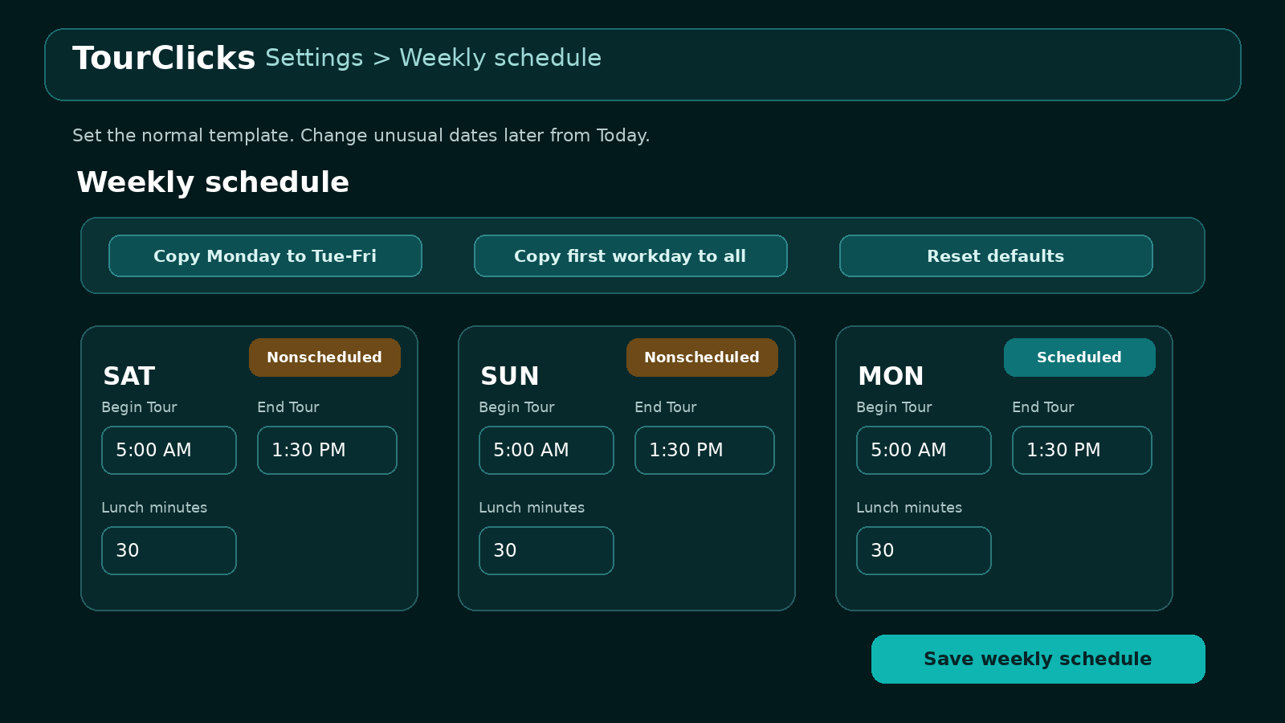
Figure 2. Weekly schedule editor. The real app lists Saturday through Friday.
- Open Settings and expand Weekly schedule.
- Review the days in postal-week order: Saturday through Friday.
- Mark each fixed day off as Nonscheduled day.
- Enter Begin Tour, End Tour, and lunch minutes for each scheduled day.
- Use Copy Monday to Tue-Fri only when those days truly match.
- Select Save weekly schedule.
Irregular schedules: Enter the most common schedule as the template. On an unusual date, use Today to select Scheduled workday, Nonscheduled day, Training schedule, or Changed schedule.

Schedule verification
[ ] The week runs Saturday through Friday.
[ ] Each fixed day off is marked Nonscheduled day.
[ ] Begin Tour, End Tour, and lunch match the normal assignment.
[ ] I know how to use Changed schedule for an exception.

Step 3. Verify the pay-period anchor
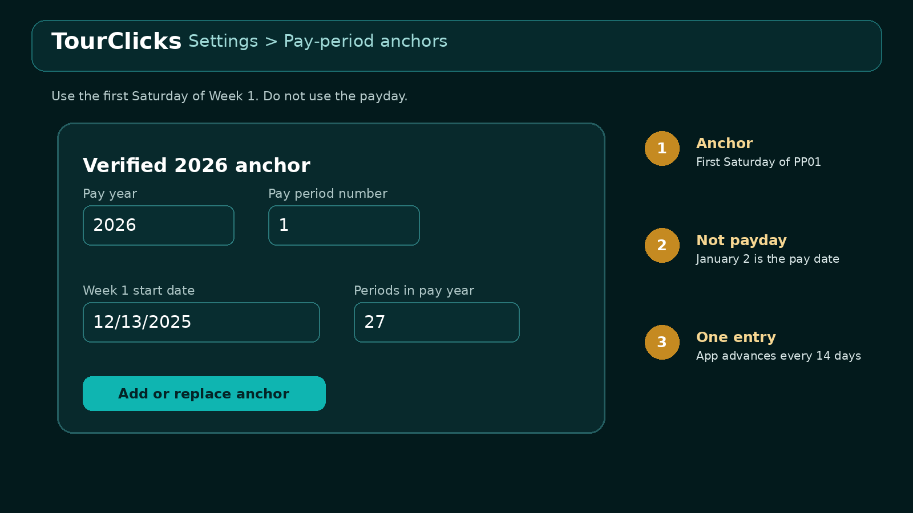
Figure 3. The verified 2026 anchor uses the first Saturday of Week 1.
TourClicks advances pay periods in 14-day blocks. One correct annual anchor is normally enough.
Field | 2026 value | Meaning
Pay year | 2026 | The pay-period year
Pay period number | 1 | The starting anchor
Week 1 start date | December 13, 2025 | The first Saturday of PP01
Periods in pay year | 27 | The official 2026 count

Source: USPS 2026 Pay Dates and Leave Year
Do not use the payday: PP01 starts December 13, 2025. Its payday is January 2, 2026. Enter December 13 as the anchor.

The 2026 pay year and the 2026 leave year are different calendars. The official 2026 leave year starts January 10, 2026, in PP03-2026, and ends January 8, 2027, at the end of PP01-2027.

Step 4. Enter one test day
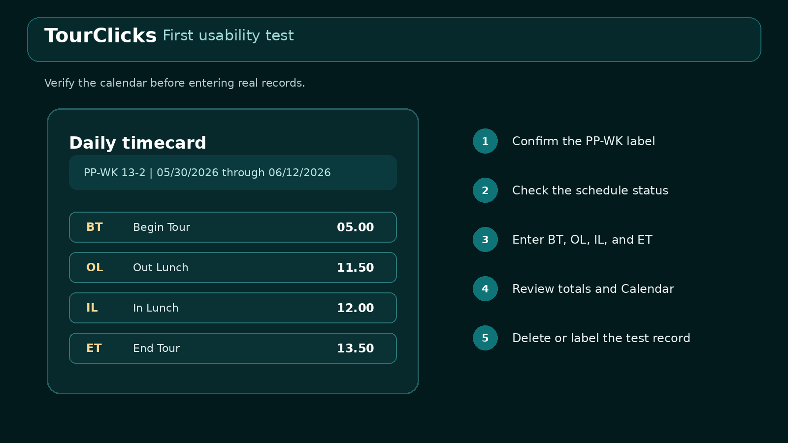
Figure 4. Use fictional or disposable values until the setup checks pass.
- Open Today and select a date whose pay period you can confirm.
- Compare the PP-WK label and date range with the official chart.
- Expand Schedule and day status. Confirm the regular template or choose Changed schedule.
- Enter BT, OL, IL, and ET. Suggested schedule values are not saved punches.
- Review Worked, Lunch, Start variance, Straight time, OT, Penalty OT, and Night differential.
- Open Calendar and confirm that the day appears.
- Delete the fictional record or label it clearly as a setup test.

Step 5. Export the first backup
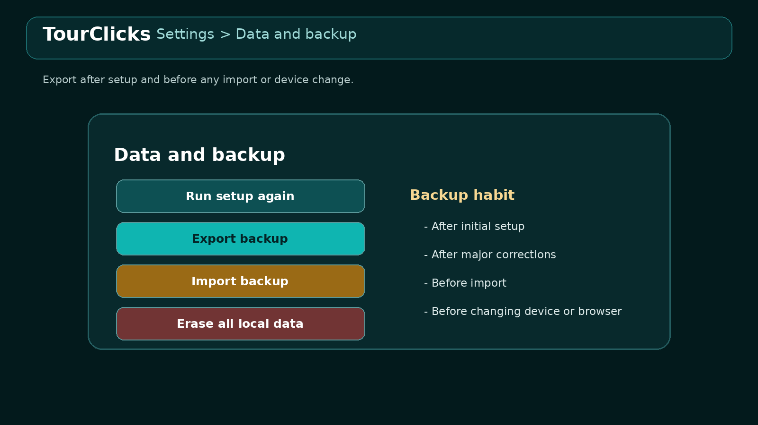
Figure 5. Export after setup and before importing or changing devices.
- Open Settings and expand Data and backup.
- Select Export backup.
- Store the JSON file somewhere separate from the app and current browser profile.
- Keep the newest known-good export before testing an import.
PART 3

Verified leave setup
Use this section only when you have a finalized ePayroll statement. TourClicks uses the values as components in a projection. It does not simply copy the displayed current total.

Read the ePayroll Leave section
ePayroll label | Meaning
AL CAT | Annual-leave earning category
AL PRIOR YR BAL | Annual leave carried into the leave year
AL EARNED YTD | Annual leave earned through the statement period
AL HOL EARNED YTD | Holiday annual-leave credits earned YTD, when shown
AL USED YTD | Annual leave used through the statement period
EARNED AL BAL | Earned annual-leave balance
AL ADVANCED | Advanced leave not yet earned
AVAIL AL BAL | Total annual leave currently shown as available
SL CAT | Sick-leave earning category
SL PRIOR YR BAL | Sick leave carried into the leave year
SL EARNED YTD | Sick leave earned through the statement period
SL USED YTD | Sick leave used through the statement period
CURRENT SL BAL | Current sick-leave balance

Source: USPS Earnings Statement Redesign of Leave Sections
One cutoff: Use the Friday end date of the pay period covered by the statement as the Baseline through date. Do not use the payday, download date, or today's date.

Map ePayroll to TourClicks
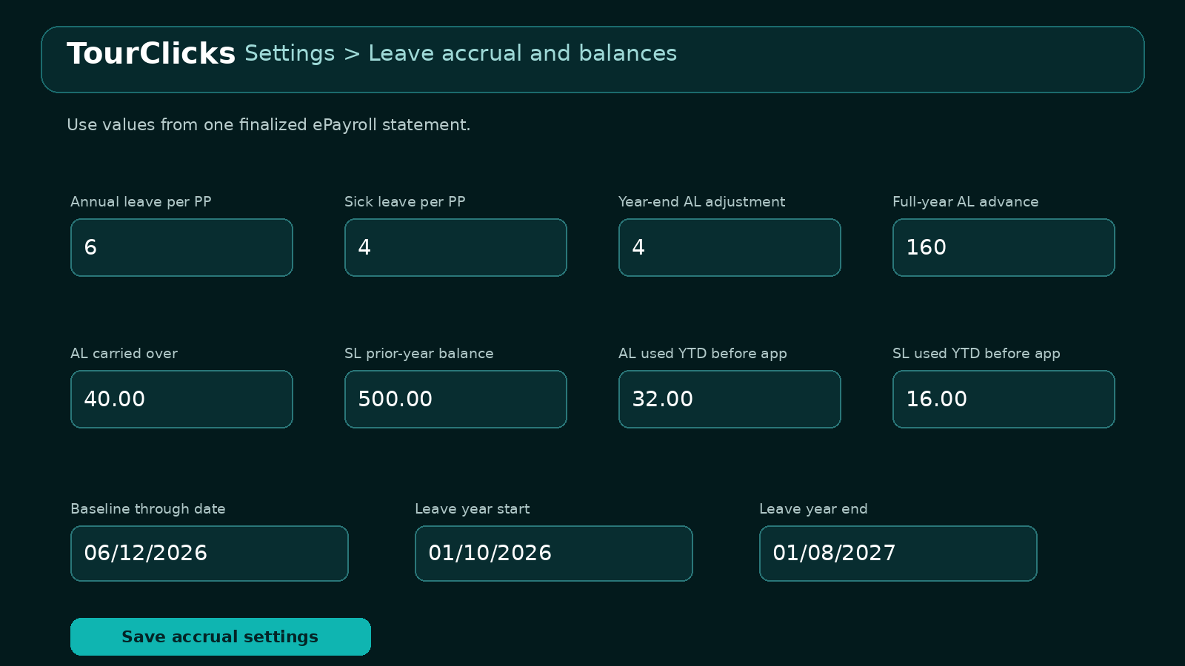
Figure 6. Fictional Category 6 example. Replace every value with your own official components.
TourClicks field | Official source | Entry rule
Annual leave per full pay period | AL CAT | Typical full-time values are 4, 6, or 8. Use the statement.
Sick leave per full pay period | SL CAT | Typical full-time value is 4. Verify status.
Year-end annual adjustment | Category rule | Use 4 for the standard full-time Category 6 pattern; 0 for Category 4 or 8.
Full-year annual leave advance | Annual entitlement | Typical full-time totals are 104, 160, or 208. Do not copy only the remaining AL ADVANCED.
AL carried over from prior year | AL PRIOR YR BAL | Do not use AVAIL AL BAL.
SL prior-year balance | SL PRIOR YR BAL | Copy the prior-year component.
AL used YTD before app tracking | AL USED YTD | Enter once from the same statement.
SL used YTD before app tracking | SL USED YTD | Enter once from the same statement.
Baseline through date | Statement pay-period end | Use the Friday cutoff date.
Leave year start/end | USPS annual chart | For 2026: Jan 10, 2026 through Jan 8, 2027.

Standard full-time accrual reference
Category | Creditable service | Accrual | 26-period total
4 | Less than 3 years | 4 hours per full PP | 104 hours
6 | 3 to less than 15 years | 6 hours per full PP plus 4 in last full PP | 160 hours
8 | 15 years or more | 8 hours per full PP | 208 hours
Sick leave | Full-time | 4 hours per full PP | 104 hours

Source: ELM 512 Annual Leave
Source: ELM 513 Sick Leave
Part-time and special cases: Part-time accrual can depend on pay-status hours. LWOP, status changes, corrections, rural leave units, or other adjustments can change the result. Keep the official statement as the controlling record.

Fictional Category 6 example
Assume one finalized statement covers the pay period ending Friday, June 12, 2026. The statement shows AL CAT 6, AL PRIOR YR BAL 40, AL USED YTD 32, SL CAT 4, SL PRIOR YR BAL 500, and SL USED YTD 16.
TourClicks field | Fictional value
AL per full PP | 6
SL per full PP | 4
Year-end AL adjustment | 4
Full-year AL advance | 160
AL carried over | 40
SL prior-year balance | 500
AL used YTD baseline | 32
SL used YTD baseline | 16
Baseline through date | June 12, 2026
Leave-year dates | Jan 10, 2026 to Jan 8, 2027

Prevent double counting
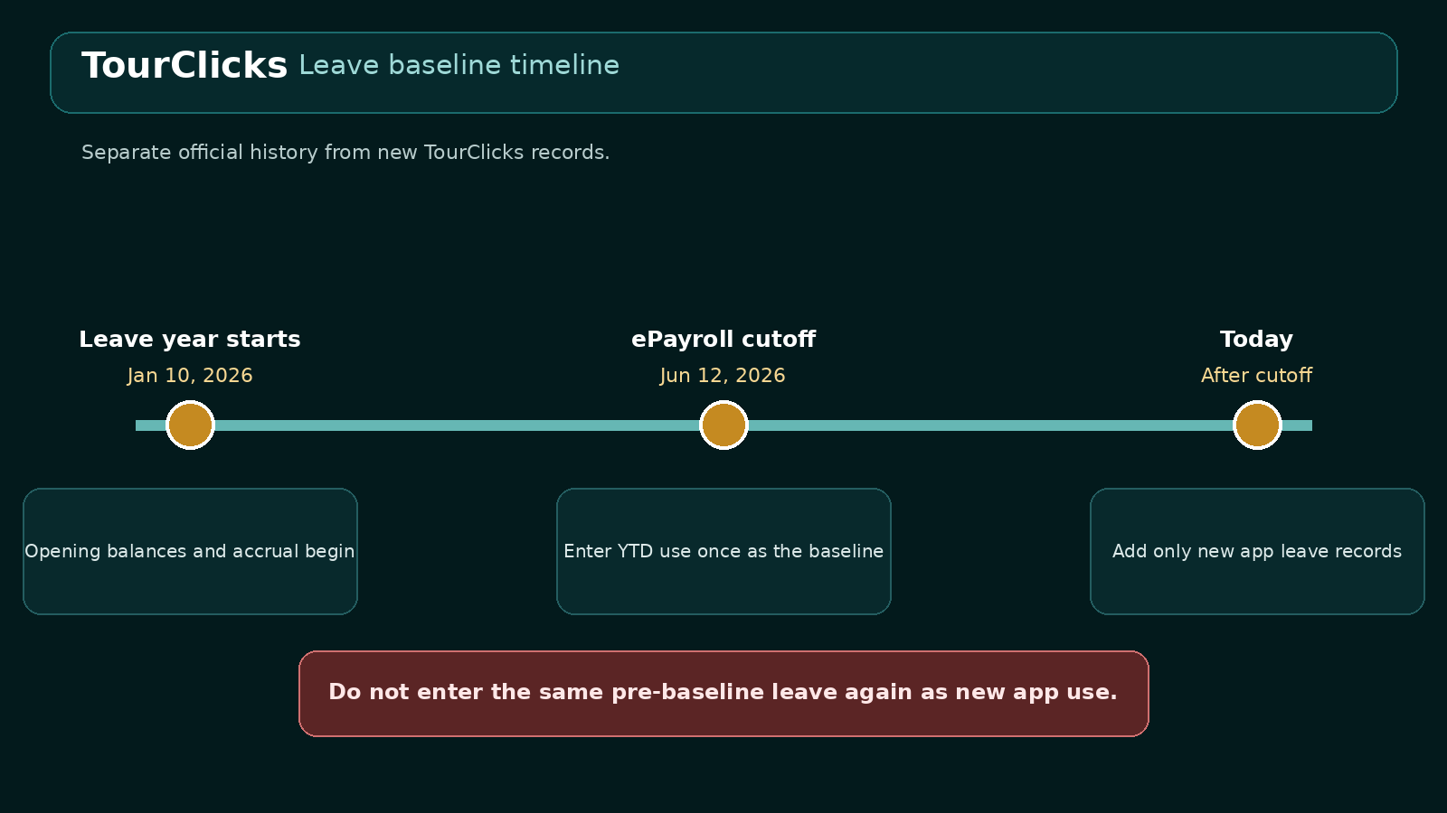
Figure 7. Official YTD values cover history through the baseline date.
- AL USED YTD and SL USED YTD already include official use through the selected statement period.
- Enter each YTD total once as baseline use.
- TourClicks adds leave records dated after the baseline.
- Do not recreate earlier leave as new use unless you verify that the baseline will not count it again.
- Do not put AVAIL AL BAL into AL carried over from prior year.
- Do not copy only the remaining AL ADVANCED into the full-year advance field.

Reconcile after saving
- Save the accrual settings.
- Open Leave/FMLA and review the Annual Leave and Sick Leave breakdown panels.
- Compare equivalent components and dates with the finalized statement.
- If the difference is large, recheck the baseline date, prior-year balances, category rates, advance, YTD use, holiday credits, and duplicate app entries.
- If correct entries still differ, record the adjustment and follow the official statement.
PART 4

Optional settings

Employee and installation profile
Profile information supports report headers. It is not required for daily time entry.
Field group | Suggested source | Privacy choice
Name and preferred report identity | Your own records | Enter only if needed
EIN | Official personnel or payroll record | Optional and sensitive; shareable reports omit it
Craft, position, level, step | PS Form 50 or eOPF | Optional
Installation, unit, city, state | PS Form 50, assignment, or local record | Optional
Finance number | Official payroll or facility record | Optional

Privacy: Leave the EIN blank unless it serves a real purpose. Preview a report in shareable mode before sending it.

FMLA case setup
Create a case only when it applies. Use the official designation or approval notice as the source.
- Use a neutral case label.
- Enter the expiration date and renewal warning when documented.
- Enter the case or reference number only when useful.
- Copy approved frequency or case limits without unnecessary medical details.
- TourClicks records usage. It does not approve, certify, renew, or submit FMLA.

Holiday and designated-holiday records
- Use the official USPS calendar for the actual holiday date.
- Confirm the designated holiday from the posted schedule, local agreement, or official instruction.
- Treat built-in suggestions as starting points, not final determinations.
- Record assignment facts and evidence when they matter.

Premium calculation settings
Enter a penalty-overtime exclusion window only when you have an official source or trusted contract guidance. Leave both dates blank when the period is unknown. TourClicks estimates do not replace payroll or contractual determinations.

Optional-setting check
[ ] Every optional value has an official or trusted source.
[ ] I left unknown dates and identifiers blank.
[ ] I removed unnecessary medical details from case notes.
[ ] I previewed a shareable report before sending it.
[ ] I exported a backup after finishing these changes.
PART 5

Verify and maintain the setup

Final setup checklist
[ ] My weekly template follows Saturday through Friday and matches my normal schedule.
[ ] My fixed nonscheduled days are marked correctly.
[ ] A known date displays the correct PP-WK and pay-period range.
[ ] I used the first Saturday of Week 1 as the anchor, not the payday.
[ ] My leave values came from one finalized statement, or I intentionally skipped leave setup.
[ ] My baseline-through date is the Friday ending that statement's pay period.
[ ] I did not place AVAIL AL BAL in the carried-over field.
[ ] I checked whether Category 6 needs the 4-hour year-end adjustment.
[ ] I understand that part-time, LWOP, status changes, and adjustments may require reconciliation.
[ ] My profile contains only information I need.
[ ] My FMLA record contains no unnecessary medical narrative.
[ ] I entered and reviewed one test day.
[ ] I exported a backup and stored it separately.

Troubleshooting
Symptom | Likely cause | What to check
PP is one or two weeks wrong | Payday, Sunday, or Week 2 used as anchor | Use the first Saturday of Week 1 from the official chart
AL balance is much too high | Current available balance treated as opening value; advance or accrual counted twice | Recheck AL PRIOR YR BAL, full-year advance, rate, YTD use, and baseline
Leave changes before baseline | Historical app entries overlap official YTD use | Correct the baseline or remove duplicate historical use
Category 6 total is four hours short | Year-end adjustment is missing | Verify the rule and enter 4 when applicable
Only one schedule date is wrong | That date is an exception to the template | Use Today and select Changed schedule or another day status

Troubleshooting - continued
Symptom | Likely cause | What to check
Suggested punches show no totals | Suggestions are not saved punches | Enter or stamp the needed BT, OL, IL, and ET
Worked time or lunch is wrong | OL or IL missing, reversed, or entered in wrong format | Check both lunch punches and clock-time versus hundredths
Browser records disappear | Browser profile or site storage changed | Restore the newest trusted export
Report shows private details | Private profile fields included | Use shareable mode and preview before sending
Projection differs from payroll | LWOP, part-time accrual, correction, or other adjustment | Follow the official record and document the difference

Routine maintenance
When | Action
Each workday | Record punches, status changes, leave, and useful notes
Each pay period | Compare selected days with Virtual Timecard and review missing punches
After finalized ePayroll | Compare leave components and record any official adjustment
After major changes | Export a new backup
New pay year | Add the official PP01 Week 1 anchor and pay-period count
New leave year | Update leave-year dates and verify opening components
Before sharing | Preview report privacy and remove unnecessary identifiers

Best usability habit: Change one section at a time, save it, verify one known record, and export before moving to the next major change.

APPENDIX A

2026 pay-period quick reference
TourClicks uses the start date in this table. The pay date is included only for comparison. PP01-2026 starts in December 2025.
PP | Start Saturday | End Friday | Pay date
01 | Dec 13, 2025 | Dec 26, 2025 | Jan 2, 2026
02 | Dec 27, 2025 | Jan 9, 2026 | Jan 16, 2026
03 | Jan 10, 2026 | Jan 23, 2026 | Jan 30, 2026
04 | Jan 24, 2026 | Feb 6, 2026 | Feb 13, 2026
05 | Feb 7, 2026 | Feb 20, 2026 | Feb 27, 2026
06 | Feb 21, 2026 | Mar 6, 2026 | Mar 13, 2026
07 | Mar 7, 2026 | Mar 20, 2026 | Mar 27, 2026
08 | Mar 21, 2026 | Apr 3, 2026 | Apr 10, 2026
09 | Apr 4, 2026 | Apr 17, 2026 | Apr 24, 2026
10 | Apr 18, 2026 | May 1, 2026 | May 8, 2026
11 | May 2, 2026 | May 15, 2026 | May 22, 2026
12 | May 16, 2026 | May 29, 2026 | Jun 5, 2026
13 | May 30, 2026 | Jun 12, 2026 | Jun 18, 2026

2026 pay-period quick reference - continued
PP | Start Saturday | End Friday | Pay date
14 | Jun 13, 2026 | Jun 26, 2026 | Jul 3, 2026
15 | Jun 27, 2026 | Jul 10, 2026 | Jul 17, 2026
16 | Jul 11, 2026 | Jul 24, 2026 | Jul 31, 2026
17 | Jul 25, 2026 | Aug 7, 2026 | Aug 14, 2026
18 | Aug 8, 2026 | Aug 21, 2026 | Aug 28, 2026
19 | Aug 22, 2026 | Sep 4, 2026 | Sep 11, 2026
20 | Sep 5, 2026 | Sep 18, 2026 | Sep 25, 2026
21 | Sep 19, 2026 | Oct 2, 2026 | Oct 9, 2026
22 | Oct 3, 2026 | Oct 16, 2026 | Oct 23, 2026
23 | Oct 17, 2026 | Oct 30, 2026 | Nov 6, 2026
24 | Oct 31, 2026 | Nov 13, 2026 | Nov 20, 2026
25 | Nov 14, 2026 | Nov 27, 2026 | Dec 4, 2026
26 | Nov 28, 2026 | Dec 11, 2026 | Dec 18, 2026
27 | Dec 12, 2026 | Dec 25, 2026 | Dec 31, 2026

Source: USPS 2026 Pay Dates and Leave Year
APPENDIX B

Printable setup worksheet

Weekly schedule source
Official or local source: ______________________________________________
Day | NS day | Begin Tour | End Tour | Lunch
Saturday | [ ] | ________ | ________ | ______
Sunday | [ ] | ________ | ________ | ______
Monday | [ ] | ________ | ________ | ______
Tuesday | [ ] | ________ | ________ | ______
Wednesday | [ ] | ________ | ________ | ______
Thursday | [ ] | ________ | ________ | ______
Friday | [ ] | ________ | ________ | ______

Pay-period anchor
Pay year | Anchor PP | Week 1 start | Periods
________ | ________ | ____________ | ________

Leave statement identification
Statement PP | Period end Friday | Leave year start | Leave year end
________ | ____________ | ____________ | ____________

Leave components
Component | Value
AL CAT | ________
SL CAT | ________
AL PRIOR YR BAL | ________
SL PRIOR YR BAL | ________
AL USED YTD | ________
SL USED YTD | ________
Full-year AL advance | ________
Year-end AL adjustment | ________

[ ] Verified known PP-WK date
[ ] Verified one test day
[ ] Previewed report privacy
[ ] Exported first backup
APPENDIX C

Sources and product links
TourClicks live web app
https://ausuba3d.github.io/TourClicks/
TourClicks public repository
https://github.com/Ausuba3D/TourClicks
USPS 2026 Pay Dates and Leave Year
https://about.usps.com/postal-bulletin/2025/pb22692/html/info_002.htm
USPS Earnings Statement Redesign of Leave Sections
https://about.usps.com/postal-bulletin/2017/pb22461/html/info_002.htm
ELM 512 Annual Leave
https://about.usps.com/manuals/elm/html/elmc5_002.htm
ELM 513 Sick Leave
https://about.usps.com/manuals/elm/html/elmc5_003.htm

Sources and product links - continued
USPS Virtual Timecard
https://news.usps.com/2019/10/23/its-about-time/
USPS ePayroll access
https://news.usps.com/2019/10/29/show-me-the-money/
USPS Official Personnel Folder and eOPF
https://about.usps.com/manuals/elm/html/elmc3_016.htm
USPS eLRA
https://news.usps.com/2019/10/21/unscheduled-leave/

Scope
TourClicks is an independent Ausuba3D project. It is not affiliated with or endorsed by USPS or any labor union. App calculations and projections support personal recordkeeping and must be compared with official records.

