${titleKind} Report
District | ${District} |  |  |  | Time |  | ${Time}
ID |  | ChildAreaName | Drought(proportion)
 |  | ChildAreaName | Moist | Normal |  | LightDrought |  | Middling | Heavy
${drought.code} |  | ${drought.name} | ${drought.moist} | ${drought.normal} |  | ${drought.lightdrought} |  | ${drought.middling} | ${drought.heavy}
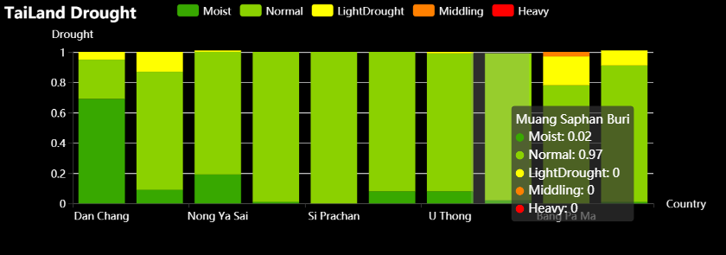

Spatial Distribution Map
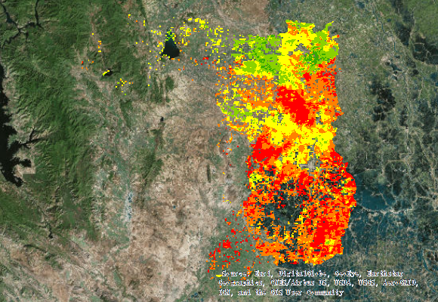
Legend | 