${titleKind} Report
District | ${District} |  | Time | ${Time}
ID |  | ChildAreaName |  |  | Yield(ton)
${yield.code} |  | ${yield.name} |  |  | ${yield.value}
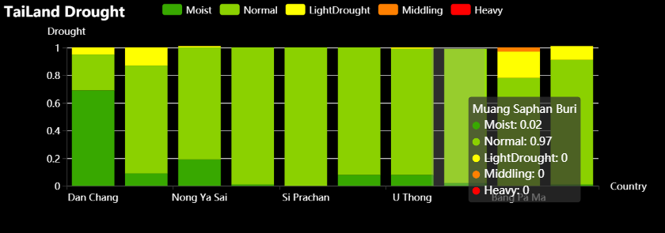

Spatial Distribution Map
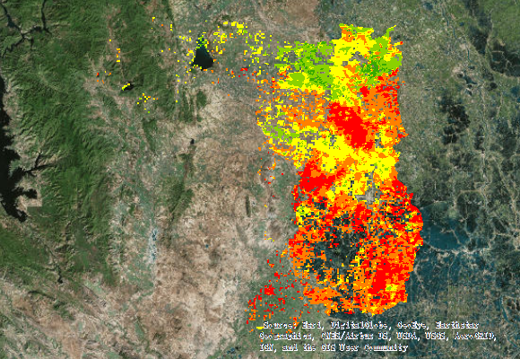
Legend | 