${titleKind} Report
District | ${District} |  | Time | ${Time}
ID |  | ChildAreaName |  |  | Acreage(rai)
${area.code} |  | ${area.name} |  |  | ${area.value}
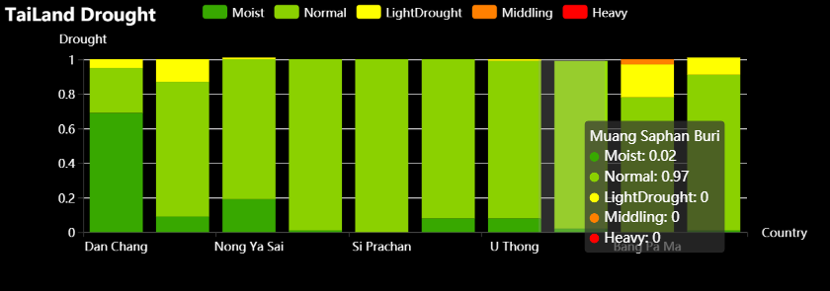

Spatial Distribution Map
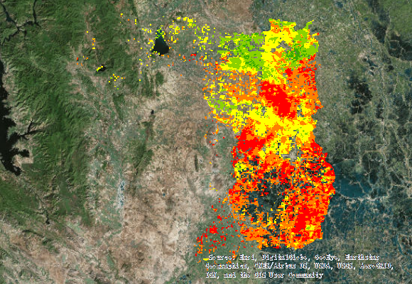
Legend | 