**Java – Document**

## **Sample-Code-Java**

### 9.Issue.1 Sample Code throwing exception

#### Cause of the issue

To run the sample app with java 11 but getting below error. Any help in this regard is appreciated.

Task :ChargeCreditCard.main()  
Exception in thread "main" java.lang.NoClassDefFoundError: javax/xml/bind/JAXBException  
at net.authorize.util.HttpUtility.postData(HttpUtility.java:101)  
at net.authorize.api.controller.base.ApiOperationBase.execute(ApiOperationBase.java:145)  
at net.authorize.api.controller.base.ApiOperationBase.execute(ApiOperationBase.java:133)  
at net.authorize.sample.PaymentTransactions.ChargeCreditCard.run(ChargeCreditCard.java:56)  
at net.authorize.sample.PaymentTransactions.ChargeCreditCard.main(ChargeCreditCard.java:15)  
Caused by: java.lang.ClassNotFoundException: javax.xml.bind.JAXBException  
at java.base/jdk.internal.loader.BuiltinClassLoader.loadClass(BuiltinClassLoader.java:581)  
at java.base/jdk.internal.loader.ClassLoaders$AppClassLoader.loadClass(ClassLoaders.java:178)  
Caused by: java.lang.ClassNotFoundException: javax.xml.bind.JAXBException  
at java.bas

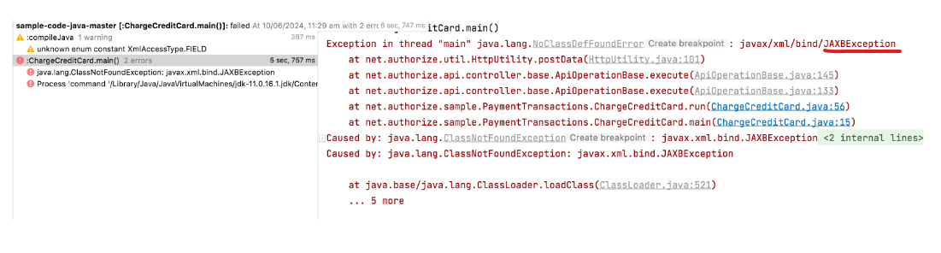

#### Proposed solution

I checked and tested with the multiple environments but it's fixed in the JAXBException in latest Version (future-alternate). I checked with Gabriel, and hence it is closing the issue ticket.

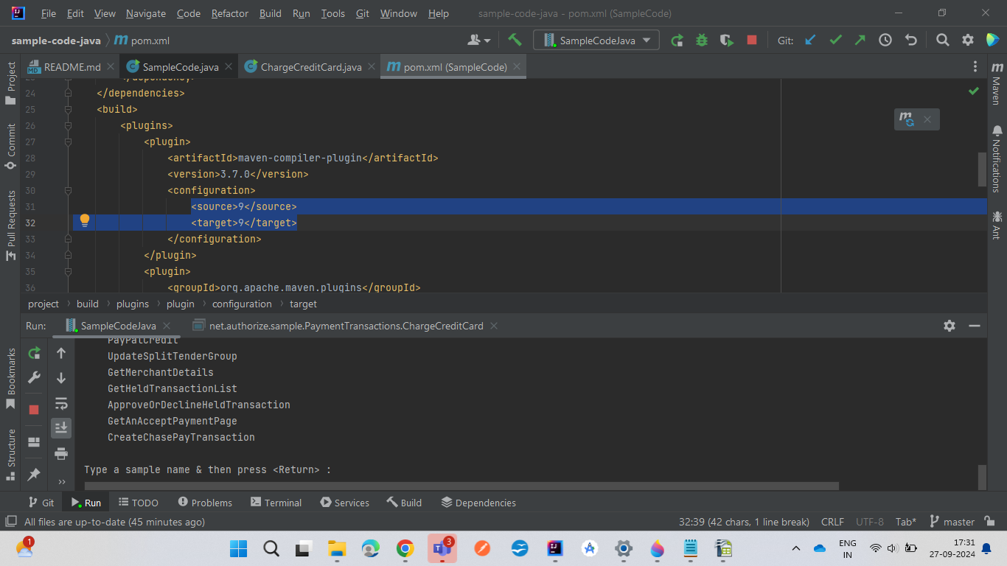

### 9.Issue.2 How to run this code into Android Studio? #96

#### Cause of the issue

<https://github.com/AuthorizeNet/sample-code-java/issues/96>

#### Proposed solution

Discussed and confirmed with Gabriel

From my understanding, to checked with Android SDK Ide and a jar file will work similar to an aar file and I have imported to java jar directly into Android Studio. However, it needs to be Android code, that is, it has to have some form of UI that will be visible to the user. Android OS does not support commandline output, because there is no commandline. You cannot run the commandline sample codes on Android because of this reason.

### 9.Issue.3 How to Set Trail Day in Java

#### Cause of the issue

<https://github.com/AuthorizeNet/sample-code-java/issues/92>

There are only Two parameter  
1.setTrialAmount(Transaction.ZERO_AMOUNT);  
2.setTrialOccurrences(1);  
No Trail Period in authoize.net

#### Proposed solution

Discussed and confirmed with Gabriel that, the mentioned issue is How to Set trial day / trial period, it is updated the year (startDate.setYear(2032) ;) in latest version. Hence it is closing the issue ticket.

### 9.Issue.4 Lack of liability shift example or incorrect example #73

### Cause of the issue

<https://github.com/AuthorizeNet/sample-code-java/issues/73>

The examples listed here for posting a previously authorized transaction via another channel are incorrect. The fields in the type CcAuthenticationType are required for a liability shift. Refer to this guide for more details: <https://community.developer.authorize.net/t5/The-Authorize-Net-Developer-Blog/Using-CardinalCommerce-with-Authorize-Net/ba-p/61267>

#### Proposed solution

Discussed and confirmed with Gabriel that, the field "ccAuthenticationType" is not defined in the API specification. It may be available in the SOAP request to the processor. But it is not present in the ANET API request. Only the API Team will be able to tell us which existing field this corresponds to OR to create a new field for this. There is nothing I can do on this issue.

Sep 19- Done Dipesh mentioned these CcAuthenticationType to check. We discussed and confirmed with Gabriel, and he is given the solution **CcAuthenticationType is deprecated and cannot be used it is referenced.**

**Java – Document**

## **Sdk-Java**

### 10.Issue.16 Error with Accept hosted page (sandbox environment) #162

#### Cause of the issue

<https://github.com/AuthorizeNet/sdk-java/issues/162>

* We use authorize.net Java SDK, latest version 2.0.1. Using JDK 11 (not 8) on Windows 10 (also confirmed this on Linux).
* But running into what appears to be a bug (or we are doing something wrong).
* We get a failed (with errors), Order Summary page in the sandbox environment  
  *if* the return URL that has more than one query parameters (delimited by &)
* If we specifiy just 1 query parameter in the return URL, the hosted page seem to work with no problem (we get the Order summary screen, can enter cc number and click continue).
* We posted this on developer forum 3 weeks ago, but did not get any guidance/replies.  
  (with screen shots of the error page, as well as the values in the debugger session)
* The errors in the Hosted page can be seen in the attached image

The errors are:

SyntaxError: "" string literal contains an unescaped line break

ERROR ReferenceError: "g_errorPanelMessage is not defined"

ERROR TypeError: "this.paymentProfileList" is undefined

#### Proposed solution

I have checked the multiple environments, it's getting the expected response token hence it is closing the issue ticket.

Test Proof

I tried to debug the GetAcceptCustomerProfilePage and to set tthe setting.setSettingValue the Ampersands URL in Hot code ( setting.setSettingValue("http://1.1.1.1/submitPayment?orderID=2540&orderAmount=13.99&submitPaymentID=4a11f608-4196-4365-929e-9e01c5fa975d") ;)

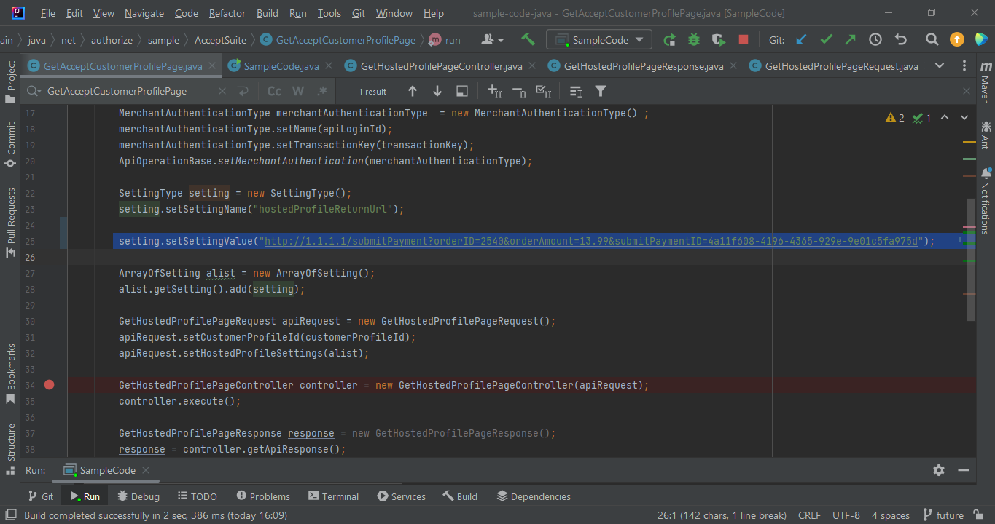

* In the code base checked on these page GetHostedProfilePageController, GetHostedProfilePageResponse, GetHostedProfilePageRequest.
* I checked the &(Ampersands ) URL I got some response token Is encode.
* Then I check to change the &(Ampersands ) to %26 and that one is also got the encode token correctly is Working.
* I checked the &(Ampersands ) URL I got some response token Is encode. 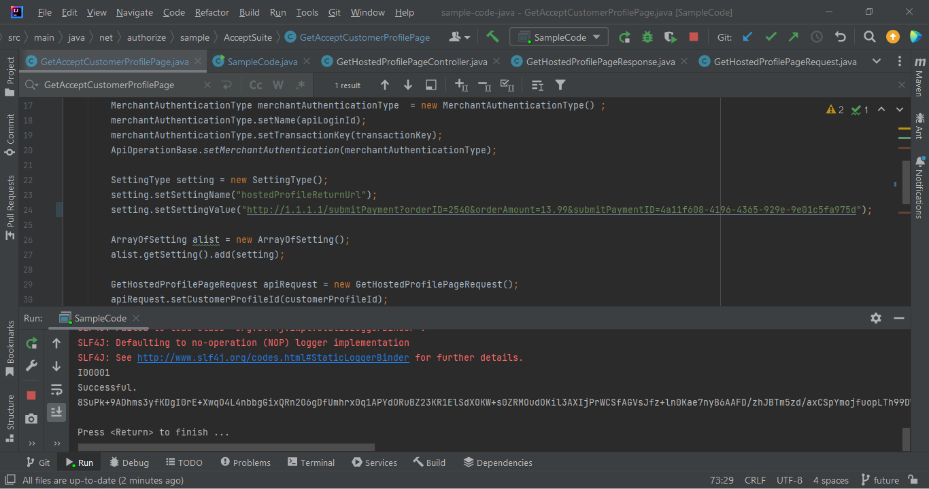
* Then I check to change the &(Ampersands ) to %26 and that one is also got the encode token correctly is Working.
* 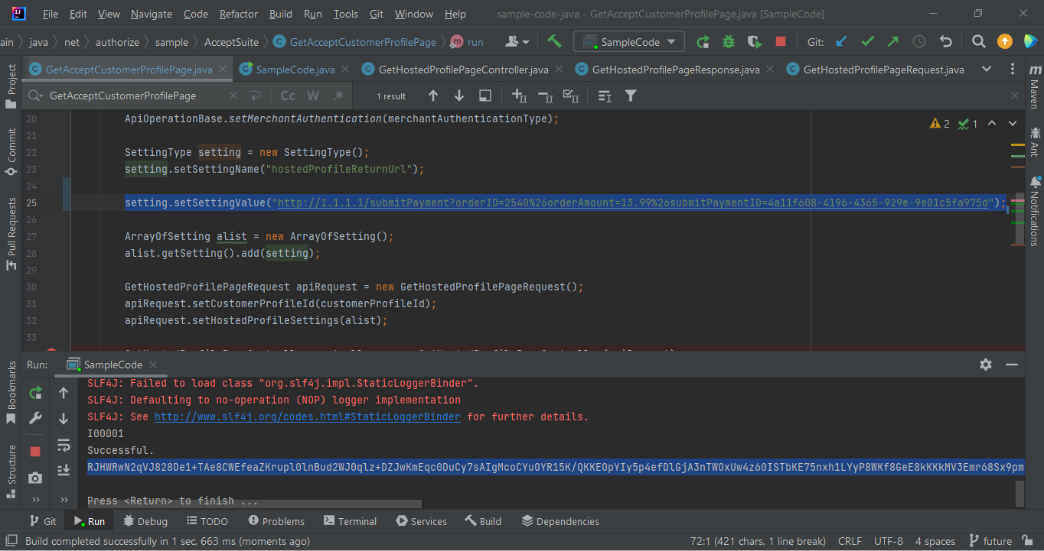
* I checked and tested with the multiple environments but it's fixed in the URL is encoded in latest Version (future-alternate). I checked with Gabriel, and hence it is closing the issue ticket.

### 10.Issue.1 Need way to support multiple Merchant Authentication credentials in one application #160

#### Cause of the issue

<https://github.com/AuthorizeNet/sdk-java/issues/162>

I'm running into an issue that we can not configure multiple merchant authentication details because ApiOperationBase declares the MerchantAuthenticationType as static. It seems that it behaves this way as "convenience" so that every request object doesn't need have them set, but in my case I need it to be composed in the object rather than declared static.

The only other solution I can come up with for using this SDK for our application would be to synchronize the set of ApiOperationBase.setMerchantAuthentication(), request creation, and request sending all in one block, which would greatly bottleneck the application.

Is there another way you would suggest handling this use case?

Thanks so much for your time and a timely response would be much appreciated.

#### Proposed solution

As per the discussion with Gabriel we understood that this is a complicated issue which needs thinking and redesign. Multithread concept will not work here since they have used singleton design. If we try any suggested changes the code will break. The issue is in design level. hence it is closing the issue ticket.

### 10.Issue.6 Ampersands in URLs break the Accept Hosted Payment Form #180

#### Cause of the issue

<https://github.com/AuthorizeNet/sdk-java/issues/180>

We are using ampersands in our cancel URL and submit URL and the payment form is failing to load! We need to build a URL with multiple GET parameters to have proper security with the cancel and submission of orders on our website. Which means we need use ampersands to divide up our parameters. The problem is if we pass an ampersand at all to the hostedPaymentReturnOptions the entire payment form fails to load. There are no errors in the logs. It just only draws the words "Order Summary" and nothing else. If we remove the ampersands everything works correctly.

We are using the AcceptHosted API solution.

SettingType returnSettings = new SettingType();  
returnSettings.setSettingName("hostedPaymentReturnOptions");  
  
JSONObject returnSettingsJSON = new JSONObject();  
  
returnSettingsJSON.put("url", "<http://1.1.1.1/submitPayment?orderID=2540&orderAmount=13.99&submitPaymentID=4a11f608-4196-4365-929e->9e01c5fa975d");  
returnSettingsJSON.put("urlText", "Complete Order" );  
returnSettingsJSON.put("cancelUrl", "<http://1.1.1.1/clearPayment?orderID=2540&cancelPaymentID=459b4c8b-e257-4d02-84e3-5>f0965b16b81" );  
returnSettingsJSON.put("cancelUrlText", "Cancel Order" );  
  
returnSettings.setSettingValue( returnSettingsJSON.toString() );

#### Proposed solution

I have checked the multiple environments, it's getting the expected response token hence it is closing the issue ticket.

Test Proof

I tried to debug the GetAcceptCustomerProfilePage and to set tthe setting.setSettingValue the Ampersands URL in Hot code ( setting.setSettingValue("http://1.1.1.1/submitPayment?orderID=2540&orderAmount=13.99&submitPaymentID=4a11f608-4196-4365-929e-9e01c5fa975d") ;)



* In the code base checked on these page GetHostedProfilePageController, GetHostedProfilePageResponse, GetHostedProfilePageRequest.
* I checked the &(Ampersands ) URL I got some response token Is encode.
* Then I check to change the &(Ampersands ) to %26 and that one is also got the encode token correctly is Working.
* I checked the &(Ampersands ) URL I got some response token Is encode. 
* Then I check to change the &(Ampersands ) to %26 and that one is also got the encode token correctly is Working.
* 
* I checked and tested with the multiple environments but it's fixed in the URL is encoded in latest Version (future-alternate). I checked with Gabriel, and hence it is closing the issue ticket.

### 10.Issue.15 Environment not set. Set environment using setter or use overloaded method to pass appropriate environment #163

#### Cause of the issue

* [**https://github.com/AuthorizeNet/sdk-java/issues/163**](https://github.com/AuthorizeNet/sdk-java/issues/163)
* According to the issue description they are getting below error while debugging the controller object.

"Environment not set. Set environment using setter or use overloaded method to pass appropriate environment"

* As per our analysis, This message is populating in the debug console as a message only not any kind of error message.

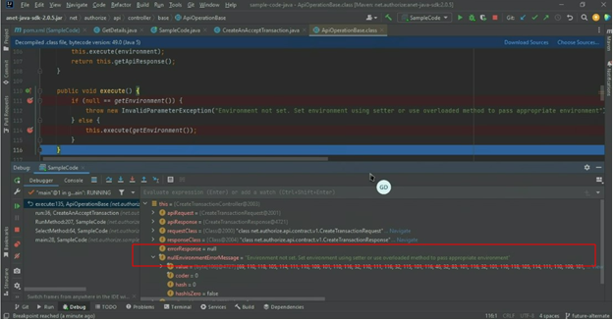

And the environment setup happening properly.

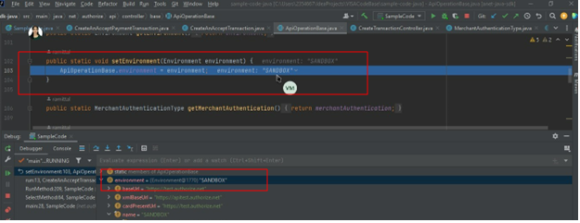

### Proposed solution

* Changed the “nullEnvironmentErrorMessage” as a constant to avoid confusion, hence we can ensure that the mentioned message will not visible in the debug console.
* Files changed - ApiOperationBase.java

Constants.java

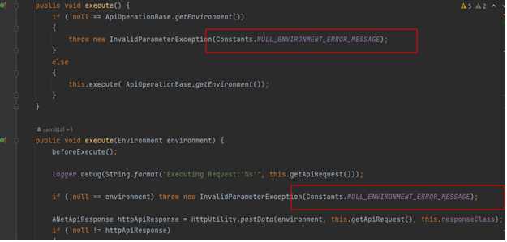

* Code Changes: <https://github.com/AuthorizeNet/sdk-java/pull/216/commits/42006ddc6056985ea1715907b06b2a742fe5a507>

## 10.Issue.13 Logging Sensitive Data section is outdated in README.md #171.

### Cause of the issue

* [**https://github.com/AuthorizeNet/sdk-java/issues/171**](https://github.com/AuthorizeNet/sdk-java/issues/171)
* README file is outdated after the switch to Log4j .
* Link to log4j.properties is broken as well.

### Proposed solution

* Gabriel Updated the README File Logging-Sensitive-data section. <https://github.com/AuthorizeNet/sdk-java#logging-sensitive-data>

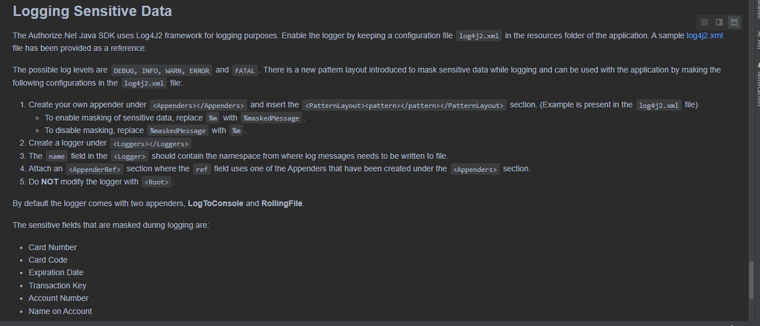

## 10.Issue.12"Defaulting to non-proxy environment" log warning #172

### Cause of the issue

* <https://github.com/AuthorizeNet/sdk-java/issues/172>
* Issue regarding WARN Message.
* Requirement is , message should be an INFO rather than a WARN.
* We are not sure why this complaint is raised for this.
* 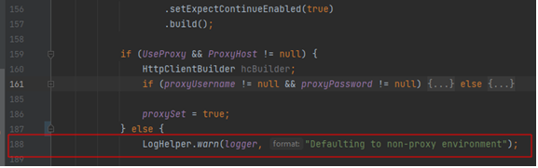

### Proposed solution

* As per the discussion no need to change the WARN into an INFO. It must be a WARN message only.
* Changed the condition for reaching the WARN message. Because If UseProxy is TRUE, In that scenario only we need to send this WARN message.
* Below mentioned are the scenarios. 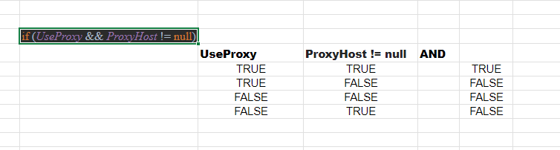If UseProxy is TRUE, In that scenario only we need to send this WARN message.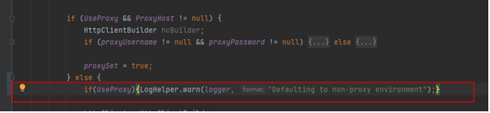
* Code changes: <https://github.com/AuthorizeNet/sdk-java/pull/216/commits/bd40452a9ed96166104a1f06aa8b718caa6c9acc>

## 10.Issue.2 - [The credit card number is invalid](https://github.com/AuthorizeNet/sdk-java/issues/207)

### Cause of the issue

* [The credit card number is invalid · Issue #207 · AuthorizeNet/sdk-java · GitHub](https://github.com/AuthorizeNet/sdk-java/issues/207)

Enter the correct credit card number and password, but the API returns an error？

visa pay response:{"messages":{"message": [ {"code":"I00001","text":"Successful."}],"resultCode":"OK"},"transactionResponse":{"accountNumber":"XXXX3631","accountType":"MasterCard","authCode":"","avsResultCode":"P","cavvResultCode":"","cvvResultCode":"P","errors":{"error":[{"errorCode":"37","errorText":"The credit card number is invalid."}]},"refTransID":"","responseCode":"2","testRequest":"0","transHash":"","transHashSha2":"","transId":"63892322261"}}

#### **Unable to Reproduce:**

We are Getting Error code as 6 and as not as 37

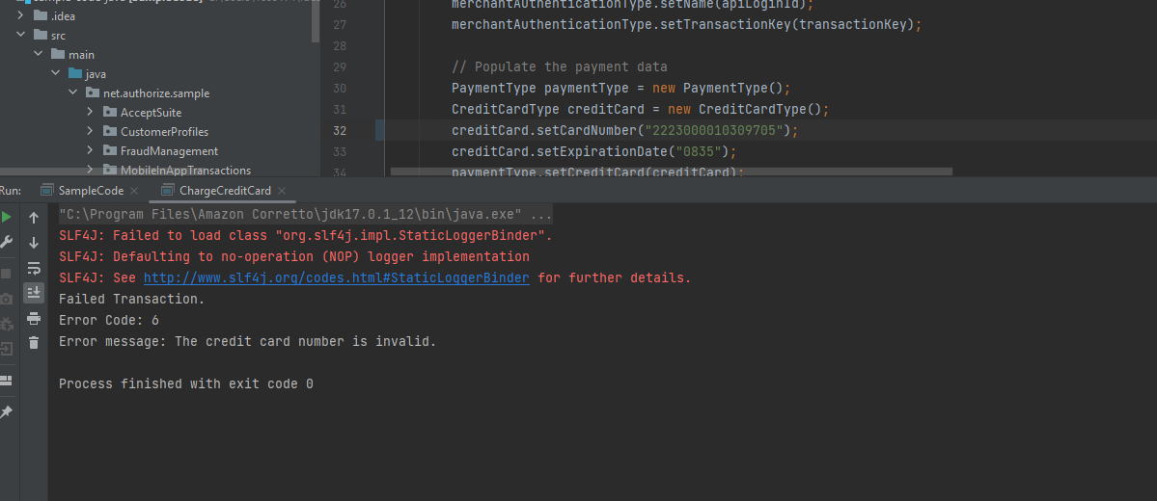

### Proposed solution:

As per Gaberial This Issue Might Occur Based on Merchant also We don't know the Exact Scenario

So we are Unable to Reproduce(Tested with all Test Accounts 4111111111111111, 5424000000000015 ,etc..), we are getting Response as 6 only ,So we can Close this Issue.

## 10.Issue.4 - [Junit being pulled in as transitive dependency in compile scope](https://github.com/AuthorizeNet/sdk-java/issues/188)

### Cause of the issue

* [Cannot found any dependency for create Customer Profiles in Android Studio? · Issue #182 · AuthorizeNet/sdk-java · GitHub](https://github.com/AuthorizeNet/sdk-java/issues/182)

log4j-1.2-api and log4j-api are pulling JUnit in as a transitive dependency in the compile scope. This causes a problem for me as the version of JUnit pulled in has security & license issues that prevent it being deployed in my env.

Since JUnit shouldn't be in the compile scope anyway, and this SDK already explicitly pulls JUnit in to the testscope, we should exclude JUnit from the log4j-1.2-api and log4j-api dependencies

### Proposed solution

Fix is Already Provided : [Exclude junit from compile scope (fixes #188) by SalesforceBrian · Pull Request #189 · AuthorizeNet/sdk-java · GitHub](https://github.com/AuthorizeNet/sdk-java/pull/189)

## 10.Issue.5 - [Cannot found any dependency for create Customer Profiles in Android Studio? · Issue #182 · AuthorizeNet/sdk-java · GitHub](https://github.com/AuthorizeNet/sdk-java/issues/182)

### Cause of the issue

[Cannot found any dependency for create Customer Profiles in Android Studio? · Issue #182 · AuthorizeNet/sdk-java · GitHub](https://github.com/AuthorizeNet/sdk-java/issues/182)

I want to create customer profiles in Android studio but i could not found any dependencies to integrate the SDK.  
can you send me latest dependencies

Proposed solution

As per gaberial Comment it is Out of scope - So we can mark it as Done

From Gaberial -We do not have an Android SDK. From my understanding, a jar file will work similar to an aar file and can be imported directly into Android Studio. However, it needs to be Android code, that is, it has to have some form of UI that will be visible to the user. Android OS does not support commandline output, because there is no commandline. You cannot run the commandline sample codes on Android because of this reason.

## 10.issue.7 : [Inconsistent types for fields shared between subscription and transaction · Issue #178 · AuthorizeNet](https://github.com/AuthorizeNet/sdk-java/issues/178)

### Cause of the issue

<https://github.com/AuthorizeNet/sdk-java/issues/178>

We are looking to add a phone number to our requests to create subscriptions and transactions. I noticed an odd discrepancy between how phone numbers are stored on TransactionRequestType and ARBSubscriptionType.

[TransactionRequestType](https://github.com/AuthorizeNet/sdk-java/blob/d910e79dc7c18cae1e449a534dcbb2818bf023ad/src/main/java/net/authorize/api/contract/v1/TransactionRequestType.java#L147-L148) supports phoneNumber on it's billTo field of type [CustomerAddressType](https://github.com/AuthorizeNet/sdk-java/blob/d910e79dc7c18cae1e449a534dcbb2818bf023ad/src/main/java/net/authorize/api/contract/v1/CustomerAddressType.java#L63).

However,

[ARBSubscriptionType](https://github.com/AuthorizeNet/sdk-java/blob/d910e79dc7c18cae1e449a534dcbb2818bf023ad/src/main/java/net/authorize/api/contract/v1/ARBSubscriptionType.java#L86-L87) does not use that same type for it's billTo field. It instead uses [NameAndAddressType](https://github.com/AuthorizeNet/sdk-java/blob/d910e79dc7c18cae1e449a534dcbb2818bf023ad/src/main/java/net/authorize/api/contract/v1/NameAndAddressType.java#L105) which does not support a phoneNumber field. It does have a customer field of [CustomerType](https://github.com/AuthorizeNet/sdk-java/blob/d910e79dc7c18cae1e449a534dcbb2818bf023ad/src/main/java/net/authorize/api/contract/v1/CustomerType.java#L83) which supports a phoneNumber.

But,

TransactionRequestType's customer field uses [CustomerDataType](https://github.com/AuthorizeNet/sdk-java/blob/d910e79dc7c18cae1e449a534dcbb2818bf023ad/src/main/java/net/authorize/api/contract/v1/CustomerDataType.java#L67) which inexplicably does not have a phoneNumber field.

This is somewhat confusing and inconsistent. I'm not sure if this is by design or something was typed incorrectly.

Since CustomerAddressType extends the NameAndAddressType I would propose changing the ARBSubscriptionType billTo field to CustomerAddressType

or change the customer field on TransactionRequestType from CustomerDataType to CustomerType since the latter supports all of the formers fields as well as adding two new ones.

### Proposed solution

Comment From Gaberial - They are asking why the specification for these two structures is NOT the same. That is a question to the API team. They have to tell us why the API is treating these two structures differently. We cannot unilaterally make a change in the SDK until the API provides us with the correct specification (XSD). ---> Need to connect with API team or informed to Dipesh about this Business Issue

## 10.issue.8 - [How to use sdk-java in android. · Issue #177 · AuthorizeNet/sdk-java · GitHub](https://github.com/AuthorizeNet/sdk-java/issues/177)

### Cause of the issue

<https://github.com/AuthorizeNet/sdk-java/issues/177>

How to use sdk-java in android.

### Proposed solution

Comment From Gaberial -We do not have an Android SDK. From my understanding, a jar file will work similar to an aar file and can be imported directly into Android Studio. However, it needs to be Android code, that is, it has to have some form of UI that will be visible to the user. Android OS does not support commandline output, because there is no commandline. You cannot run the commandline sample codes on Android because of this reason.

## 10.issue.19 -Method uses soon to be depricated transHash

### Cause of the issue:

* [Method uses soon to be depricated transHash · Issue #154 · AuthorizeNet/sdk-java · GitHub](https://github.com/AuthorizeNet/sdk-java/issues/154)

**My main concern / question was this: Will our existing implementation break once transHash goes away** - we are not using this method ourselves, but I took a quick look at the code base here and it appears that at least one method isAuthorizeNet seems to rely on this transHash? **Taking that a step further, it appears that**createResult**relies on**isAuthorizeNet**, so I'm wondering if this isn't something that pretty soon is going to "break"?**

### Proposed solution

As per the official announcements, transHash (which uses MD5 based hashing) will be deprecated and a new field transHashSHA2 (based on SHA-512 based hash utilizing a Signature Key) has been made available