**JavaScript Documentation**

**8.Issue.9**  
**Authorize.net shows E00040 when Creating Subscription from Customer Profile #78  
  
link**: <https://github.com/AuthorizeNet/sdk-node/issues/78>  
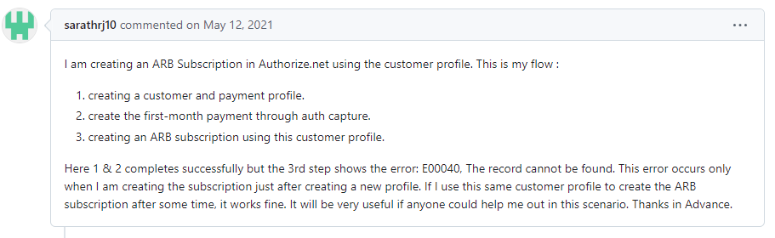  
**Explanation:**  
The error occurs due to sending back to back requests, it will take some time to replicate the data, to overcome this issue we should add some waiting time in between one request to other request.  
  
**Issue status:** **closed**.

**8.Issue.10**

**"networkTransId" is missing in response!! #75**

**Link:** <https://github.com/AuthorizeNet/sdk-node/issues/75>

**Explanation:**  
the person who raised this issue have shared issue link which doesn’t exist anymore. With this info we are closing this issue  
  
**Issue status:** **closed**.

**8.Issue.12**

**The transaction takes to long! #70**

Link: [https://github.com/AuthorizeNet/sdk-node/issues/70](issue,s://github.com/AuthorizeNet/sdk-node/issues/70)  
  
**Explanation:**  
The error occurs due to sending back-to-back requests, it will take some time to replicate the data, to overcome this issue we should add some waiting time in between one request to other request.

**Issue status:** **closed**.

**8.Issue.13**

**Why the execute function on APIOperationBase class does not return the response? #69**

Link: <https://github.com/AuthorizeNet/sdk-node/issues/69>  
  
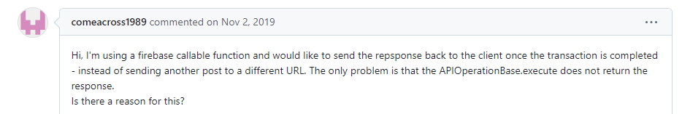

Customer stating that promise is not used properly and he don’t want to wait for callback, he wants ctrl.execute() to return a promise.

**Explanation:**

When the execute function is called it performs line by line operations, when it reaches axios.request it will creates new child thread and performs separate operation and main thread will continue.

The separate child thread performs operation and gives call back and this thread ends and gives control over to sample code  
  
Between these threads closing, getting started and ending of threads, it will take some time depending on the task.

for this axios is introduced, this issue is already covered.it is a promise chain and it should work with the latest patch ([github link](https://github.com/AuthorizeNet/sdk-node/commit/b04dfc5c06bf69d7d3906d2fb8bc46c63ff81d46)).

Reply comment for this issue:  
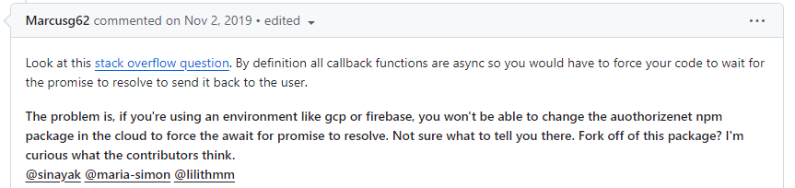

this is already asynchronous function, it doesn’t wait for customer to control or if customer wants output, he must wait for threads to complete and gives call back.  
  
For this issue the code needs redesign, as per Gabriel comments we are closing this issue.

**Issue status:** **closed**.

**8.Issue.14**

**Uncaught SyntaxError #68**

Link:  [https://github.com/AuthorizeNet/sdk-node/issues/68](%20https://github.com/AuthorizeNet/sdk-node/issues/68)  
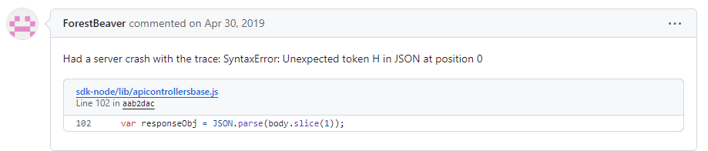

**Explanation:**

The person is trying to parse the html as a Json file using slice () it is unable handle that error. In the latest patch ( [github link](https://github.com/AuthorizeNet/sdk-node/commit/b04dfc5c06bf69d7d3906d2fb8bc46c63ff81d46)) axios is introduced it will stringify the response data and handles the exception.

**Issue status:** **closed**.

**8.Issue.15**

**MD5 hash End of Life #66**

Link:  [https://github.com/AuthorizeNet/sdk-node/issues/66](%20https://github.com/AuthorizeNet/sdk-node/issues/68)

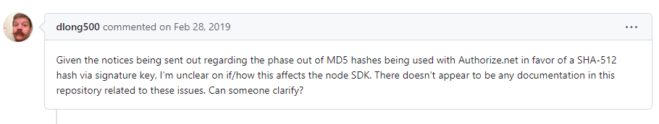

**Explanation:**

Gabriel has responded and did not receive any further replies from the customer.

So, this issue can be closed.

**Issue status:** **closed**.  
  
  
**8.Issue.20**

**Option to truncate data at max length #29**  
Link:  [https://github.com/AuthorizeNet/sdk-node/issues/29](%20https://github.com/AuthorizeNet/sdk-node/issues/68)

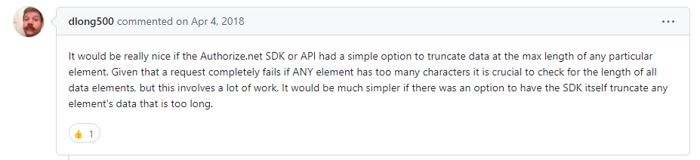

**Explanation**:

Gabriel has responded and did not receive any further replies from the customer.

So, this issue can be closed.

**Issue status:** **closed**.

**8.Issue.21**

**Use NODE_DEBUG to enable debug vs. config option #12**

Link:  [https://github.com/AuthorizeNet/sdk-node/issues/12](%20https://github.com/AuthorizeNet/sdk-node/issues/68)

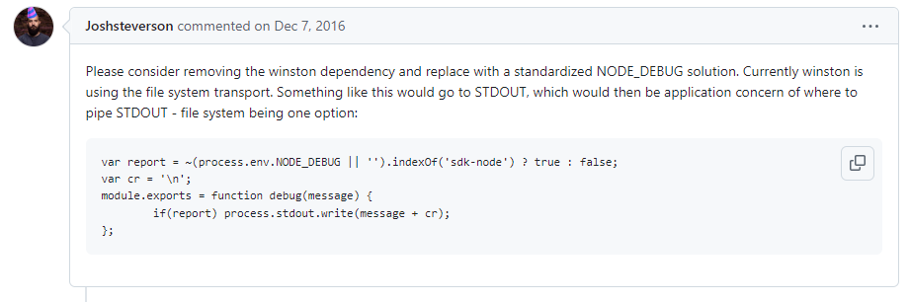

**Explanation:**

Implementing logging option to write to console using a new config property.

Added new property in lib/config.js and adds condition in logger.js Implementing logging option to write to console logs based on transport type. transport - { 'File', 'Console' }.  
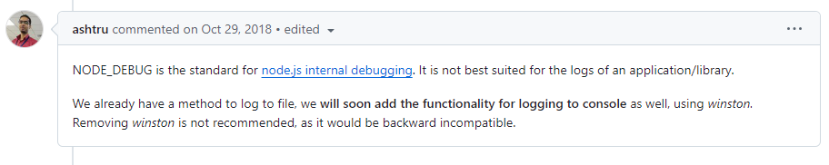  
  
  
**Issue status:** **closed**.