**Python**

**(sdk-python & sample-code-python)**

| **Issue No.** | **Name of Issue** | **Page No.** |
| --- | --- | --- |
| 2.Issue.1 | Getting issue with create_subscription TypeError: function takes 3 arguments plus optional tzinfo (8 given) #160 | 3 |
| 2.Issue.4 | AttributeError: no such child: {AnetApi/xml/v1/schema/AnetApiSchema.xsd}response #155 | 4 |
| 2.Issue.6 | Document production constants settings #153 | 5 |
| 2.Issue.8 | Create Document Exception masked by objectify error handling #148 | 6 |
| 2.Issue.10 | ARBSubscriptionType issue with Python 3.8 #145 | 7 |
| 2.Issue.13 | Question: Deprecated transHash Field #136 | 8 |
| 2.Issue.15 | createTransactionRequest with Tax #134 | 10 |
| 2.Issue.16 | Get Transaction Details Info Errror #109 | 12 |
| 2.Issue.17 | Roadmap? #57 | 13 |
| 11.Issue.1 | Doesnt work with python 3.12 #61 | 14 |
| 11.Issue.2 | Error when using Python 3.10 #60 | 15 |
| 11.Issue.3 | get_transaction_details() method issue #58 | 16 |
| 11.Issue.4 | UnboundLocalError: local variable 'element_binding' referenced before assignment #56 | 17 |
| 11.Issue.5 | Create a Customer Profile from a Transaction #52 | 18 |
| 11.Issue.6 | Adding a Tip to a transaction #51 | 19 |

**2.Issue.1**

# Getting issue with create_subscription TypeError: function takes 3 arguments plus optional tzinfo (8 given) #160

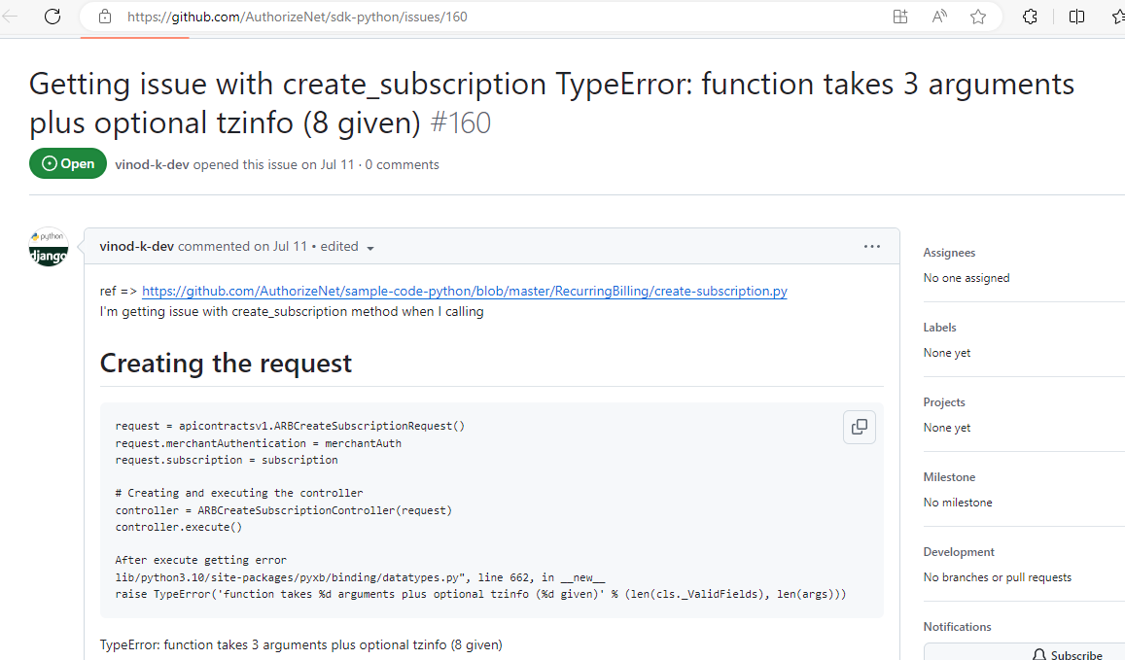

If I try to execute the file I am not able to reproduce the error because we have replaced the offending serialization library with a newer one, which will hopefully not cause more issues like this.

PyXB is replaced with PyXB-X. (datatype.py file is updated)

This issue has been fixed in v1.1.5.

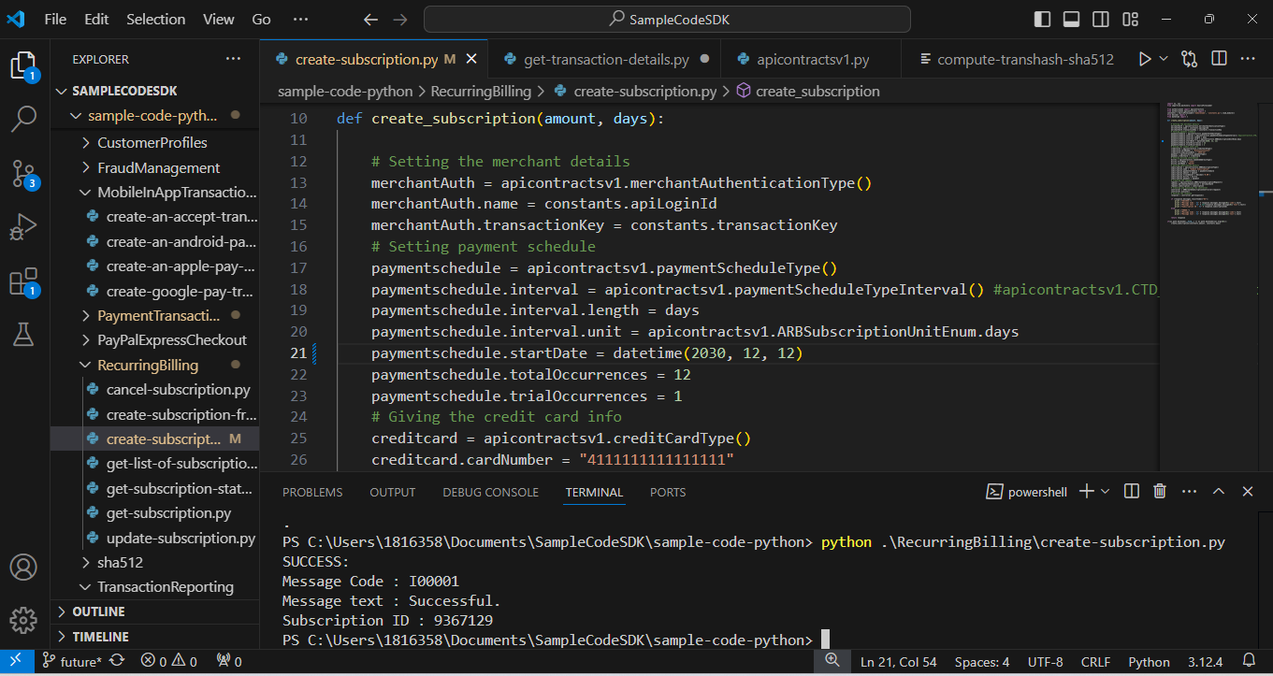

**2.Issue.4**

AttributeError: no such child: {AnetApi/xml/v1/schema/AnetApiSchema.xsd}response #155

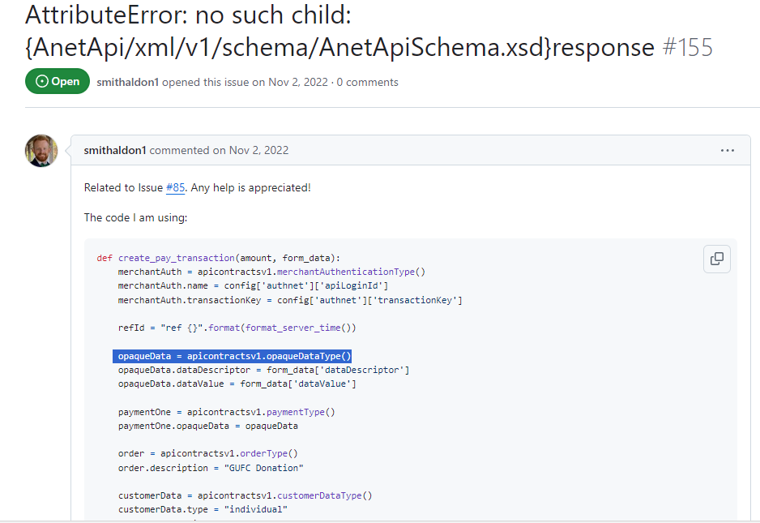

The user is trying to create a customer profile using opaque data but please be informed that our API currently does not support creating a customer profile and Payment Profile using opaque data.

**2.Issue.6**

# Document production constants settings #153

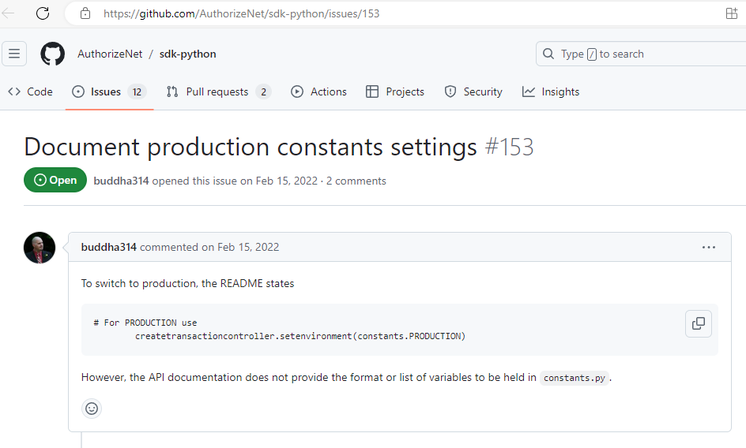

**Solution:**

The constants.py file is already present in the SDK. If you want to use the constants.py file inside the SDK, you have to include the below line in your code.

**“from authorizenet.constants import constants”**

**2.Issue.8**

# Create Document Exception masked by objectify error handling #148

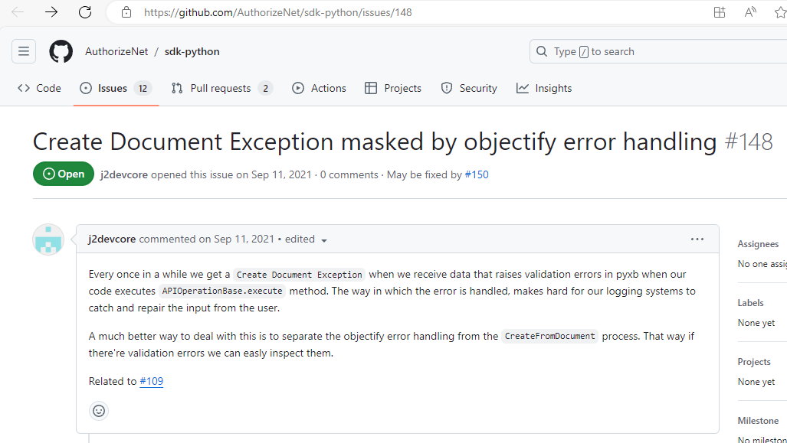

**User Comment:** We are getting a Create Document Exception: <class 'pyxb.exceptions_.ContentNondeterminismExceededError'>, (<authorizenet.apicontractsv1. customerAddressType object at 0x7f2ecf0129b0> every time we pull transaction details from the API. The error is occurring on line 149 of apicontrollersbase.py.

If I try to execute the file I am not able to reproduce the error because we have replaced PyXB with PyXB-X. This issue has been fixed in v1.1.5.

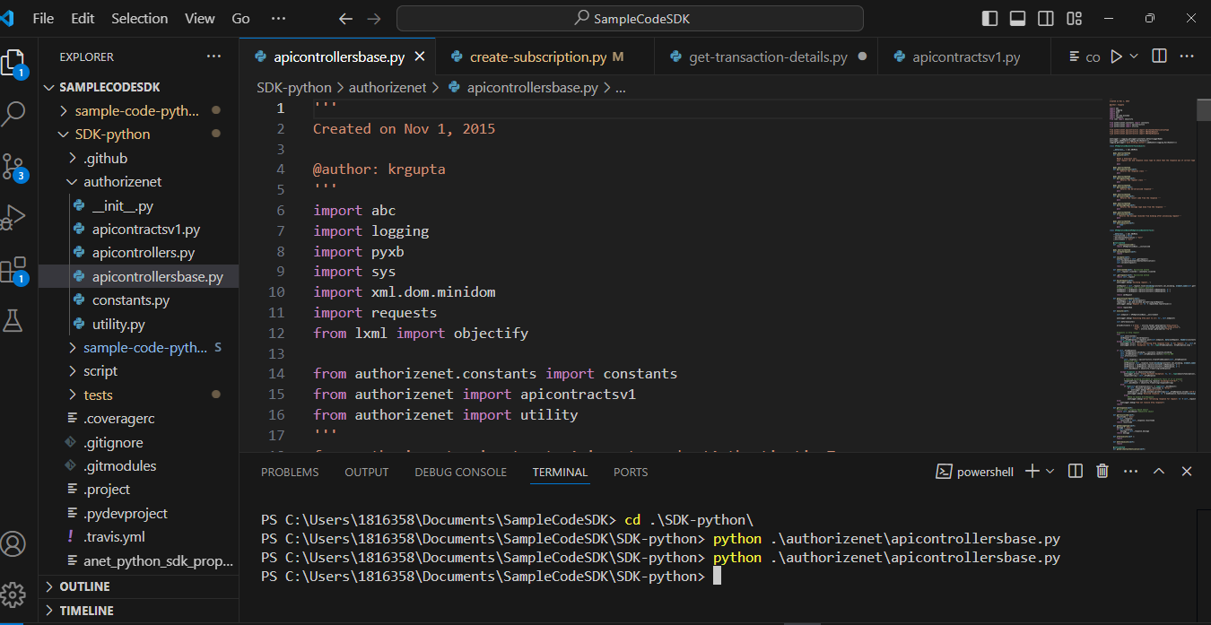

**2.Issue.10**

# ARBSubscriptionType issue with Python 3.8 #145

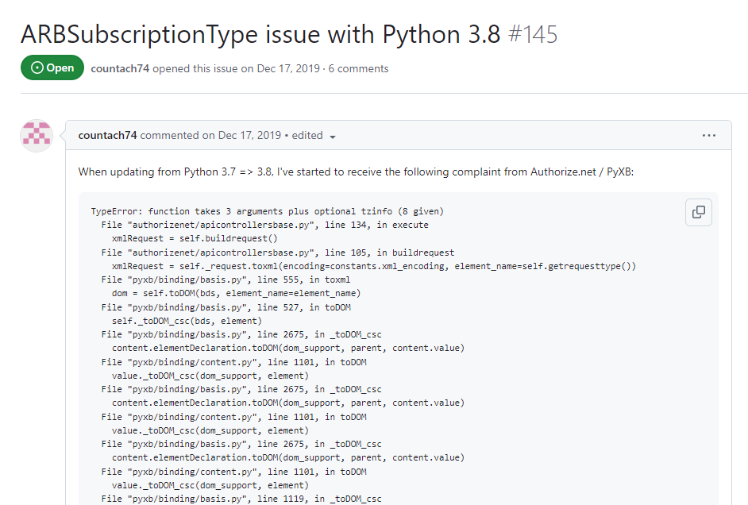

If I try to execute the file I am not able to reproduce the error because we have replaced the offending serialization library with a newer one, which will hopefully not cause more issues like this.

PyXB is replaced with PyXB-X. (e.g. datatype.py, basis.py, content.py, etc files are updated)

This issue has been fixed in v1.1.5.



**2.Issue.13**

Question: Deprecated transHash Field #136

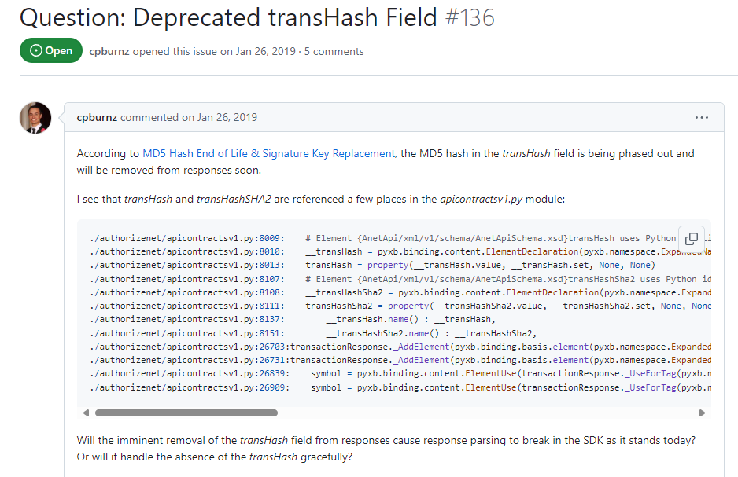

As per the official announcements, transHash (which uses MD5 based hashing) will be deprecated and a new field transHashSHA2 (based on SHA-512 based hash utilizing a Signature Key) has been made available thats why not able to reproduce error.

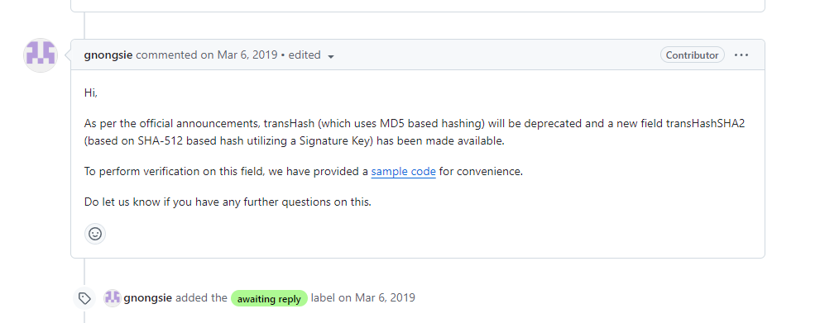

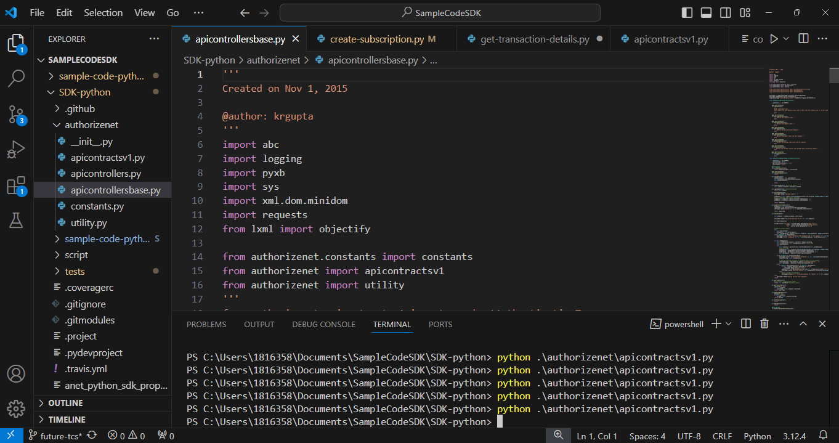

**2.Issue.15**

createTransactionRequest with Tax #134

**User Comment:**

I am trying to add tax via the SDK in the "charge-credit-card.py" file, but it seems that the sdk does not support this function. Is there a fix for this?

**Solution:**

If you try adding below lines in the "charge-credit-card.py" file to add tax, you will get the required output.

tax = apicontractsv1.extendedAmountType()

tax.amount = "1.99"

transactionrequest.tax = tax

**OR**

from decimal import Decimal

tax = apicontractsv1.extendedAmountType()

tax.amount = Decimal('1.99')

transactionrequest.tax = tax

Below is the output after adding tax field in code:

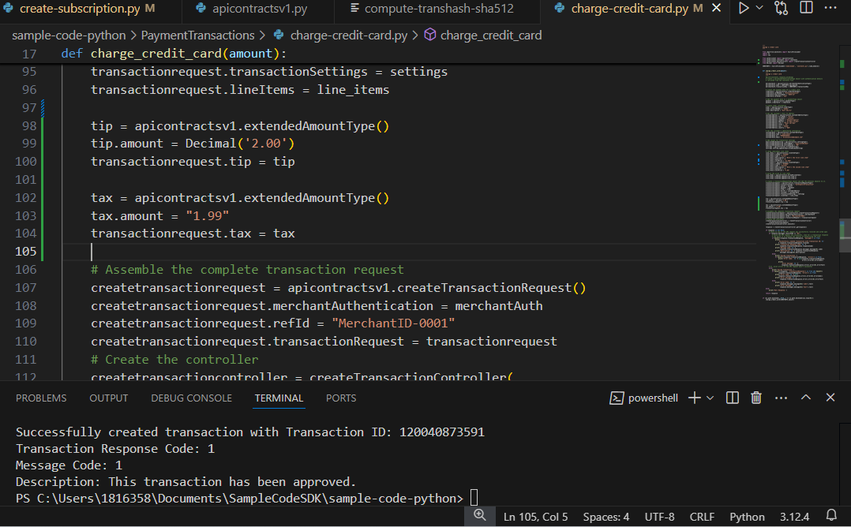

**Output:**

PS C:\Users\1816358\Documents\SampleCodeSDK\sample-code-python> python .\PaymentTransactions\charge-credit-card.py

Successfully created transaction with Transaction ID: 120040873591

Transaction Response Code: 1

Message Code: 1

Description: This transaction has been approved.

Use this Transaction ID: 120040873591 in API LIVE CONSOLE and get the transaction details.

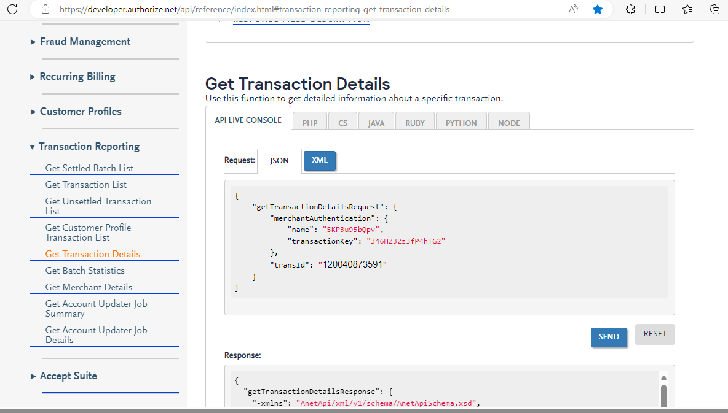

Below is the required response with tax amount,

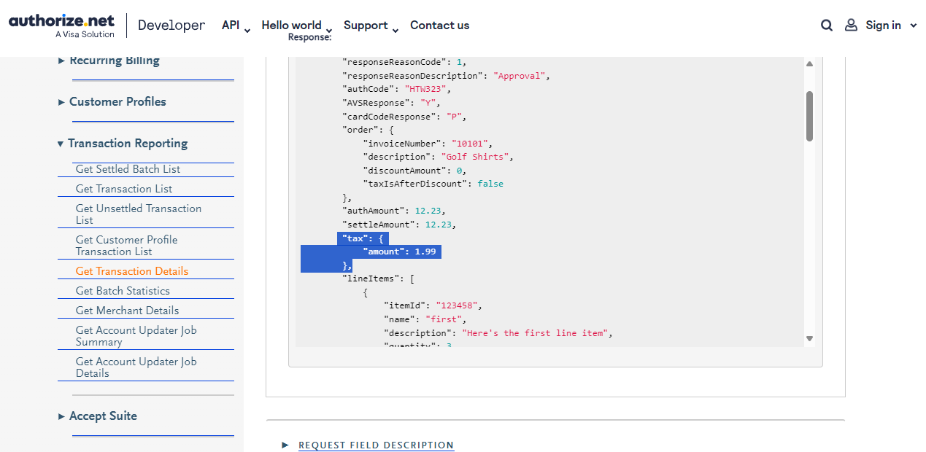

**2.Issue.16**

Get Transaction Details Info Errror #109

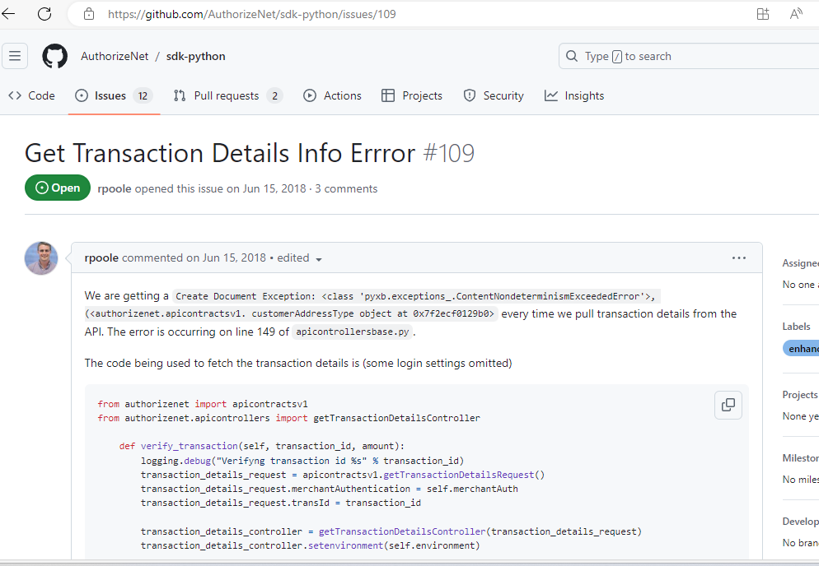

User Comment:We are getting a Create Document Exception: <class 'pyxb.exceptions_.ContentNondeterminismExceededError'>, (<authorizenet.apicontractsv1. customerAddressType object at 0x7f2ecf0129b0> every time we pull transaction details from the API. The error is occurring on line 149 of apicontrollersbase.py.

If I try to execute the file I am not able to reproduce the error because we have replaced PyXB with PyXB-X. This issue has been fixed in v1.1.5.



**2.Issue.17**

Roadmap? #57

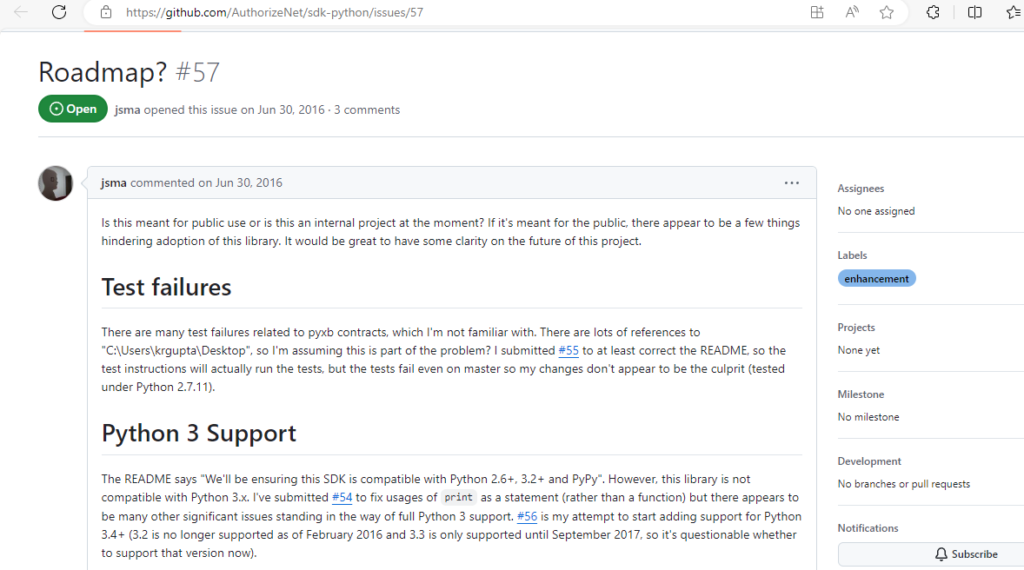

Closing this based on inactivity as per Gabriel’s confirmation.

**11.Issue.1**

Doesnt work with python 3.12 #61

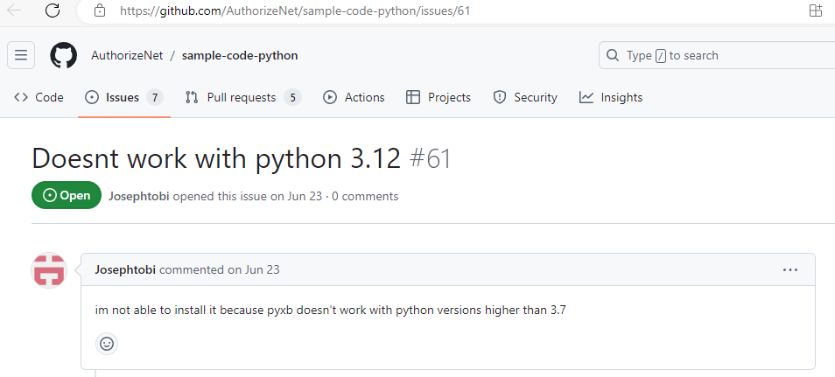

We have replaced PyXB with PyXB-X. The PyXB issue has been fixed in v1.1.5.

**11.Issue.2**

Error when using Python 3.10 #60

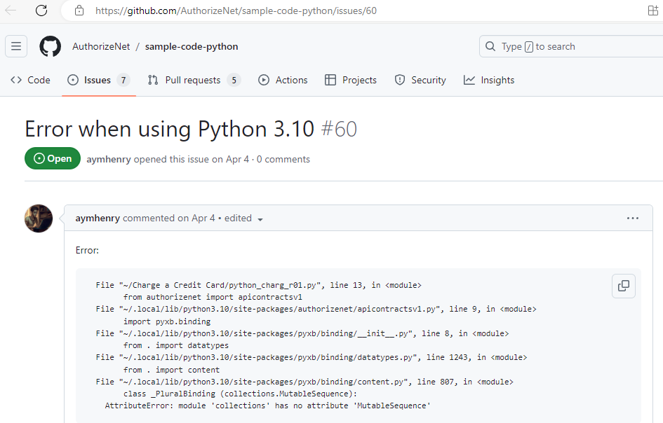

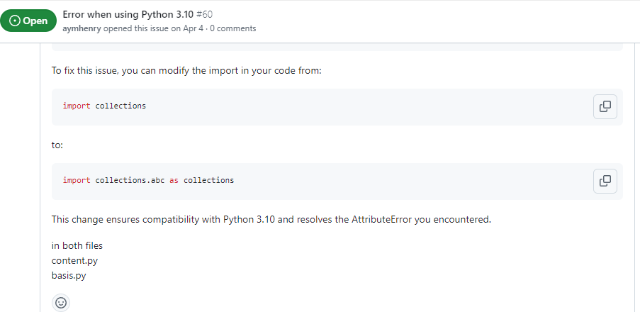

The above changes are made in an updated version of SDK and that has been released. So, I am not able to reproduce the error because we have replaced the offending serialization library with a newer one, which will hopefully not cause more issues like this.

PyXB is replaced with PyXB-X. (e.g. datatype.py, basis.py, content.py, etc files are updated)

This issue has been fixed in v1.1.5.

**11.Issue.3**

get_transaction_details() method issue #58

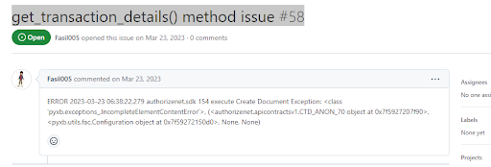

**Solution:**

We have replaced the offending serialization library with a newer one, which will hopefully not cause more issues like this. (This issue has been fixed in v1.1.5)

PyXB is replaced with PyXB-X.

**11.Issue.4**

UnboundLocalError: local variable 'element_binding' referenced before assignment #56

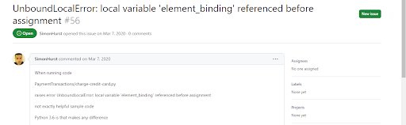

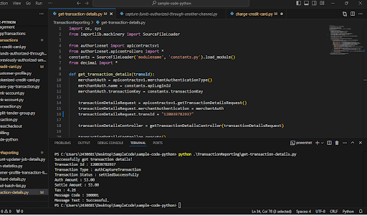

**Solution:** Not able to reproduce it, able to run from my side.

**11.Issue.5**

Create a Customer Profile from a Transaction #52

This issue is already fixed by Gabriel and it will be released.

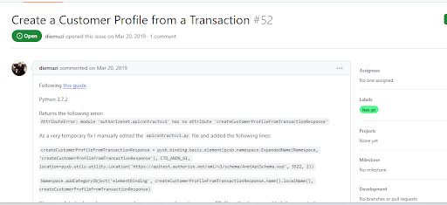

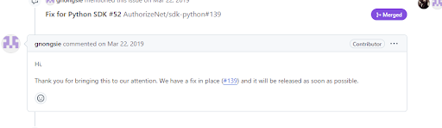

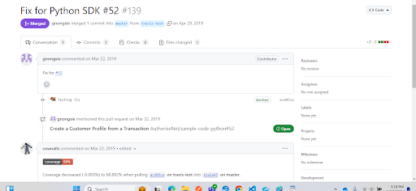

**11.Issue.6**

Adding a Tip to a transaction #51

If you try adding below lines in the "charge-credit-card.py" file to add a tip, you will get the required output.

tip = apicontractsv1.extendedAmountType()

tip.amount = "2.00"

transactionrequest.tip = tip

**OR**

from decimal import Decimal

tip = apicontractsv1.extendedAmountType()

tip.amount = Decimal('2.00')

transactionrequest.tip = tip

Below is the output after adding tax field in code:

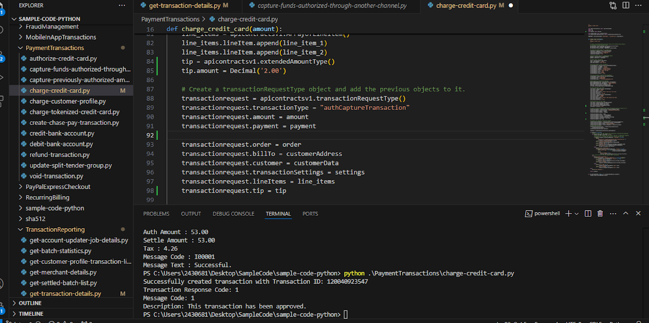

Tax : 4.26

Message Code : I00001

Message Text : Successful.

PS C:\Users\2430681\Desktop\SampleCode\sample-code-python> python .\PaymentTransactions\charge-credit-card.py

Successfully created transaction with Transaction ID: 120040923547

Transaction Response Code: 1

Message Code: 1

Description: This transaction has been approved.

