**TYPNI WEBSITE CHALLENGE**

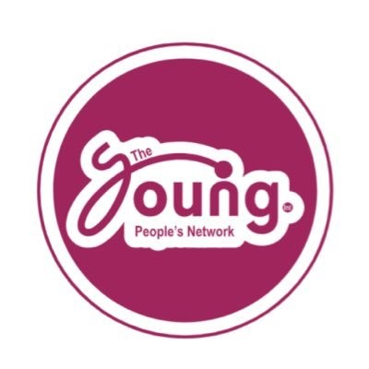

Table of Contents

**INTRODUCTION** 3

Purpose 3

EXECUTIVE SUMMARY 4

**PROBLEM STATEMENT** 5

**PROPOSED SOLUTIONS** 8

**PROJECT OBJECTIVES** 9

**SCOPE OF WORK** 10

Project Constraints: 11

Phase 1: Project Definition and Research (January 12 - January 15, 2025 – 4 days) 11

Phase 2: Website Design and Development (January 16 - January 28, 2025 - 13 days) 11

Phase 3: Content Creation and Curation (January 29 - February 4, 2025 - 7 days) 12

Phase 4: Website Assembly and Testing (February 5 - February 7, 2025 - 3 days) 13

Phase 4: Design 13

Key Considerations : 14

**TECHNICAL REQUIREMENTS AND SPECIFICATIONS** 14

Development Environment: 14

Programming Languages and Technologies: 16

Content Management: 16

Data Storage: 17

Browser Compatibility: 17

Accessibility: 17

Testing: 18

Delivery Format: 18

Limitations: 18

**Implementation Plan: Buni Website (Student Project - Local File Delivery)** 18

Phase 1: Project Definition and Research (January 11 - January 15, 2025 - 5 days) 19

Day 1 (Jan 11): 19

Day 2 (Jan 12): 19

Day 3 (Jan 13): 19

Day 4 (Jan 14): 19

Day 5 (Jan 15): 19

Phase 2: Website Design and Development (January 16 - January 28, 2025 - 13 days) 19

Day 6-7 (Jan 16-17): 19

Day 8-9 (Jan 18-19): 20

Day 10-11 (Jan 20-21): 20

Day 12-13 (Jan 22-23): 20

Day 14-15 (Jan 24-25): 20

Day 16-17 (Jan 26-27): 20

Day 18 (Jan 28): 20

Phase 3: Content Creation and Curation (January 29 - February 4, 2025 ) 21

Day 19-21 (Jan 29-31): 21

Day 22-24 (Feb 1-3): 21

Day 25 (Feb 4): 21

Phase 4: Website Assembly and Testing (February 5 - February 7, 2025 - 3 days) 21

Day 26 (Feb 5): 21

Day 27 (Feb 6): 21

Day 28 (Feb 7): 21

Communication: 22

Contingency: 22

**TEAM OVERVIEW** 22

**RISK ASSESSMENT** 23

Challenges 23

Mitigation Strategies 23

# **INTRODUCTION**

We are Mecra, a team of three highly motivated college students with a passion for crafting exceptional digital experiences. Driven by a shared dedication to coding and innovative design, we specialize in developing high-quality websites and mobile applications. We're thrilled to participate in this competition and eager to showcase our skills and creativity in building a website that not only meets but exceeds the competition's requirements. We believe our combined strengths in coding and design will allow us to deliver a truly impactful and user-friendly product.

Young People's Network International (TYPNI) has a proven track record of empowering Kenyan youth through various initiatives, including engaging competitions for young creatives. This proposal addresses TYPNI's need for a comprehensive website that serves as a central hub for addressing the critical challenges facing young people in Kenya today, complementing and extending the reach of TYPNI’s existing programs. We understand the importance of providing resources, fostering community, and empowering youth to take control of their futures. This proposed website will act as a powerful tool to achieve these goals.

## Purpose

The purpose of this project is to develop a dynamic and user-friendly website that tackles the complex issues impacting Kenyan youth, including unemployment, drug abuse, limited access to education, lack of empowerment opportunities, and social and political exclusion. This website will serve as a vital resource, connecting young people with the tools, information, and support they need to thrive. It will also amplify TYPNI's existing work, including its creative competitions, by providing a platform to showcase winners, promote upcoming events, and engage a broader audience.

# EXECUTIVE SUMMARY

**Buni : Empowering Youth for a Brighter Future**

This website, "Buni," addresses the critical challenges facing today's youth, offering a centralized platform for information, resources, and community support. Recognizing that young people are the future, we aim to empower them to overcome obstacles and reach their full potential. "Buni" tackles six key areas: unemployment, drug abuse, lack of education, diseases such as AIDS, lack of empowerment, and social and political exclusion.

These interconnected challenges create a complex web of disadvantage, hindering individual growth and societal progress. "Buni" offers a multi-pronged approach:

* **Unemployment:** We provide access to job boards, skills training resources, and mentorship opportunities, connecting young people with potential employers and equipping them with the tools they need to succeed in the workforce.
* **Drug Abuse:** The website offers confidential resources for individuals struggling with addiction, including helplines, treatment center locators, and educational materials on the dangers of substance abuse. We also provide support for families and friends of those affected.
* **Lack of Education:** "Buni" connects young people with educational opportunities, including scholarships, online courses, and information on continuing education programs. We highlight the importance of education and provide guidance on navigating the educational system.
* **Diseases such as AIDS:** We offer comprehensive information on disease prevention, testing, and treatment, focusing on HIV/AIDS awareness and providing links to local health services. We aim to destigmatize these diseases and promote healthy lifestyles.
* **Lack of Empowerment:** The website features inspiring stories, leadership training resources, and platforms for young people to share their voices and ideas. We aim to foster a sense of agency and empower youth to become active agents of change in their communities.
* **Social and Political Exclusion:** "Buni" provides information on civic engagement, encourages participation in community initiatives, and offers resources for young people to connect with local leaders and advocate for their needs. We strive to create a space for youth to engage in meaningful dialogue and contribute to shaping their future.

"Buni" is more than just a website; it's a call to action. We believe that by providing access to information, resources, and a supportive community, we can empower young people to overcome these challenges and build a brighter future for themselves and their communities. This website is designed to be a dynamic and evolving platform, continuously adapting to the needs of youth and fostering a positive impact on their lives. We invite you to join us in bridging the gap and empowering the next generation.

# **PROBLEM STATEMENT**

Youth across the globe, and particularly in Kenya, face a complex and interconnected set of challenges that hinder their development and limit their potential. These challenges include:

* **High rates of unemployment:** Lack of access to job opportunities and inadequate skills training leave many young people unemployed or underemployed, leading to financial instability and a sense of hopelessness.

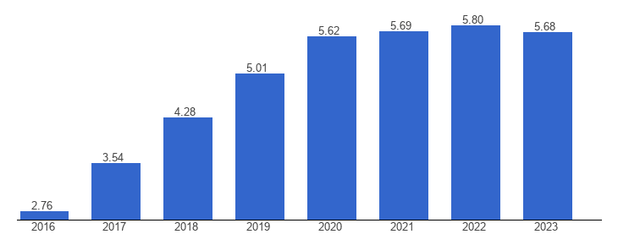

1: Credits: https://www.theglobaleconomy.com/Kenya/unemployment_rate/

* **Prevalence of drug abuse:** Substance abuse among youth is a growing concern, often fueled by lack of opportunity, peer pressure, and mental health issues. This leads to health problems, addiction, and further marginalization.

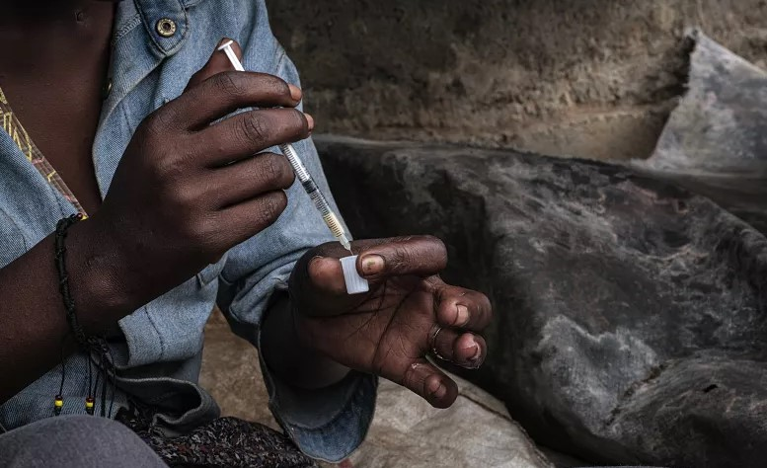

2.Credits: https://eastleighvoice.co.ke/coast/21343/alarm-as-coast-region-records-highest-instances-of-drug-abuse-in-kenya

* **Limited access to quality education:** Many young people lack access to quality education, either due to financial constraints, geographical limitations, or inadequate educational infrastructure. This perpetuates a cycle of poverty and limits their future prospects.
* **Vulnerability to diseases, including HIV/AIDS:** Lack of access to information, preventative measures, and treatment makes youth particularly vulnerable to infectious diseases, including HIV/AIDS. This poses serious health risks and undermines their well-being.
* **Lack of empowerment and agency:** Young people often lack a voice in decisions that affect their lives and communities. This lack of empowerment can lead to feelings of apathy, disengagement, and a lack of motivation to contribute to positive change.
* **Social and political exclusion:** Youth are often excluded from social and political processes, limiting their ability to advocate for their needs and contribute to shaping their future. This can lead to feelings of alienation and disenfranchisement.

These interconnected challenges create a vicious cycle, hindering individual growth, hindering community development, and ultimately impacting societal progress. Addressing these issues is crucial for creating a more equitable and prosperous future for all.

# **PROPOSED SOLUTIONS**

Buni website offers a multi-faceted approach to address these challenges:

* **Connecting youth with employment opportunities:** The website will feature a job board, skills training resources and mentorship programs to connect young people with potential employers and equip them with the skills they need to succeed in the workforce.
* **Providing resources and support for drug abuse prevention and treatment:** The website will offer confidential resources for individuals struggling with addiction, including helplines, treatment center locators, educational materials on the dangers of substance abuse, and support for families and friends.
* **Facilitating access to education and training:** The website will connect young people with educational opportunities, including scholarships, online courses, and information on continuing education programs. It will also highlight the importance of education and provide guidance on navigating the educational system.
* **Disseminating information and resources on disease prevention and treatment:** The website will offer comprehensive information on disease prevention, testing, and treatment, focusing on HIV/AIDS awareness and providing links to local health services. It will aim to destigmatize these diseases and promote healthy lifestyles.
* **Empowering youth through leadership training and community engagement:** The website will feature inspiring stories, leadership training resources, and platforms for young people to share their voices and ideas. It will aim to foster a sense of agency and empower youth to become active agents of change in their communities.
* **Promoting social and political inclusion:** The website will provide information on civic engagement, encourage participation in community initiatives, and offer resources for young people to connect with local leaders and advocate for their needs. It will strive to create a space for youth to engage in meaningful dialogue and contribute to shaping their future.

# **PROJECT OBJECTIVES**

The Buni project aims to achieve the following objectives:

* **Increase youth employment rates:** By connecting young people with job opportunities and providing skills training, the project aims to reduce youth unemployment and improve their economic prospects.
* **Reduce drug abuse among youth:** By providing resources and support for prevention and treatment, the project aims to reduce the prevalence of substance abuse and its negative consequences.
* **Improve access to education and training opportunities:** By connecting young people with educational resources, the project aims to increase access to quality education and improve their educational attainment.
* **Enhance awareness and knowledge of disease prevention and treatment:** By disseminating information and resources, the project aims to improve awareness of diseases like HIV/AIDS and promote healthy behaviors.
* **Empower youth to become active agents of change:** By providing leadership training and platforms for engagement, the project aims to empower young people to become active participants in their communities.
* **Promote social and political inclusion of youth:** By providing resources and information on civic engagement, the project aims to increase youth participation in social and political processes.

These objectives are interconnected and contribute to the overall goal of empowering youth to overcome challenges and build a brighter future. Success will be measured through website analytics (traffic, resource downloads, engagement), feedback surveys, and partnerships with local organizations working with youth.

# **SCOPE OF WORK**

This Scope of Work outlines the tasks, deliverables, and responsibilities involved in the development of the Buni website as our project, existing as a local file deliverable, based on internet research findings. This project emphasizes resourcefulness and utilizes readily available tools and knowledge.

## Project Constraints:

* **No Hosting or Domain:** The website will not be hosted online and will be delivered as a local file package.
* **Internet-Based Research:** All problem identification and information gathering will be conducted through internet research.
* **Student Project:** This is a non-commercial, student-led initiative with limited resources.
* **Laptop-Based Development:** Development will be done using personal laptops and readily available software.

### Phase 1: Project Definition and Research (January 12 - January 15, 2025 – 4 days)

* **Tasks:**
  + Define specific problem areas based on internet research (unemployment, drug abuse, etc.).
  + Outline core website sections based on these problems.
  + Create a simple sitemap for navigation.
  + Gather initial information and resources from reputable online sources.
* **Deliverables:**
  + Problem statement document based on research.
  + Basic website sitemap.
  + List of initial online resources.

### Phase 2: Website Design and Development (January 16 - January 28, 2025 - 13 days)

* **Tasks:**
  + Design a simple and user-friendly website layout using HTML and CSS.
  + Develop core website pages with basic content structure.
  + Implement interactive elements using JavaScript (e.g., simple forms, resource links).
  + Test the website locally on different browsers.
* **Deliverables:**
  + Functional website files (HTML, CSS, JavaScript).
  + Basic website content (text, images sourced responsibly from Creative Commons or similar).
  + Local testing documentation.

### Phase 3: Content Creation and Curation (January 29 - February 4, 2025 - 7 days)

* **Tasks:**
  + Write and curate content for each website section, based on research.
  + Ensure proper attribution for any external content used.
  + Format content for readability and accessibility.
  + Create any necessary graphics or visuals using free online tools.
* **Deliverables:**
  + Finalized website content.
  + Properly attributed external resources.
  + Any created graphics/visuals.

### Phase 4: Website Assembly and Testing (February 5 - February 7, 2025 - 3 days)

* **Tasks:**
  + Assemble all website files and content into a cohesive package.
  + Conduct thorough testing on different laptops and browsers.
* **Deliverables:**
  + Complete website file package.
  + Final testing documentation.

### Phase 4: Design

**Responsibilities:** (Shared among student team members)

* **Research and Content:** Conducting internet research, writing content, and curating resources.
* **Web Development:** Designing the website layout, coding the website, and implementing interactive elements.
* **Testing and Documentation:** Testing the website on different platforms and creating project documentation.
* **Presentation:** Preparing and delivering the project presentation.

**Budget:** Minimal, covering only internet access costs (if any). All software and tools used are assumed to be freely available.

**Timeline:** As detailed above, the project spans 30 days, from January 11, 2025, to February 10, 2025.

### Key Considerations :

* **Scope Management:** Focus on a manageable set of core features due to the limited timeframe and resources.
* **Open-Source Tools:** Utilize free and open-source software and tools for development.
* **Collaboration:** Effective communication and collaboration within the student team are essential.
* **Ethical Considerations:** Ensure proper attribution for any external content or resources used.

This Scope of Work reflects the constraints and resources available for our website project. The emphasis is on creating a functional and informative website as a local file deliverable, showcasing research and development skills.

# **TECHNICAL REQUIREMENTS AND SPECIFICATIONS**

This section outlines the technical requirements and specifications for the Buni website development.

## Development Environment:

* **IDE (Integrated Development Environment):** Visual Studio Code (VS Code) will be the primary IDE used for coding and development. This choice is based on its free availability, cross-platform compatibility, rich feature set, and extensive community support.

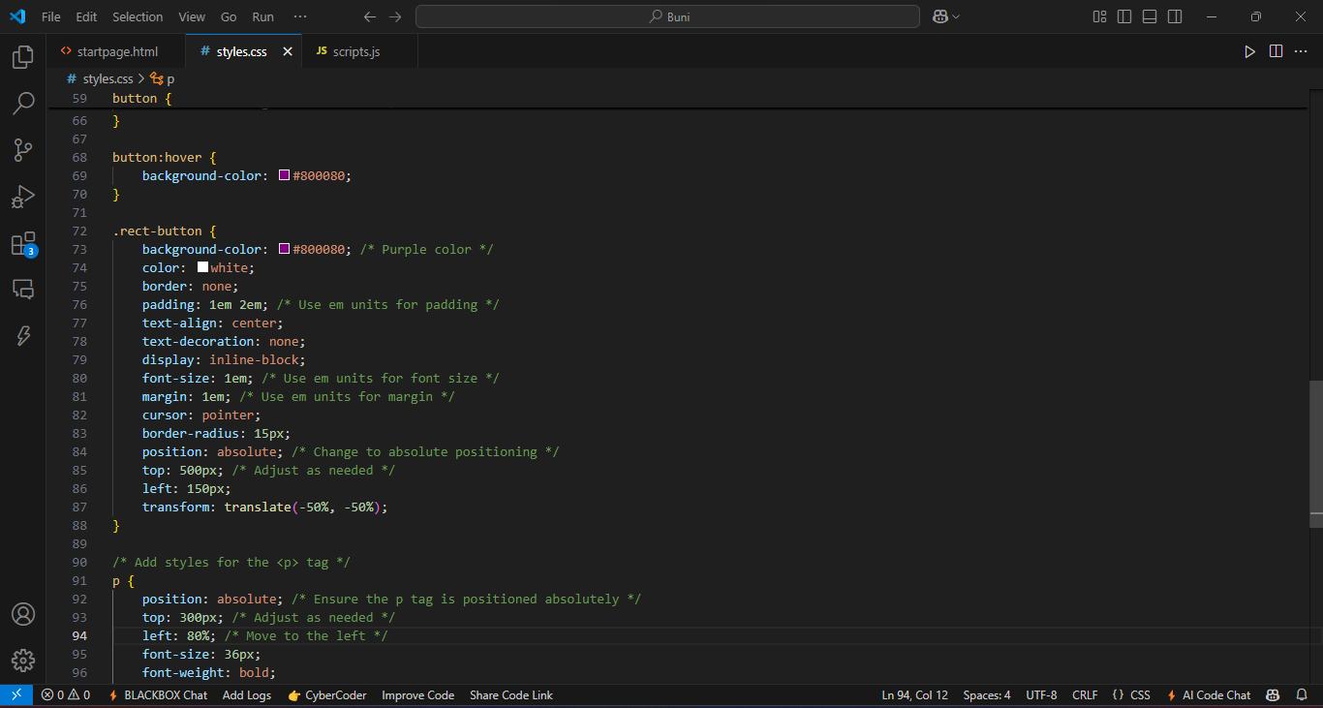

* **Prototyping Tool:** Figma was used for initial website prototyping and design. The Figma designs serve as a visual guide for the development process. While the Figma files themselves are not a deliverable in the final website package, they inform the HTML/CSS structure and design.
* 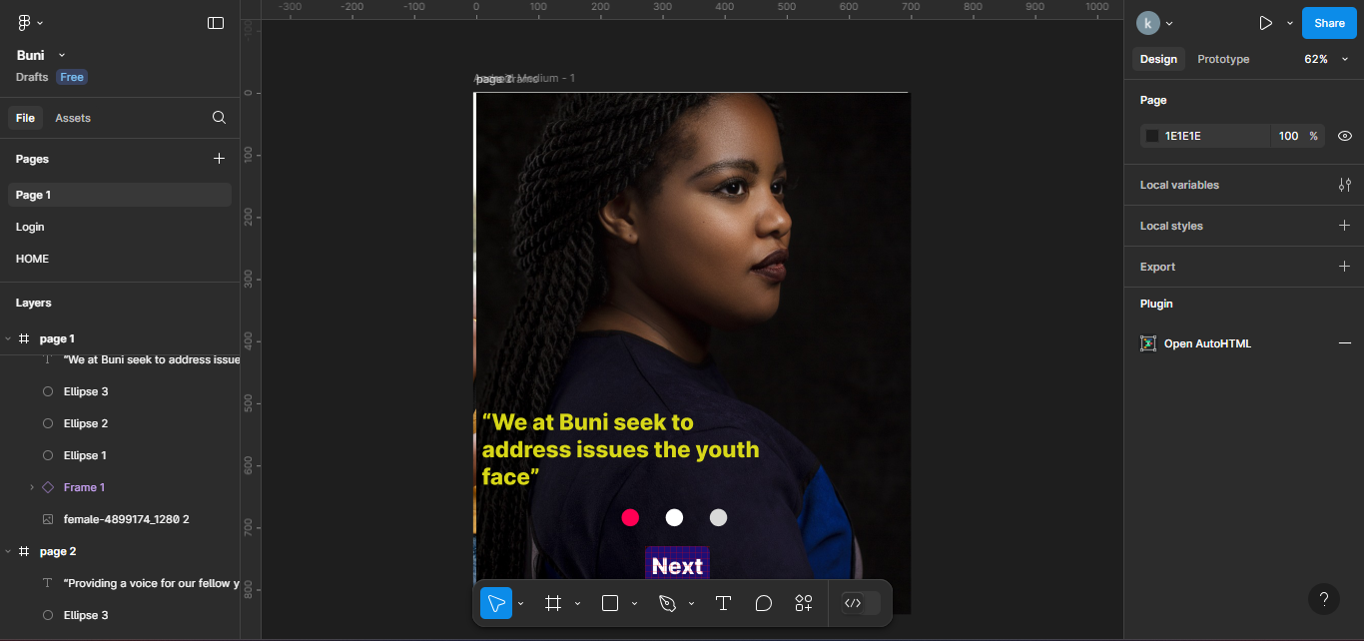

## Programming Languages and Technologies:

* **HTML (HyperText Markup Language):** HTML will be used for structuring the content and layout of the website. Semantic HTML will be prioritized to ensure accessibility and maintainability.
* **CSS (Cascading Style Sheets):** CSS will be used for styling the website's visual presentation, including layout, typography, colors, and responsive design. A CSS framework (e.g., Bootstrap, Tailwind CSS - if time permits and the team has prior experience, otherwise plain CSS) may be considered to accelerate development, but the focus will be on clean and maintainable CSS.
* **JavaScript:** JavaScript will be used for adding interactivity and dynamic behavior to the website, such as form validation, interactive resource links, and any other dynamic elements. The use of JavaScript will be kept to a minimum to ensure simplicity and maintainability, focusing on core interactive features.

## Content Management:

* **Static Website:** The website will be a static website, meaning that content will be directly embedded in the HTML files. This approach is chosen for its simplicity and ease of delivery as a local file package. A Content Management System (CMS) will *not* be used due to the project's constraints and local file delivery requirement.

## Data Storage:

* **Local Files:** All website content and data will be stored within the local files of the website package. No external databases will be used. This simplifies the project and aligns with the local file delivery requirement.

## Browser Compatibility:

* **Target Browsers:** The website will be tested and optimized for compatibility with modern web browsers, including:
  + Google Chrome (latest version)
  + Mozilla Firefox (latest version)
  + Microsoft Edge (latest version)
  + Safari (latest version - if team members have access for testing)
* **Responsive Design:** The website will be designed to be responsive, meaning it will adapt its layout and presentation to different screen sizes (desktop, laptop, tablet, mobile).

## Accessibility:

* **Basic Accessibility:** Efforts will be made to ensure basic website accessibility, including:
  + Semantic HTML structure
  + Alternative text for images
  + Keyboard navigation (where applicable)
  + Sufficient color contrast

## Testing:

* **Local Testing:** The website will be thoroughly tested locally on different browsers and devices available to the student team.
* **Limited Scope:** Due to the project's scope and resources, comprehensive cross-browser and cross-device testing may be limited.

## Delivery Format:

* **File Package:** The website will be delivered as a package of HTML, CSS, JavaScript, image, and other asset files. A "readme" file will be included with instructions on how to open and navigate the website locally.

## Limitations:

* **No Server-Side Functionality:** Due to the static website approach, server-side functionality (e.g., user authentication, dynamic content updates from a database) will not be included.
* **Limited Scalability:** The static website architecture is not designed for high traffic or complex data management.
* **Local Access Only:** The website will only be accessible locally on the machines where the files are stored.

These technical requirements and specifications are designed to be realistic and achievable within the constraints of this student project. They prioritize simplicity, maintainability, and local file delivery.

# **Implementation Plan: Buni Website (Student Project - Local File Delivery)**

This Implementation Plan details the steps, timelines, and responsibilities for developing Buni website as a student project, delivered as a local file package.

## Phase 1: Project Definition and Research (January 11 - January 15, 2025 - 5 days)

### Day 1 (Jan 11):

* + Team meeting: Discuss project goals, assign roles, and review the Scope of Work.
  + Initial internet research: Identify key problem areas related to youth challenges.

### Day 2 (Jan 12):

* + Deep dive into chosen problem areas: Gather statistics, facts, and relevant information from reputable online sources.
  + Begin drafting the problem statement document.

### Day 3 (Jan 13):

* + Continue research and refine the problem statement document.
  + Start brainstorming website sections and features.

### Day 4 (Jan 14):

* + Finalize the problem statement document.
  + Create a preliminary sitemap and basic website structure.

### Day 5 (Jan 15):

* + Team meeting: Review the problem statement, sitemap, and planned website sections.
  + Begin gathering initial online resources for content.

## Phase 2: Website Design and Development (January 16 - January 28, 2025 - 13 days)

### Day 6-7 (Jan 16-17):

* + Design initial website layout and wireframes (using pen and paper or a free online wireframing tool if desired).
  + Begin coding basic HTML structure for key pages.

### Day 8-9 (Jan 18-19):

* + Implement CSS styling for the website layout, focusing on responsiveness.
  + Develop core functionality (e.g., resource links, simple forms) using JavaScript.

### Day 10-11 (Jan 20-21):

* + Continue coding and refining website functionality.
  + Begin integrating placeholder content into the HTML structure.

### Day 12-13 (Jan 22-23):

* + Focus on cross-browser compatibility testing on available devices.
  + Refine CSS to ensure consistent display across browsers.

### Day 14-15 (Jan 24-25):

* + Implement any remaining interactive elements using JavaScript.
  + Begin populating website sections with basic content.

### Day 16-17 (Jan 26-27):

* + Finalize the HTML structure and CSS styling.
  + Thoroughly test all interactive elements and functionality.

### Day 18 (Jan 28):

* + Code review and debugging.

## Phase 3: Content Creation and Curation (January 29 - February 4, 2025 )

### Day 19-21 (Jan 29-31):

* + Focus on writing and curating content for each website section.
  + Ensure proper attribution for all external resources.

### Day 22-24 (Feb 1-3):

* + Format content for readability and accessibility.
  + Create any necessary graphics or visuals using free online tools.

### Day 25 (Feb 4):

* + Final content review and editing.

## Phase 4: Website Assembly and Testing (February 5 - February 7, 2025 - 3 days)

### Day 26 (Feb 5):

* + Assemble all website files into a cohesive package.
  + Create the "readme" file with instructions.

### Day 27 (Feb 6):

* + Conduct final testing on different laptops and browsers.

### Day 28 (Feb 7):

* + Final website review and bug fixes.

**Responsibilities:** (Shared among student team members – specific tasks can be assigned based on individual skills and interests)

* **Research and Content:** Kwame Otieno
* **Web Development:** Austin Sakari
* **Testing and Documentation:** Aaron Kibet

## Communication:

* Regular team meetings (online or in-person) will be held to track progress, discuss challenges, and coordinate tasks.
* A shared communication platform (e.g., messaging app, project management tool) will be used for ongoing communication and file sharing.

## Contingency:

* A buffer of a few hours has been built into the schedule for unexpected issues or delays.
* The team should be flexible and adaptable to adjust the plan as needed.

This Implementation Plan provides a detailed roadmap for the development of the Buni website. Consistent communication, collaboration, and adherence to the timeline will be crucial for the successful completion of this project.

# **TEAM OVERVIEW**

We started this project as classmates studying ICT from Nairobi National Polytechnic as we saw the problems most of us as the youths faced.

We consist of three students namely:

* Austin Sakari – Excels in coding especially in java that’s why we assigned him the role of coding the website
* Kwame Otieno- Perfect in design and documentation
* Aaron Kibet- best in prototyping and design also.

# **RISK ASSESSMENT**

## Challenges

1. **Balancing the project and school work since most of the weekdays we are normally in school**
2. **Tension to keep up with the project due to time**
3. **Number of people since it requires a lot of work and effort**

## Mitigation Strategies

1. **Assign the project at least one hour in a day to cover something rather than not doing it completely**
2. **We take at least a day off to rest our minds**
3. **We dedicate each one a role and ample time to complete it**