Hello, this is my sum-up informations.

* Among those companies:
  + 90,3% are retention.
  + 9.7% are churn.
* Sale channel:

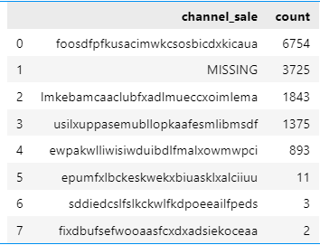

* The average of each energy and power price is:

|  |  |  |
| --- | --- | --- |
|  | Energy | Power |
| Off_peak | 0.14 | 43.33 |
| Peak | 0.05 | 10.62 |
| Mid_peak | 0.03 | 6.4 |

* The maximum of each energy and power price is:

|  |  |  |
| --- | --- | --- |
|  | Energy | Power |
| Off_peak | 0.28 | 59.44 |
| Peak | 0.22 | 36.49 |
| Mid_peak | 0.11 | 17.45 |

* The different between each:

|  |  |  |  |  |
| --- | --- | --- | --- | --- |
| Type | Energy | | Power | |
| Period | 1st – 2nd | 2nd – 3rd | 1st – 2nd | 2nd – 3rd |
| Average | 0.08 | 0.02 | 32.71 | 4.21 |
| Maximum | 0.05 | 0.11 | 22.95 | 19.03 |

* Sources of data that client should provide:
  + What is the most using product.
  + What is the less using product.
* Open source that useful:
  + Price of Gas and energy in the world of each country.