Hardware Detailed Design Specifications

AutoGoni

Prepared for: Dr. Robert Scheidt and Richard Schroeder

Project Leader:

**David Vitale**

Project Team:

**Jalen Battle**

**Paul Dang**

**Ben Durette**

**Emmali Hanson**

**Justin Hauter**

**JP Rivera**

**Gleb Sklyr**

**Kevin Wright**

Revision History

|  |  |  |  |
| --- | --- | --- | --- |
| Revision | Date | Revised By | Notes |
| 1 | 12.07.2016 | Emmali Hanson | Original Document |

**Table of Contents**

**1. Introduction…………………………………………………………………………………….3**

**1.1 Purpose…………………………………………………………………………………...3**

**1.2 Scope……………………………………………………………………………………...3**

**1.3 Hardware Description………………………………………………………….…..3**

**1.4 Terms and Definitions……………………………………………………………...4**

**2. Hardware Overview………………………………………………………………………….4**

**2.1 Overall Description…………………………………………………………………..4**

**2.2 Final Schematic………………………………………………………………………10**

**1. Introduction**

**1.1 Purpose**

The purpose of this document is to describe the Hardware Detailed Design Specifications. These are the minimum requirements, functionality, and capabilities of the hardware to be used in this project. This is based on the minimum viable product requirements gained from customer interviews.

**1.2 Scope**

All of the design principles involving the hardware will be outlined and described in this document. For details regarding the system and software, please refer to the System and Software Detailed Design Specification documents.

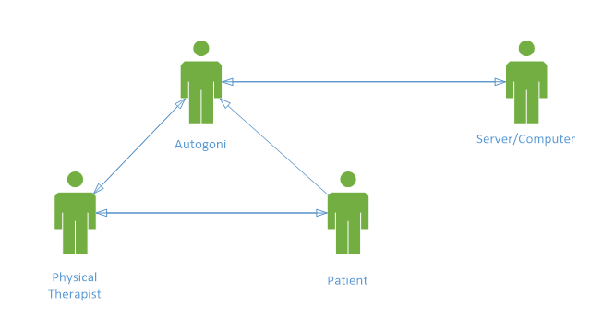

**Figure 1:** Basic, interaction based use case diagram of the Autogoni device.

**1.3 Hardware Description**

The hardware of the AutoGoni is responsible for taking joint angle measurements, displaying them to the user, and transmitting the data to the software. It provides an accurate and familiar method of taking measurements. It also provides power to the device and provides means of communication.

**1.4 Terms and Definitions**

**Table 1:** Terms and definitions listed for reference.

|  |  |
| --- | --- |
| **Term** | **Definition** |
| Goniometer | Instrument for the precise measurement of angles, especially one used to measure the angles of joints of the body |
| Joint angle | Angle between two body segments linked by a joint |
| Physical Therapist (PT) | Health care professionals who help patients reduce pain and improve or restore mobility |
| System Usability Scale (SUS) | Tool for measuring the usability of a system |
| User interface | Visual part of system through which a user interacts |
| GUI | Graphical user interface |
| PC | Personal computer |
| USB | Universal serial bus |

**2. Hardware Overview**

**2.1 Overall Description**

This section describes the overall hardware of the system.

**2.1.1 Hardware Functions**

This section describes the functions that each aspect of the hardware will accomplish.

**2.1.1.1 Navigate GUI**

The hardware will provide a method of easily navigating the GUI. This method of navigation will be user intuitive and simplistic. This will prevent unnecessary user errors and confusion with new product users.

**2.1.1.2 Measure Angles**

The hardware will have a component that measures angles electronically with minimal or no error. This device will transmit these values to the microcontroller for further processing and printing.

**2.1.1.3 Provide Guide for Measurements**

The hardware will have a component that provides a guide for the physical therapist taking measurements. This guide will consist of two arms that will extend over a reasonable distance as to act a references to the user. This will provide more accurate measurements as well as optimal space to securely hold the device.

**2.1.1.4 Display Information**

The hardware will provide an interface that displays information for the GUI and measurement data. The display will have large type that is clearly visible to the user at arms length. This will reduce eye strain, as well as give the user a fully immersive user experience.

**2.1.1.5 Provide Power**

The hardware will provide power to the electronics of the device. This will allow the device portability and continuous operation for long term of use and storage of data.

**2.1.2 Parts Required**

**2.1.2.1 Microcontroller**

**2.1.2.1.1 Description**

A processor is needed to provide computing power to the system. The microcontroller will store the software and receive inputs and output from the other electronic components. It will also connect to the PC and provide data transfer mechanisms. This microcontroller will be a low power system as to reserve battery live, and meet environmentally conscious device standards.

**2.1.2.1.2 Function Requirements**

**2.1.2.1.2.1 GPIO Ports**

The microcontroller must have 14 GPIO ports. These pins will be required to interface with other hardware components such as the angle measurement device and the screen.

**2.1.2.1.2.2 Memory**

The microcontroller must have 10kb memory. This memory will allow for the storage of multiple data sets pertaining to patient angle measurements.

**2.1.2.1.2.3 Power**

The microcontroller must be able to supply 3.3V. A power supply of 3.3V is required to operate the screen and the angle measurement device.

**2.1.2.1.2.4 Communication**

The microcontroller must be able to send and receive data via USB. This will be the main form of communication for the device with customers computers and the server side application. This will serve as the measurement data transfer method.

**2.1.2.2 Angle Measurement Device**

**2.1.2.2.1 Description**

The angle measurement device will electronically measure angles. It will transmit this data to the microcontroller for processing.

**2.1.2.2.2 Function Requirements**

**2.1.2.2.2.1 Accuracy**

The angle measurement device will have an accuracy within 3 degrees. This margin of error was deemed acceptable in customer interviews as it is standard between measurements.

**2.1.2.2.2.2 Precision**

The angle measurement device will have a precision within 3 degrees. This margin of error was deemed acceptable in customer interviews as it is standard between measurements.

**2.1.2.2.2.3 Range**

The angle measurement device will have a range of 360. The device must be able to measure any angle.

**2.1.2.2.2.4 Communication**

The angle measurement device will communicate with the microcontroller via GPIO. This is the standard form of device communication with a microcontroller.

**2.1.2.2.2.5 Power**

The angle measurement device will operate on 3.3V of power. This will be the power output supplied by the microcontroller.

**2.1.2.3 Display Screen**

**2.1.2.3.1 Description**

The display screen will present data and the GUI to the user. It will be the visual output for the device. It will be the primary method of communication with the user.

**2.1.2.3.2 Function Requirements**

**2.1.2.3.1 Character Display**

The screen will have the capacity to display a minimum of 15 alphanumeric characters. These characters will be required to display measurement angles as well as options.

**2.1.2.3.2 Power**

The display screen will operate on 3.3V of power. This will be the power output supplied by the microcontroller.

**2.1.2.4 Option Selection Mechanism**

**2.1.2.4.1 Description**

A mechanism will be implemented that will allow the user to navigate through the user interface and select options. This navigation method will be elegant and simplistic for quick and easy measurement toggling and saving.

**2.1.2.4.2 Function Requirements**

The mechanism will have two states that will trigger events. This two states will effectively be on and off for the desired effect.

**2.1.2.5 Angle Alignment Device**

**2.1.2.5.1 Description**

The angle alignment device will provide guidelines for performing the measurements accurately. They will allow the PT to line up the AutoGoni correctly along the patient’s joint to ensure accuracy in the measurements.

**2.1.2.5.2 Function Requirements**

**2.1.2.5.2.1 Reference Point**

The angle alignment device will provide a central reference point for the placement over joints. This point will protrude from the back of the device for added clarity.

**2.1.2.5.2.2 Rotation**

The angle alignment device will allow the user to easily turn the dial - connected to the angle measurement device. This device will allow for 360 degree rotations.

**2.1.2.5.2.3 Positioning**

The angle alignment device will allow the user to align the system with the patient’s joint angle.

**2.1.2.5.2.4 Familiarity**

The angle alignment device will provide a sense of familiarity for the user by allowing the device to be operated similar to the basic goniometer.

**2.1.2.6 Power Supply**

**2.1.2.6.1 Description**

The power supply will provide power to the system. This power supply will be able to be turned on and off for storage and use periods respectively.

**2.1.2.6.2 Function Requirements**

**2.1.2.6.2.1 Time**

The power supply will provide a minimum of 10 hours of power to the system. This will be representative of a work shift for a typical user.

**2.1.2.6.3 Voltage**

The power supply will provide 3.3V to the system. This power output will be required for all of the electronic devices operating in the system.

**2.2 Final Schematic**

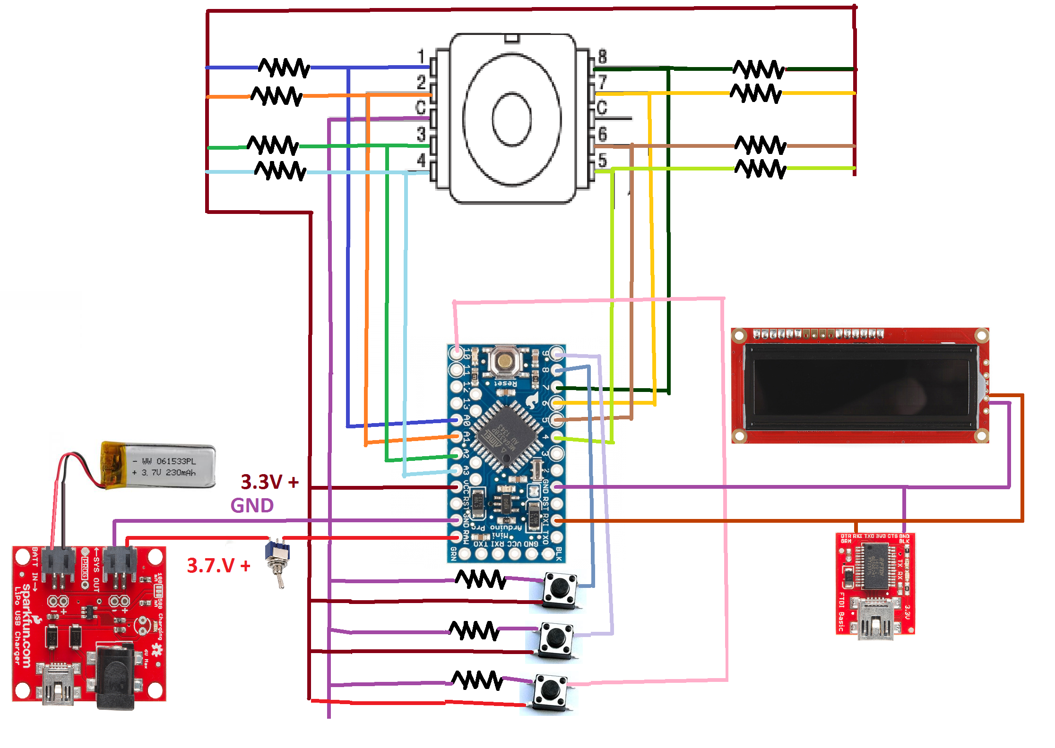

**Figure 2:** Schematic of the Autogoni