Software Detailed Design Specifications

Autogoni

Prepared for: Dr. Robert Scheidt and Richard Schroeder

Project Leader:

**David Vitale**

Project Team:

**Jalen Battle**

**Paul Dang**

**Ben Durette**

**Emmali Hanson**

**Justin Hauter**

**JP Rivera**

**Gleb Sklyr**

**Kevin Wright**

Revision History

|  |  |  |  |
| --- | --- | --- | --- |
| Revision | Date | Revised By | Notes |
| 1 | 12.07.2016 | Emmali Hanson | Original Document |

**Table of Contents**

**1. Introduction…………………………………………………………………………………….3**

**1.1 Purpose…………………………………………………………………………………...3**

**1.2 Scope……………………………………………………………………………………...3**

**1.3 Software Description………………………………………………………………..3**

**1.4 Terms and Definitions……………………………………………………………...4**

**2. Software Overview…………………………………………………………………………...4**

**2.1 Overall Description…………………………………………………………………..4**

**2.2 State Diagram………………………………………………………………………….6**

**3. Specific Requirements……………………………………………………………………...7**

**3.1 Operating System Requirements………………………………………………..7**

**3.2 Coding Language Requirements………………………………………………..7**

**1. Introduction**

**1.1 Purpose**

The purpose of this document is to describe the Software Detailed Design Specifications.

**1.2 Scope**

All of the design principles involving the software will be outlined and described in this document. For details regarding the hardware and system, please refer to the Hardware and System Detailed Design Specification documents.

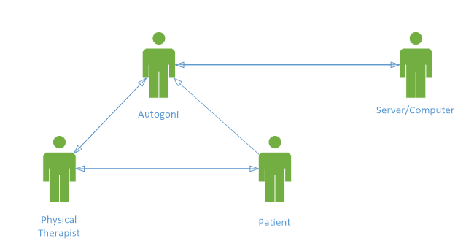

**Figure 1:** Basic, interaction based use case diagram of the Autogoni device.

**1.3 Software Description**

The software on the AutoGoni receives the measured joint angles from the hardware. It stores this data and transmits it to the PC when connected via USB. The software also includes the GUI. It displays menu items that the user can cycle through to navigate to their desired option.

**1.4 Terms and Definitions**

**Table 1:** Terms and definitions listed for reference.

|  |  |
| --- | --- |
| **Term** | **Definition** |
| Goniometer | Instrument for the precise measurement of angles, especially one used to measure the angles of joints of the body |
| Joint angle | Angle between two body segments linked by a joint |
| Physical Therapist (PT) | Health care professionals who help patients reduce pain and improve or restore mobility |
| System Usability Scale (SUS) | Tool for measuring the usability of a system |
| User interface | Visual part of system through which a user interacts |
| GUI | Graphical user interface |
| PC | Personal computer |
| USB | Universal serial bus |

**2. Software Overview**

**2.1 Overall Description**

This section describes the software of the system.

**2.1.1 Software Functions**

This section describes the functions that the software will accomplish.

**2.1.1.1 Interpretation of Angle Measurements**

The software must be able to coordinate with the hardware to read and interpret the angle measurements. This is accomplished by interpreting values sent by the rotary encoder hardware, and a 8-bit value is interpreted to represent a 7-bit position value. This allows the system to have a resolution of 128 values when interpreting angle measurements. The received value is converted to degrees by multiplying by (360 / 128).

**2.1.1.2 Display of Values and User Interface**

The software must be able to coordinate with the hardware to display output to the user. There are four overall variables to be tracking: the current angle measurement, all passive measurements, all active measurements, and the current measurement number.

These values are stored internally and the values are updated at 5Hz, by transmission over serial to the LCD.

**2.1.1.3 User Interface of Autogoni**

The software must be able to operate a user interface for control of the menu. The user interface implemented displays the current measurement number, the live angle measurement, the passive angle of the current measurement and active angle of the the current measurement.

**2.1.1.4 User Interface of Computer Application**

The computer application gives the user the ability to view all measurements in a table, make edits to the measurements, and store the measurements to a CSV file. The graphical user interface (GUI) was written in Python. There is a “Transfer Data” button to connect the computer to the Autogoni through a serial communication, a table to display all the measured values from the Autogoni, and entry field for the user to type in the name of the file they want to save to, and a “Save” button.

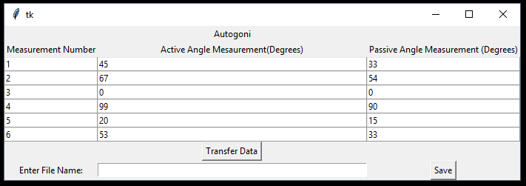

**Figure 2:** Screenshot of the computer application UI.

**2.1.1.5 Data Transfer to Computer**

To complete the data transfer from the Autogoni to the computer, the Autogoni must first be connected to the computer with a USB. Once connected, the user must hit the “Transfer Data” button to set up a serial communication port between the computer and the device. Next, the user must press all three buttons on the Autogoni at the same time to tell it to transfer the data. The data gets transferred through the serial port and processed through the Python code. The code is able to filter out the overhead from the data transfer and isolate the various measurements. These measurements are used to display on the computer UI. If the user chooses to save the values to a file, Python is able to write all of these data values to individual, formatted elements in a CSV file.

**2.2 State Diagram**

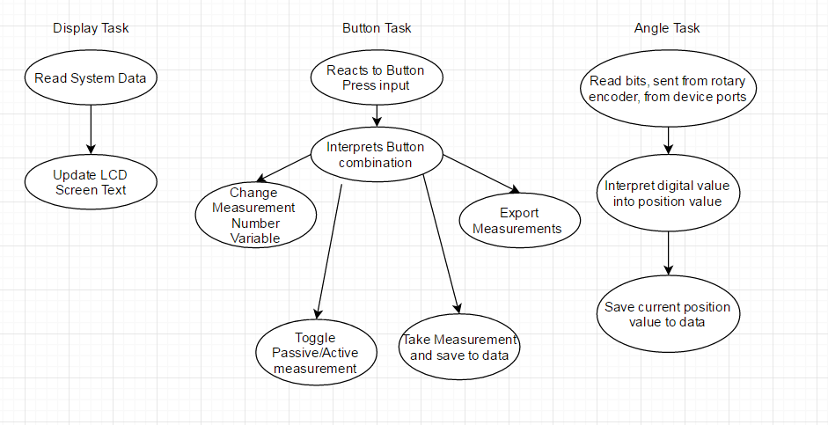

**Figure 3: State diagram of software**

**3. Specific Requirements**

**3.1 Operating System Requirements**

The operating system for the Autogoni will be a real time operating system that is operable on the chosen microcontroller.

**3.2 Coding Language Requirements**

The coding language used will have important functionality.

**3.2.1 Interrupts**

The coding language will have the ability to use and implement interrupts.

**3.2.2 Multitasking**

The coding language will have the ability to run multiple tasks at once.