System Detailed Design Specifications

Autogoni

Prepared for: Dr. Robert Scheidt and Richard Schroeder

Project Leader:

**David Vitale**

Project Team:

**Jalen Battle**

**Paul Dang**

**Ben Durette**

**Emmali Hanson**

**Justin Hauter**

**JP Rivera**

**Gleb Sklyr**

**Kevin Wright**

Revision History

|  |  |  |  |
| --- | --- | --- | --- |
| Revision | Date | Revised By | Notes |
| 1 | 12.07.2016 | Emmali Hanson | Original Document |

**Table of Contents**

**1. Introduction…………………………………………………………………………………….3**

**1.1 Purpose…………………………………………………………………………………...3**

**1.2 Scope……………………………………………………………………………………...3**

**1.3 System Description...………………………………………………………………..3**

**1.4 Terms and Definitions……………………………………………………………...4**

**2. System Overview………...…………………………………………………………………...4**

**2.1 Overall Description…………………………………………………………………..4**

**3. Specific Requirements……………………………………………………………………...9**

**3.1 Functional Requirements………………………………………………………….9**

**3.2 Data Requirements………………………………………………………………...11**

**3.3 Quality Requirements……………………………………………………………..11**

**1. Introduction**

**1.1 Purpose**

The purpose of this document is to describe the System Detailed Design Specifications.

**1.2 Scope**

All of the design principles involving the entire system will be outlined and described in this document. For details regarding the software and hardware, please refer to the Software and Hardware Detailed Design Specification documents.

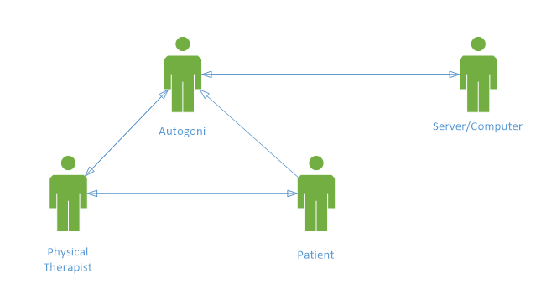

**Figure 1:** Basic, interaction based use case diagram of the Autogoni device.

**1.3 System Description**

The Autogoni is an automated goniometer. It is used for physical therapy applications where joint angle measurements need to be taken quickly and accurately. The angle measurements are measured electronically, and the data is stored to be transferred to a PC. It is a self-sufficient system that operates independently of a computer.

**1.4 Terms and Definitions**

**Table 1:** Terms and definitions listed for reference.

|  |  |
| --- | --- |
| **Term** | **Definition** |
| Goniometer | Instrument for the precise measurement of angles, especially one used to measure the angles of joints of the body |
| Joint angle | Angle between two body segments linked by a joint |
| Physical Therapist (PT) | Health care professionals who help patients reduce pain and improve or restore mobility |
| System Usability Scale (SUS) | Tool for measuring the usability of a system |
| User interface | Visual part of system through which a user interacts |
| GUI | Graphical user interface |
| PC | Personal computer |
| USB | Universal serial bus |

**2. System Overview**

**2.1 Overall Description**

This section describes the system as a whole and how it works together.

**2.1.1 Product Functions**

This section describes the key functions that the system will accomplish.

**2.1.1.1 Take Angle Measurements**

The system will take joint angle measurements when operated by a user.

**2.1.1.2 Store Angle Measurement Data**

The system will store the joint angle measurement data for later use.

**2.1.1.3 Transfer Angle Measurement Data**

The system will transfer the joint angle measurements to a PC.

**2.1.1.4 User Interface**

There will be a user interface for the user to use to make choices regarding the joint being measured and the movement of data.

**2.1.2 Customer Description**

The typical customer is a physical therapist who takes measurements using a goniometer. They will interact with the whole device as one unit. They will operate the user interface, take the joint measurements, and transfer the data to the computer. They will have an interest of saving time and taking accurate joint measurements.

**2.1.3 Constraints**

The constraints come from the fact that the Autogoni is an improvement on the original goniometer. The Autogoni is constrained in that it must look and operate like a basic goniometer. Since physical therapists are used to using a basic goniometer, a new version will need to operate similarly. The Autogoni will provide no instructions for taking angle measurements, so PT’s must be able to use the same methods they already use for taking angle measurements.

**2.1.4 Assumptions and Dependencies**

**2.1.4.1 Goniometer Use**

One assumption is that the users will be trained physical therapists who know how to use a traditional goniometer. The Autogoni will not have any instructions for basic goniometer use or measuring angles of joints.

**2.1.4.2 Data Transfer**

Another assumption is that the data transfer will be performed over a secure connection. The USB cord and port will not be compromised in any way that would cause that data to be corrupted.

**2.1.4.3 Privacy**

Since the data collected is medical data, privacy laws must be taken into account. It is assumed that the physical therapist is trained on patient privacy laws and will treat the data as confidential, especially once it is stored on the PC.

**2.1.5 Use Cases**

**2.1.5.1 Performing Goniometric Measurements**

The Autogoni will have the same basic functionality as a goniometer, allow users to scroll through previous measurements, and allow users to designate passive and active ROM measurements.

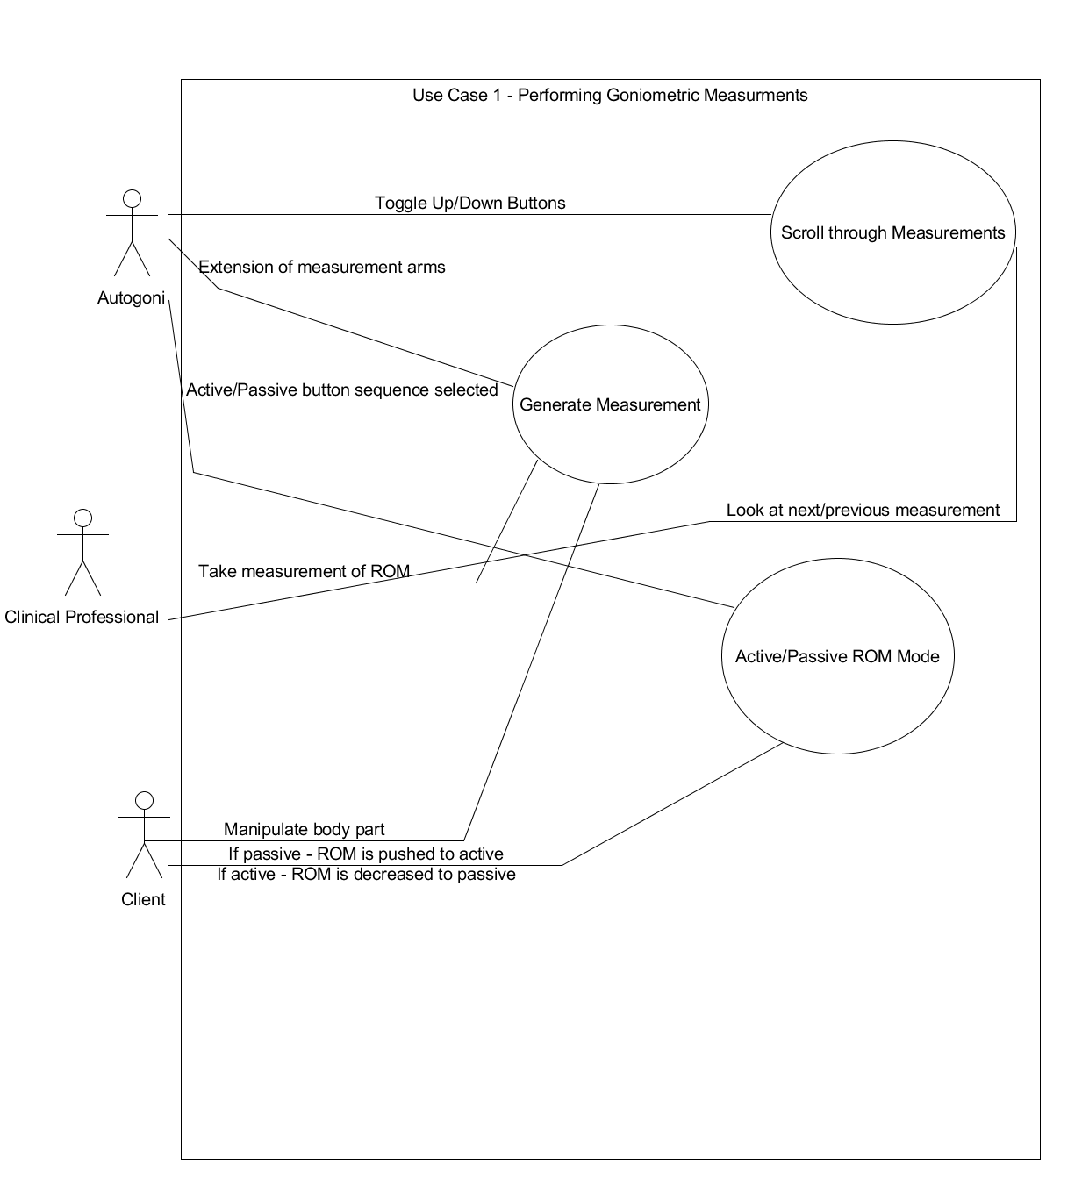

**Figure 2:** Use case diagram of the first use case, Performing Goniometric Measurements

**2.1.5.2 Device Data Archival**

The Autogoni will be able to save measurements, clear and delete measurements, overwrite previously recorded data, and export measurements to external software application.

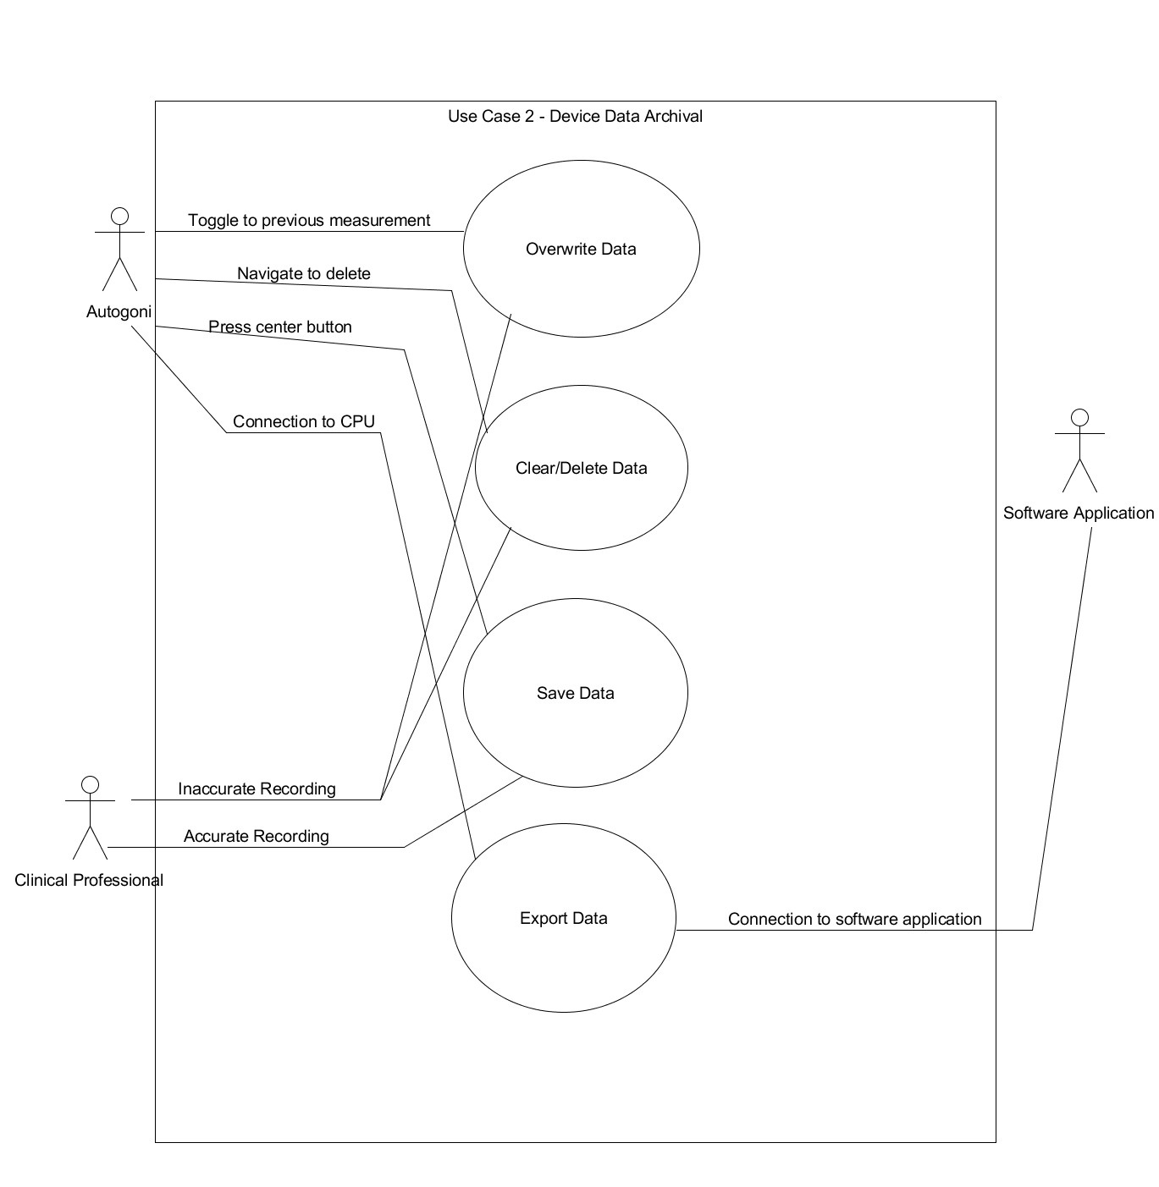

**Figure 3:** Use case diagram of the second use case, Device Data Archival

**2.1.5.3 Application of Data with Software Components**

External software should be able to store data on an accessible location. This will involve retrieving previous measurements and showing trends in progress which will utilize analytics. It will also notify the clinician and patient in various scenarios.

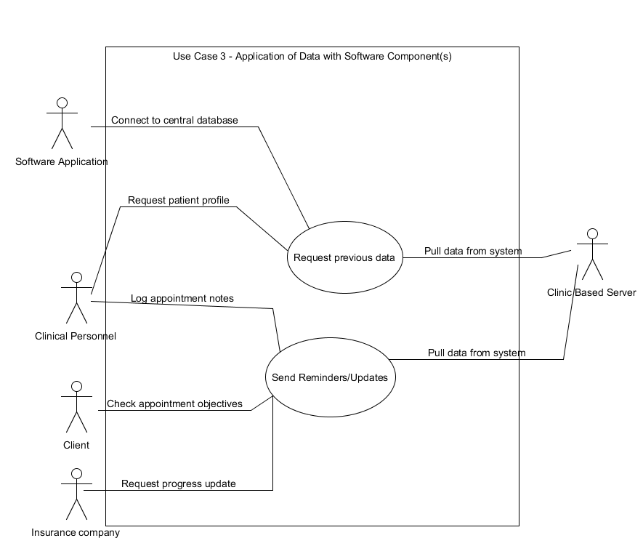

**Figure 4:** Use case diagram of the third use case, Application of Data with Software Components

**3. Specific Requirements**

**3.1 Functional Requirements**

This section lists the functional requirements for the whole system.

**3.1.1 User Interface**

The user interface will be the parts of the device that the user will work with and have access to. It will consist of three buttons (two for scrolling up or down and one for selecting) a screen to display text (where the GUI will be displayed), and a basic goniometer.

**3.1.1.1 GUI**

**3.1.1.1.1 Usability**

The GUI will be user friendly and efficient and will have a score of 68 or above (considered above average) on the System Usability Scale.

**3.1.1.1.2 Duration of Operation**

The time of device operating the device should be shorter than the time it takes operating existing manual goniometers.

**3.1.1.1.3 Options**

The GUI will allow users to cycle through menu options and select their desired choice.

**3.1.1.2 Ergonomic**

The device will be ergonomical. The buttons will be placed so that the user can easily operate them with one hand.

**3.1.1.2.1 Dimensions**

The dimensions will be similar to that of a traditional goniometer to measure joint angles in a similar fashion. The device must be able to be held comfortably in a below average sized hand. If it is too big, more petit PT’s will have difficulty gripping the device and operating it. However, if the device is too small, it will also be difficult to operate because it would be difficult to grip. The current dimensions of goniometers have been proven to be effective, so maintaining those will result in a proper size.

**3.1.1.2.2 Weight**

The weight will be such that a person with below average muscle mass can comfortably hold the device with one hand and operate with two hands. If the device is too heavy, it will be difficult to move around and operate properly. For some joint measurements, the device may need to be held at awkward angles, this cannot be done if the device is too heavy.

**3.1.1.2.3 Torque**

The torque required to rotate the Autogoni must be similar to that of a basic goniometer. If more or less torque is required, the operation will be very different and the accuracy of measurements could be compromised. If the Autogoni rotates too easily (less torque), then it may fall out of the position it is supposed to be in and cause the measurement to be off. If it does not rotate easily enough (more torque), then the PT will have to spend too much effort rotating the device and it will take more time than necessary.

**3.1.2 Hardware Interfaces**

The hardware interfaces will be responsible for obtaining the measurement data. They will have measurement arms for the PT to line up along the joint. The electronics will power the device, store the program, and allow the user to operate the user interface.

**3.1.3. Software Interfaces**

The software interfaces will run the user interface, allowing the user to make choices about measurement options and operating states. It will also record and store the data.

**3.1.4 Communication Interfaces**

The system will work together to facilitate communication between the software, the hardware, and the PC. The hardware will collect all angle measurements and will transmit the data to the software for storage. When the device is connected to the PC, the software will pass the data to the PC for permanent storage.

The hardware and software will communicate via the Arduino Mini. The Arduino Mini will communicate with the PC via a USB connection.

**3.2 Data Requirements**

**3.2.1 Data Storage**

The data will be stored in a secure and accurate way.

**3.2.2 Data Transfer**

The data will be transferred to the PC in a secure and accurate way.

**3.3 Quality Requirements**

**3.3.1 Reliability**

The Autogoni will operate consistently when there is sufficient battery power. It will have greater than 95% reliability.

**3.3.2 Accuracy**

The accuracy of the measurements shall be within 3 degrees.

**3.3.3 Absolute Precision**

The precision of the measurements shall be within 3 degrees.

**3.3.4 Variation in Precision among Physicians**

The precision of the measurements shall vary at most by 5 degrees among physicians.

**3.3.5 Maintainability**

The robustness of the system will be strong so that the maintenance will be simple. It will mostly consist of replacing the battery when it gets low. As long as the Autogoni is well taken care of and not abused, there should be no other maintenance issues.