* ACNalert Help Contents

File God Mode 1.0.X.X

Banana Pancake



By Marcelo Saied & Dimas Aguirre

General Information 2

Introduction 2

Software License 3

Install Directory Structure 4

Frequently Asked Questions (FAQ) 5

Using ACNalert 5

Running the application 7

The icons 7

The popup alert 8

The Systray Menu 9

Send message 10

Show Last Alert 12

List last Messages 12

Send File 13

Help 13

Groups options 17

Options 24

Menu Style 27

Tools 27

System Availability 33

Close 35

Appendix Reference 35

Troubleshooting 35

Credits and Thanks 35

*Active Authors* 35

*Testers* 36

*Additional Contributions* 36

*Special Thanks* 36

Documentation information 37

ChangeLog information 37

Version 1.3.1 37

Version 1.3.2 37

Version 1.3.3 38

Version 1.3.4 38

Version 1.3.5 39

Version 1.3.6 40

Version 1.3.6.5 41

Version 1.3.6.6 41

Version 1.3.6.7 42

Version 1.3.6.8 42

Version 1.3.6.9 43

Version 1.3.6.10 44

Version 1.3.6.11 44

# General Information

ACNalert 1.3.X.X

Banana Pancake



By Marcelo Saied & Dimas Aguirre

## Introduction

ACNalert is a freeware client application for sending messages to a group of followers .

ACNalert can be used from any network with internet access .

Messages can be sent also by a script. Ex.. From a server, where you run scheduled task , and you want to be alerted.(for this feature you need to use ACNalertSend.exe. Contact the authors to get the command line tool.([marcelo.saied@accenture.com](mailto:marcelo.saied@accenture.com) – [marcelosaied@gmail.com](mailto:marcelosaied@gmail.com) - [seymoure@gmail.com](mailto:seymoure@gmail.com) )

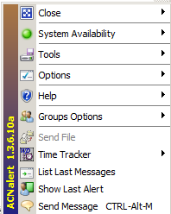



## Software License

**ACNalert**

**Author** : Marcelo Saied & Dimas Aguirre . with the assistance of many friends, testing it.  
  
**Email** : [marcelosaied@gmail.com](mailto:marcelosaied@gmail.com) & [seymoure@gmail.com](mailto:seymoure@gmail.com)   
________________________________________________________

**END-USER LICENSE AGREEMENT FOR THIS SOFTWARE**

This End-User License Agreement ("EULA") is a legal agreement between you (either an individual or a single entity) and the mentioned author of this Software for the software product identified above, which includes computer software and may include associated media, printed materials, and "online" or electronic documentation ("SOFTWARE PRODUCT"). By installing, copying, or otherwise using the SOFTWARE PRODUCT, you agree to be bound by the terms of this EULA. If you do not agree to the terms of this EULA, do not install or use the SOFTWARE PRODUCT.

**SOFTWARE PRODUCT LICENSE**

The SOFTWARE PRODUCT is protected by copyright laws and international copyright treaties, as well as other intellectual property laws and treaties. The SOFTWARE PRODUCT is licensed, not sold.

The definition of SOFTWARE PRODUCT does not includes any files generated by the SOFTWARE PRODUCT, such as compiled script files in the form of standalone executables.

**1. GRANT OF LICENSE**

This EULA grants you the following rights:

Installation and Use. You may install and use an unlimited number of copies of the SOFTWARE PRODUCT.

Reproduction and Distribution. You may reproduce and distribute an unlimited number of copies of the SOFTWARE PRODUCT either in whole or in part; each copy should include all copyright and trademark notices, and shall be accompanied by a copy of this EULA. Copies of the SOFTWARE PRODUCT may be distributed as a standalone product or included with your own product.

Commercial Use. You may use the SOFTWARE PRODUCT for commercial purposes. You may not sell for profit of the SOFTWARE PRODUCT.

Reverse engineering. You may not reverse engineer or disassemble the SOFTWARE PRODUCT.

**2. COPYRIGHT**

All title and copyrights in and to the SOFTWARE PRODUCT (including but not limited to any images, photographs, animations, video, audio, music, text, and "applets" incorporated into the SOFTWARE PRODUCT), the accompanying printed materials, and any copies of the SOFTWARE PRODUCT are owned by the Author of this Software. The SOFTWARE PRODUCT is protected by copyright laws and international treaty provisions. Therefore, you must treat the SOFTWARE PRODUCT like any other copyrighted material.

**MISCELLANEOUS**

If you acquired this product in the United Kingdom, this EULA is governed by the laws of the United Kingdom. If this product was acquired outside the United Kingdom, then local law may apply.

Should you have any questions concerning this EULA, or if you desire to contact the author of this Software for any reason, please contact him/her at the email address mentioned at the top of this EULA.

**LIMITED WARRANTY**

**1. NO WARRANTIES**

The Author of this Software expressly disclaims any warranty for the SOFTWARE PRODUCT. The SOFTWARE PRODUCT and any related documentation is provided "as is" without warranty of any kind, either express or implied, including, without limitation, the implied warranties or merchantability, fitness for a particular purpose, or non-infringement. The entire risk arising out of use or performance of the SOFTWARE PRODUCT remains with you.

**2. NO LIABILITY FOR DAMAGES**

In no event shall the author of this Software be liable for any damages whatsoever (including, without limitation, damages for loss of business profits, business interruption, loss of business information, or any other pecuniary loss) arising out of the use of or inability to use this product, even if the Author of this Software has been advised of the possibility of such damages. Because some states/jurisdictions do not allow the exclusion or limitation of liability for consequential or incidental damages, the above limitation may not apply to you.

[END OF LICENSE]

## Install Directory Structure

Save the file ACNalert.exe in any folder that you have full permissions to read and write. ( no as Administrator). This can be downloaded from <https://dl.dropboxusercontent.com/u/77390425/ACNalert/ACNalert.exe>

|  |  |
| --- | --- |
| **Files and Directories** | **Description** |
| (Top-level files) | |
| ACNalert.exe | The Software main file . the only one needed .  This can be downloaded from <https://dl.dropboxusercontent.com/u/77390425/ACNalert/ACNalert.exe> |
| ACNalert.chm | The help file of the software. This is created when the application runs |
| Config.ini | The configuration file used for some of the versions of the software. This is created when the application runs. Or configured by your system administrator |
| Icon files | They are stored in the temp folder. These are created when the application runs. |
| ACNupdater.exe | Updater application for ACNalert. You will be prompt to do the updates when a new version is released |

## Frequently Asked Questions (FAQ)

This section gives some of the more frequently asked questions.

Send your feedback , questions and requests . Check the “Send Feedback” section , or send mail to [marcelo.saied@accenture.com](mailto:marcelo.saied@accenture.com) , [a.dimas.aguirre@accenture.com](mailto:a.dimas.aguirre@accenture.com) ; [marcelosaied@gmail.com](mailto:marcelosaied@gmail.com) ; [seymoure@gmail.com](mailto:seymoure@gmail.com)

Questions

# Using ACNalert

Sending messages to your team members , followers , any ACNalert user, and from automated scripts or tools.

* Running the application
* The Icons
* The Systray menu
  + Send message
  + Show Last Alert
  + List Last Messages
  + Send Scheduled Message
  + Send File
  + Help
    - Help Document
    - About
    - Update Version
    - Send Feedback
  + Groups Options
    - Create Groups
    - Delete Groups
    - Follow Groups
    - Groups Request Approvals
    - Groups Members
  + Options
    - Settings
    - Alert Status
      * Active
      * Pause
      * Snooze
    - Menu Style
      * Modern
      * Classic
  + Tools
    - Driveinfo
    - Alarm
      * Set Alarm
      * Stop Alarm
    - Banner
      * Banner Settings
      * Banner Messages
      * Start Banner
      * Stop Banner
    - ScreenSaver
      * Active
      * Blocked
    - Percentage ACN
    - ACNalert Radio
    - Stock Values (NYSE)
    - Lync (Autosave conversation history)
      * Active
      * Disabled
  + System Availability  (Accenture CIO version)
    - Outlook 2012 (Cloud)
    - Lync
    - WebMail Connectivity
    - MyTimeAndExpenses
    - Accenture BlackBerry Enterprise
    - Enterprise Sing On
  + Close
    - Restart
    - Exit

## Running the application

After downloading the application , run it.

The aplication will create a folder in “Start” “All Programs” “ACNalert” (Windows 7)

When running ACNalert.exe, you will see in the systray , the ACNalert icon .

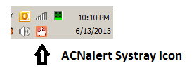

The fist seconds of the application inizialization , you will see the Icon of “starting ACNalert” . Wait for a moment , while the aplication is conecting to the server.

|  |
| --- |
| ATTENTION! The first time running the application you must be connected to the internet. |

If the“starting ACNalert” icon  , don’t change to “ready” icon . Then restart the application from the TASK MANAGER. For more dataills refer to Troubleshuting section.

First time the application connect to the server , you will recive an alert popup , remainding you to join a group.

You can join an existing group , or create a new one . For more dataills refer to “Creating a group” or “Following a group” sections.

## The icons

The Icon represent a status:

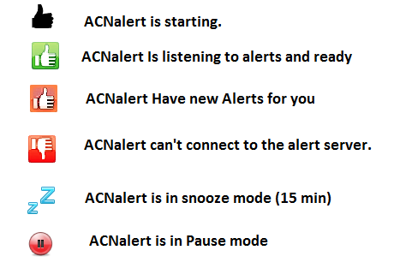

## The popup alert

Information Alert

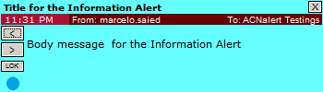

Warning Alert

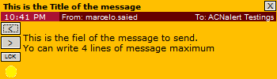

Critical Alert

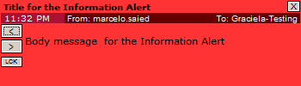

Popup fields

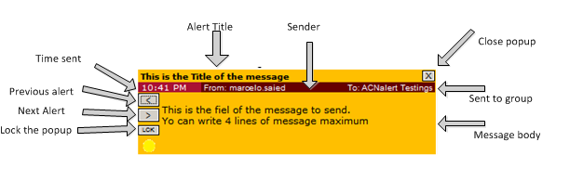

## The Systray Menu



* The Systray menu
  + Send message
  + Show Last Alert
  + List Last Messages
  + Send Scheduled Message
  + Send File
  + Help
    - Help Document
    - About
    - Update Version
    - Send Feedback
  + Groups Options
    - Create Groups
    - Delete Groups
    - Follow Groups
    - Groups Request Approvals
    - Groups Members
  + Options
    - Settings
    - Alert Status
      * Active
      * Pause
      * Snooze
    - Menu Style
      * Modern
      * Classic
  + Tools
    - Driveinfo
    - Alarm
      * Set Alarm
      * Stop Alarm
    - Banner
      * Banner Settings
      * Banner Messages
      * Start Banner
      * Stop Banner
    - ScreenSaver
      * Active
      * Blocked
    - Percentage ACN
    - ACNalert Radio
    - Stock Values (NYSE)
    - Lync (Autosave conversation history)
      * Active
      * Disabled
  + System Availability  (Accenture CIO version)
    - Outlook 2012 (Cloud)
    - Lync
    - WebMail Connectivity
    - MyTimeAndExpenses
    - Accenture BlackBerry Enterprise
    - Enterprise Sing On
  + Close
    - Restart
    - Exit

### Send message

* Open the “Send Message” window . “Menu” “Send Message”
* You can use the Key shortcut ATL+F10 to open this window

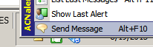

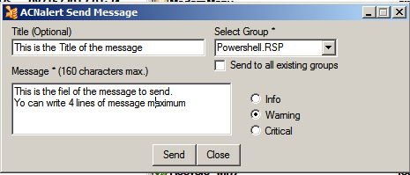

1. Title, is optional.
2. Message. (is not optional ☺)
3. Select a group to send the message. (is not optional ☺)
4. You can Paste text if this fits in the 160 characters limit.
5. Select the priority.
   1.  Critical
   2.  Warning
   3.  Information
6. Send the message.
7. You will receive a confirmation for the message been sent .
8. If you get an error , probably there are network connection issues. Please try again later.
9. The message will be delivered within a minute approximately.

|  |
| --- |
| ATTENTION! Each message you send to a group will taka apoximately a minute to reach the users.  Don’t send more than one alert to the same group too often , because each message you send will replace the previous one. |

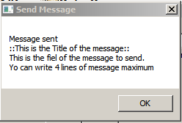

### 

### Show Last Alert

* Open the “Send Message” window. “Menu” “Show Last Alert”
* The last alert popup for each group you are following , will apear.

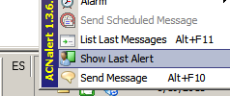

### List last Messages

* Open the “List Last Messages” window. “Menu” “List Last Messages”
* This will list the last 6 hours messages sent to the group you follow.

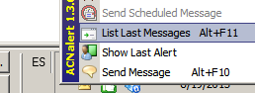

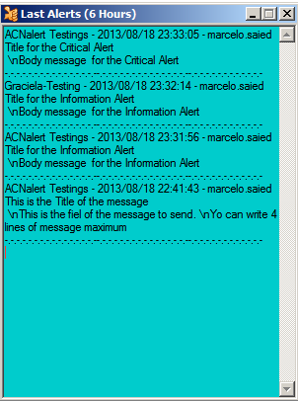

### Send File

(Version 1.3.9.0 and later)





### Help

* Help
  + Help Document
  + About
  + Update Version
  + Send Feedback

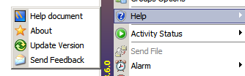

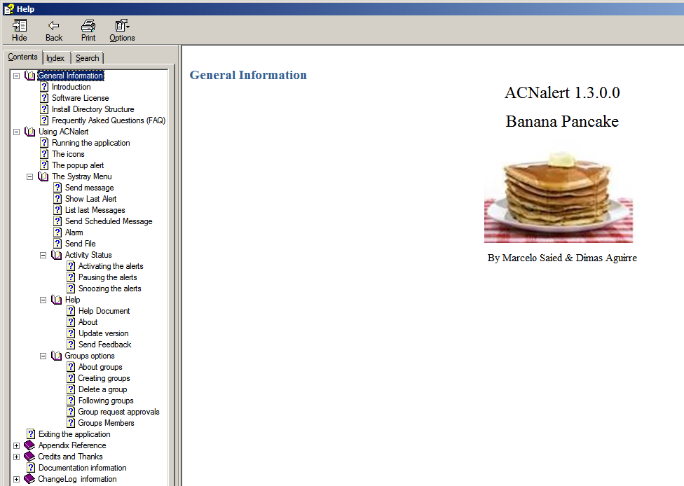

#### Help Document

* To see the Help of the application (This file).
* Open the “Help Document”. “Menu” “Help” “Help Document”

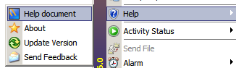

#### About

* To see the “About” and “Credits” for the application.
* Open the “About”. “Menu” “Help” “About”

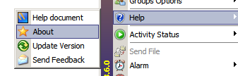

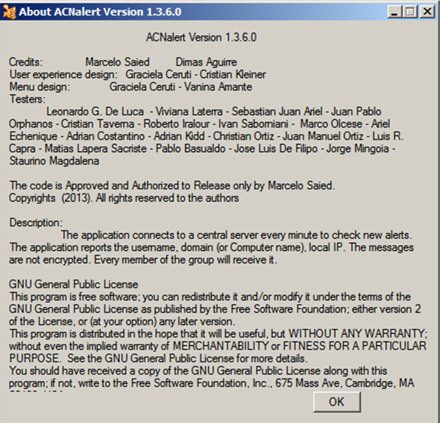

#### Update version



|  |
| --- |
| ATTENTION!   * + - Best practice to update the application version . |

* Updating the application to a new release version.
* A message for a “ACNalert New Version Release” will popup when the application can be updated.

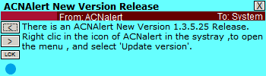

* Open the “Update Version”. “Menu” “Help” “Update Version”

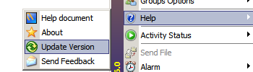

* “ACNalert Updater” application will start.
* Select “Update” to initiate the file download and update.
* The new version can be downloaded manually from
  + <https://dl.dropboxusercontent.com/u/77390425/ACNalert/ACNalert.exe>
  + <https://beta.accenture.com/betasite/ApplicationDetails.aspx?StatusId=1672>
  + Send an email to the Authors, to get a free copy

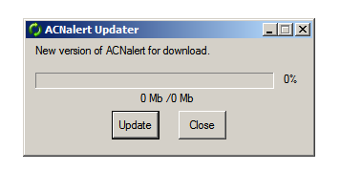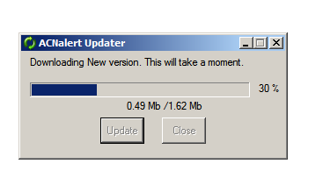

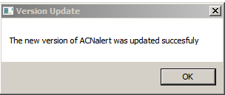

#### Send Feedback

* We appreciate your feedback , and we need it to improve the application to suit the users needs
* To send a feedback. open the menu and select “MENU” “HELP” “SEND FEEDBACK”
* User name and email are optional. But if you thing, it could be helpful to have your mail , so we can contact you.
  + You can directly send us an email to
  + Marcelo N. Saied [marcelosaied@gmail.com](mailto:marcelosaied@gmail.com) [marcelosaied@gmail.com](mailto:marcelosaied@gmail.com)
  + Dimas Aguirre [seymoure@gmail.com](mailto:seymoure@gmail.com) [A.dimas.aguirre@accenture.com](mailto:A.dimas.aguirre@accenture.com)

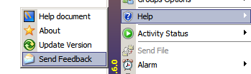

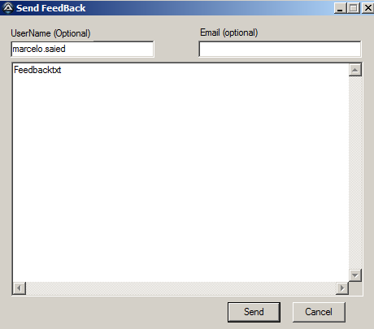

### Groups options

* Groups Options
  + About Groups
  + Create Groups
  + Delete Groups
  + Follow Groups
  + Groups Request Approvals
  + Groups Members

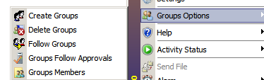

#### About groups



This section explains about the different kind of groups.

* Public Groups.
* Private Groups.
* Restricted Groups.

#### Creating groups

* To Create a group. open the menu and select “MENU” “GROUP OPTIONS” “CREATE GROUP”.

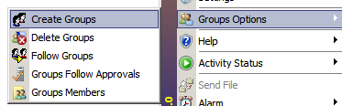

* Input the Group Name.
* Chose if this will be a “Private Group”.
* “Create”.

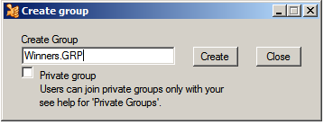

* You will receive a message , if the group was created successfully .

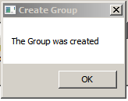

#### Delete a group

* To Delete a group.
  + Open the menu and select “MENU” “GROUP OPTIONS” “DELETE GROUP”.
* You can only delete the groups you Own. These are the ones you have created or the ones you are designed as an owner.
* At the moment you delete the group , all the user will be cleared from this group.

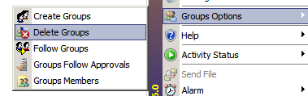

* At the “Delete Groups” window, Select a group to delete.

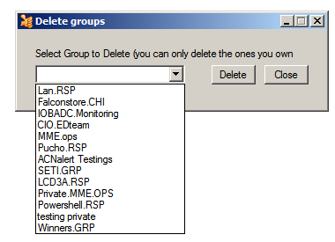

* You will receive a message, if the group was deleted successfully.

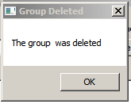

#### Following groups

* To Follow or Un-Follow a group.
  + Open the menu and select “MENU” “GROUP OPTIONS” “FOLLOW GROUPS”

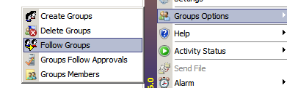

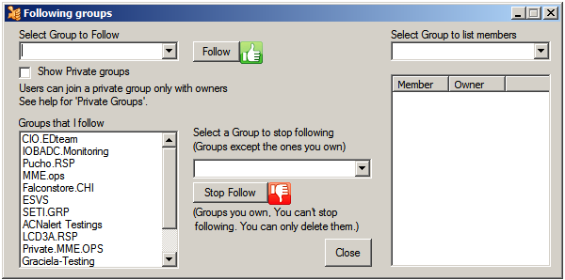

Follow groups

* To see the private groups , select “Show Private Groups”
* Select a group to follow.
* The “ Select Group to list members” will be updated with the group members
* “Follow” button.

Stop following groups

* To see the private groups , select “Show Private Groups”
* Select a group to Un-follow.
* The “ Select Group to list members” will be updated with the group members
* “Stop Follow” button.

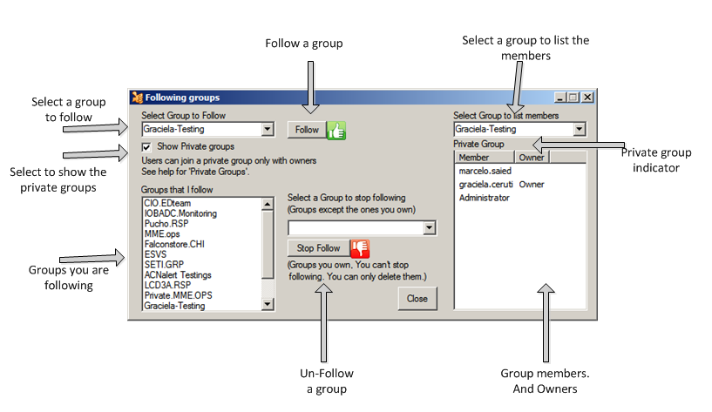

#### Group request approvals

* Private groups , can be followed if the owner approves the group membership.
* The user need to request for approval , to follow a private group. See “Follow Groups” and “About Groups”
* A message for a “Request to Follow” will popup when there is a “Request to follow” pending for approval..

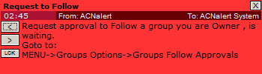

* To approve a user to follow a private group.
  + Open the menu and select “MENU” “GROUP OPTIONS” “GROUP FOLLOW APPROVALS”

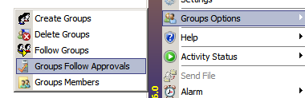

* The “Group Follow Approvals” will open.
* Select the user request , and select “Add to group” or “Deny request”.

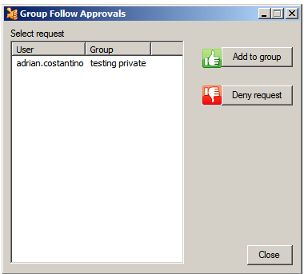

* Confirm to Approve/Deny user request.

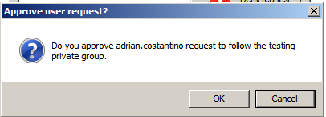

* Confirmation message , if the action success .

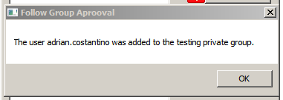

#### Groups Members

* To see the members of a group.
  + Open the menu and select “MENU” “GROUP OPTIONS” “GROUP MEMBERS”

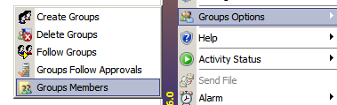

* Select a group to list the members.

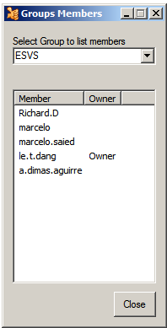

### Options

Configuration options for ACNalert

#### Settings

* Set various settings can be configured in the settings window.
  + Open the menu and select “MENU” “OPTIONS” “SETTINGS”

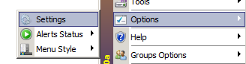

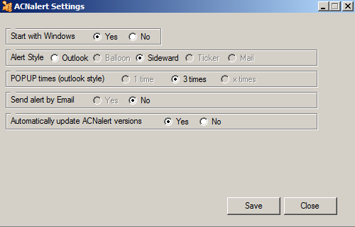

#### Alert Status

* Alert Status
  + Active Alerts
  + Pause Alerts
  + Snooze Alerts

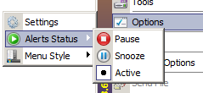

|  |
| --- |
| ATTENTION!   * + - The icon  shows the selected status |

##### **Activating the alerts**

* Set the “Activity status” to “Active”, to receive the Alerts popups.
* “Menu” “Activity status” “Active”

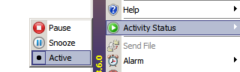

##### **Pausing the alerts**

* Set the “Activity status” to “Pause”, to pause the Alerts popups.
* “Menu” “Activity status” “Pause”
* The icon  will be in the Systray while the alerts are paused

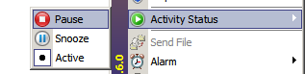

* To start getting alerts again, you need to Activate the alerts by selecting “active” in the “Activity status”
* The icon  will appear in the Systray , and new alerts will popup

##### **Snoozing the alerts**

* Set the “Activity status” to “Snooze ”, to snooze for 15 minutes the Alerts popups.
* “Menu” “Activity status” “Snooze”
* The icon  will be in the Systray while the alerts are snoozed

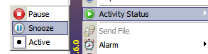

* To start getting alerts again, you need to Activate the alerts by selecting “active” in the “Activity status”
* The icon  will appear in the Systray , and new alerts will popup

### Menu Style

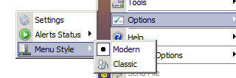

* Setting the Menu style. “MENU” “OPTIONS” “MENU STYLE”
  + Modern
    - Open the menu and select “MENU” “OPTIONS” “MENU STYLE” “Modern”
  + Classic
    - Open the menu and select “MENU” “OPTIONS” “MENU STYLE” “Classic”

Classic Modern

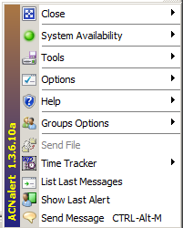 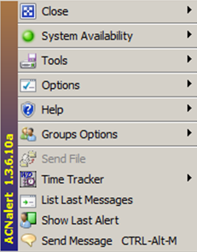

### Tools

Set of useful tools



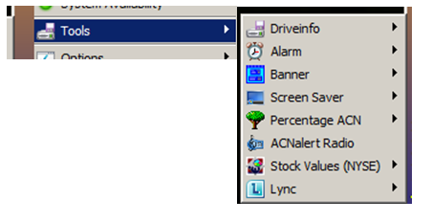

* Driveinfo
* Alarm
  + Set Alarm
  + Stop Alarm
* Banner
  + Banner Settings
  + Banner Messages
  + Start Banner
  + Stop Banner
* ScreenSaver
  + Active
  + Blocked
* Percentage ACN
* ACNalert Radio
* Stock Values (NYSE)
* Lync (Autosave conversation history)
  + Active
  + Disabled

#### Drive Info



* To see free space of fixed drives.
  + Open the menu and select “MENU” “TOOLS” “DRIVEINFO”

#### Alarm

* Personal Alarms can be set with this feature.
* At the time set , a sound alarm will be heared

|  |
| --- |
| ATTENTION!   * The Alarm will sound only once at the time set. * The alarm will be cleared once the time is over. * No alarm will be sound if the application is not running at that time |

Set Alarm

* Open the “Set Alarm” window. “Menu” “Alarm” “Set Alarm”

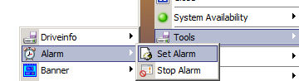

* Set Alarm
  + Select the date and hour for the alarm
  + Select “Once” or “Daily”
  + “Set Alarm”
* Delete Alarm
  + Select the alarm to delete
  + “Delete Alarm”
* The alarm will be cleared once the time is over.
* No alarm will be sound if the application is not running at that time

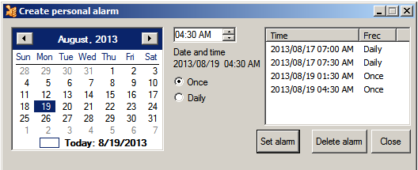

Stop Alarm

* Open the “Stop Alarm” window. “Menu” “Alarm” “Stop Alarm”

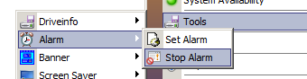

#### Banner



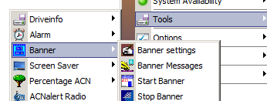

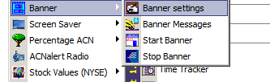

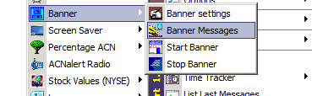

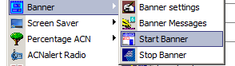

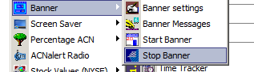

#### Screen Saver

* To Block the Activation of the screensaver
  + Open the menu and select “MENU” “EXTRAS” “SCREEN SAVER” “BLOCK”

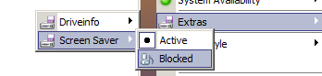

* To Un-Block the Activation of the screensaver
  + Open the menu and select “MENU” “EXTRAS” “SCREEN SAVER” “ACTIVE”



#### Percentage CAN

* To Know the Percentage of people who joined after you did
  + Open the menu and select “MENU” “EXTRAS” “Percentage ACN”

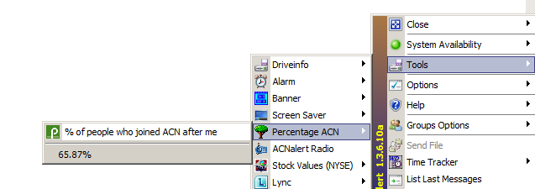

#### ACNalert Radio

* To Know the Percentage of people who joined after you did
  + Open the menu and select “MENU” “EXTRAS” “Radio.Accenture.Com”

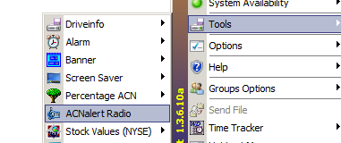

* When the “ACNalert Radio” is maximized

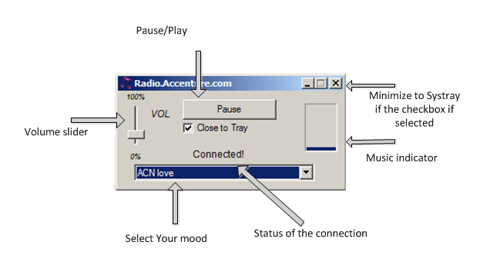

* When The Radio.Accenture.com is minimized to the Systray  the icon will blink if the radio is playing
* To restore the application double click the Systray icon.
* You can pause / Play / close by right click on the icon at the systray

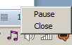

#### Lync

Autosave conversation history





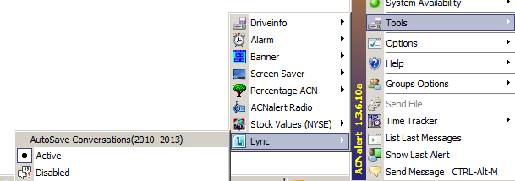

### System Availability

(Accenture CIO version)

* System Availability information is gathered from “Technology Support “ site <https://portal.accenture.com/sites/Portal/support/Pages/TechnologySupport.aspx?IsMobile=0>

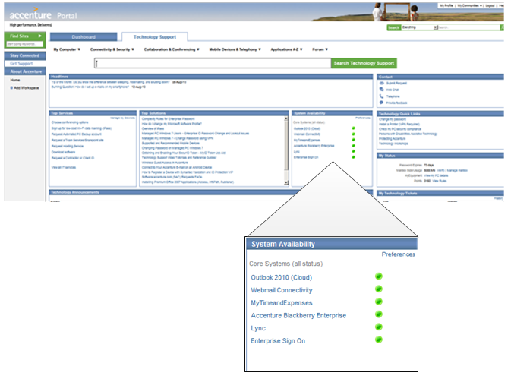

* The information is refreshed every minute
* An alert is sent to all ACNalert Users when there is a change of status

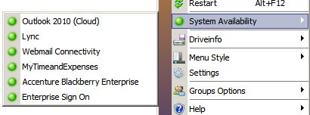

* Outlook 2012 (Cloud)
* Lync
* WebMail Connectivity
* MyTimeAndExpenses
* Accenture BlackBerry Enterprise
* Enterprise Sing On

|  |
| --- |
| ATTENTION!   * + - The data is gathered from “Technology Support site” .     - We relay on this site information     - We do not asure the acurance of the information. |

### Close

#### Restart

(ALT + F12)

* To Restart the application. open the menu and select Restart



|  |
| --- |
| ATTENTION!   * If the application Hangs, use ALT + F12 , or see “Troubleshuting” section |

#### Exit

* To close the application. open the menu and select EXIT



# Appendix Reference

## Troubleshooting

# Credits and Thanks

ACNalert Coding

### Active Authors

* Marcelo N. Saied
* Dimas A. Aguirre

**User experience design**

* Graciela Ceruti
* Cristian Kleiner

**Menu design**

* Vanina Amante
* Graciela Ceruti

:

### Testers

* Leonardo G. De Luca
* Viviana Laterra
* Sebastian Juan Ariel
* Cristian Kleiner
* Graciela Ceruti
* Ariel Echenique
* Ivan Saborniani
* Adrian Costantino
* Adrian Kidd
* Juan Pablo Orphanos
* Cristian G. Taverna
* Roberto P. Iralour
* Marco Olcese
* Luis R. Capra
* Christian Ortiz
* Juan Manuel Ortiz
* Matias Lapera Sacriste
* Pablo Basualdo
* Jose Luis De Filipo
* Jorge Mingoia
* Staurino Magdalena

### Additional Contributions

* Contributions that were submitted to the authors directly or by email.
* -

### Special Thanks

* Everyone who continues to use and support ACNalert.

# Documentation information

|  |  |  |  |
| --- | --- | --- | --- |
| **Title** | ACNalert Help file | **Version** | 1.3.6.0 |
| **Developed by** | Marcelo N. Saied & Dimas A. Aguirre | **Date** | August 19th 2013 |
| **Author of the documentation** | Marcelo N. Saied |  |  |

# ChangeLog information

## Version 1.3.1



Date:

5/12/2013

Version code:

Banana Pancake

Releases notes:

The application server was stress tested , to find issues.

New features:

* None

Bugs Fix:

* Server code was improved for better performance

## Version 1.3.2



Date:

5/19/2013

Version code:

Banana Pancake

Releases notes:

Halt on the features addition , to remediate all existing bugs. Preparing the application for public release.

New features:

* None

Bugs Fix:

* Many few ……

## Version 1.3.3



Date:

5/26/2013

Version code:

Banana Pancake

Releases notes:

Preparing the application for public release.

New features:

* Help file ( the one you are reading now..)
* About updated
* Red-ish icon when there are new alerts

Bugs Fix:

Few may more…

## Version 1.3.4



Date:

6/1/2013

Version code:

Banana Pancake

Releases notes:

Public release to Beta.accenture.com and massive publishing to Accenture users

New features:

* Update new release version feature.

Bugs Fix:

* The old update method was changed. The automatic update , trying to update silently was been recognized as a virus by many antivirus.

## Version 1.3.5



Date:

***6/30/2013***

Version code:

Banana Pancake

Releases notes:

New features:

* New line when typing a message (ctrl+enter)
* StartUp with Windows ( or not) at settings
* Add a shortcut to stratup folder

Bugs Fix:

* Alert message popup when not selecting the group to send the message , and clicked the button to send it.
* Alert message popup when no messages are written , and clicked the button to send it.
* “List Last alerts” label “loading alerts” cleared when there is an alert.
* Show lasts alerts, took too long… now take les time ☺

## Version 1.3.6



Date:

*8/19/2013*

Version code:

Banana Pancake

Releases notes:

New features:

* New Modern Menu
* Easier selection of activity status (Active, Pause, Snooze)
* Set personal Alarm
* Help document updated
* Group members id “Follow groups” and un “group Members”
* Drive Info (Free space of fix drives)
* System availability (Accenture Technology Support information)
  + Outlook 2012 (Cloud)
  + Lync
  + WebMail Connectivity
  + MyTimeAndExpenses
  + Accenture BlackBerry Enterprise
  + Enterprise Sing On
* User membership by Domain\User
* Popup functionality
  + Previous message
  + Next message
  + Lock popup
  + Close popup
  + Alerts Colors

Bugs Fix:

* Change to event driven functionality
* Popup lock
* Memory leak
* Messages improved

## Version 1.3.6.5



Date:

*9/30/2013*

Version code:

Banana Pancake

Releases notes:

New features:

* + ScreenSaver Activation blocker
  + “Set Alarm”
    - Better Sounds ☺
  + Percentage ACN
  + Radio.Accenture.Com ( part 1)

Bugs Fix:

* When the computer is locked , do not check for new alerts
* Percentage ACN , to show stored data when the site or connection is not available

## Version 1.3.6.6



Version code:

Banana Pancake

Releases notes:

New features:

* Lync Autosave for LYNC 2010
* AutoUpdate version option (check "Settings" on MENU->HELP->SETTINGS)
* Uninstall (on MENU->HELP->UNISTALL)
* "What's New" in the version release (on MENU->HELP->WHATS NEW)

Bugs Fix:

* Fix SET ALERT - sounds issues
* Fix Update method
* Delete unused icons from the systray
* "Group Request approval" false alerts
* ACN Percentage not updating. temporarily disabled till a solution is found

## Version 1.3.6.7



Version code:

Banana Pancake

Releases notes:

New features:

* AutoUpdate version option (check "Settings" on MENU->HELP->SETTINGS)
* Uninstall (on MENU->HELP->UNISTALL)
* "What's New" in the version release (on MENU->HELP->WHATS NEW)

Bugs Fix:

* Fix ACN NYSE feature
* Fix alerts for messages without title
* "Group Request approval" false alerts
* ACN Percentage not updating. temporarily disabled till a solution is found

## Version 1.3.6.8



Version code:

Banana Pancake

Releases notes:

Attention !! Expected some issues with following groups. May be necesary to delete the group and create it again

New features:

* Improved user authentication
* AutoUpdate version option (check "Settings" on MENU->HELP->SETTINGS)
* Active Ticker Banner ( for Signage Boards)
* "What's New" in the version release (on MENU->HELP->WHATS NEW)

Bugs Fix:

* Fix ESC Conversation save for Lync
* Fix alerts for messages without title
* "Group Request approval" false alerts
* Performance issues
* ACN Percentage not updating. temporarily disabled till a solution is found

.

## Version 1.3.6.9



Version code:

Banana Pancake

Releases notes:

New features:

* Lync Autosave for LYNC 2013
* Reordering the menu
* change of shortcuts for "send message" and "List last messages"
* Active Ticker Banner ( for Signage Boards)
* "What's New" in the version release (on MENU->HELP->WHATS NEW)

Bugs Fix:

* Fix ESC Conversation save for Lync
* Fix Banner refresh
* Performance issues with Autosave for Lync
* ACN Percentage not updating. temporarily disabled till a solution is found

## Version 1.3.6.10



Version code:

Banana Pancake

Releases notes:

New features:

* Time Tracker (prototype)
* Lync Autosave for LYNC 2013
* Active Ticker Banner ( for Signage Boards)

Bugs Fix:

* Reordering the menu
* Fix Banner refresh
* After the computer enters in sleep mode (close laptop lid), the Lync conversation where not been saved.
* "Update version" option fix
* Performance network issues
* shortcut change (problem with writing special polish leter "L" )
* ACN Percentage not updating. temporarily disabled till a solution is found

## Version 1.3.6.11



Version code:

Banana Pancake

Date:

1/1/2014

Releases notes:

Addition of a third server

New features:

* Time Tracker (Pass 1)
* ACN Percent reloaded
* Stocktracker - Ticker NYSE values (for milloners)
* ACNaler Radio ( Ex Radio.accenture.com)

Bugs Fix:

* Reordering the menu
* Stock time report (check every 20 min) last time checked
* banner refresh issues
* Lync auto save improvement
* After the computer enter in sleep mode (close laptop lid), the Lync conversation where not been saved.
* "Update version" option fix
* Performance network issues
* Update help document
* “Select Groups” Selection dropdownbox mistaken groups
* "Outlook Style" Importance , title indicators