Measurement overview!

* Measurement date: 2023-11-28
* Random seed: 1
* Number of PCA calculated features: 0
* Outliert detection per bin: True
* Autosklearn runtime per dataset: 1800 seconds
* Autosklearn time limit per algorithm: 180 seconds

# Results for merged-files

* Input data file name: merged-files-final-2022-07-06.csv
* Input data file creation date: 2022-07-06
* Number of processed data points: 2910

### R2 results for merged-files

|  |  |  |  |  |
| --- | --- | --- | --- | --- |
|  | basic-subset | extension | location | extension-location |
| nn | 0.7457 | 0.7997 | 0.7842 | 0.8206 |
| manual | 0.7628 | 0.7927 | 0.8122 | 0.8291 |
| autosklearn | 0.7636 | 0.7934 | 0.8071 | 0.8337 |
| autogluon | 0.7532 | 0.7957 | 0.8004 | **0.8452** |
| flaml | 0.7619 | 0.7558 | 0.8101 | 0.775 |
| autokeras | 0.6138 | 0.6541 | 0.6044 | 0.6402 |

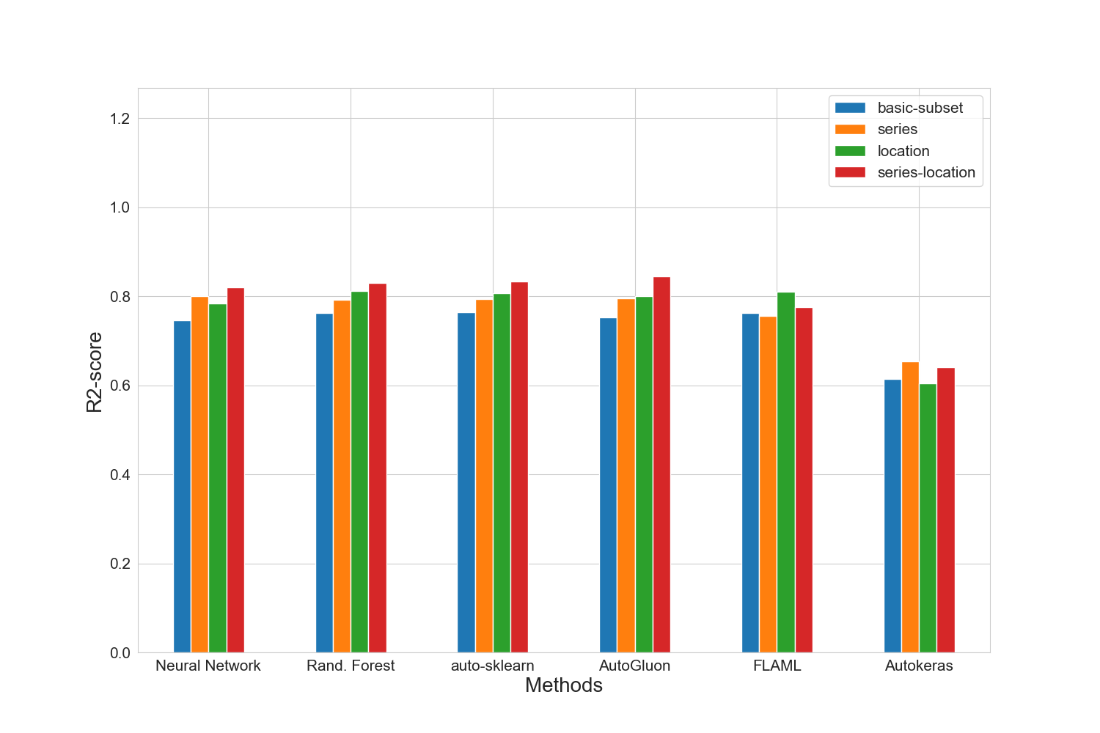

### MAE results for merged-files

|  |  |  |  |  |
| --- | --- | --- | --- | --- |
|  | basic-subset | extension | location | extension-location |
| nn | 15848.4 | 14315.8 | 14645.6 | 13169.0 |
| manual | 14813.2 | 14042.0 | 13228.2 | 12547.4 |
| autosklearn | 15089.4 | 13993.6 | 13334.6 | 12359.2 |
| autogluon | 15070.6 | 13834.0 | 13542.2 | **12011.4** |
| flaml | 14983.8 | 15245.0 | 13501.4 | 14534.4 |
| autokeras | 18778.4 | 17762.8 | 19376.0 | 17720.6 |

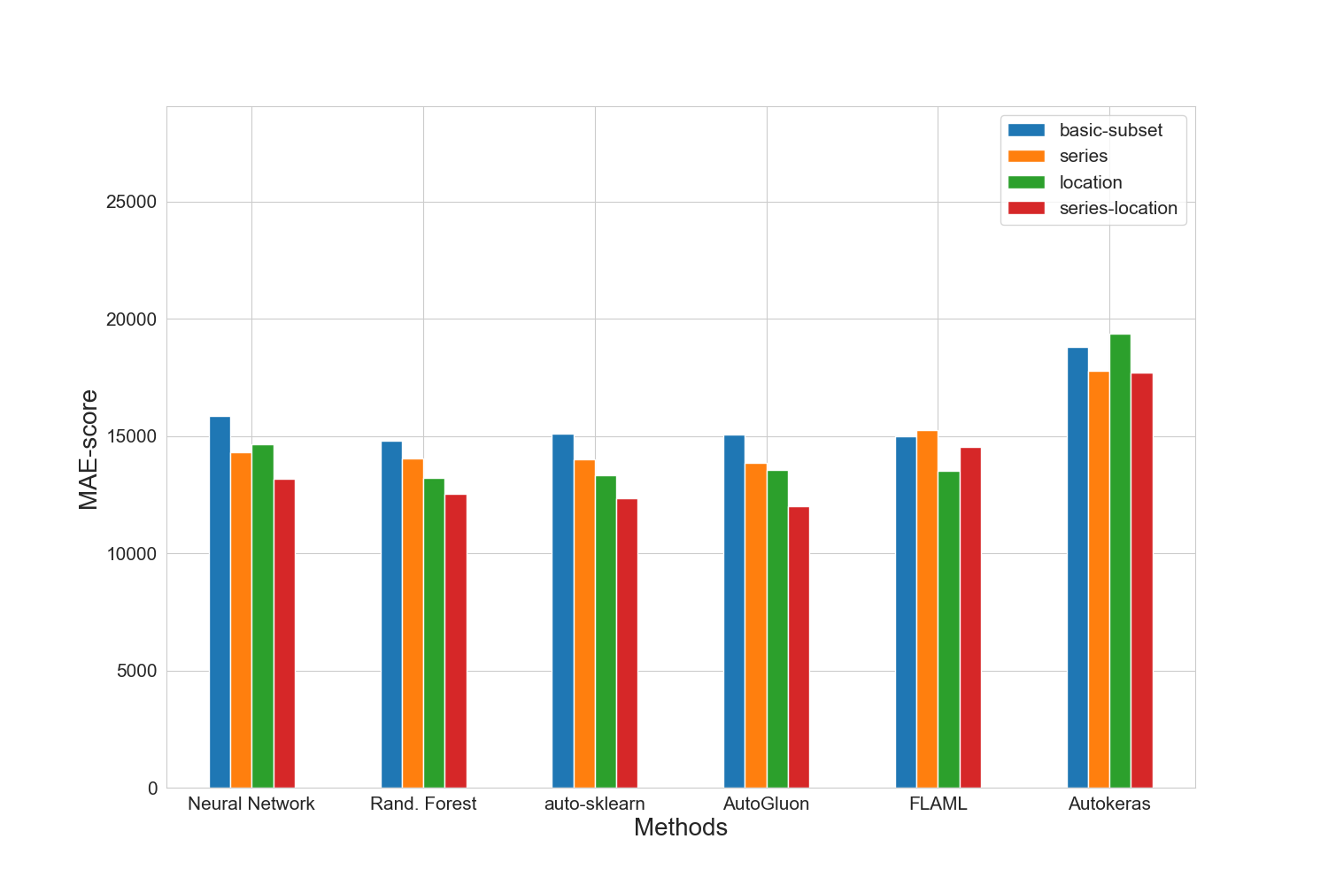

### MAPE results for merged-files

|  |  |  |  |  |
| --- | --- | --- | --- | --- |
|  | basic-subset | extension | location | extension-location |
| nn | 0.1839 | 0.1734 | 0.1699 | 0.157 |
| manual | 0.1717 | 0.1663 | 0.1574 | 0.1512 |
| autosklearn | 0.1764 | 0.1676 | 0.1586 | 0.1502 |
| autogluon | 0.1669 | 0.1591 | 0.1562 | **0.1429** |
| flaml | 0.1744 | 0.1749 | 0.1588 | 0.1717 |
| autokeras | 0.2131 | 0.2099 | 0.2381 | 0.2149 |

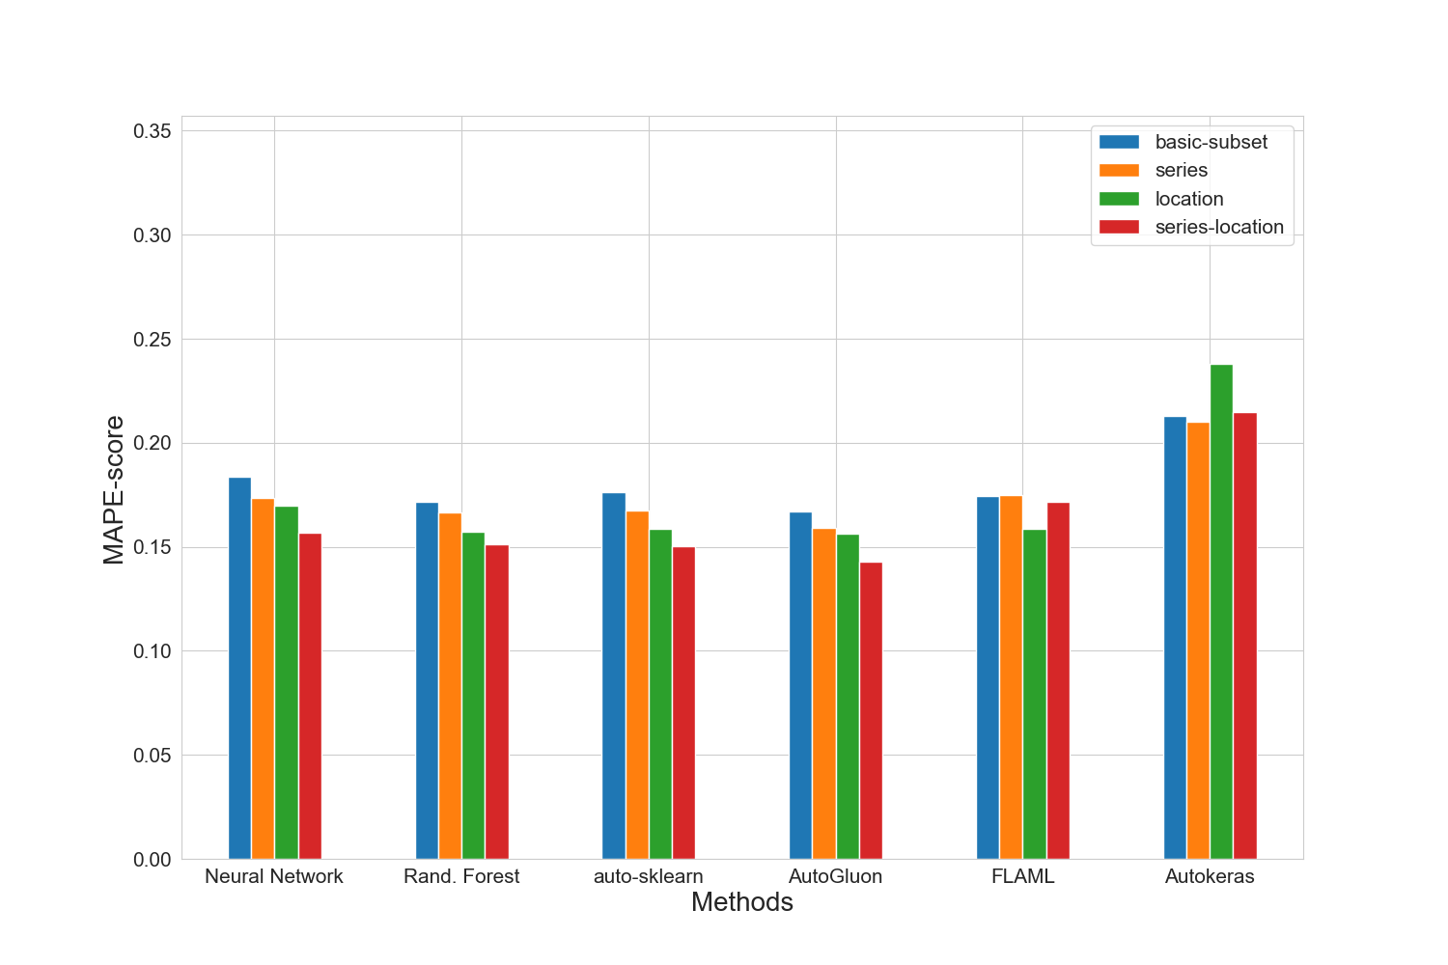

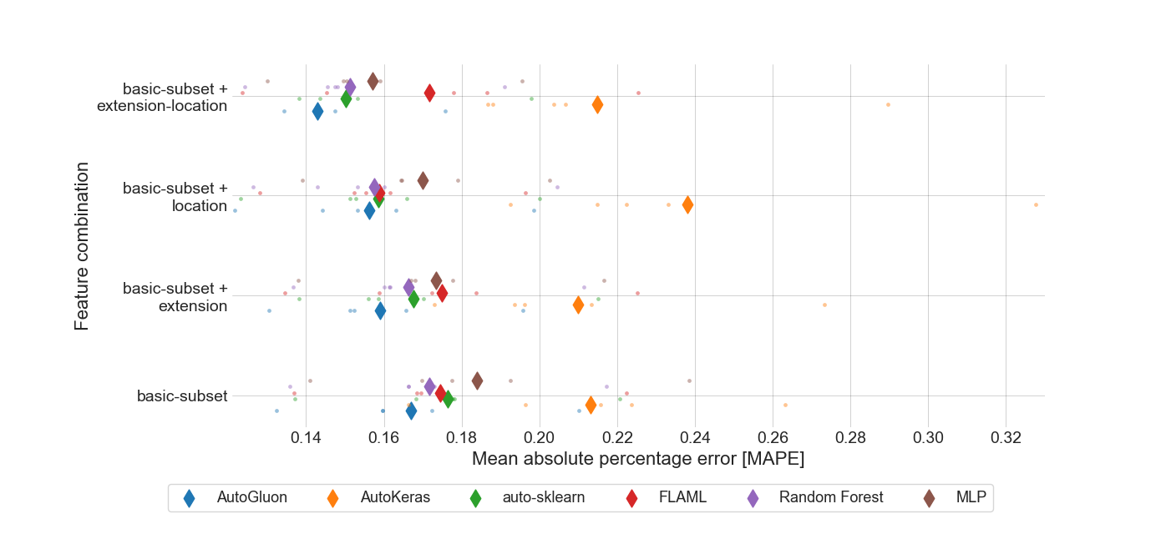

### RMSE results for merged-files

|  |  |  |  |  |
| --- | --- | --- | --- | --- |
|  | basic-subset | extension | location | extension-location |
| nn | 23343.6 | 20672.8 | 21443.6 | 19546.8 |
| manual | 22539.6 | 21054.4 | 19997.8 | 19131.2 |
| autosklearn | 22495.8 | 21048.6 | 20327.4 | 18837.8 |
| autogluon | 22951.4 | 20865.6 | 20558.2 | **18149.0** |
| flaml | 22587.4 | 22893.2 | 20129.0 | 21933.0 |
| autokeras | 28773.6 | 27098.2 | 29049.4 | 27505.2 |

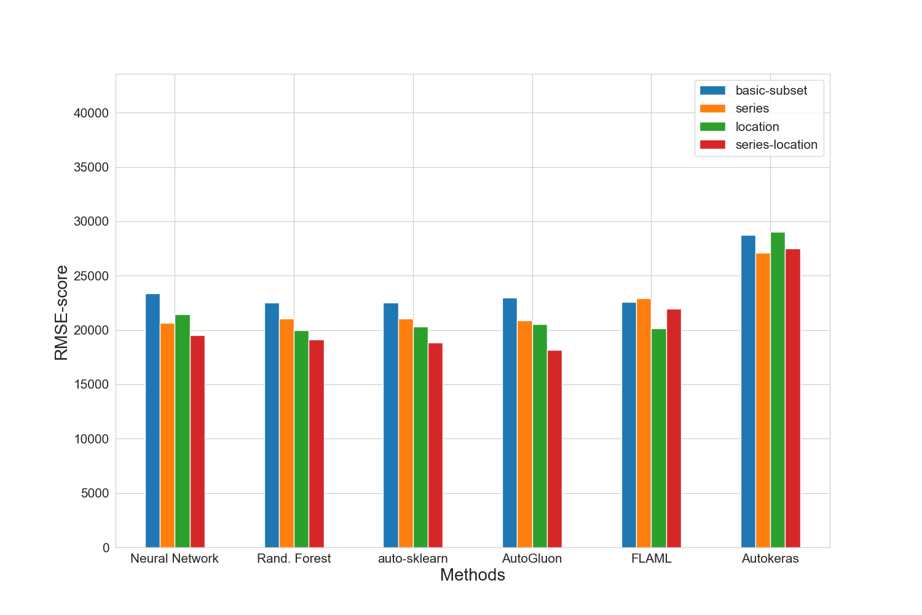

### Training run-time of each method and feature subset in seconds for merged-files

|  |  |  |  |  |
| --- | --- | --- | --- | --- |
|  | basic-subset | extension | location | extension-location |
| nn | 2167.6 | 1197.4 | 1604.8 | 1248.4 |
| manual | 381.2 | 800.2 | 877.0 | 1161.3 |
| autosklearn | 2228.9 | 2032.8 | 2048.6 | 1905.1 |
| autogluon | 13.0 | 15.2 | 17.3 | 18.5 |
| flaml | 1800.2 | 1800.0 | 1800.3 | 1801.4 |
| autokeras | 69.3 | 65.9 | 65.7 | 66.1 |

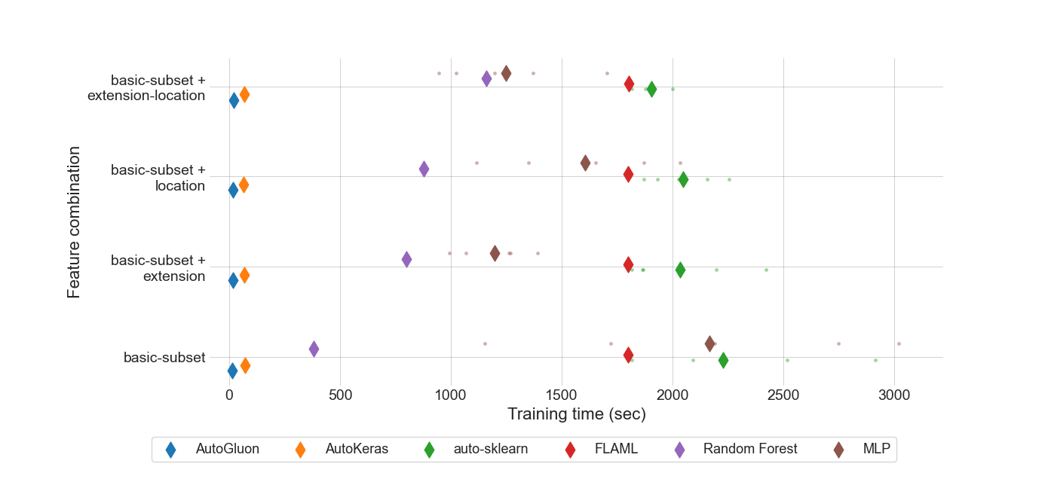

### Prediction time of each method and feature subset in seconds for merged-files

|  |  |  |  |  |
| --- | --- | --- | --- | --- |
|  | basic-subset | extension | location | extension-location |
| nn | 6.553e-07 | 6.597e-07 | 6.984e-07 | 8.934e-07 |
| manual | 2.73015e-05 | 1.63544e-05 | 3.34833e-05 | 4.2145e-05 |
| autosklearn | 0.0010649249 | 0.0008728914 | 0.0011290908 | 0.0097545068 |
| autogluon | 0.0002561124 | 0.0004645369 | 0.0004363247 | 0.0005880874 |
| flaml | 1.99093e-05 | 2.13807e-05 | 3.16738e-05 | 3.41781e-05 |
| autokeras | 0.0014354434 | 0.0016045755 | 0.0015931303 | 0.0017561341 |

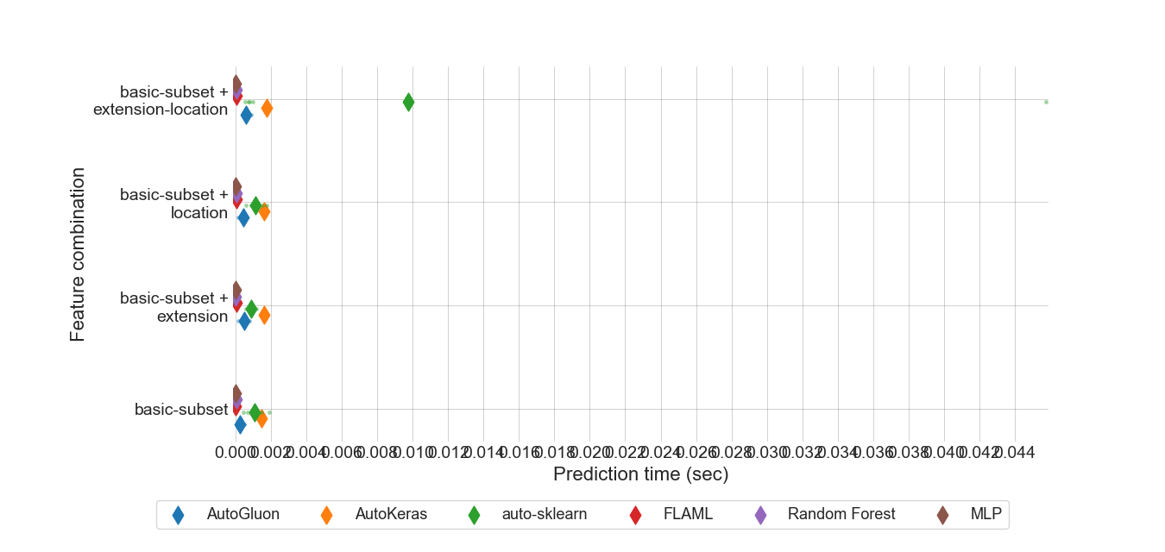

### MEV results for all feature sets.

|  |  |  |  |  |
| --- | --- | --- | --- | --- |
|  | basic-subset | extension | location | extension-location |
| nn | 0.928737 | 0.871958 | 0.835119 | 0.830816 |
| manual | 0.819965 | 0.835505 | 0.773343 | 0.812749 |
| autosklearn | 0.67389 | 0.659238 | 0.593053 | 0.609465 |
| autogluon | 0.552183 | 0.539738 | **0.488858** | 0.493451 |
| flaml | 0.649964 | 0.665175 | 0.581353 | 0.654045 |
| autokeras | 0.663109 | 0.663242 | 0.663207 | 0.66347 |

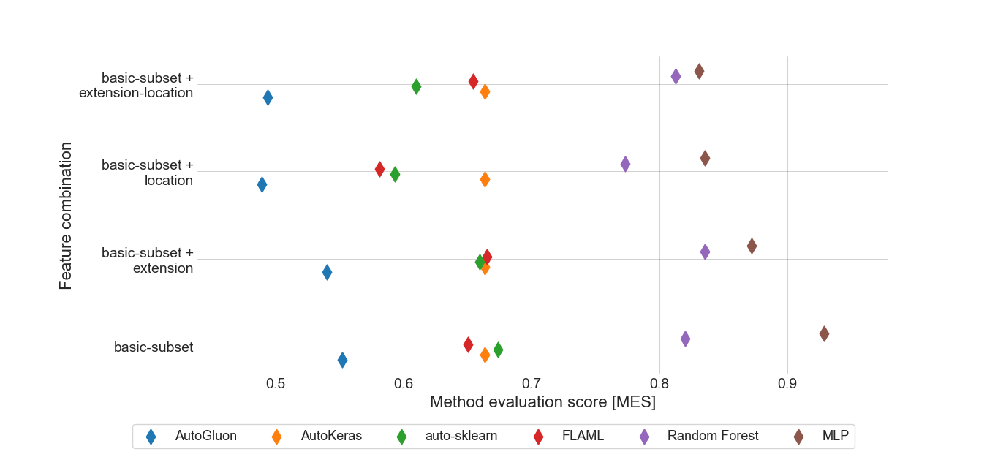

### Standard deviation for MAPE results for location feature set.

|  |  |
| --- | --- |
|  | location |
| autogluon | 0.0252633 |
| autokeras | 0.0466958 |
| autosklearn | 0.02495768 |
| flaml | 0.02198718 |
| manual | 0.02614019 |
| nn | 0.02083775 |

### Boxplot for MAPE results for location feature set.

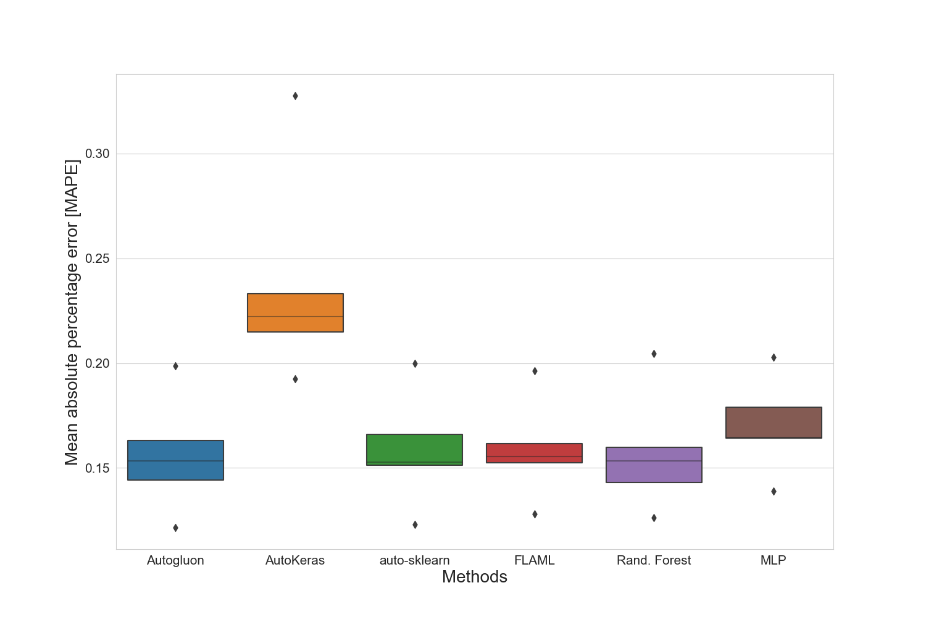

### Standard deviation for training time for location feature set.

|  |  |
| --- | --- |
|  | location |
| autogluon | 3.83593177 |
| autokeras | 0.07118314 |
| autosklearn | 140.84043054 |
| flaml | 0.7091784 |
| manual | 3.80405736 |
| nn | 334.95808468 |

### Standard deviation for prediction time for location feature set.

|  |  |
| --- | --- |
|  | location |
| autogluon | 0.000155355454 |
| autokeras | 3.273313e-06 |
| autosklearn | 0.000427471426 |
| flaml | 3.613797e-06 |
| manual | 1.454741e-05 |
| nn | 5.8784e-08 |

### Best manual model for merged-files

|  |
| --- |
| Best manual model |
| RandomForestRegressor(max_features=15, min_samples_split=3, n_estimators=168) |

### Best NN parameter set for merged-files

|  |  |  |  |
| --- | --- | --- | --- |
| Activation | Hidden-layer-size | Learning rate | Solver |
| relu | (10, 10, 10, 10, 10) | 0.0001 | adam |

### Best results for merged-files

|  |  |  |  |  |  |  |  |
| --- | --- | --- | --- | --- | --- | --- | --- |
|  | R2-Score | MAPE | MAE | RMSE | N-RMSE | IQR-RMSE | CV-RMSE |
| Feature-Set | extension-location | extension-location | extension-location | extension-location | extension-location | extension-location | extension-location |
| Method | autogluon | autogluon | autogluon | autogluon | autogluon | autogluon | autogluon |
| Value | 0.8452 | 0.1429 | 12011.4 | 18149.0 | 0.0658 | 0.3096 | 0.1937 |

# Summary of the best results for all data sets

|  |  |  |  |  |  |  |  |  |
| --- | --- | --- | --- | --- | --- | --- | --- | --- |
|  | # data points | R2-Score | MAPE | MAE | RMSE | N-RMSE | IQR-RMSE | CV-RMSE |
| merged-files | 2910 | **0.8452** | **0.1429** | **12011.4** | **18149.0** | **0.0658** | **0.3096** | **0.1937** |

# Statistics for all data sets

|  |  |  |  |  |  |  |
| --- | --- | --- | --- | --- | --- | --- |
|  | # data points | Mean | Median | Std. diviation | Max | Min |
| merged-files | 2910 | 92522 | 80000 | 46927 | 453434 | 1000 |