Measurement overview!

* Measurement date: 2023-11-30
* Random seed: 1
* Number of PCA calculated features: 0
* Outliert detection per bin: True

# Results for merged-files

* Input data file name: merged-files-final-2023-11-30.csv
* Input data file creation date: 2023-11-30
* Number of processed data points: 2813

### R2 results for merged-files

|  |  |  |  |  |
| --- | --- | --- | --- | --- |
|  | basic-subset | extension | location | extension-location |
| nn | 0.7395 | 0.7562 | 0.7373 | 0.7858 |
| manual | 0.7573 | 0.7781 | 0.7851 | **0.8125** |
| autosklearn | 0.7515 | 0.7827 | 0.7869 | 0.8106 |
| autogluon | 0.7568 | 0.7875 | 0.7918 | 0.8105 |
| flaml | 0.754 | 0.7373 | 0.7761 | 0.7441 |
| autokeras | 0.623 | 0.6638 | 0.5897 | 0.6379 |

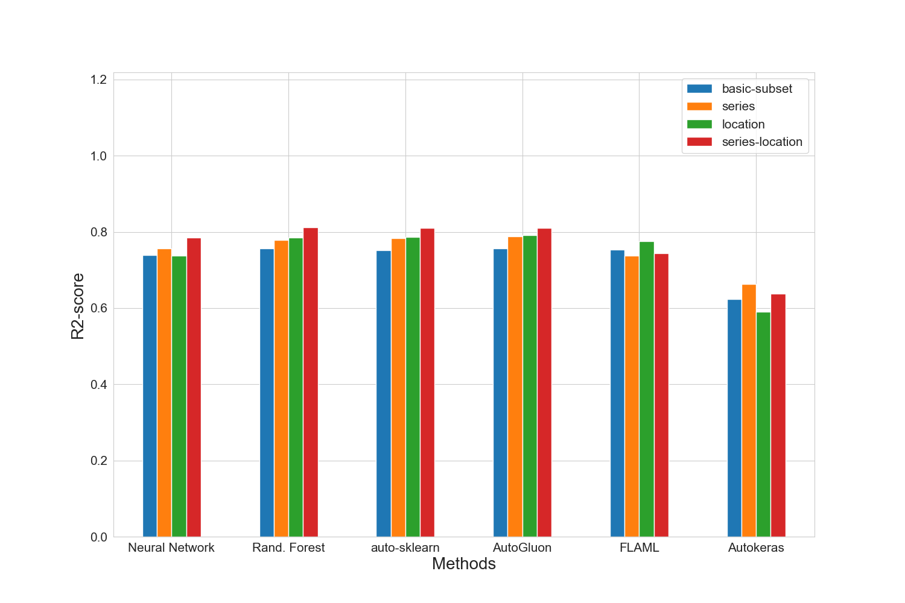

### MAE results for merged-files

|  |  |  |  |  |
| --- | --- | --- | --- | --- |
|  | basic-subset | extension | location | extension-location |
| nn | 14062.2 | 13669.8 | 14196.8 | 12774.2 |
| manual | 13523.8 | 13041.4 | 12475.0 | 11818.4 |
| autosklearn | 13600.8 | 12920.0 | 12506.0 | 11964.6 |
| autogluon | 13446.8 | 12560.4 | 12043.6 | **11589.0** |
| flaml | 13631.0 | 14082.4 | 12871.0 | 14149.8 |
| autokeras | 16747.6 | 15441.0 | 17168.6 | 16010.2 |

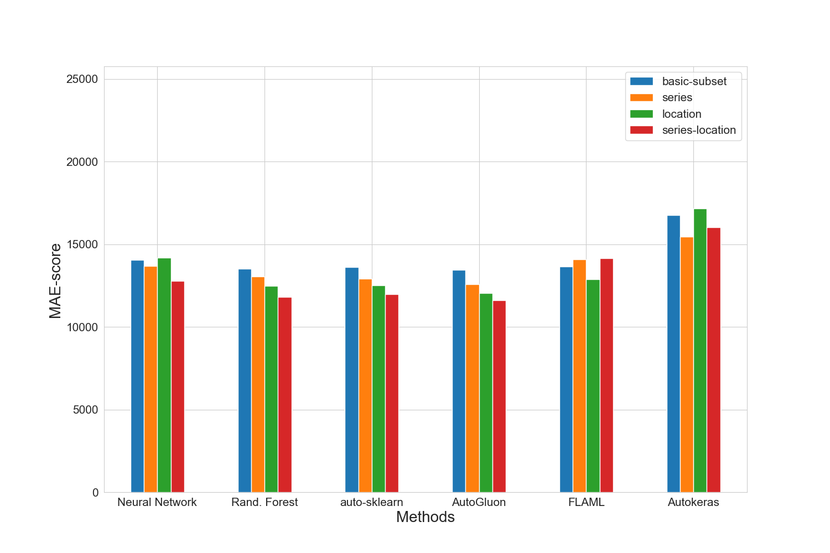

### MAPE results for merged-files

|  |  |  |  |  |
| --- | --- | --- | --- | --- |
|  | basic-subset | extension | location | extension-location |
| nn | 0.1771 | 0.1709 | 0.1752 | 0.1585 |
| manual | 0.171 | 0.1675 | 0.1585 | 0.1515 |
| autosklearn | 0.1724 | 0.1649 | 0.16 | 0.1543 |
| autogluon | 0.1634 | 0.155 | 0.1492 | **0.1465** |
| flaml | 0.1719 | 0.1695 | 0.1635 | 0.1745 |
| autokeras | 0.2083 | 0.1881 | 0.207 | 0.196 |

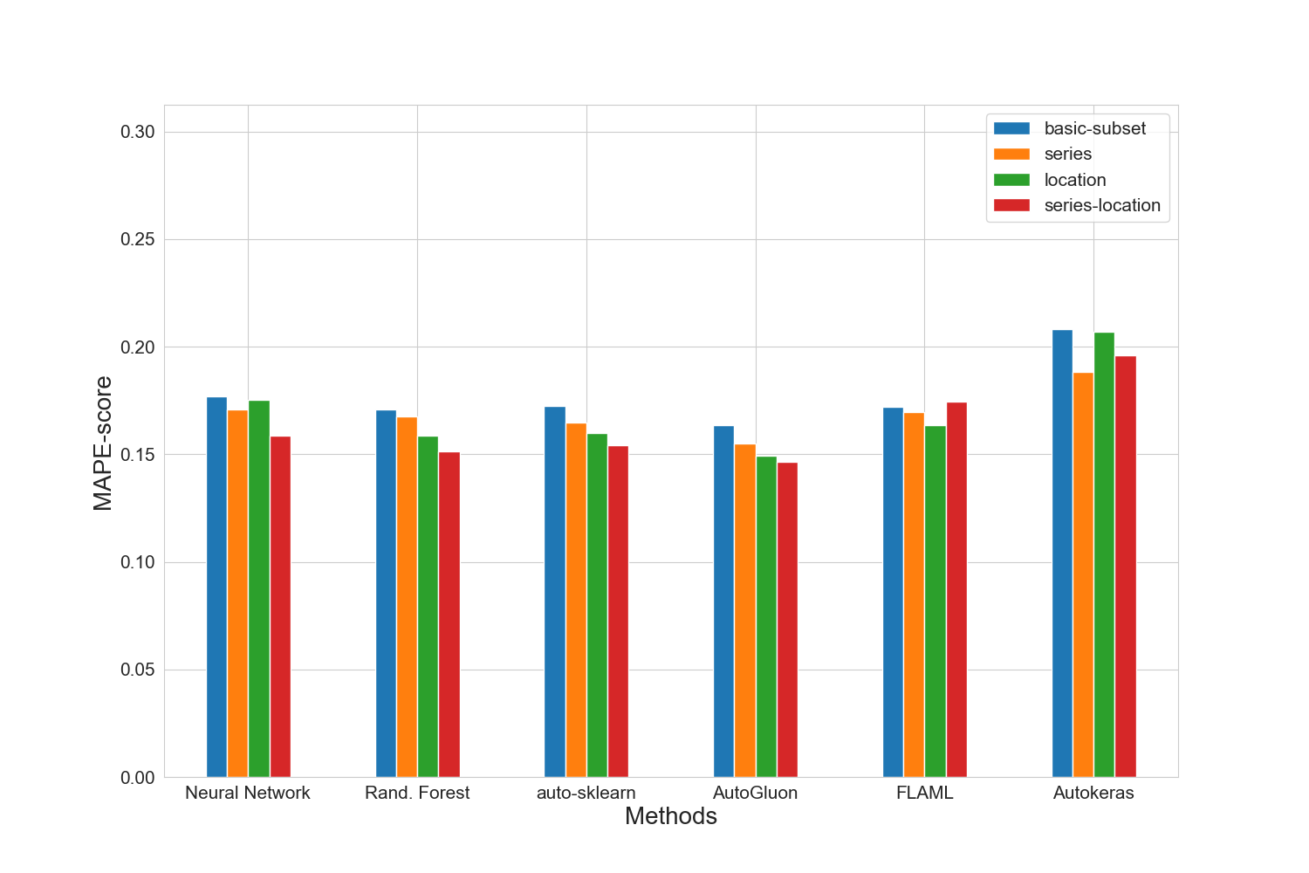

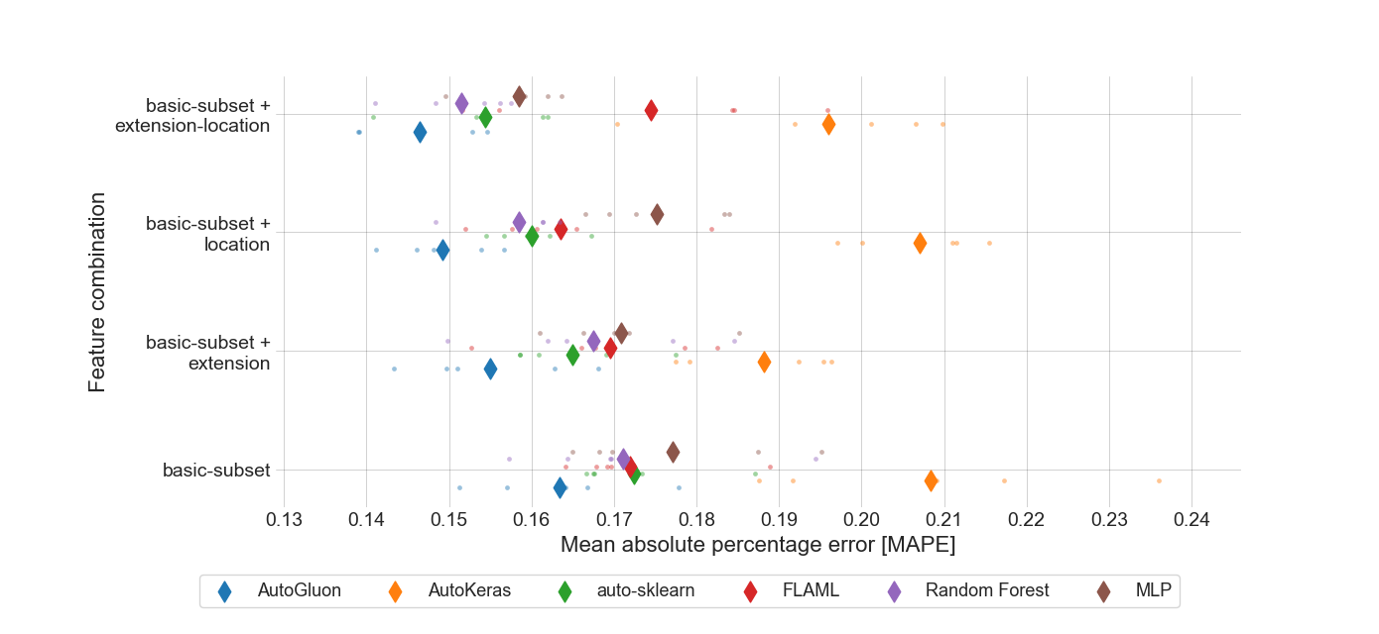

### RMSE results for merged-files

|  |  |  |  |  |
| --- | --- | --- | --- | --- |
|  | basic-subset | extension | location | extension-location |
| nn | 19761.2 | 19147.8 | 19836.2 | 17929.0 |
| manual | 19102.8 | 18277.2 | 17945.8 | **16776.2** |
| autosklearn | 19323.6 | 18075.8 | 17873.4 | 16835.2 |
| autogluon | 19114.4 | 17871.8 | 17653.2 | 16865.0 |
| flaml | 19220.4 | 19772.2 | 18262.4 | 19416.4 |
| autokeras | 23829.6 | 22474.0 | 24832.2 | 23313.2 |

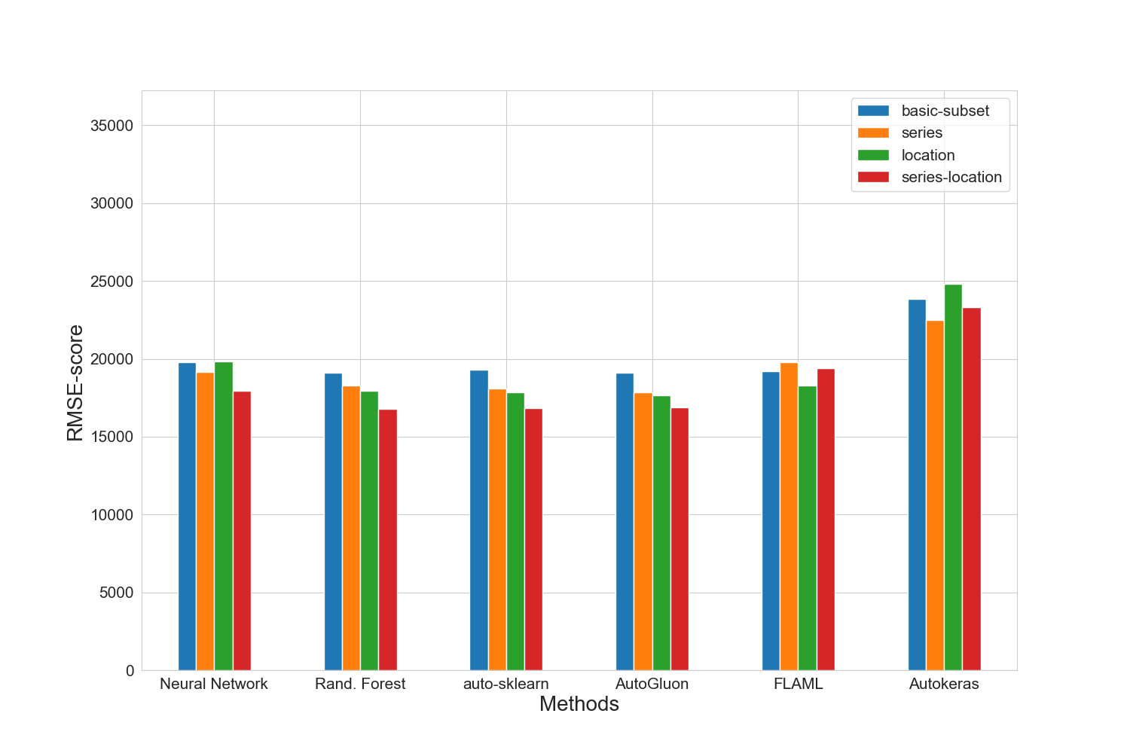

### Training run-time of each method and feature subset in seconds for merged-files

|  |  |  |  |  |
| --- | --- | --- | --- | --- |
|  | basic-subset | extension | location | extension-location |
| nn | 1283.4 | 857.9 | 950.6 | 752.3 |
| manual | 353.7 | 740.3 | 836.0 | 1641.9 |
| autosklearn | 1869.5 | 2000.6 | 2185.3 | 2292.0 |
| autogluon | 14.5 | 17.0 | 19.9 | 21.7 |
| flaml | 1800.2 | 1800.8 | 1801.4 | 1802.1 |
| autokeras | 64.7 | 64.2 | 64.2 | 64.6 |

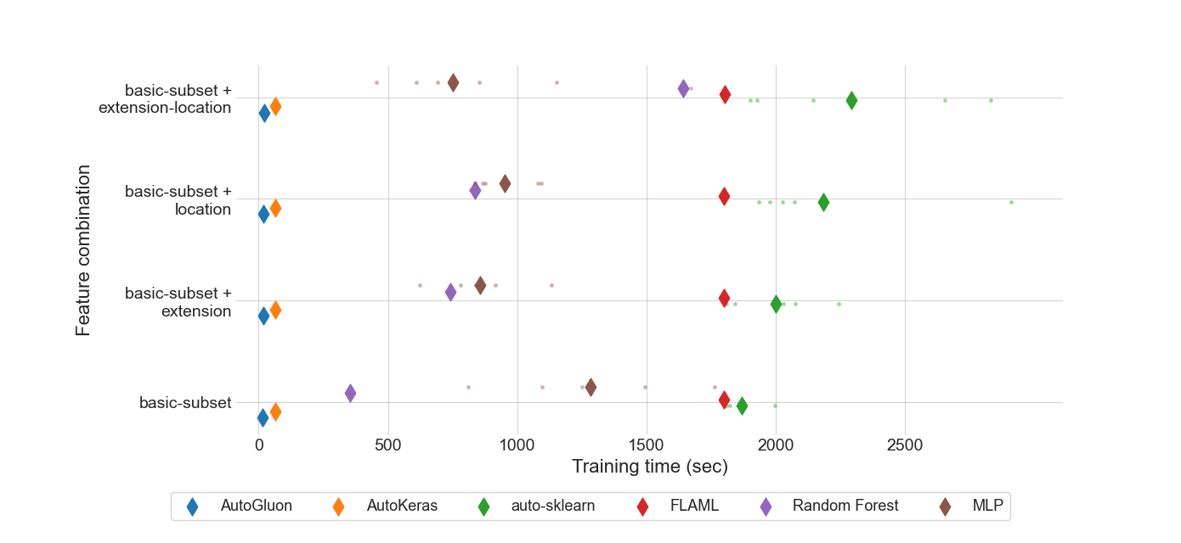

### Prediction time of each method and feature subset in seconds for merged-files

|  |  |  |  |  |
| --- | --- | --- | --- | --- |
|  | basic-subset | extension | location | extension-location |
| nn | 7.776e-07 | 8.382e-07 | 9.074e-07 | 7.9e-07 |
| manual | 2.08765e-05 | 1.54774e-05 | 4.28206e-05 | 3.12191e-05 |
| autosklearn | 0.0007386382 | 0.0012763429 | 0.0018427541 | 0.0010438148 |
| autogluon | 0.0002683174 | 0.0004477858 | 0.0004449078 | 0.000397369 |
| flaml | 2.05114e-05 | 2.75928e-05 | 2.88519e-05 | 3.58047e-05 |
| autokeras | 0.0014939494 | 0.0016604466 | 0.0016737664 | 0.0018253468 |

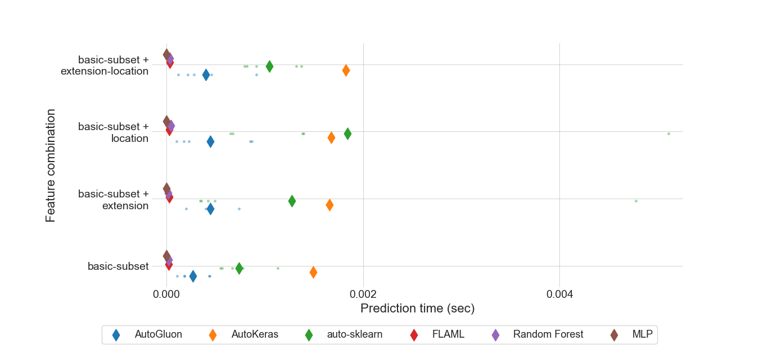

### MEV results for all feature sets.

|  |  |  |  |  |
| --- | --- | --- | --- | --- |
|  | basic-subset | extension | location | extension-location |
| nn | 0.893757 | 0.897162 | 0.866688 | 0.83716 |
| manual | 0.829385 | 0.882246 | 0.821106 | 0.858116 |
| autosklearn | 0.673826 | 0.698331 | 0.646473 | 0.653622 |
| autogluon | 0.552998 | 0.572865 | **0.521297** | 0.534671 |
| flaml | 0.668919 | 0.700571 | 0.63736 | 0.683779 |
| autokeras | 0.663461 | 0.663209 | 0.662938 | 0.662818 |

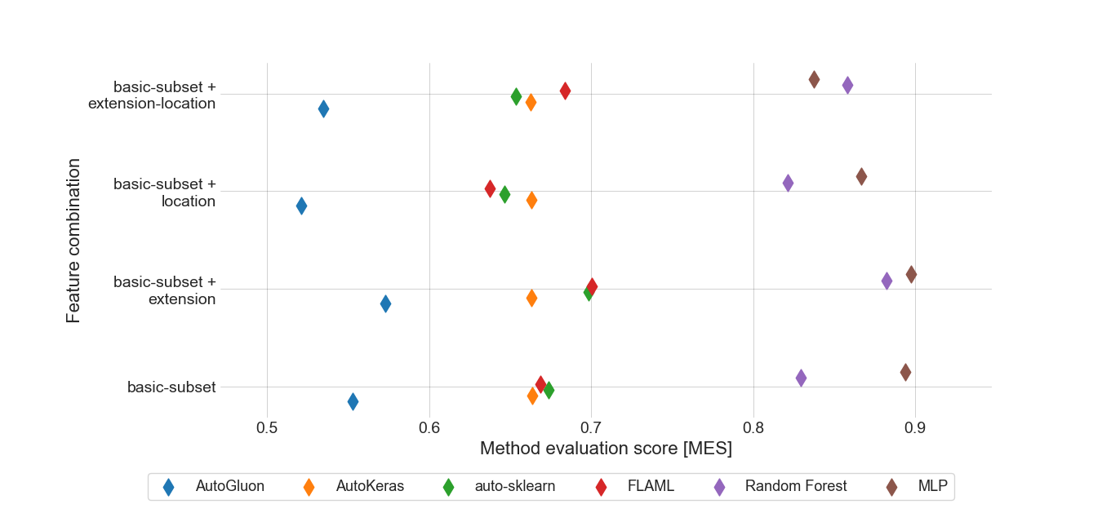

### Standard deviation for MAPE results for location feature set.

|  |  |
| --- | --- |
|  | location |
| autogluon | 0.00553462 |
| autokeras | 0.0071333 |
| autosklearn | 0.00443125 |
| flaml | 0.01013872 |
| manual | 0.00537513 |
| nn | 0.00722174 |

### Boxplot for MAPE results for location feature set.

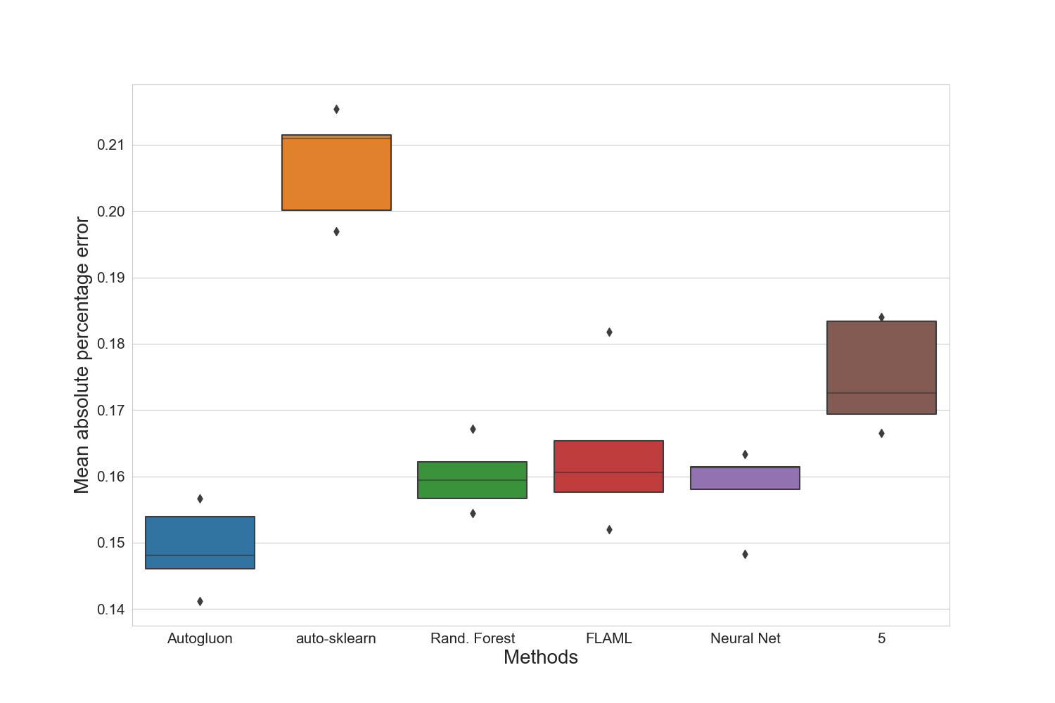

### Standard deviation for training time for location feature set.

|  |  |
| --- | --- |
|  | location |
| autogluon | 4.3722932 |
| autokeras | 0.08786581 |
| autosklearn | 365.98452251 |
| flaml | 0.47224951 |
| manual | 10.12147652 |
| nn | 111.69820207 |

### Standard deviation for prediction time for location feature set.

|  |  |
| --- | --- |
|  | location |
| autogluon | 0.0003402112 |
| autokeras | 1.2281229e-05 |
| autosklearn | 0.001664033727 |
| flaml | 2.299098e-06 |
| manual | 1.1700328e-05 |
| nn | 1.02595e-07 |

### Best manual model for merged-files

|  |
| --- |
| Best manual model |
| RandomForestRegressor(criterion='poisson', max_features=15, min_samples_split=7,  n_estimators=187) |

### Best NN parameter set for merged-files

|  |  |  |  |
| --- | --- | --- | --- |
| Activation | Hidden-layer-size | Learning rate | Solver |
| relu | (10, 10, 10) | 0.001 | adam |

### Best results for merged-files

|  |  |  |  |  |  |  |  |
| --- | --- | --- | --- | --- | --- | --- | --- |
|  | R2-Score | MAPE | MAE | RMSE | N-RMSE | IQR-RMSE | CV-RMSE |
| Feature-Set | extension-location | extension-location | extension-location | extension-location | extension-location | extension-location | extension-location |
| Method | manual | autogluon | autogluon | manual | manual | manual | manual |
| Value | 0.8125 | 0.1465 | 11589.0 | 16776.2 | 0.0819 | 0.3165 | 0.1875 |

# Summary of the best results for all data sets

|  |  |  |  |  |  |  |  |  |
| --- | --- | --- | --- | --- | --- | --- | --- | --- |
|  | # data points | R2-Score | MAPE | MAE | RMSE | N-RMSE | IQR-RMSE | CV-RMSE |
| merged-files | 2813 | **0.8125** | **0.1465** | **11589.0** | **16776.2** | **0.0819** | **0.3165** | **0.1875** |

# Statistics for all data sets

|  |  |  |  |  |  |  |
| --- | --- | --- | --- | --- | --- | --- |
|  | # data points | Mean | Median | Std. diviation | Max | Min |
| merged-files | 2813 | 89701 | 79900 | 40707 | 261545 | 10000 |