Measurement overview!

* Measurement date: 2023-12-02
* Random seed: 1
* Number of PCA calculated features: 0
* Outliert detection per bin: True
* Autosklearn runtime per dataset: 1800 seconds
* Autosklearn time limit per algorithm: 180 seconds

# Results for merged-files

* Input data file name: merged-files-final-selected-features-2023-12-01.csv
* Input data file creation date: 2023-12-01
* Number of processed data points: 2812

### R2 results for merged-files

|  |  |  |  |  |
| --- | --- | --- | --- | --- |
|  | basic-subset | location | extension | location-extension |
| nn | 0.7348 | 0.7791 | 0.7528 | 0.7882 |
| manual | 0.7476 | 0.8003 | 0.7789 | 0.8175 |
| autosklearn | 0.7525 | 0.7993 | 0.7817 | **0.822** |
| autogluon | 0.743 | 0.8035 | 0.7789 | 0.8151 |
| flaml | 0.758 | 0.7779 | 0.7592 | 0.7893 |
| autokeras | 0.6385 | 0.6147 | 0.6733 | 0.6847 |

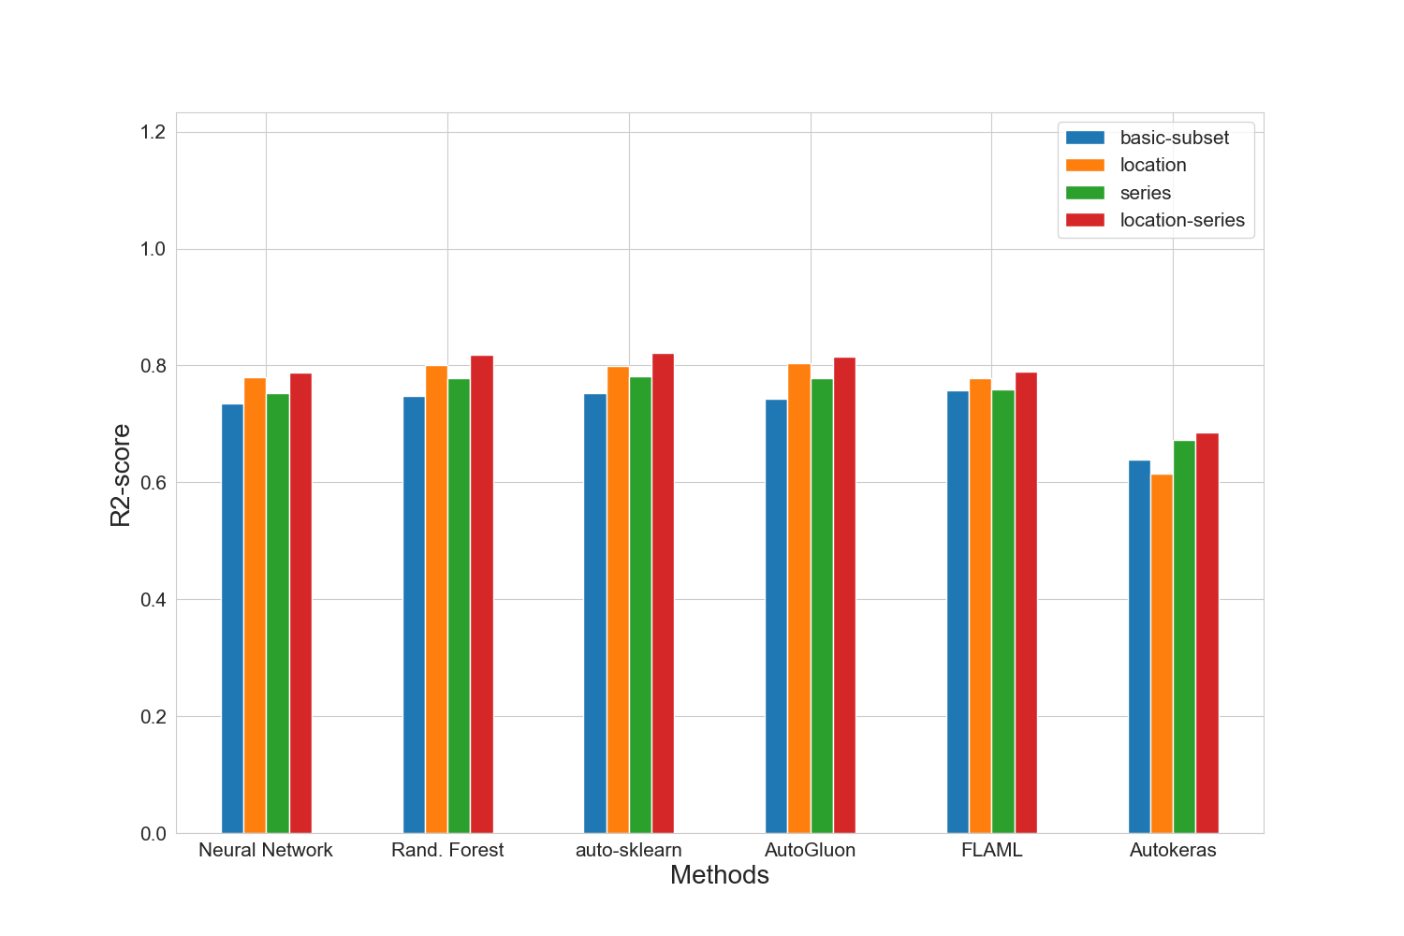

### MAE results for merged-files

|  |  |  |  |  |
| --- | --- | --- | --- | --- |
|  | basic-subset | location | extension | location-extension |
| nn | 14473.0 | 13034.6 | 13910.8 | 12669.2 |
| manual | 13836.8 | 12011.6 | 12999.4 | 11499.8 |
| autosklearn | 13793.8 | 11991.6 | 13042.4 | 11411.6 |
| autogluon | 13737.2 | 11697.0 | 12785.2 | **11403.6** |
| flaml | 13617.2 | 13015.8 | 13651.4 | 12603.8 |
| autokeras | 16167.6 | 17007.0 | 16053.0 | 15248.8 |

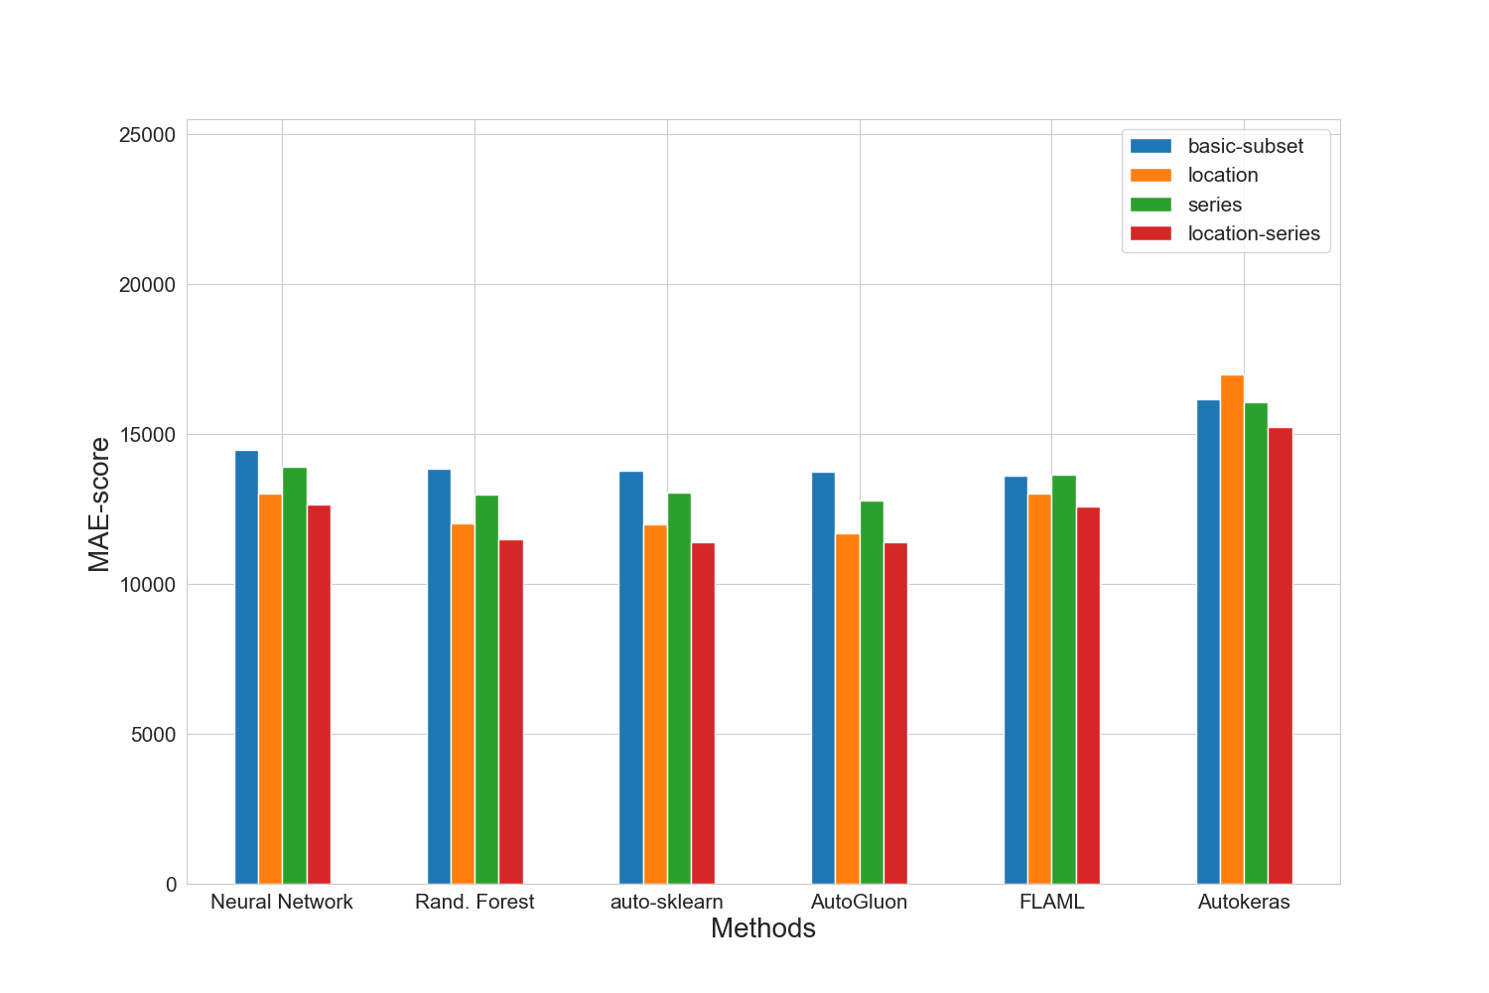

### MAPE results for merged-files

|  |  |  |  |  |
| --- | --- | --- | --- | --- |
|  | basic-subset | location | extension | location-extension |
| nn | 0.1823 | 0.1616 | 0.1755 | 0.1628 |
| manual | 0.1733 | 0.1534 | 0.165 | 0.1475 |
| autosklearn | 0.1723 | 0.1537 | 0.1656 | 0.1476 |
| autogluon | 0.1661 | 0.1467 | 0.1591 | **0.1432** |
| flaml | 0.1717 | 0.1648 | 0.1709 | 0.1616 |
| autokeras | 0.1966 | 0.2121 | 0.1976 | 0.1825 |

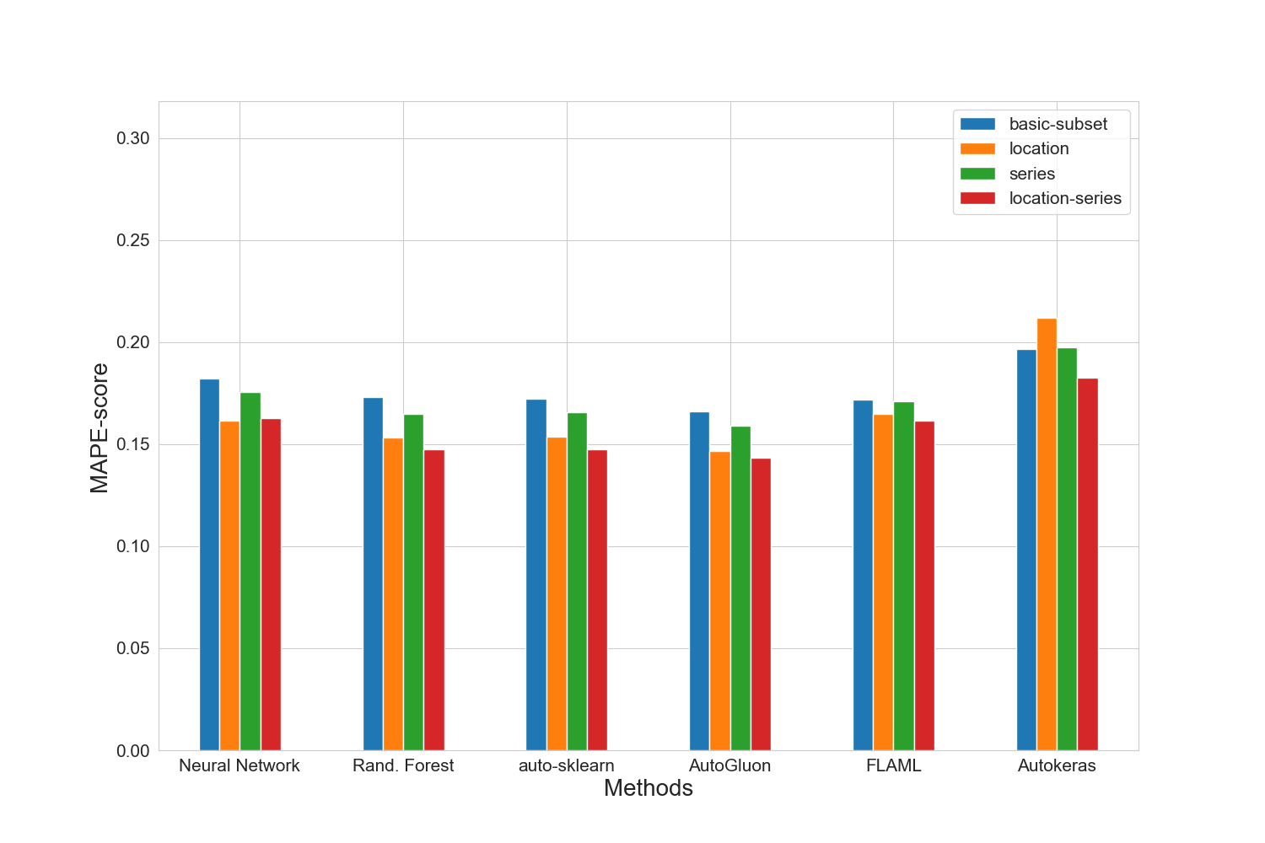

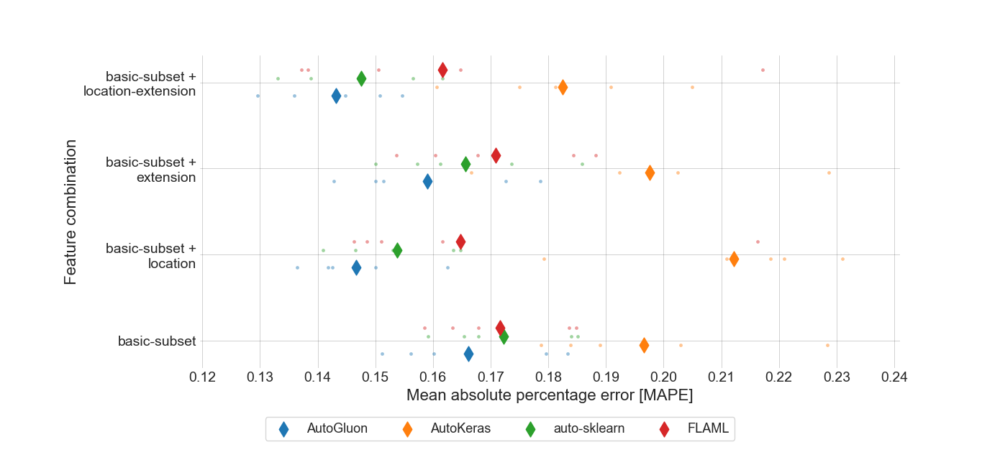

### RMSE results for merged-files

|  |  |  |  |  |
| --- | --- | --- | --- | --- |
|  | basic-subset | location | extension | location-extension |
| nn | 20674.0 | 18834.0 | 19951.6 | 18437.6 |
| manual | 20153.8 | 17909.0 | 18866.0 | 17123.2 |
| autosklearn | 19965.6 | 17977.4 | 18750.4 | **16909.2** |
| autogluon | 20346.0 | 17741.4 | 18871.6 | 17230.8 |
| flaml | 19738.0 | 18781.4 | 19679.4 | 18177.0 |
| autokeras | 24131.8 | 24845.6 | 22935.6 | 22475.6 |

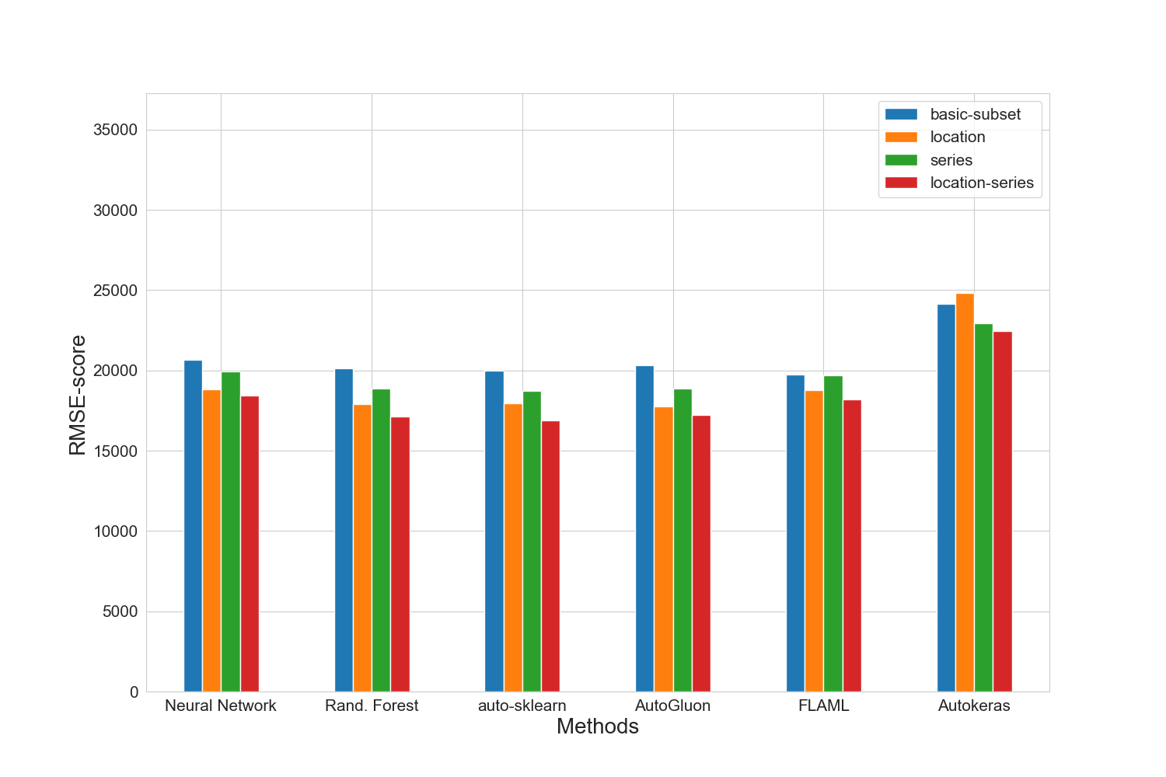

### Training run-time of each method and feature subset in seconds for merged-files

|  |  |  |  |  |
| --- | --- | --- | --- | --- |
|  | basic-subset | location | extension | location-extension |
| nn | 1240.7 | 1121.4 | 966.8 | 1001.9 |
| manual | 360.7 | 835.2 | 747.5 | 1675.2 |
| autosklearn | 2040.7 | 2061.8 | 2427.4 | 2473.4 |
| autogluon | 13.0 | 16.9 | 14.6 | 19.8 |
| flaml | 1800.7 | 1800.8 | 1800.2 | 1801.3 |
| autokeras | 64.7 | 64.0 | 64.1 | 64.4 |

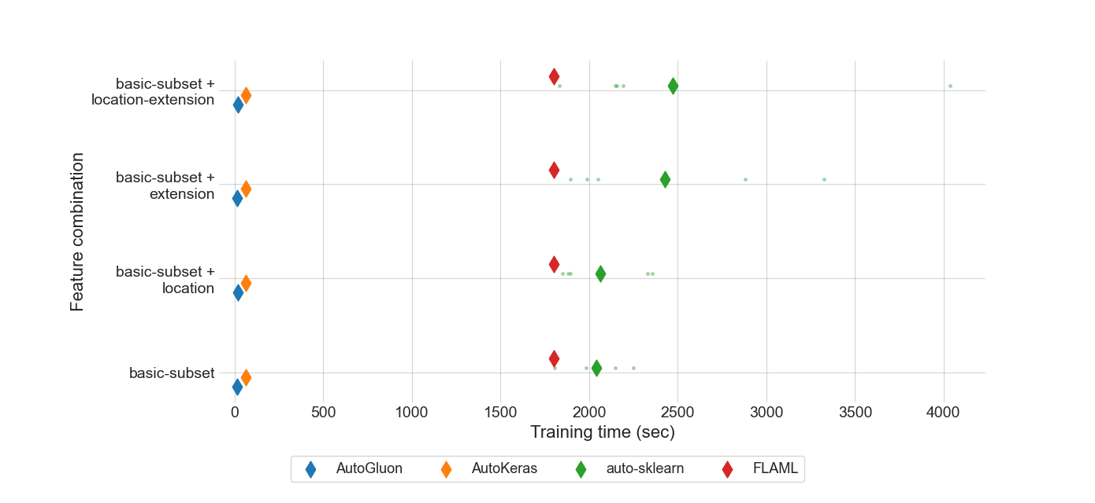

### Prediction time of each method and feature subset in seconds for merged-files

|  |  |  |  |  |
| --- | --- | --- | --- | --- |
|  | basic-subset | location | extension | location-extension |
| nn | 8.033e-07 | 8.975e-07 | 8.164e-07 | 8.986e-07 |
| manual | 2.74337e-05 | 4.87557e-05 | 1.85899e-05 | 4.53146e-05 |
| autosklearn | 0.0005927395 | 0.0012243237 | 0.0009184408 | 0.0009217578 |
| autogluon | 0.0003448618 | 0.0003493277 | 0.0004043165 | 0.0002441124 |
| flaml | 2.47661e-05 | 2.82113e-05 | 8.02368e-05 | 3.83463e-05 |
| autokeras | 0.001472553 | 0.0016412926 | 0.0016409326 | 0.0017898883 |

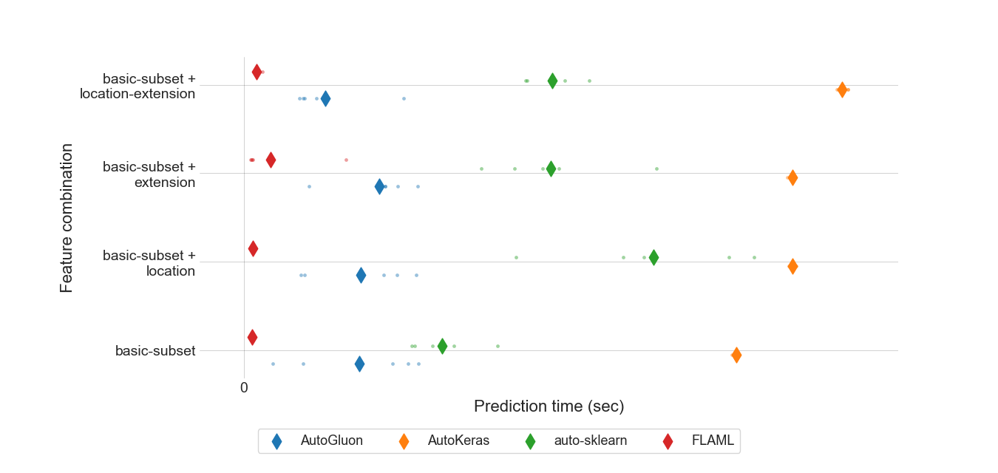

### MEV results for all feature sets.

|  |  |  |  |  |
| --- | --- | --- | --- | --- |
|  | basic-subset | location | extension | location-extension |
| autosklearn | 0.698199 | 0.622329 | 0.679028 | 0.664384 |
| autogluon | 0.583068 | **0.506647** | 0.563182 | 0.553129 |
| flaml | 0.684913 | 0.635837 | 0.666601 | 0.675567 |
| autokeras | 0.66317 | 0.663104 | 0.662641 | 0.662604 |

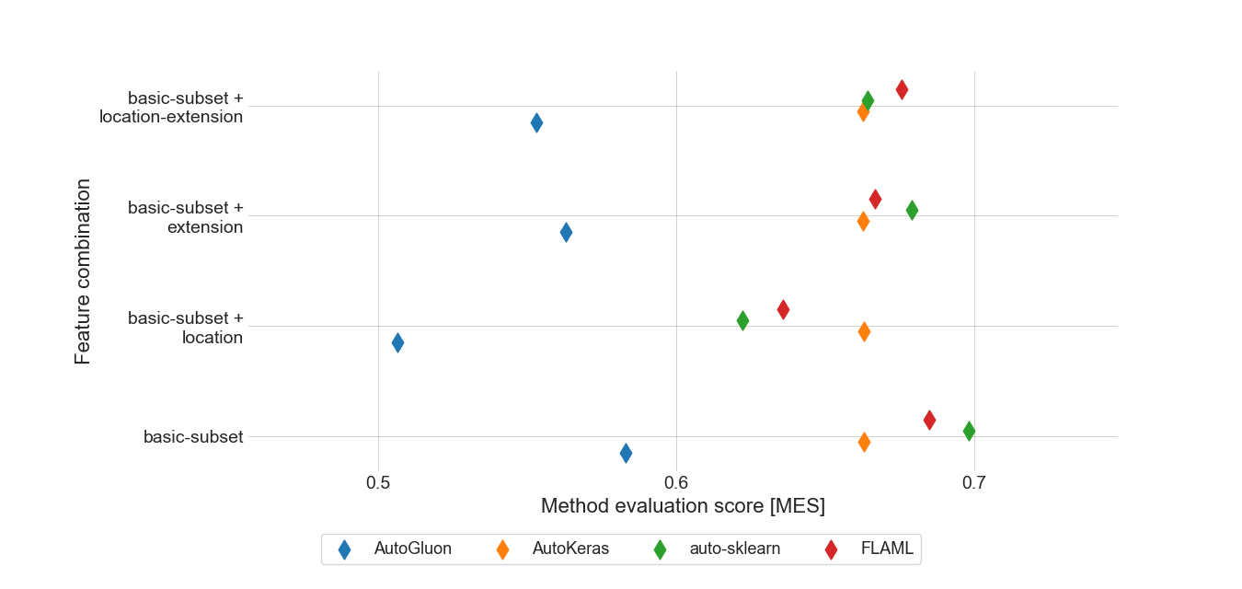

### Standard deviation for MAPE results for location feature set.

|  |  |
| --- | --- |
|  | location |
| autogluon | 0.00903447 |
| autokeras | 0.01762321 |
| autosklearn | 0.0093318 |
| flaml | 0.02629634 |

### Boxplot for MAPE results for location feature set.

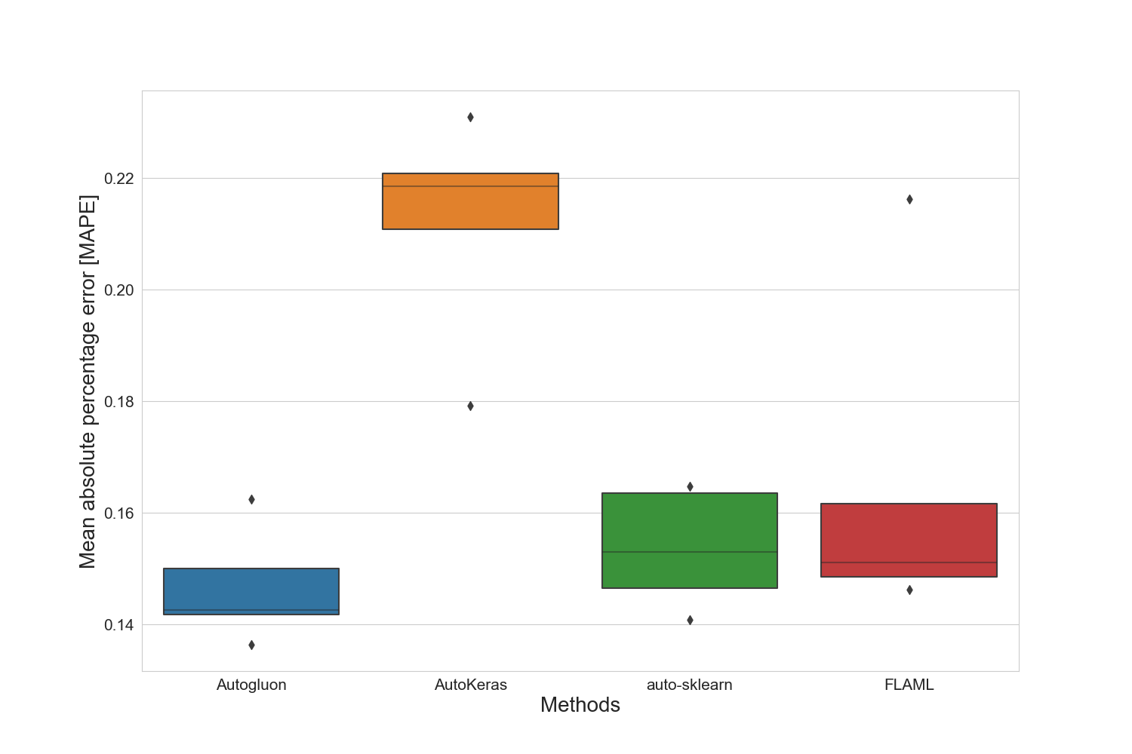

### Standard deviation for training time for location feature set.

|  |  |
| --- | --- |
|  | location |
| autogluon | 1.46313726 |
| autokeras | 0.28920401 |
| autosklearn | 229.19149327 |
| flaml | 0.58840075 |

### Standard deviation for prediction time for location feature set.

|  |  |
| --- | --- |
|  | location |
| autogluon | 0.00014407013 |
| autokeras | 7.63209e-06 |
| autosklearn | 0.000252720053 |
| flaml | 3.86661e-06 |

### Best manual model for merged-files

|  |
| --- |
| Best manual model |
| RandomForestRegressor(criterion='poisson', max_features=15, min_samples_split=7,  n_estimators=187) |

### Best NN parameter set for merged-files

|  |  |  |  |
| --- | --- | --- | --- |
| Activation | Hidden-layer-size | Learning rate | Solver |
| relu | (10, 10, 10, 10, 10, 10, 10) | 0.0001 | adam |

### Best results for merged-files

|  |  |  |  |  |  |  |  |
| --- | --- | --- | --- | --- | --- | --- | --- |
|  | R2-Score | MAPE | MAE | RMSE | N-RMSE | IQR-RMSE | CV-RMSE |
| Feature-Set | location-extension | location-extension | location-extension | location-extension | location-extension | location-extension | location-extension |
| Method | autosklearn | autogluon | autogluon | autosklearn | autosklearn | autosklearn | autosklearn |
| Value | 0.822 | 0.1432 | 11403.6 | 16909.2 | 0.0743 | 0.3179 | 0.1887 |

# Summary of the best results for all data sets

|  |  |  |  |  |  |  |  |  |
| --- | --- | --- | --- | --- | --- | --- | --- | --- |
|  | # data points | R2-Score | MAPE | MAE | RMSE | N-RMSE | IQR-RMSE | CV-RMSE |
| merged-files | 2812 | **0.822** | **0.1432** | **11403.6** | **16909.2** | **0.0743** | **0.3179** | **0.1887** |

# Statistics for all data sets

|  |  |  |  |  |  |  |
| --- | --- | --- | --- | --- | --- | --- |
|  | # data points | Mean | Median | Std. diviation | Max | Min |
| merged-files | 2812 | 89730 | 79900 | 40687 | 261545 | 10000 |