Measurement overview!

* Measurement date: 2023-12-04
* Random seed: 1
* Number of PCA calculated features: 0
* Outliert detection per bin: True
* Autosklearn runtime per dataset: 1800 seconds
* Autosklearn time limit per algorithm: 180 seconds

# Results for merged-files

* Input data file name: merged-files-final-selected-features-2023-11-23.csv
* Input data file creation date: 2023-11-23
* Number of processed data points: 2916

### R2 results for merged-files

|  |  |  |  |  |
| --- | --- | --- | --- | --- |
|  | basic-subset | location | extension | location-extension |
| nn | -2.6974 | -0.6763 | -1.8018 | -2.0061 |
| manual | 0.5279 | 0.5542 | 0.5779 | 0.5849 |
| autosklearn | 0.5627 | 0.5634 | **0.6075** | 0.6014 |
| autogluon | -1.3456 | -1.3496 | -1.3373 | -1.3367 |
| flaml | -0.36 | -0.315 | -2.3739 | -0.0019 |
| autokeras | 0.4696 | 0.4477 | 0.5371 | 0.5366 |

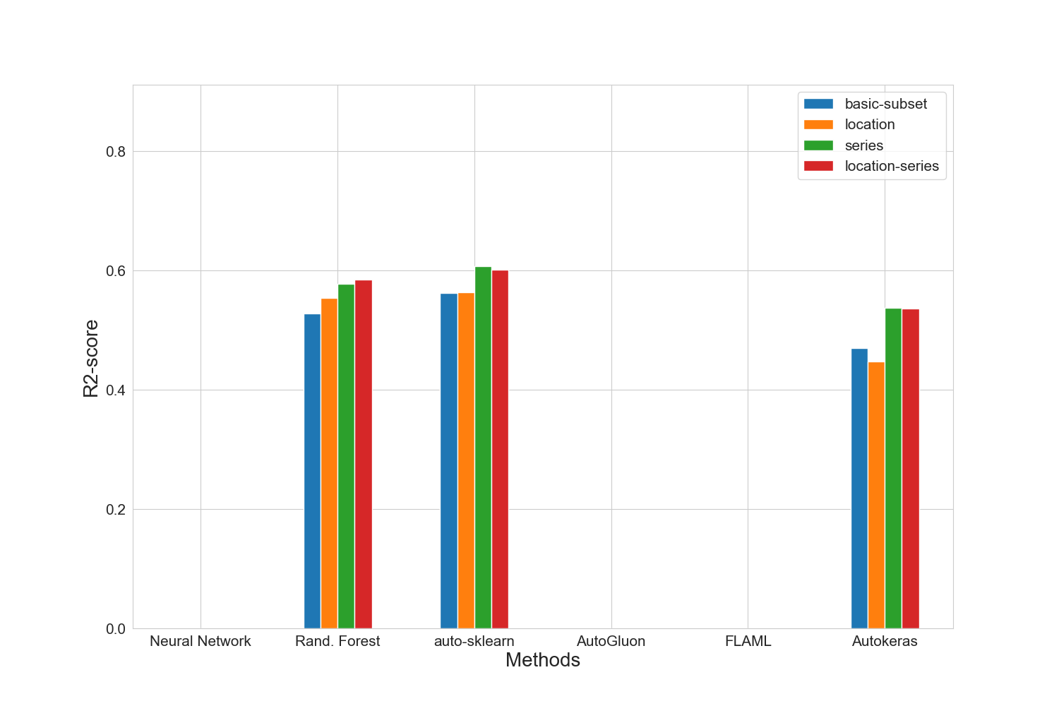

### MAE results for merged-files

|  |  |  |  |  |
| --- | --- | --- | --- | --- |
|  | basic-subset | location | extension | location-extension |
| nn | 95838.0 | 61746.0 | 77248.5 | 75108.5 |
| manual | 19012.25 | 19514.0 | 17548.25 | 17560.75 |
| autosklearn | 17582.5 | 16297.5 | 16028.25 | **15391.0** |
| autogluon | 68677.0 | 68428.25 | 68378.75 | 67981.25 |
| flaml | 31007.5 | 36059.75 | 43345.5 | 38581.0 |
| autokeras | 20674.75 | 20870.0 | 18820.25 | 18433.0 |

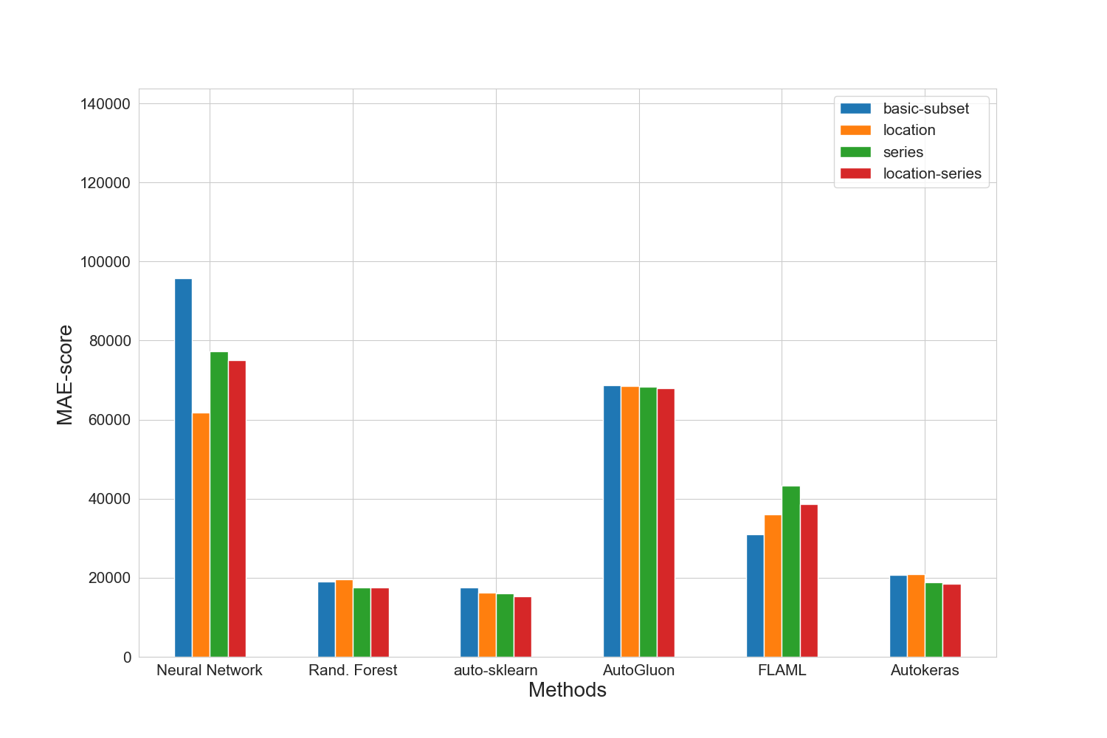

### MAPE results for merged-files

|  |  |  |  |  |
| --- | --- | --- | --- | --- |
|  | basic-subset | location | extension | location-extension |
| nn | 0.9996 | 0.6478 | 0.8175 | 0.7944 |
| manual | 0.1991 | 0.2074 | 0.1856 | 0.184 |
| autosklearn | 0.1846 | 0.1675 | 0.1687 | **0.1626** |
| autogluon | 0.7106 | 0.7089 | 0.709 | 0.7055 |
| flaml | 0.3566 | 0.4052 | 0.4946 | 0.4615 |
| autokeras | 0.2144 | 0.2116 | 0.1982 | 0.1982 |

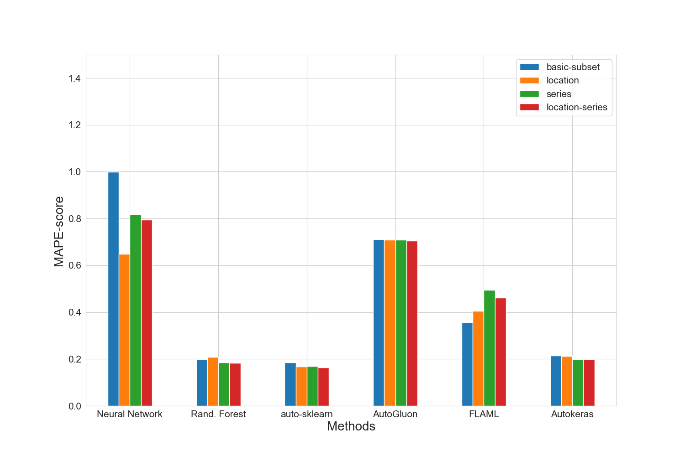

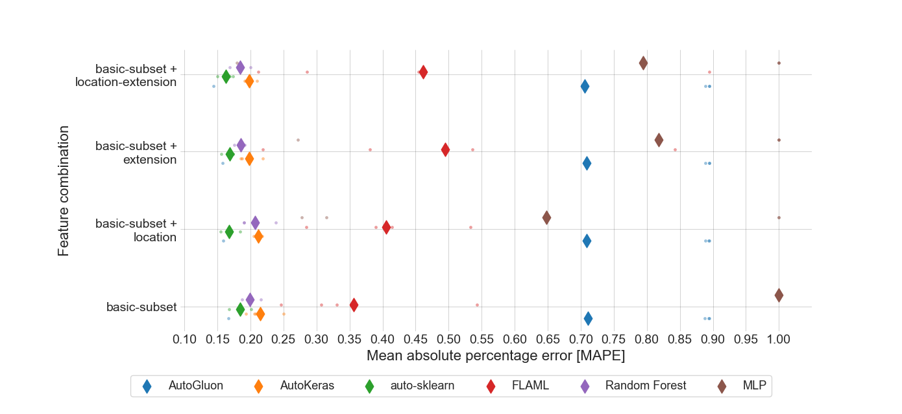

### RMSE results for merged-files

|  |  |  |  |  |
| --- | --- | --- | --- | --- |
|  | basic-subset | location | extension | location-extension |
| nn | 114787.0 | 80803.5 | 96616.25 | 95387.25 |
| manual | 43662.5 | 42544.25 | 41477.75 | 41149.0 |
| autosklearn | 42214.0 | 42157.5 | **40061.25** | 40366.25 |
| autogluon | 88641.25 | 88661.25 | 88172.25 | 88003.0 |
| flaml | 67462.5 | 68289.0 | 83596.75 | 63875.0 |
| autokeras | 46346.75 | 47199.0 | 43405.75 | 43231.25 |

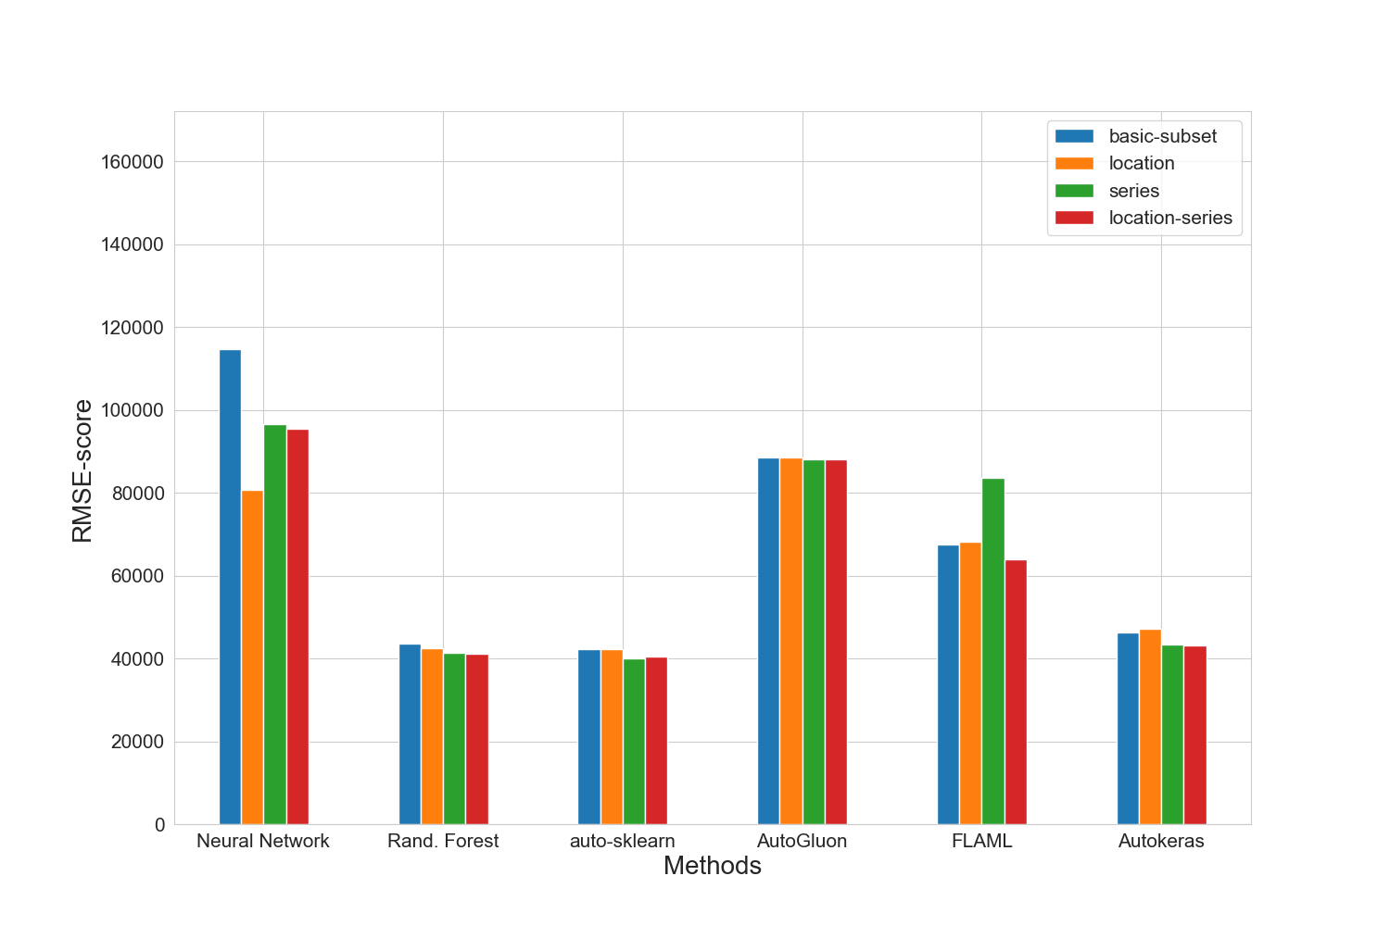

### Training run-time of each method and feature subset in seconds for merged-files

|  |  |  |  |  |
| --- | --- | --- | --- | --- |
|  | basic-subset | location | extension | location-extension |
| nn | 1192.9 | 1204.4 | 1362.3 | 1236.0 |
| manual | 32.9 | 264.4 | 24.6 | 67.1 |
| autosklearn | 2146.1 | 2037.3 | 1916.0 | 1945.4 |
| autogluon | 11.2 | 24.2 | 11.5 | 16.0 |
| flaml | 1800.3 | 1800.2 | 1800.0 | 1800.1 |
| autokeras | 66.4 | 65.6 | 65.7 | 66.0 |

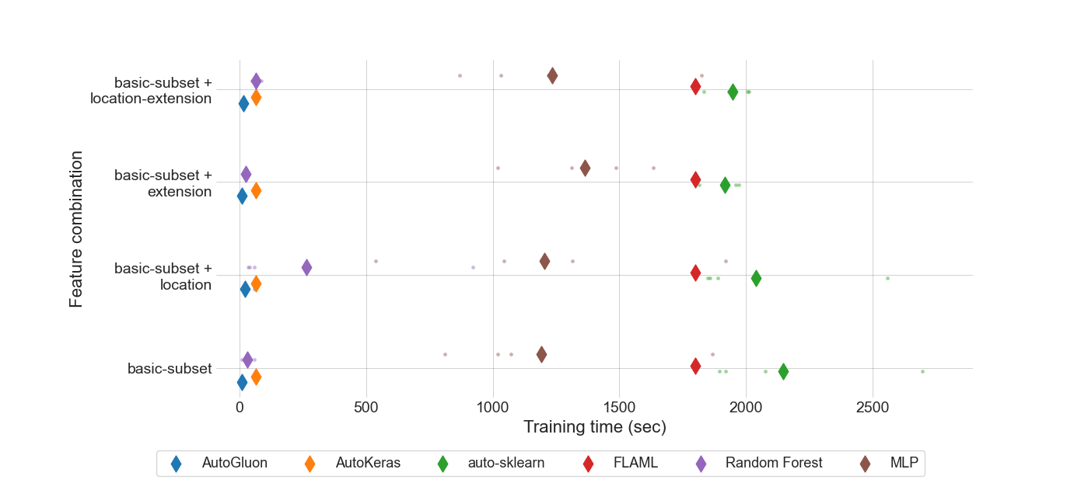

### Prediction time of each method and feature subset in seconds for merged-files

|  |  |  |  |  |
| --- | --- | --- | --- | --- |
|  | basic-subset | location | extension | location-extension |
| nn | 4.472e-07 | 5.142e-07 | 4.705e-07 | 6.469e-07 |
| manual | 3.21938e-05 | 7.78108e-05 | 3.62512e-05 | 0.0001372073 |
| autosklearn | 0.0008814118 | 0.0009504012 | 0.0008426417 | 0.0010626418 |
| autogluon | 7.82662e-05 | 0.0001397761 | 0.0001542211 | 0.0002375368 |
| flaml | 2.10843e-05 | 2.04224e-05 | 2.04268e-05 | 2.35773e-05 |
| autokeras | 0.001436416 | 0.0015965312 | 0.0016021949 | 0.0017382421 |

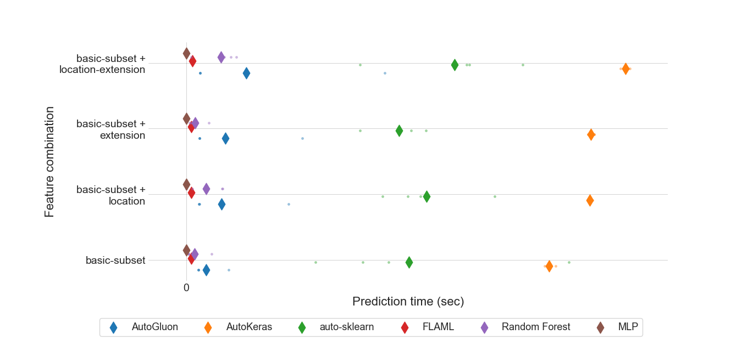

### MEV results for all feature sets.

|  |  |  |  |  |
| --- | --- | --- | --- | --- |
|  | basic-subset | location | extension | location-extension |
| nn | 0.955585 | 0.916023 | 0.971101 | 0.963534 |
| manual | 0.501123 | 0.559261 | 0.514801 | 0.51926 |
| autosklearn | 0.352337 | 0.378141 | 0.36318 | 0.362341 |
| autogluon | 0.515964 | 0.661188 | 0.594239 | 0.604868 |
| flaml | 0.422258 | 0.534157 | 0.556453 | 0.543002 |
| autokeras | **0.270337** | 0.312465 | 0.284652 | 0.288141 |

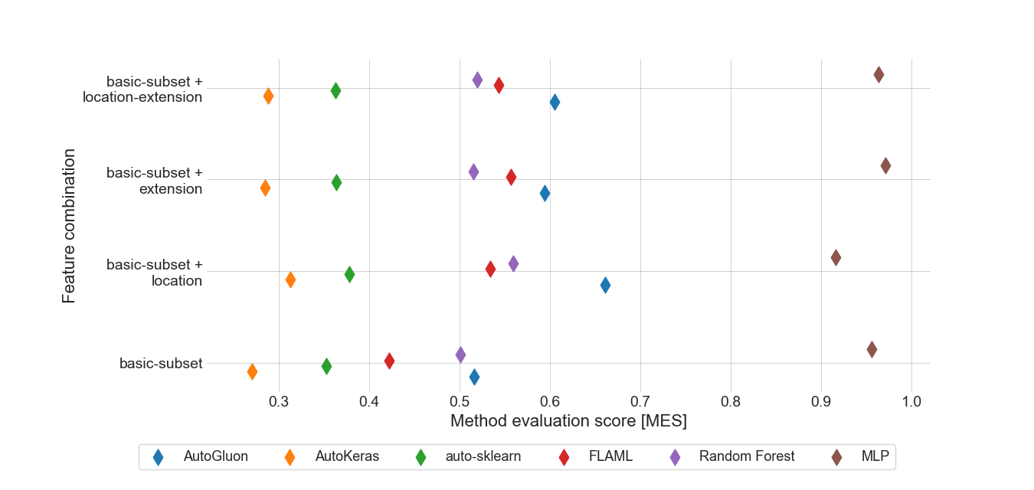

### Standard deviation for MAPE results for basic-subset feature set.

|  |  |
| --- | --- |
|  | basic-subset |
| autogluon | 0.31398871 |
| autokeras | 0.02140759 |
| autosklearn | 0.01204645 |
| flaml | 0.11164954 |
| manual | 0.01019347 |
| nn | 0.0001479 |

### Boxplot for MAPE results for basic-subset feature set.

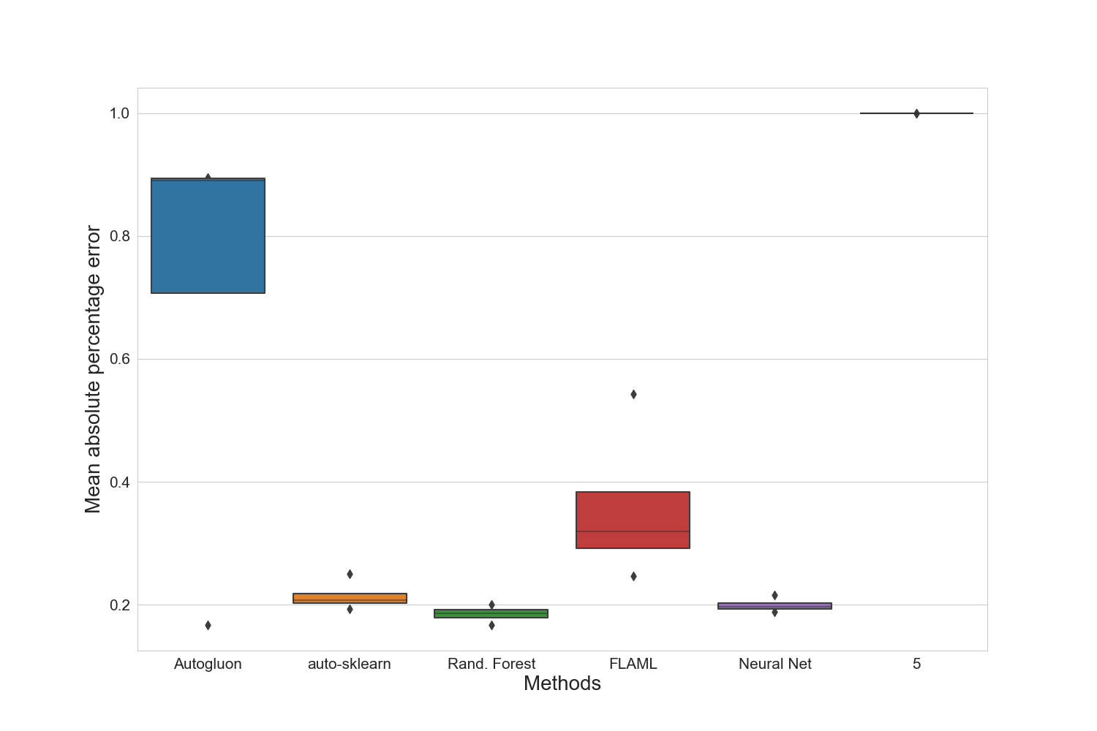

### Standard deviation for training time for basic-subset feature set.

|  |  |
| --- | --- |
|  | basic-subset |
| autogluon | 3.22151264 |
| autokeras | 1.99538247 |
| autosklearn | 323.90914117 |
| flaml | 0.211122 |
| manual | 16.87039622 |
| nn | 401.44771584 |

### Standard deviation for prediction time for basic-subset feature set.

|  |  |
| --- | --- |
|  | basic-subset |
| autogluon | 5.141402e-05 |
| autokeras | 1.5972095e-05 |
| autosklearn | 0.000380044005 |
| flaml | 3.570872e-06 |
| manual | 3.9642211e-05 |
| nn | 1.3773e-08 |

### Best manual model for merged-files

|  |
| --- |
| Best manual model |
| KNeighborsRegressor(n_neighbors=10, p=3) |

### Best NN parameter set for merged-files

|  |  |  |  |
| --- | --- | --- | --- |
| Activation | Hidden-layer-size | Learning rate | Solver |
| relu | (10, 10, 10, 10, 10, 10, 10, 10, 10) | 0.01 | adam |

### Best results for merged-files

|  |  |  |  |  |  |  |  |
| --- | --- | --- | --- | --- | --- | --- | --- |
|  | R2-Score | MAPE | MAE | RMSE | N-RMSE | IQR-RMSE | CV-RMSE |
| Feature-Set | extension | location-extension | location-extension | extension | extension | extension | extension |
| Method | autosklearn | autosklearn | autosklearn | autosklearn | autosklearn | autosklearn | autosklearn |
| Value | 0.6075 | 0.1626 | 15391.0 | 40061.25 | 0.0603 | 0.6876 | 0.4125 |

# Summary of the best results for all data sets

|  |  |  |  |  |  |  |  |  |
| --- | --- | --- | --- | --- | --- | --- | --- | --- |
|  | # data points | R2-Score | MAPE | MAE | RMSE | N-RMSE | IQR-RMSE | CV-RMSE |
| merged-files | 2916 | **0.6075** | **0.1626** | **15391.0** | **40061.25** | **0.0603** | **0.6876** | **0.4125** |

# Statistics for all data sets

|  |  |  |  |  |  |  |
| --- | --- | --- | --- | --- | --- | --- |
|  | # data points | Mean | Median | Std. diviation | Max | Min |
| merged-files | 2916 | 94089 | 80000 | 58342 | 998000 | 1 |