Measurement overview!

* Measurement date: 2023-12-07
* Random seed: 1
* Number of PCA calculated features: 0
* Outliert detection per bin: True
* Autosklearn runtime per dataset: 1800 seconds
* Autosklearn time limit per algorithm: 180 seconds

# Results for merged-files

* Input data file name: merged-files-final-2022-07-06.csv
* Input data file creation date: 2022-07-06
* Number of processed data points: 2910

### R2 results for merged-files

|  |  |  |  |  |
| --- | --- | --- | --- | --- |
|  | basic-subset | extension | location | extension-location |
| nn | 0.7494 | 0.8013 | 0.7854 | 0.6597 |
| manual | 0.768 | 0.7948 | 0.8056 | 0.8289 |
| autosklearn | 0.7621 | 0.7944 | 0.8065 | 0.8337 |
| autogluon | 0.7532 | 0.7957 | 0.8004 | **0.8452** |
| flaml | 0.7619 | 0.7586 | 0.8101 | 0.775 |
| autokeras | 0.6123 | 0.6363 | 0.6233 | 0.6378 |

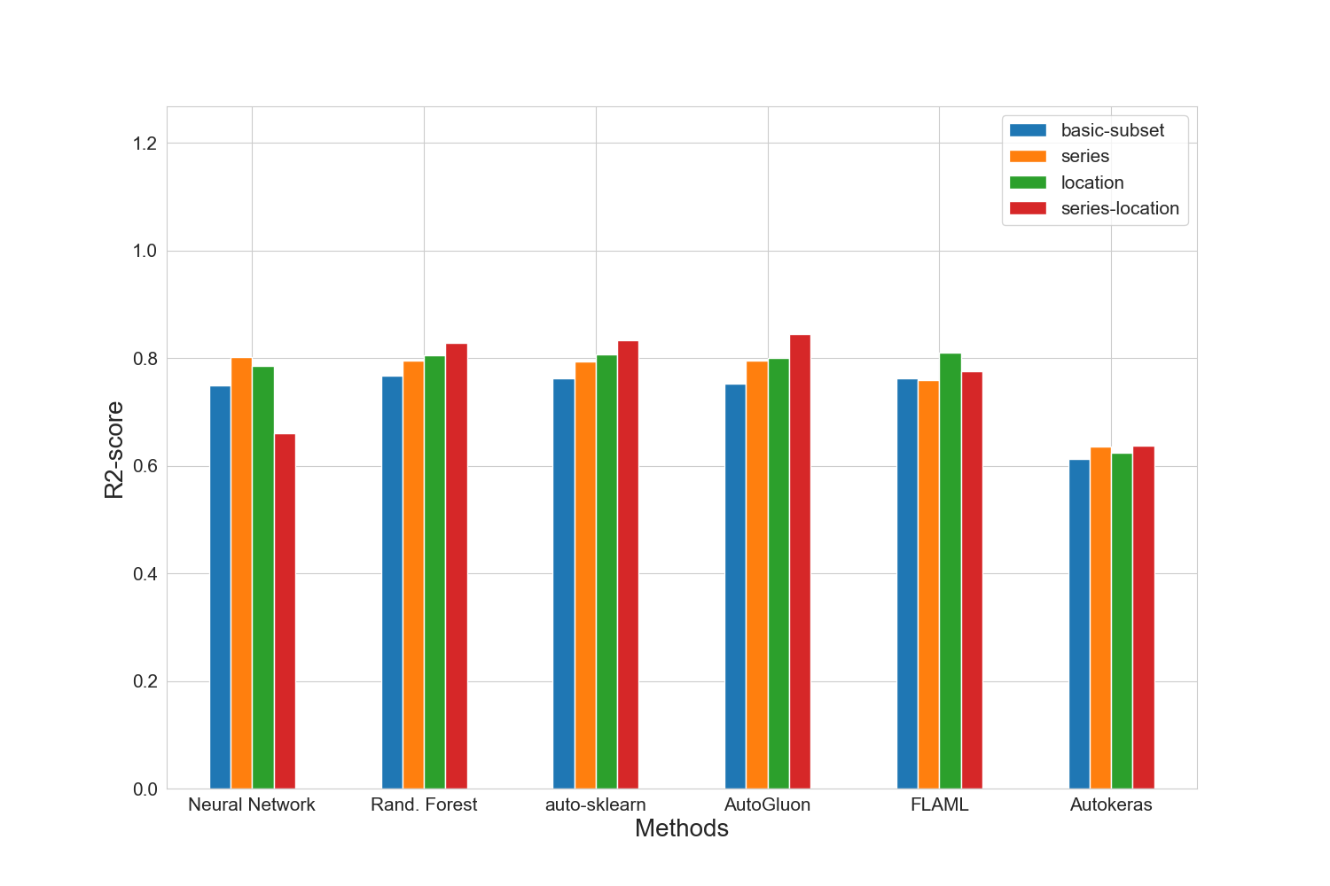

### MAE results for merged-files

|  |  |  |  |  |
| --- | --- | --- | --- | --- |
|  | basic-subset | extension | location | extension-location |
| nn | 15520.8 | 14066.2 | 14659.4 | 17713.8 |
| manual | 14746.2 | 13965.8 | 13360.0 | 12526.6 |
| autosklearn | 15087.2 | 13964.6 | 13365.4 | 12359.2 |
| autogluon | 15070.6 | 13834.0 | 13542.2 | **12011.4** |
| flaml | 14983.8 | 15164.2 | 13501.4 | 14534.4 |
| autokeras | 18947.4 | 18074.6 | 18489.4 | 17536.6 |

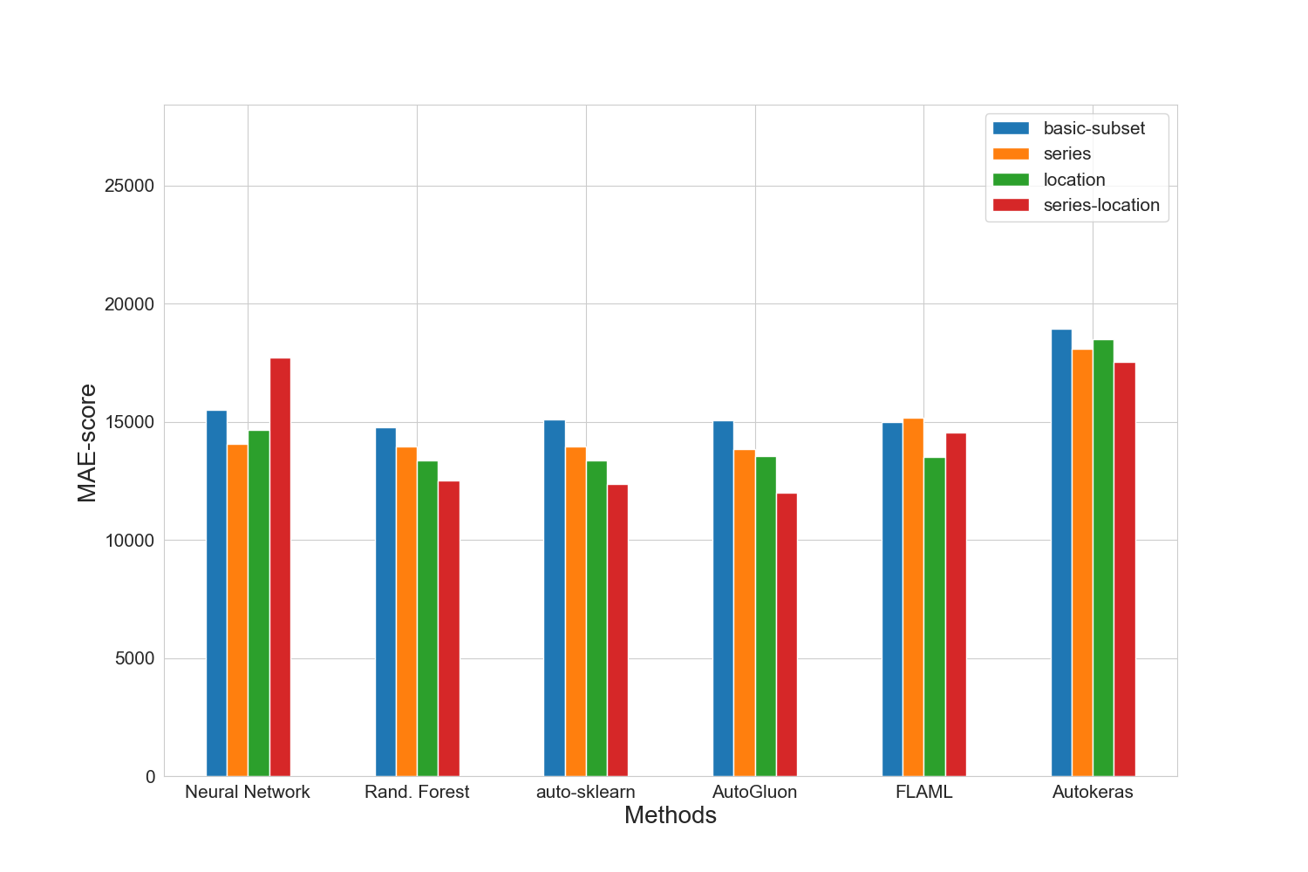

### MAPE results for merged-files

|  |  |  |  |  |
| --- | --- | --- | --- | --- |
|  | basic-subset | extension | location | extension-location |
| nn | 0.1763 | 0.1685 | 0.1723 | 0.2172 |
| manual | 0.1712 | 0.1665 | 0.1589 | 0.1505 |
| autosklearn | 0.1763 | 0.1672 | 0.1584 | 0.1502 |
| autogluon | 0.1669 | 0.1591 | 0.1562 | **0.1429** |
| flaml | 0.1744 | 0.1741 | 0.1588 | 0.1717 |
| autokeras | 0.2208 | 0.2097 | 0.2195 | 0.203 |

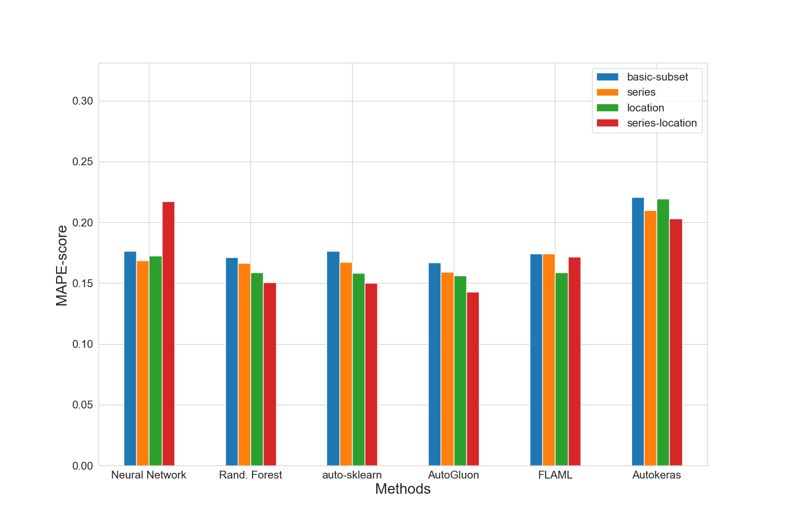

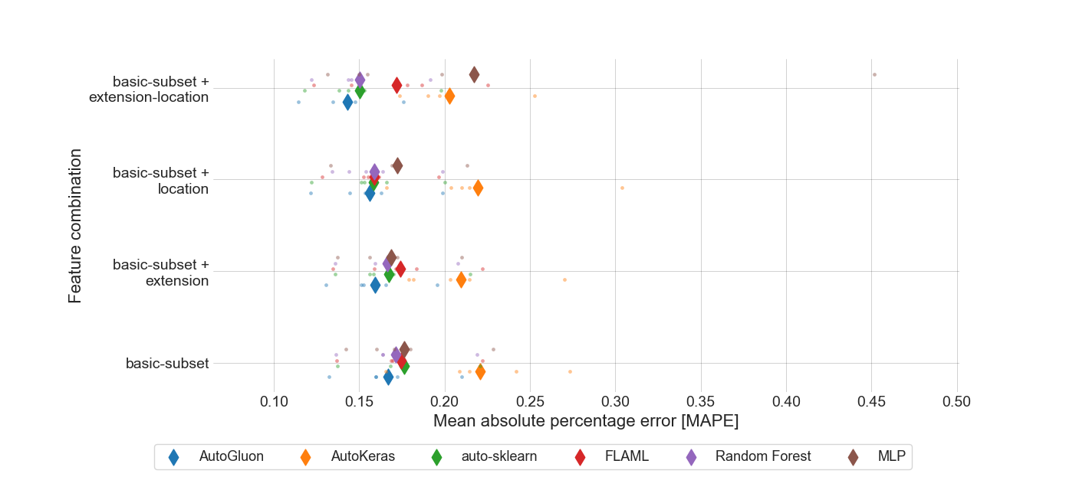

### RMSE results for merged-files

|  |  |  |  |  |
| --- | --- | --- | --- | --- |
|  | basic-subset | extension | location | extension-location |
| nn | 23149.6 | 20602.8 | 21399.0 | 24935.8 |
| manual | 22278.8 | 20961.0 | 20334.6 | 19132.4 |
| autosklearn | 22566.2 | 20999.8 | 20357.6 | 18837.8 |
| autogluon | 22951.4 | 20865.6 | 20558.2 | **18149.0** |
| flaml | 22587.4 | 22762.6 | 20129.0 | 21933.0 |
| autokeras | 28827.8 | 27850.2 | 28388.6 | 27755.0 |

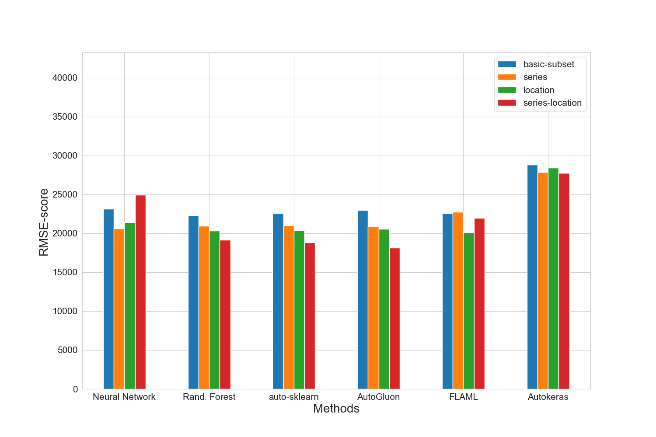

### Training run-time of each method and feature subset in seconds for merged-files

|  |  |  |  |  |
| --- | --- | --- | --- | --- |
|  | basic-subset | extension | location | extension-location |
| nn | 1575.0 | 1023.6 | 1475.9 | 1161.9 |
| manual | 377.7 | 795.9 | 884.7 | 1165.2 |
| autosklearn | 2373.1 | 2117.0 | 1973.6 | 2135.9 |
| autogluon | 13.3 | 15.5 | 17.5 | 18.8 |
| flaml | 1800.2 | 1800.0 | 1800.2 | 1801.2 |
| autokeras | 66.2 | 65.8 | 65.7 | 66.0 |

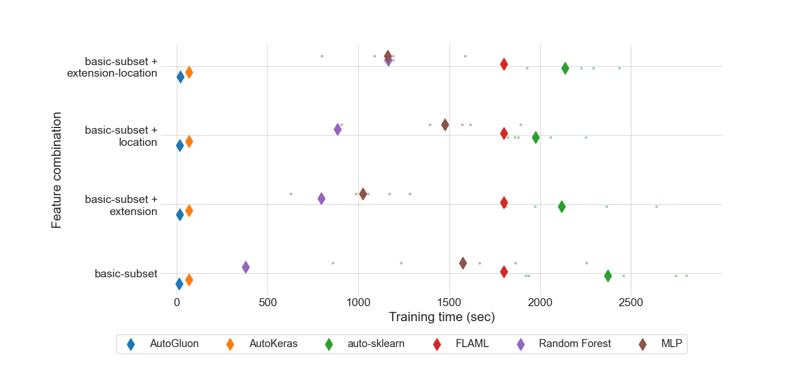

### Prediction time of each method and feature subset in seconds for merged-files

|  |  |  |  |  |
| --- | --- | --- | --- | --- |
|  | basic-subset | extension | location | extension-location |
| nn | 7.597e-07 | 7.193e-07 | 7.724e-07 | 8.631e-07 |
| manual | 2.07937e-05 | 1.46866e-05 | 3.73178e-05 | 2.57746e-05 |
| autosklearn | 0.0013025394 | 0.0008691508 | 0.0011672131 | 0.0096584338 |
| autogluon | 0.0002519883 | 0.0004648387 | 0.000435003 | 0.0005787558 |
| flaml | 2.01715e-05 | 2.13794e-05 | 2.79867e-05 | 3.4054e-05 |
| autokeras | 0.0014543637 | 0.0016025856 | 0.0016098975 | 0.0017505738 |

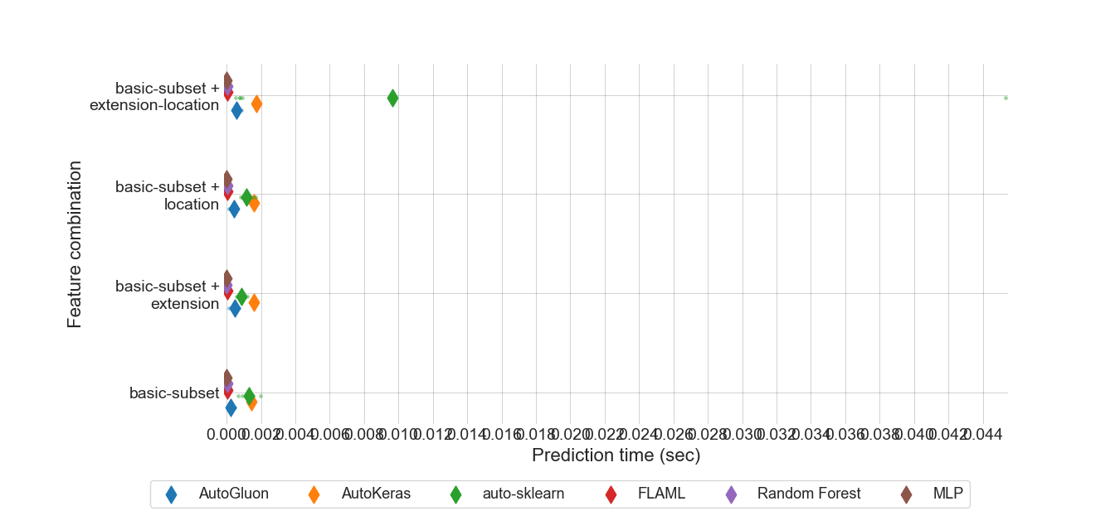

### MEV results for all feature sets.

|  |  |  |  |  |
| --- | --- | --- | --- | --- |
|  | basic-subset | extension | location | extension-location |
| nn | 0.865599 | 0.850116 | 0.867265 | 0.954399 |
| manual | 0.803597 | 0.834591 | 0.806786 | 0.801008 |
| autosklearn | 0.65923 | 0.658665 | 0.62082 | 0.605764 |
| autogluon | 0.538504 | 0.540084 | 0.516695 | **0.48984** |
| flaml | 0.630786 | 0.660143 | 0.612945 | 0.639588 |
| autokeras | 0.66279 | 0.663108 | 0.663329 | 0.630401 |

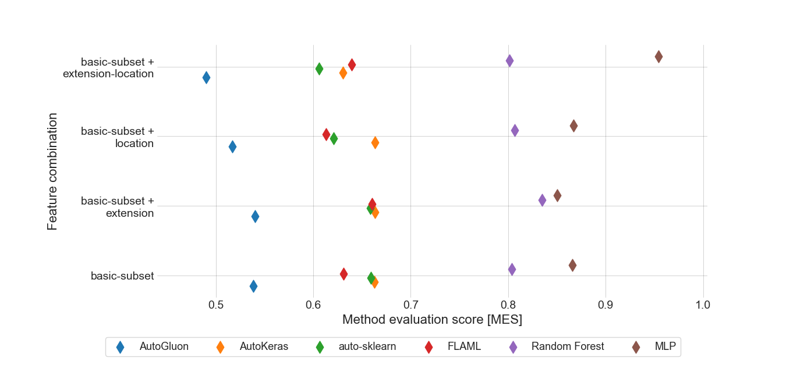

### Standard deviation for MAPE results for extension-location feature set.

|  |  |
| --- | --- |
|  | extension-location |
| autogluon | 0.01987455 |
| autokeras | 0.02660747 |
| autosklearn | 0.02643001 |
| flaml | 0.03513082 |
| manual | 0.02266368 |
| nn | 0.11919399 |

### Boxplot for MAPE results for extension-location feature set.

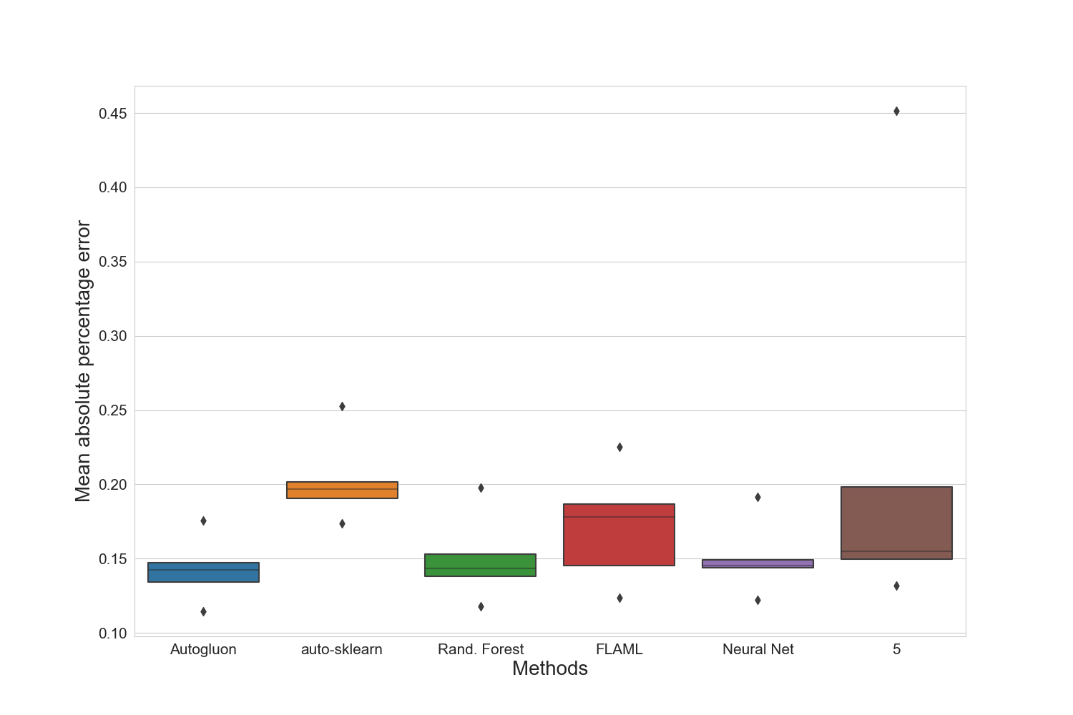

### Standard deviation for training time for extension-location feature set.

|  |  |
| --- | --- |
|  | extension-location |
| autogluon | 2.63837336 |
| autokeras | 0.15941769 |
| autosklearn | 235.6547093 |
| flaml | 1.36941073 |
| manual | 16.15603476 |
| nn | 253.23684262 |

### Standard deviation for prediction time for extension-location feature set.

|  |  |
| --- | --- |
|  | extension-location |
| autogluon | 0.000161340473 |
| autokeras | 6.668649e-06 |
| autosklearn | 0.017831461669 |
| flaml | 8.481782e-06 |
| manual | 8.771264e-06 |
| nn | 1.12684e-07 |

### Best manual model for merged-files

|  |
| --- |
| Best manual model |
| RandomForestRegressor(max_depth=15, max_features=29, min_samples_split=4,  n_estimators=69) |

### Best NN parameter set for merged-files

|  |  |  |  |
| --- | --- | --- | --- |
| Activation | Hidden-layer-size | Learning rate | Solver |
| relu | (10, 10, 10, 10, 10) | 0.0001 | adam |

### Best results for merged-files

|  |  |  |  |  |  |  |  |
| --- | --- | --- | --- | --- | --- | --- | --- |
|  | R2-Score | MAPE | MAE | RMSE | N-RMSE | IQR-RMSE | CV-RMSE |
| Feature-Set | extension-location | extension-location | extension-location | extension-location | extension-location | extension-location | extension-location |
| Method | autogluon | autogluon | autogluon | autogluon | autogluon | autogluon | autogluon |
| Value | 0.8452 | 0.1429 | 12011.4 | 18149.0 | 0.0658 | 0.3096 | 0.1937 |

# Summary of the best results for all data sets

|  |  |  |  |  |  |  |  |  |
| --- | --- | --- | --- | --- | --- | --- | --- | --- |
|  | # data points | R2-Score | MAPE | MAE | RMSE | N-RMSE | IQR-RMSE | CV-RMSE |
| merged-files | 2910 | **0.8452** | **0.1429** | **12011.4** | **18149.0** | **0.0658** | **0.3096** | **0.1937** |

# Statistics for all data sets

|  |  |  |  |  |  |  |
| --- | --- | --- | --- | --- | --- | --- |
|  | # data points | Mean | Median | Std. diviation | Max | Min |
| merged-files | 2910 | 92522 | 80000 | 46927 | 453434 | 1000 |