Measurement overview!

* Measurement date: 2023-12-15
* Random seed: 1
* Number of PCA calculated features: 0
* Outliert detection per bin: True
* Autosklearn runtime per dataset: 1800 seconds
* Autosklearn time limit per algorithm: 180 seconds

# Results for merged-files

* Input data file name: merged-files-final-2022-07-06.csv
* Input data file creation date: 2022-07-06
* Number of processed data points: 2910

### R2 results for merged-files

|  |  |
| --- | --- |
|  | 1+2 |
| manual | 0.8467 |
| autosklearn | 0.8514 |
| autogluon | **0.8559** |
| flaml | 0.8329 |
| autokeras | 0.7173 |

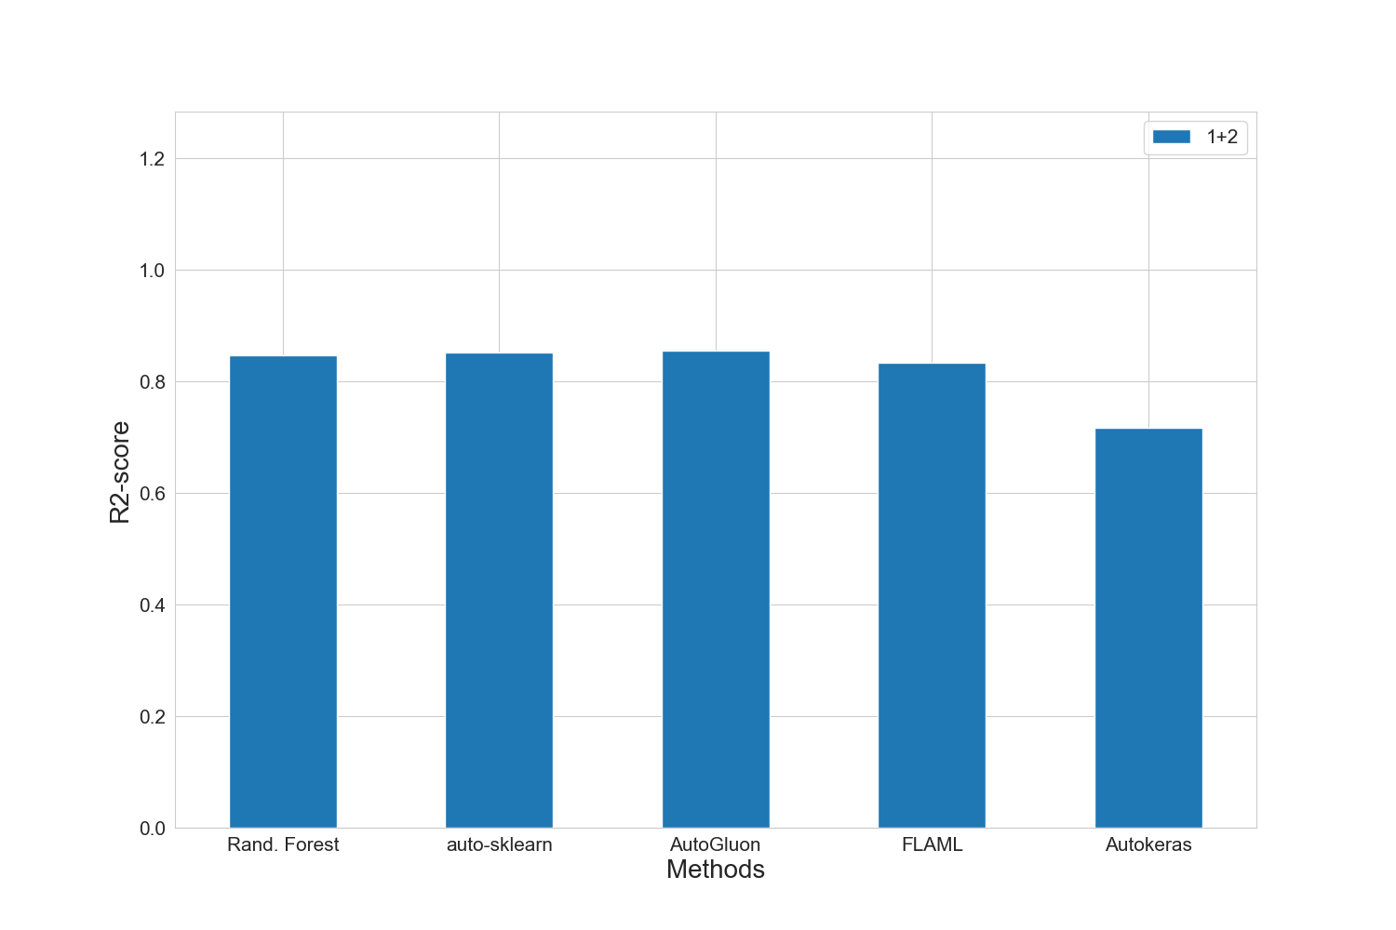

### MAE results for merged-files

|  |  |
| --- | --- |
|  | 1+2 |
| manual | 11898.6 |
| autosklearn | 11767.0 |
| autogluon | **11599.0** |
| flaml | 12399.4 |
| autokeras | 15168.8 |

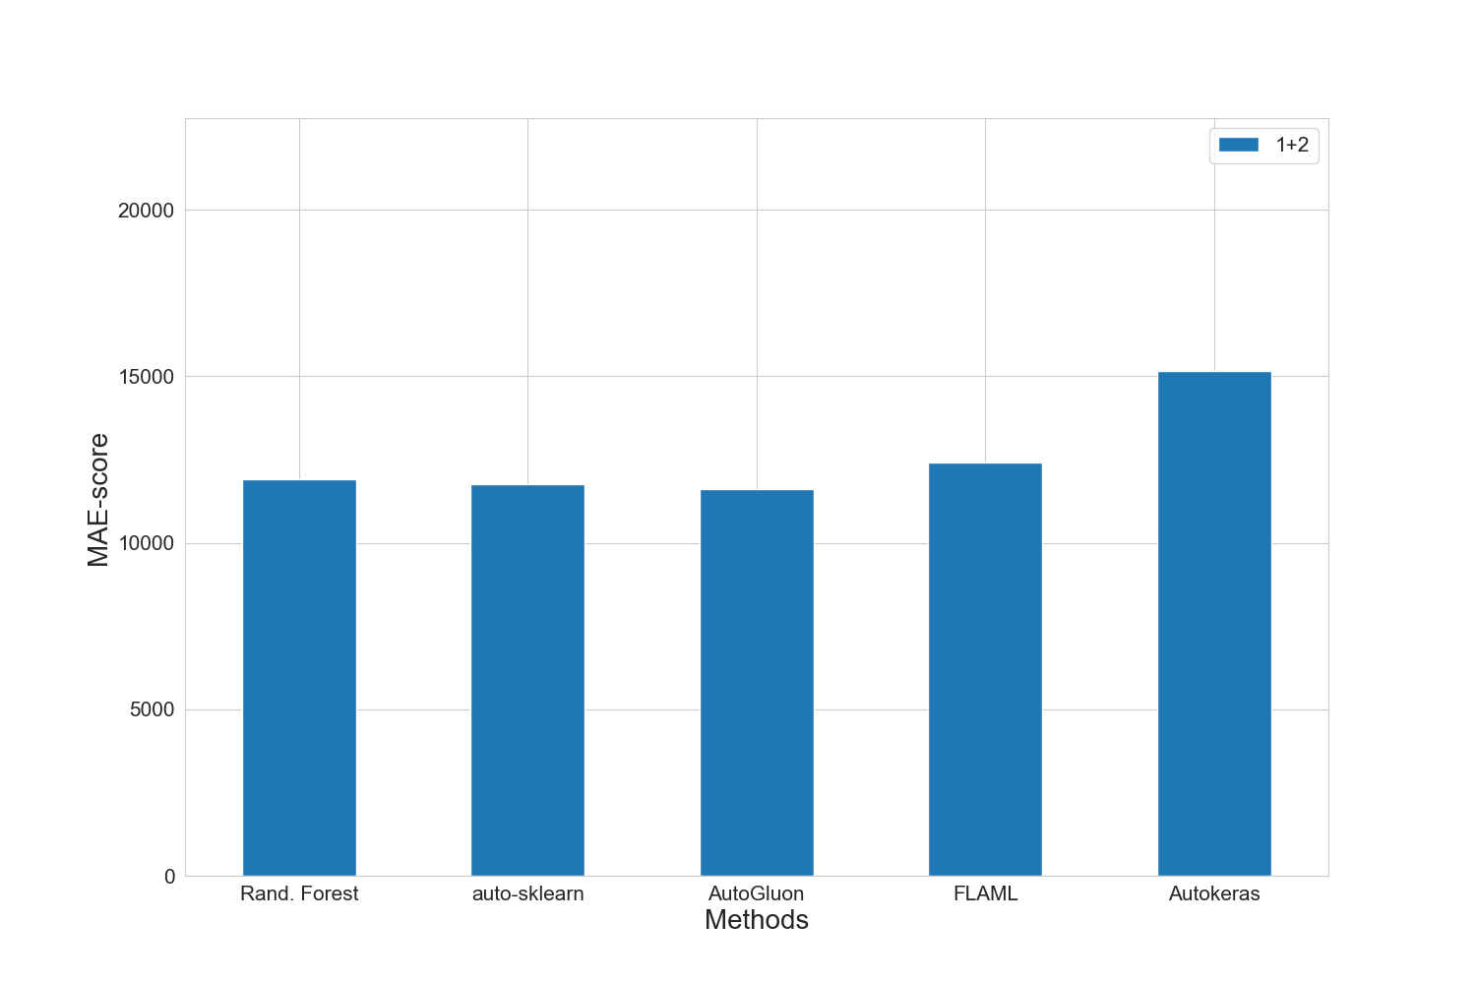

### MAPE results for merged-files

|  |  |
| --- | --- |
|  | 1+2 |
| manual | 0.1477 |
| autosklearn | 0.145 |
| autogluon | **0.1411** |
| flaml | 0.1502 |
| autokeras | 0.1945 |

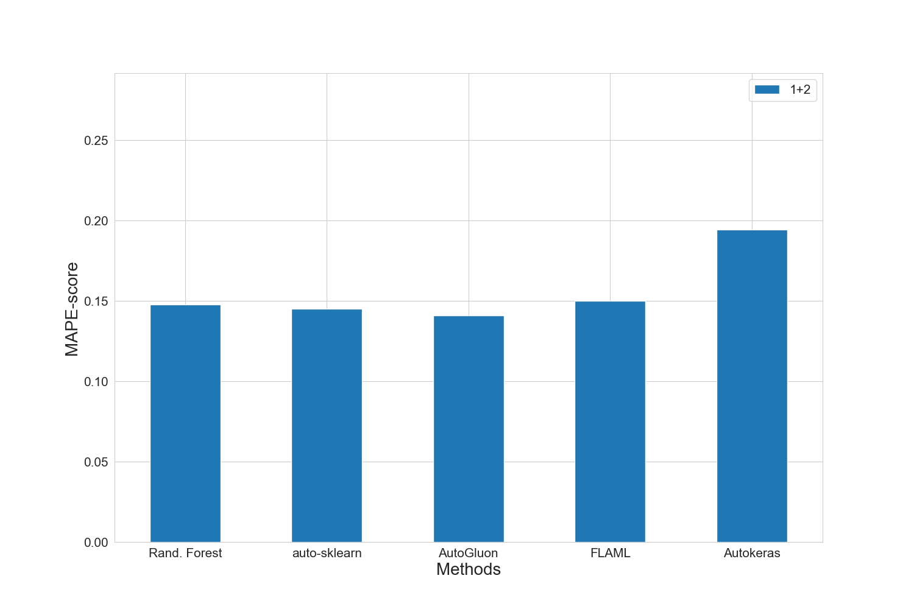

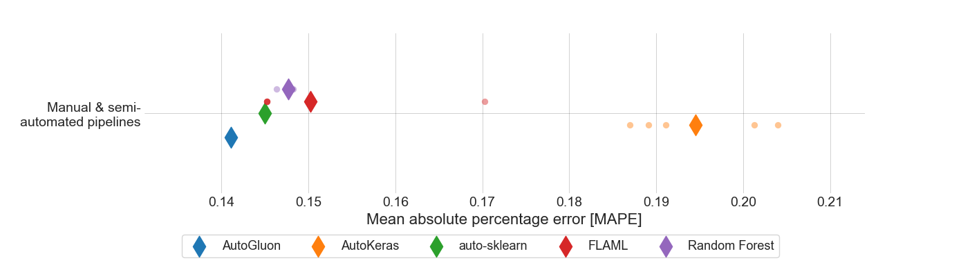

### RMSE results for merged-files

|  |  |
| --- | --- |
|  | 1+2 |
| manual | 17667.4 |
| autosklearn | 17395.0 |
| autogluon | **17128.0** |
| flaml | 18420.6 |
| autokeras | 23986.4 |

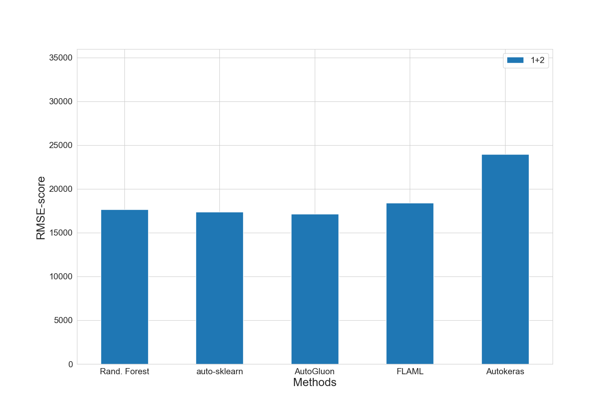

### Training run-time of each method and feature subset in seconds for merged-files

|  |  |
| --- | --- |
|  | 1+2 |
| manual | 1128.0 |
| autosklearn | 1797.7 |
| autogluon | 16.4 |
| flaml | 1800.3 |
| autokeras | 146.8 |

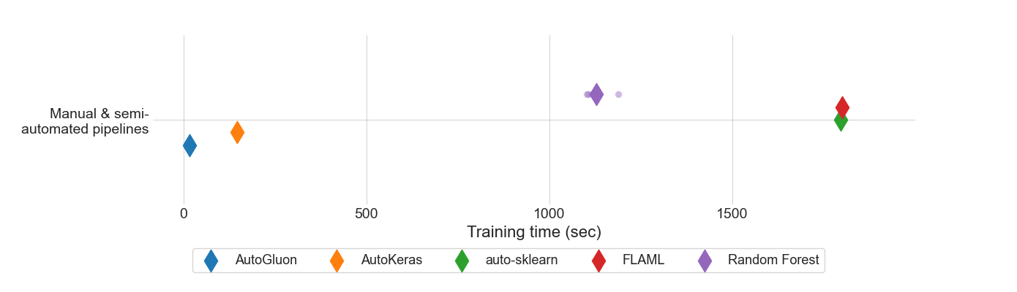

### Prediction time of each method and feature subset in seconds for merged-files

|  |  |
| --- | --- |
|  | 1+2 |
| manual | 3.75731e-05 |
| autosklearn | 0.0017846589 |
| autogluon | 0.0010737145 |
| flaml | 9.56858e-05 |
| autokeras | 0.002715391 |

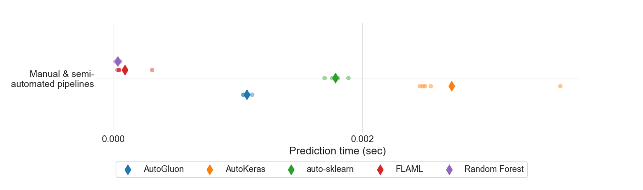

### MEV results for all feature sets.

|  |  |
| --- | --- |
|  | 1+2 |
| manual | 0.842348 |
| autosklearn | 0.632606 |
| autogluon | **0.523636** |
| flaml | 0.646118 |
| autokeras | 0.668154 |

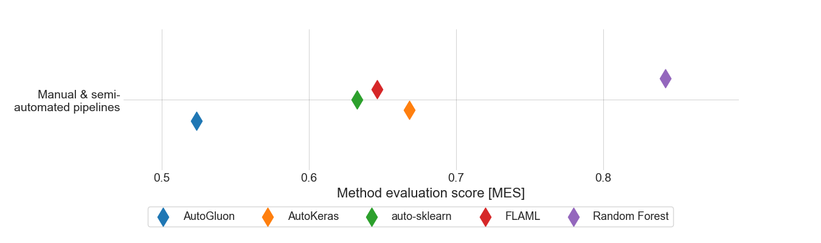

### Standard deviation for MAPE results for 1+2 feature set.

|  |  |
| --- | --- |
|  | 1+2 |
| autogluon | 0.0 |
| autokeras | 0.00683315 |
| autosklearn | 0.0 |
| flaml | 0.01004 |
| manual | 0.00071106 |

### Boxplot for MAPE results for 1+2 feature set.

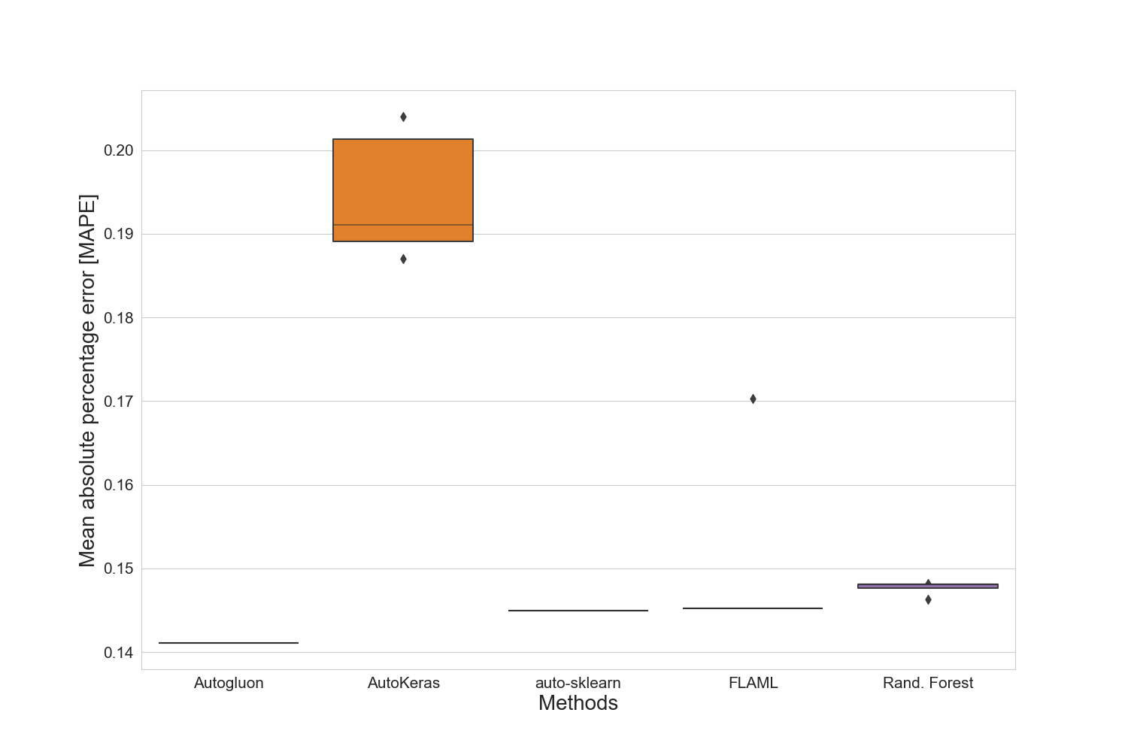

### Standard deviation for training time for 1+2 feature set.

|  |  |
| --- | --- |
|  | 1+2 |
| autogluon | 0.75395957 |
| autokeras | 0.31733364 |
| autosklearn | 2.75571004 |
| flaml | 0.33997153 |
| manual | 31.58043701 |

### Standard deviation for prediction time for 1+2 feature set.

|  |  |
| --- | --- |
|  | 1+2 |
| autogluon | 2.6946637e-05 |
| autokeras | 0.000436594218 |
| autosklearn | 6.2873647e-05 |
| flaml | 0.000107700032 |
| manual | 1.2812355e-05 |

### Best manual model for merged-files

|  |
| --- |
| Best manual model |
| RandomForestRegressor(bootstrap=False, max_features=18, min_samples_split=10,  n_estimators=142) |

### Best results for merged-files

|  |  |  |  |  |  |  |  |
| --- | --- | --- | --- | --- | --- | --- | --- |
|  | R2-Score | MAPE | MAE | RMSE | N-RMSE | IQR-RMSE | CV-RMSE |
| Feature-Set | 1+2 | 1+2 | 1+2 | 1+2 | 1+2 | 1+2 | 1+2 |
| Method | autogluon | autogluon | autogluon | autogluon | autogluon | autogluon | autogluon |
| Value | 0.8559 | 0.1411 | 11599.0 | 17128.0 | 0.0646 | 0.2776 | 0.188 |

# Summary of the best results for all data sets

|  |  |  |  |  |  |  |  |  |
| --- | --- | --- | --- | --- | --- | --- | --- | --- |
|  | # data points | R2-Score | MAPE | MAE | RMSE | N-RMSE | IQR-RMSE | CV-RMSE |
| merged-files | 2910 | **0.8559** | **0.1411** | **11599.0** | **17128.0** | **0.0646** | **0.2776** | **0.188** |

# Statistics for all data sets

|  |  |  |  |  |  |  |
| --- | --- | --- | --- | --- | --- | --- |
|  | # data points | Mean | Median | Std. diviation | Max | Min |
| merged-files | 2910 | 92522 | 80000 | 46927 | 453434 | 1000 |