Measurement overview!

* Measurement date: 2024-12-12
* Random seed: 1
* Number of PCA calculated features: 0
* Outliert detection per bin: True

# Results for merged-files

* Input data file name: merged-files-final-selected-features-2023-12-12.csv
* Input data file creation date: 2023-12-12
* Number of processed data points: 2804

### R2 results for merged-files

|  |  |
| --- | --- |
|  | 3 |
| manual | 0.7925 |
| autosklearn | 0.7754 |
| autogluon | **0.8123** |
| flaml | 0.7155 |
| autokeras | 0.6495 |

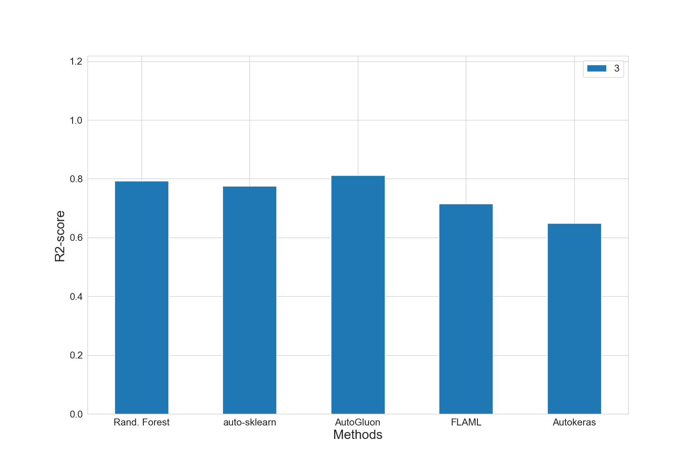

### MAE results for merged-files

|  |  |
| --- | --- |
|  | 3 |
| manual | 12502.0 |
| autosklearn | 12690.0 |
| autogluon | **12082.0** |
| flaml | 15279.0 |
| autokeras | 16403.2 |

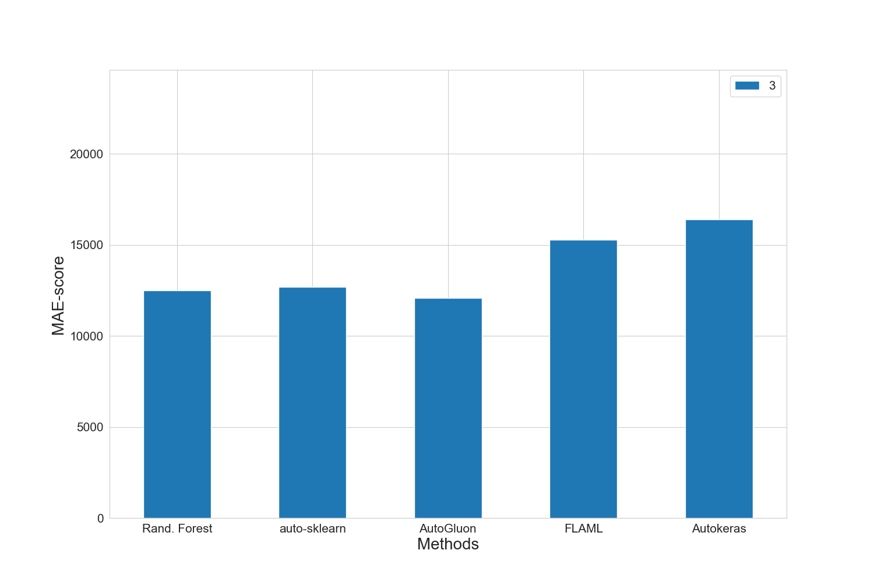

### MAPE results for merged-files

|  |  |
| --- | --- |
|  | 3 |
| manual | 0.1495 |
| autosklearn | 0.1591 |
| autogluon | **0.1438** |
| flaml | 0.185 |
| autokeras | 0.1907 |

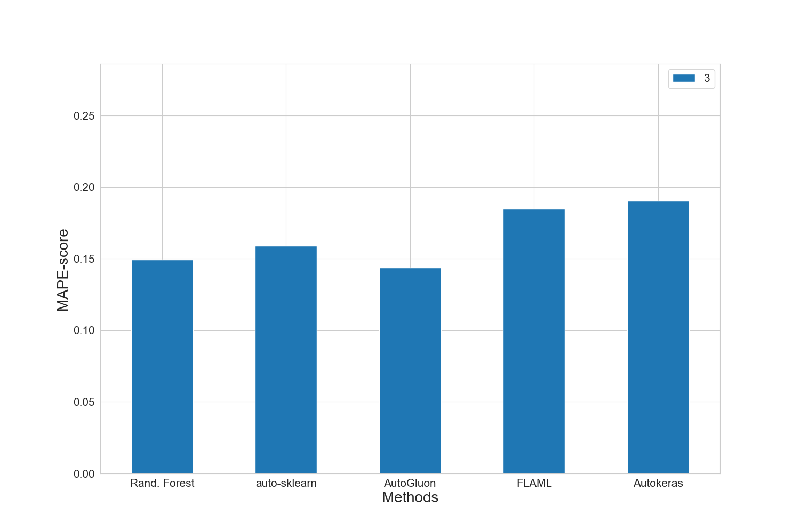

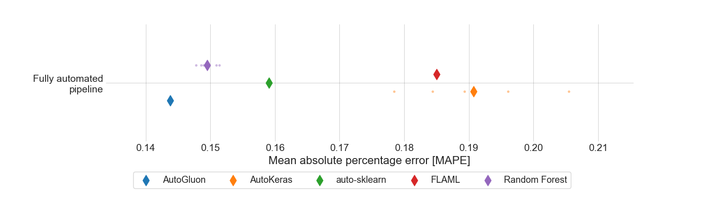

### RMSE results for merged-files

|  |  |
| --- | --- |
|  | 3 |
| manual | 17712.2 |
| autosklearn | 18425.0 |
| autogluon | **16846.0** |
| flaml | 20739.0 |
| autokeras | 23006.6 |

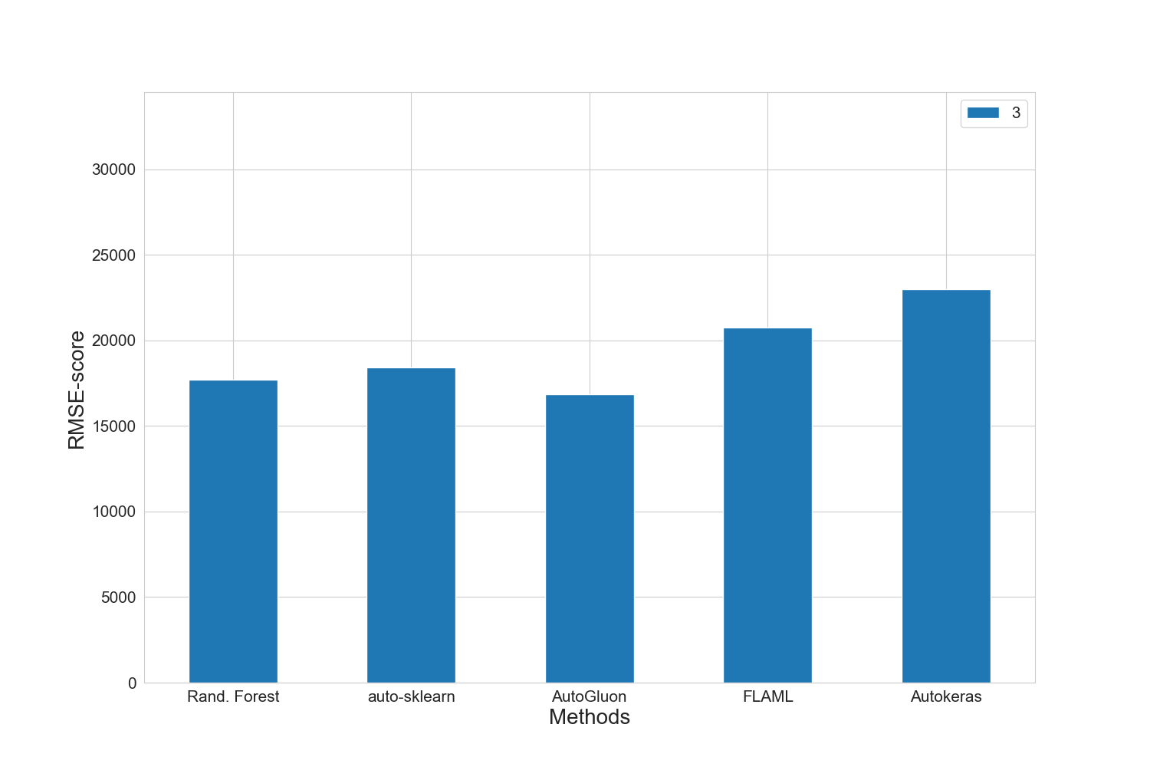

### Training run-time of each method and feature subset in seconds for merged-files

|  |  |
| --- | --- |
|  | 3 |
| manual | 1502.1 |
| autosklearn | 1801.8 |
| autogluon | 13.7 |
| flaml | 1802.6 |
| autokeras | 138.8 |

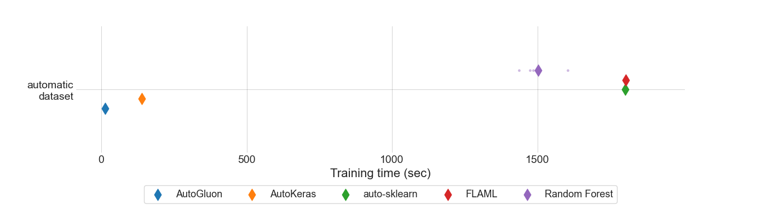

### Prediction time of each method and feature subset in seconds for merged-files

|  |  |
| --- | --- |
|  | 3 |
| manual | 4.79914e-05 |
| autosklearn | 0.0009724629 |
| autogluon | 0.0006434077 |
| flaml | 5.69708e-05 |
| autokeras | 0.0024968074 |

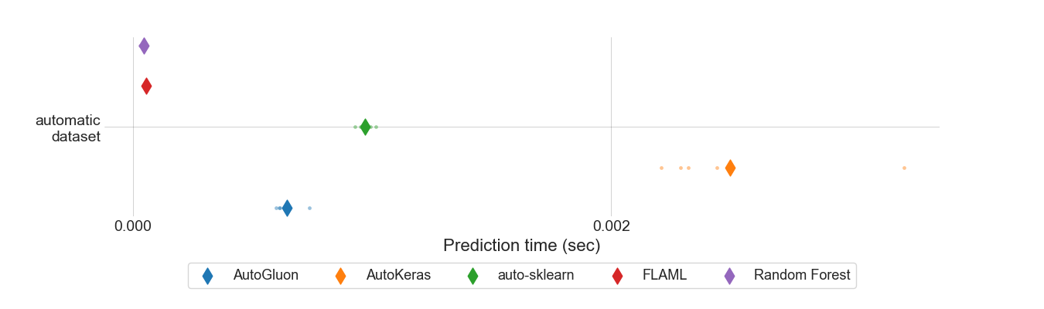

### MEV results for all feature sets.

|  |  |
| --- | --- |
|  | 3 |
| manual | 0.875307 |
| autosklearn | 0.677103 |
| autogluon | **0.537792** |
| flaml | 0.745055 |
| autokeras | 0.6677 |

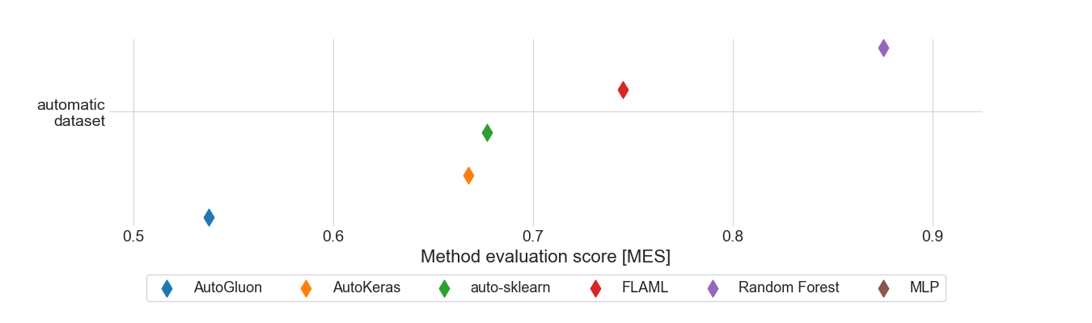

### Standard deviation for MAPE results for 3 feature set.

|  |  |
| --- | --- |
|  | 3 |
| autogluon | 0.0 |
| autokeras | 0.00939289 |
| autosklearn | 0.0 |
| flaml | 0.0 |
| manual | 0.00137928 |

### Boxplot for MAPE results for 3 feature set.

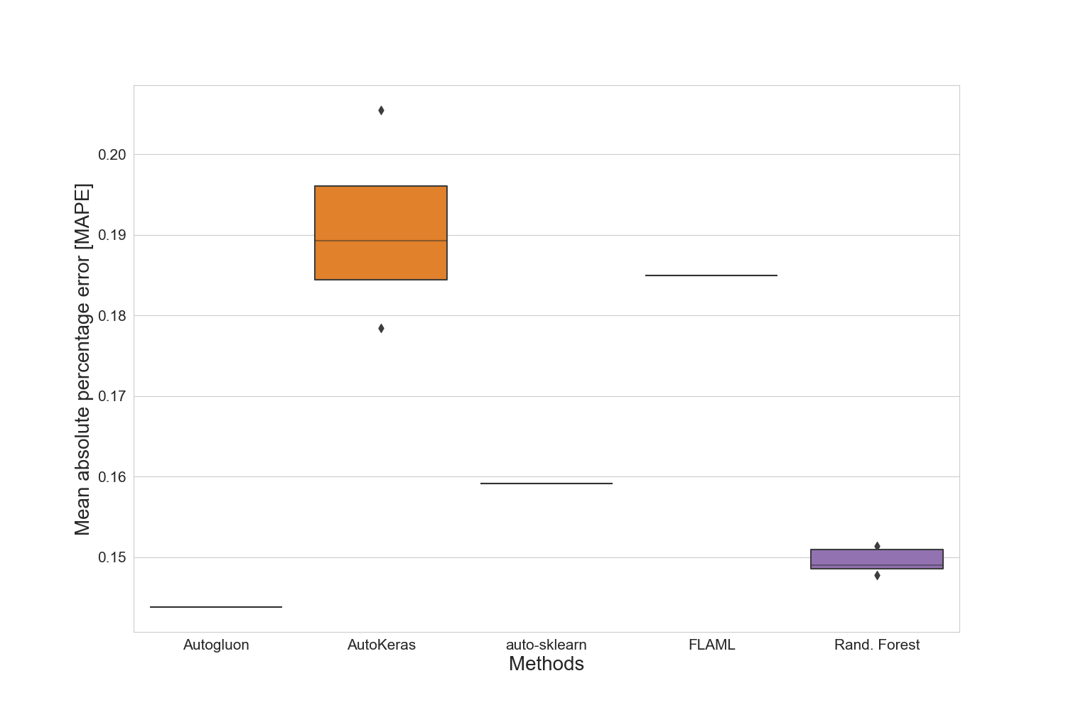

### Standard deviation for training time for 3 feature set.

|  |  |
| --- | --- |
|  | 3 |
| autogluon | 0.30668068 |
| autokeras | 0.82052261 |
| autosklearn | 3.19066881 |
| flaml | 0.33256783 |
| manual | 56.35259825 |

### Standard deviation for prediction time for 3 feature set.

|  |  |
| --- | --- |
|  | 3 |
| autogluon | 5.0582444e-05 |
| autokeras | 0.000370447692 |
| autosklearn | 3.0998094e-05 |
| flaml | 3.888875e-06 |
| manual | 8.186658e-06 |

### Best manual model for merged-files

|  |
| --- |
| Best manual model |
| RandomForestRegressor(criterion='poisson', max_features=15, min_samples_split=7,  n_estimators=187) |

### Best results for merged-files

|  |  |  |  |  |  |  |  |
| --- | --- | --- | --- | --- | --- | --- | --- |
|  | R2-Score | MAPE | MAE | RMSE | N-RMSE | IQR-RMSE | CV-RMSE |
| Feature-Set | 3 | 3 | 3 | 3 | 3 | 3 | 3 |
| Method | autogluon | autogluon | autogluon | autogluon | autogluon | autogluon | autogluon |
| Value | 0.8123 | 0.1438 | 12082.0 | 16846.0 | 0.0791 | 0.3343 | 0.186 |

# Summary of the best results for all data sets

|  |  |  |  |  |  |  |  |  |
| --- | --- | --- | --- | --- | --- | --- | --- | --- |
|  | # data points | R2-Score | MAPE | MAE | RMSE | N-RMSE | IQR-RMSE | CV-RMSE |
| merged-files | 2804 | **0.8123** | **0.1438** | **12082.0** | **16846.0** | **0.0791** | **0.3343** | **0.186** |

# Statistics for all data sets

|  |  |  |  |  |  |  |
| --- | --- | --- | --- | --- | --- | --- |
|  | # data points | Mean | Median | Std. diviation | Max | Min |
| merged-files | 2804 | 90814 | 80148 | 41516 | 261545 | 10000 |