Cloning Masking Rules to Objects
AutoRABIT Vault User Guide
This guide explains how to clone existing masking rules to fields on one or more destination objects, review the rules that Vault will create, start the cloning operation, and monitor or retry the resulting bulk clone jobs.
Audience | Vault users who configure and manage masking rules
Feature | Masking > Bulk Clone Rules > Clone to Object
Outcome | Compatible fields are assigned cloned masking rules and tracked as destination-specific bulk clone jobs

How rule consolidation works
Vault creates cloned rules by destination object and compatible field type. Within a destination object, selected fields with the same field type are combined under one cloned rule. The resulting rule retains the masking style and masking value of the selected source rule.
Observed selection | Result | Interpretation
6 picklist fields on AccountTeamMember | 1 rule masks 6 fields | All six fields share the picklist type and are combined into one rule.
133 fields across 5 destination objects | 12 rules mask 133 fields | Vault counts each distinct compatible field type within each destination object as a separate cloned rule.
Important: The number of rules that will be created is not the same as the number of selected fields. It is the sum of applicable field-type groups across the selected destination objects.

Before you begin
- Confirm that the required source masking rules exist in the selected Salesforce org.
- Identify the destination objects and fields to which the rules must be cloned.
- Ensure each destination field has the same field type as the selected source rule.
- Review fields marked as already having masking configured; these fields are not available for a new cloned assignment in the observed flow.

Open the clone workflow
- From the left navigation, expand Masking and select Bulk Clone Rules.
- Select the Salesforce org and select Apply.
- Select Clone to Obj to open the Clone Masking Rules to Objects workflow.
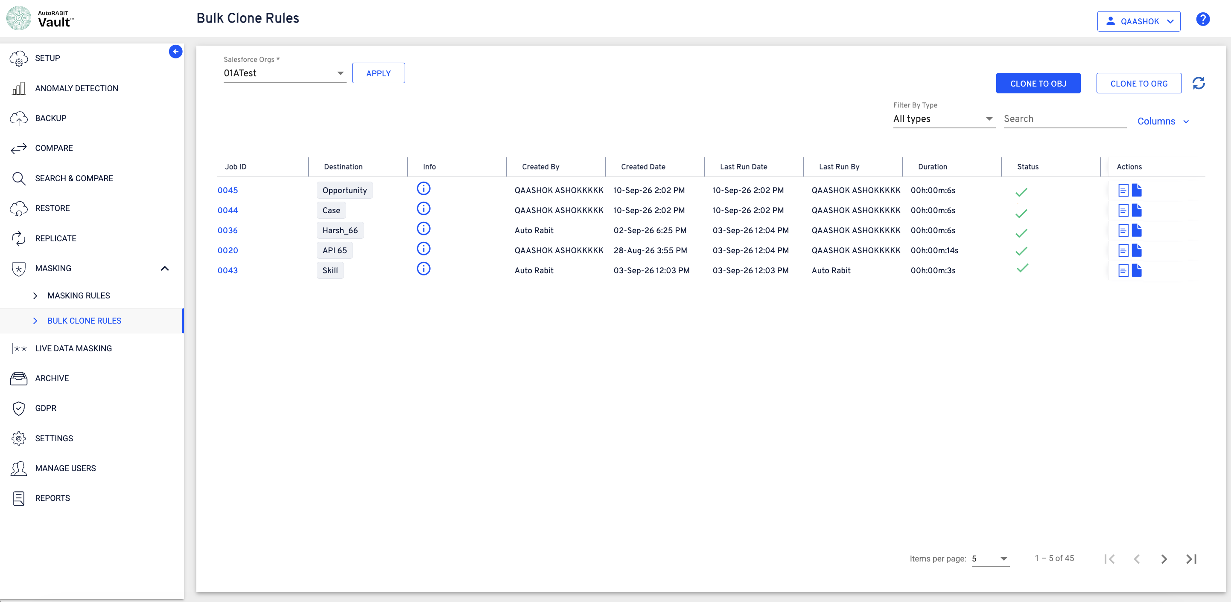
Figure 1 Bulk Clone Rules page and Clone to Obj action

Select source masking rules
The Select Rules step lists available masking rules from the selected source org.
- Use the object filter or search controls to locate the required source rule.
- Select a masking rule. Only one rule for each field type can be selected.
- Review the selected-rule count and select Continue.
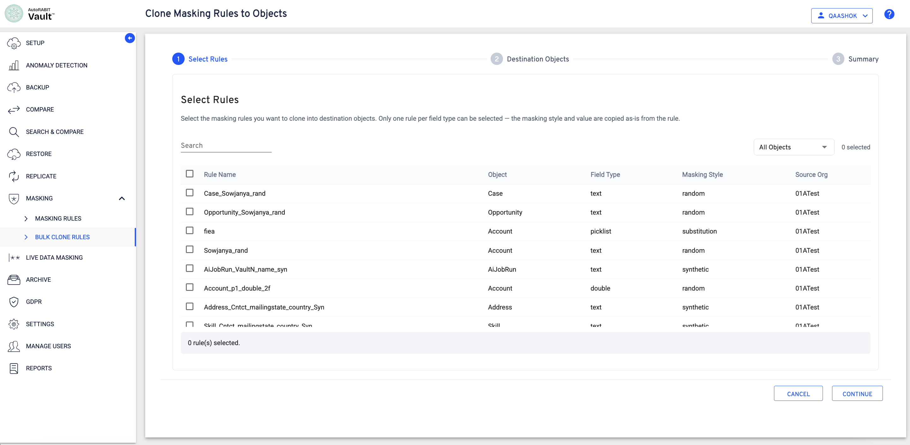
Figure 2 Available source masking rules
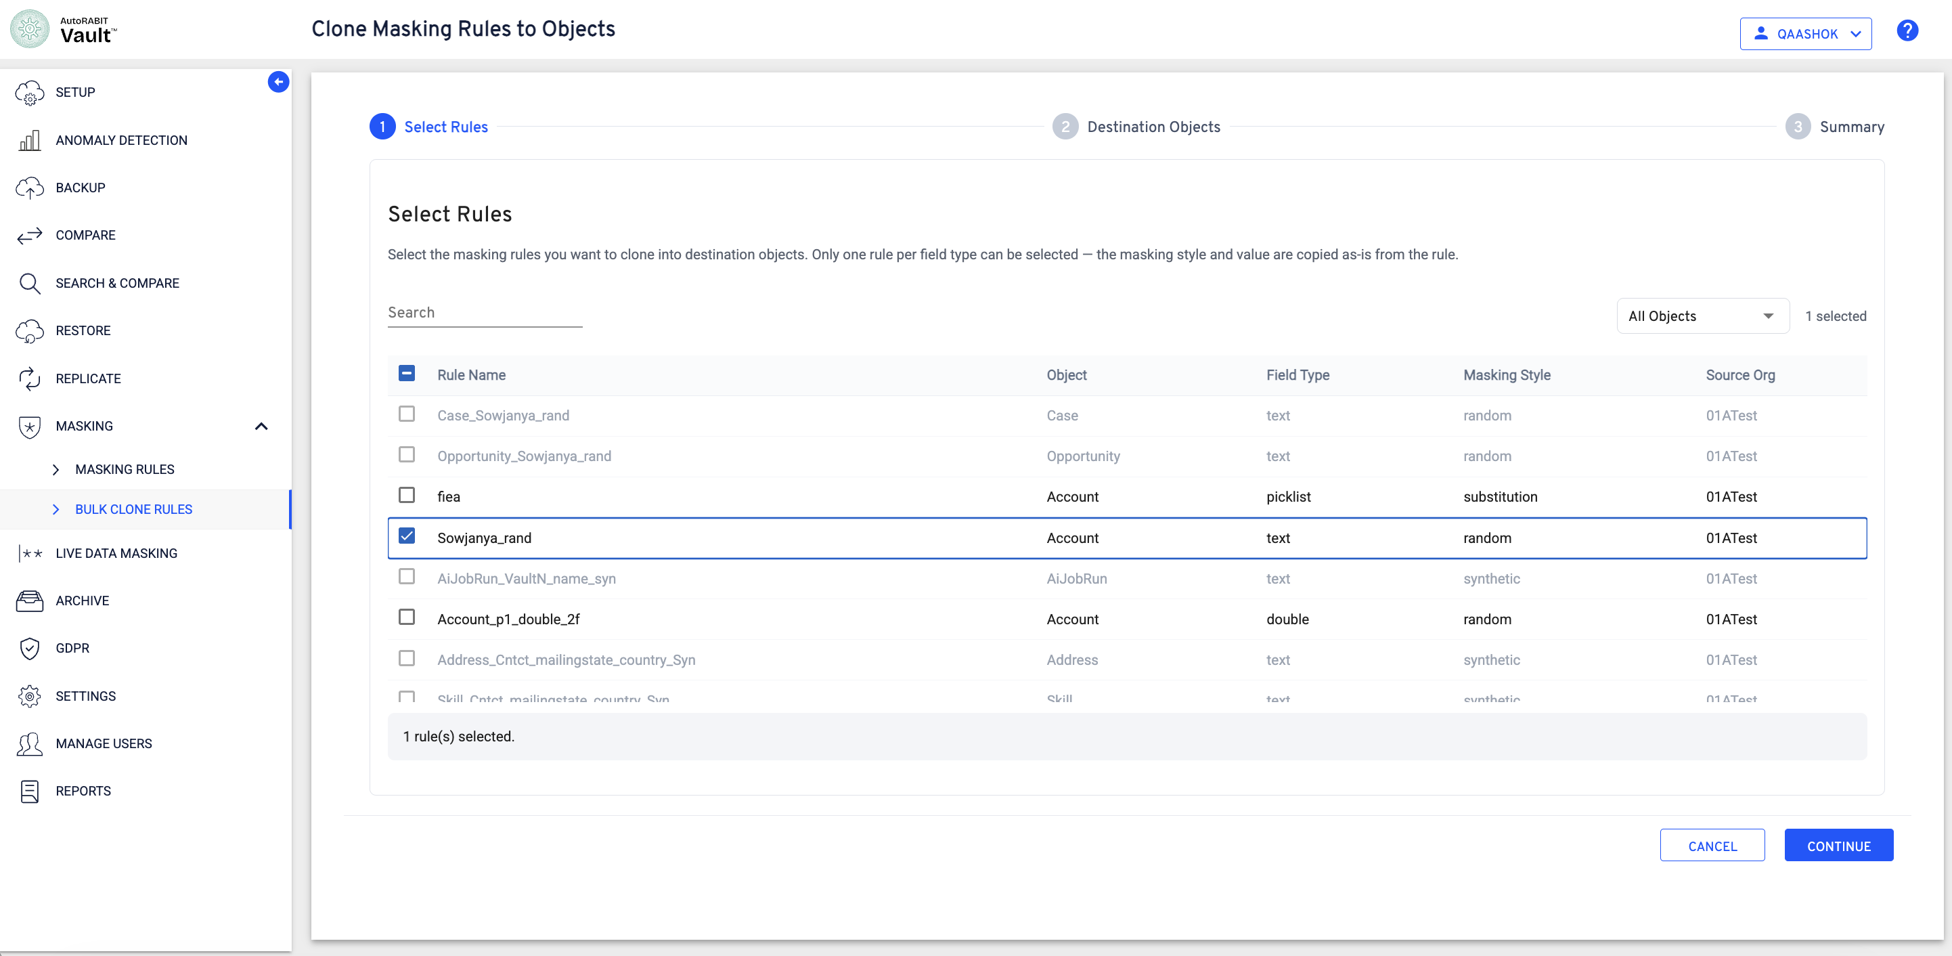
Figure 3 One source masking rule selected

Add destination objects
The Destination Objects step is used to select target objects and configure compatible fields for each object.
- Select Add Object.
- Search for or select the required destination objects.
- Select Add to include the objects in the destination configuration.
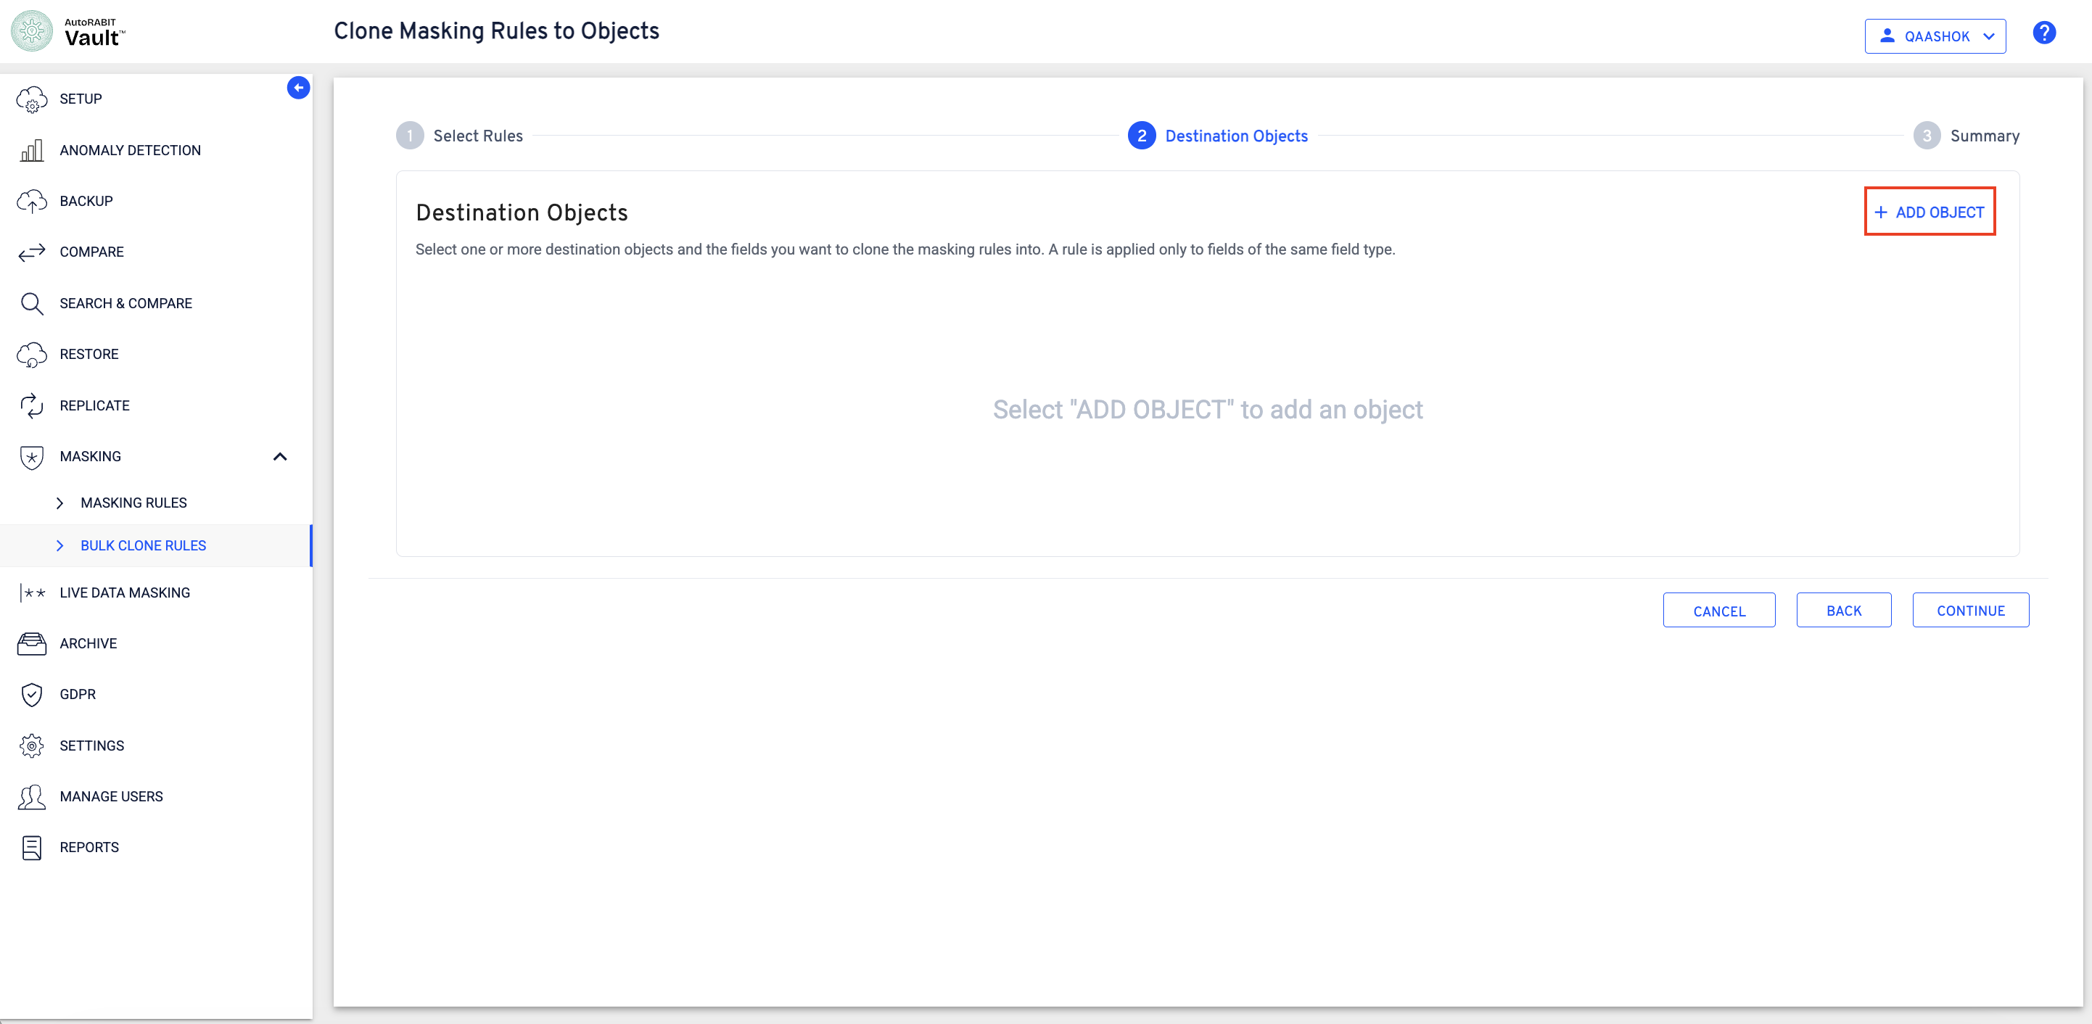
Figure 4 Destination Objects step before objects are added
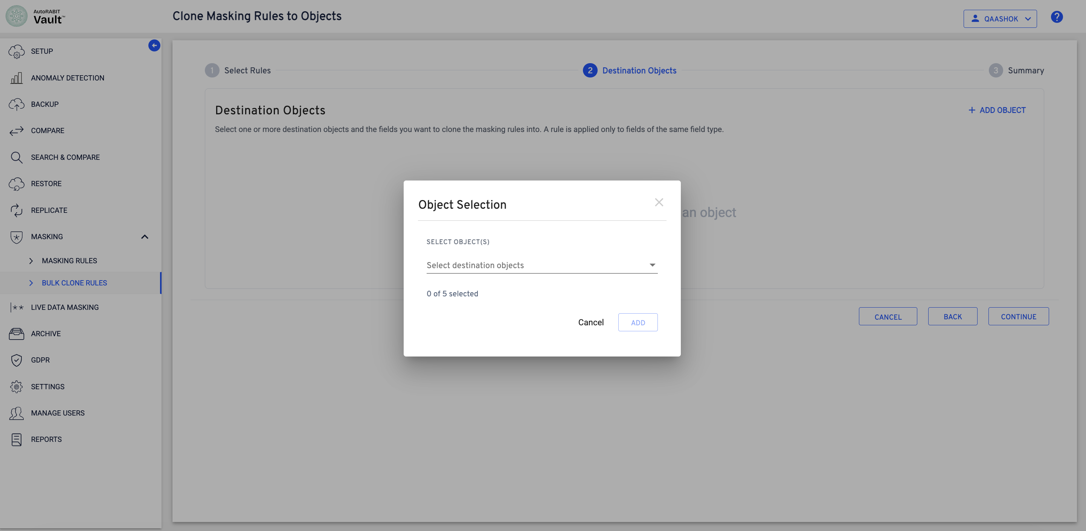
Figure 5 Object Selection dialog
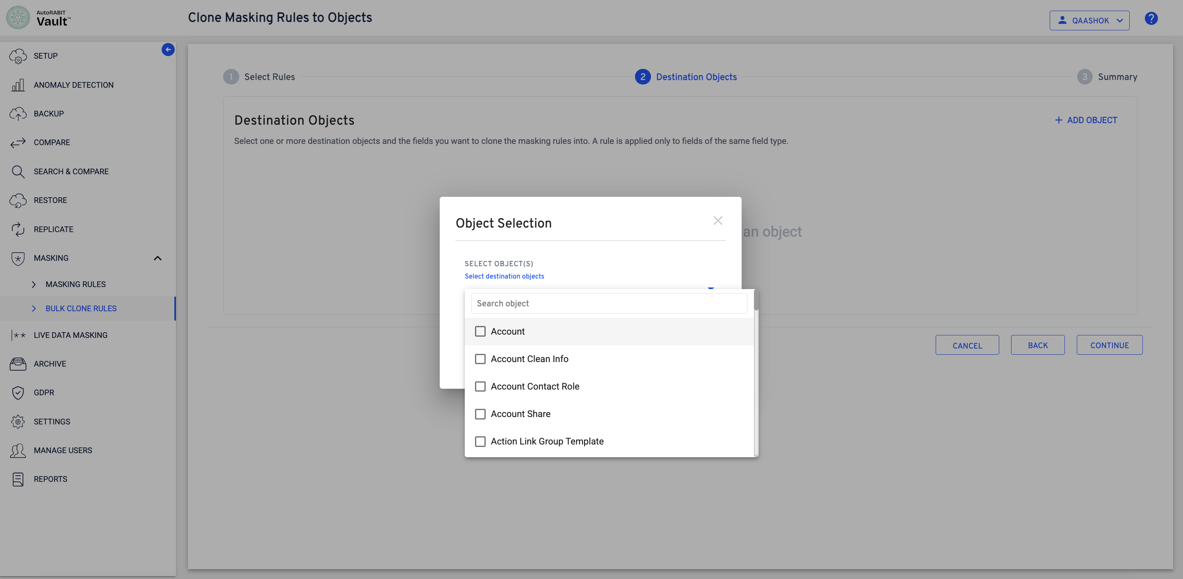
Figure 6 Destination object search and available objects
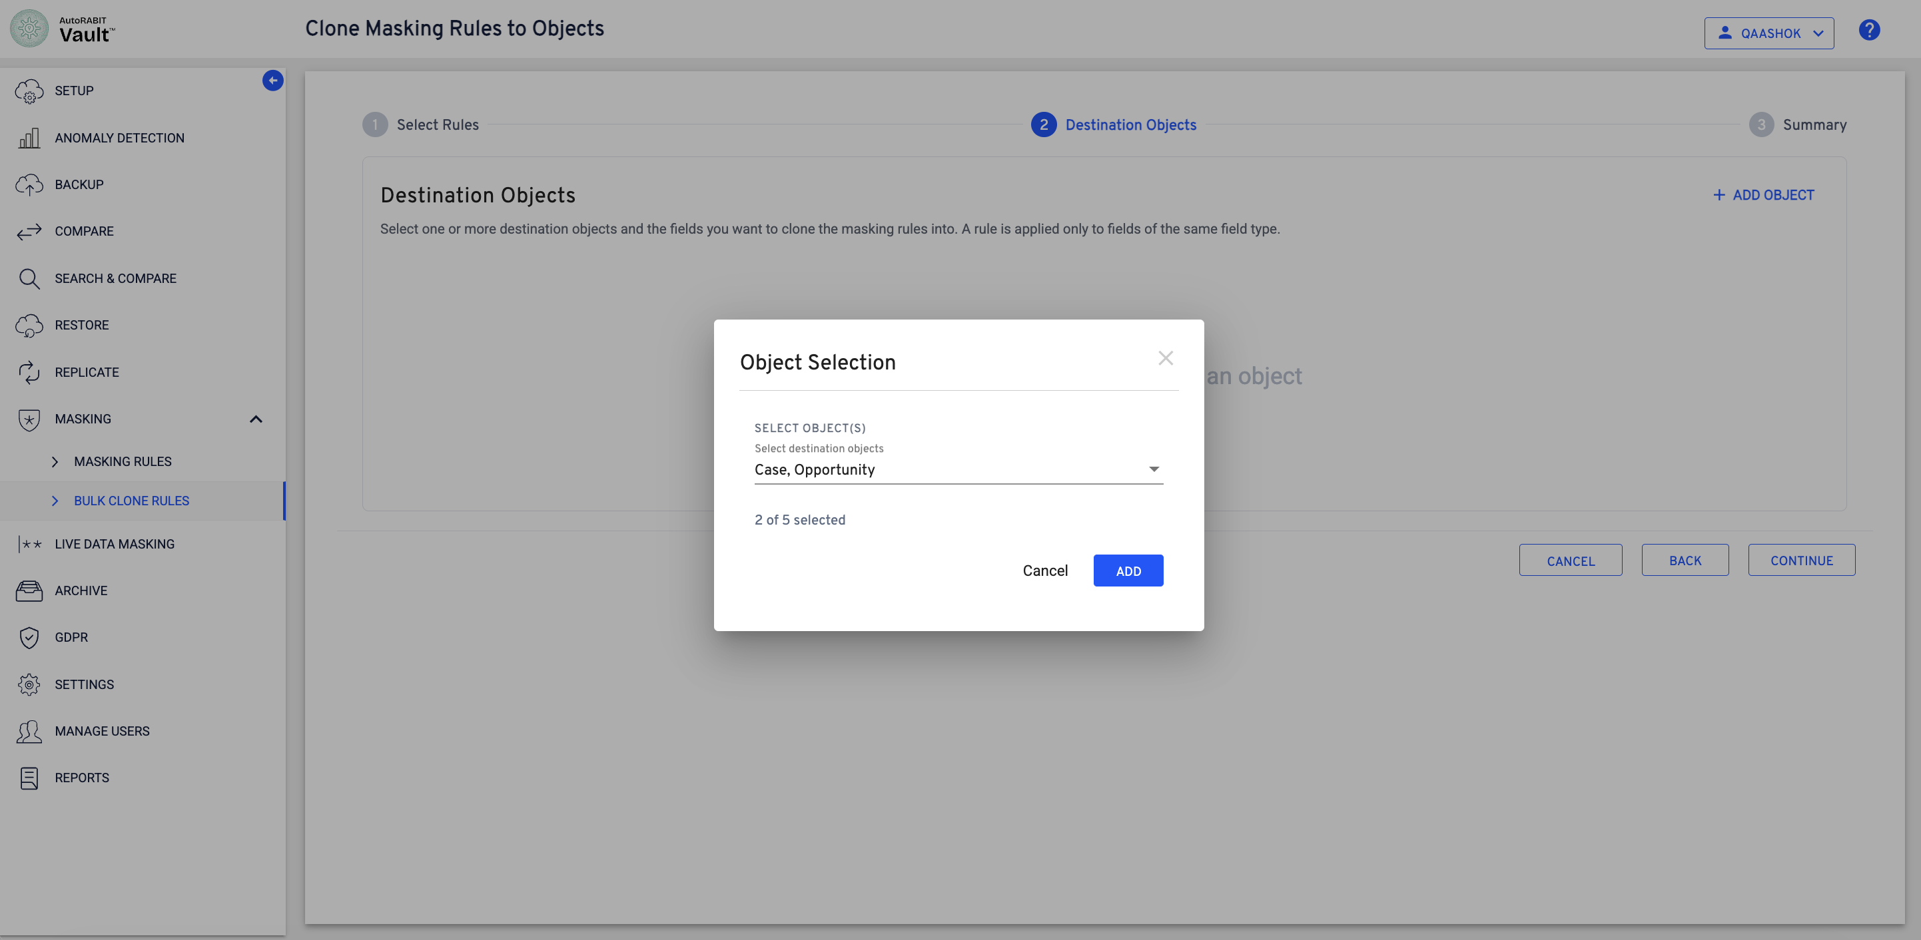
Figure 7 Two destination objects selected
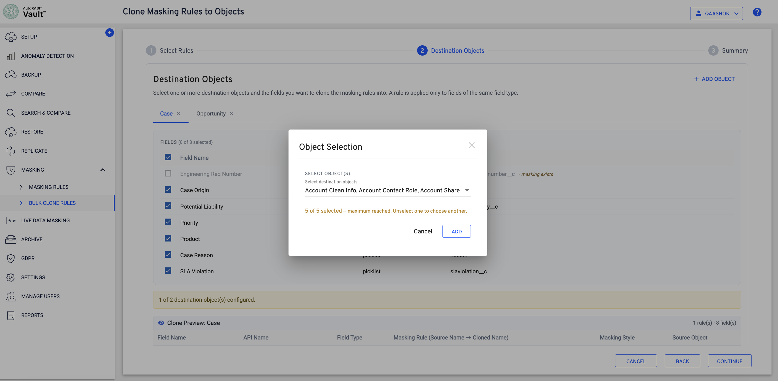
Figure 8 Maximum of five destination objects selected
Observed limit: The interface allows up to five destination objects in one clone operation. To choose another object after reaching the limit, unselect an existing object first.

Select compatible destination fields
Select each destination object tab and choose the fields that must receive the cloned rule. Vault applies a source rule only to destination fields of the same field type and displays a clone preview for the active object.
- Open a destination object tab.
- Select one or more eligible fields. Fields that already have masking configured are identified in the field list.
- Repeat the selection for each destination object.
- Confirm that the configured-object count reflects every intended destination object.
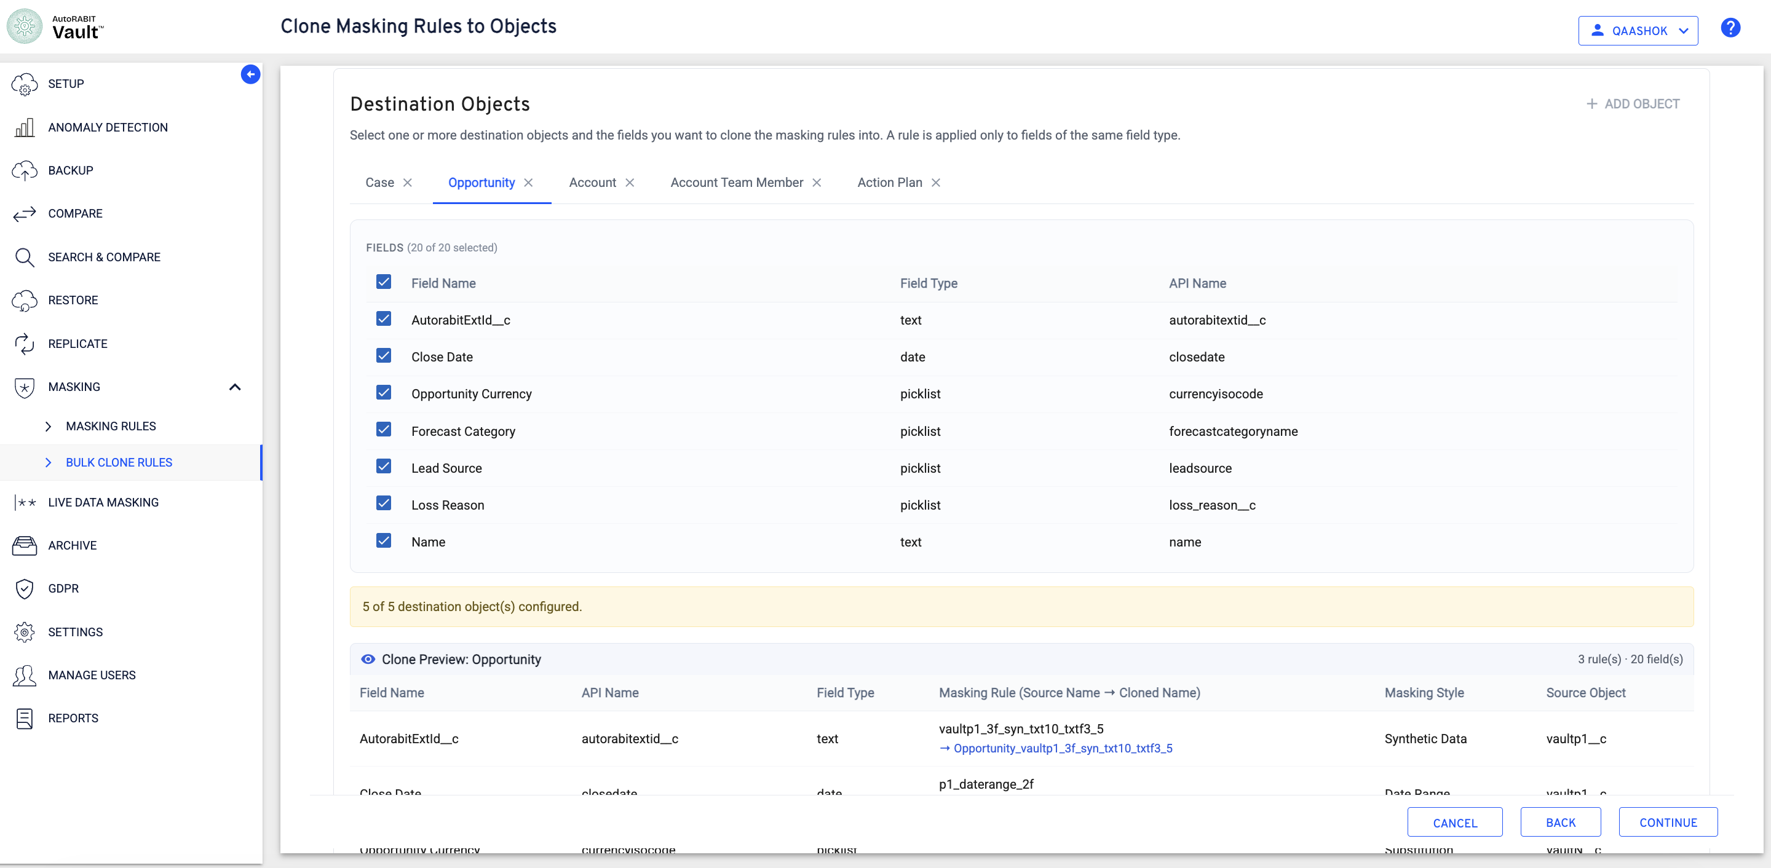
Figure 9 Configured destination objects and object-level clone preview
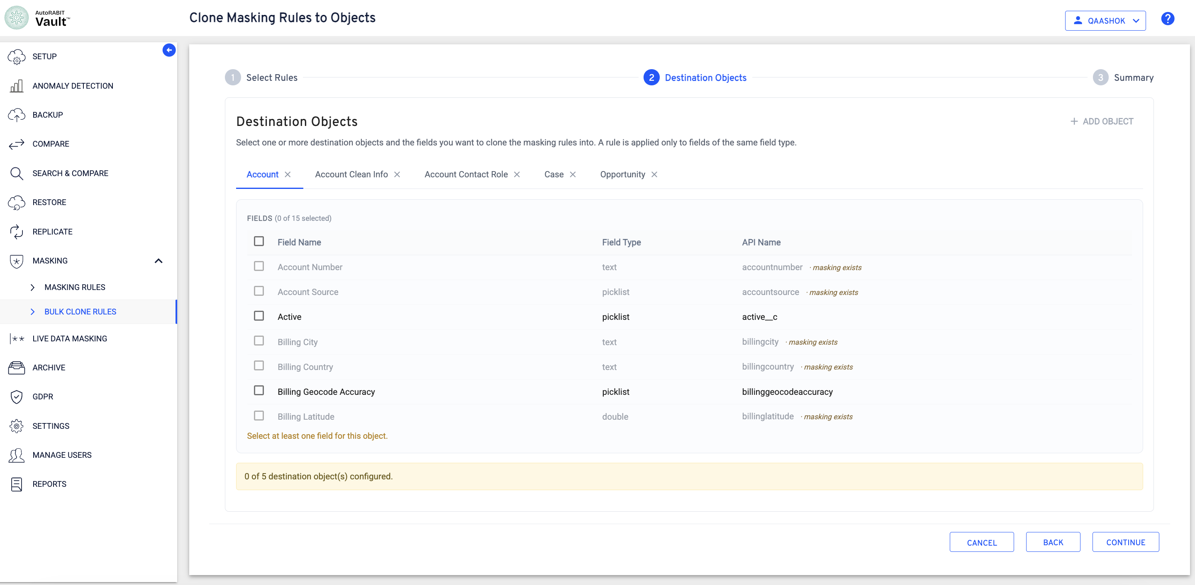
Figure 10 Fields with existing masking and required field selection
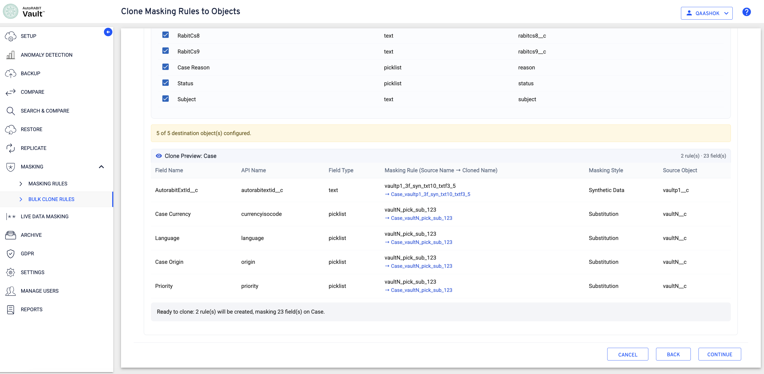
Figure 11 Case preview showing field groups and cloned rule names

Understand the object-level readiness summary
For AccountTeamMember, all six selected fields are picklist fields. Because they share the same compatible field type, Vault groups them under one cloned substitution rule.
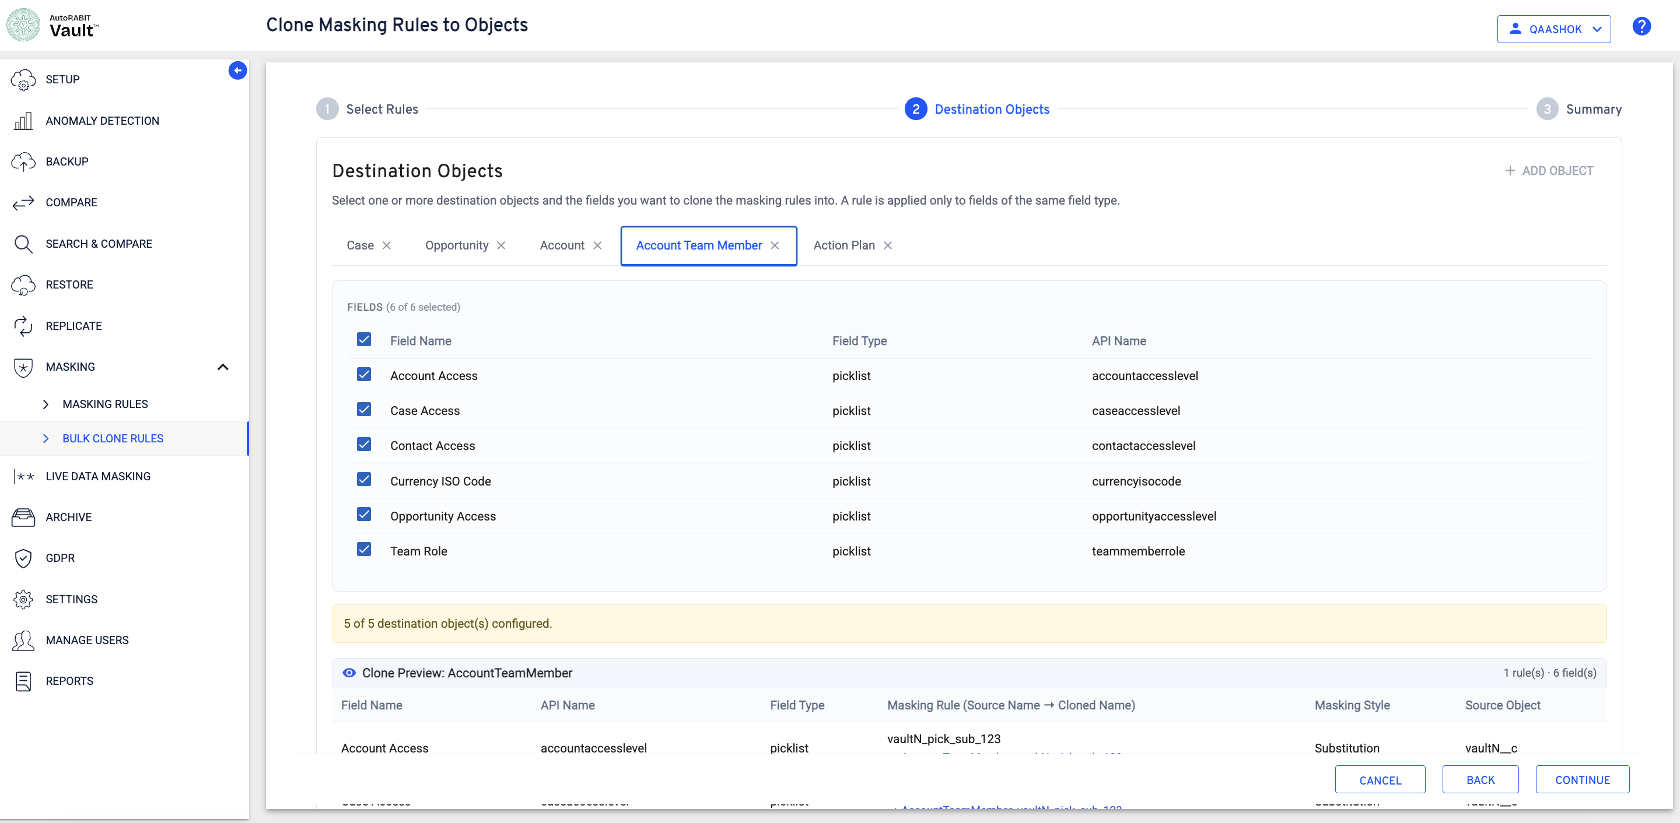
Figure 12 Six selected picklist fields on AccountTeamMember
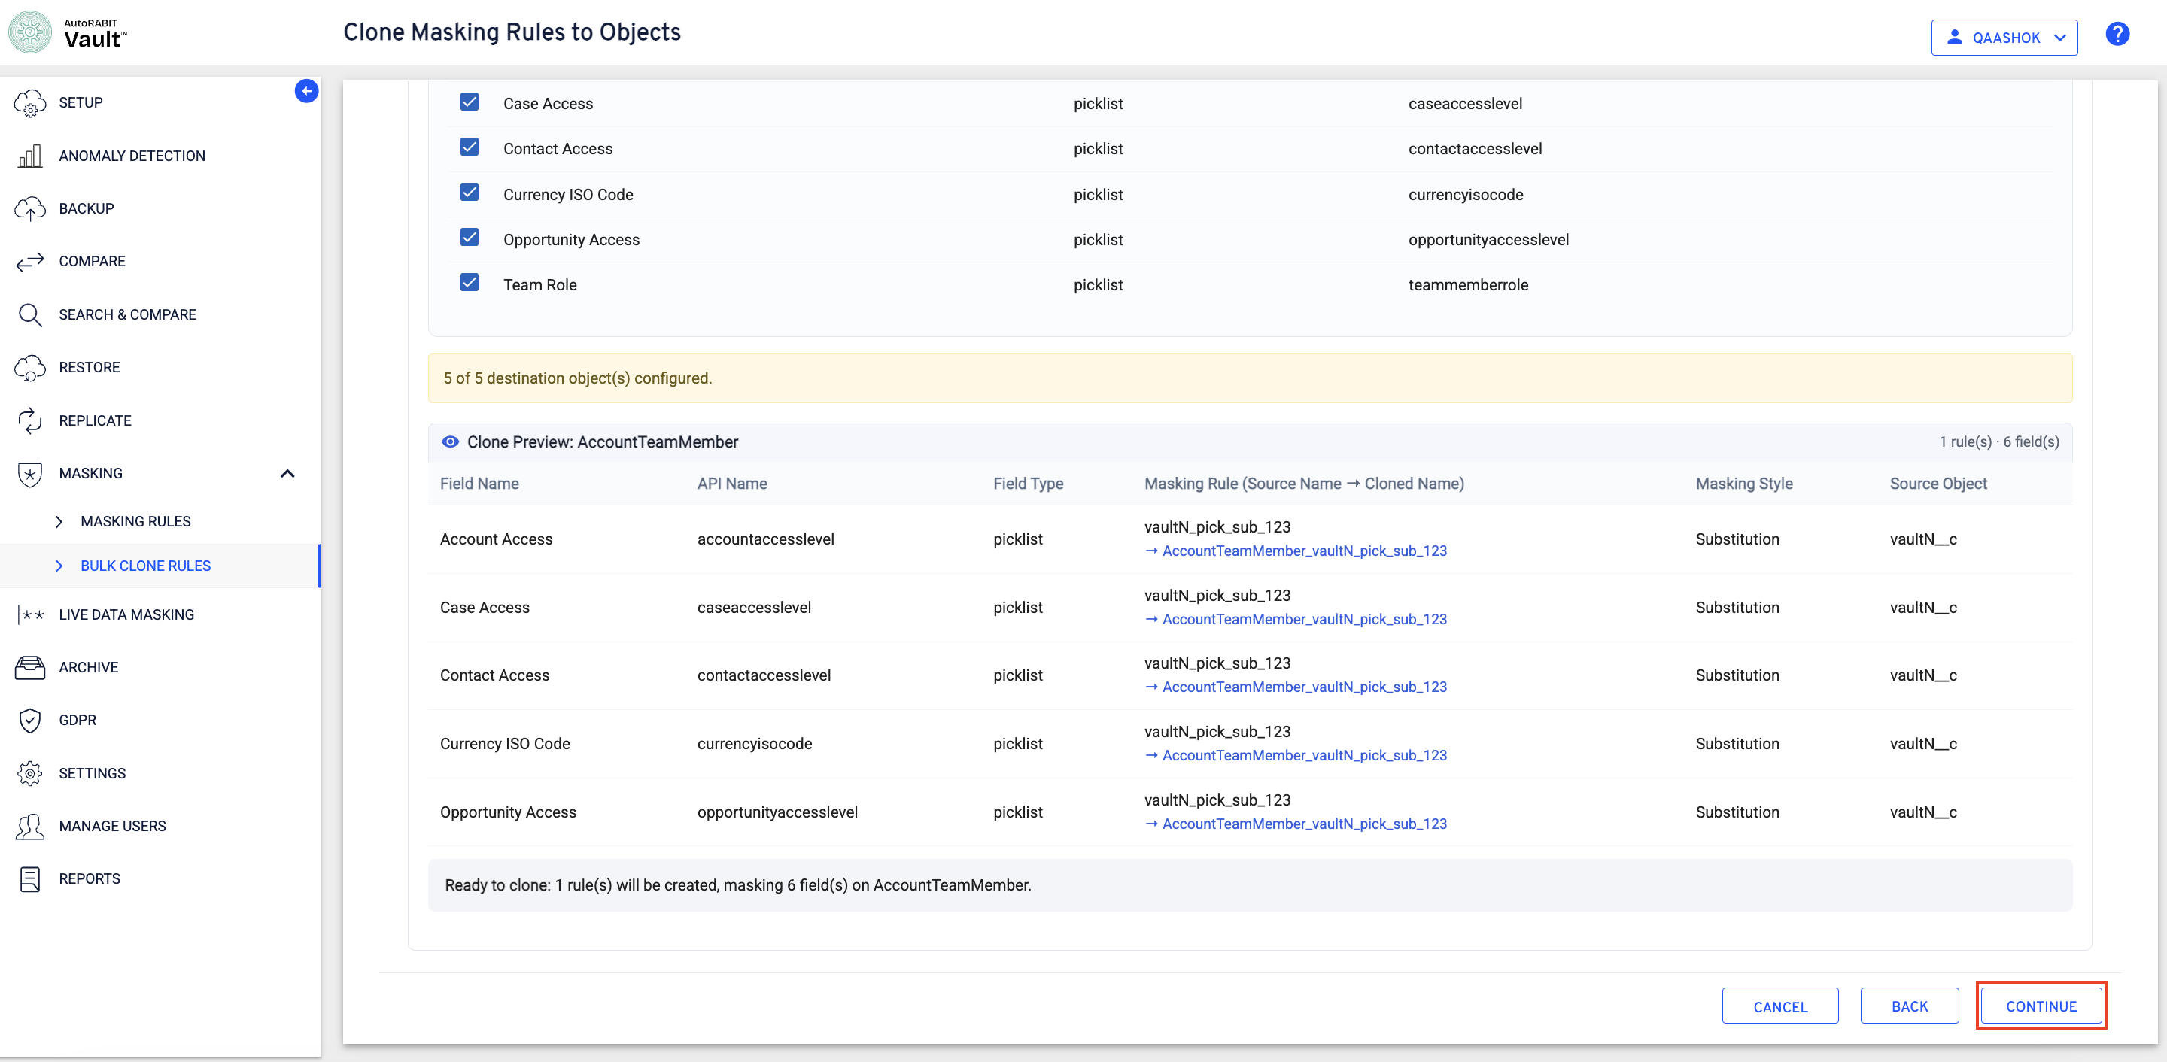
Figure 13 One cloned rule configured to mask six AccountTeamMember fields
Displayed summary: Ready to clone: 1 rule will be created, masking 6 fields on AccountTeamMember.

Review the complete clone summary
Select Continue to open Summary. Review the source org, selected masking rules, destination objects, field-to-rule mappings, masking styles, source objects, and clone eligibility before starting the operation.
- Confirm that each selected source rule shows the expected field type, masking style, and Cloneable status.
- Review each destination object and its selected field count.
- Verify the source-to-cloned rule names and the masking style assigned to each field.
- Review the final Ready to clone summary and select Clone.
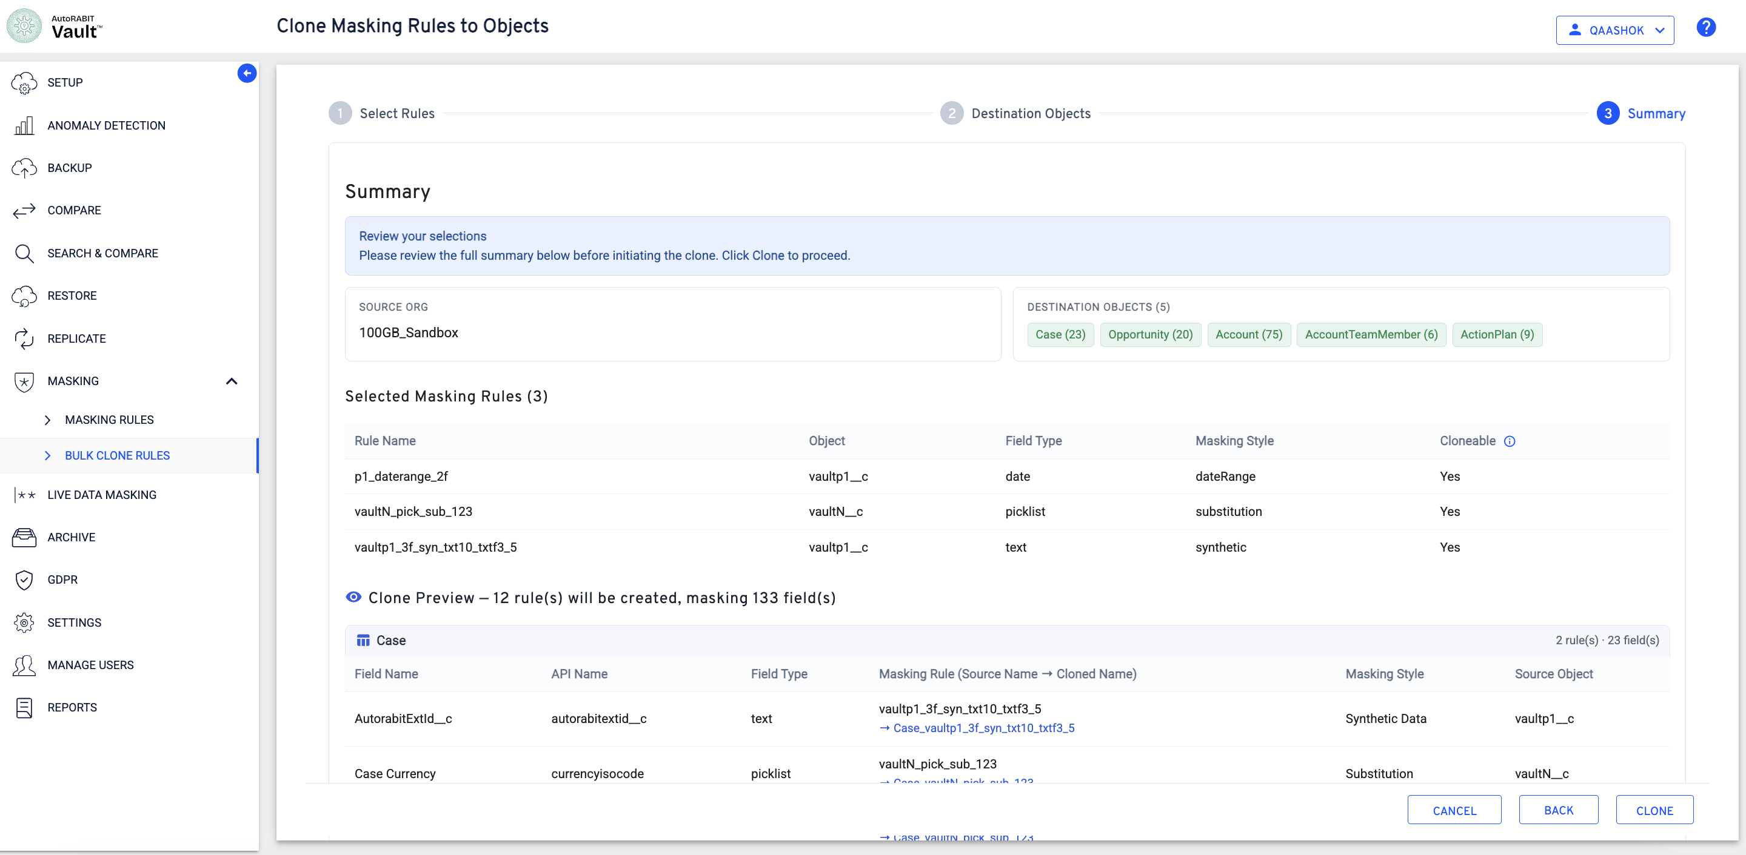
Figure 14 Summary with source rules, destination objects, and clone preview
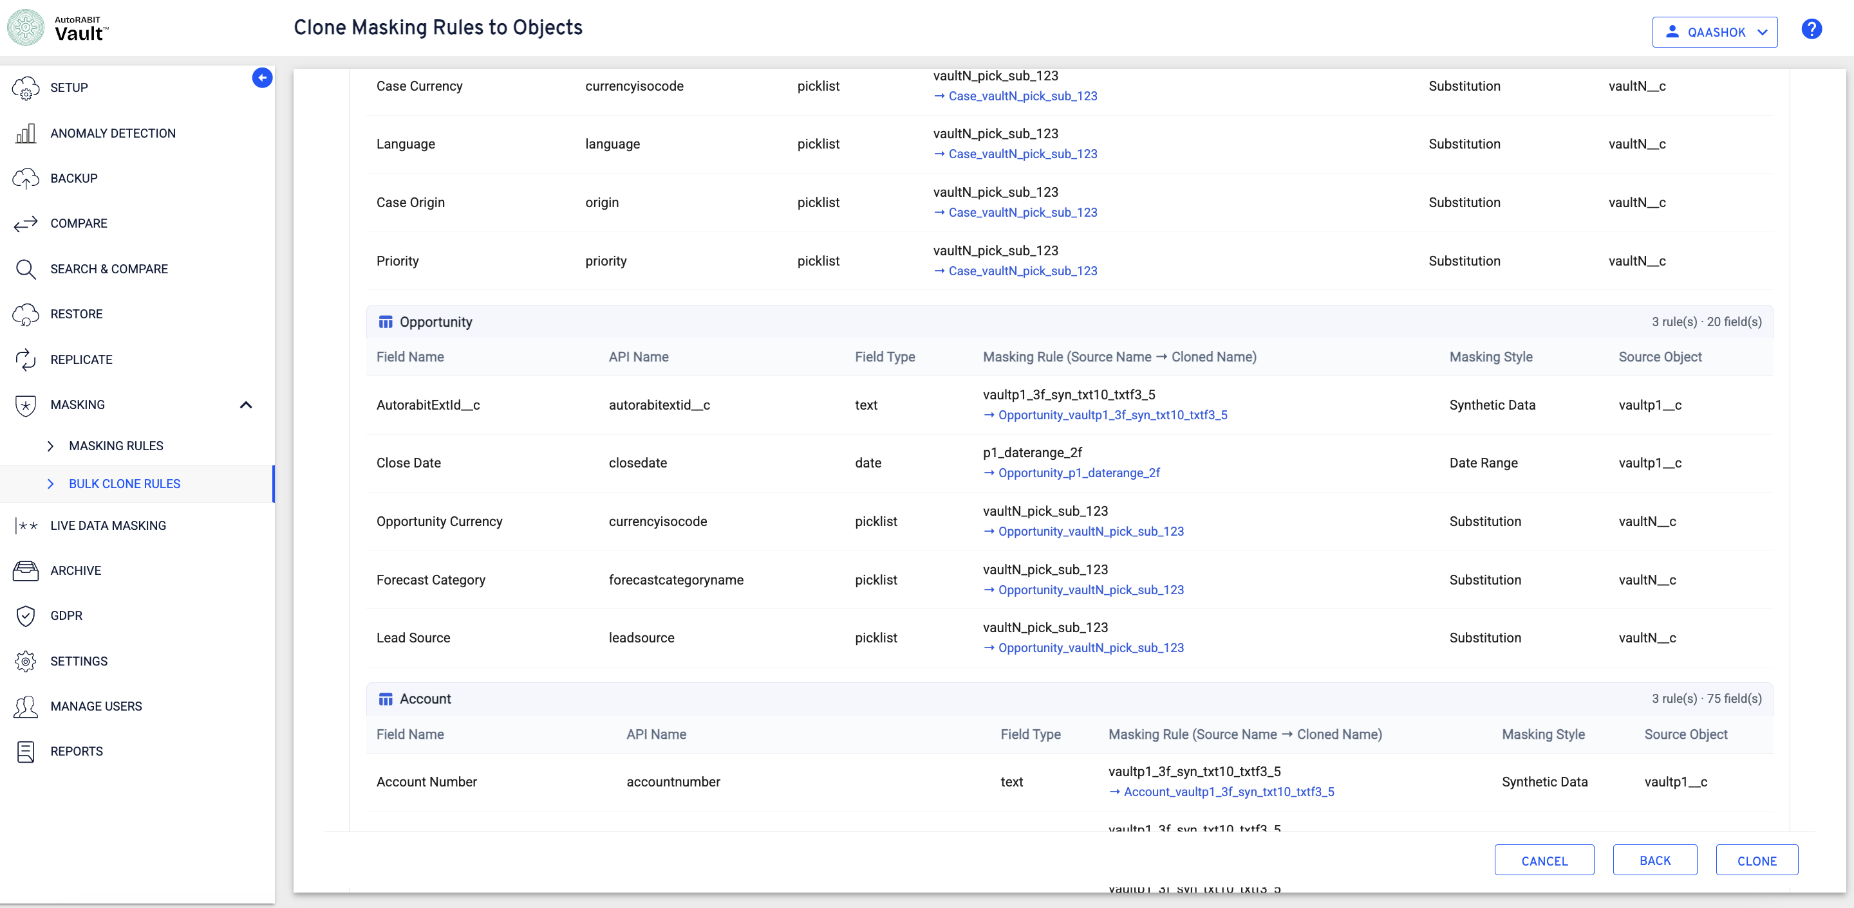
Figure 15 Summary mappings for Case, Opportunity, and Account
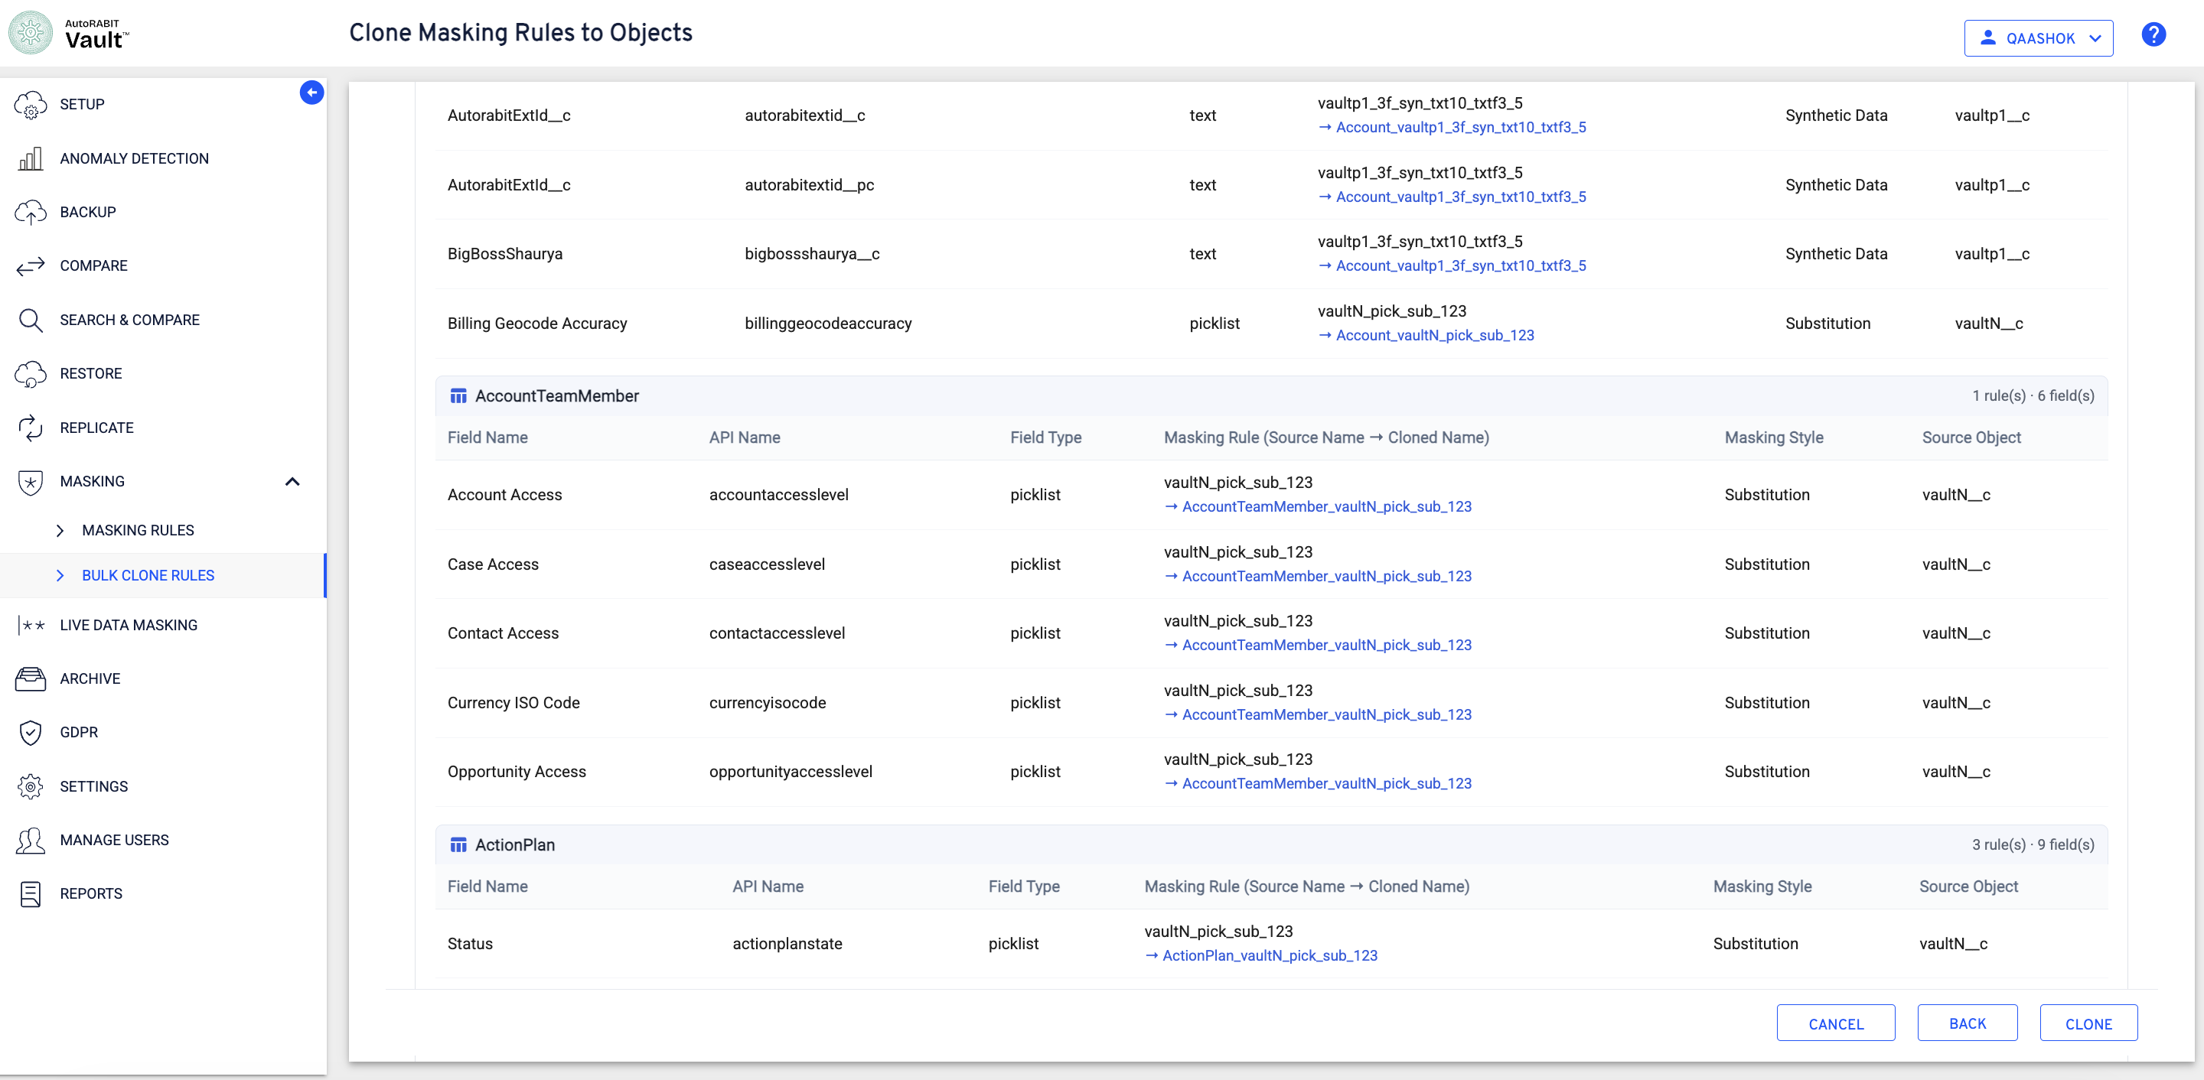
Figure 16 Summary mappings for Account and AccountTeamMember
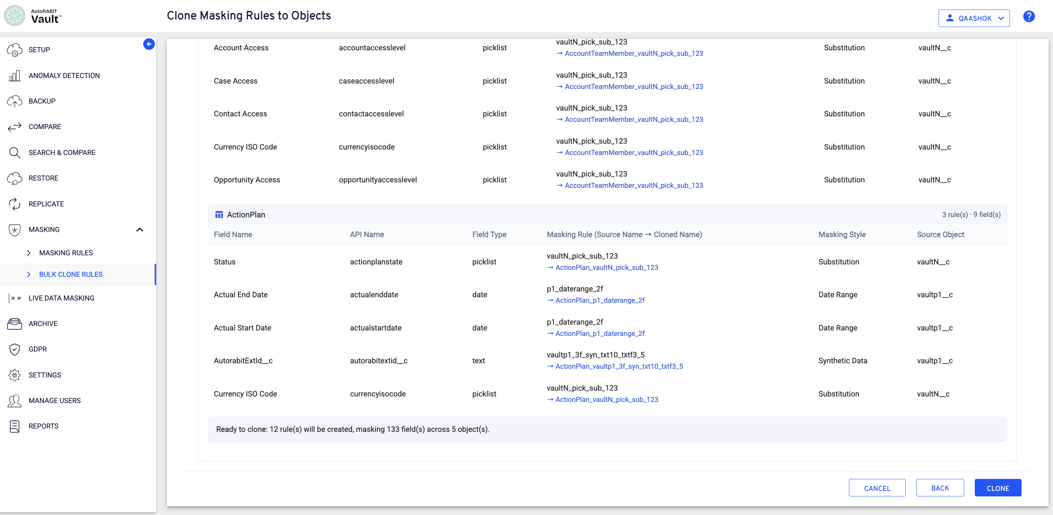
Figure 17 Final readiness summary across five destination objects
Displayed summary: Ready to clone: 12 rules will be created, masking 133 fields across 5 objects.

Start and monitor the clone operation
After Clone is selected, Vault confirms that the operation was initiated and directs the user to Masking > Bulk Clone Rules. A separate job is created for each destination object.
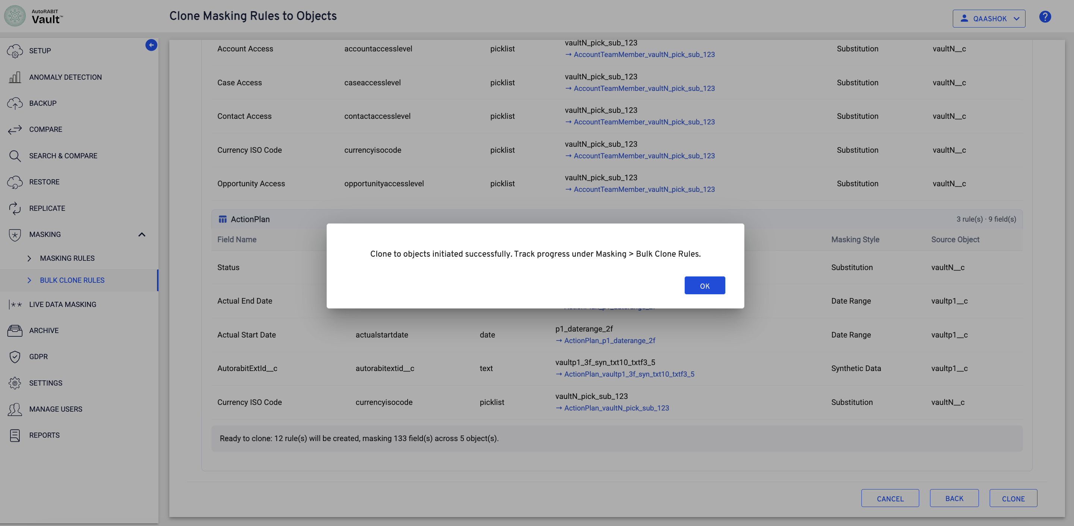
Figure 18 Clone operation initiated successfully
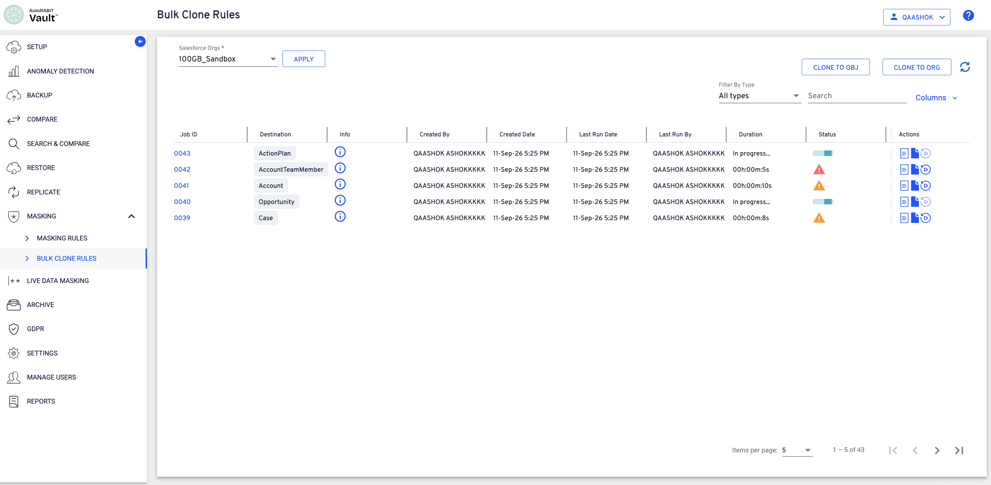
Figure 19 Bulk clone jobs created for the destination objects
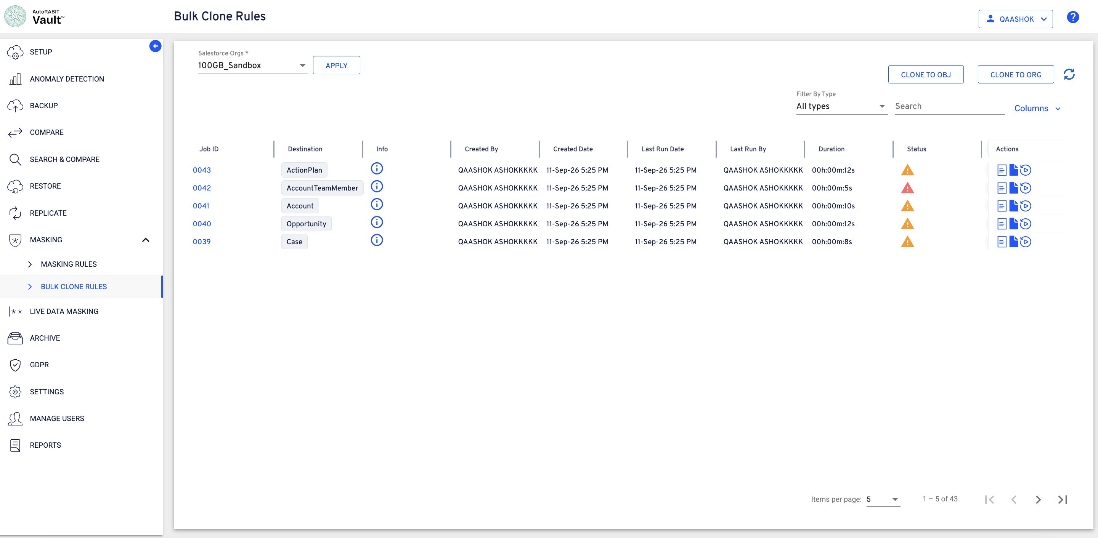
Figure 20 Bulk Clone Rules list with destination-specific jobs
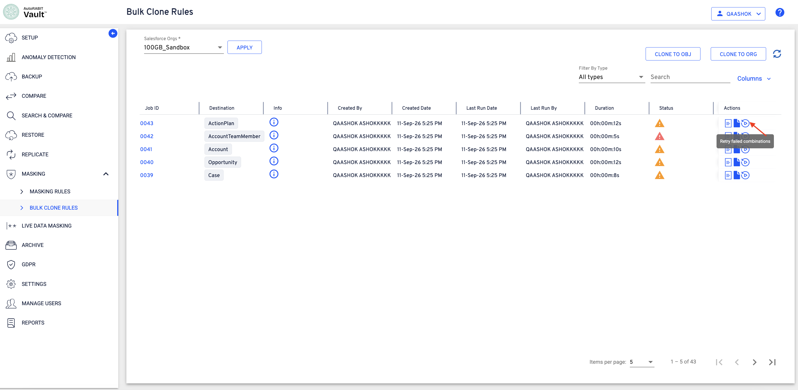
Figure 21 Job statuses and actions
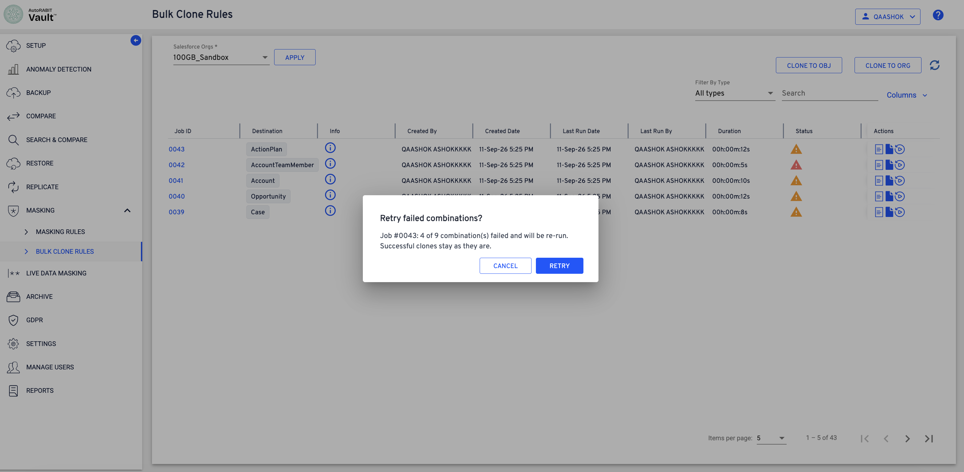
Figure 22 Available action for an unsuccessful bulk clone job

Retry an unsuccessful job
If a destination-specific bulk clone job does not complete successfully, use the Retry action for that job.
- Locate the unsuccessful job in Bulk Clone Rules.
- Select the Retry action and confirm the operation when prompted.
- Verify the confirmation message and monitor the updated Last Run Date, status, and retry result.
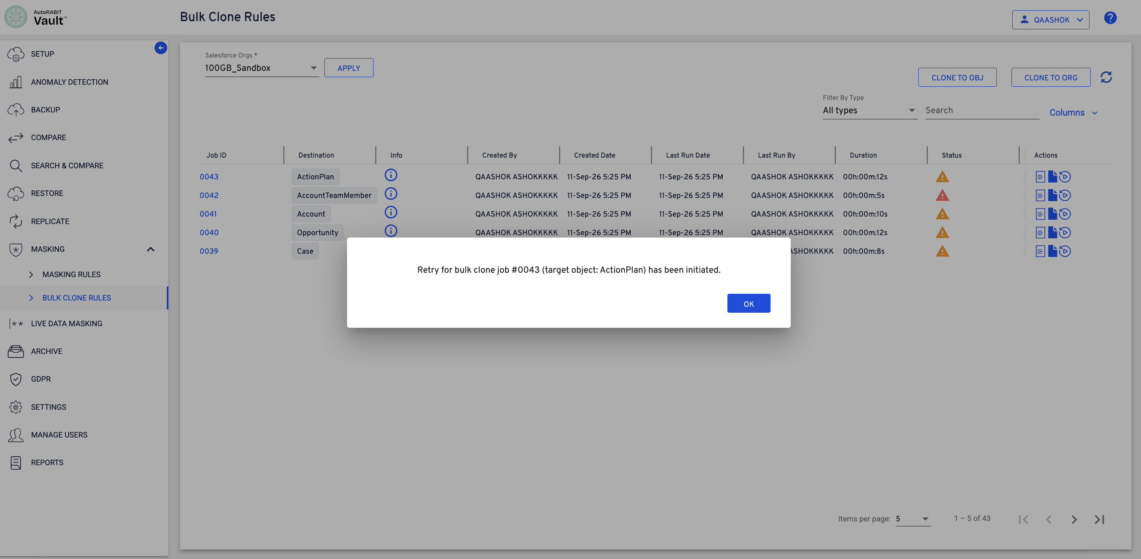
Figure 23 Retry initiated for the selected bulk clone job
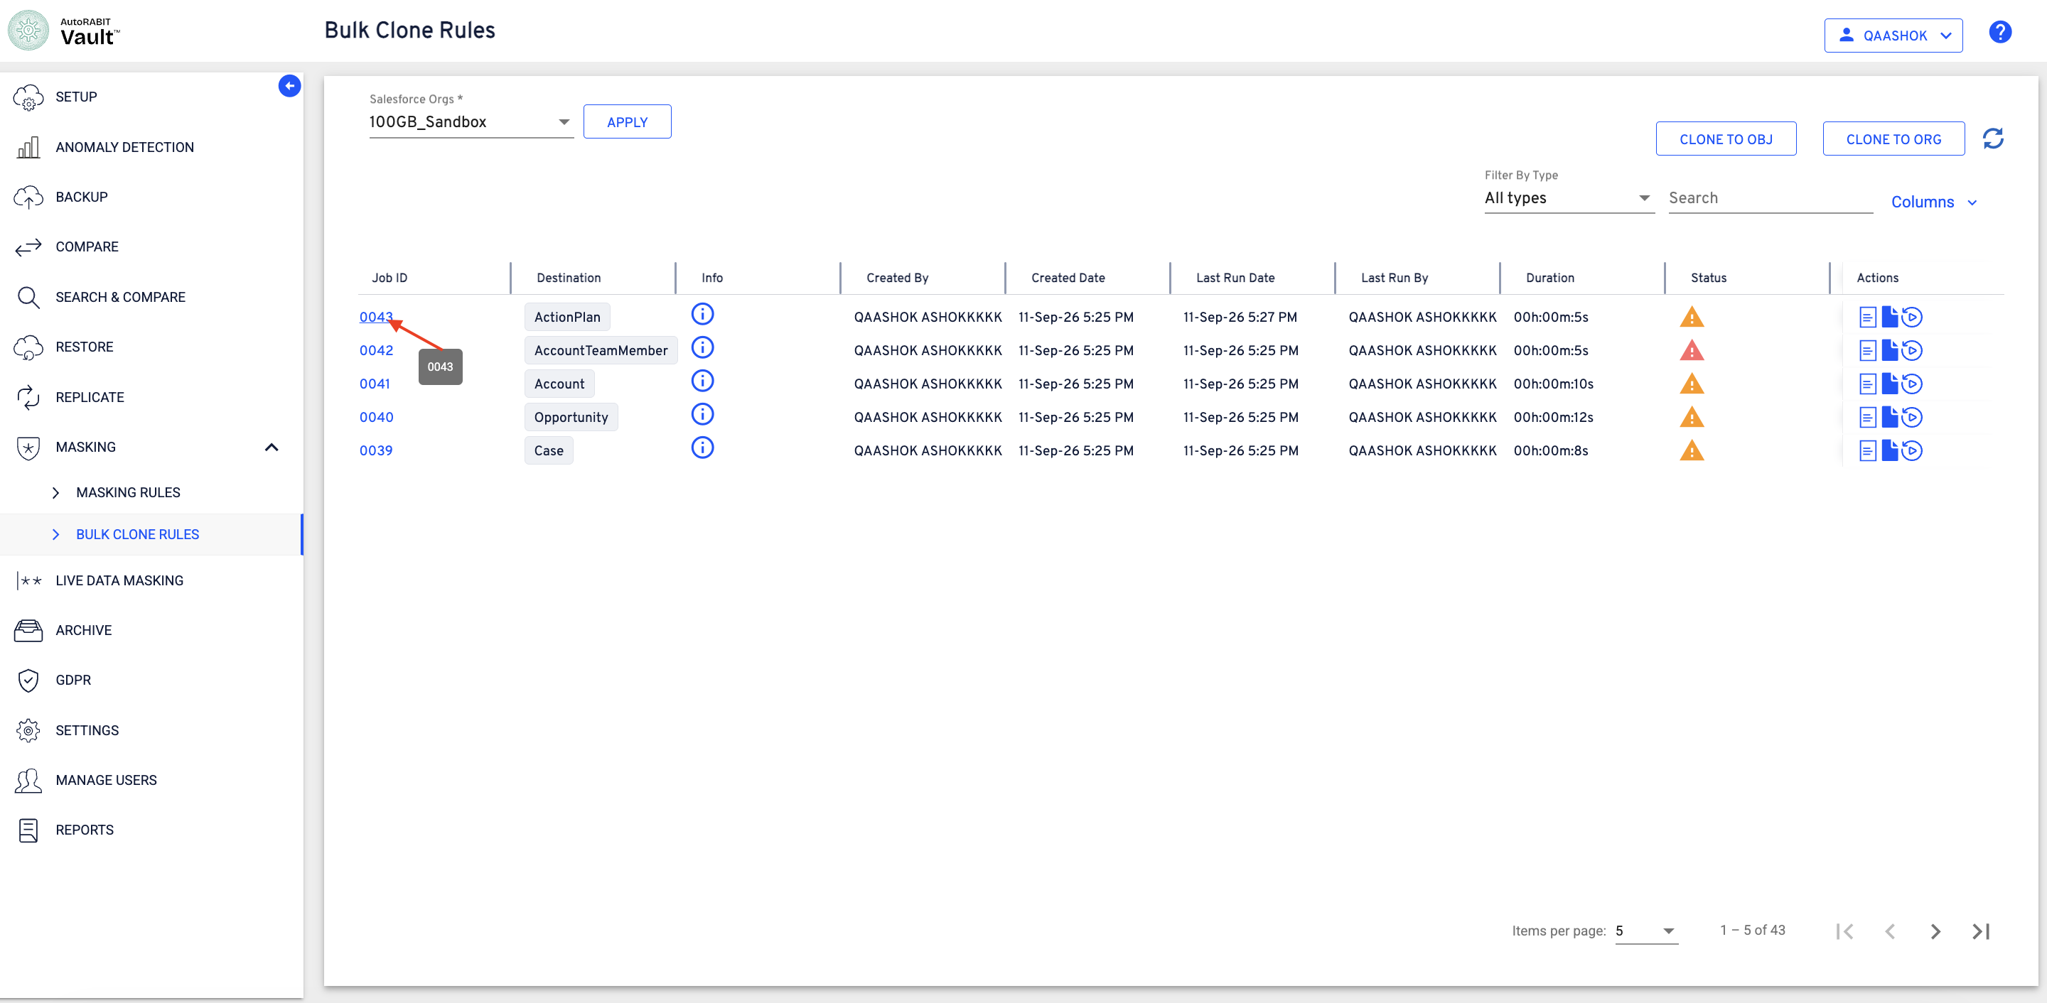
Figure 24 Bulk clone job list after retry

Review bulk clone job details
Use the job information action to review the bulk job ID, operation type, destination, overall status, retry count, and field-level outcomes. The details identify the source and cloned rule, object, masking style, masking value, and remarks for each field.
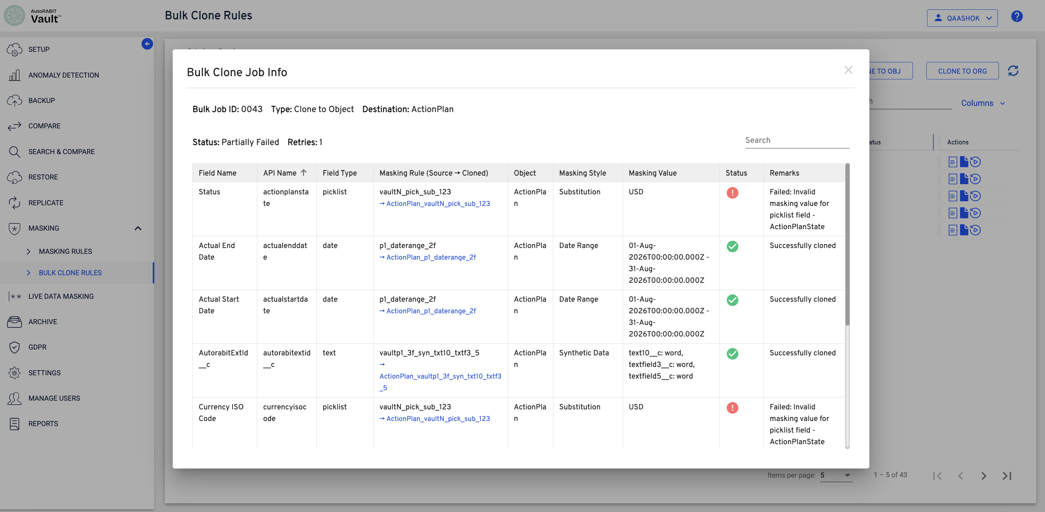
Figure 25 Bulk clone job information
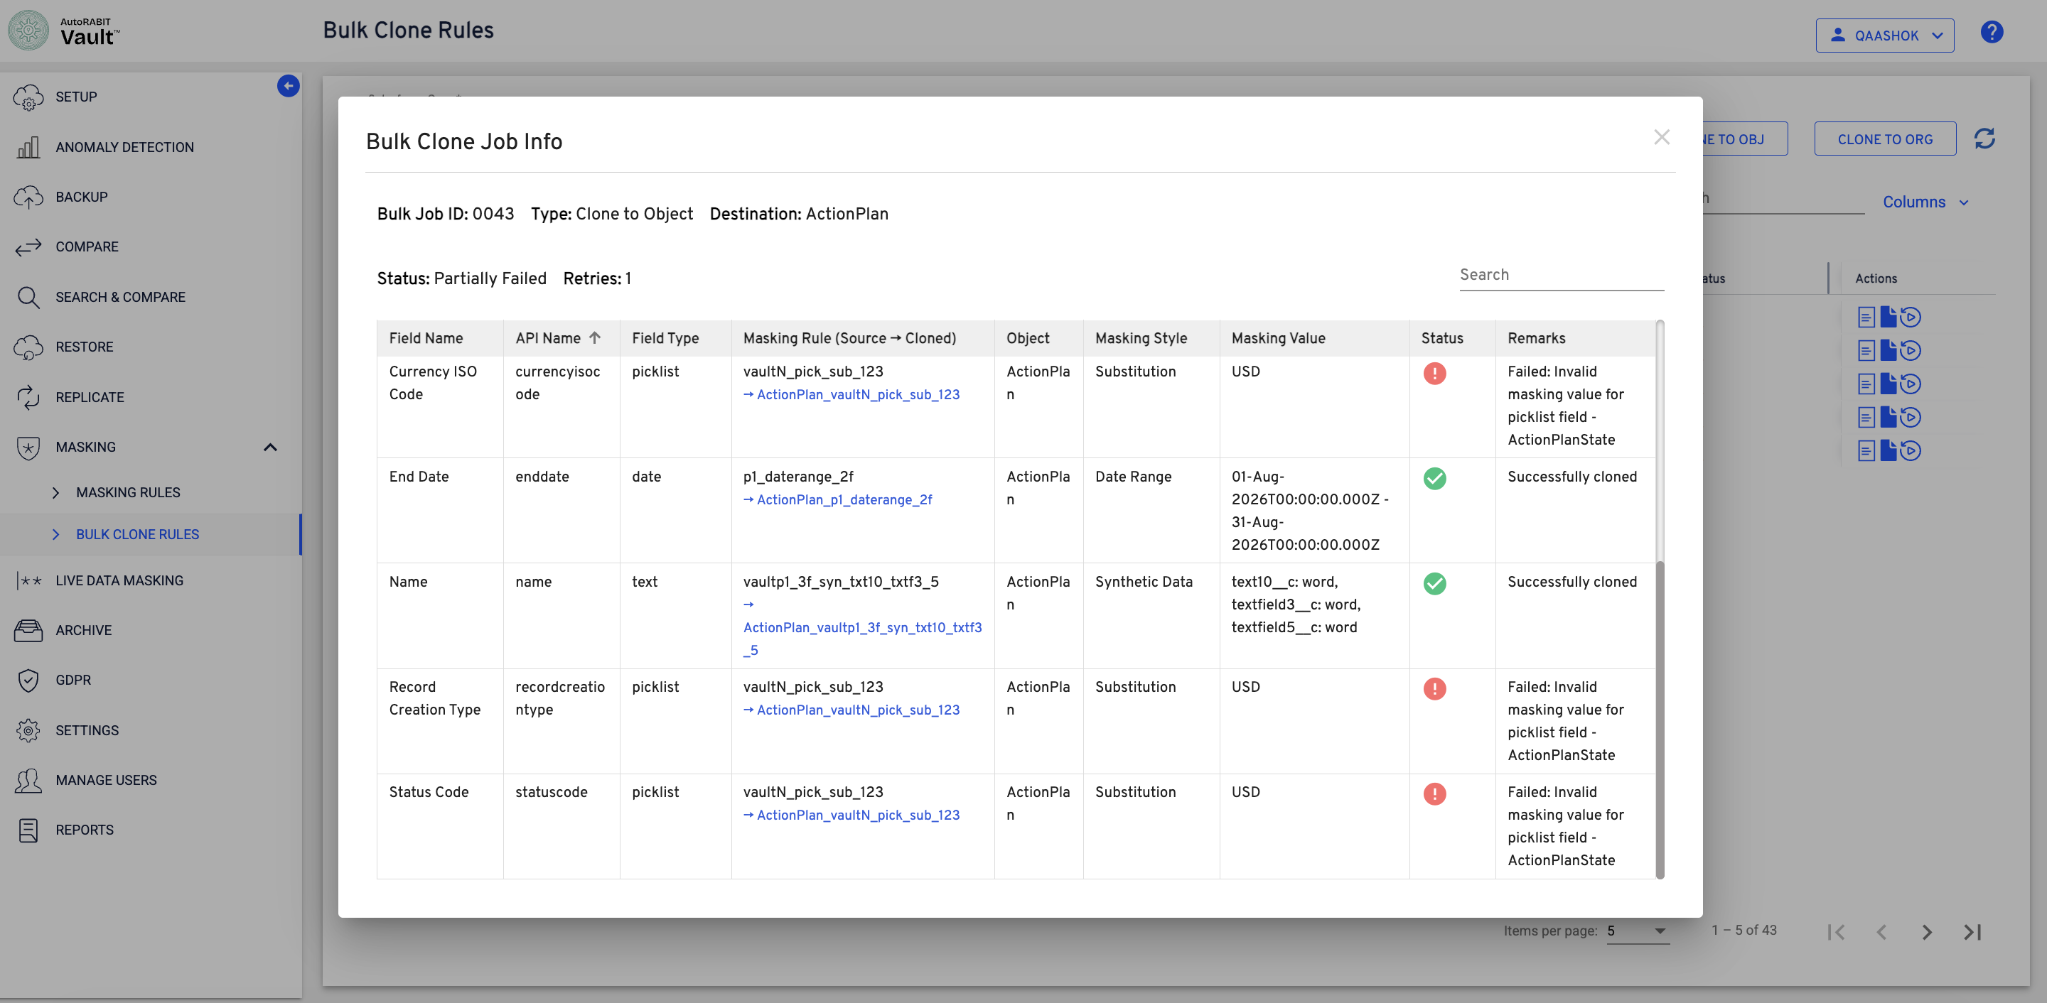
Figure 26 Partially failed job with field-level remarks
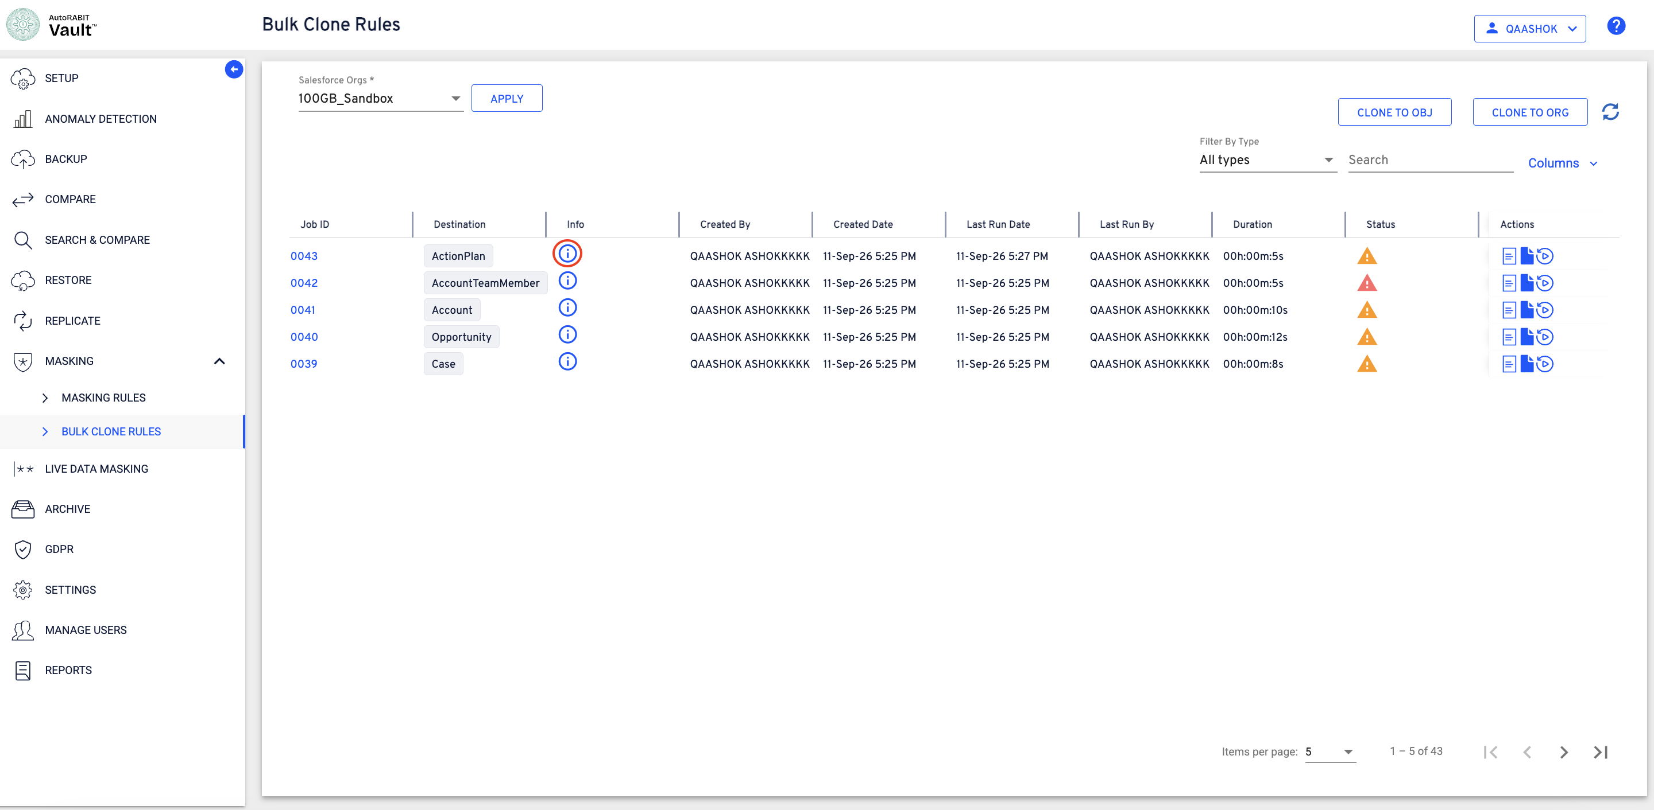
Figure 27 Bulk Clone Rules list after job-detail review
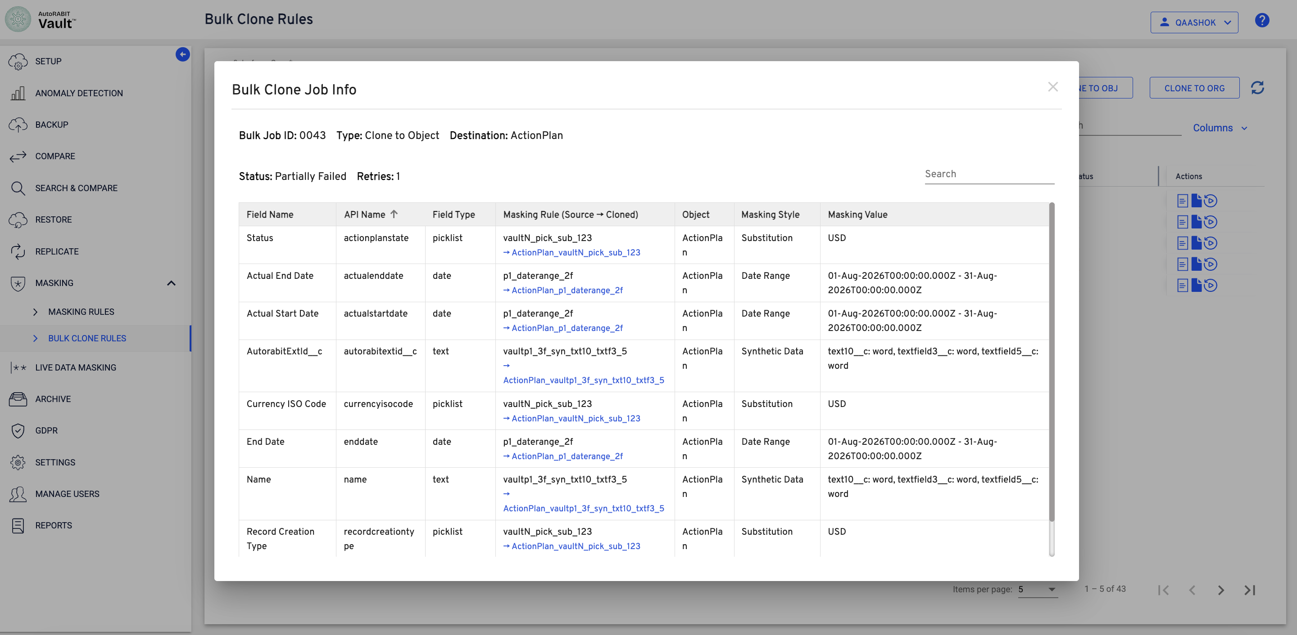
Figure 28 Detailed field mappings and masking values
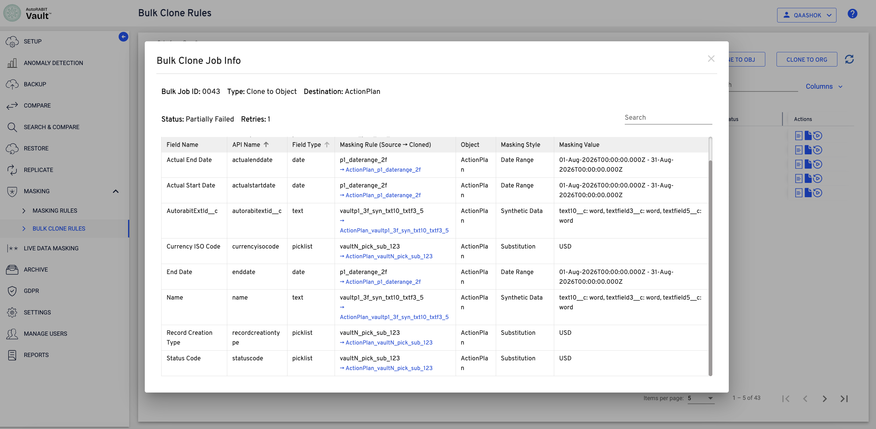
Figure 29 Additional field-level job information

Interpret job results
Result | Recommended review
Successfully cloned | Confirm that the expected cloned rule and masking style are shown for the field.
Partially Failed | Review Remarks to identify failed fields, correct the reported configuration issue, and retry the destination-specific job.
Invalid masking value | Verify that the source masking value is valid for the corresponding destination field. Picklist values must be valid for the destination field configuration.

Key points
- Only one source masking rule can be selected for each field type.
- A source rule can be applied only to destination fields with the same field type.
- Within one destination object, compatible fields of the same type are combined into one cloned rule.
- The same cloned rule can therefore mask multiple fields on that destination object.
- The total rule count is calculated across the field-type groups of all selected destination objects.
- Each destination object is tracked through its own bulk clone job, allowing object-specific monitoring and retry.

