# Dynamic 365 Integration

The AutoAddress controller is basically just a JavaScript and CSS that can be easily add it in to a Dynamic365 form. You can load the AutoAddress required JavaScript and CSS files by using our simple loader. If you don’t know how to add resource to a form, click here for instrcution.

## GitHub Repo

To get you started, we provided JavaScript and CSS files that can be downloaded from our GitHub repo: <https://github.com/Autoaddress-AA2/autoaddress2.0-dynamics>. To make things easier, these files will help you implement AutoAddress control to your Dynamic CRM form.

### AutoAddress Loader

If you’re running an online version of the CRM, then you should download [AutoAddressLoader.js](https://github.com/Autoaddress-AA2/autoaddress2.0-dynamics/blob/master/AutoAddressLoader-Premise.js) otherwise download [AutoAddressLoader-Premise.js](https://github.com/Autoaddress-AA2/autoaddress2.0-dynamics/blob/master/AutoAddressLoader-Premise.js) instead. The AutoAddress loader will automatically load the AutoAddress control to the specified field. This is just a simple function that takes in the settings, target element, input name, and the CSS name i.e. AutoAddressLoader([AutoAddress Setting], [Target Element], [Target Input Name], [CSS Name]). To learn how to use it, check out AutoAddressContact.js example from our repo.

#### AutoAddress Setting

The AutoAddress setting is a JSON that contains needed information for the controller to work. The setting should look like the example below. The onEcadFound callback function is optional, but if supplied, it will automatically call get Ecad and pass in the result to the supplied function.

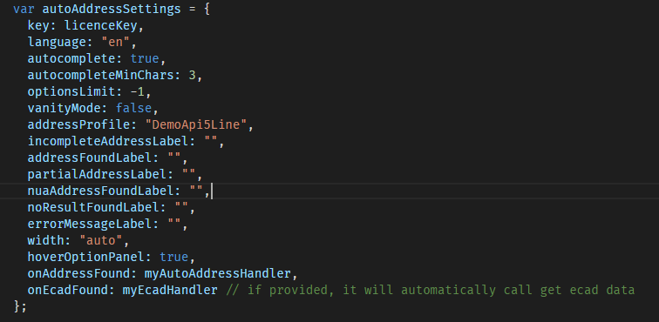

#### Address and ECAD Handlers

As there are a lot of ways you can consume the data from our API, you need to supply your own onAddressFound function. But all you must do in this function is to seed the result to the desired inputs like in the example below.

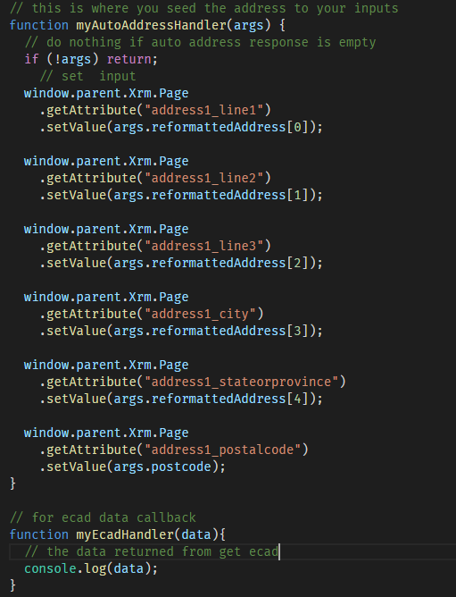

### On-Load Function Example

Along with AutoAddress Loader and styles, we also written a simple implementation of On-Load function script called AutoAddressContact.js, that will work on the default composite address field or fly-out address form. “*This example only works with the online version of the CRM*”.

### Styles

We also provide style sheets that you can use to match the CRM’s look and feel. If you’re implementing the control on a fly-out address form (composite field), then you should use [CompositeAddress.css](https://github.com/Autoaddress-AA2/autoaddress2.0-dynamics/blob/master/CompositeAddress.css) otherwise, use the [AutoAddress.css](https://github.com/Autoaddress-AA2/autoaddress2.0-dynamics/blob/master/AutoAddress.css).

## Loading AutoAddress

The AutoAddress control requires JQuery to run. If you haven’t included it yet, you can download the latest JQuery (min version) on their main website. Once you have it, import it to the desired form along with the AutoAddress Loader and your Load Function (i.e. new_AutoAddressContact.js) scripts. Make sure the JQuery file is at the very top of the list. You script imports should look like the example below.

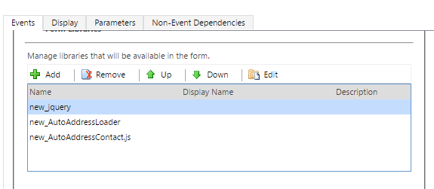

### Load Function

The load function is the function that get called when the form is loaded. This is where you set up auto address using the AutoAddress Loader. We provided an example in our GitHub repo called AutoAddressContact.js that works for the default composite address field of Dynamic CRM(Online) Contacts Form. You can use this example to investigate or to understand how to set AutoAddress to your specific requirements.

You can set the On-Load event function in form properties, then on the event handler section just below the Form Libraries section. For our example, you must select new_autoAddressContact.js library as the library for the On-Load event, and type in “load” in the Function field; then from this example you must pass in your licence key with double quotes as a parameter like in the example below.

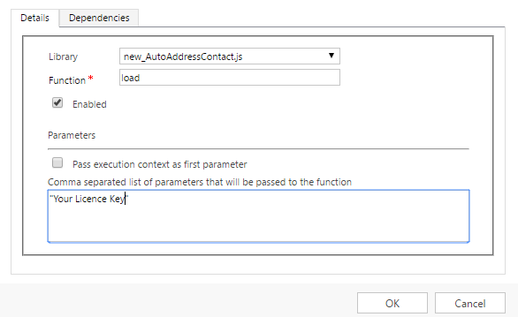

# Adding Resources

There are multiple ways of adding a JavaScript to a form. One way of doing this is to go to the form where you want the script, then press new. In the new entry form, there is a “FORM/FORM EDITOR” button on the top left of the form just below the navigation bar. In the form editor, and in the home tab, click “form properties” and in Form Libraries section, you can add your JavaScript/Web Resource files and sets the on-load function. You can also use this method to add stylesheets (CSS) to your web resources, then use a script to load it in to your form.

