StreamingApp Container Orchestration and Scaling
Graded Project Implementation and Execution Evidence

Candidate | Praveen Kumar P
Project | StreamingApp
AWS Region | Asia Pacific Mumbai ap south 1
Repository | https://github.com/Autobot1998/StreamingApp

Open the GitHub repository

Executive Summary
This report documents the completed container orchestration and scaling implementation for a five service MERN streaming platform. The application was containerized with Docker, published to dedicated Amazon ECR repositories, automated through Jenkins CI, and deployed to Amazon EKS using a reusable Helm chart. The running platform uses persistent MongoDB storage, Nginx Ingress, controlled rolling updates, horizontal scaling, CloudWatch Container Insights, centralized Fluent Bit logs, and a CPU alarm.
The implementation was validated through successful image builds and pushes, Ready EKS nodes, a deployed Helm release, Bound persistent storage, HTTP 200 frontend access, a four replica streaming deployment, a zero downtime auth rollout, and a Jenkins build automatically triggered by a source control change.

Solution Architecture
Layer | Technology | Responsibility | Validated Result
Source and CI | GitHub and Jenkins | Checkout, build, tag and publish five images | SCM triggered build succeeded
Registry | Amazon ECR | Separate repositories with scan on push | Versioned images available
Orchestration | Amazon EKS and Helm | Deploy, expose, scale and update services | Helm release deployed
Data | MongoDB and Amazon EBS | Stateful database with persistent volume | PVC Bound at 5 GiB
Traffic | Nginx Ingress and AWS ELB | Host and path based routing | Frontend returned HTTP 200
Observability | CloudWatch and Fluent Bit | Metrics, logs and alerting | Addon active and alarm created

Service Map
The platform separates user interface, identity, catalogue, administration and real time chat responsibilities into independently deployable services. Kubernetes Services provide stable internal names while the MongoDB StatefulSet retains data through an Amazon EBS backed persistent volume.
Service | Port | Image | Kubernetes Resource
Frontend | 80 | streaming-frontend | Deployment and Service
Authentication | 3001 | streaming-auth | Deployment and Service
Streaming | 3002 | streaming-stream | Deployment and Service
Administration | 3003 | streaming-admin | Deployment and Service
Chat | 3004 | streaming-chat | Deployment and Service
MongoDB | 27017 | mongo 6 | StatefulSet Service and PVC

Version Control and Repository Setup
The upstream application repository was forked into the candidate GitHub account and cloned locally. The main branch is used by both local development and Jenkins.
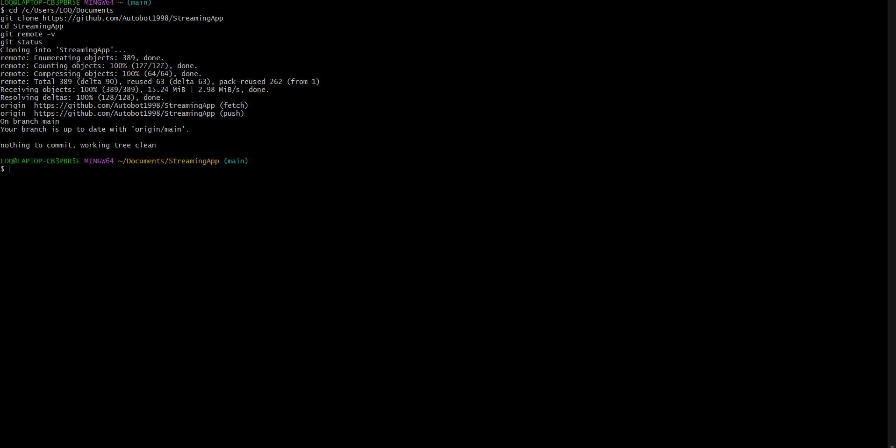
Figure 1 Repository fork and local clone confirmation

Application Inspection and Docker Validation
The frontend and four backend services were inspected to identify Dockerfiles, package scripts, build contexts, ports, environment variables and MongoDB dependencies. Local builds validated every component before registry publication.
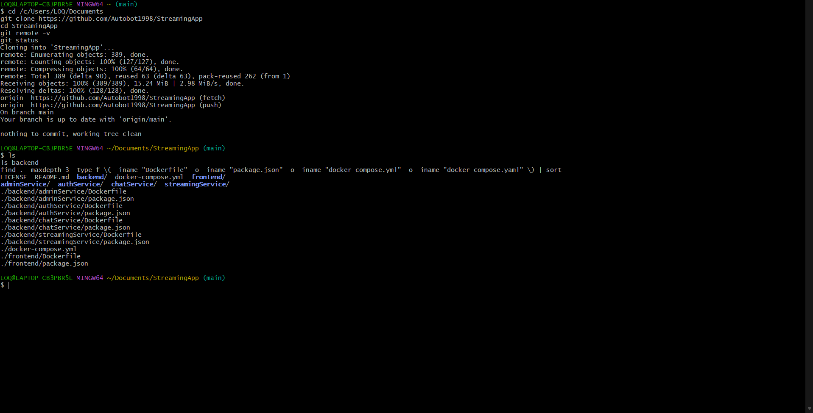
Figure 2 Application Inspection and Docker Validation evidence 1
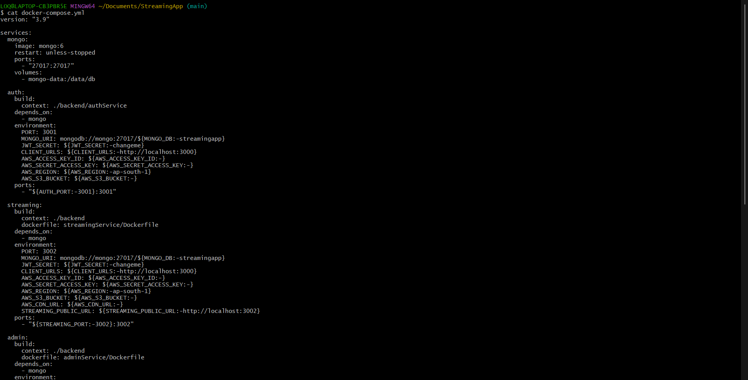
Figure 3 Application Inspection and Docker Validation evidence 2
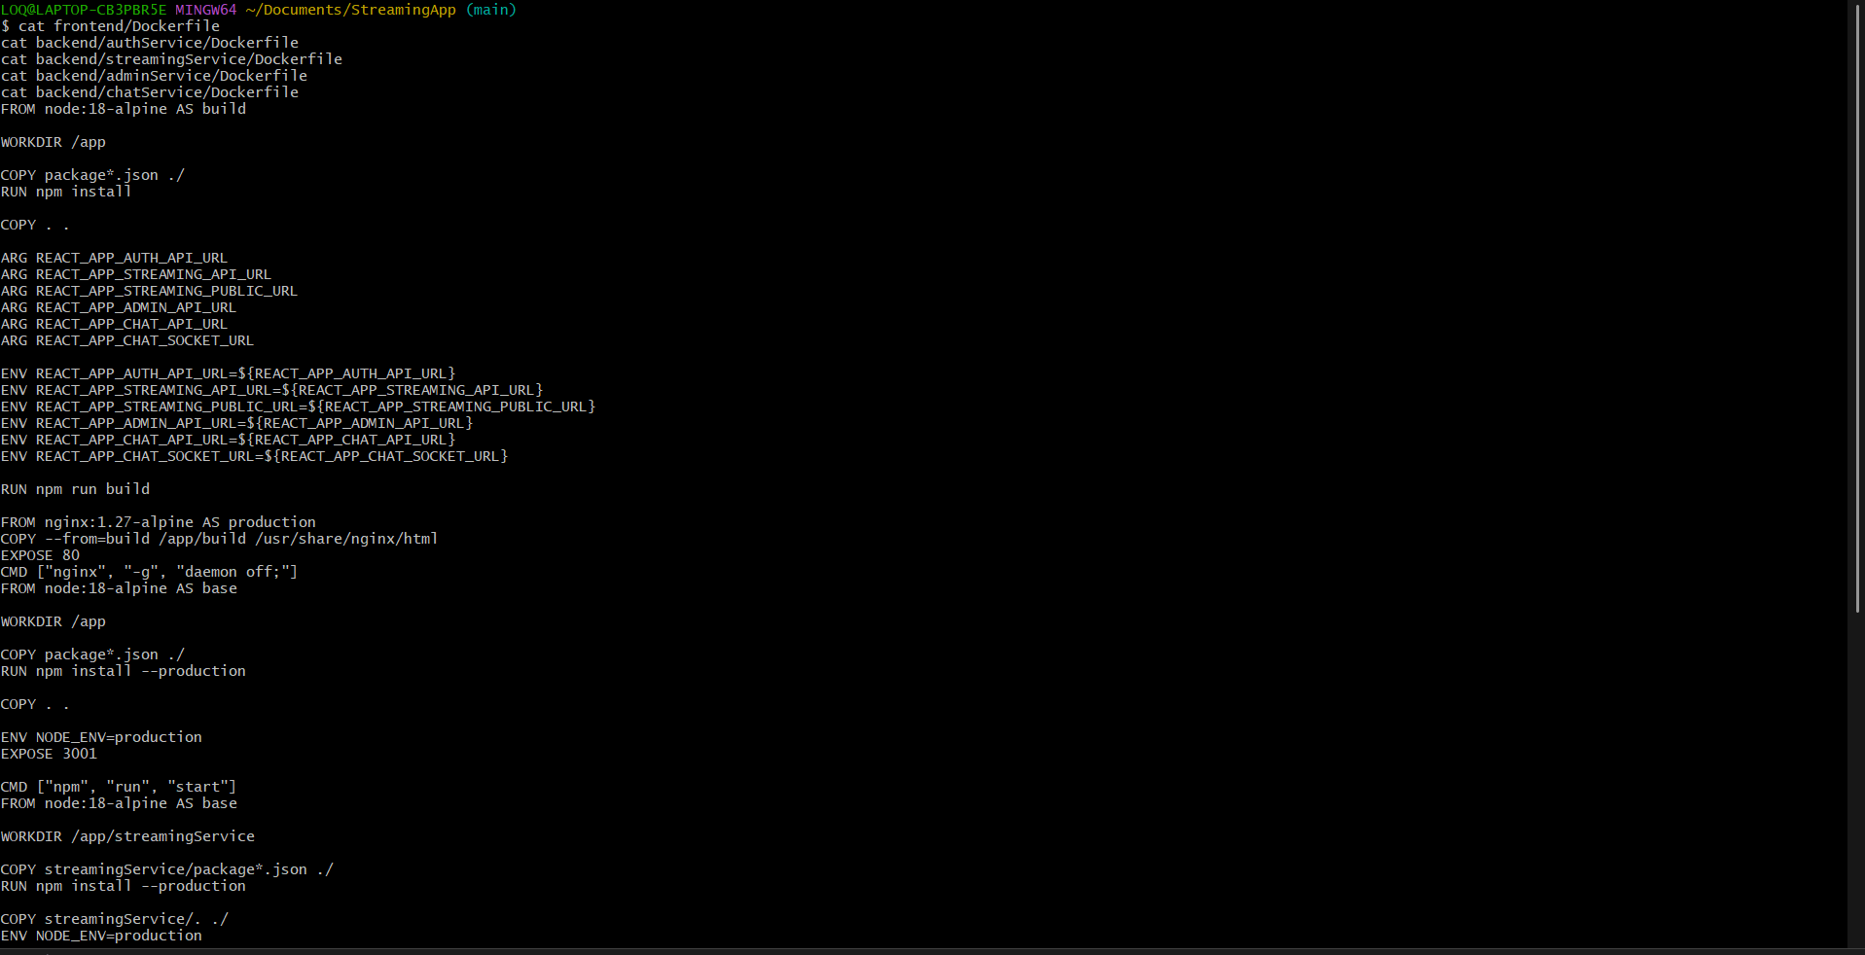
Figure 4 Application Inspection and Docker Validation evidence 3
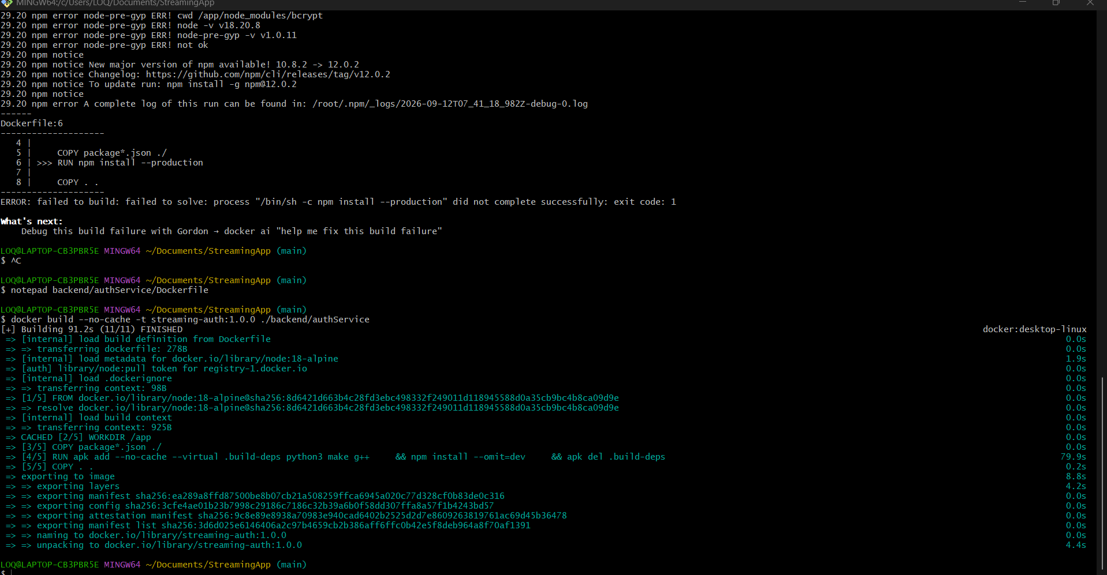
Figure 5 Application Inspection and Docker Validation evidence 4
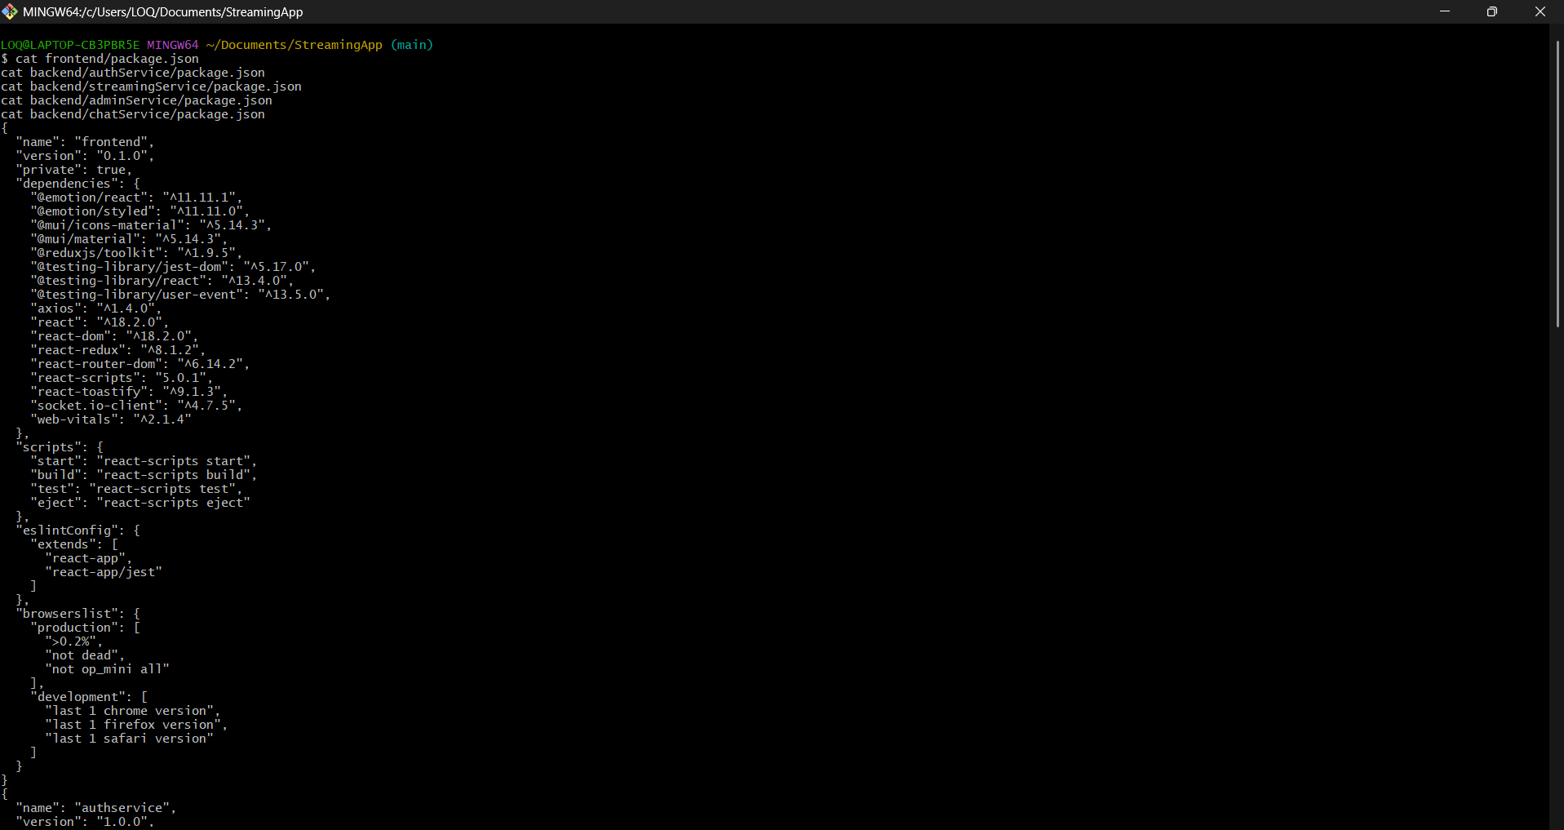
Figure 6 Application Inspection and Docker Validation evidence 5
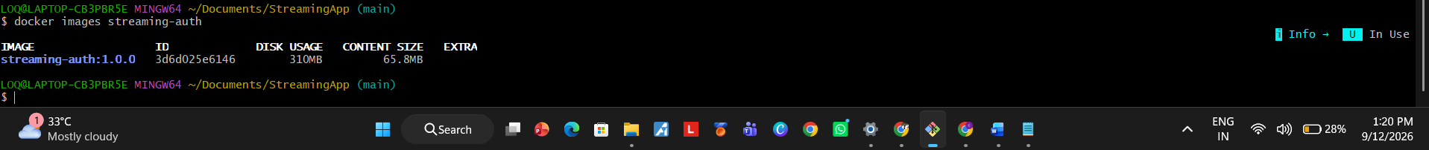
Figure 7 Application Inspection and Docker Validation evidence 6
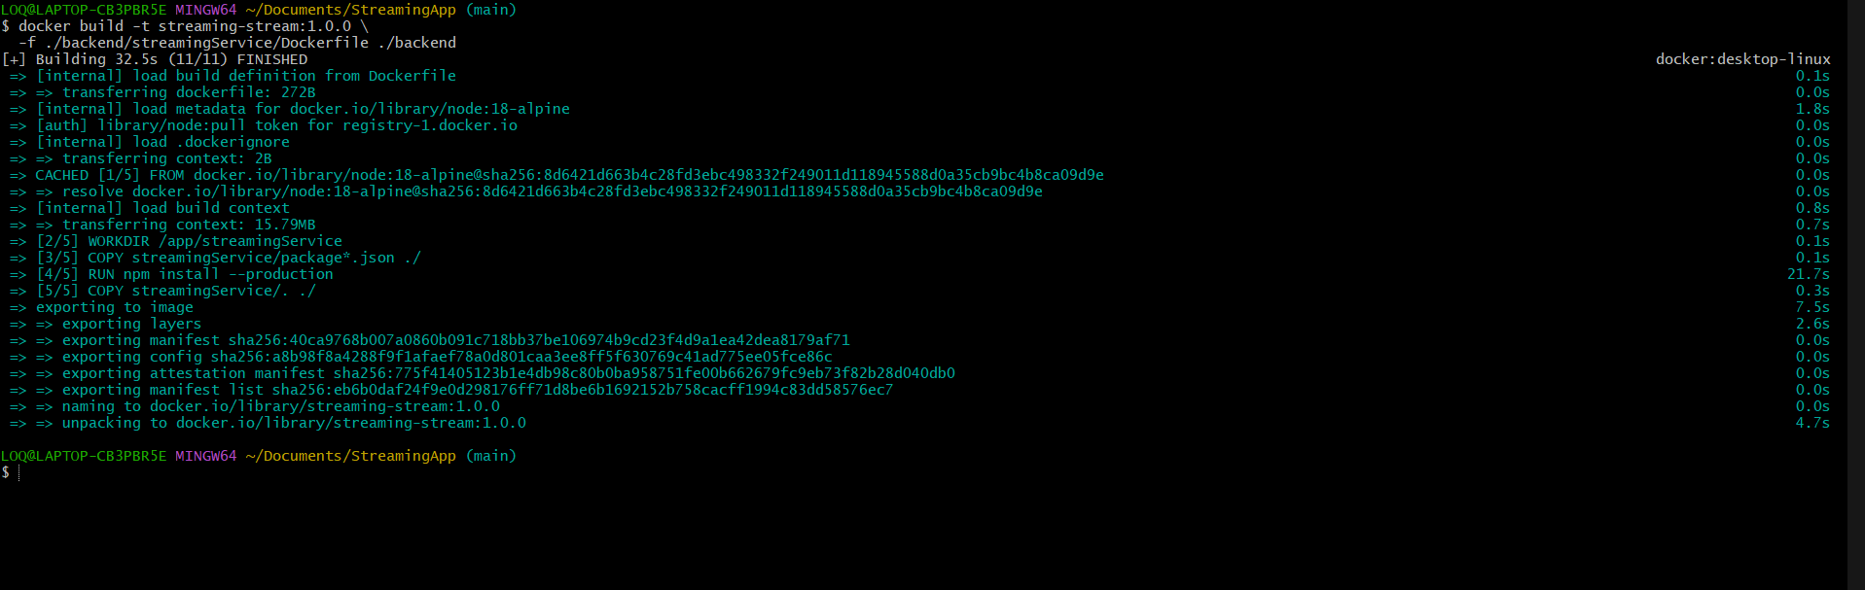
Figure 8 Application Inspection and Docker Validation evidence 7
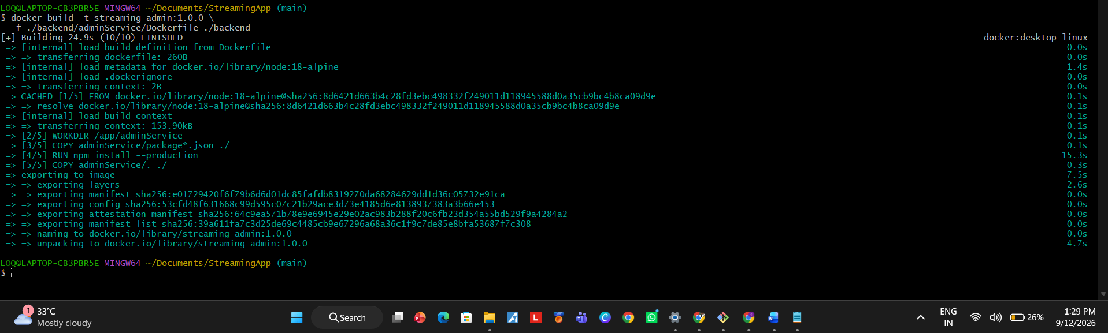
Figure 9 Application Inspection and Docker Validation evidence 8

Amazon ECR and Helm Preparation
Dedicated ECR repositories were created for each component with scan on push enabled. Images were authenticated, tagged and pushed. A Helm chart was then prepared for the five services and MongoDB.
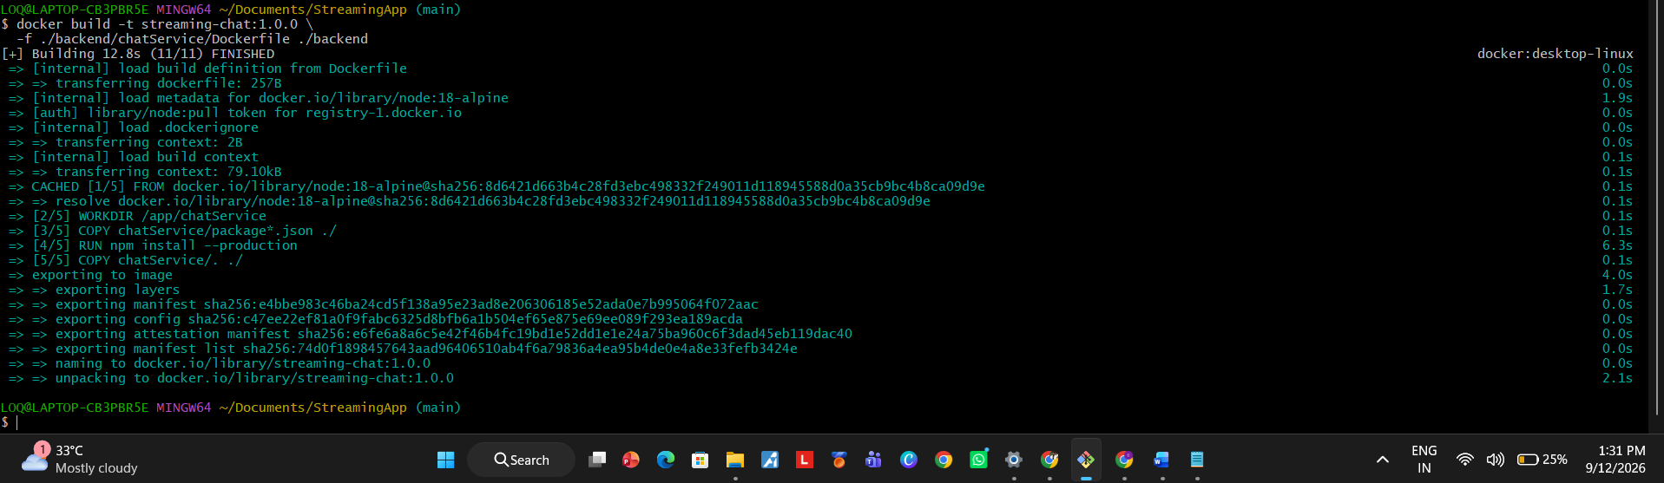
Figure 10 Amazon ECR and Helm Preparation evidence 1
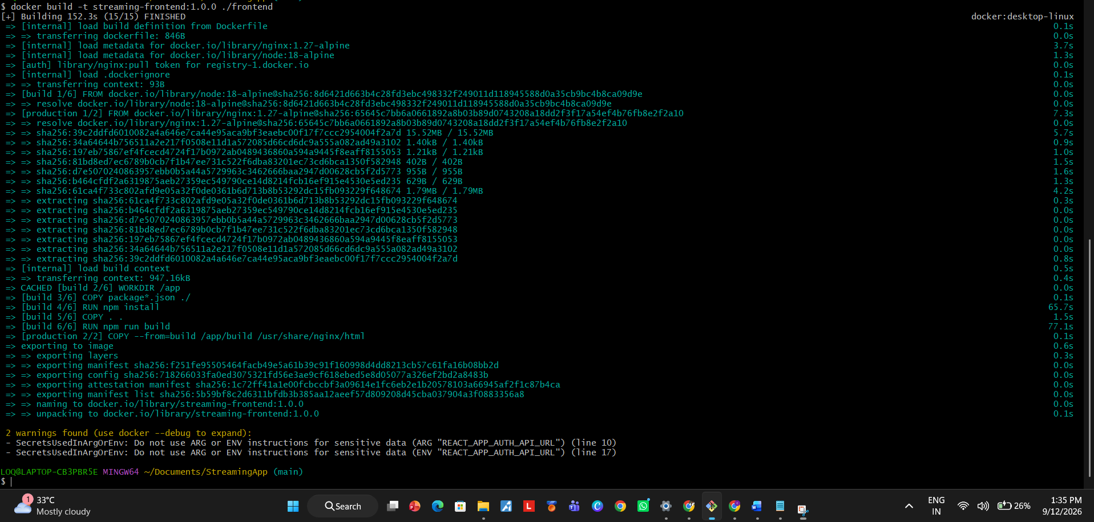
Figure 11 Amazon ECR and Helm Preparation evidence 2
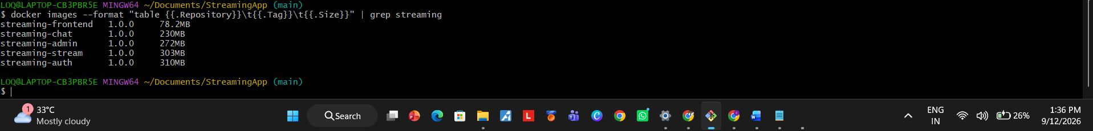
Figure 12 Amazon ECR and Helm Preparation evidence 3
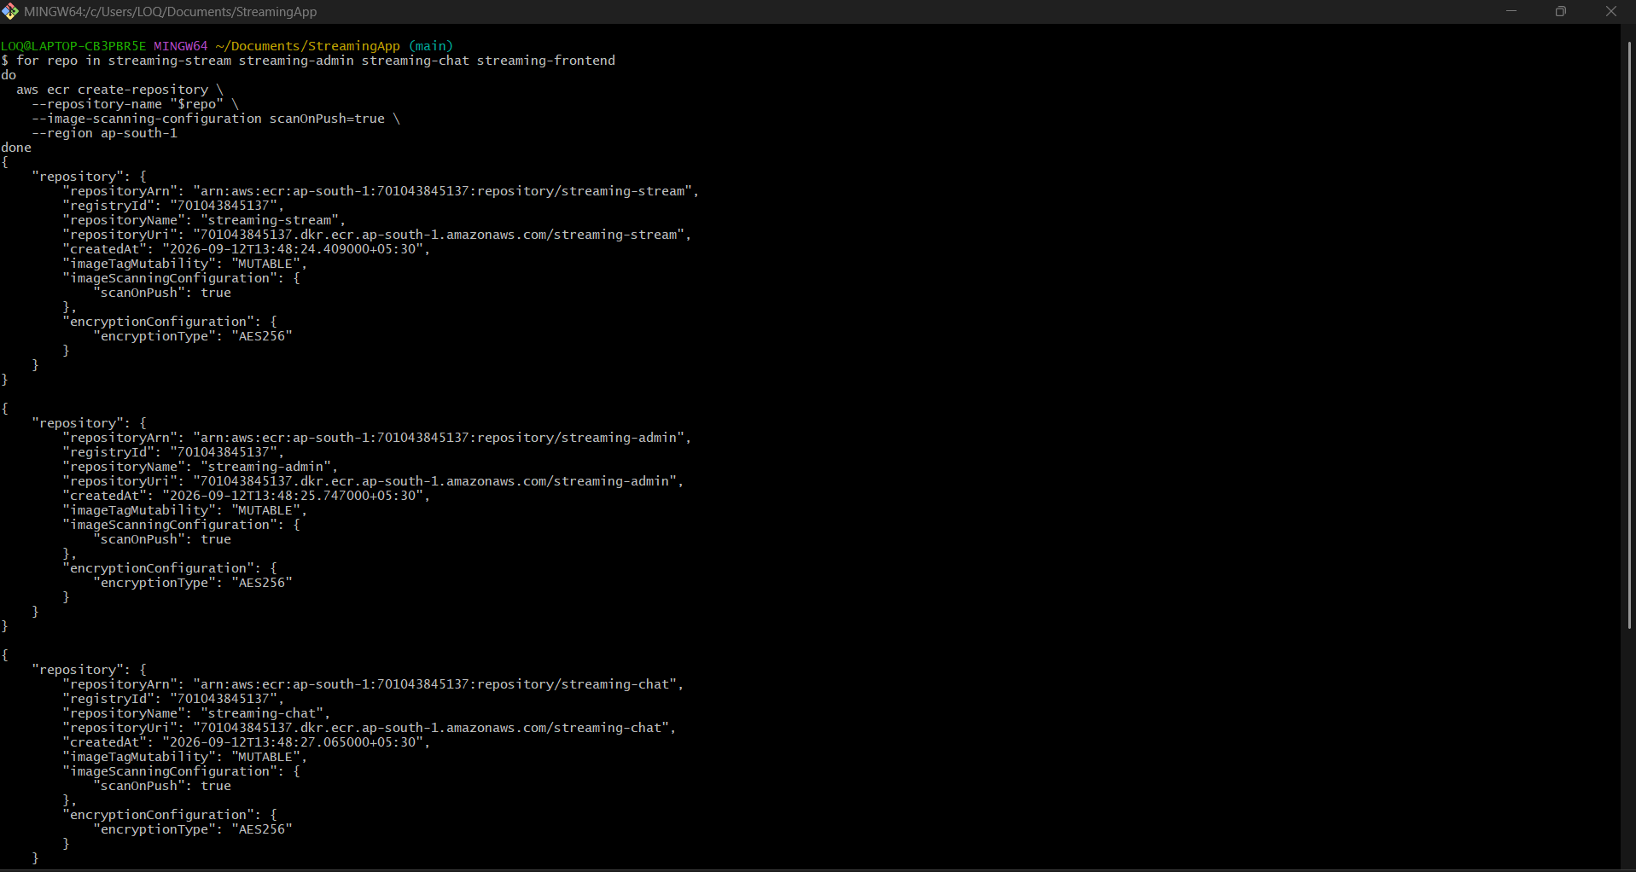
Figure 13 Amazon ECR and Helm Preparation evidence 4
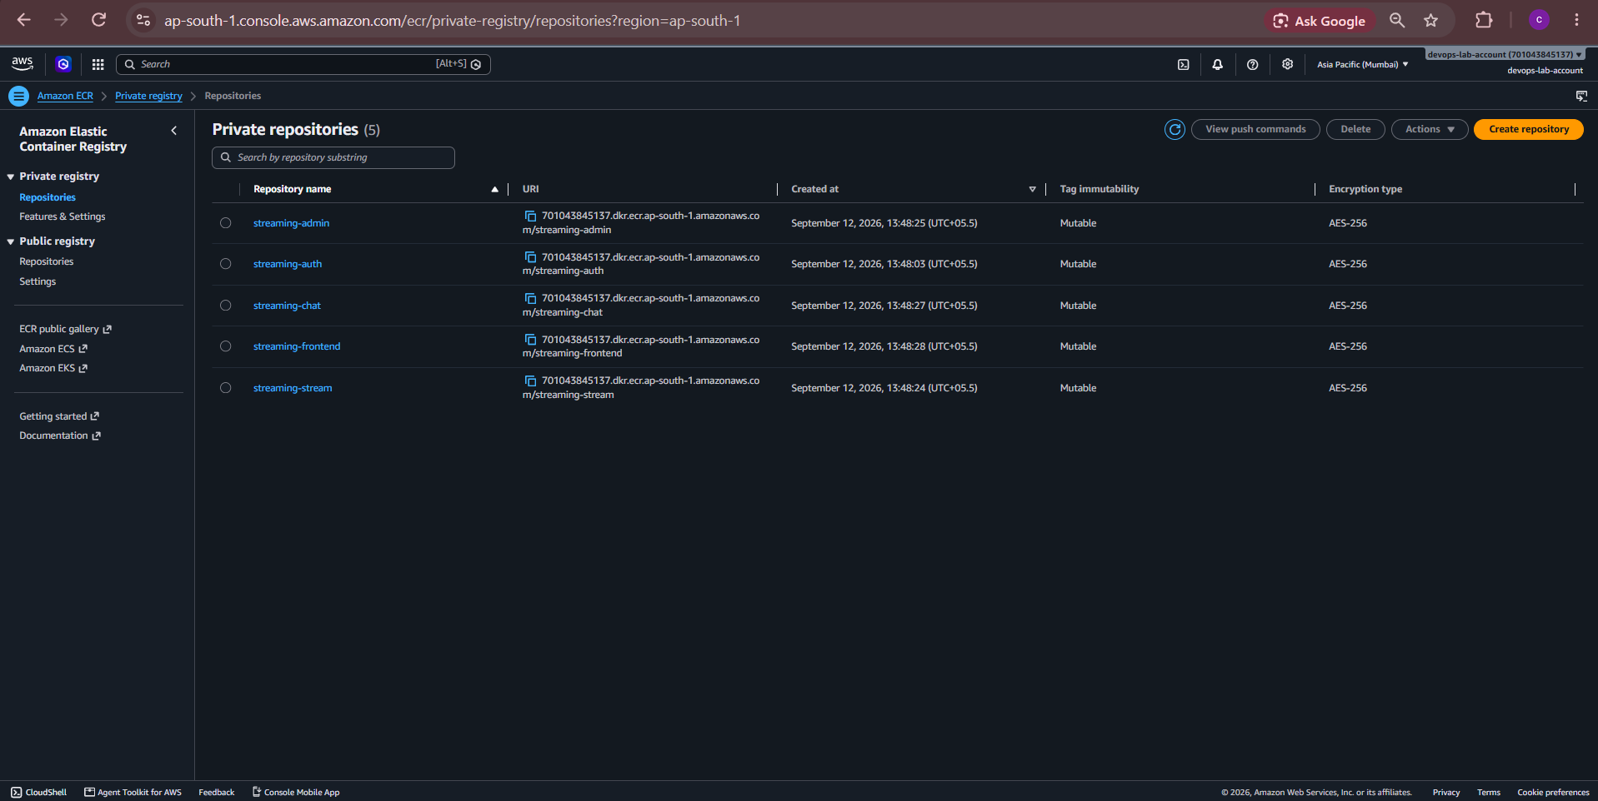
Figure 14 Amazon ECR and Helm Preparation evidence 5
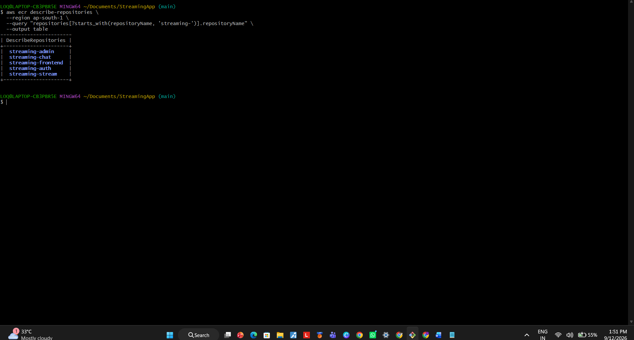
Figure 15 Amazon ECR and Helm Preparation evidence 6
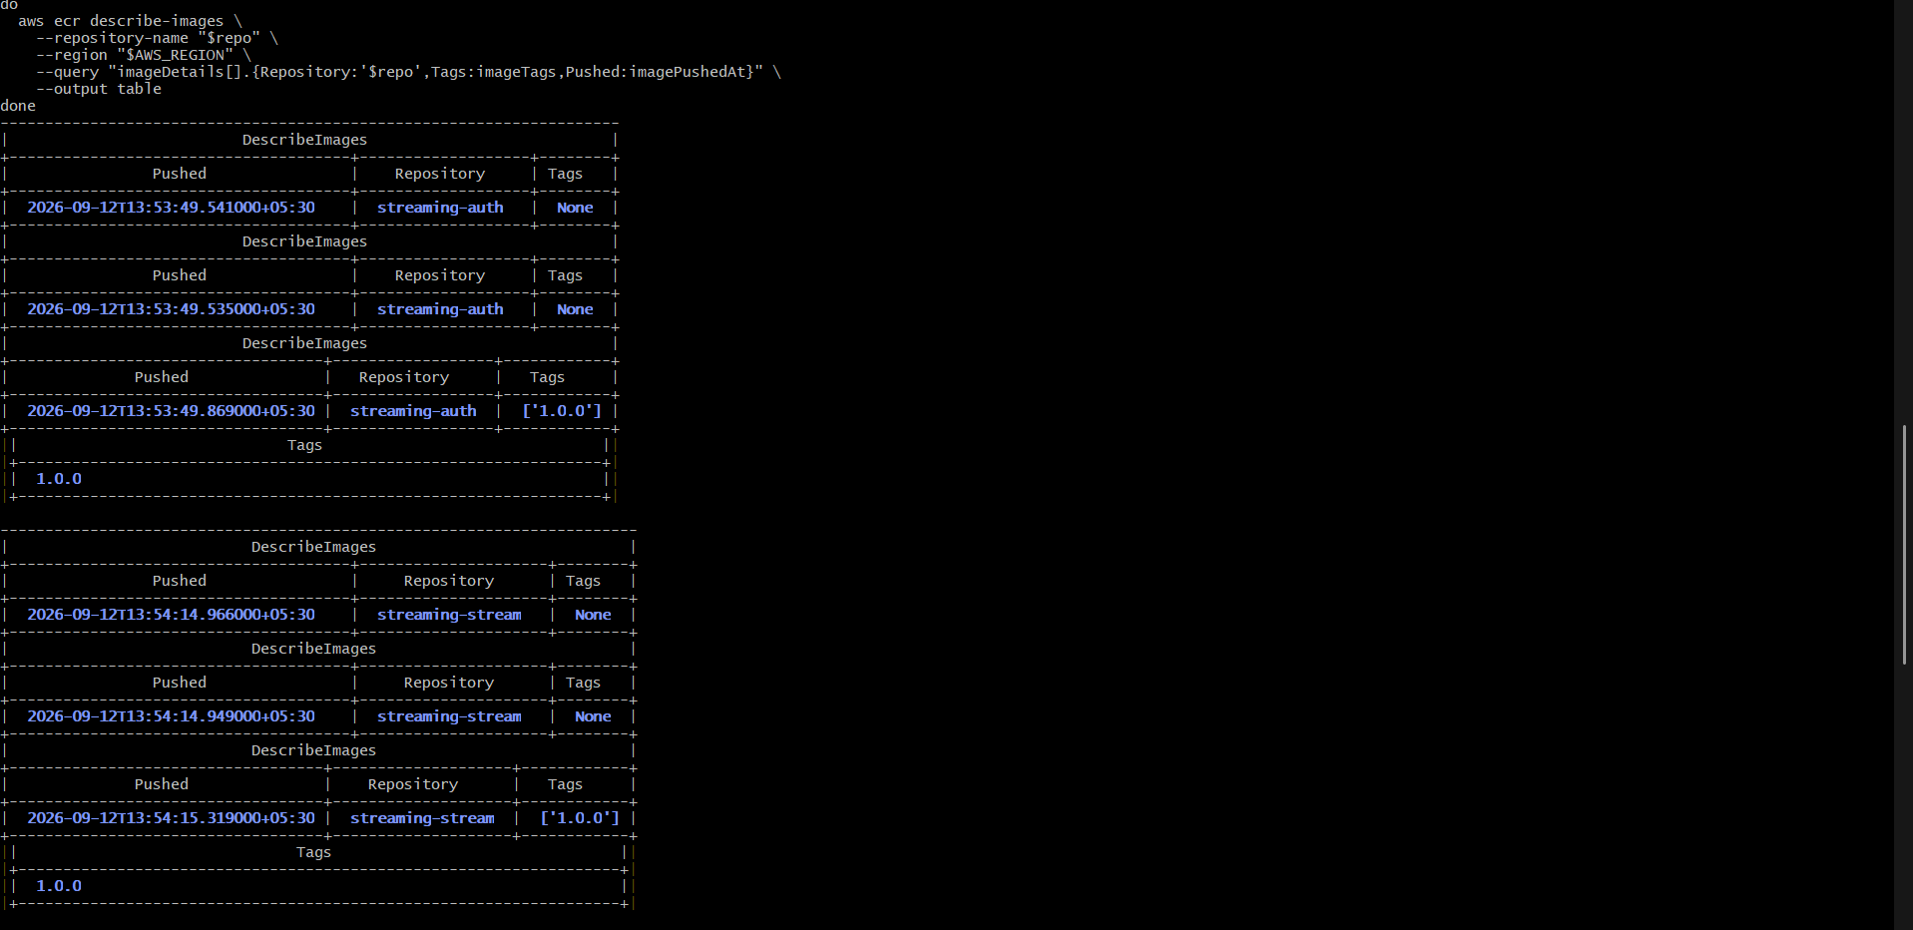
Figure 16 Amazon ECR and Helm Preparation evidence 7
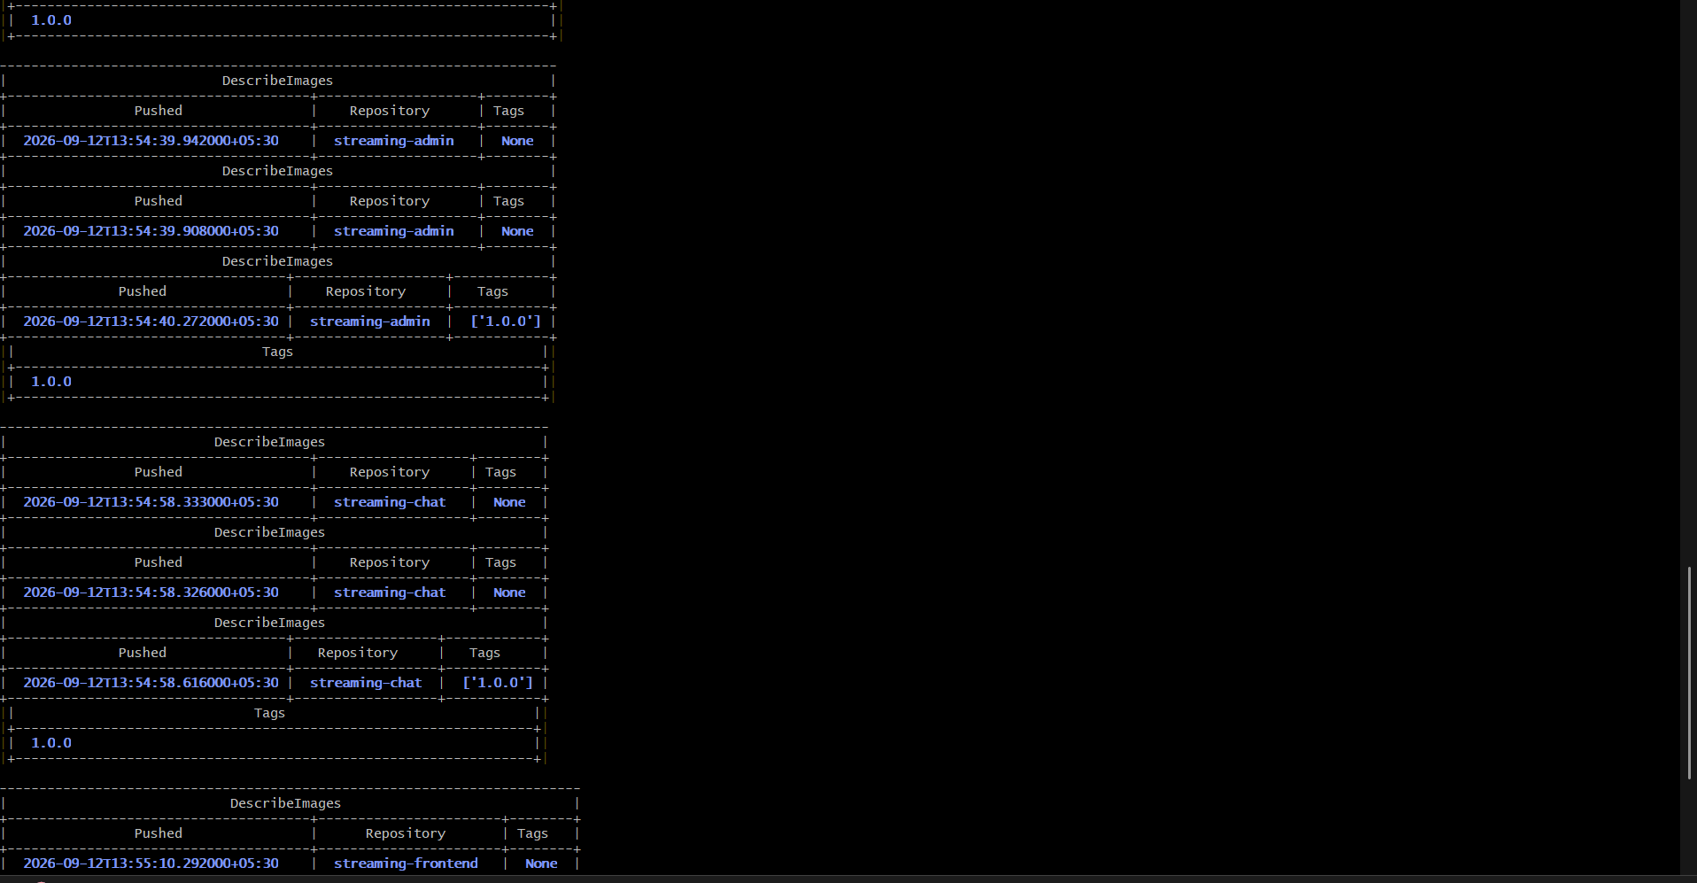
Figure 17 Amazon ECR and Helm Preparation evidence 8
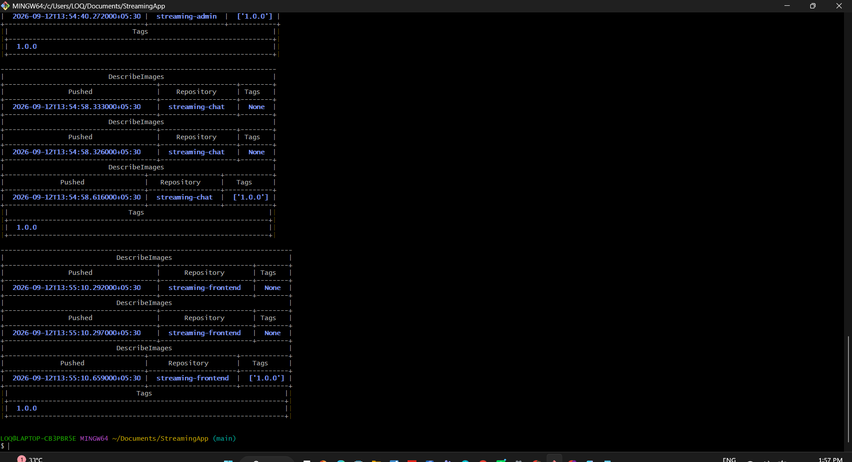
Figure 18 Amazon ECR and Helm Preparation evidence 9
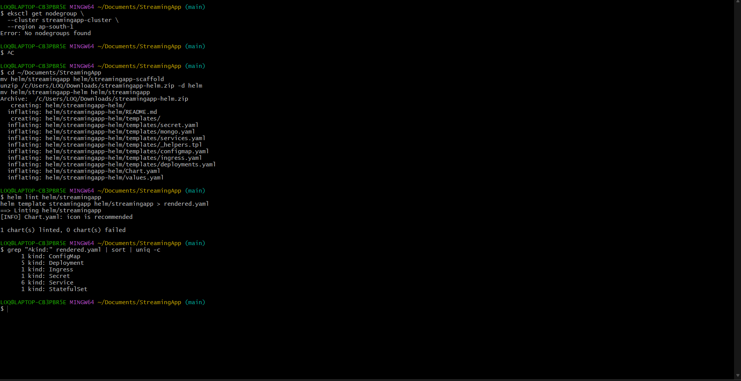
Figure 19 Amazon ECR and Helm Preparation evidence 10
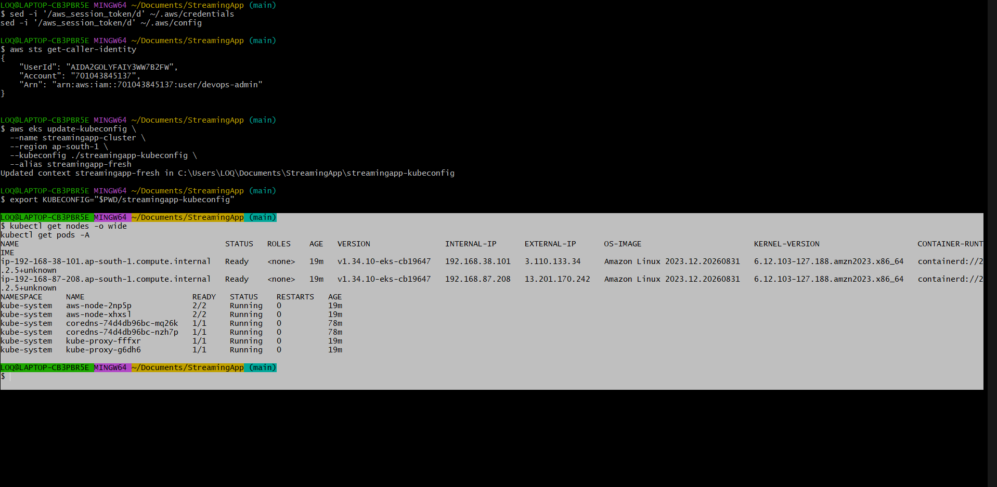
Figure 20 Amazon ECR and Helm Preparation evidence 11

EKS Deployment and Health Validation
The EKS cluster, managed nodes, EBS CSI storage and Helm release were validated. MongoDB received a 5 GiB persistent volume and all application workloads reached Ready state.
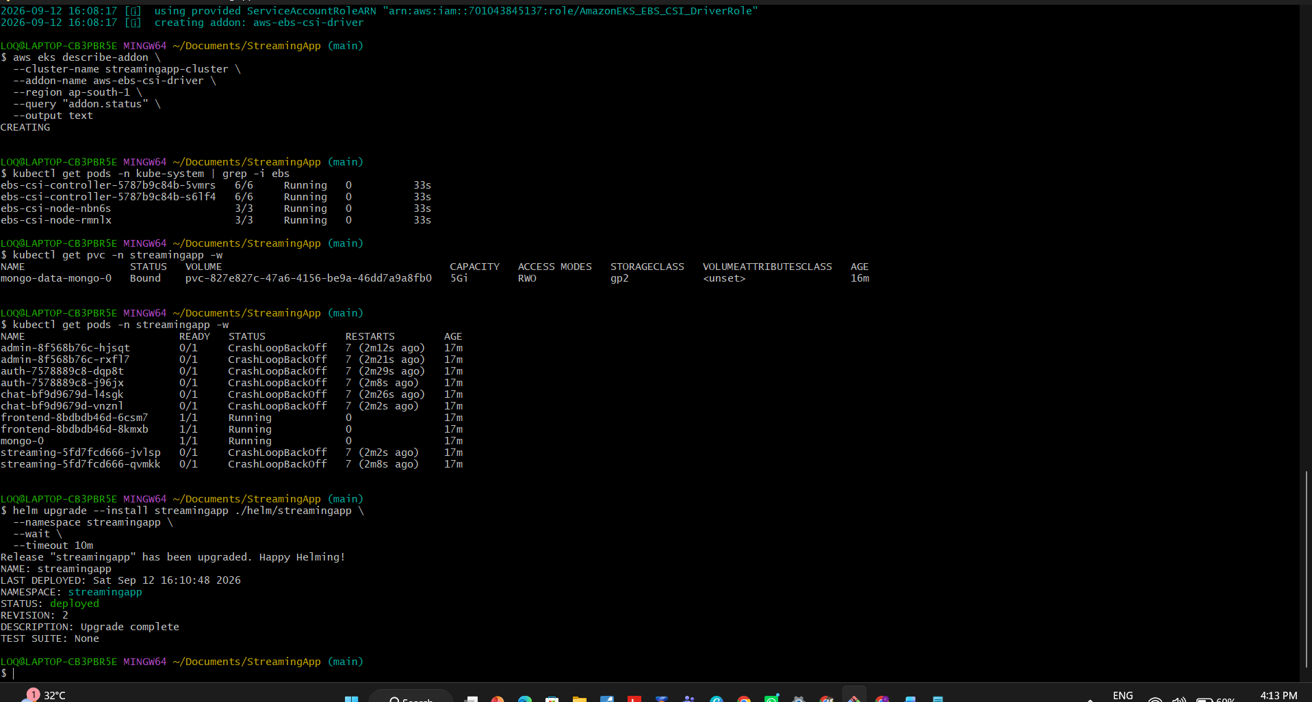
Figure 21 EKS Deployment and Health Validation evidence 1
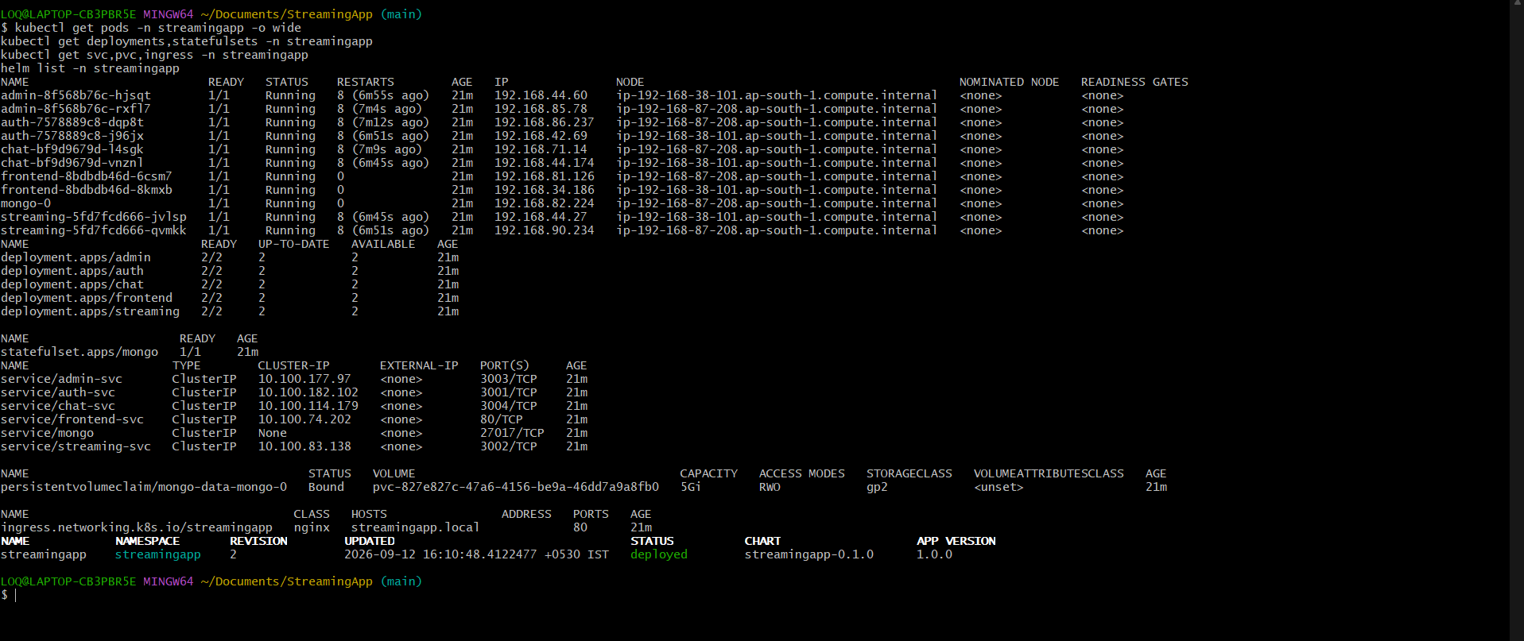
Figure 22 EKS Deployment and Health Validation evidence 2
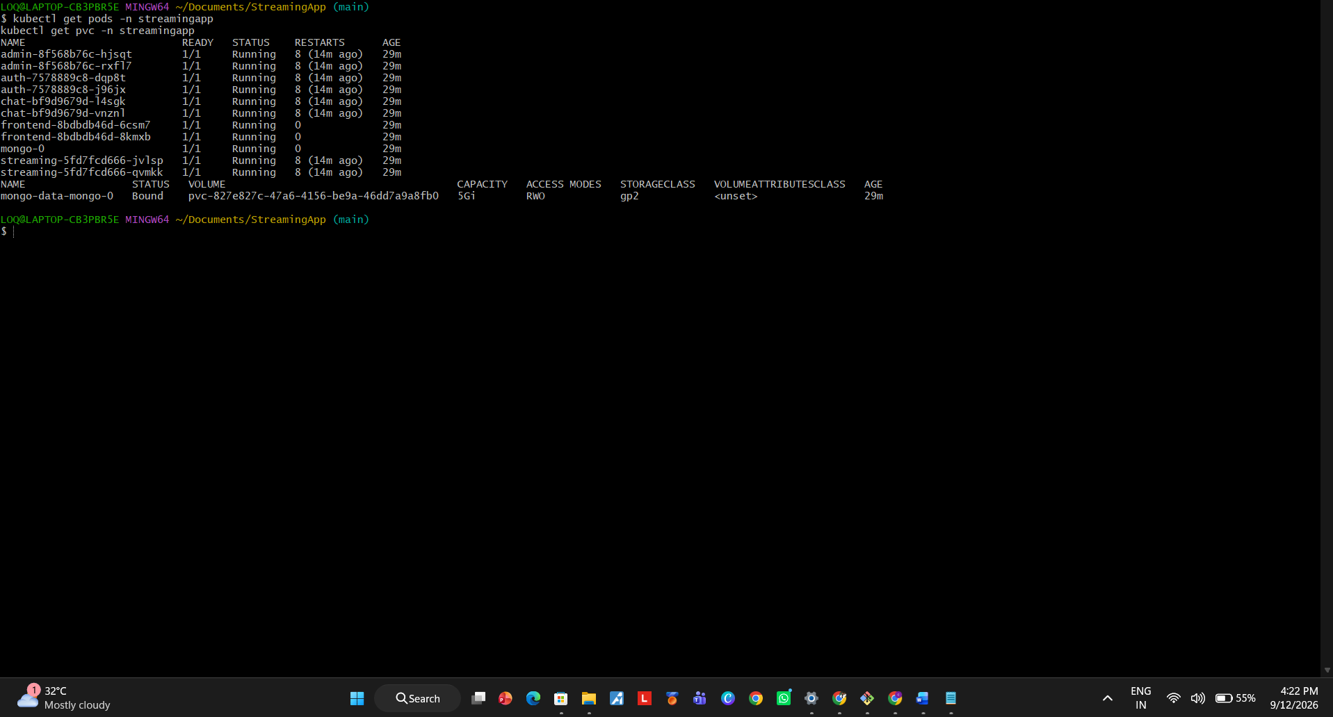
Figure 23 EKS Deployment and Health Validation evidence 3
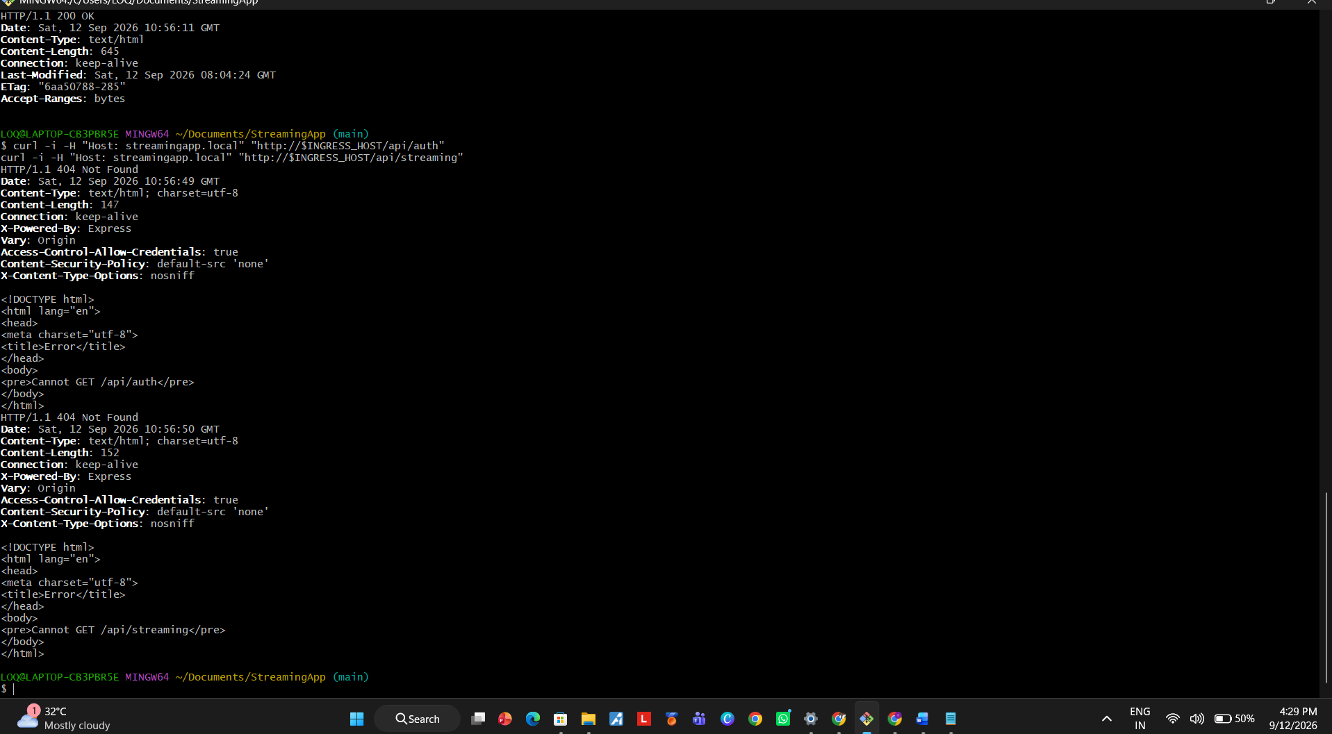
Figure 24 EKS Deployment and Health Validation evidence 4

Scaling and Safe Rolling Updates
The streaming deployment was scaled to four replicas. Auth was updated with maxUnavailable set to zero and maxSurge set to one, preserving service availability during rollout.
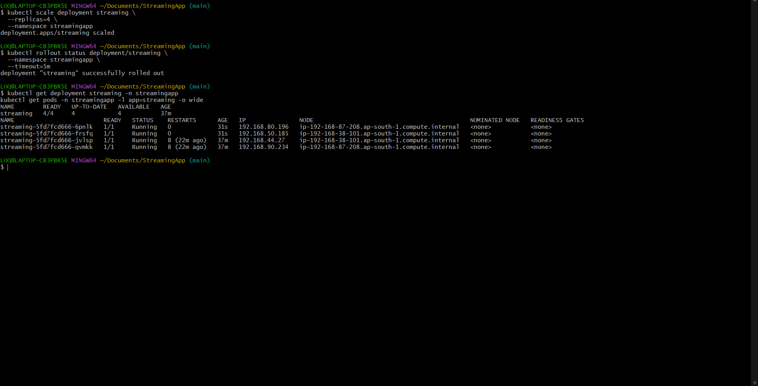
Figure 25 Streaming deployment scaled and auth rollout validated

Jenkins and CloudWatch Configuration
Jenkins was configured to build and push all five images using a restricted ECR credential. CloudWatch Observability, CloudWatch Agent and Fluent Bit provided cluster metrics and centralized logs.
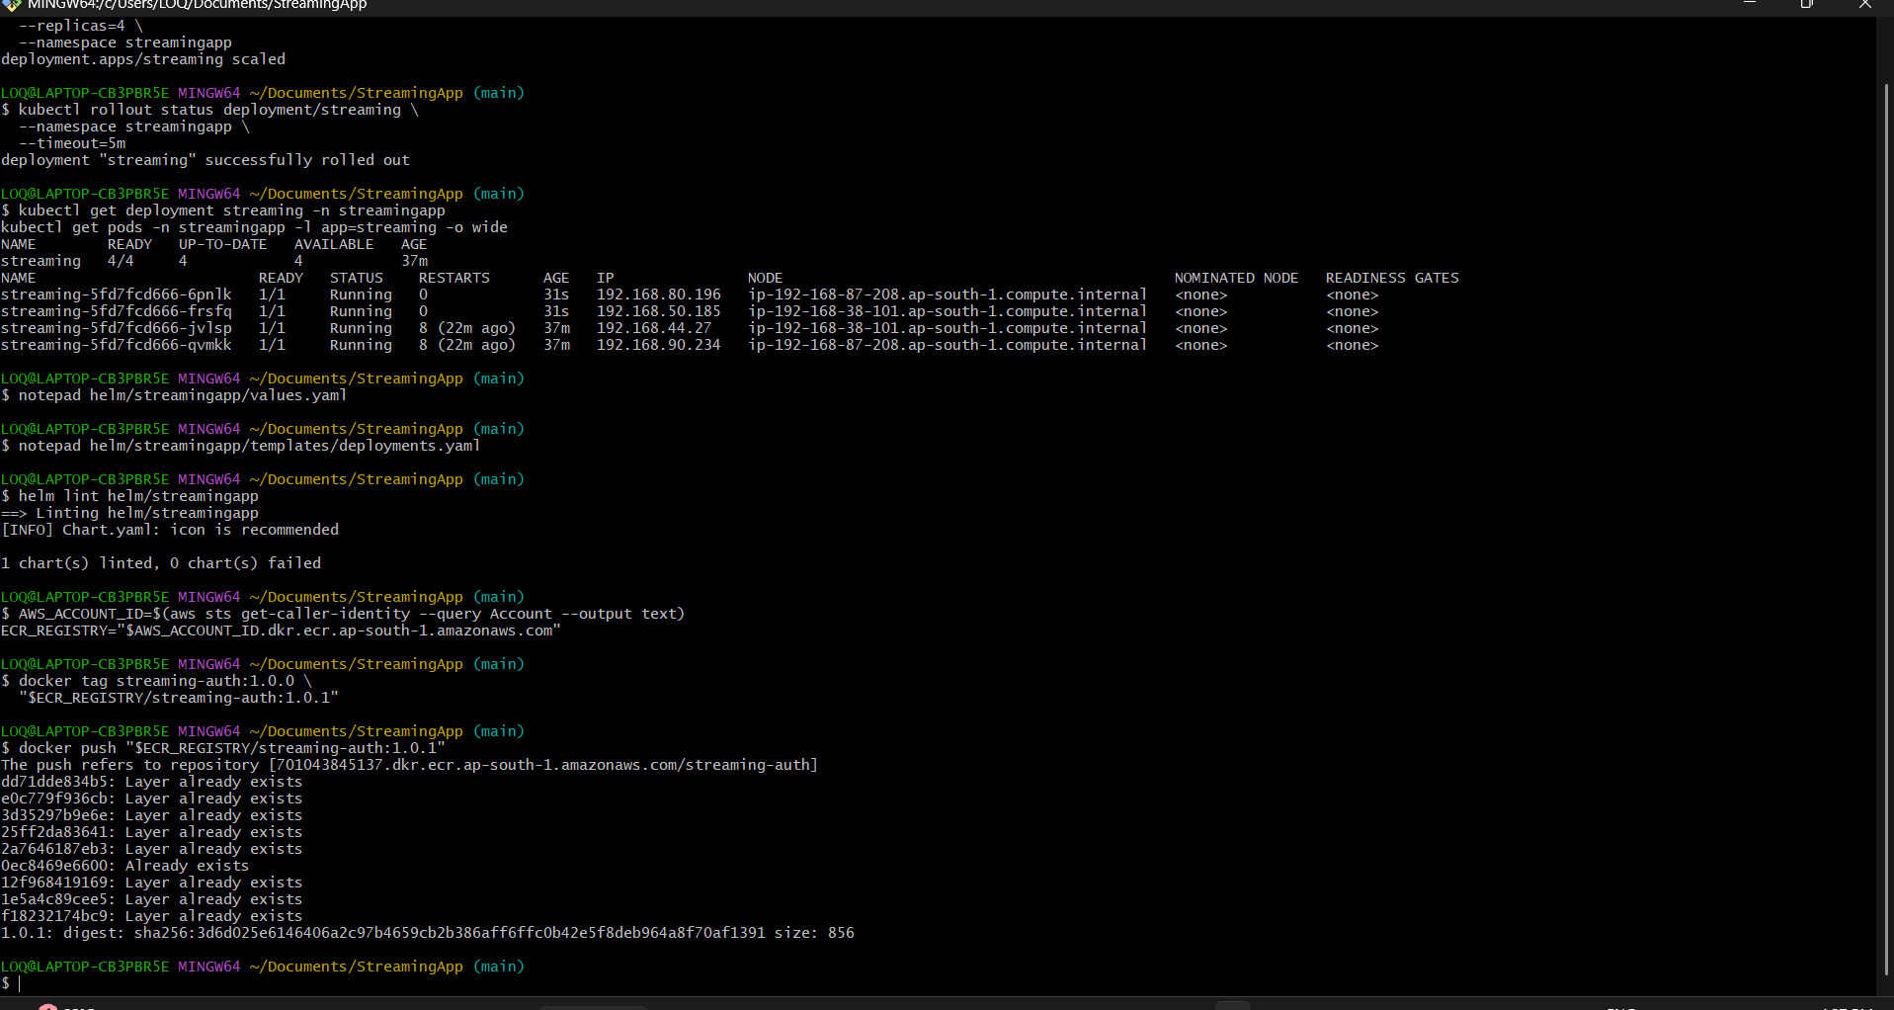
Figure 26 Jenkins and CloudWatch Configuration evidence 1
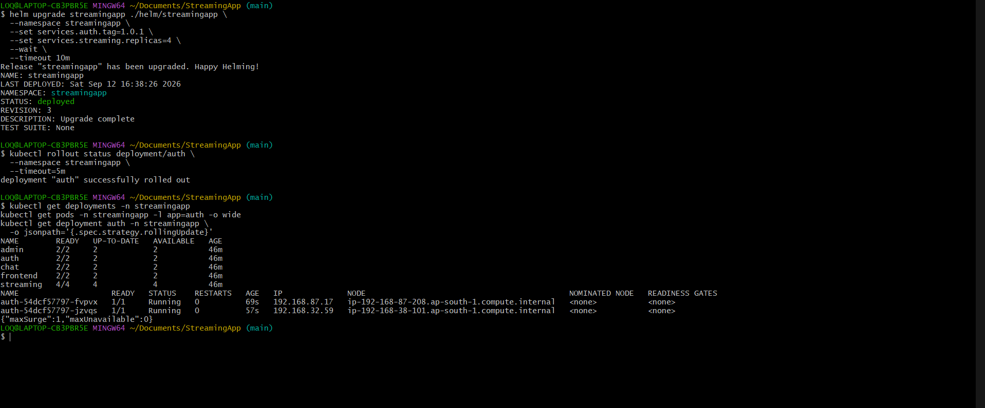
Figure 27 Jenkins and CloudWatch Configuration evidence 2
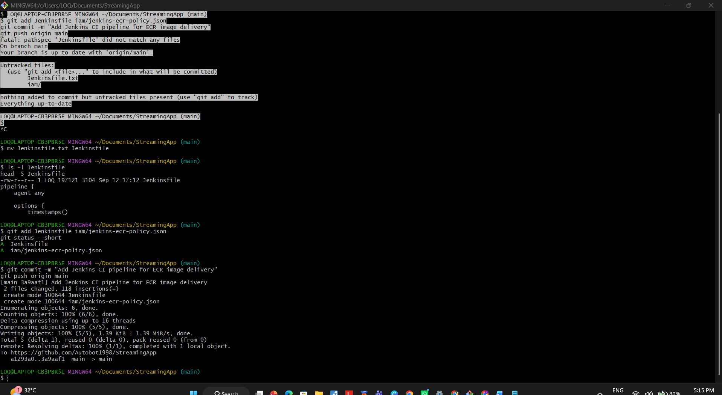
Figure 28 Jenkins and CloudWatch Configuration evidence 3
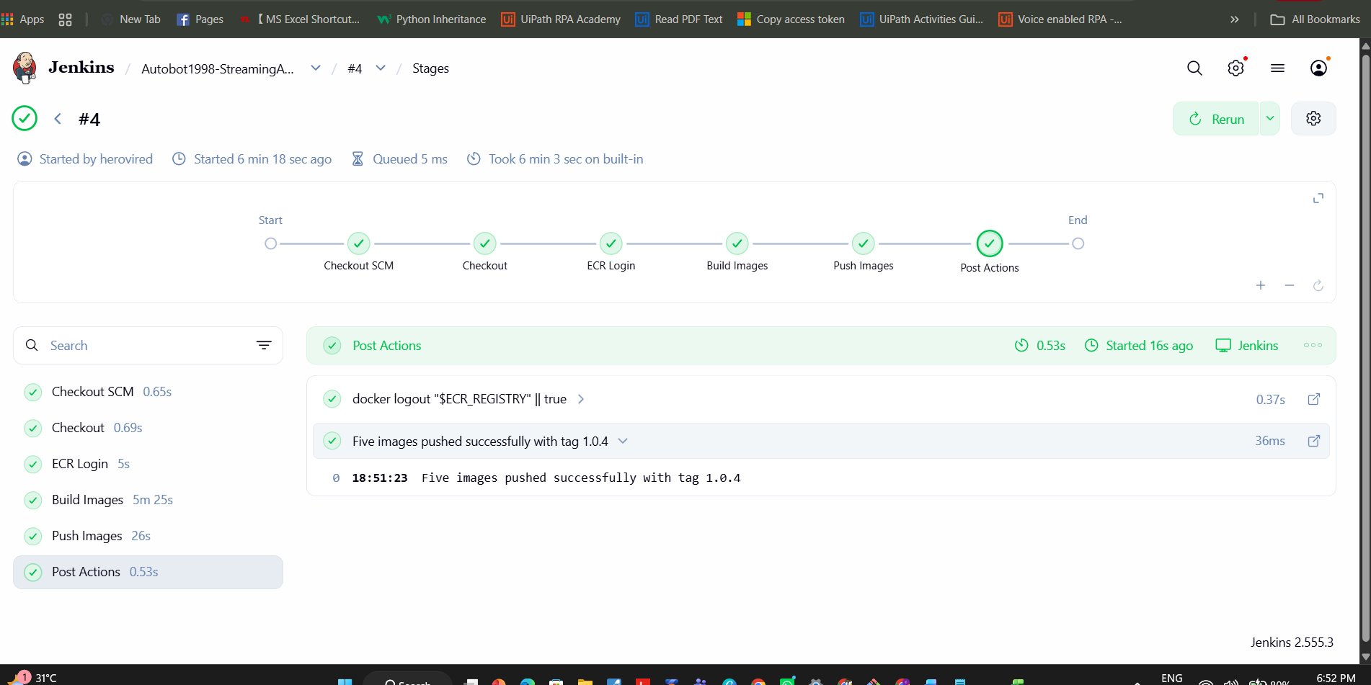
Figure 29 Jenkins and CloudWatch Configuration evidence 4
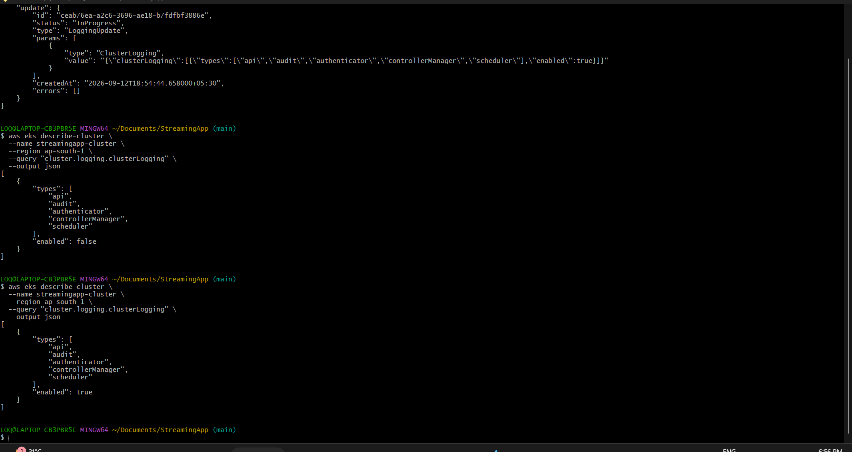
Figure 30 Jenkins and CloudWatch Configuration evidence 5
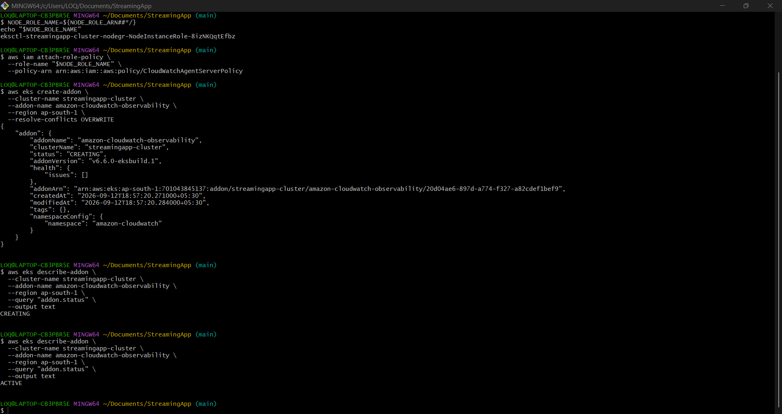
Figure 31 Jenkins and CloudWatch Configuration evidence 6

Final Platform Validation
Final checks confirmed working ECR artifacts, Kubernetes workloads, Helm resources, Ingress routing, scaling behavior and observability components.
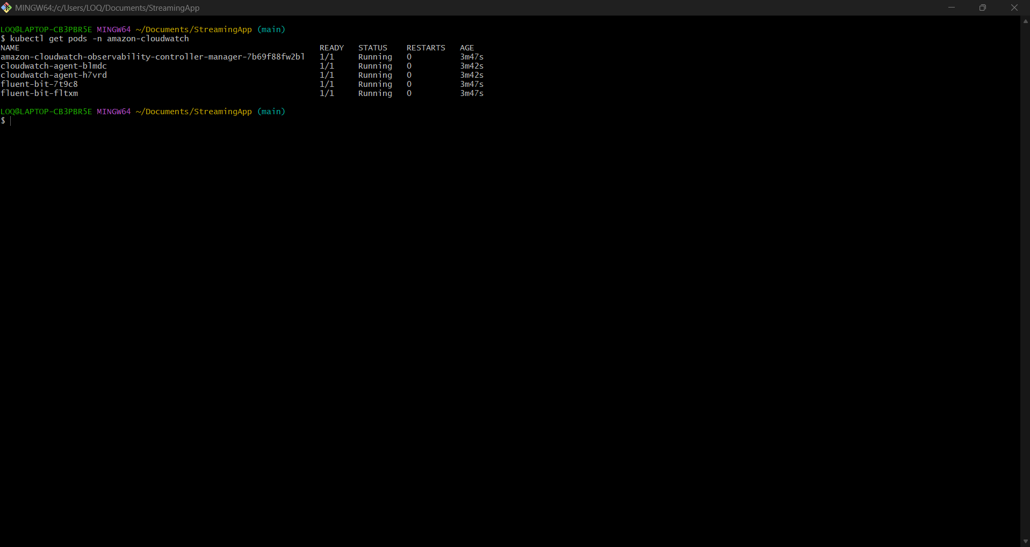
Figure 32 Final Platform Validation evidence 1
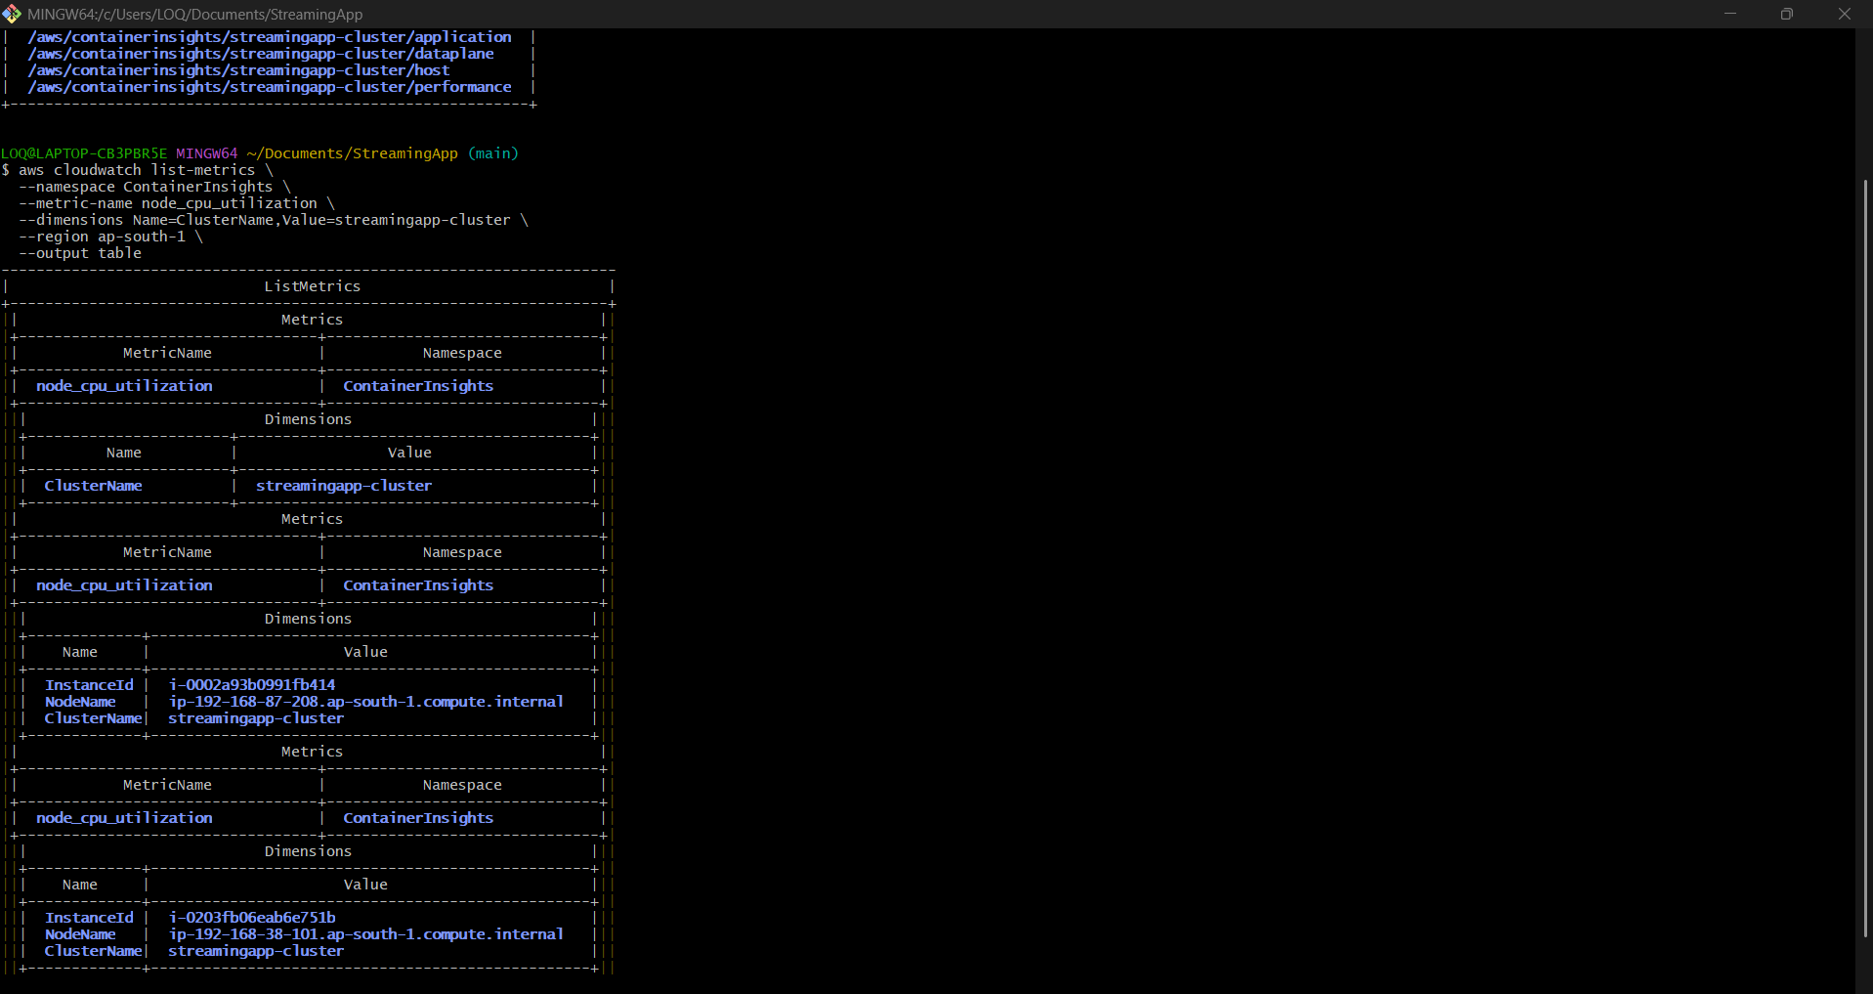
Figure 33 Final Platform Validation evidence 2
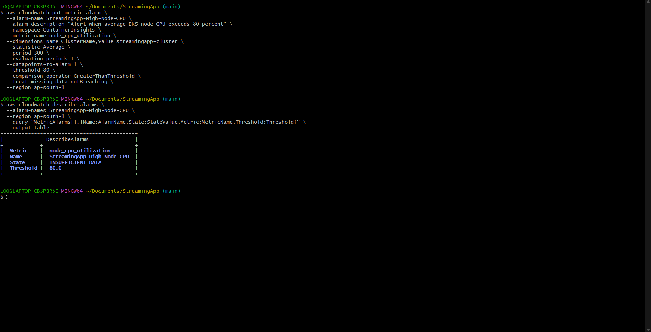
Figure 34 Final Platform Validation evidence 3

Automatic Source Control Trigger
A documentation commit was detected by Jenkins Poll SCM. The resulting build was started by an SCM change and pushed all five images with a new build tag.
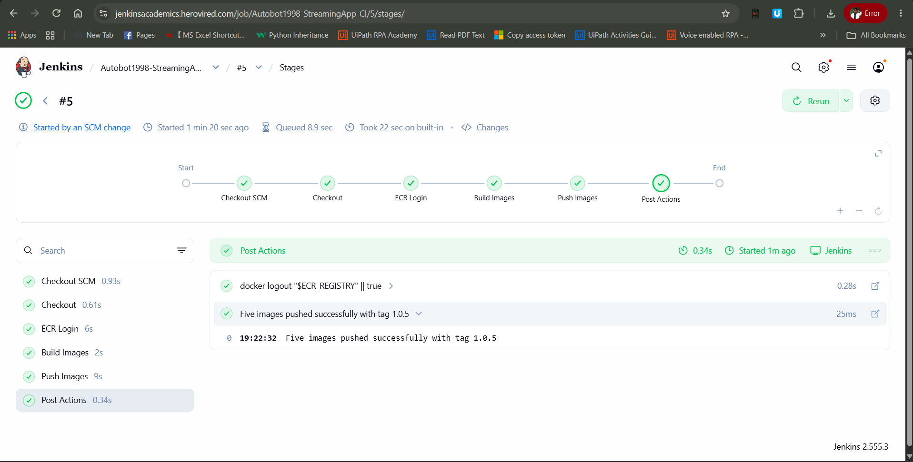
Figure 35 Successful Jenkins pipeline execution
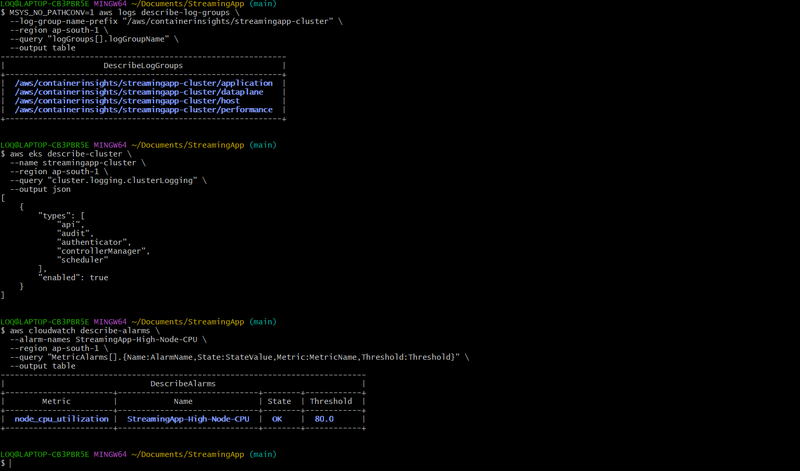
Figure 36 Automatic Jenkins build triggered by an SCM change

Final Validation Matrix
Requirement | Evidence | Status
Five Docker images | Local image list and successful build output | Complete
Dedicated ECR repositories | Repository list and versioned image pushes | Complete
Jenkins continuous integration | Checkout ECR login build and push stages passed | Complete
Automatic source trigger | Build started by an SCM change | Complete
Amazon EKS cluster | Two managed nodes in Ready state | Complete
Helm packaging | Lint passed and release deployed | Complete
Persistent database | MongoDB StatefulSet and 5 GiB Bound PVC | Complete
Ingress exposure | AWS Load Balancer and HTTP 200 frontend response | Complete
Scaling | Streaming deployment reached four replicas | Complete
Rolling update | Auth rollout succeeded with zero unavailable replicas | Complete
Monitoring and logging | CloudWatch addon Agent and Fluent Bit running | Complete
Alarm | High node CPU alarm configured at 80 percent | Complete

Repository Deliverables
- Dockerfiles for the frontend and four backend services
- Jenkinsfile for multi image ECR delivery
- Restricted Jenkins ECR IAM policy
- Reusable Helm chart under helm streamingapp
- Project documentation under docs
- This structured execution evidence report
https://github.com/Autobot1998/StreamingApp

End-to-End Smoke Test Validation
A final smoke-test cycle validated service health, MongoDB-backed API execution, NGINX Ingress rewriting, AWS load balancer routing, user authentication and access to a protected endpoint. The test completed successfully on 12 September 2026.
Validation | Observed result | Status
Auth service health | HTTP 200; status OK | PASS
Admin service health | HTTP 200; service admin OK | PASS
Chat service health | HTTP 200; service chat OK | PASS
Streaming API | HTTP 200; valid videos response | PASS
Ingress and load balancer | External routes returned HTTP 200 | PASS
Registration and persistence | HTTP 201; user stored in MongoDB | PASS
Login and password validation | HTTP 200; bcrypt validation succeeded | PASS
Protected authentication | HTTP 200; Verified response | PASS
Security note: screenshots that exposed the complete JWT were excluded. The final evidence uses health and verified-response outputs without embedding reusable credentials.

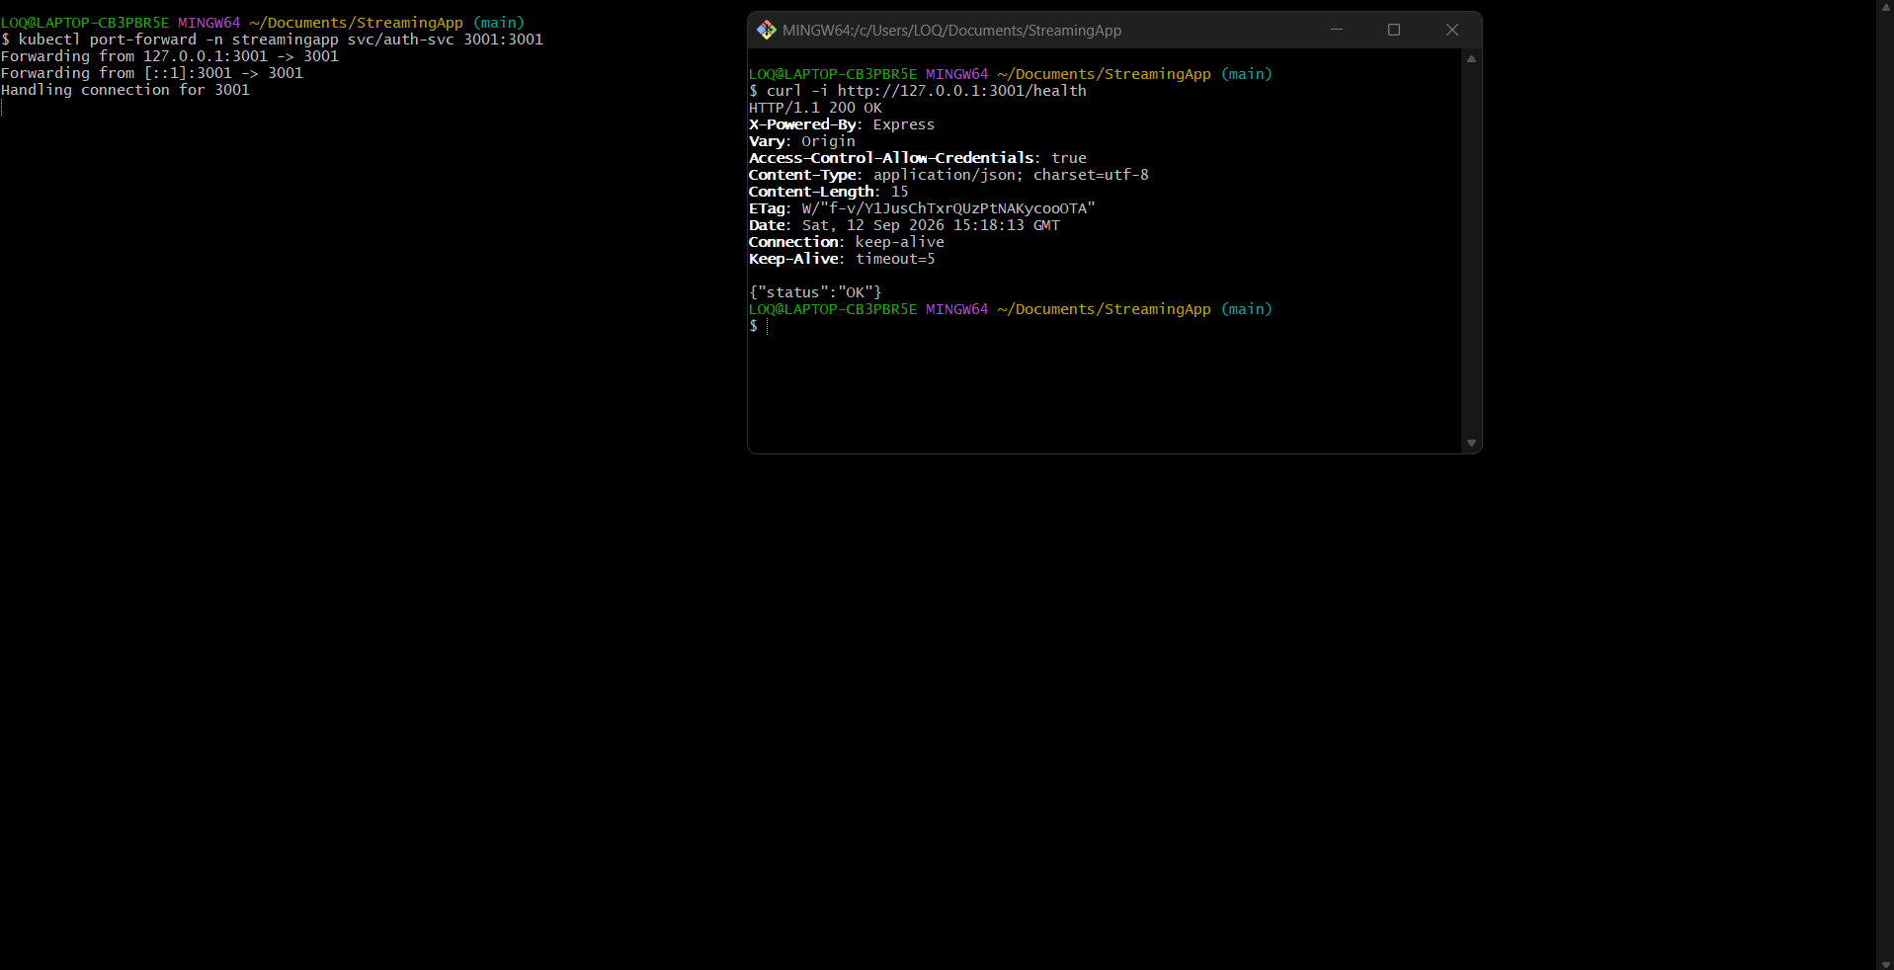
Figure 37 Auth service health validation
The authentication service responded with HTTP 200 and status OK through a controlled port-forward.
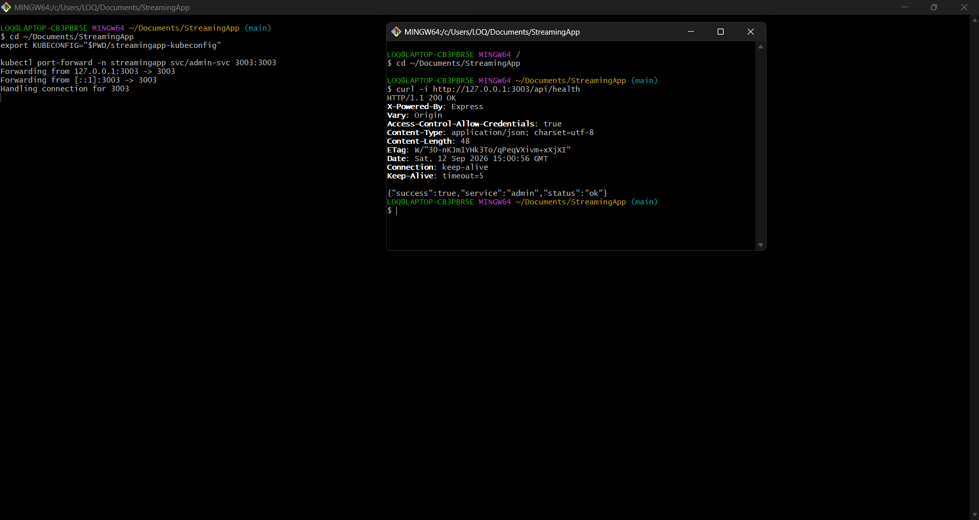
Figure 38 Admin service health validation
The administration service responded with HTTP 200 and a successful health payload.

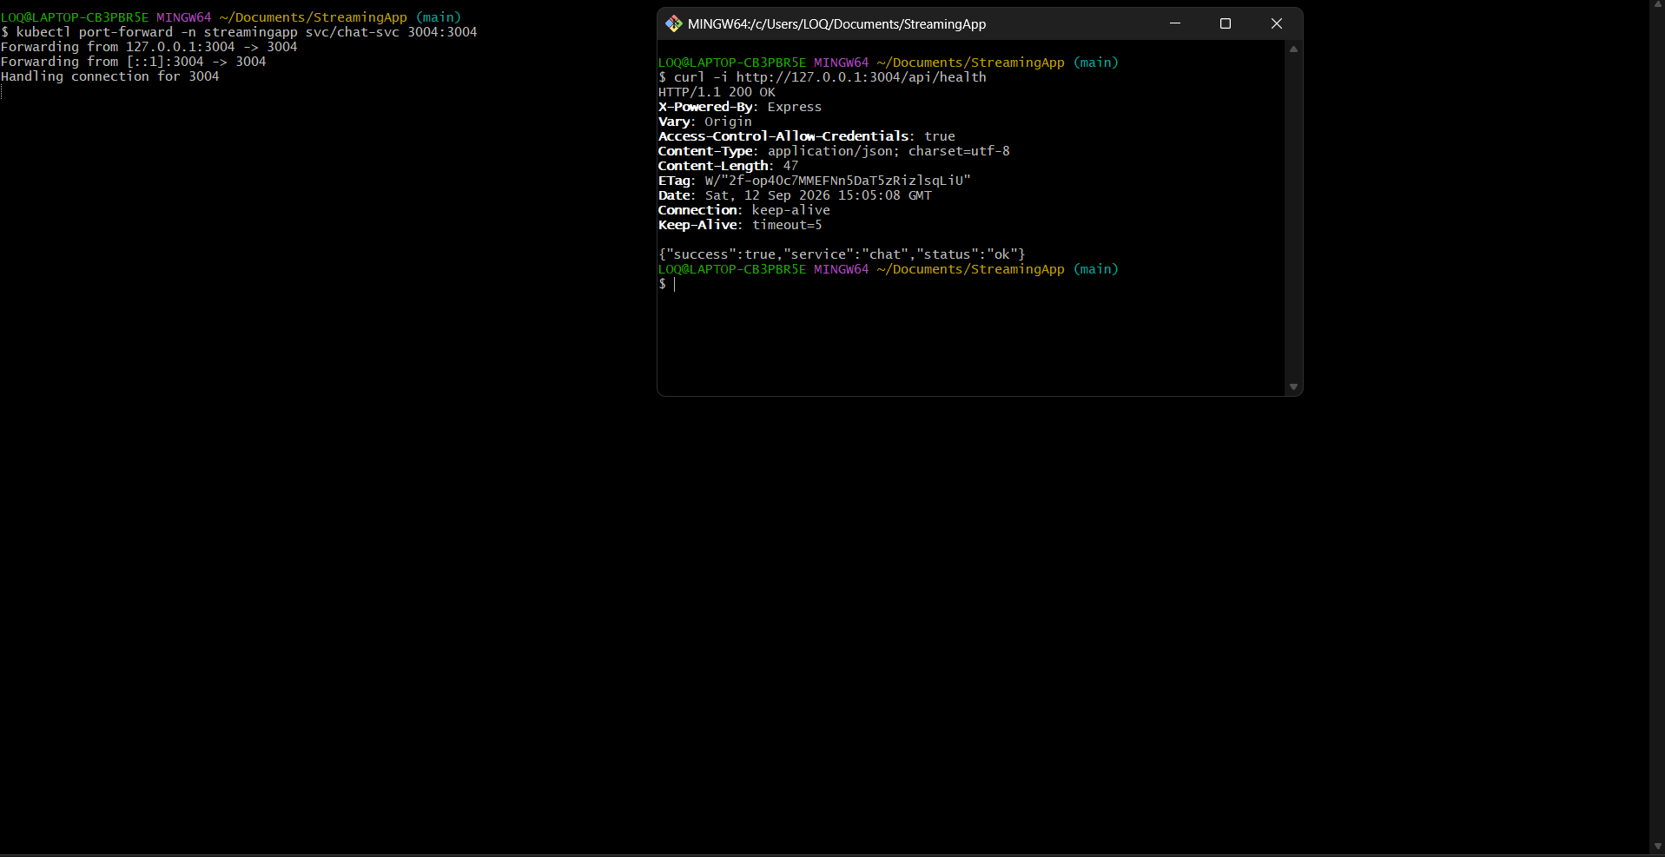
Figure 39 Chat service health validation
The chat service responded with HTTP 200 and a successful health payload.
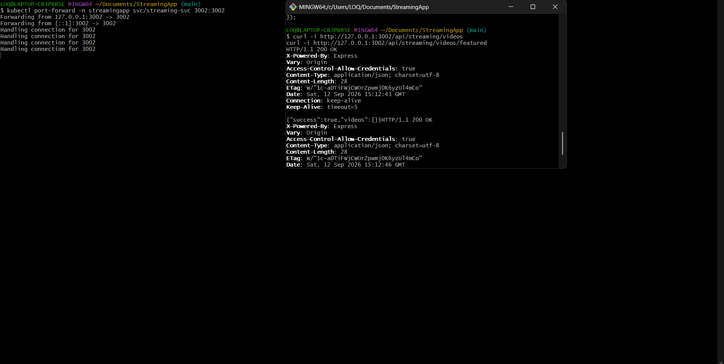
Figure 40 Streaming API and MongoDB query validation
The streaming endpoints returned HTTP 200. An empty videos array is a valid response and confirms routing and database query execution.

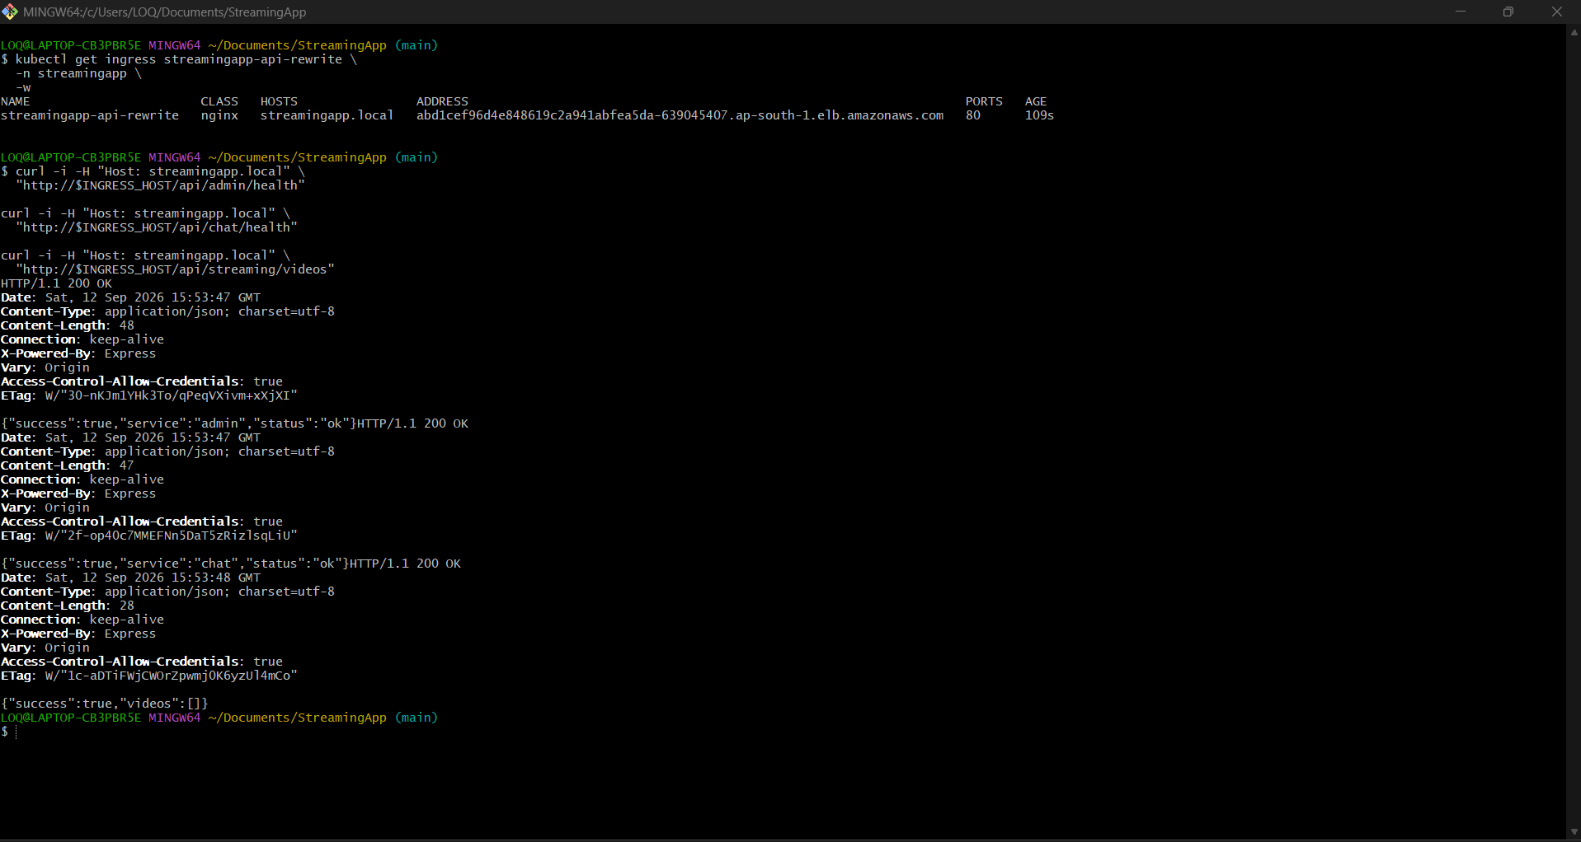
Figure 41 Ingress rewrite and external service routing
The NGINX Ingress rewrite resource received an AWS load balancer address; admin, chat and streaming routes returned HTTP 200 externally.
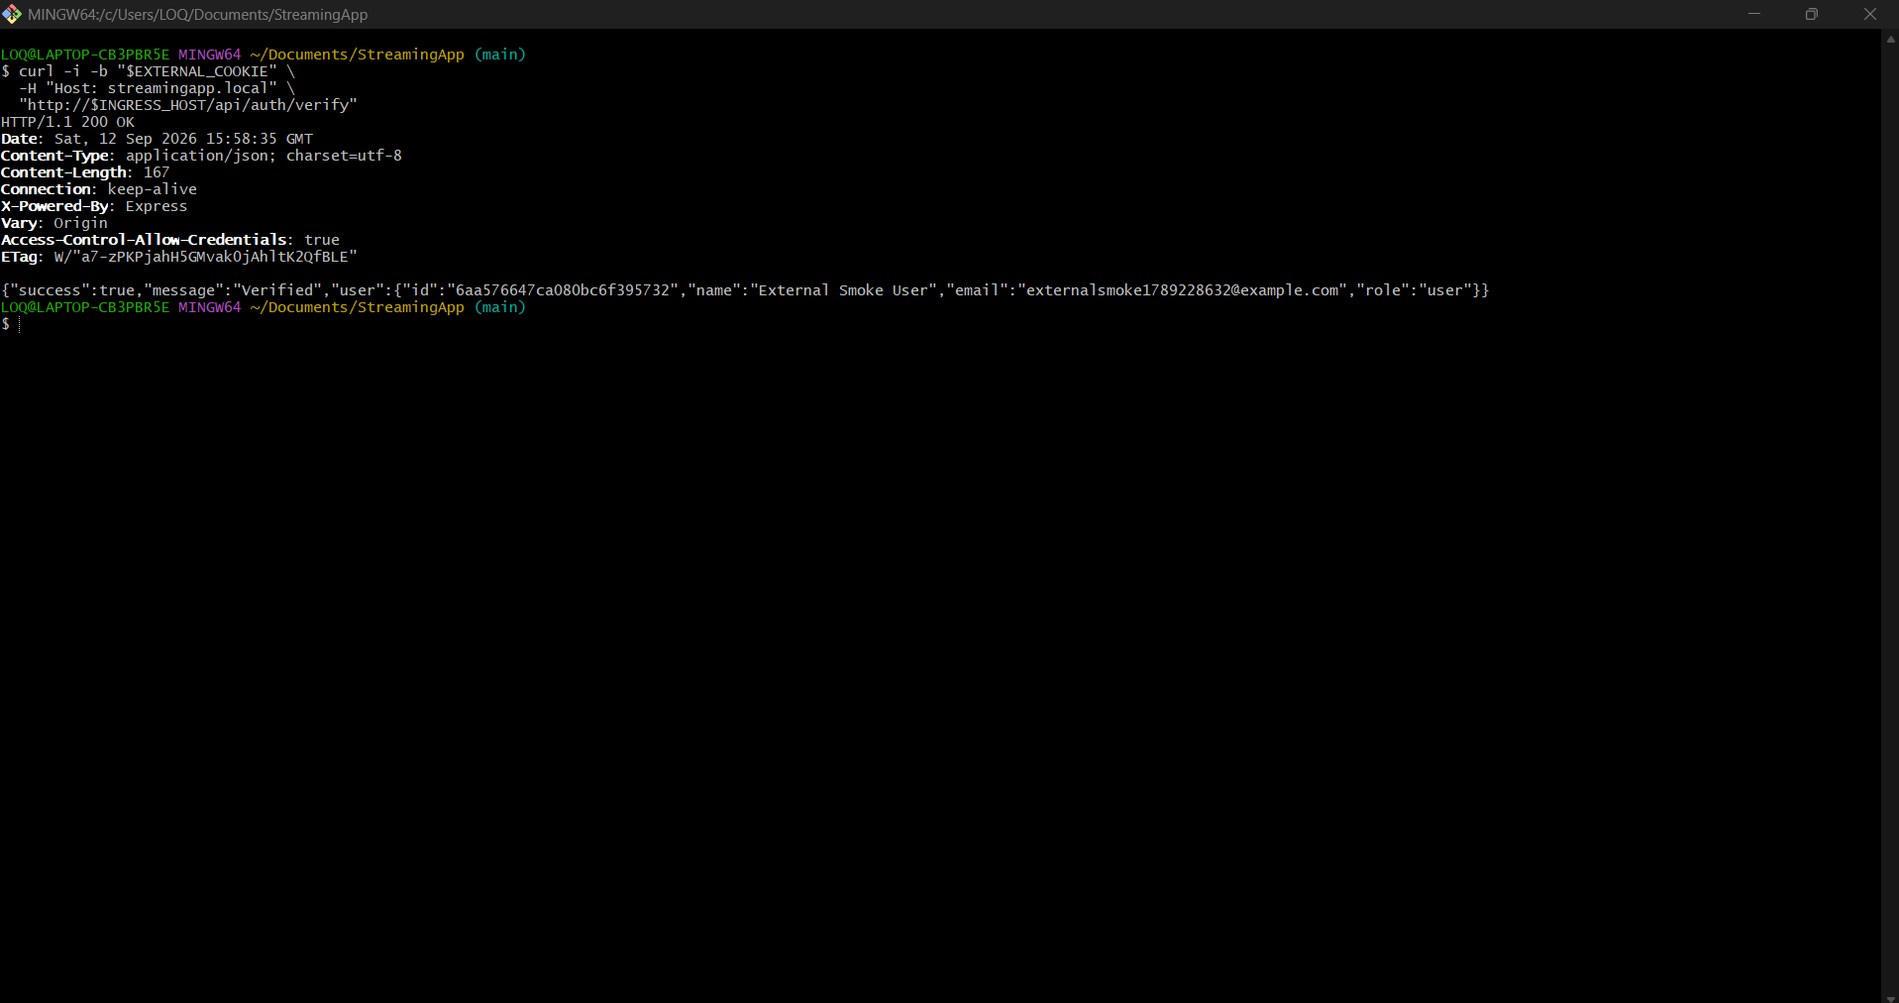
Figure 42 Final authenticated end-to-end smoke test
The protected authentication endpoint returned HTTP 200 with Verified through the external load balancer and NGINX Ingress.

Conclusion
The StreamingApp platform was successfully moved from source code to a production style container orchestration workflow. The solution demonstrates repeatable image delivery, managed Kubernetes deployment, persistent state, external routing, safe scaling, rolling updates, centralized observability and automated CI execution. The GitHub repository contains the implementation artifacts required to reproduce and review the deployment. Final smoke testing also confirmed external Ingress routing, MongoDB-backed registration, login and protected-route verification.

