StreamingApp Container Orchestration and Scaling
Graded Project Implementation and Execution Evidence

Candidate | Praveen Kumar P
Project | StreamingApp
AWS Region | Asia Pacific Mumbai ap south 1
Repository | https://github.com/Autobot1998/StreamingApp

Open the GitHub repository

Executive Summary
This report documents the completed container orchestration and scaling implementation for a five service MERN streaming platform. The application was containerized with Docker, published to dedicated Amazon ECR repositories, automated through Jenkins CI, and deployed to Amazon EKS using a reusable Helm chart. The running platform uses persistent MongoDB storage, Nginx Ingress, controlled rolling updates, horizontal scaling, CloudWatch Container Insights, centralized Fluent Bit logs, and a CPU alarm.
The implementation was validated through successful image builds and pushes, Ready EKS nodes, a deployed Helm release, Bound persistent storage, HTTP 200 frontend access, a four replica streaming deployment, a zero downtime auth rollout, and a Jenkins build automatically triggered by a source control change.

Solution Architecture
Layer | Technology | Responsibility | Validated Result
Source and CI | GitHub and Jenkins | Checkout, build, tag and publish five images | SCM triggered build succeeded
Registry | Amazon ECR | Separate repositories with scan on push | Versioned images available
Orchestration | Amazon EKS and Helm | Deploy, expose, scale and update services | Helm release deployed
Data | MongoDB and Amazon EBS | Stateful database with persistent volume | PVC Bound at 5 GiB
Traffic | Nginx Ingress and AWS ELB | Host and path based routing | Frontend returned HTTP 200
Observability | CloudWatch and Fluent Bit | Metrics, logs and alerting | Addon active and alarm created

Service Map
The platform separates user interface, identity, catalogue, administration and real time chat responsibilities into independently deployable services. Kubernetes Services provide stable internal names while the MongoDB StatefulSet retains data through an Amazon EBS backed persistent volume.
Service | Port | Image | Kubernetes Resource
Frontend | 80 | streaming-frontend | Deployment and Service
Authentication | 3001 | streaming-auth | Deployment and Service
Streaming | 3002 | streaming-stream | Deployment and Service
Administration | 3003 | streaming-admin | Deployment and Service
Chat | 3004 | streaming-chat | Deployment and Service
MongoDB | 27017 | mongo 6 | StatefulSet Service and PVC

Version Control and Repository Setup
The upstream application repository was forked into the candidate GitHub account and cloned locally. The main branch is used by both local development and Jenkins.
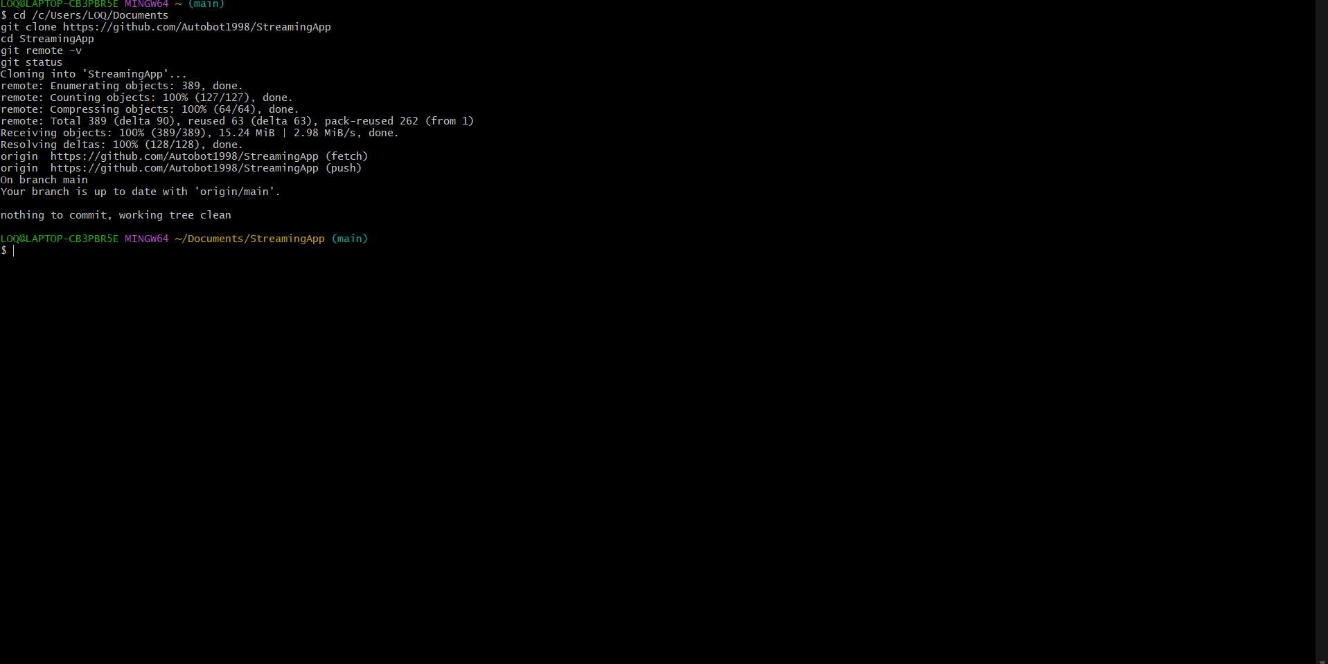
Figure 1 Repository fork and local clone confirmation

Application Inspection and Docker Validation
The frontend and four backend services were inspected to identify Dockerfiles, package scripts, build contexts, ports, environment variables and MongoDB dependencies. Local builds validated every component before registry publication.
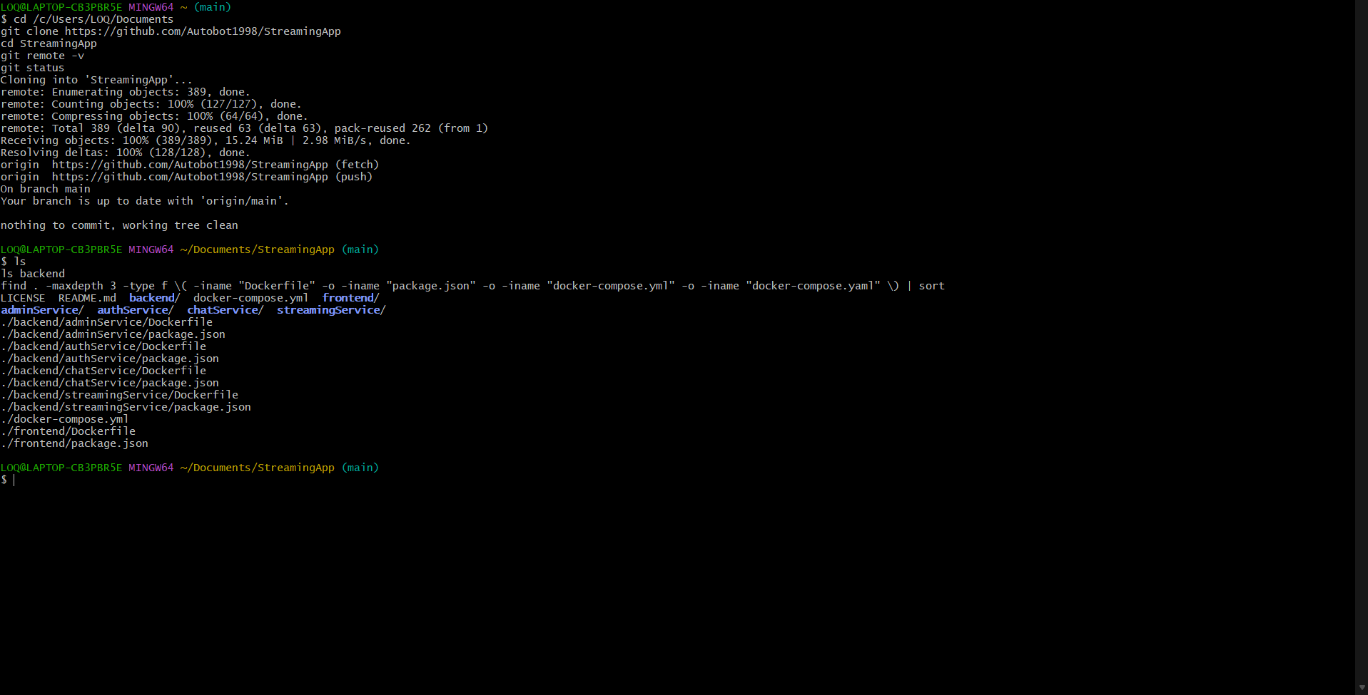
Figure 2 Application Inspection and Docker Validation evidence 1
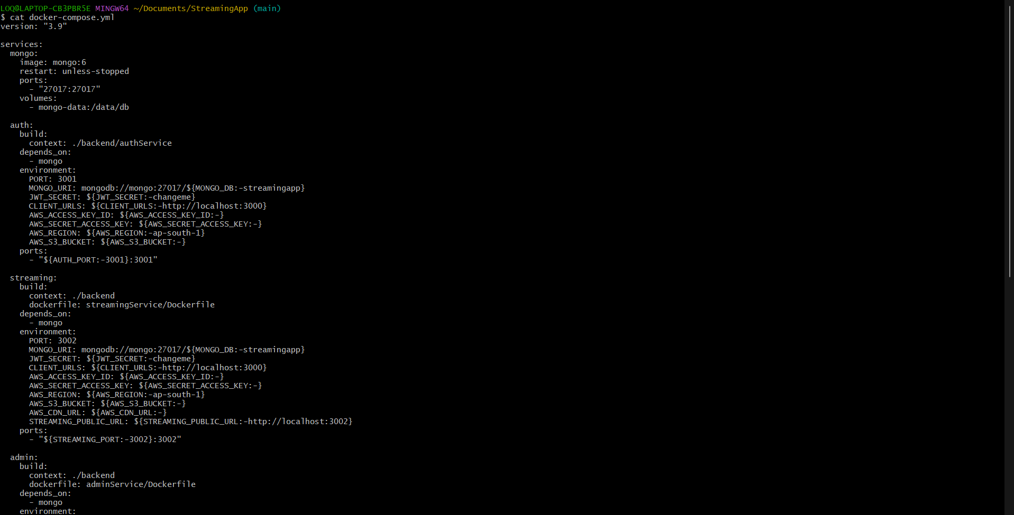
Figure 3 Application Inspection and Docker Validation evidence 2
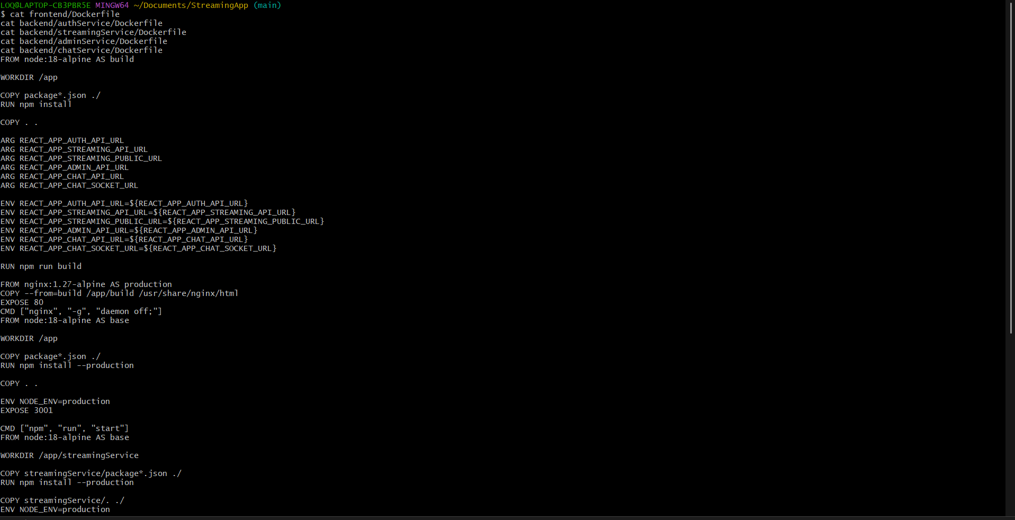
Figure 4 Application Inspection and Docker Validation evidence 3
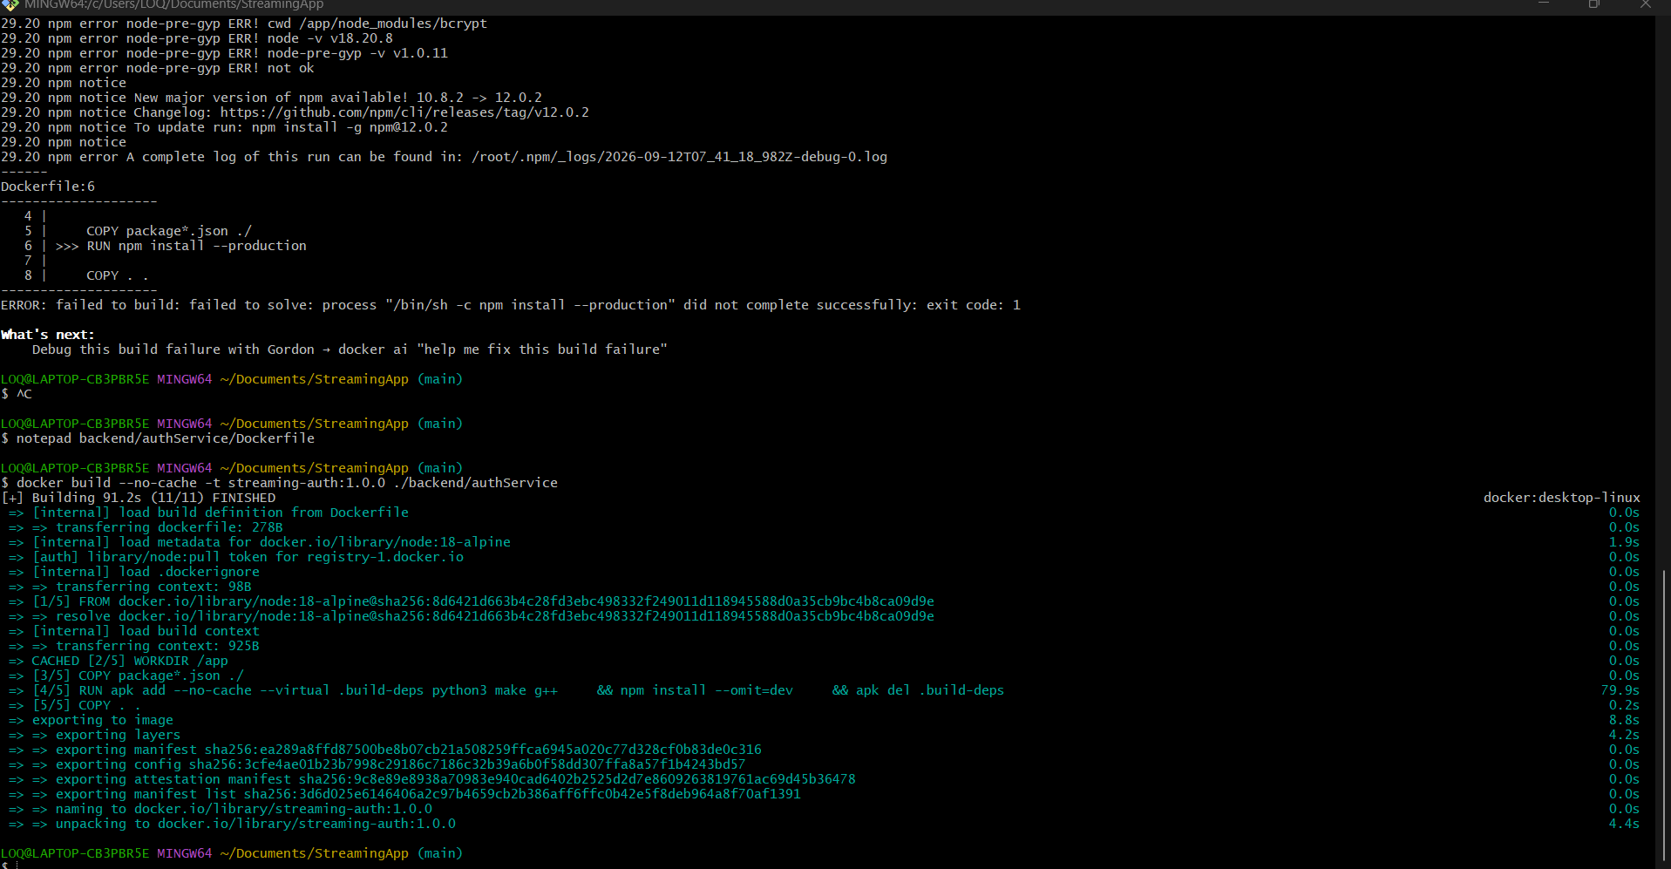
Figure 5 Application Inspection and Docker Validation evidence 4
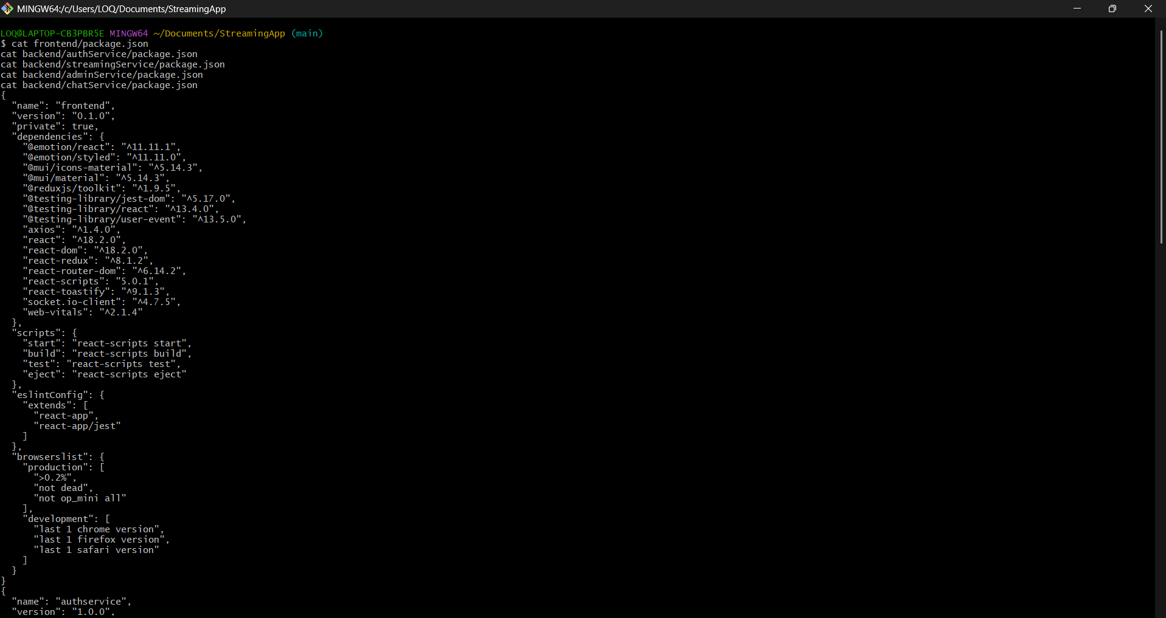
Figure 6 Application Inspection and Docker Validation evidence 5
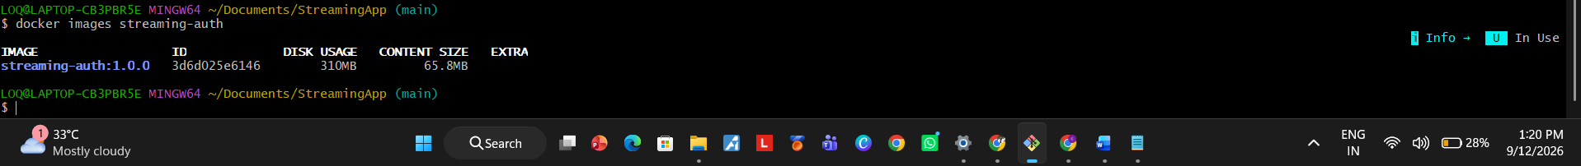
Figure 7 Application Inspection and Docker Validation evidence 6
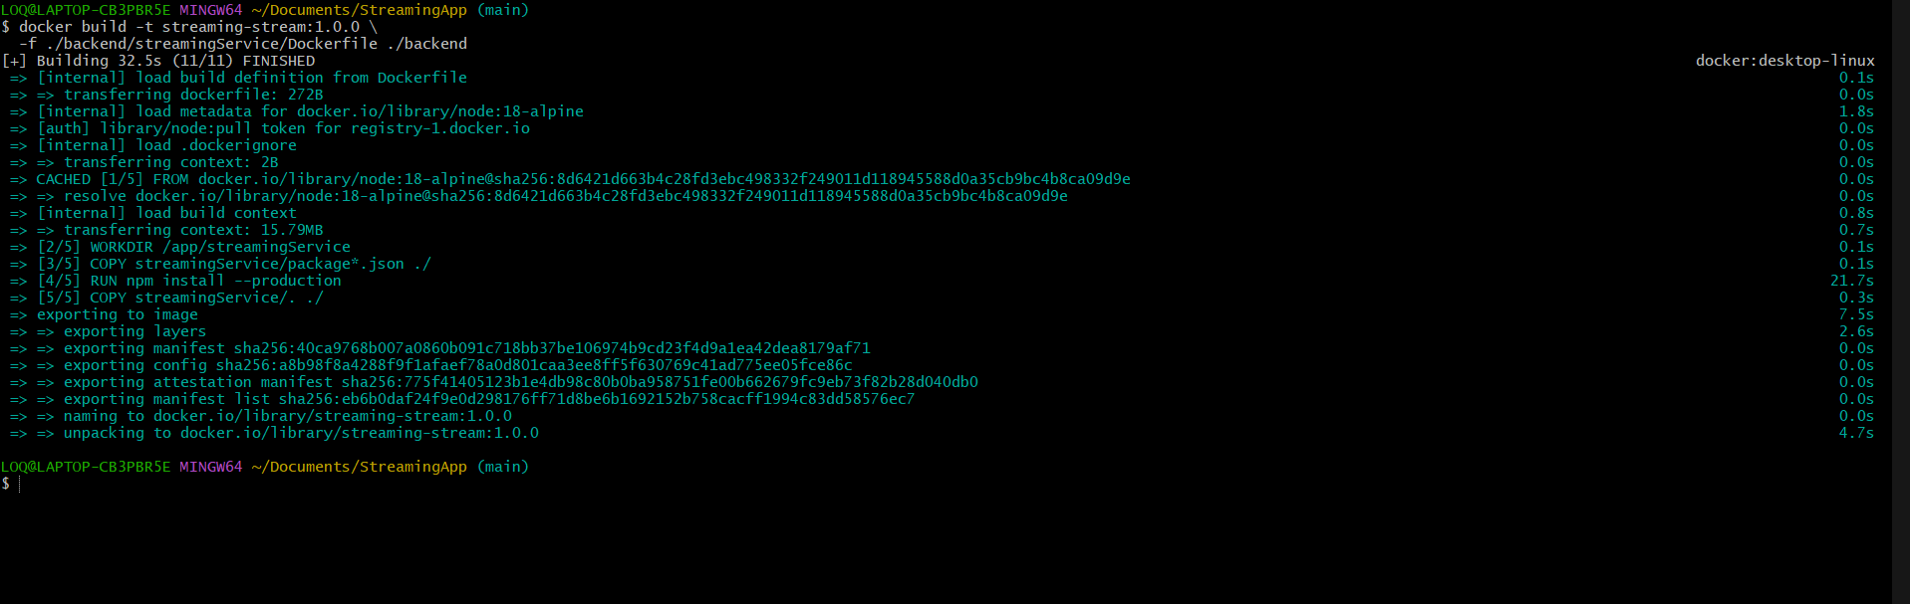
Figure 8 Application Inspection and Docker Validation evidence 7
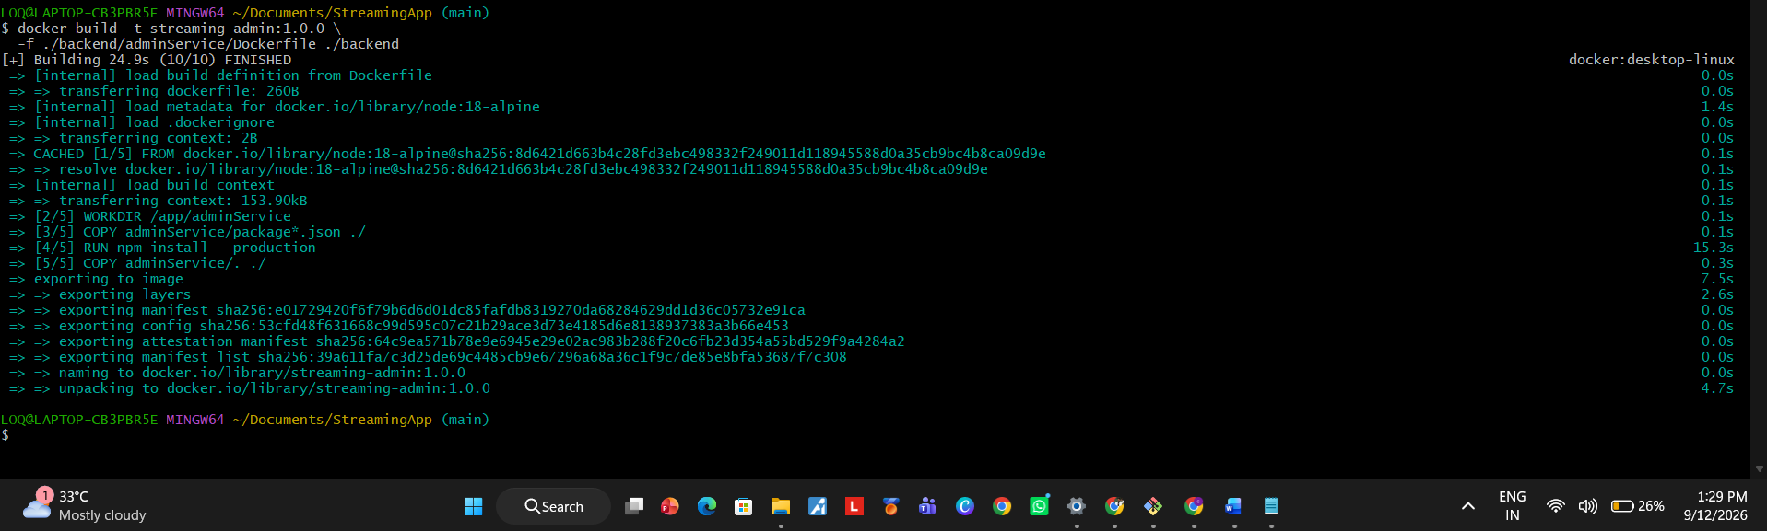
Figure 9 Application Inspection and Docker Validation evidence 8

Amazon ECR and Helm Preparation
Dedicated ECR repositories were created for each component with scan on push enabled. Images were authenticated, tagged and pushed. A Helm chart was then prepared for the five services and MongoDB.
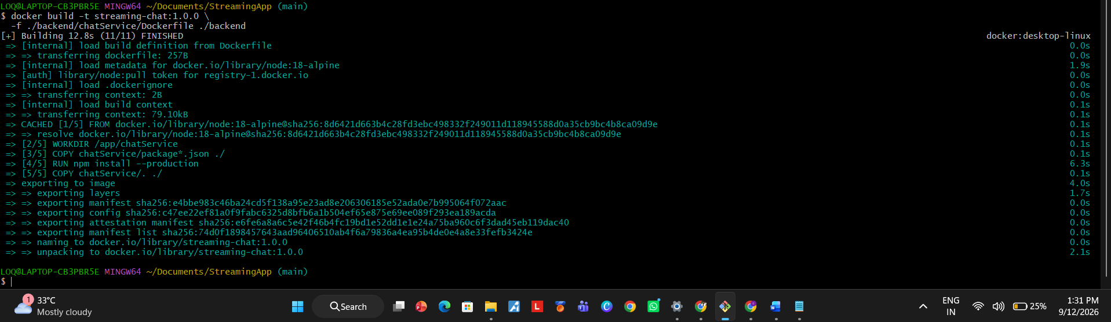
Figure 10 Amazon ECR and Helm Preparation evidence 1
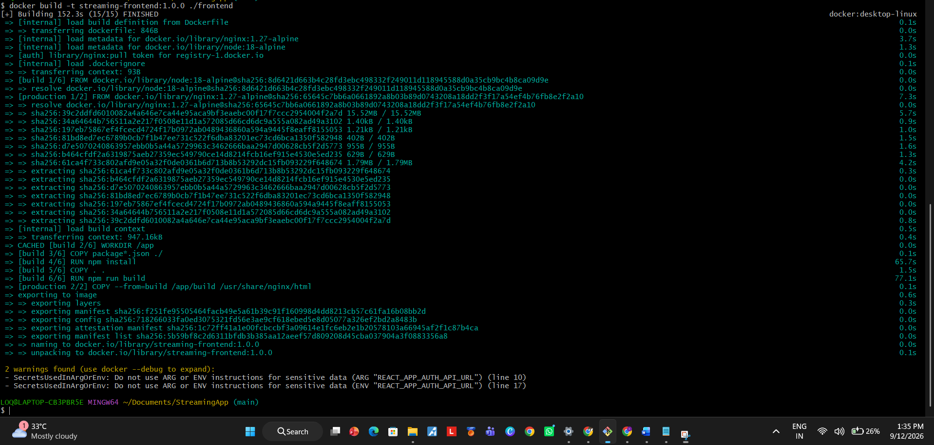
Figure 11 Amazon ECR and Helm Preparation evidence 2
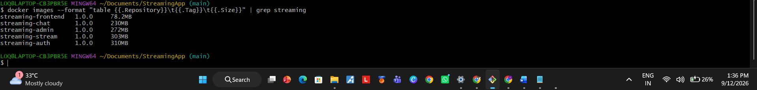
Figure 12 Amazon ECR and Helm Preparation evidence 3
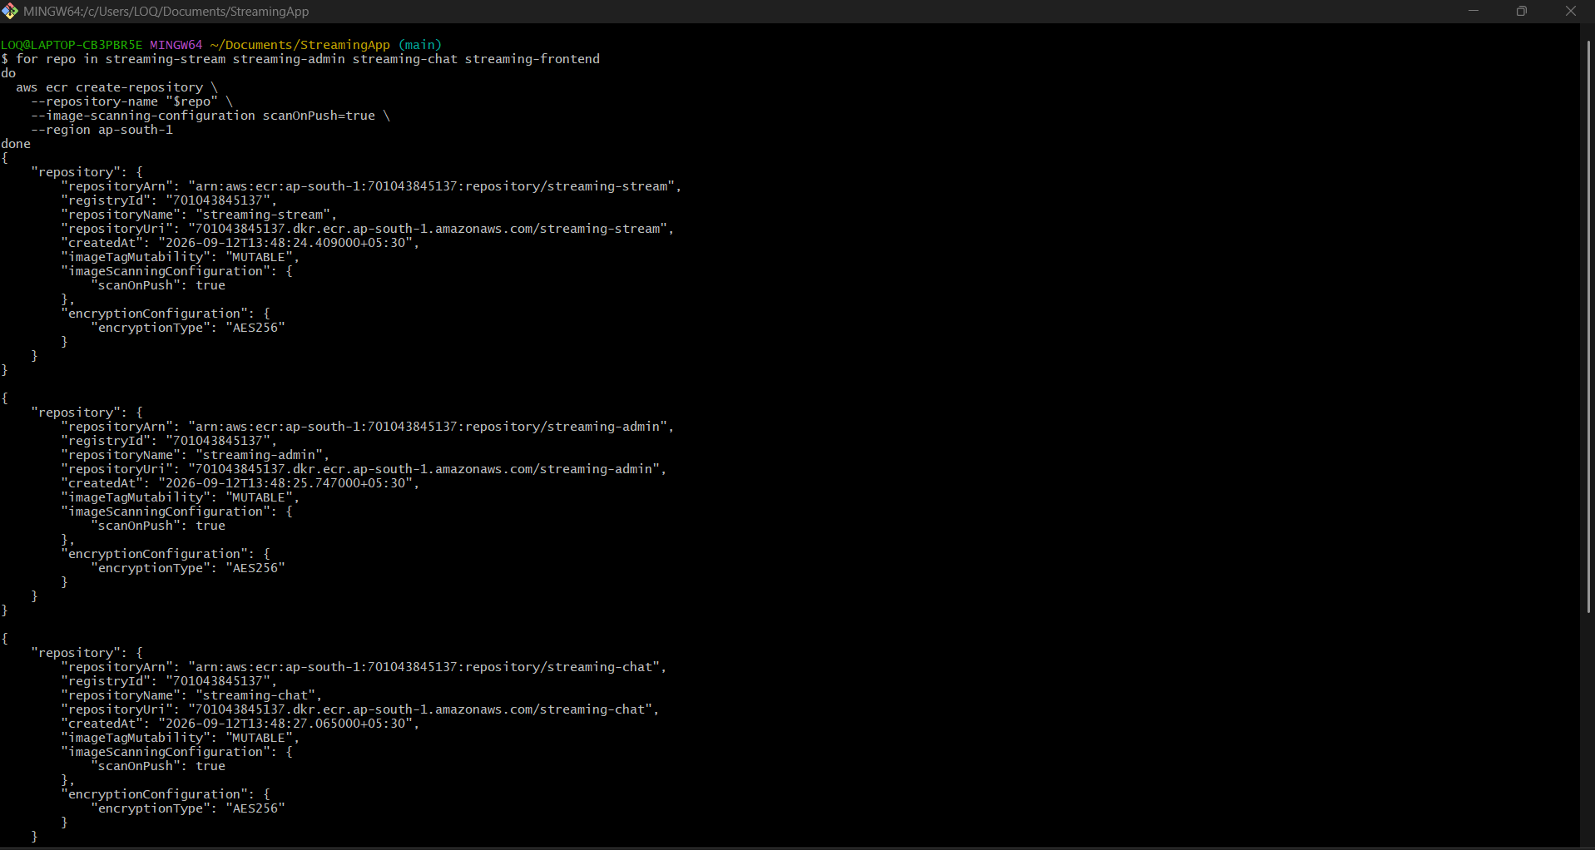
Figure 13 Amazon ECR and Helm Preparation evidence 4
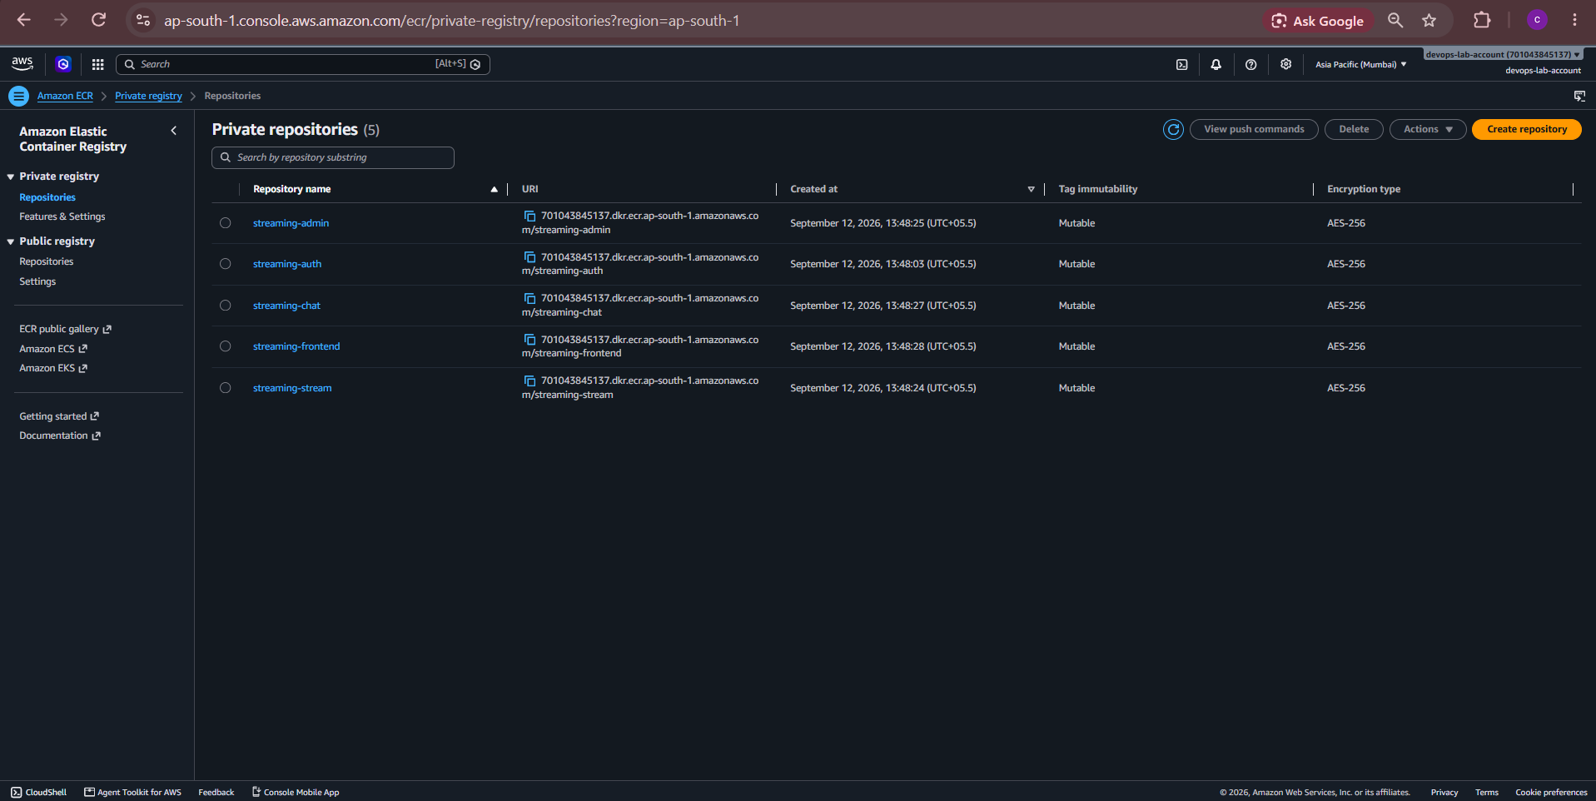
Figure 14 Amazon ECR and Helm Preparation evidence 5
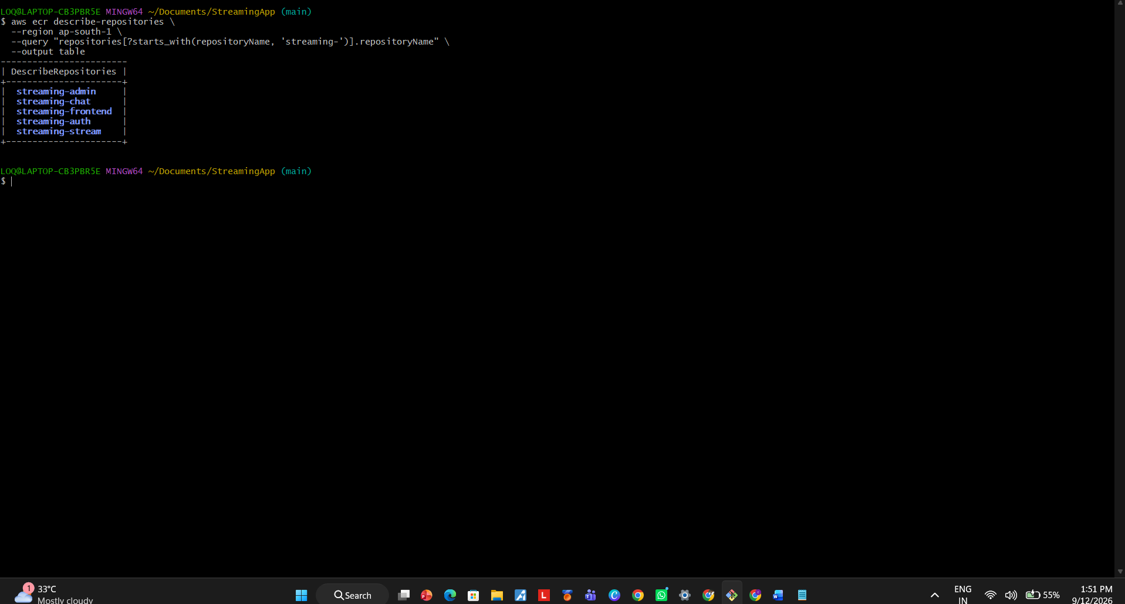
Figure 15 Amazon ECR and Helm Preparation evidence 6
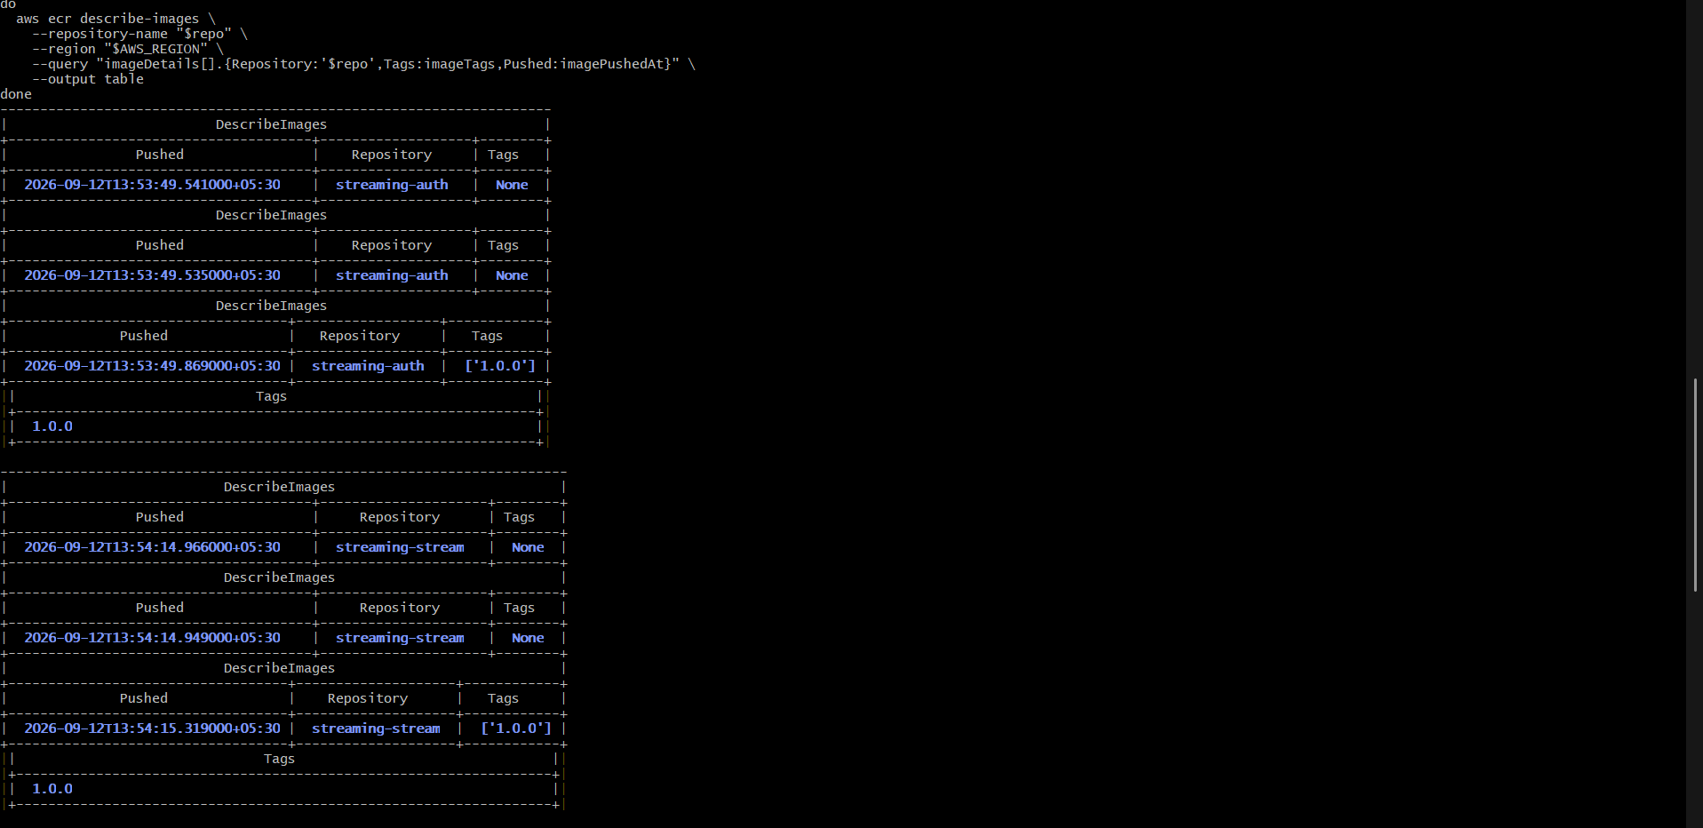
Figure 16 Amazon ECR and Helm Preparation evidence 7
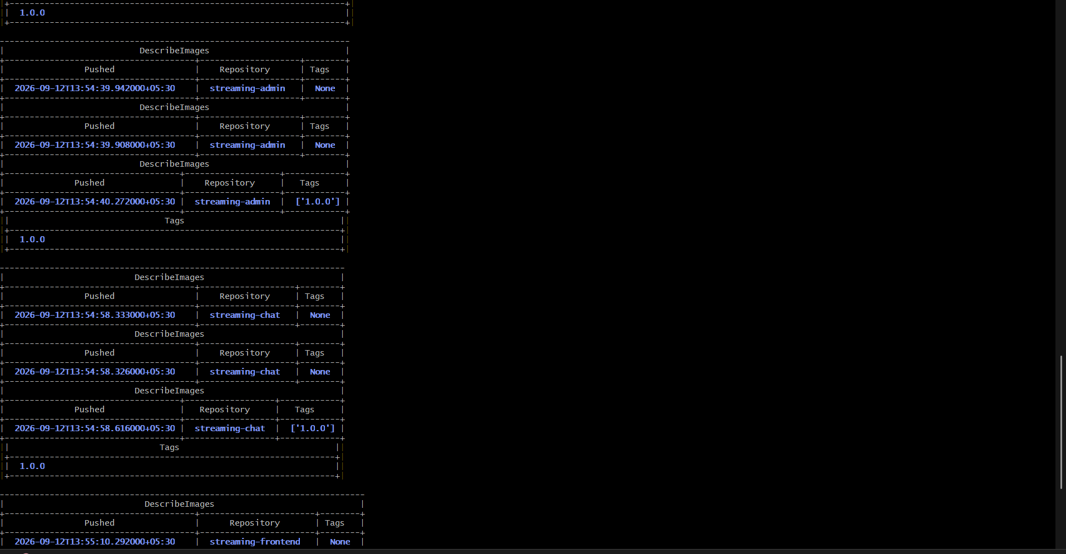
Figure 17 Amazon ECR and Helm Preparation evidence 8
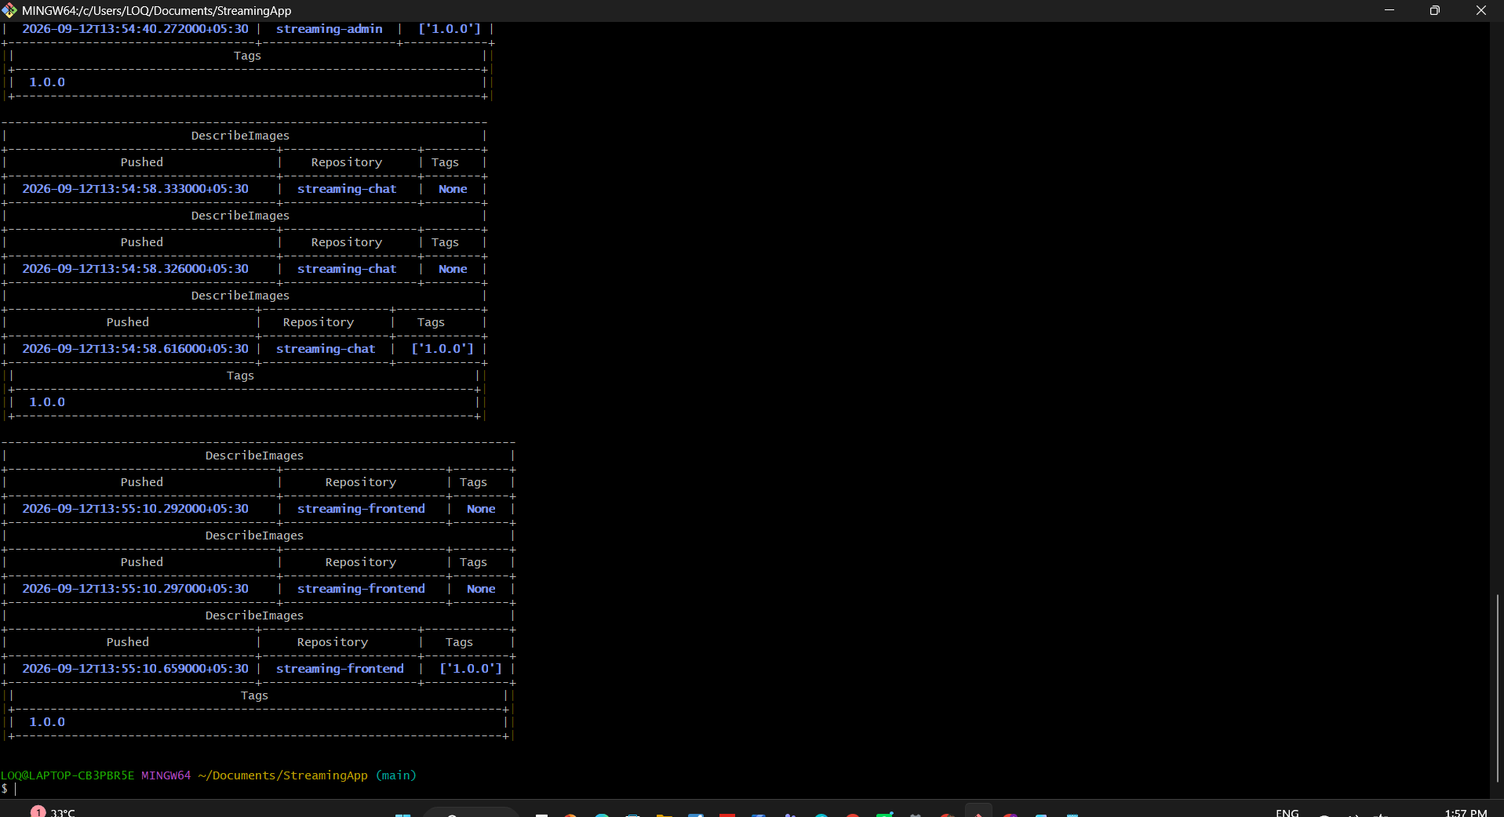
Figure 18 Amazon ECR and Helm Preparation evidence 9
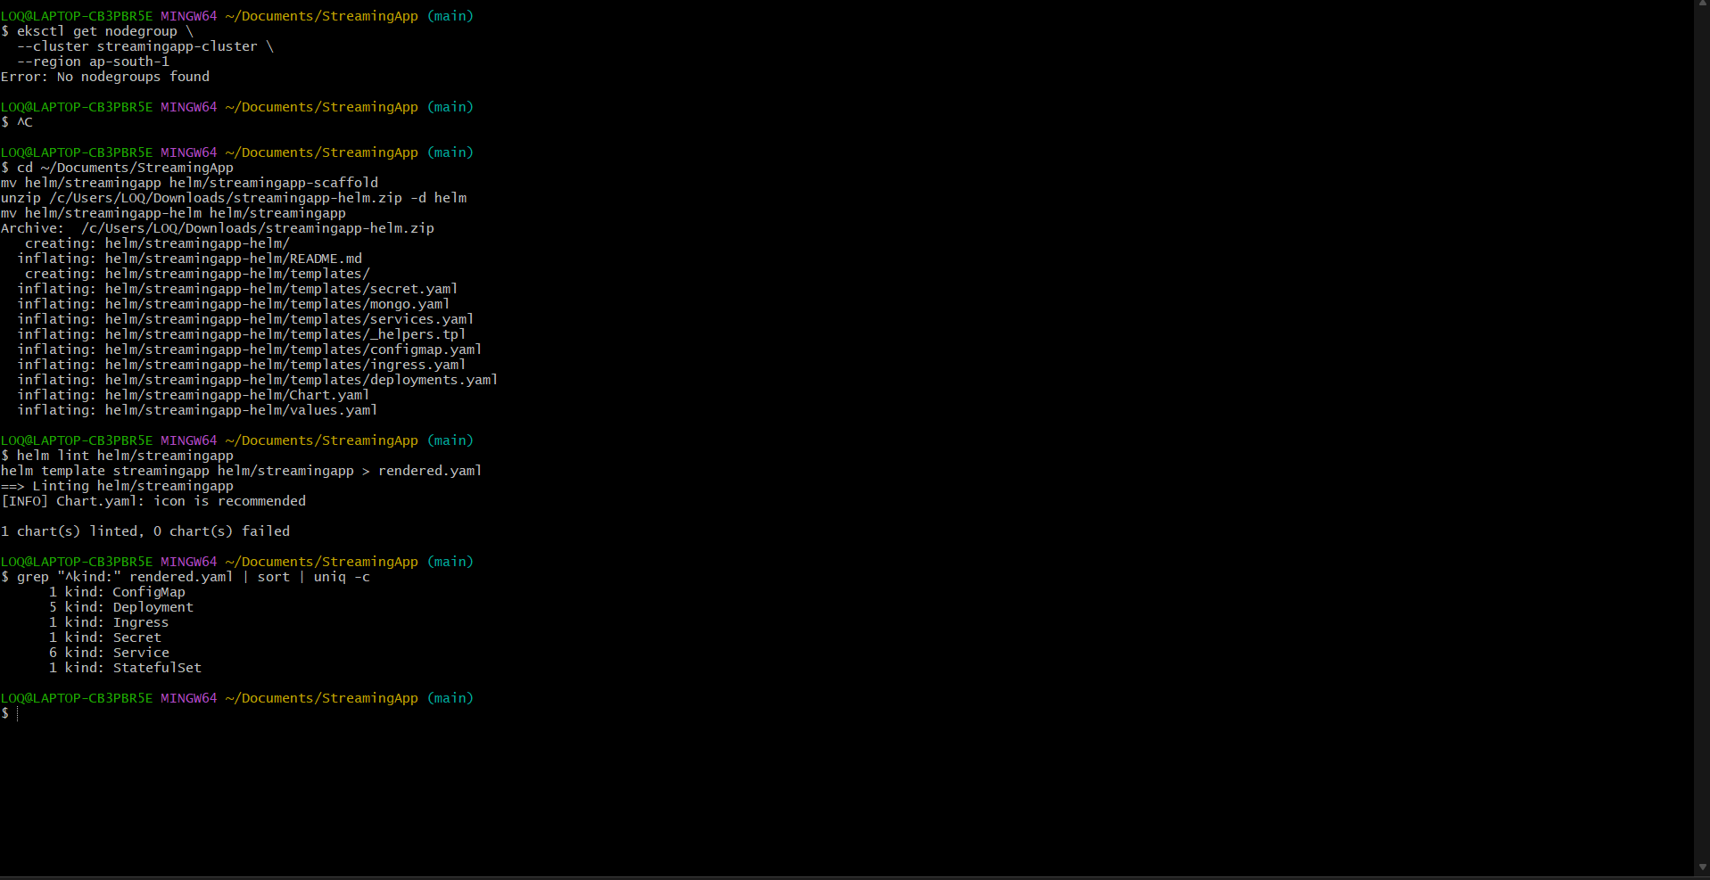
Figure 19 Amazon ECR and Helm Preparation evidence 10
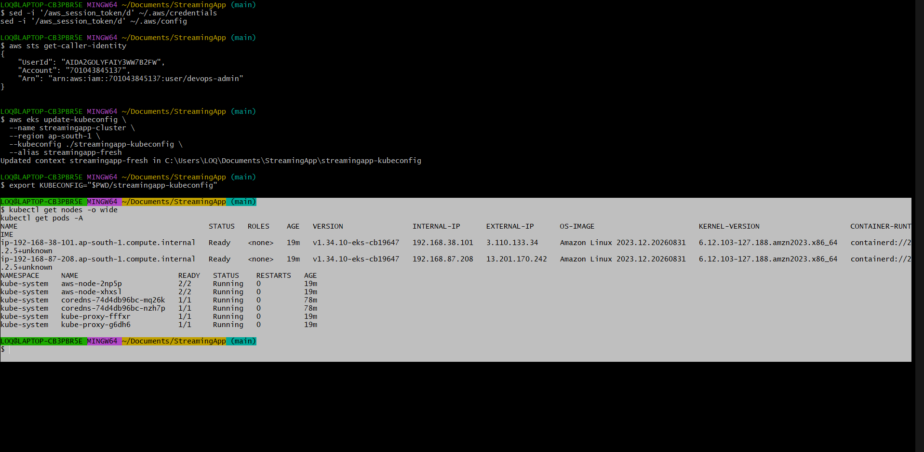
Figure 20 Amazon ECR and Helm Preparation evidence 11

EKS Deployment and Health Validation
The EKS cluster, managed nodes, EBS CSI storage and Helm release were validated. MongoDB received a 5 GiB persistent volume and all application workloads reached Ready state.
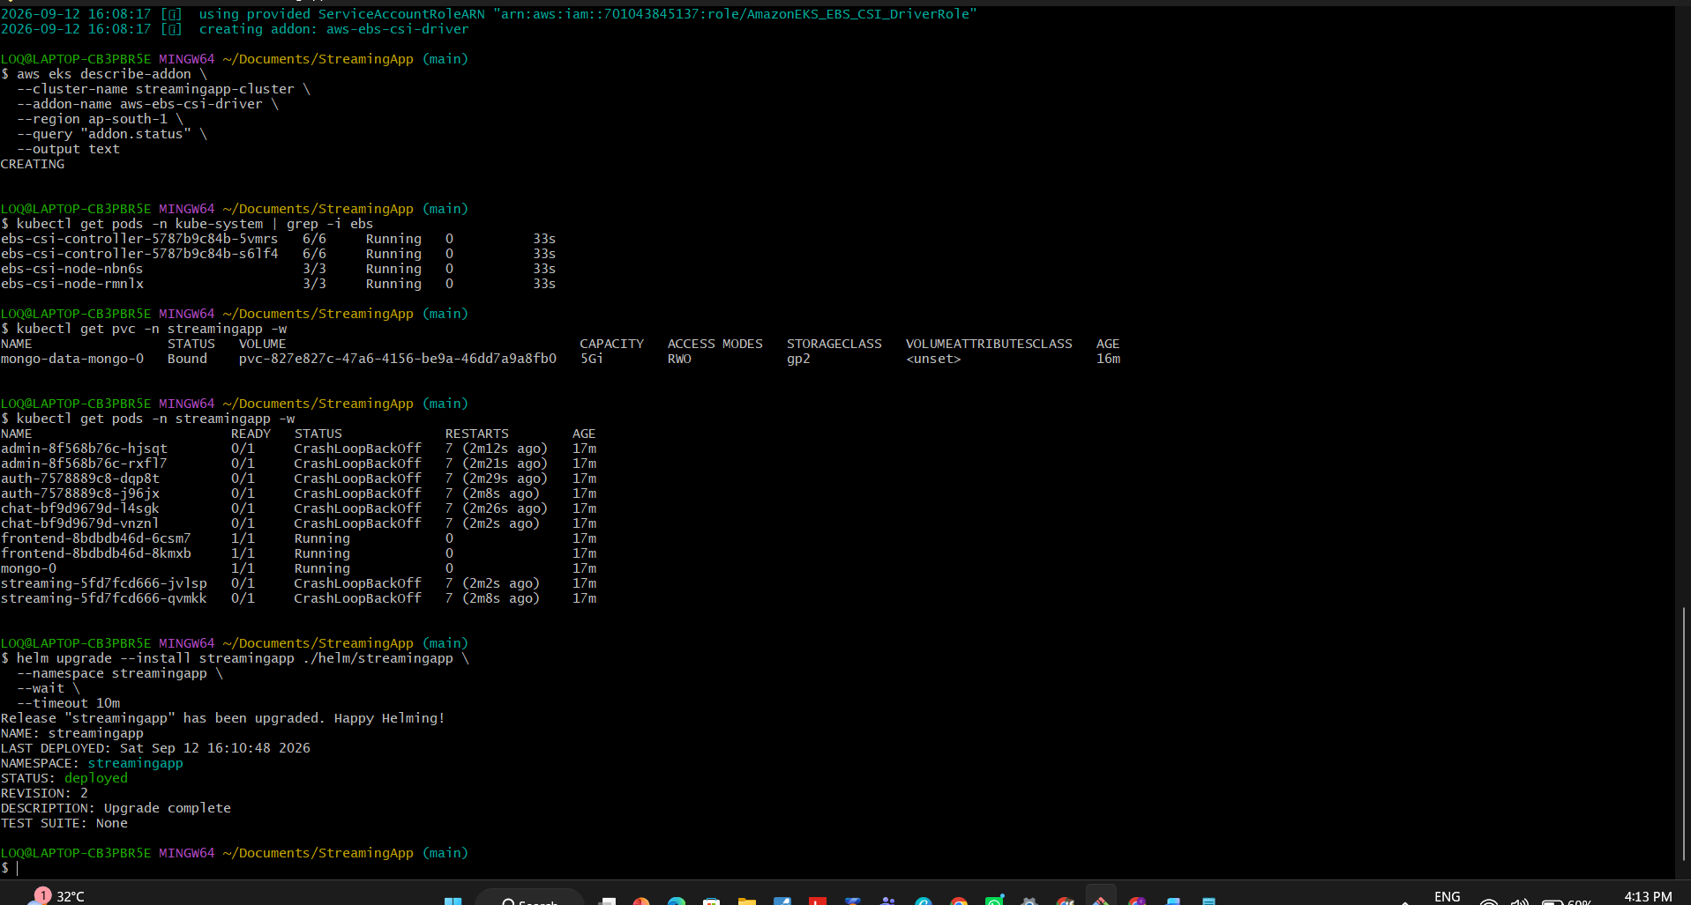
Figure 21 EKS Deployment and Health Validation evidence 1
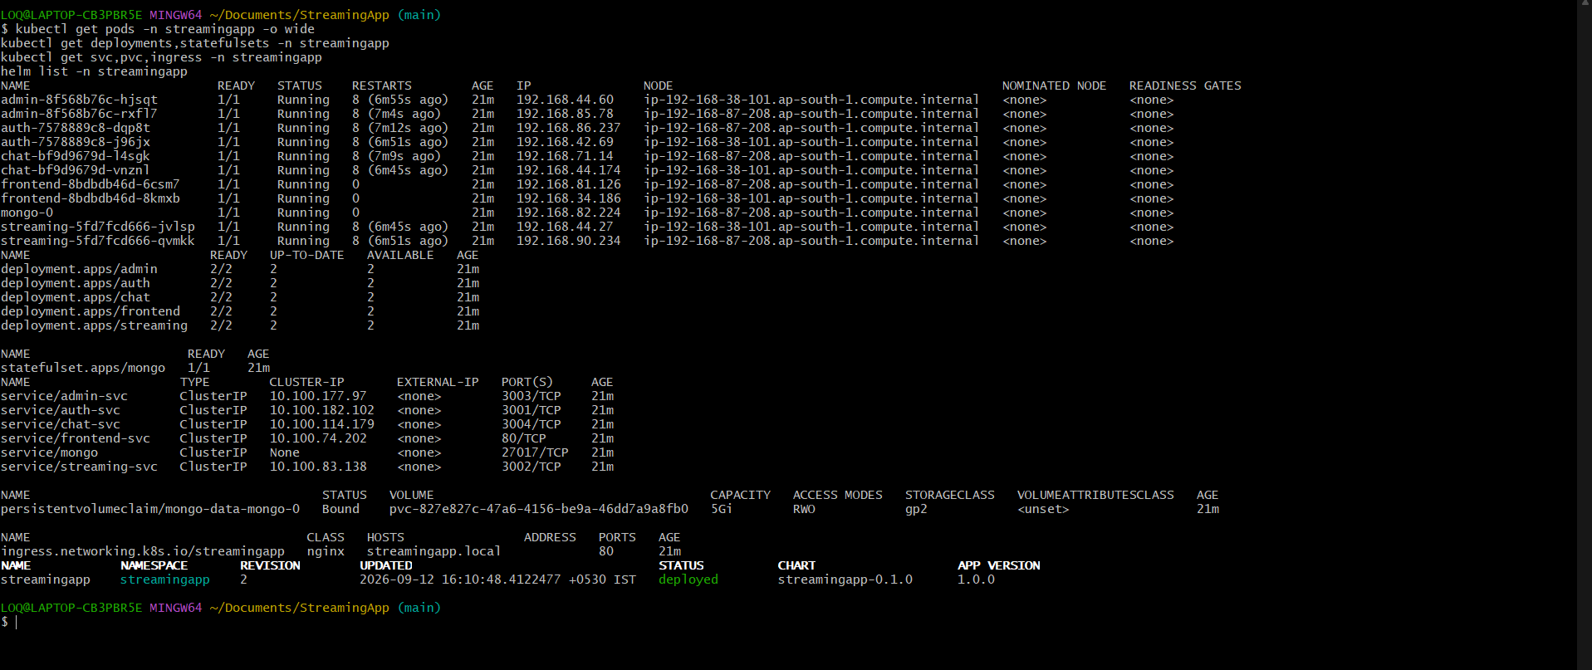
Figure 22 EKS Deployment and Health Validation evidence 2
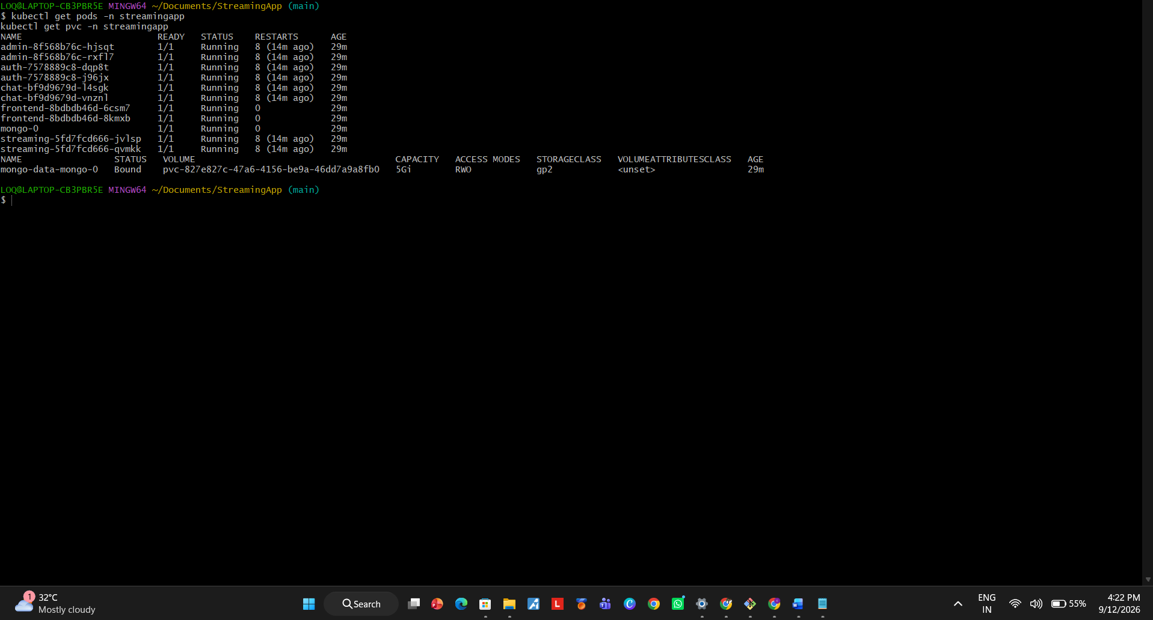
Figure 23 EKS Deployment and Health Validation evidence 3
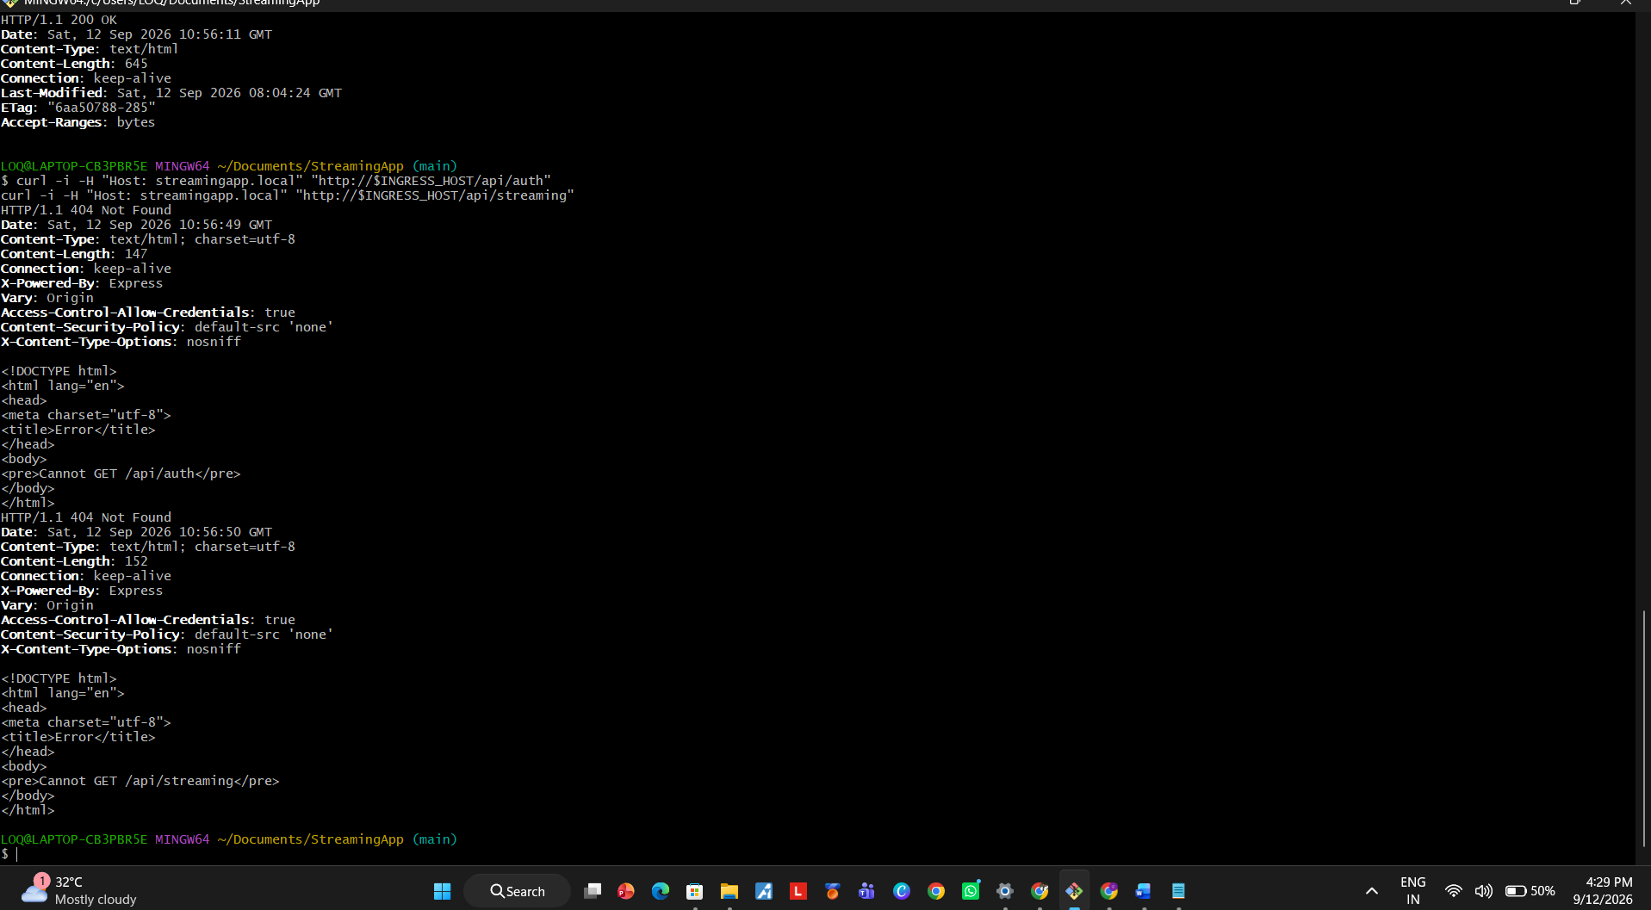
Figure 24 EKS Deployment and Health Validation evidence 4

Scaling and Safe Rolling Updates
The streaming deployment was scaled to four replicas. Auth was updated with maxUnavailable set to zero and maxSurge set to one, preserving service availability during rollout.
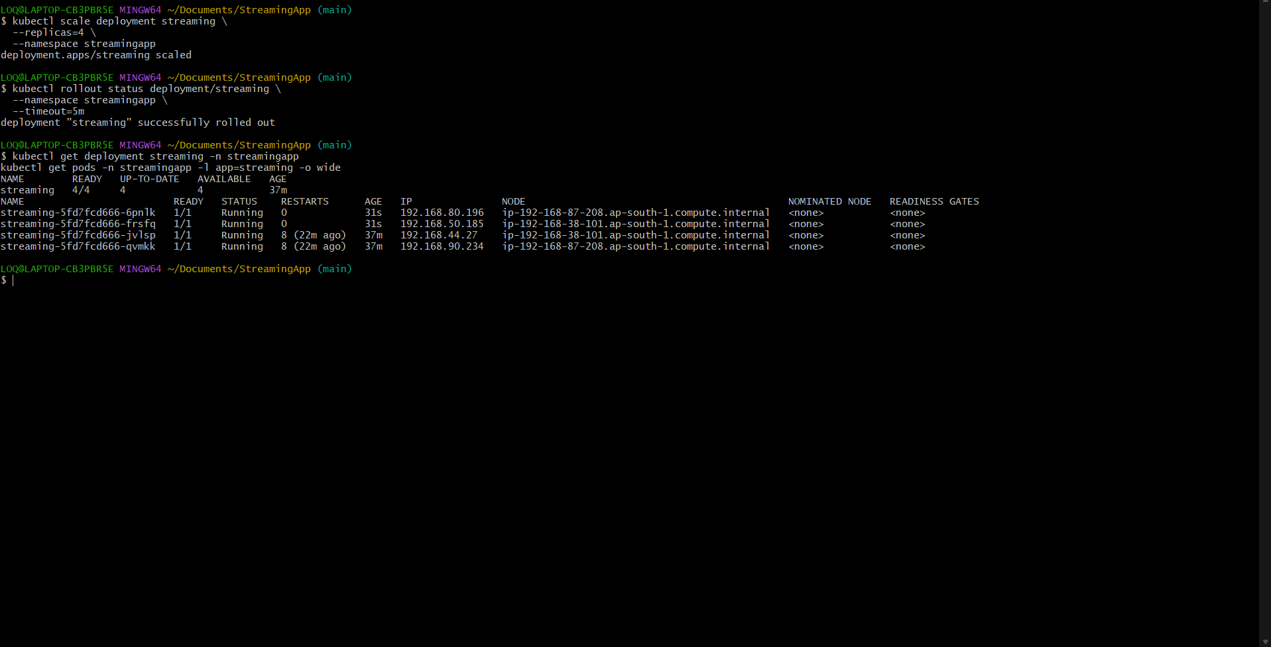
Figure 25 Streaming deployment scaled and auth rollout validated

Jenkins and CloudWatch Configuration
Jenkins was configured to build and push all five images using a restricted ECR credential. CloudWatch Observability, CloudWatch Agent and Fluent Bit provided cluster metrics and centralized logs.
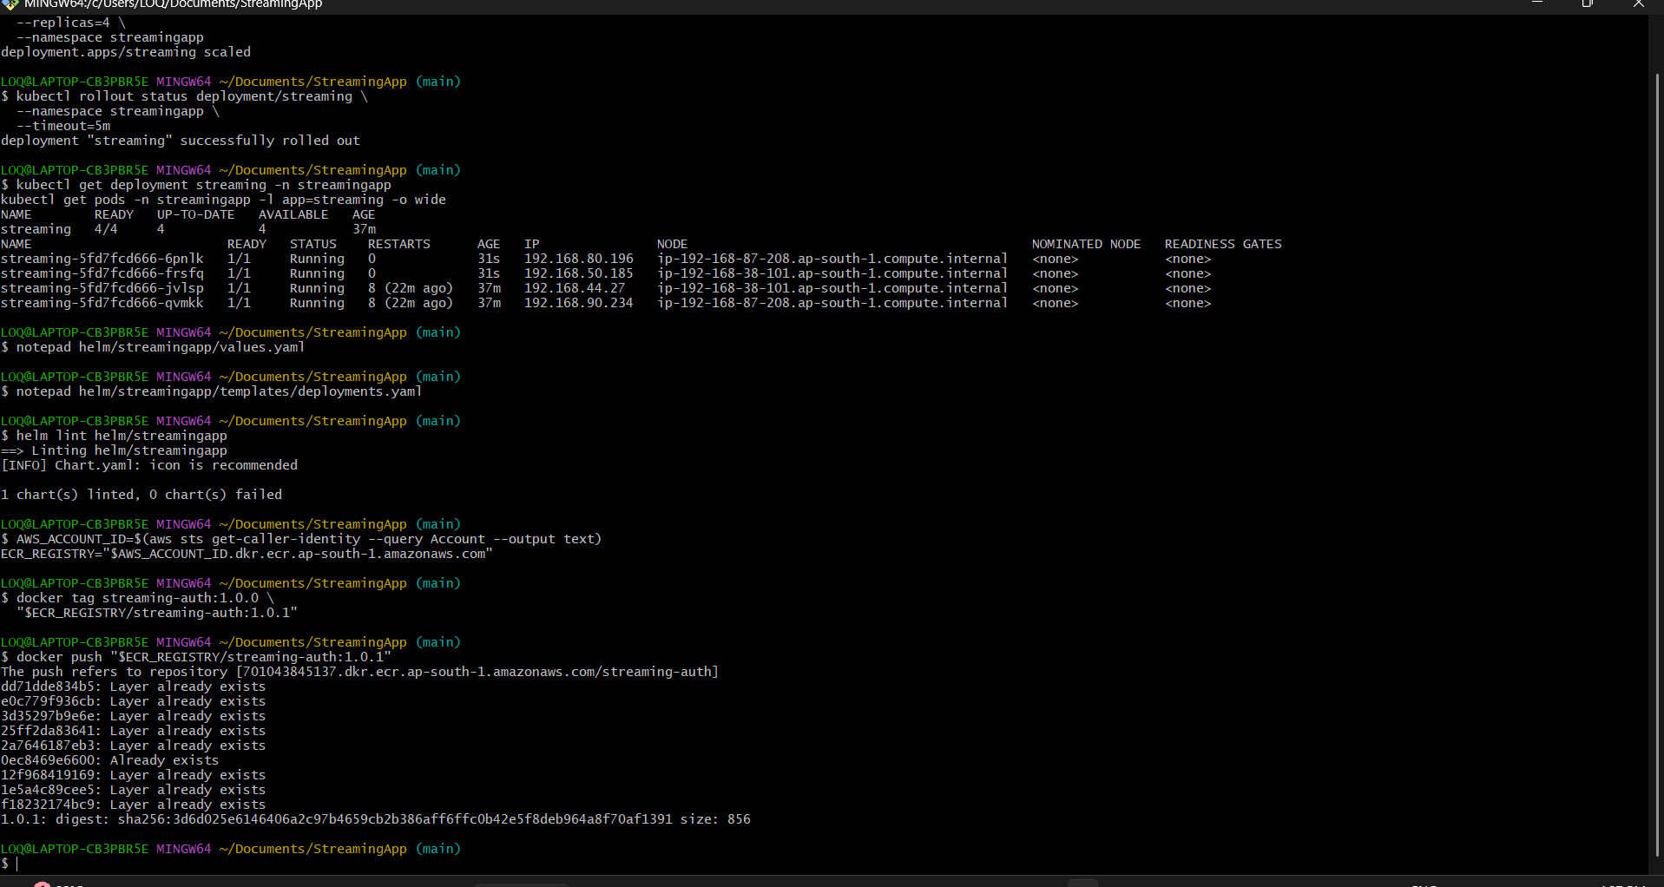
Figure 26 Jenkins and CloudWatch Configuration evidence 1
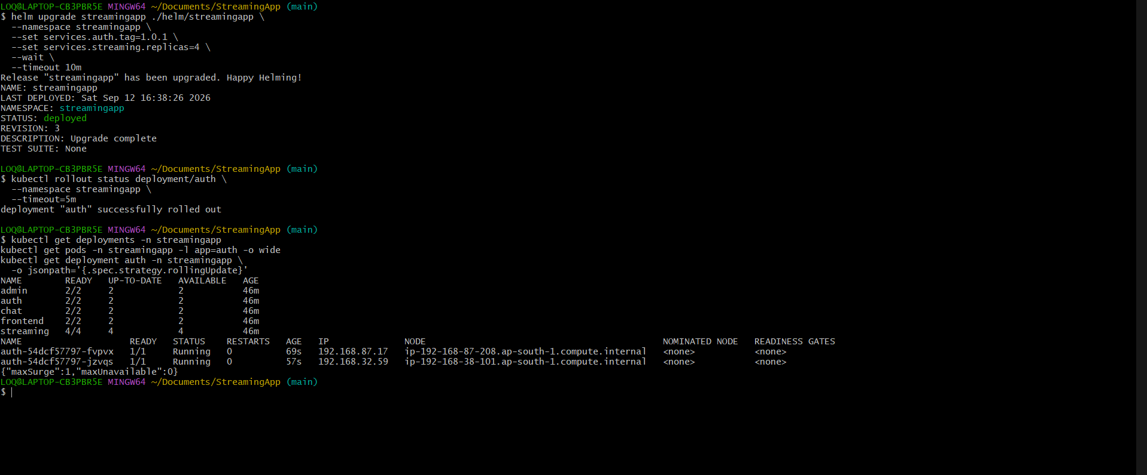
Figure 27 Jenkins and CloudWatch Configuration evidence 2
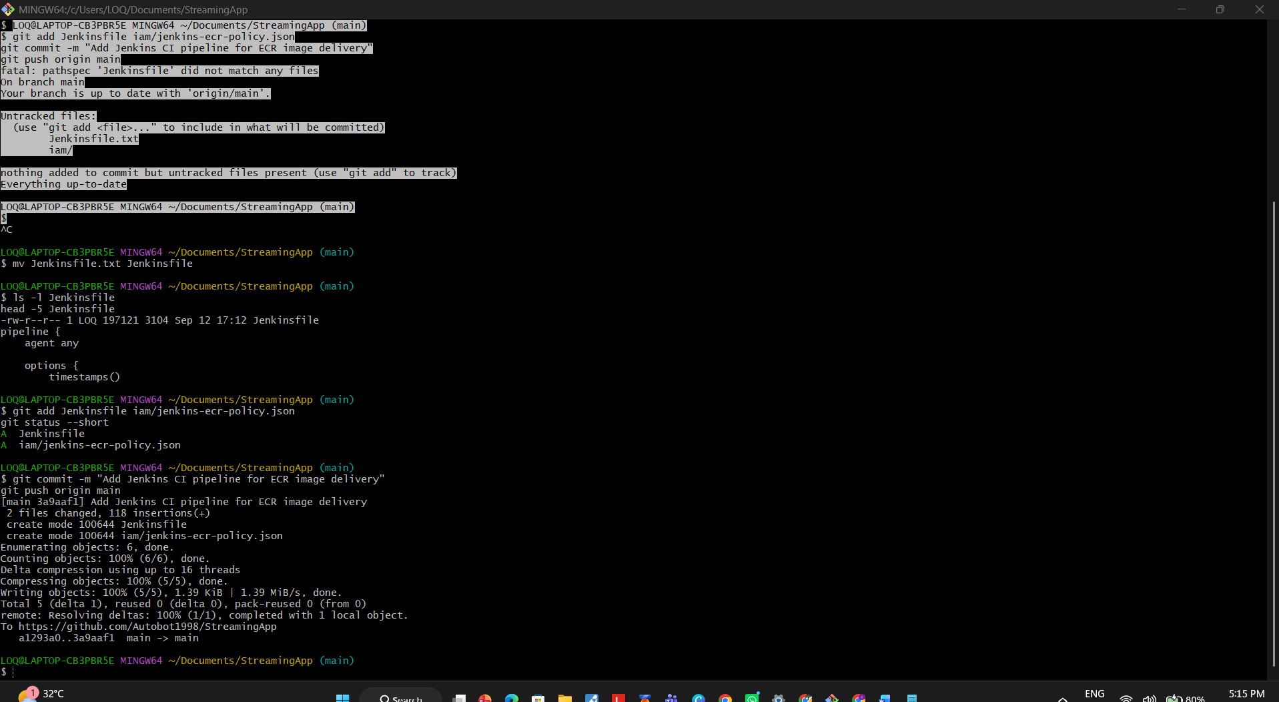
Figure 28 Jenkins and CloudWatch Configuration evidence 3
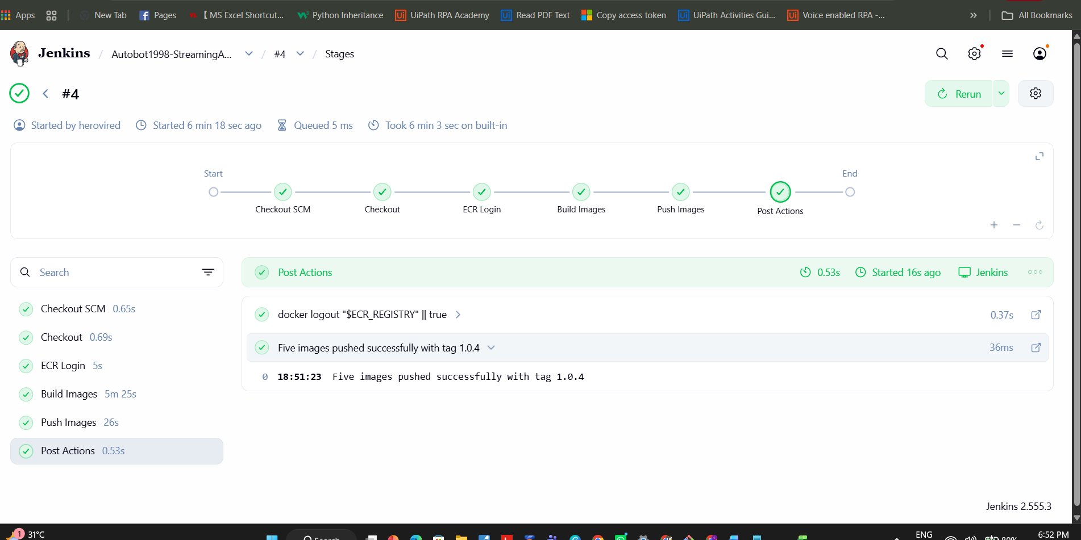
Figure 29 Jenkins and CloudWatch Configuration evidence 4
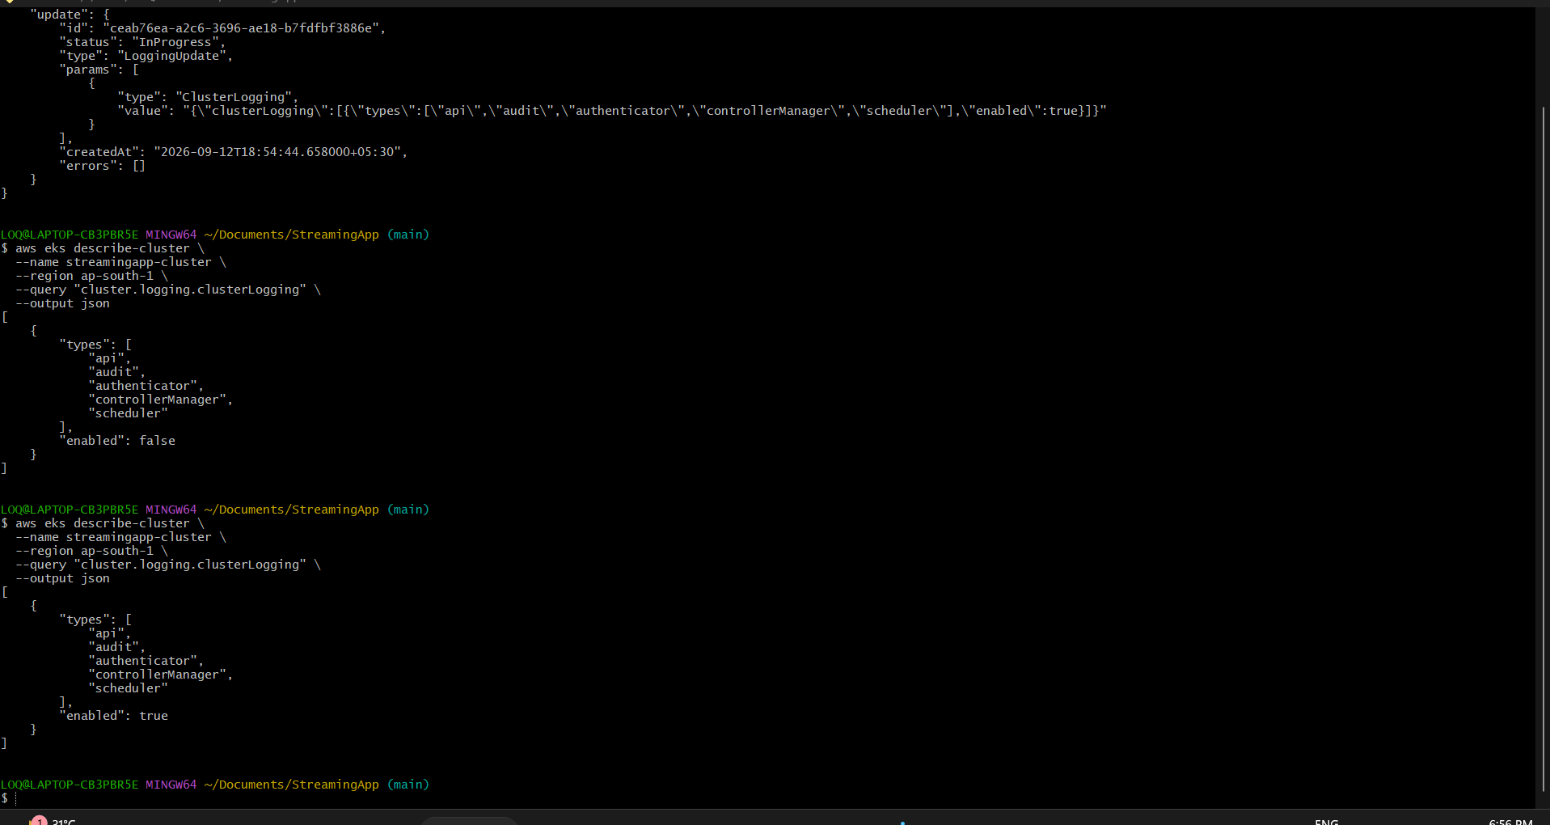
Figure 30 Jenkins and CloudWatch Configuration evidence 5
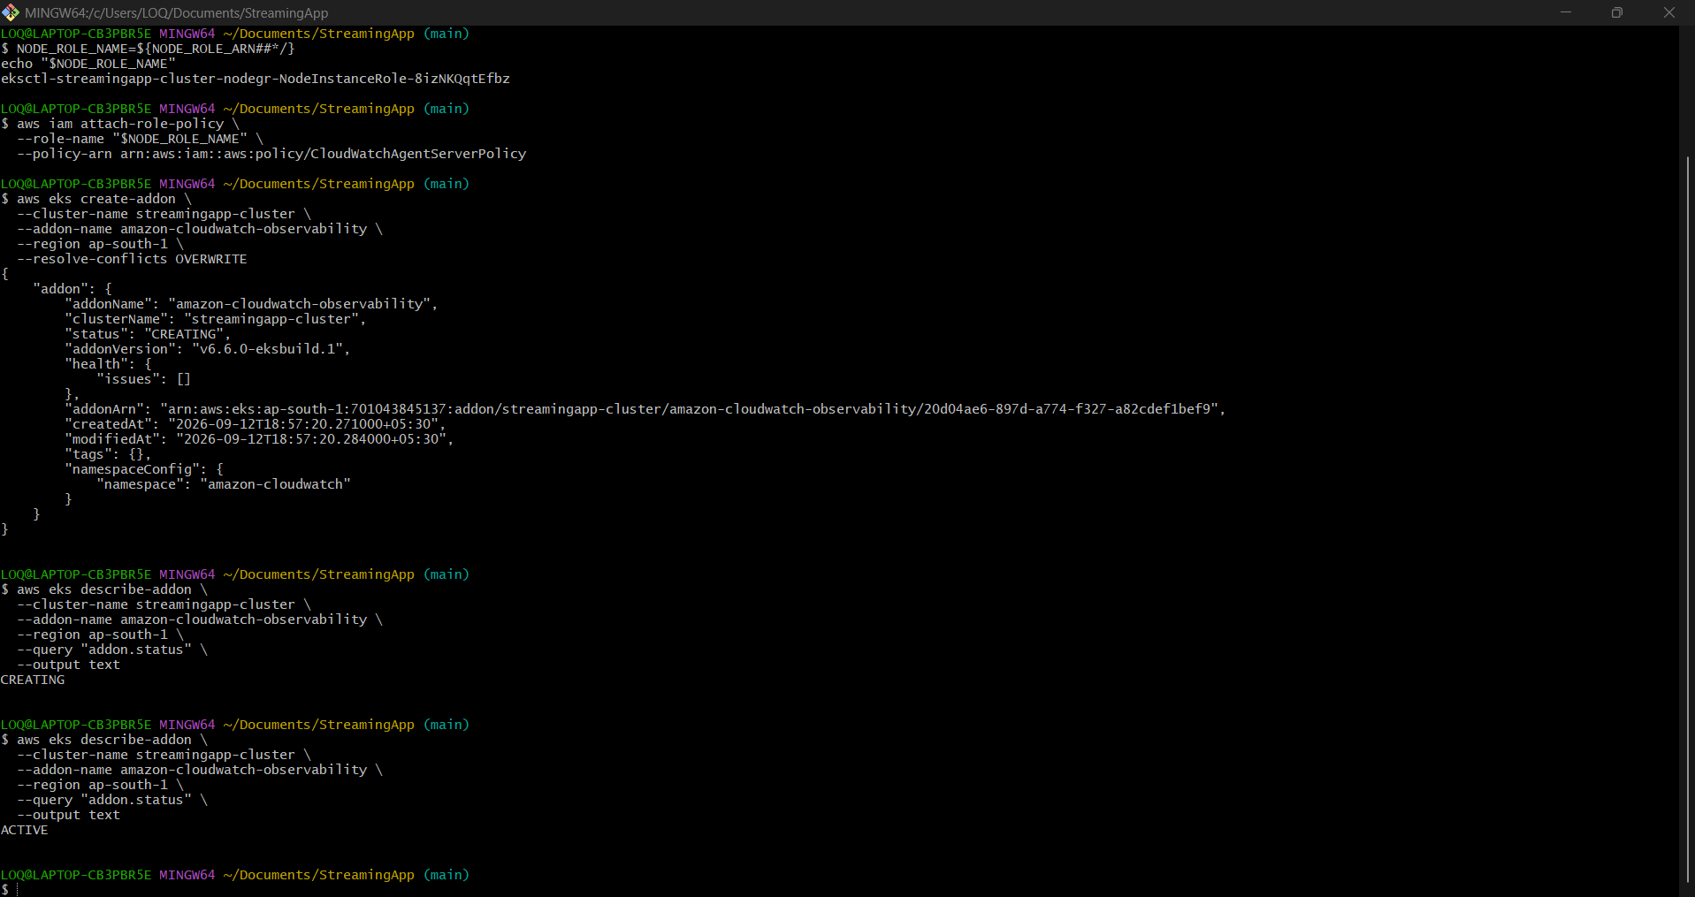
Figure 31 Jenkins and CloudWatch Configuration evidence 6

Final Platform Validation
Final checks confirmed working ECR artifacts, Kubernetes workloads, Helm resources, Ingress routing, scaling behavior and observability components.
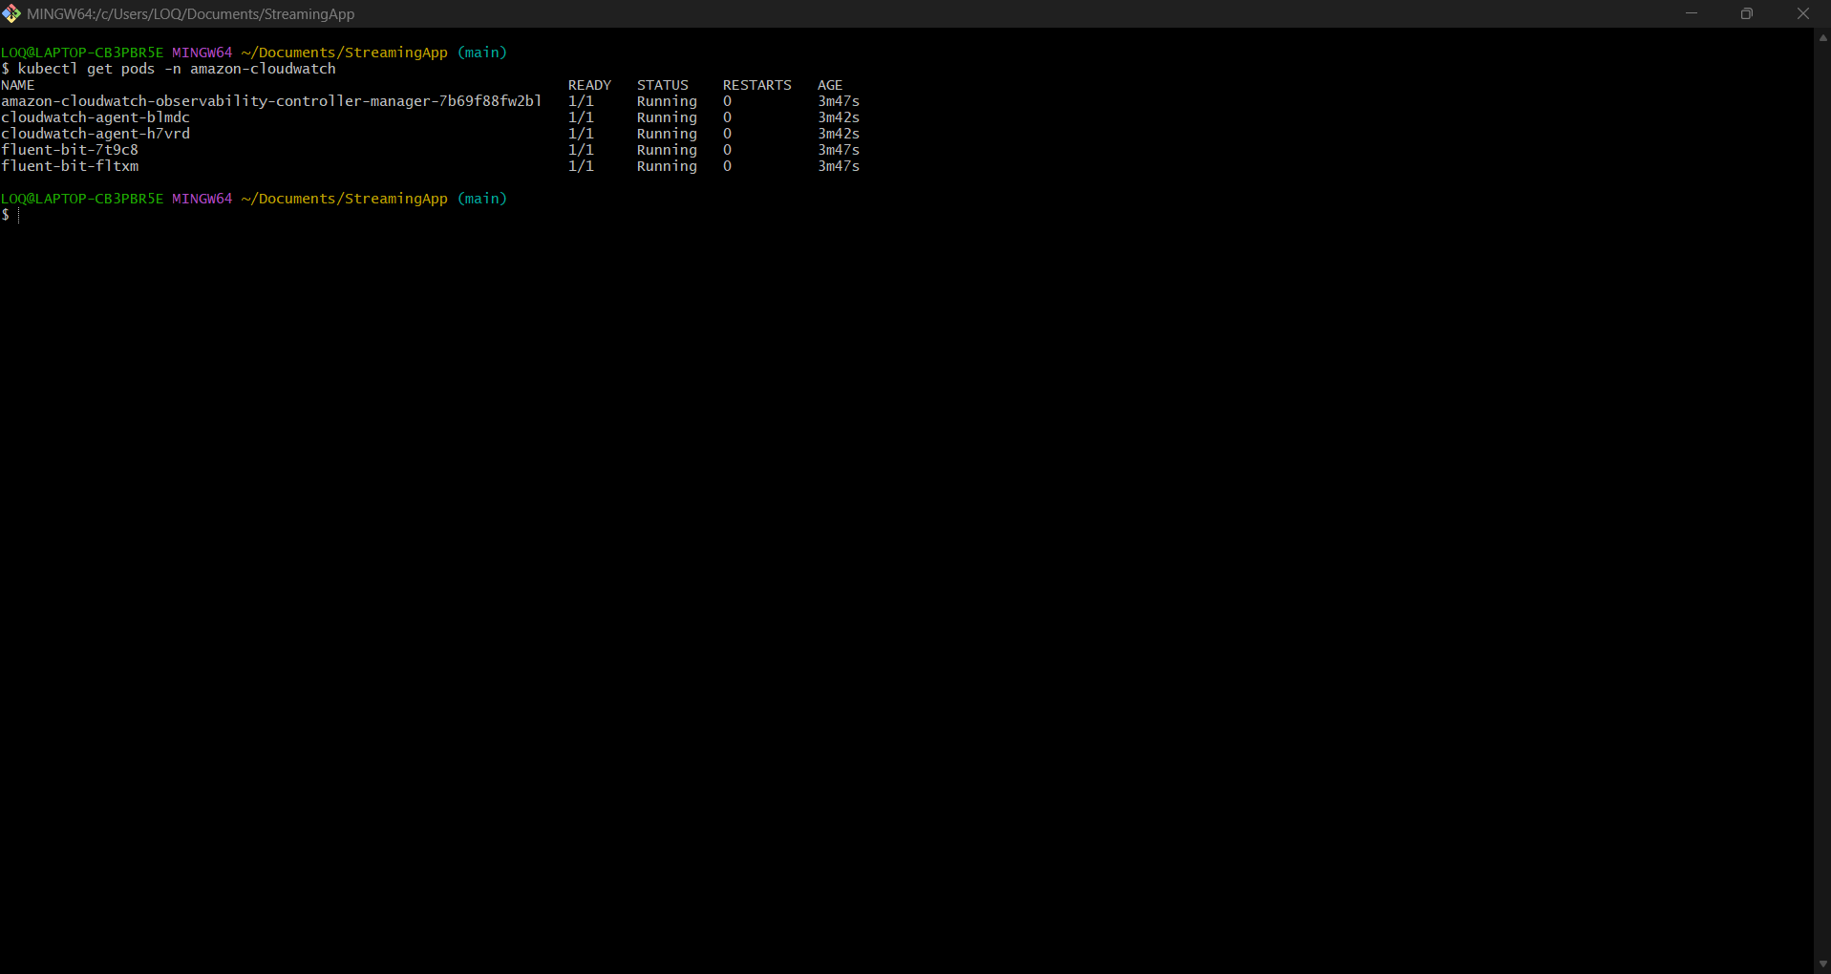
Figure 32 Final Platform Validation evidence 1
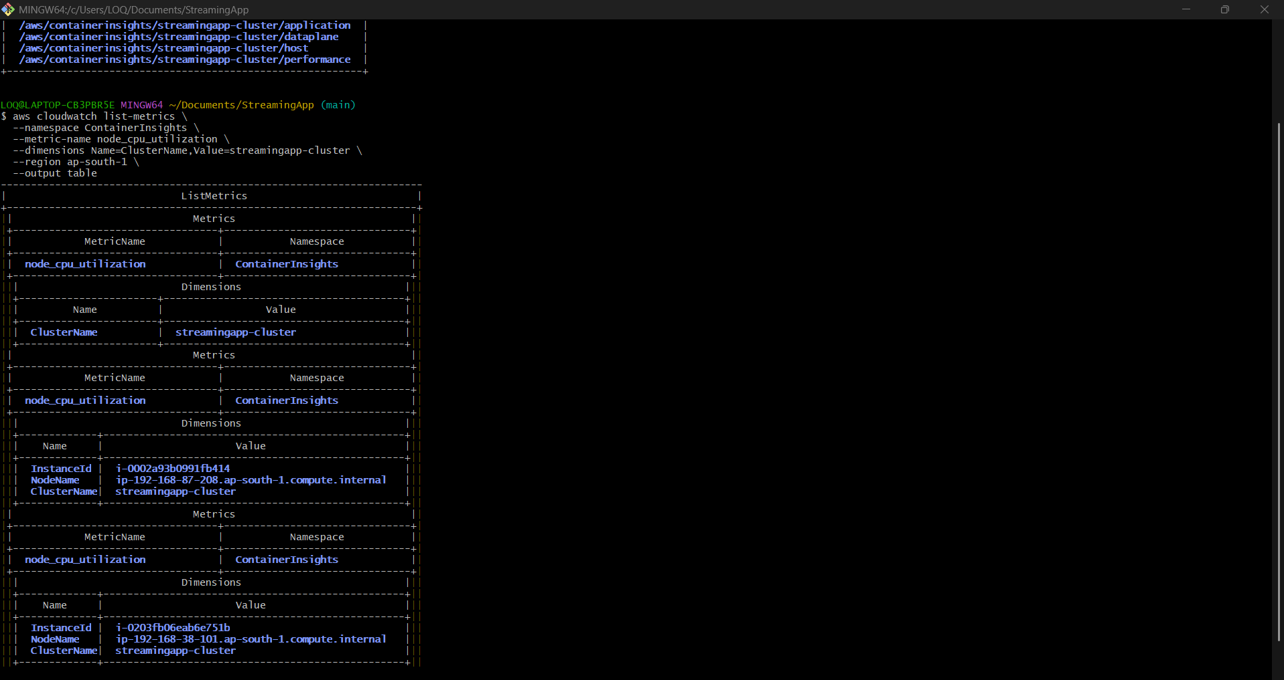
Figure 33 Final Platform Validation evidence 2
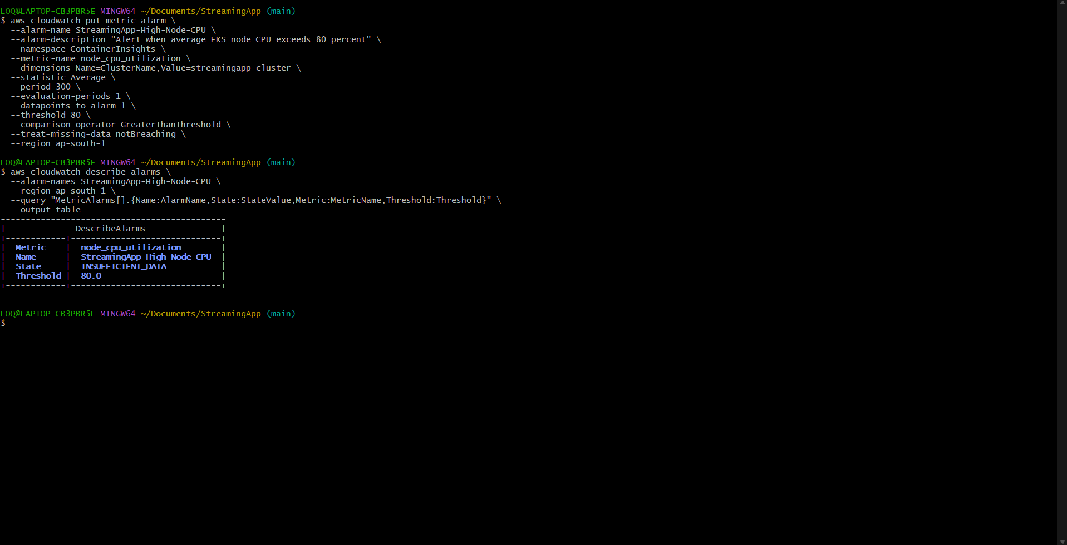
Figure 34 Final Platform Validation evidence 3

Automatic Source Control Trigger
A documentation commit was detected by Jenkins Poll SCM. The resulting build was started by an SCM change and pushed all five images with a new build tag.
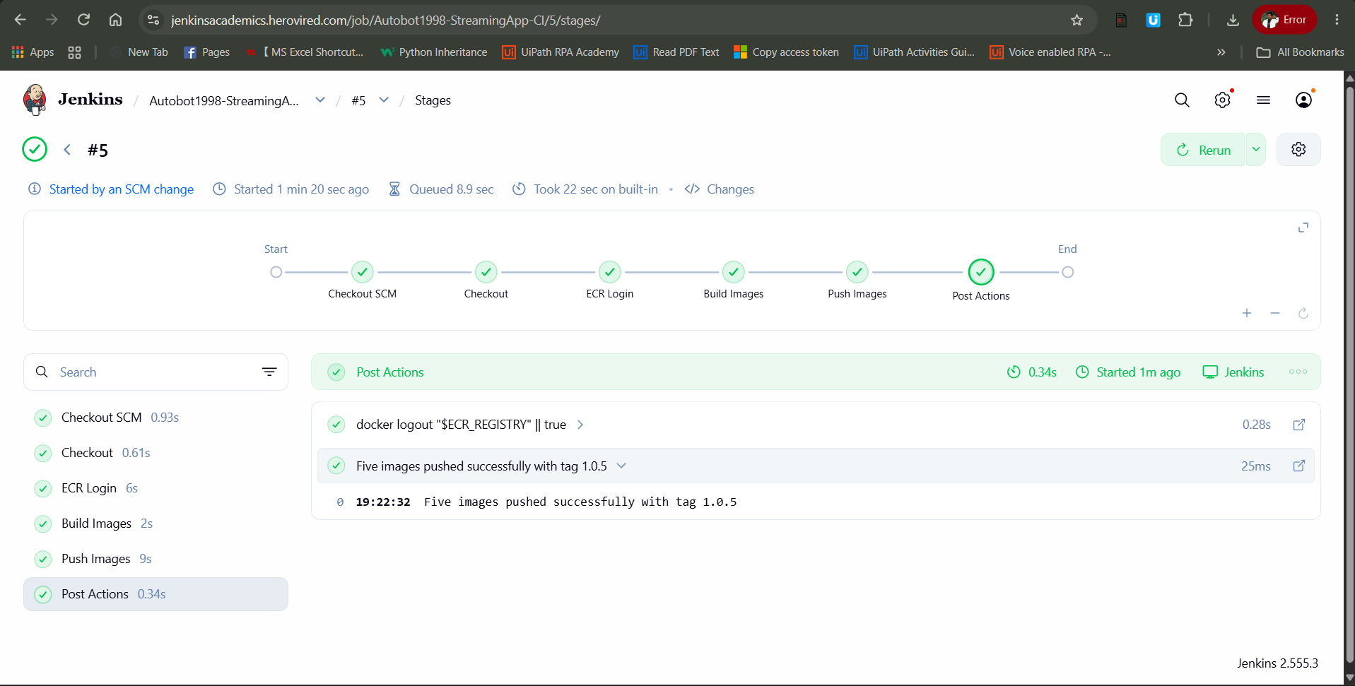
Figure 35 Successful Jenkins pipeline execution
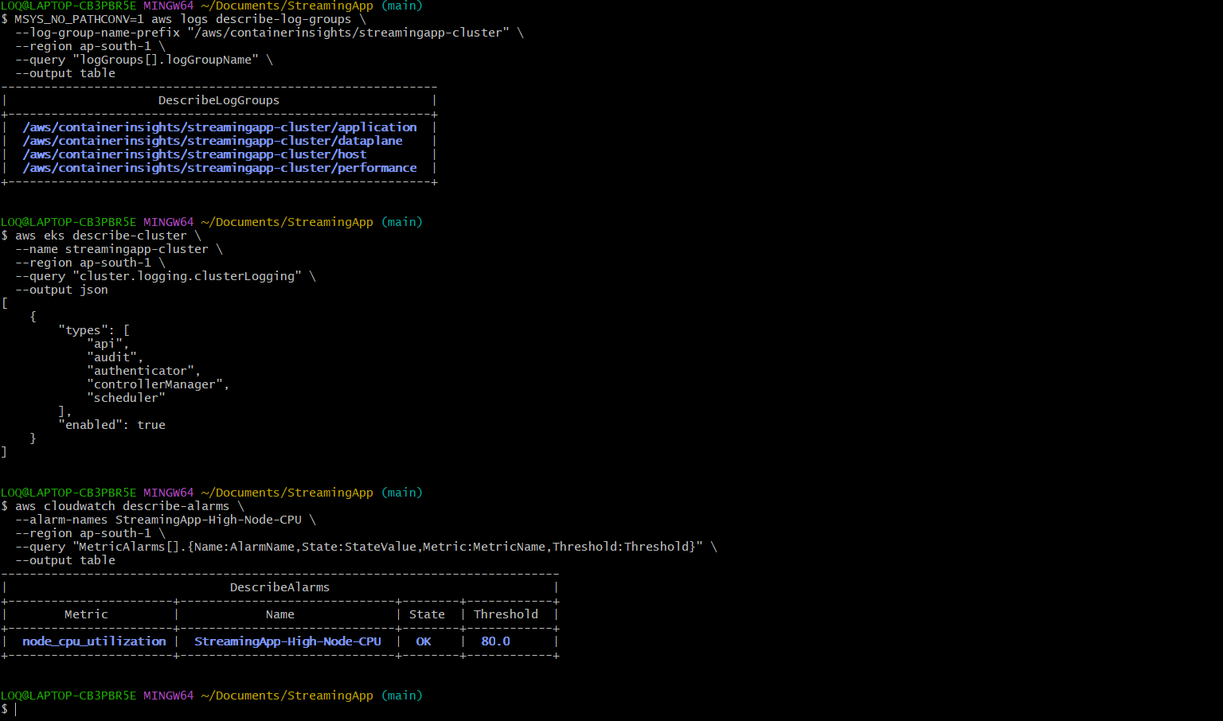
Figure 36 Automatic Jenkins build triggered by an SCM change

Final Validation Matrix
Requirement | Evidence | Status
Five Docker images | Local image list and successful build output | Complete
Dedicated ECR repositories | Repository list and versioned image pushes | Complete
Jenkins continuous integration | Checkout ECR login build and push stages passed | Complete
Automatic source trigger | Build started by an SCM change | Complete
Amazon EKS cluster | Two managed nodes in Ready state | Complete
Helm packaging | Lint passed and release deployed | Complete
Persistent database | MongoDB StatefulSet and 5 GiB Bound PVC | Complete
Ingress exposure | AWS Load Balancer and HTTP 200 frontend response | Complete
Scaling | Streaming deployment reached four replicas | Complete
Rolling update | Auth rollout succeeded with zero unavailable replicas | Complete
Monitoring and logging | CloudWatch addon Agent and Fluent Bit running | Complete
Alarm | High node CPU alarm configured at 80 percent | Complete

Repository Deliverables
- Dockerfiles for the frontend and four backend services
- Jenkinsfile for multi image ECR delivery
- Restricted Jenkins ECR IAM policy
- Reusable Helm chart under helm streamingapp
- Project documentation under docs
- This structured execution evidence report
https://github.com/Autobot1998/StreamingApp

Conclusion
The StreamingApp platform was successfully moved from source code to a production style container orchestration workflow. The solution demonstrates repeatable image delivery, managed Kubernetes deployment, persistent state, external routing, safe scaling, rolling updates, centralized observability and automated CI execution. The GitHub repository contains the implementation artifacts required to reproduce and review the deployment.

