AutoCAD IO + Viewer Web Sample

**Initial Setup:**

Ensure that the following custom activities have been created in AutoCAD IO:

1. PlotToPNG

This activity creates a PNG image for a drawing and can be created using the following script :

-------> PlotToPNG activity script

FILEDIA

0

-PLOT

Yes

Model

PublishToWeb PNG.pc3

VGA (640.00 x 480.00 Pixels)

Landscape

No

Extents

Fit

No

.

No

Result.png

No

Yes

-------> script ends here

1. CreateCloset

This activity creates a drawing with the closet and can be created using the following script :

------> CreateCloset activity script

(command "CreateCloset")

_.Zoom

Extents

_.VSCURRENT

sketchy

_.SaveAs

Result.dwg

-------> script ends here

The CreateCloset script uses a custom command named “CreateCloset”. This is part of the bundle available for download in the AutoCAD IO Devdays sample. Please refer to AutoCADIODemoReadMe for details on creating a custom AppPackage and linking it with a custom activity.

Open the AutoCADIOUtil library project in Visual Studio 2012

Add service reference to the following endpoint:

<https://developer.api.autodesk.com/autocad.io/v1>

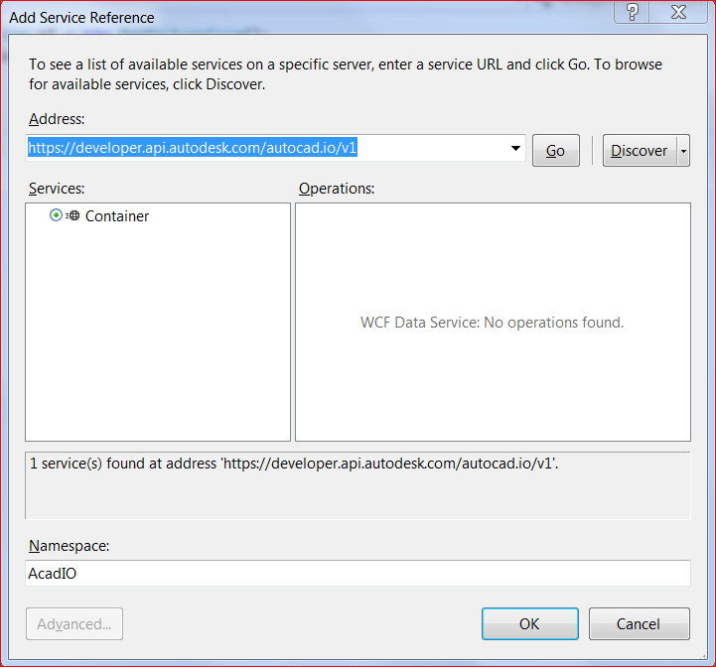

You can find an explanation of this and in the AutoCAD IO documentation:

<http://developer.api.autodesk.com/documentation/v1/acad_io/sampleapp.html#acad-io-sample>

Add the following NuGet packages to the project:

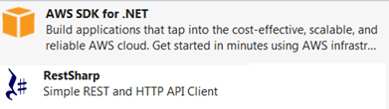

Build the library project.

Open the AutoCADIODemoWebApp sample project in Visual Studio 2012

Add reference to AutoCADIOUtil library

In the project settings, provide the following details:

* AutoCAD IO Client Id
* AutoCAD IO Client Secret
* Bucket name in your AWS S3 Storage

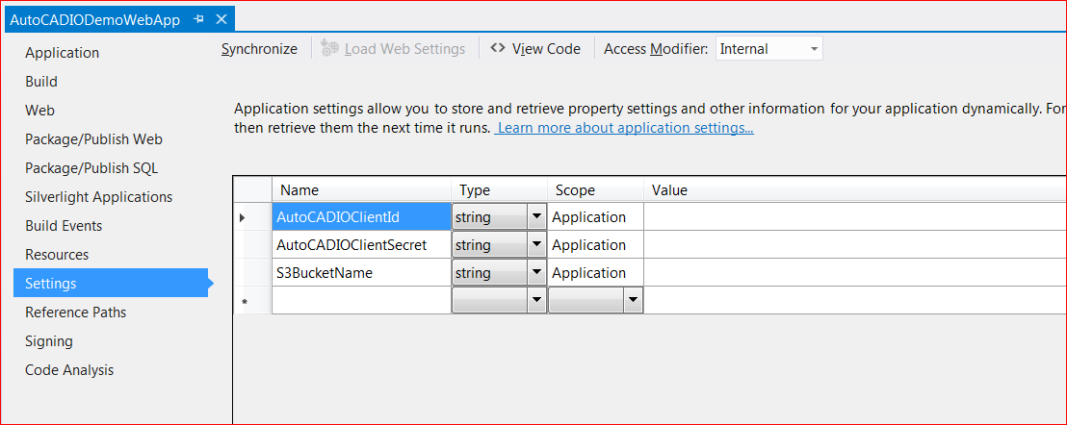

Open “Web.Config” file and provide AWS credentials. This will allow the sample project to access S3 storage in your AWS profile.

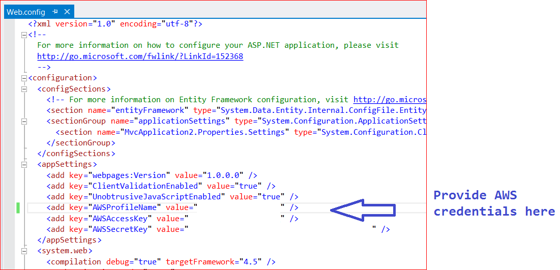

Open “UserSettings.cs” file and provide View & Data API credentials. This will allow the sample project to display the drawing using viewer.

Also provide your email credentials. This will allow the web app to send the drawing as an attachment in an email.

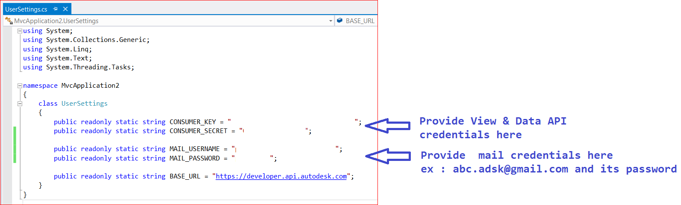

Build the sample project

Host the web app or run it locally. This will display the web page as shown in below screenshot :

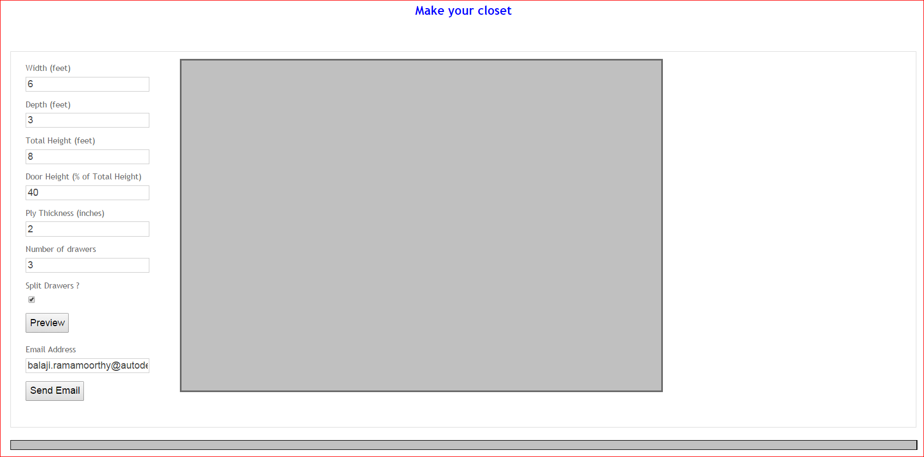

Change the closet parameters as needed.

Click on “Preview” button

This generate a drawing with the closet model using AutoCAD IO and this drawing is loaded in the viewer as shown in below screenshot.

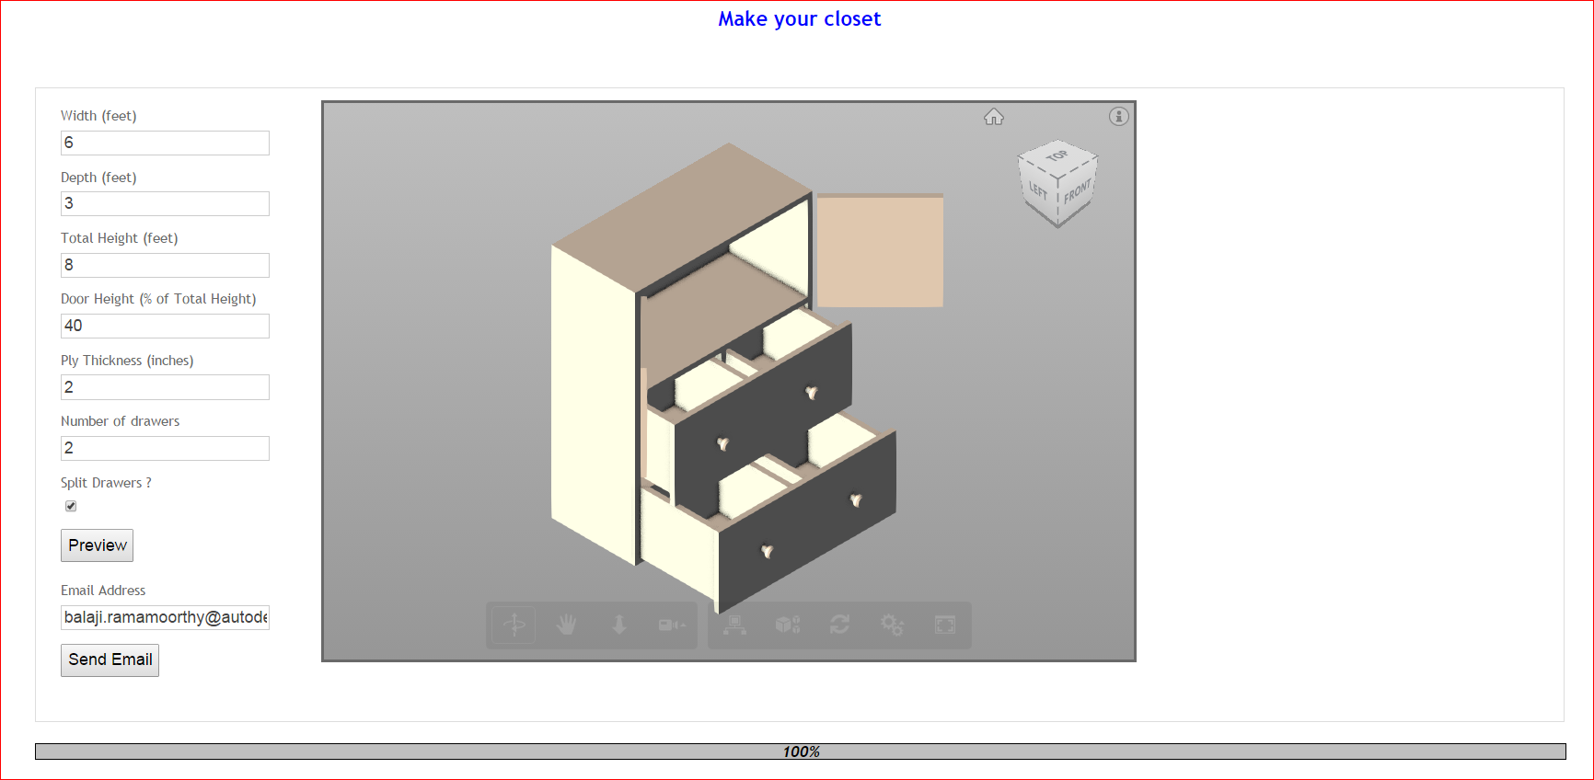

Click on “Send Email” button

This generate a drawing with the closet model using AutoCAD IO and this drawing is emailed as an attachment to the email id provided. A screenshot of the email that is sent is shown below.

