PlotToPDF windows service sample

**Initial Setup:**

Open the AutoCADIOUtil library project in Visual Studio 2012

Add service reference to the following endpoint:

<https://developer.api.autodesk.com/autocad.io/v1>

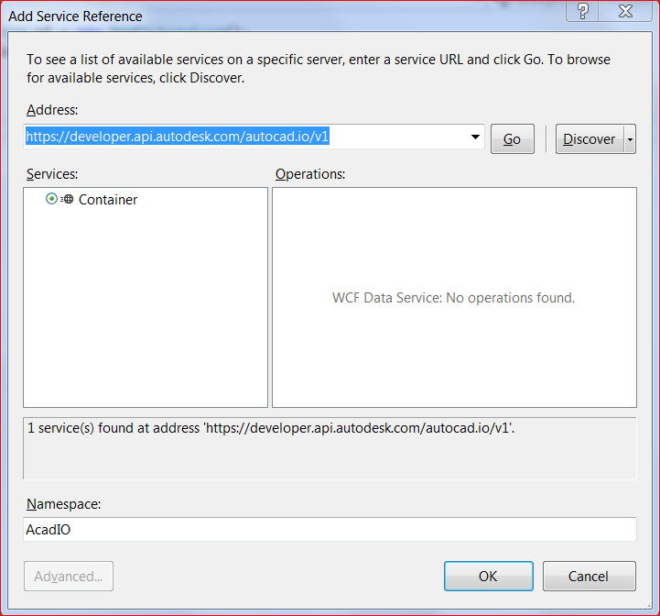

You can find an explanation of this and in the AutoCAD IO documentation:

<http://developer.api.autodesk.com/documentation/v1/acad_io/sampleapp.html#acad-io-sample>

Add the following NuGet packages to the project:

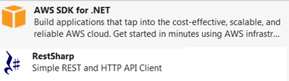

Build the library project.

Open the PlotToPDF windows service sample project in Visual Studio 2012

Add reference to AutoCADIOUtil library

In the project settings, provide the following details:

* Path to a local folder in your system that contains AutoCAD drawings.
* AutoCAD IO Client Id
* AutoCAD IO Client Secret
* Bucket name in your AWS S3 Storage

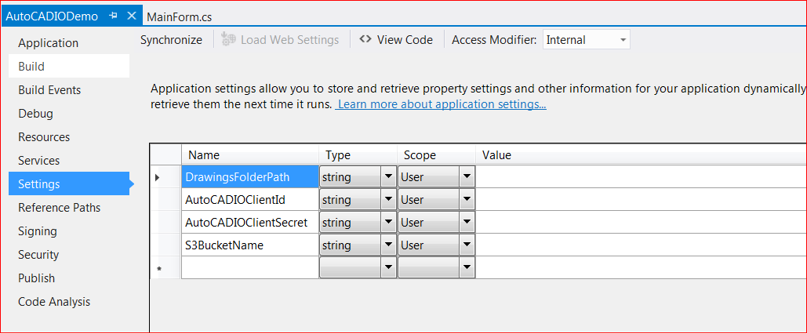

Open “App.Config” file and provide AWS credentials. This will allow the sample project to access S3 storage in your AWS profile.

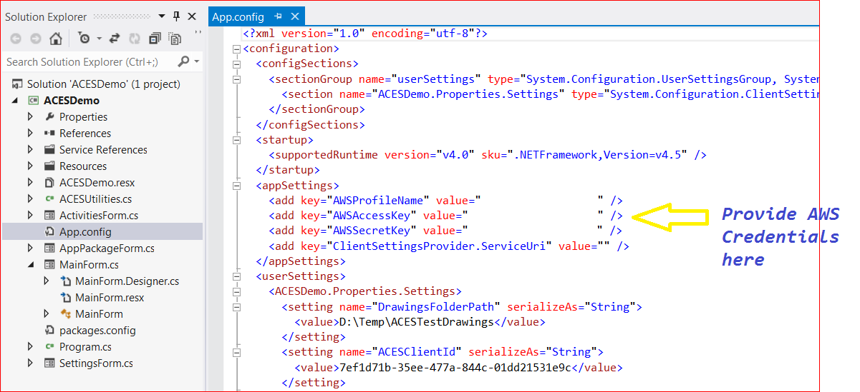

Build the sample project

Install the windows service using “installutil”. To do this open Visual studio command prompt and run : installutil <path to PlotToPDF.exe”

Start the windows service. To do this from the Run windows, type services.msc and look for Plot2PDFService and start it.

Copy any drawing to the watched folder (C:\Temp by default). After some time, a PDF of the same name should be available in the watched folder.