#Types of Join

#1. Cross Join

#2. Natural Join

#3. Inner Join

#4. Outer Join

#5. Left Outer Join

#6. Right Outer Join

#7. self join

#1. cross join

#Q1. Find all customers who have a loan from bank. Find their names,loan_no and loan amount.

#borrower X loan - Cartcian Product m*n rows

select * from borrower b, loan l;

select * from borrower b cross join loan l;

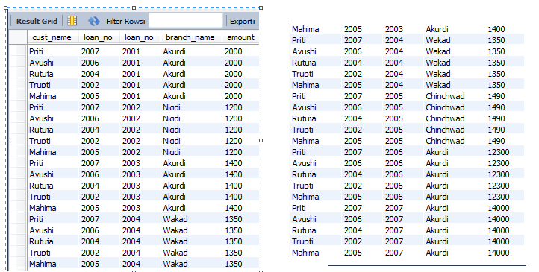

#2.Natural Join

#Q1. Find all customers who have a loan from bank. Find their names,loan_no and loan amount.

select * from borrower b, loan l where b.loan_no = l.loan_no;

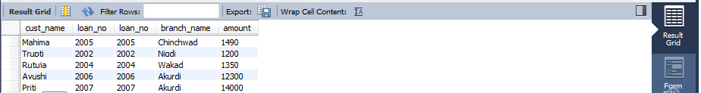

select b.cust_name, l.loan_no, l.amount from borrower b, loan l where b.loan_no = l.loan_no;

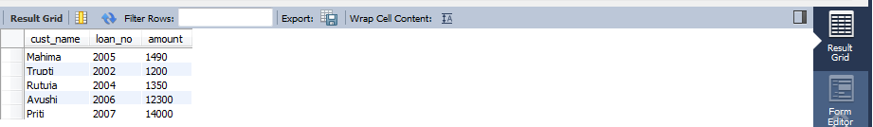

#3. Inner Join

#Q1. Find all customers who have a loan from bank. Find their names, loan_no and loan amount.

select b.cust_name,b.loan_no,l.amount from borrower b inner join loan l on b.loan_no=l.loan_no;

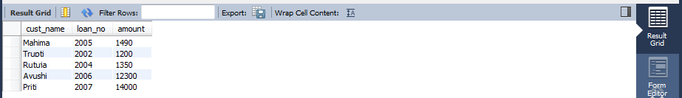

#4. Right Outer Join

select b.cust_name,l.loan_no,l.amount from borrower b right join loan l on b.loan_no=l.loan_no;

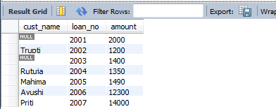

select * from borrower b right join loan l on b.loan_no=l.loan_no;

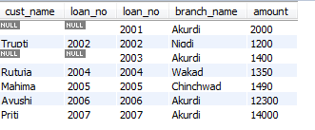

#5. Left Outer Join

select b.cust_name,l.loan_no,l.amount from borrower b left join loan l on b.loan_no=l.loan_no;

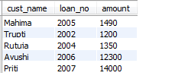

#6.Full Outer Join

select * from borrower b left join loan l on b.loan_no=l.loan_no;

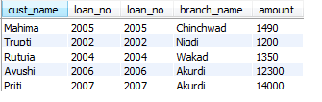

select * from borrower b right join loan l on b.loan_no=l.loan_no;

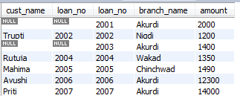

select * from borrower b left join loan l on b.loan_no=l.loan_no union select * from borrower b right join loan l on b.loan_no=l.loan_no;

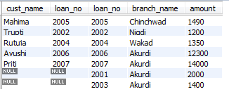

#7.self join

#Q1. Find all customers who have a loan from bank. Find their names, loan_no and loan amount.

select b.cust_name,b.loan_no,l.amount from borrower b inner join loan l on b.loan_no=l.loan_no;

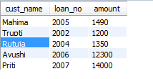

#Subquery

#Q1. Find all loans who have a loan from bank.

select * from loan where loan_no in(select loan_no from borrower);

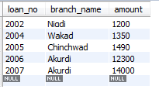

select * from loan where amount < (select max(amount) from loan);

