EasySVNdiff Design Document

Document History and Information
Revision History
Date of this revision:30-Oct-13 | (Planned) date of next revision: 5-Nov-13

Revision Number | Revision date | Summary of changes | Changes made by
1.0 | 21-Oct-13 | Initial draft | Ramesh
2.0 | 30-Oct-13 | Revised with addition information | Jayganesh S
Approvals
This document requires the following approvals. Records of the appropriate approvals are filed in the Quality section of the project control documentation.
Name | Title
Jayganesh Sambath | PL
Rameshbhaabu Subramanian | ASA
Distribution list
This document has been distributed to:
Name | Title
Review
In the review and/or authorization process this document has to be routed as follows:
Name | Title
Sreeraj Vinod | Project Manager
Abstract
This document can be summarized as follows:
The document explains the detailed design specifications of EasySVNdiff tool.

Introduction

Purpose
The purpose of this document is to record in detail the technical aspects of the solution provided to manually doing the verification of Backup restoration process of an SVN Repository.
-The manual work of doing the verification process is automated to save time and efforts.
- The automated solution assures 100% quality of verification.

Intended Audience
This Tool is intended for the following group of people and their SCM tool is SVN
- Currently Configuration Librarians (CLs)
- Anyone who wants to verify one’s Project repository's backup version

Definitions, Acronyms and Abbreviations
Acronym | Definition/Expansion
SVN | Subversion (SVN) is a software versioning and revision control system distributed under an open source license.
Backup data | Copying and archiving the server data.
Restoration | Process of replacing the original data.
VisualSVN Server | VisualSVN Server is a free Apache Subversion server package for Windows.
Repository | A repository serves as the core storage mechanism for Subversion's versioned data.
Checkout | Copying the server file to local.
Backup-Restored repository | Repository that was created from backup data. Usually, this process is taken care by IT team. After IT team restored the backed up data, they will send the URL of the SvN repository to CLs.
Live repository | The actual SVN Server repository of the project

Application Overview

Functional Requirements
The main function of this tool is to compare two SVN repositories and to generate the report. The two repositories are Project’s “live” and backup-restored versions. Backup-restored repository is verified against the live data on the backup date. Once both versions are same then we can be sure that backup data is intact.

System Expectations
The system will gather details such as SVN repositories info, log on credentials, backup date. It will checkout live data from live SVN repository on the backup date and also from the backup-restored repository. Both repositories are configured automatically in the local machine. After successful configuration, they both are compared using standard SVN commands. It will say whether both the repositories are same or different by comparing all the files and folders both sides.

Functional Modules
This tool constraints four screens
- Pre-Requisites
- User Inputs
- Find the Difference
- Generate Report

Application Boundaries / Design Constraints
EasySVNdiff can only be used to compare repositories in SVN. It will not support other SCM tools than SVN.

Assumptions and Dependencies
EasySVNdiff can only be used to compare repositories in SVN. It will not support other SCM tools than SVN. This tool is specifically designed and developed for easing the process of Backup Restoration Verification process in the organization.
To run the tool, it is better the user be administrator or a user with access to install/ modify applications in the system.

Build Strategy
There is no build activity for the tool. User can execute the application straightway by double clicking the executable.

Platform Description

User Roles & Actions
Only one user role is played while using the tool. As the application/ tool is a simple one with four screens there are no other user roles involved.

Software Requirements
- Visual SVN Server
- Tortoise SVN
- PowerShell 2.0 or more

Hardware Requirements
- RAM - 512 MB
- Disk space (minimum) – Twice the size of repository.

Infrastructure Requirements
- .Net framework 4.0 or more

System Function

System Architecture
“EasySVNdiff” will get the required details from the user and based on the user credentials it will checkout the files (which need to be compared) from Live and Backup-restored repository. Then it will import the files to local VisualSVN server temporarily. Now the files are ready to compare. Logic in the tool will compare each and every file in the local folder and it will generate the report with all required details. Once the process is completed, it will remove all the temporarily used folders automatically.
“EasySVNdiff” work-flow steps:
- Pre-Requisites
- User Inputs
- Find the Difference
- Generate Report

System Architecture Description

Pre-Requisites:
Its needs to check for required software installed in the local machine or not. If any software is not installed it will help the user to install the software.

User Inputs:
It used to get the input from user and validate it.

Find the Difference:
It used to compare two repositories and find the difference.

Generate Report:
It used to generate the HTML report based on the difference and the user inputs.

Interface Details

Step 1: Pre-Requisites

- In this Pre-requisites screen, it will check whether the required software already installed in the system.
- If any software is not available, then that particular software name will be displayed in Red color Hyperlink.
- By clicking the hyperlink, it will navigate to the web page to download the missing software.

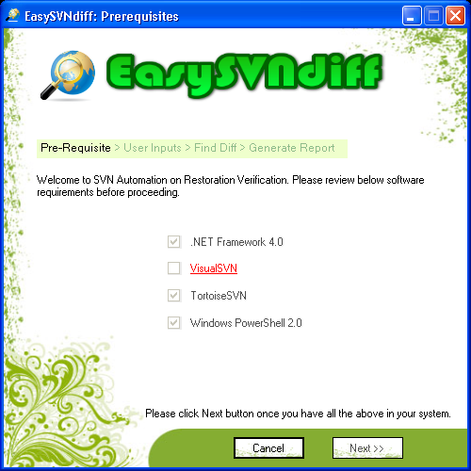

Step 2: User Inputs

- In this screen, the tool will get the required information from the user like Username, Password, etc of both the repositories – Live & Backup restored.
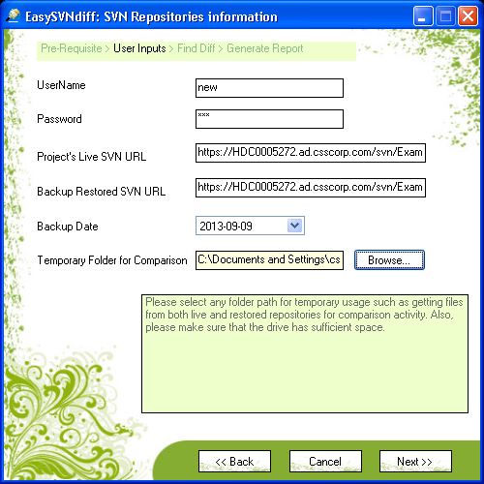
- It will validate all the fields and it will prompt the user if any field has invalid details

Step 3: Find the Difference

- While clicking the Next button in the previous screen, it will navigate to this screen and start comparing the files. This screen will display the process log.
- If any repository is empty it will prompt the user with repository details and go to previous screen.
- After successful comparison clicking “Get HTML Report”, it will generate the HTML report with required details
- While clicking “Done” it will end the process.
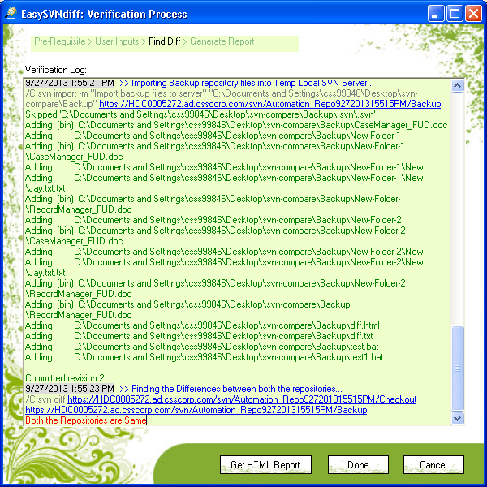
- If we want to cancel the operation during file comparison, we can click Cancel button to stop the process.

Step 4: Generate Report

- After clicking Get HTML Report button, tool will require some project specific details from user for the purpose of displaying in the HTML report.
- It is possible to save the detailed log to a text file by enabling the check box provided for it. By default, it will be checked.

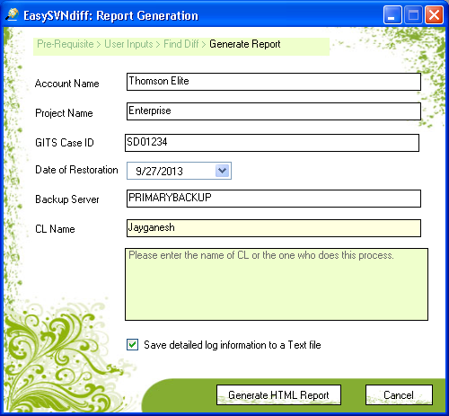

Step 5: Save the Report
- Final step; HTML report is generated successfully.

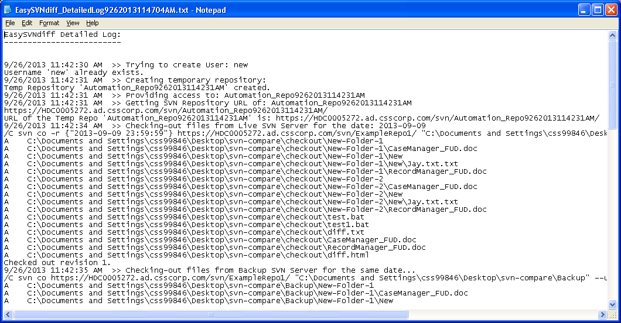
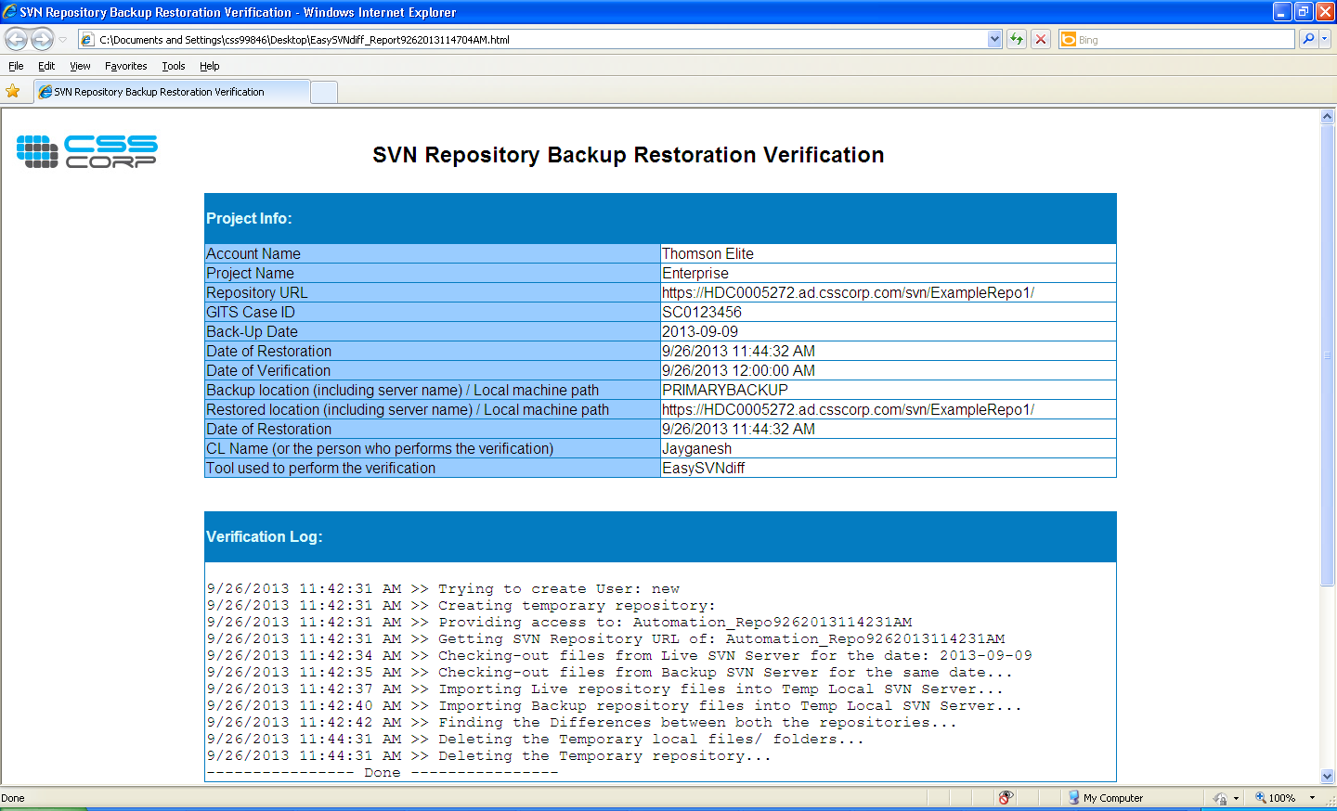

Process Diagram
The process undergo the following process:
- Download files from Live SVN repository
- Download files from Backup SVN repository
- Import Live SVN repository files to local SVN repository
- Import Backup SVN repository files to local SVN repository
- Find the differences
- Generate the verification Reports in HTML format
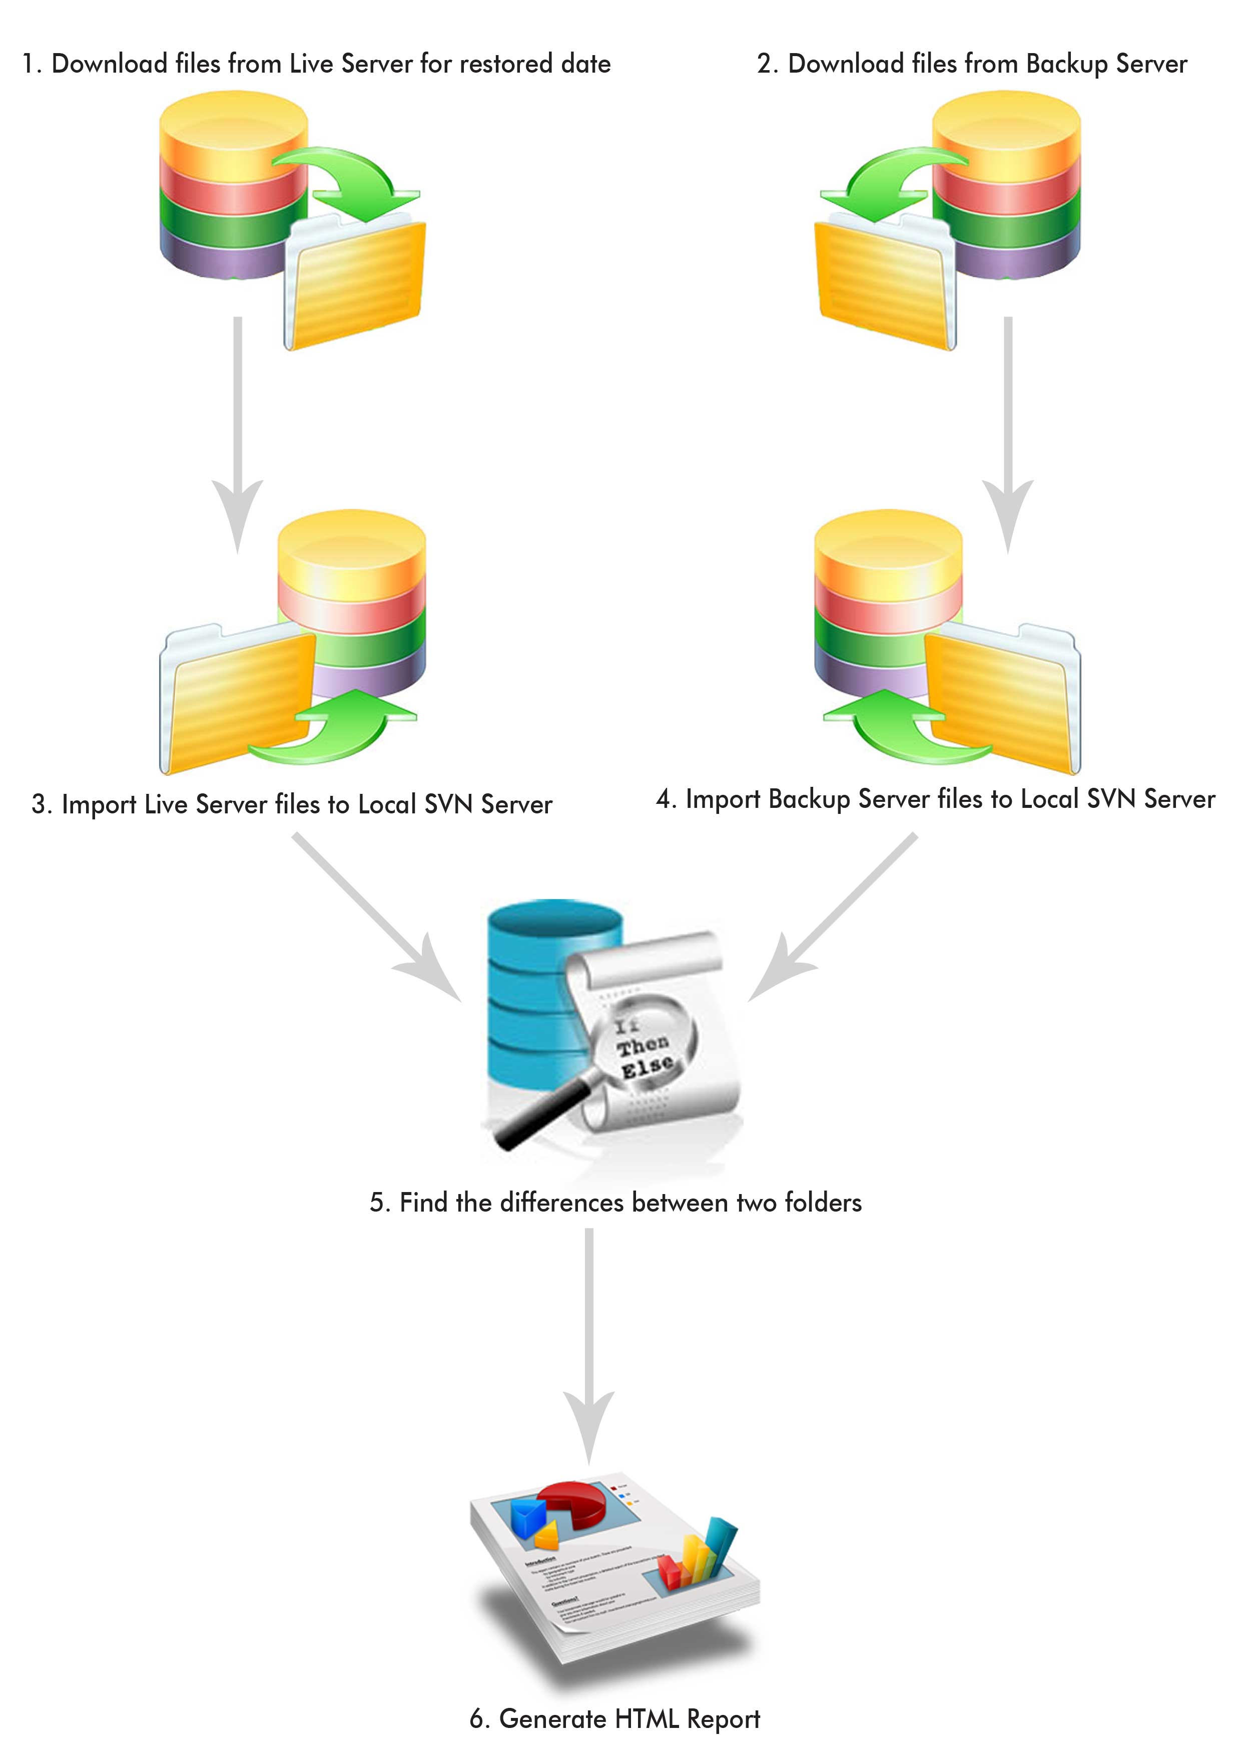

Process Diagram Description

Download files from Live SVN repository:
Download the file from the Live repository for the particular date when the database has been restored.

Download files from Backup SVN repository:
Download the head version from the restored database.

Import Live SVN repository files to local SVN repository:
Import the downloaded live repository files to local SVN repository.

Import Backup SVN repository files to local SVN repository:
Import the downloaded restored repository files to local SVN repository.

Find the differences:
Find the difference between two repositories

Generate the verification Reports in HTML format:
Generate the HTML report based on the data given by the user.

Functional Components

Pre-Requisites:
Module name: | Pre-Requisites
Component name: | Pre-Requisites
Who can trigger: | It will trigger automatically
When will it be triggered: | As soon as the application starts
Purpose: | To check whether the required software are installed in the system or not.
Input requirements: | It will get details from Registry.
Output: | When any of pre-requisites is not available on the system, that item will be displayed in red.

User Inputs:
Module name: | User Inputs
Component name: | User Inputs Validation
Who can trigger: | User
When will it be triggered: | As soon as the user click next button in Pre-Requisites screen.
Purpose: | To get details on the repositories, log on credentials to SVN Server and Backup date etc.
Input requirements: | All the input fields in the form are mandatory
Output: | Validate all the inputs and proceed to next step

Find the Differences:
Module name: | Find the Differences
Component name: | Find the Differences
Who can trigger: | User
When will it be triggered: | After validating the inputs in ‘User Inputs’ screen
Purpose: | To check the differences between two repositories.
Input requirements: | No inputs are collected from user.
Output: | Displays the differences between two repositories if they are different.

Generate Report:
Module name: | Generate Report
Component name: | Generate Report
Who can trigger: | User
When will it be triggered: | As soon as the “Generate HTML Report” button is clicked.
Purpose: | To generate the HTML report on the verification process.
Input requirements: | All the input fields in the generate report form
Output: | HTML report on the verification process.

Re-Used Components:
Based on the make or reuse analysis on the component availability, business alliance and available skills, Components that can be reused from other projects are identified with help of DAR procedure .For more details on DAR refer QMS DAR procedure.
S.No | Component Name | Project Name from which the component is reused.

Stored Procedure/Function
Procedure Name
Purpose:
Parameter |  |  | Tables
IN | OUT | Return | Main | Look-Up
Pseudo-code:

Common Stored Procedures/Functions
Stored Procedure
Purpose:
Parameter |  |  | Tables
IN | OUT | Return | Main | Look-Up
Logic:

Access Controls

<Name of the Database>
Entries | Access rights

Appendix

Reference
This subsection should
- Provide a complete list of all documents referenced elsewhere in this document
- Identify each document by title, report number (if applicable), date, and publishing organization
- Specify the sources from which the references can be obtained

This information may be provided by reference to an appendix or to another document.

