

**COE/ELE 70AB Milestones Compliance Report (MCR)**

| Project Title | AA05 - Automated Parking Management System |
| --- | --- |
| MCR Number | I (weeks 4 & 5) |
| Project Manager for the MCR period | Taskin Abdur-Rahman (Student A) is responsible for weeks 4 & 5 activities and submitting the MCR at 2pm. |
| Team Players for the MCR period | Yadu Krishnan Madhu, Zohraan Badar, Kisoban Rajendran |
| Faculty Supervisor | Alagan Anpalagan |

# **Tasks Outlined for the Reporting Period (e.g. MCR I – Weeks 4 & 5)** (Provide detailed information on the tasks to be completed for the reporting period as per the milestone submitted to your FLC in Week3)

Group:

# Create high-level breakdown of project into subsystems

# Establish all initial features of the system.

# Establish all requirements for each subsystem.

# FLC Meeting

# Update requirements and specs document if necessary.

Student A: Contributes to all above

Student B: Contributes to all above

Student C: Contributes to all above

Student D: Contributes to all above

# **Progress Made in Reporting Period (e.g. MCR I – Weeks 4 & 5) -** (Provide detailed information on the progress that you (as a group and individual) made during the reporting period. You can include figures, datasheets, flowcharts etc. and additional information as requested by your FLC. You should use your progress to justify compliance to the tasks outlined for the reporting period as per the milestones submitted to your FLC in Week3)

# We did a breakdown of the project into high-level large subsystems which can be seen below.

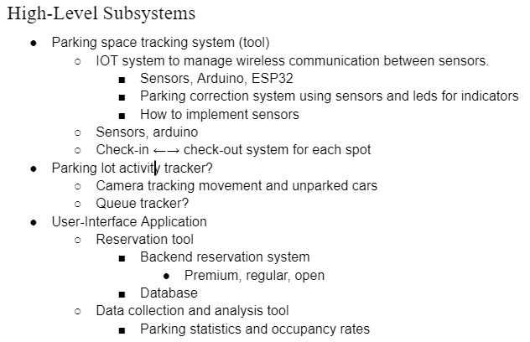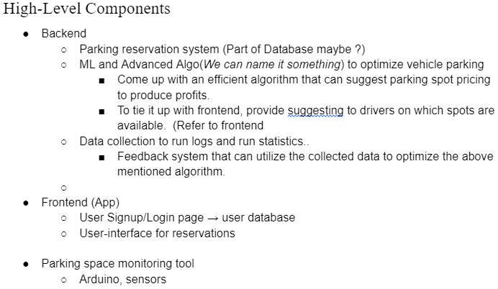

# Then we created a flowchart for the parking use case.

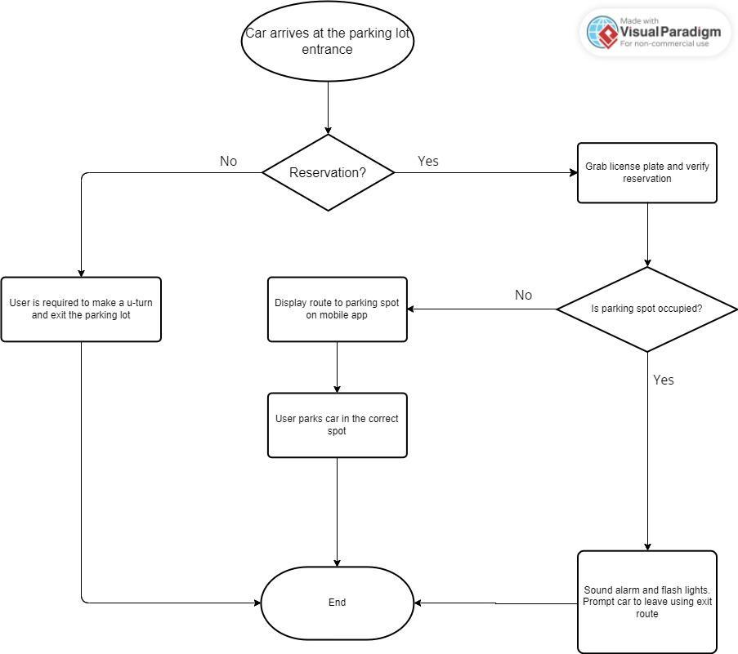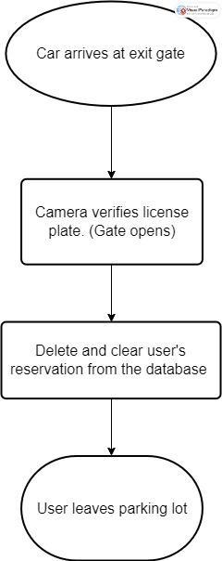

# We also made a picture diagram describing the GUI application as well as the top-down view of the entrance of the parking lot.

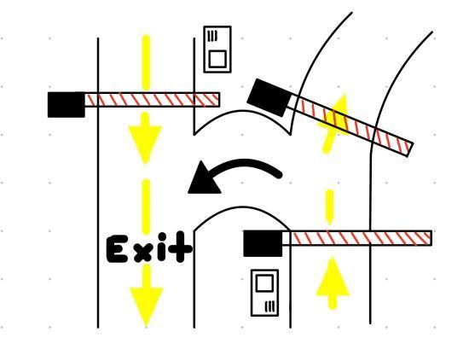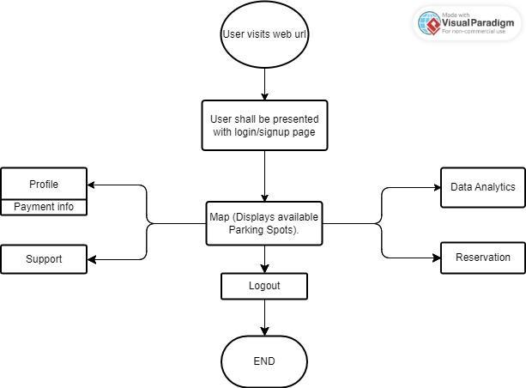

# Based on the above we developed a few requirements for the GUI application as well as the parking spot tracking system, which are contained the following documents:

* [Parking Spot Tracker Requirements](https://docs.google.com/spreadsheets/d/1qTnHE_w7UMYlCVHuSRmgs8qNpQOkMhMjpAGY8QBLDyE/edit#gid=0)
* [User-Interface Application Requirements](https://docs.google.com/spreadsheets/d/18foC7Kem3-0fJzZ6tsyBcbZWIyHNe9tzzDcwxJEUdVA/edit#gid=0)

We also have meeting notes from our FLC meetings to keep track of our discussions.

* [Meeting #1 with FLC - Sept. 15, 2023](https://docs.google.com/document/d/1OzZ0Nlshtqkdl8pTHcmeParMqwLg2AFEQMOFZkhG_Og/edit?usp=drive_link)
* [Meeting #2 with FLC - Sept. 28, 2023](https://docs.google.com/document/d/132z89yrlRLHXhW68gGm8AaKcNibzn0GjqmDx1MUJTjw/edit?usp=drive_link)

Group:

Student A: Contributed to each activity.

Student B: Contributed to parking entrance flowchart and entrance design

Student C: Contributed to each activity.

Student D: Participated in all FLC meetings and contributed to the high-level breakdown.

# **Difficulties Encountered in Reporting Period** (Provide detailed information on the difficulties and issues that you encountered during the reporting period and how you plan to address this in the following periods)

Group:

We as a group had difficulties in defining some of the top level functional requirements without deciding on the sensor capabilities of our system. We had to decide between mechanical sensors or cameras to keep track of the parking spots. However, with guidance from the FLC, we decided on implementing a system primarily based on cameras, however, a hybrid system is under consideration as well. From defining the sensors, we were then able to define the function requirements for our high level systems as well as break down those high level systems into functional and non-functional requirements.

Student A:

Student B:

Student C: I fell sick during the FLC meeting week (week 4) and as a result I was unfortunately unable to meet with the FLC.

Student D:

# **Tasks to Be Completed in the Next Reporting Period** (Outline the tasks to be completed in the next reporting period. Please note this should match with your milestones submitted to your FLC in Week3, however in consultation with (and approval of) your FLC, you can modify this to accommodate incomplete tasks from previous period. Here you should also identify the Project Manager for the next period)

Group:

Breakdown the following subsystems into low-level components and specifications Week(6 & 7):

* Complete design for parking spot tracker.
* Design a solution for the GUI application.
* Meeting with FLC, and updating design after meeting.

# Complete design for GUI application.

# Complete design solution for database.

* Submit MCR

Student A: Contributes to all above.

Student B: Contributes to all above.

Student C: Contributes to all above.

Student D: Contributes to all above.