

**COE/ELE 70AB Milestones Compliance Report (MCR)**

| Project Title | AA05 - Automated Parking Management System |
| --- | --- |
| MCR Number | II (weeks 6 & 7) |
| Project Manager for the MCR period | Yadu Krishnan Madhu is responsible for weeks 6 & 7 activities and submitting the MCR at 2pm. |
| Team Players for the MCR period | Taskin Abdur-Rahman, Zohraan Badar, Kisoban Rajendran |
| Faculty Supervisor | Alagan Anpalagan |

# **Tasks Outlined for the Reporting Period (e.g. MCR I – Weeks 4 & 5)** (Provide detailed information on the tasks to be completed for the reporting period as per the milestone submitted to your FLC in Week3)

Group:

# Complete design for parking spot tracker.

# Complete Database Design.

# Design a solution for the GUI Application.

# FLC Meeting.

# Update requirements and specs and design documents if necessary.

Student A (Yadu): is tasked with the role of project manager for the phase, hence his tasks included updating requirements or specs documents as well as keeping track of the progress made and creating meeting schedules. Responsibilities relating to the project include establishing the block diagram of the Parking Management System along with Taskin and initiating the Database Design.

Student B (Zohraan): Zohraan was not assigned any specific responsibilities this phase. Instead he was asked to stay up to date with team activities.

Student C (Taskin): Is responsible for researching the limitations of the tech stack that was chosen for this project.

Student D (Kisoban): Kisoban worked on designing our parking lot prototype model. Some key decisions he made to improve our baseline parking lot model design includes adding various types of parking space’s found across parking lots in Canada. Some examples include, angled parking spots, parking spots for the disabled, 90 degree parking spots etc…

# **Progress Made in Reporting Period (e.g. MCR I – Weeks 4 & 5) -** (Provide detailed information on the progress that you (as a group and individual) made during the reporting period. You can include figures, datasheets, flowcharts etc. and additional information as requested by your FLC. You should use your progress to justify compliance to the tasks outlined for the reporting period as per the milestones submitted to your FLC in Week3)

We created a high-level block diagram for our parking management system:

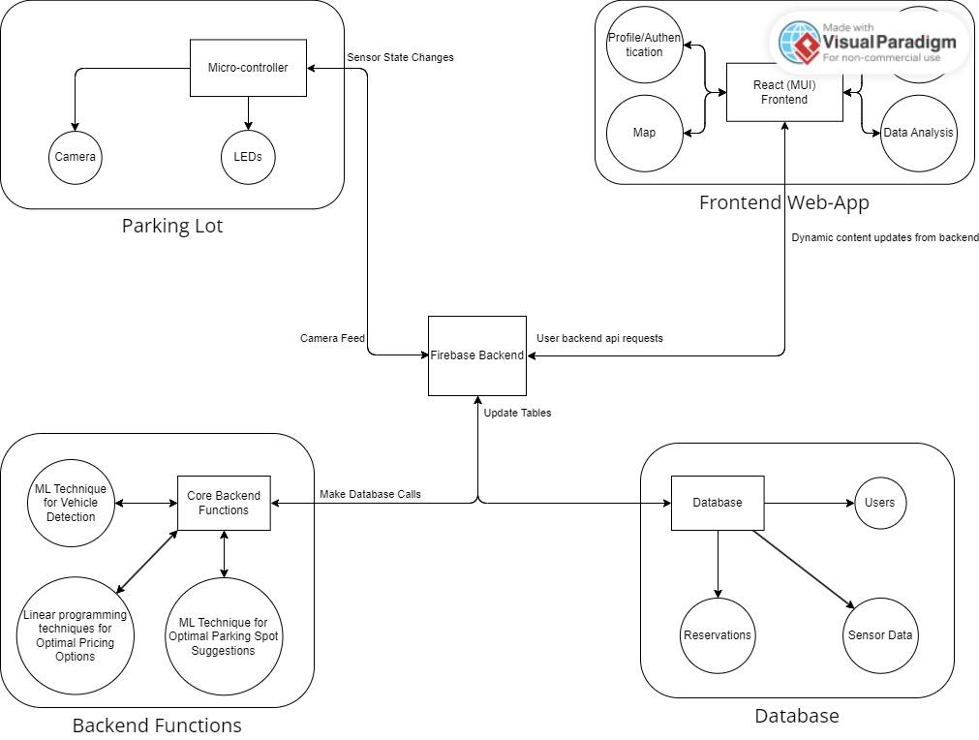

We made an initial sketch of our parking lot model:

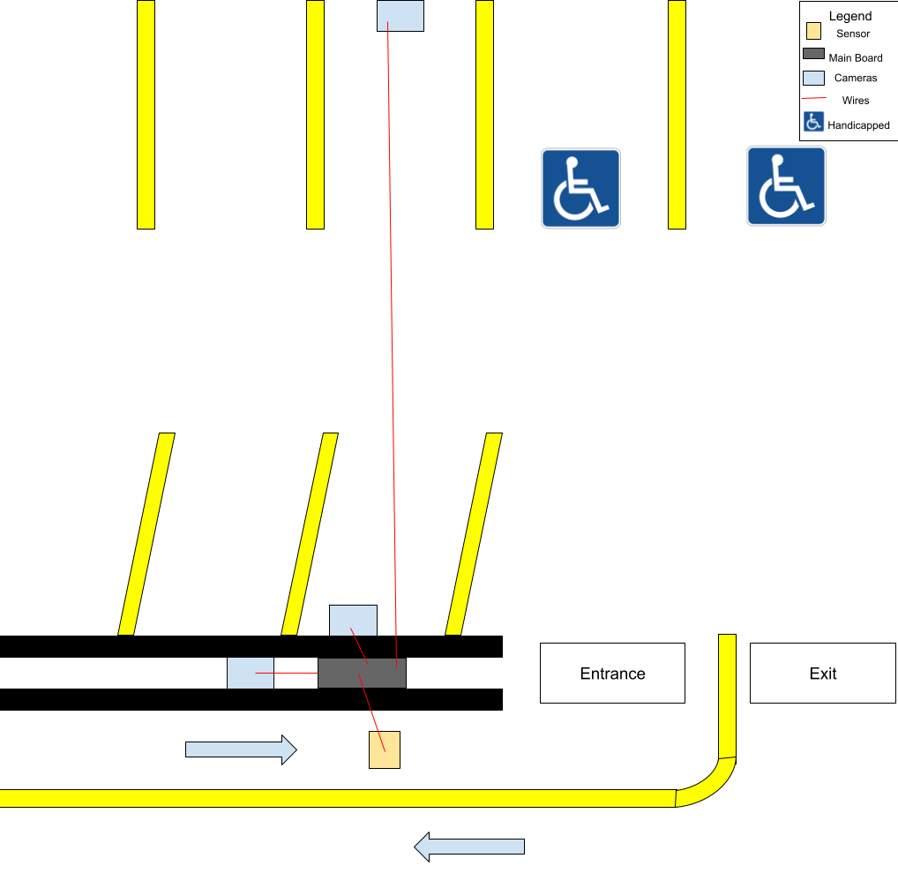

Database Schema (Prototype):

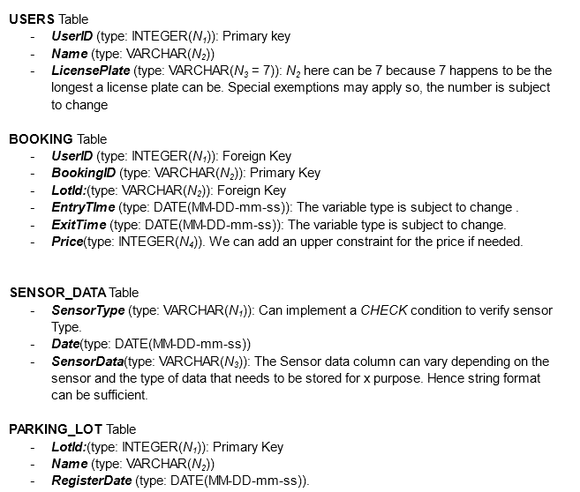

Group:

Student A (Yadu): Carried out project management duties during this phase, which included MCR submissions and assigning team members tasks. Also worked on establishing a database design (prototype) and the database/backend functions of the Parking Management System block diagram. Due to time constraints caused by midterms and labs, he was not able to establish the complete design for the database nor the parking management system block diagram.

Student B (Zohraan): Was not assigned any specific responsibilities. Although he stayed up to date on group activities.

Student C (Taskin): Taskin established the overall (Frontend, Parking lot and Firebase) entities in the Parking Management System block diagram. However, due to midterm exams, Taskin was not able to carry out sufficient research into the limitations, pros, cons of the tools chosen for this project. He will carry this task on to the next MCR submission.

Student D (Kisoban): Finished the initial sketch of the parking lot and participated in the FLC meeting.

# **Difficulties Encountered in Reporting Period** (Provide detailed information on the difficulties and issues that you encountered during the reporting period and how you plan to address this in the following periods)

Group:

We as a group had difficulties in defining some of the top level functional requirements without deciding on the sensor capabilities of our system. We had to decide between mechanical sensors or cameras to keep track of the parking spots. However, with guidance from the FLC, we decided on implementing a system primarily based on cameras, however, a hybrid system is under consideration as well. From defining the sensors, we were then able to define the function requirements for our high level systems as well as break down those high level systems into functional and non-functional requirements.

Student A (Yadu): Due to midterm exams, Yadu was not able to fully establish the complete database schema nor expand on the Parking Management System block diagram. He also faced difficulties in setting up meeting schedules due to the above mentioned reason.

Student B (Zohraan): N/A

Student C (Taskin): Due to midterm exams, Taskin was not able to carry out sufficient research into the limitations, pros, cons of the tools chosen for this project. He will carry this task on to the next MCR submission.

Student D: (Kiosban): Due to midterm exams, Kisoban was not able to carry out the complete design of the parking lot with detailed specifications such as model dimensions, material type to use etc.. He will look to complete the requirements during the next Phase.

# **Tasks to Be Completed in the Next Reporting Period** (Outline the tasks to be completed in the next reporting period. Please note this should match with your milestones submitted to your FLC in Week3, however in consultation with (and approval of) your FLC, you can modify this to accommodate incomplete tasks from previous period. Here you should also identify the Project Manager for the next period)

Group:

1. Complete breakdown of software tools to be used, including pros and cons and limitations.
2. Software environment setup and documentation.
3. Create a more detailed sketch of parking lot
   * dimensions and specifications (material type, etc)
4. Document parts to be used for parking lot model creation.
5. Meeting with FLC, and updating design after meeting.
6. Submit MCR

Student A (Yadu): 1, 2, 5

Student B (Zohraan): 3, 4, 5

Student C (Taskin): 1, 2, 5

Student D (Kisoban): 3, 4, 6.