

**COE/ELE 70AB Milestones Compliance Report (MCR)**

| **Project Title** | AA05 - Automated Parking Management System |
| --- | --- |
| **MCR Number** | IV (Weeks 10-11) |
| **Project Manager for the MCR period** | Zohraan Badar |
| **Team Players for the MCR period** | Yadu Krishnan Madhu, Taskin Abdur-Rahman, Kisoban Rajendran |
| **Faculty Supervisor** | Alagan Anpalagan |

# **Tasks Outlined for the Reporting Period (e.g. MCR I – Weeks 10 & 11)** (Provide detailed information on the tasks to be completed for the reporting period as per the milestone submitted to your FLC in Week3)

**Group:**

1. Design reviews for parking entrance, parking lot.
2. Update flowcharts

**Student A (Yadu):** Key participant in all design reviews.

**Student B (Zohraan):** Key participant in all design reviews.

**Student C (Taskin):** Took design review and updated flowcharts.

**Student D (Kisoban):** Participated in FLC meeting and is currently working on the schematic design of the parking lot model.

# **Progress Made in Reporting Period (e.g. MCR I – Weeks 10 & 11) -** (Provide detailed information on the progress that you (as a group and individual) made during the reporting period. You can include figures, datasheets, flowcharts etc. and additional information as requested by your FLC. You should use your progress to justify compliance to the tasks outlined for the reporting period as per the milestones submitted to your FLC in Week3)

**Group:**

**Student A (Yadu):** Participated in design reviews for subsystems.

**Student B (Zohraan):** Participated in design reviews for subsystems.

**Student C (Taskin):** Participated in design reviews for subsystems. Updated flowcharts to match.

**Student D (Kisoban):** Participated in FLC meeting and is currently working on the schematic design of the parking lot model.

**Results of Design Review**

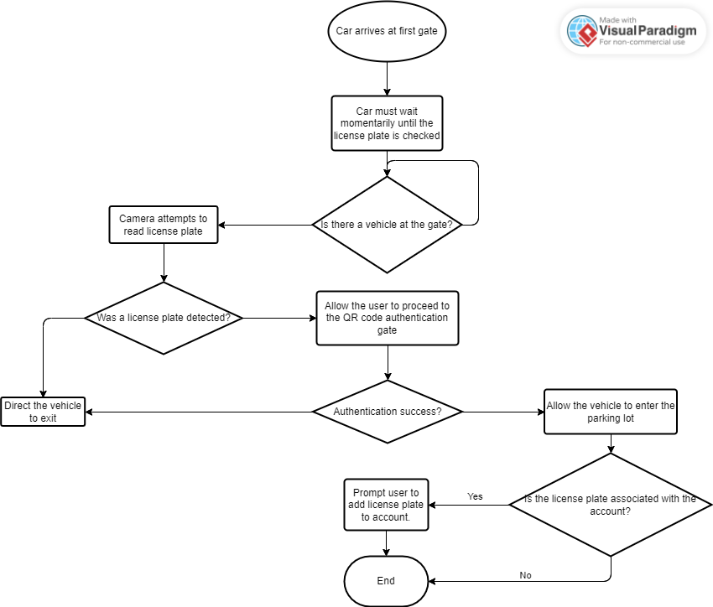

**Figure 1:** Parking lot entry flowchart.

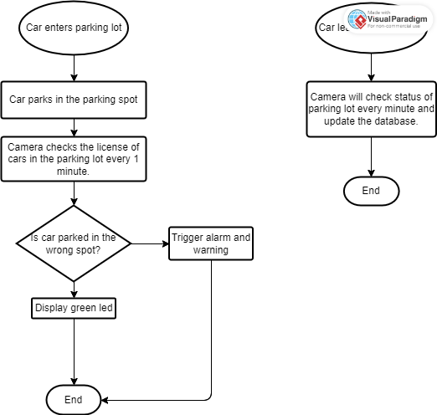

**Figure 2:** Processes taking place in the parking lot.

# **Difficulties Encountered in Reporting Period** (Provide detailed information on the difficulties and issues that you encountered during the reporting period and how you plan to address this in the following periods)

**Group:**

**All:** Due to the upcoming final project/ lab deadlines in the upcoming weeks, I was not able to cover as much as was planned for this phase.

# **Tasks to Be Completed in the Next Reporting Period** (Outline the tasks to be completed in the next reporting period. Please note this should match with your milestones submitted to your FLC in Week3, however in consultation with (and approval of) your FLC, you can modify this to accommodate incomplete tasks from previous period. Here you should also identify the Project Manager for the next period)

**Group:**

1. Design review for GUI application.
2. Design review for parking lot model.
3. Design review for testing process/ simulation.
4. Review integration between subsystems.
5. Complete 15% of Oral Exam Preparation
6. Complete 15% of Fall EDP Report.

**Student A (Yadu):** 1, 2, 3, 4, 5, 6

**Student B (Taskin):** 1, 2, 3, 4, 5, 6

**Student C (Zohraan):** 1, 3, 4, 5, 6

**Student D (Kisoban):** 2, 3, 4, 5, 6