**Project 3**

Team 9 Name:

Artificially Intelligent

Team Members:

Radhika Balasubramaniam, Chad Dubiel, Katy Fuentes, Pankaj Tahiliani

Scope of Research:

Stock NLP and Prediction

Are there key words in the 2020 earnings calls that can be linked to changes in stock price shortly after the calls are posted? Will machine learning identify key words in the top S&P 100 companies?

Github Repo:

Stock NLP and Prediction

<https://github.com/cdubiel08/Earnings-Calls-NLP>

Data Sources:

Stock NLP and Prediction

<https://seekingalpha.com/earnings/earnings-call-transcripts>

Read me language: The transcripts from Seeking Alpha are protected by copyright and cannot be used for commercial purposes. This is an educational project for the Data Visualization Program at Rice University and the use of the information should be permitted on the Copyright Fair Use principal.

<https://en.wikipedia.org/wiki/List_of_stock_exchanges>

https: //sg.finance.yahoo.com/

Type of ML analysis

Prediction

Natural Learning Programming (NLP)

Model Ideas

Stock Price Prediction

Benchmark of change- percentage change

NLP key words

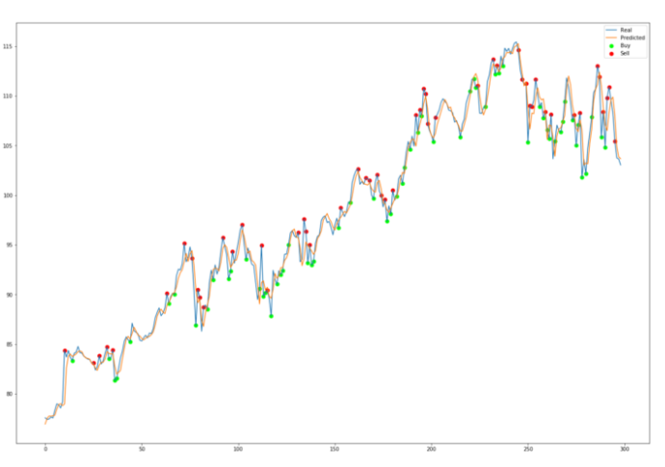

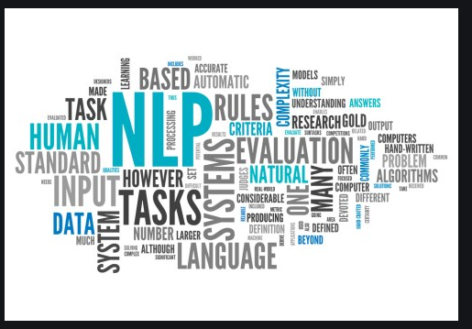

To do

Data scraping Jan 16- Chad

S&P 100- Pricing data scrape-Katy

Data cleaning- add sector information- Chad

Tableau candlestick- Pankaj

Consider before and after prices

NPL- All 400 documents for top words- mention of words, define list Katy

TFIDF Analysis- Chad

Database/AWS?- Katy to start

List, price, article-

Flask- Radhika-Draft Jan 18

Webpage Development- Radhika

Heroku Development-Pankaj and Chad

PowerPoint/Readme Jan 24- Katy

Team Feedback Jan 25

Add challenges and assumption in each step