Background

Every quarter, public companies report earnings and company updates. Companies host a conference call in order to provide additional commentary and answer questions from participants.

Data

The dataset used consists of earnings call transcripts for S&P 500 companies.

The team webscraped Seeking Alpha earning transcripts. The transcripts include a prepared remarks section, a question-and-answer section, and instructions from the call operator.

Sentiment Analysis

For the purpose of this analysis, only the prepared remarks for 2020 earnings calls for S&P100 companies compared to the full transcript text to compare the difference.

The transcripts were modified by the following processing steps:

• Removed numbers and punctuation

•Preprocessed text by cleaning up contractions, removing html, tokenizing words, lemmatized words, removed stop words, and minimum character words

• Removed infrequent words

Sentiment analysis is used to measure the attitude, sentiments, evaluations, or emotions of a speaker based on the algorithmic treatment of subjectivity in a text.

LDA  
Latent Dirichlet Allocation (LDA) models can be used to reveal a hidden structure in a collection of texts representing the weight of text in a topic space. The process involves loading data, cleaning, exploring general output in form of a word cloud, preparing the data for LDA analysis, training the LDA model, and analyzing the results with a visual. The earning call transcripts were uploaded in the raw format and cleaned with the various steps detailed above. The wordcloud for the full transcript and prepared remarks are different but mostly contain the same common words. Next, the text was tokenized into a corpus and dictionary for each. The model was trained on 25 topics which was a combination of keywords based on a weight to the topic. To visual the topics pyLDAvis was used to better understand and interpret individual topics and their relationships. For the most part the terms overlapped in the full transcript and prepared remarks, but the topic distribution varied significantly between the two.

Full Transcript

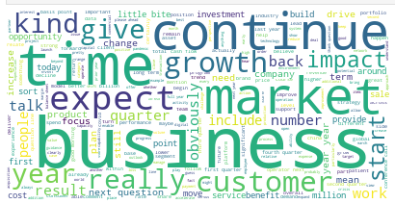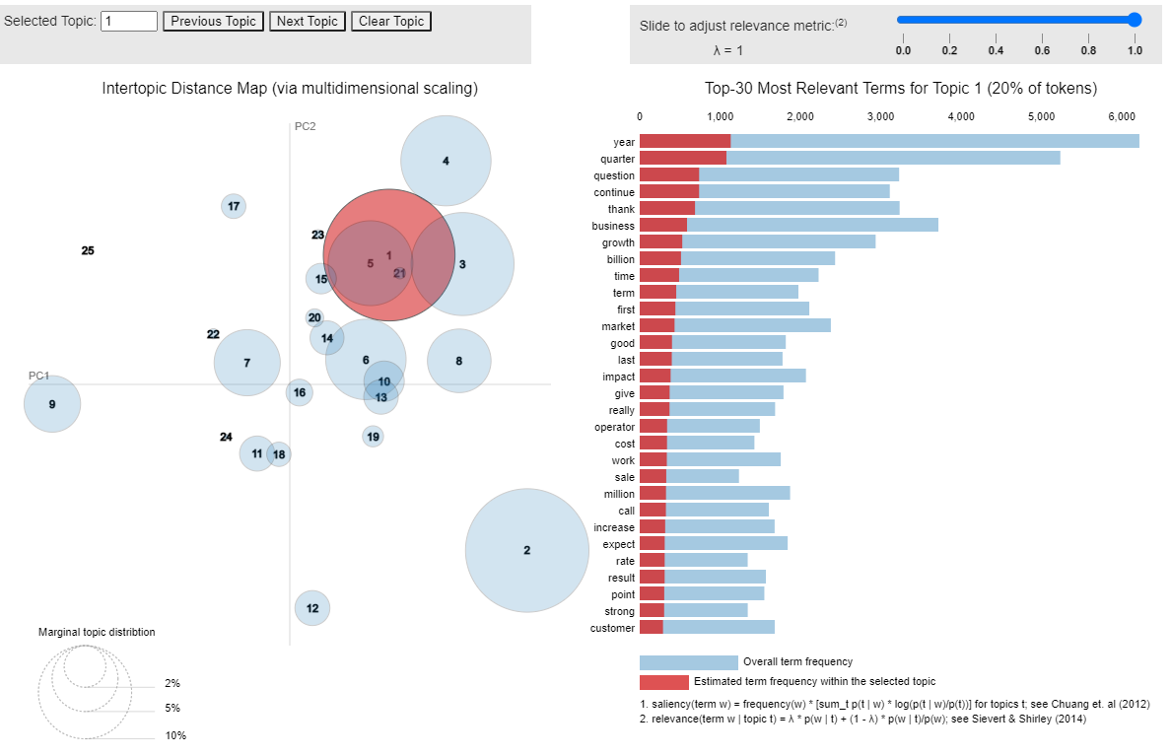

Prepared Remarks

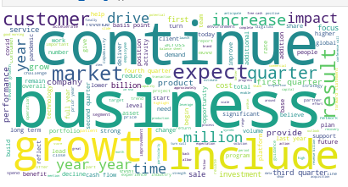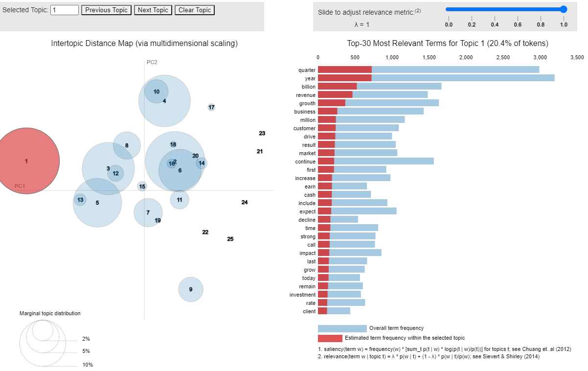

VADER

VADER (Valence Aware Dictionary for Sentiment Reasoning) is a model used for text sentiment analysis that is sensitive to both polarity (positive/negative) and intensity. VADER sentimental analysis relies on a prepackaged dictionary that maps lexical features into scores, which categorize text into positive, neutral, and negative. These texts are aggregated by document to arrive at overall opinion. VADER uses a combination of sentiment lexicon and list of lexical features which are generally labelled according to their semantic orientation as either positive or negative[1].

VADER was applied across the processed text of the full and prepared remarks section of the earnings call transcripts. The prepacked VADER Sentiment Intensity Analyzer (SIA) polarity scoring and lexicon was used and compared to Hu Liu[2] (HL) and Loughran McDonald[3] (LM) word lists to compare tone and impact of classifying a call’s sentiment correctly. The Hu-Liu lexicon was developed from a feature space of online movie reviews that were assigned negativity/positivity scores by the reviewers themselves. The HL lexicon consists of 6,786 words labeled positive or negative. The LM lexicon was constructed from words that are prevalent in 10-K reports of publicly-traded companies. The positive and negative labels assigned to these words are specific to the finance domain. The LM lexicon consists of 2,707 positive or negative words.

|  |  |  |
| --- | --- | --- |
| Sentiment Totals | Using HL Dictionary | Using LM Dictionary |
| Positive | 255 | 374 |
| Negative | 88 | 16 |
| Neutral | 58 | 11 |

Full Transcript

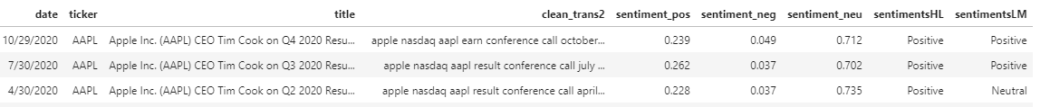

Prepared Remarks

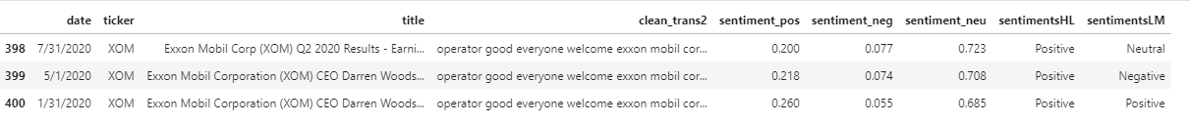

Linear Discriminant Analysis

Linear Discriminant Analysis is the linear classification technique for multi-classes of data. LDA consists of statistical properties of the data calculated for each class. LDA was applied across the processed text of the full and prepared remarks section of the earnings call transcripts. For purposes of this model, the “X” input consists of the adjusted close, close, high, low, open stock price and the SIA polarity which consists computations of subjectivity, polarity, negative, positive, and neutral scores. The “y” input consists of an imputed “label” value that measured the positivity score and assigned 1 for positive scores over 0.15 in the full transcript, based on the average of 0.150631, and 0.10 in the prepared remarks, based on the average of 0.143419. Based on the f1 score and classification numbers the model performed better with the condensed text in the prepared remarks which makes sense due to the variety of questions and answers included in the full transcript of the calls.

Full Transcript

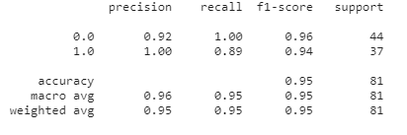

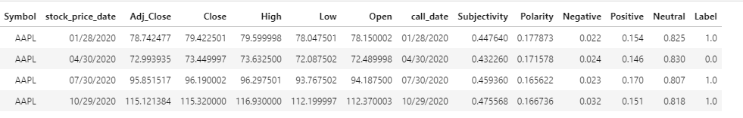

Prepared Remarks

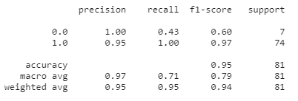

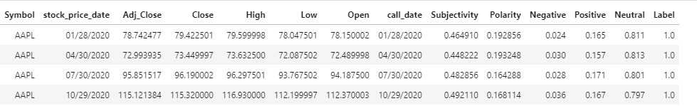

1. http://comp.social.gatech.edu/papers/icwsm14.vader.hutto.pdf
2. https://www.cs.uic.edu/~liub/FBS/sentiment-opinion-emotion-analysis.html
3. https://sraf.nd.edu/textual-analysis/resources/#Master%20Dictionary