# README - V2G Modeling Framework

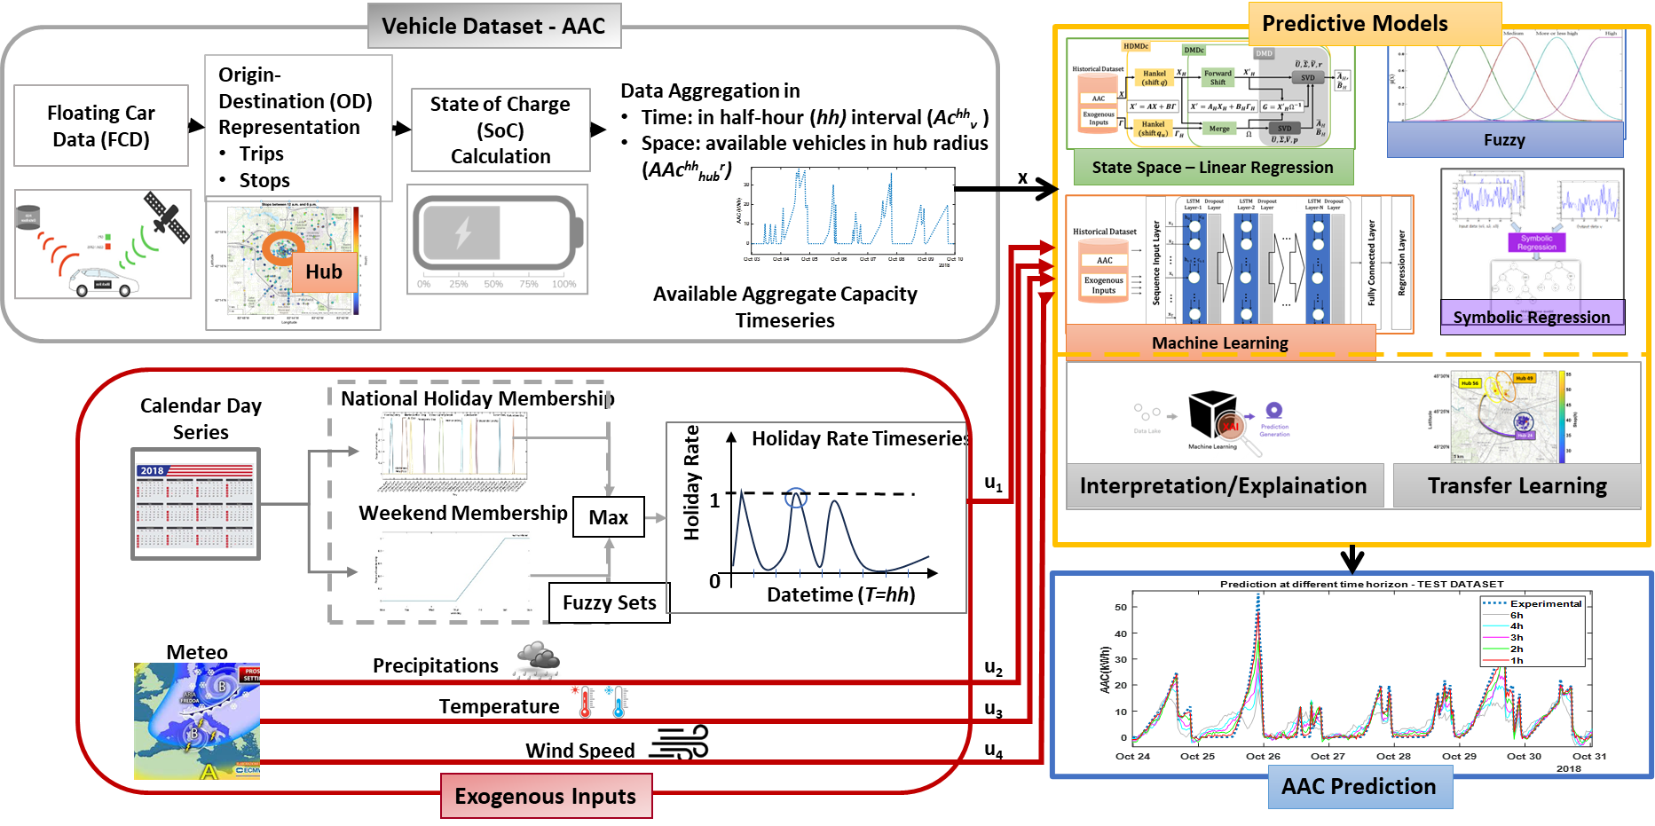

## Input Data Format

• Supported format: .mat (MATLAB format)  
• Required structure: The file must contain tabular data with variables organized in MATLAB structures or tables.  
• Typical variables: FCD (Floating Car Data), meteo (weather), calendario (calendar).

## Dataset-specific Information

* VED Dataset:
  + Contains: FCD, weather data, calendar data.
  + Data are organized in one year long datasets.
* Padova Dataset:
  + Contains: FCD, datetime, traffic data.
  + Data are organized in single day datasets.
* Roma Dataset:
  + Contains: FCD, weather data, calendar data.
  + Data are organized in 4 periods of 2 weeks.

## Model Implementation Notes

* The predictive model architecture depends on the available data in the dataset.
* Models include ARX, NARX, FIR, NFIR, and MLP.
* Pre-processing includes: correlation analysis, standardization.
* Interpretability analysis with SHAP.
* Transferability analysis through fine tuning.

