**Software Testing Course**

**What is Software Testing? What is the software Quality?**

1. Software Testing is a process of software development process
2. Software Testing is an activity to detect and identify the defect in the software.
3. The Objective of Software Testing is to release the quality of product to the client.

**Software Quality**

1. Bug free
2. Delivered on Time
3. Within Budget
4. Meet Requirement and expectation

**Project Vs Product**

If Software application is developed for specific customer based on the customer, then it is called project

If Software application is developed for multiple customer based on the customer, then it is called product

**Why we need the Software Testing**

**Error, Bug/defect And Failure**

**Error:- is a Human Mistake. While developing the application, developer do lots of mistake.**

**Bug/defect:- when actual and expected requirement does not match**

**Failure:- The deviation observed by an end user**

**SDLC is process from 3 P**

**P-> People**

**P-> Process**

**P -> Product**

**Requirement -> Understand -> Design -> develop -> testing-> Maintenance**

**WaterFall Model**

**BlackBox testing and White Box Testing**

**Levels Of testing**

1. **Unit Testing**
2. **Integration Testing**
3. **System testing**
4. **User Acceptance Testing**
5. **Unit Testing:-**
6. **Test the single Module**
7. **Comes under White box testing**
8. **Conducted By Developer**

**b) Integration testing**

1. **Integration Testing performed between 2 or more modules**
2. **It focus on the data communication between modules**
3. **Conducted by Developer**

**c) System testing**

**1. Conducted by tester**

**2. Testing overall functionality of the application with respect to client requirement**

**3. Is is a black box testing technique**

1. **Functional testing, Non Functional testing**
2. **After Completion of Unit and Integration testing**

**d) UAT**

1. **Alpha testing—Testing by end user on development environment**
2. **Beta Testing– Testing by end user on product environment**

**System Testing Types**

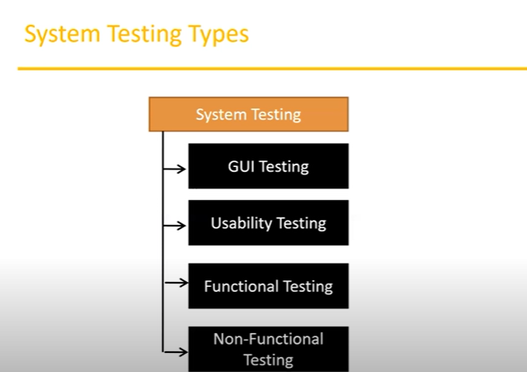

**GUI Testing**

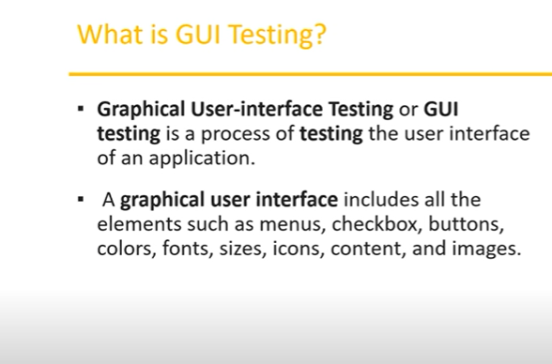

**Usability Testing**

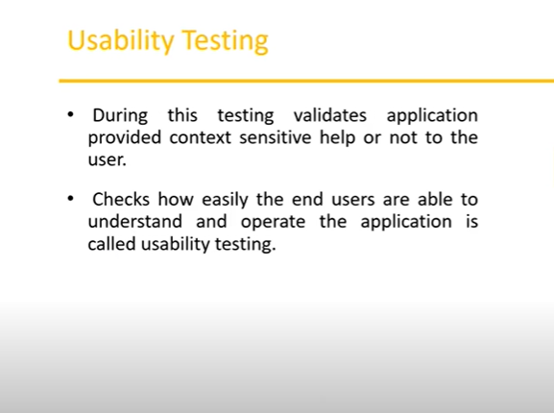

**Functional testing**

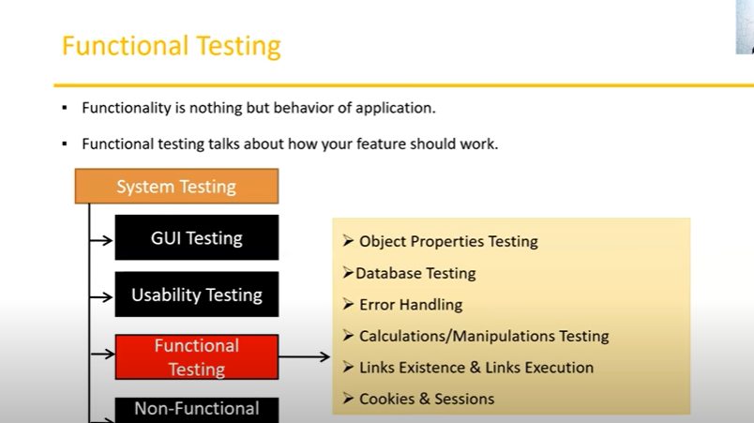

**Types of Functional testing**

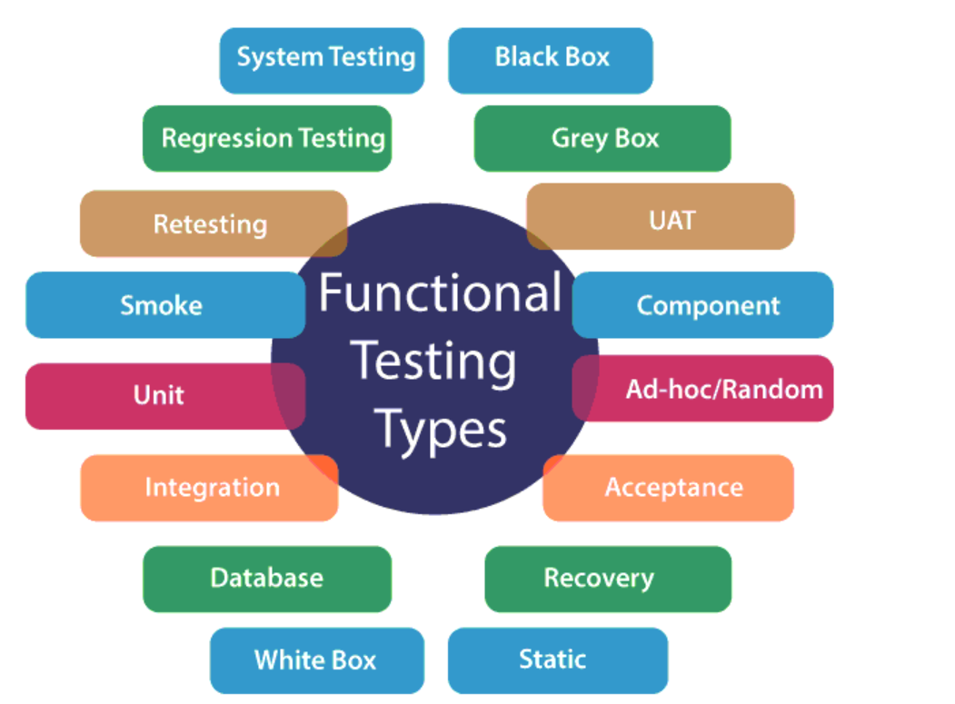

**STLC**

1. **Requirement Analysis**
2. **Test Planning**
3. **Test Design**
4. **Test Execution**
5. **Defect Reporting**
6. **Test Closure**

**Test Plan**

**A Test Plan is document that describe the test scopes, test strategy, objective, schedule deliverable, and resources required to perform the testing for a software product.**

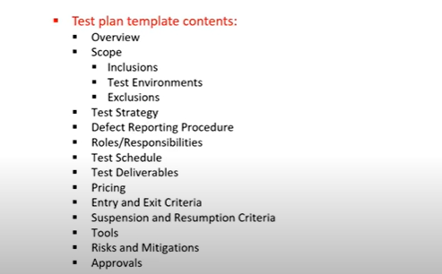

**Test Scenarios and test Cases**

**Defect/Bugs**

1. **Any mismatch functionality found ina application is called as defect/bug**
2. **During Test execution test Engineer are reporting mismatched as defects to developers through template**

**Defect Reporting tool**

1. **JIRA**
2. **Bugzilla**
3. **Quality Center**

**Defect Clssification**

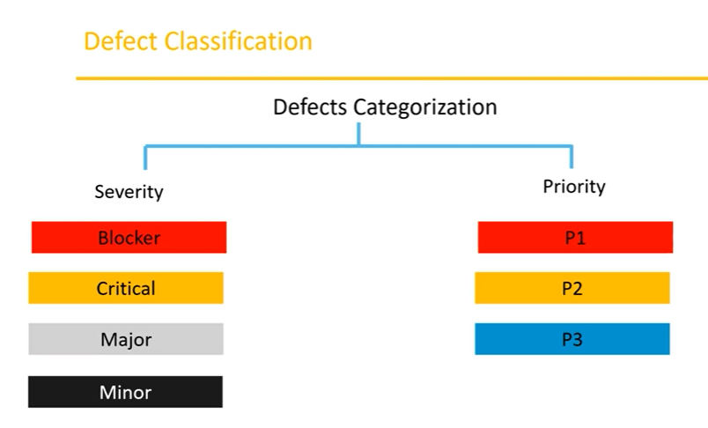

**Defect Triage:-**

**efect triage is a process that tries to do the re-balancing of the process where the test team faces the problem of limited availability of resources. So, when there are large number of the defect and limited testers to verify them, defect triage helps to try to get as many defects resolved based on defect parameters like severity and priority.**

**How to determine Defect Triage:**

**Most systems use priority as the main criteria to assess the defect. However, a good triage process considers the severity as well.**

