Steps to create the project

- mkdir house-price-prediction
- cd house-price-prediction
- python -m venv venv
- venv\Scripts\activate
- pip install fastapi uvicorn pandas numpy scikit-learn joblib python-dotenv pydantic
- pip freeze > requirements.txt

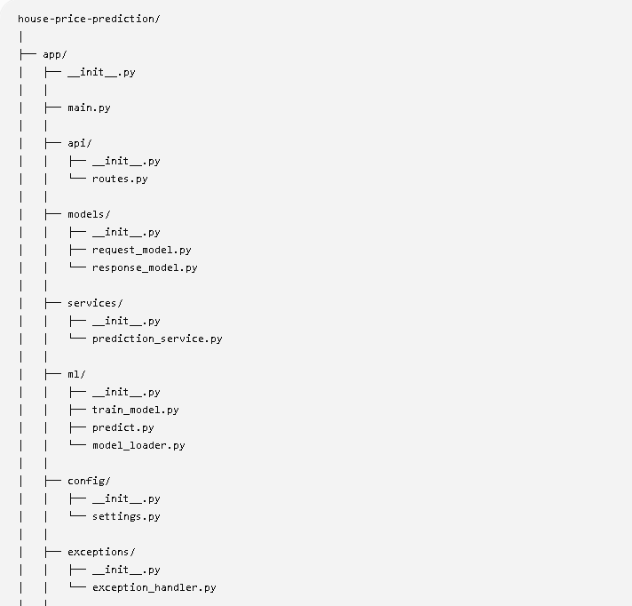

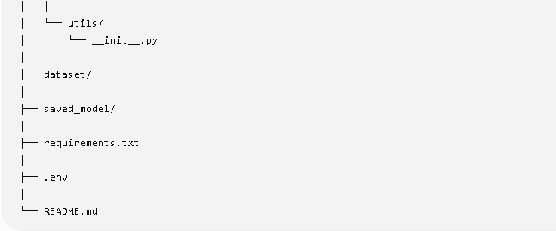

app/main.py
from fastapi import FastAPI

from app.api.routes import router

app = FastAPI(
title="House Price Prediction API",
description="Machine Learning API using FastAPI",
version="1.0.0"
)

app.include_router(router)

@app.get("/")
def home():
return {
"message": "Welcome to House Price Prediction API"
}

app/api/routes.py

from fastapi import APIRouter

router = APIRouter()

@router.get("/health")
def health_check():
return {
"status": "Application is Running"
}

Run the APP with command
python -m uvicorn app:app --reload --port 8000

