Complete Linear Regression Case Study

Problem Statement
A coaching institute stores student data in a CSV file.
CSV File (student_marks.csv)
Hours | Marks
2 | 40
4 | 60
6 | 80
8 | 95
NULL | 75
10 | 110
4 | 60
50 | 500
Problems in the dataset:
- Missing Value (NULL)
- Duplicate Record (4,60)
- Outlier (50,500)
Goal:
Predict marks for a student who studies 7 hours.

Step 1: Load Dataset
import pandas as pd
df = pd.read_csv("student_marks.csv")
print(df)
Output:
Hours | Marks
2 | 40
4 | 60
6 | 80
8 | 95
NaN | 75
10 | 110
4 | 60
50 | 500

Step 2: Data Cleaning

A. Handle Missing Values
Check null values:
print(df.isnull().sum())
Output:
Hours 1
Marks 0
Replace null with mean.

Mathematical Formula
$$Mean=\frac{∑X}{N}$$
Ignoring NULL:
$$Mean=\frac{2+4+6+8+10+4+50}{7} \\ Mean=\frac{84}{7} \\ Mean=12$$
Replace NULL with 12.
df["Hours"] = df["Hours"].fillna(df["Hours"].mean())

B. Remove Duplicate Records
Before:
Hours | Marks
4 | 60
4 | 60
Remove duplicates.
df = df.drop_duplicates()

C. Detect Outliers Using IQR
Current Hours column:
2,4,6,8,10,12,50
Sort:
2,4,6,8,10,12,50

Q1
25th percentile
$$Q1=4$$

Q3
75th percentile
$$Q3=12$$

IQR
$$IQR=Q3-Q1 \\ IQR=12-4 \\ IQR=8$$

Lower Bound
$$Q1-1.5(IQR) \\ 4-1.5(8) \\ 4-12 \\ -8$$

Upper Bound
$$Q3+1.5(IQR) \\ 12+12 \\ 24$$
Any value > 24 is outlier.
Thus:
50
is Outlier.

Python Outlier Removal
Q1 = df["Hours"].quantile(0.25)
Q3 = df["Hours"].quantile(0.75)
IQR = Q3 - Q1
lower = Q1 - 1.5 * IQR
upper = Q3 + 1.5 * IQR
df = df[
(df["Hours"] >= lower)
&
(df["Hours"] <= upper)
]

Clean Dataset
Hours | Marks
2 | 40
4 | 60
6 | 80
8 | 95
10 | 110
12 | 75

Step 3: Linear Regression Mathematical Solution
Dataset:
X | Y
2 | 40
4 | 60
6 | 80
8 | 95
10 | 110
12 | 75

Calculate Required Values
X | Y | XY | X²
2 | 40 | 80 | 4
4 | 60 | 240 | 16
6 | 80 | 480 | 36
8 | 95 | 760 | 64
10 | 110 | 1100 | 100
12 | 75 | 900 | 144

Summations
$$∑X=42 \\ ∑Y=460 \\ ∑XY=3560 \\ ∑X^{2}=364 \\ n=6$$

Slope
$$m=\frac{n∑XY-(∑X)(∑Y)}{n∑X^{2}-(∑X)^{2}}$$
Substitute values:
$$m=\frac{6(3560)-42(460)}{6(364)-{42}^{2}} \\ m=\frac{21360-19320}{2184-1764} \\ m=\frac{2040}{420} \\ m=4.857$$

Intercept
$$c=\frac{∑Y-m∑X}{n} \\ c=\frac{460-(4.857)(42)}{6} \\ c=42.67$$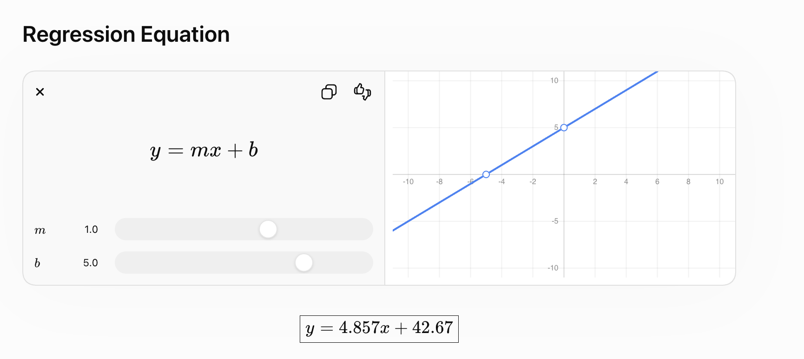

Predict Marks for 7 Hours
$$y=4.857(7)+42.67 \\ y=76.67$$

Final Prediction
$$\boxed{76.67}$$
Expected Marks ≈ 77

Complete Python Code
import pandas as pd
import numpy as np
from sklearn.linear_model import LinearRegression
from sklearn.model_selection import train_test_split
from sklearn.metrics import r2_score
# ----------------------------
# Load Dataset
# ----------------------------
df = pd.read_csv("student_marks.csv")
print("Original Data")
print(df)
# ----------------------------
# Missing Value Handling
# ----------------------------
df["Hours"] = df["Hours"].fillna(
df["Hours"].mean()
)
# ----------------------------
# Remove Duplicates
# ----------------------------
df = df.drop_duplicates()
# ----------------------------
# Outlier Removal (IQR)
# ----------------------------
Q1 = df["Hours"].quantile(0.25)
Q3 = df["Hours"].quantile(0.75)
IQR = Q3 - Q1
lower = Q1 - 1.5 * IQR
upper = Q3 + 1.5 * IQR
df = df[
(df["Hours"] >= lower)
&
(df["Hours"] <= upper)
]
print("\nCleaned Dataset")
print(df)
# ----------------------------
# Features and Target
# ----------------------------
X = df[["Hours"]]
y = df["Marks"]
# ----------------------------
# Train Test Split
# ----------------------------
X_train, X_test, y_train, y_test = train_test_split(
X,
y,
test_size=0.2,
random_state=42
)
# ----------------------------
# Train Model
# ----------------------------
model = LinearRegression()
model.fit(X_train, y_train)
# ----------------------------
# Model Equation
# ----------------------------
print(
"Slope:",
model.coef_[0]
)
print(
"Intercept:",
model.intercept_
)
# ----------------------------
# Prediction
# ----------------------------
hours = 7
predicted_marks = model.predict([[hours]])
print(
f"Predicted Marks for {hours} Hours:",
predicted_marks[0]
)
# ----------------------------
# Evaluation
# ----------------------------
y_pred = model.predict(X_test)
print(
"R2 Score:",
r2_score(y_test, y_pred)
)

Interview Questions

Why handle missing values?
Most ML algorithms cannot process NULL values.

Why remove duplicates?
Duplicates bias the model and can distort learned relationships.

Why remove outliers?
Outliers can significantly affect the slope and intercept of a regression line.

Why use Linear Regression?
Because both Hours and Marks are continuous numerical variables, and we want to predict a continuous output.

What is the regression equation?
General form:
$$y=mx+c$$
where:
- $m$= slope
- $c$= intercept
- $x$= Hours
- $y$= Marks
This complete workflow (CSV → Cleaning → Outlier Removal → Linear Regression → Prediction) is a very common end-to-end ML

