Supervised Classification Learning (in Simple Language)
Imagine you are teaching a child to recognize fruits.
You show the child many pictures.

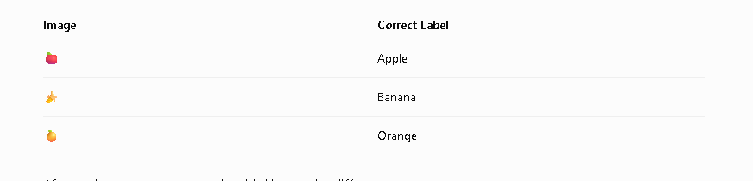

After seeing many examples, the child learns the difference.
Later, you show a new fruit.
The child says "This is an Apple."
This is exactly what Supervised Classification Learning does.
- Supervised = We already know the correct answers (labels).
- Classification = Predicting a category (class), not a number.

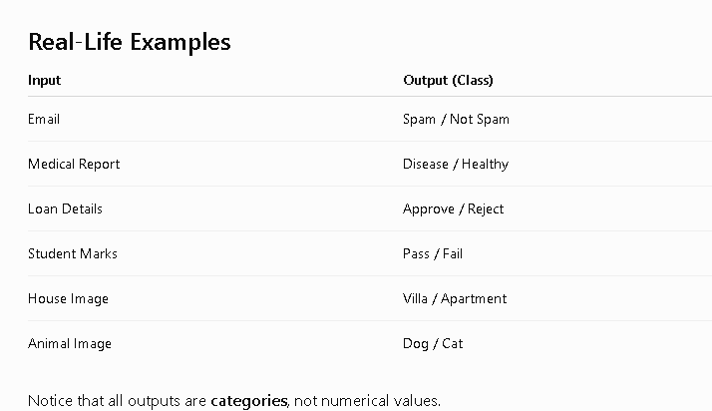

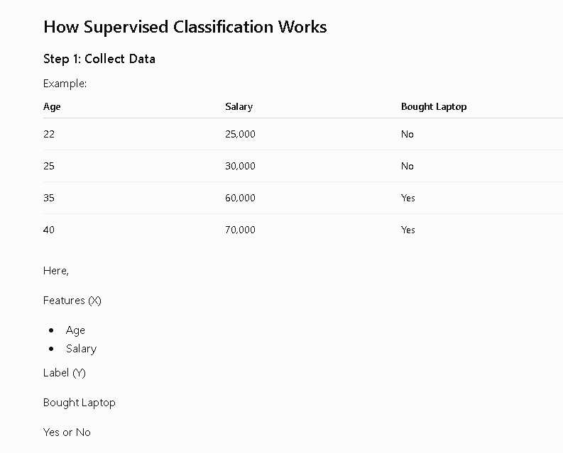

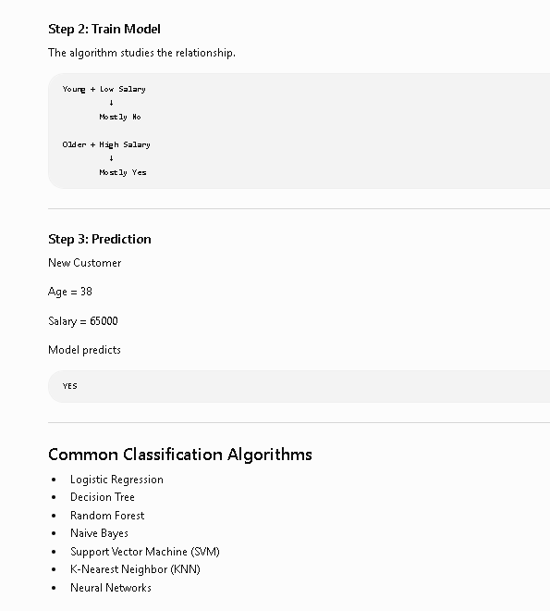

Types of Classification

1. Binary Classification
Only two classes.
Example
Spam
Not Spam
or
Yes
No

2. Multi-Class Classification
More than two classes.
Example
Cat
Dog
Horse
Cow

3. Multi-Label Classification
One object can belong to multiple classes.
Example
Movie Genres
Action
Comedy
Adventure
A movie can belong to all three.

Mathematical Example (Logistic Regression)
Suppose we want to predict whether a student passes or fails.

Step 1
Weights
w0 = -5
w1 = 0.1
where
- w0 = Bias
- w1 = Weight of Marks
Student Marks
Marks = 70

Step 2
Find Linear Equation
Formula
z=w0+w1x
Substitute values
z=−5+(0.1×70)
z = -5 + (0.1 \times 70)
z=−5+(0.1×70)
z=−5+7
z=2

Step 3
Apply Sigmoid Function
Formula
P=11+e−zP=\frac{1}{1+e^{-z}}P=1+e−z1​
Substitute
P=11+e−2P=\frac{1}{1+e^{-2}}P=1+e−21​
We know
e−2=0.1353e^{-2}=0.1353e−2=0.1353
Therefore
P=11+0.1353P=\frac{1}{1+0.1353}P=1+0.13531​ P=11.1353P=\frac{1}{1.1353}P=1.13531​ P=0.881P=0.881P=0.881
Probability
88.1%

Step 4
Classification Rule
If
Probability ≥ 0.5
Predict
PASS
Otherwise
FAIL
Since
0.881 > 0.5
Prediction
PASS

Numerical Problem: Binary Classification using Logistic Regression

Problem Statement
A bank wants to predict whether a customer will repay a loan.
Output Classes:
- 1 = Loan Repaid
- 0 = Loan Not Repaid
The bank uses two features:
- Income (₹1000/month)
- Credit Score
The trained Logistic Regression model has the following parameters:
- Bias (w₀) = -15
- Income Weight (w₁) = 0.08
- Credit Score Weight (w₂) = 0.02
The sigmoid function is
P=11+e−zP=\frac{1}{1+e^{-z}}P=1+e−z1​
where
z=w0+w1x1+w2x2z=w_0+w_1x_1+w_2x_2z=w0​+w1​x1​+w2​x2​
If
P≥0.5P \ge 0.5P≥0.5
Predict Loan Repaid (1)
Otherwise
Predict Loan Not Repaid (0)

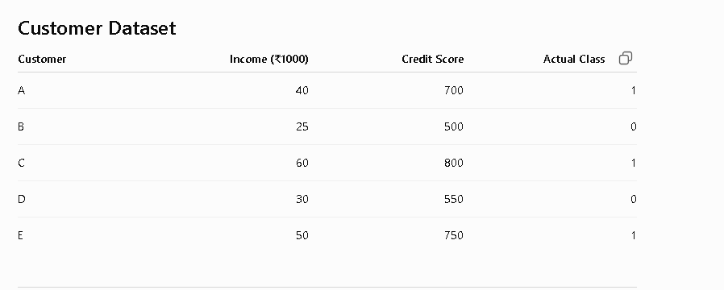

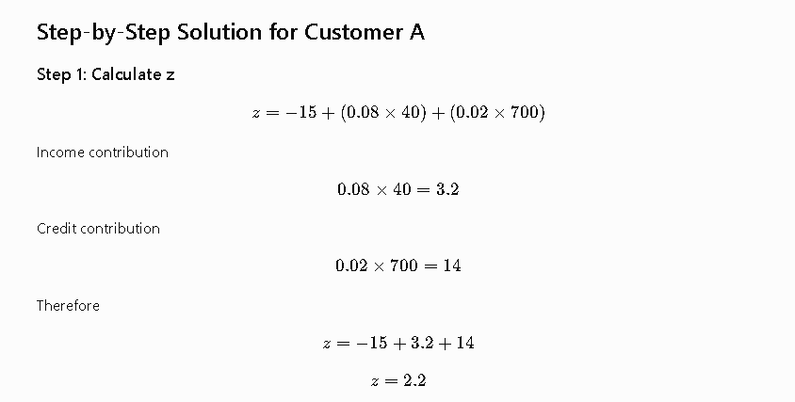

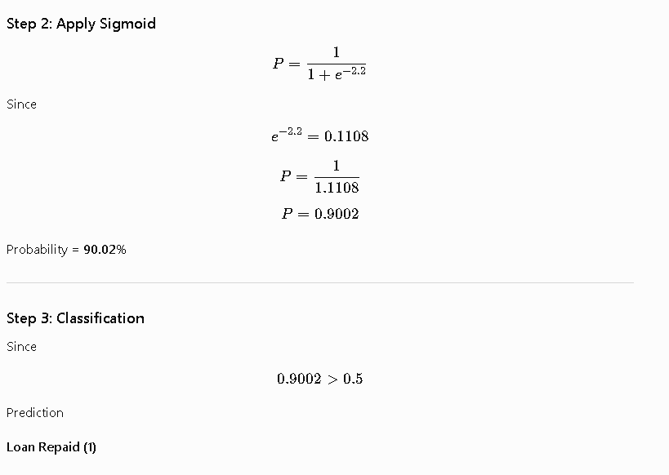

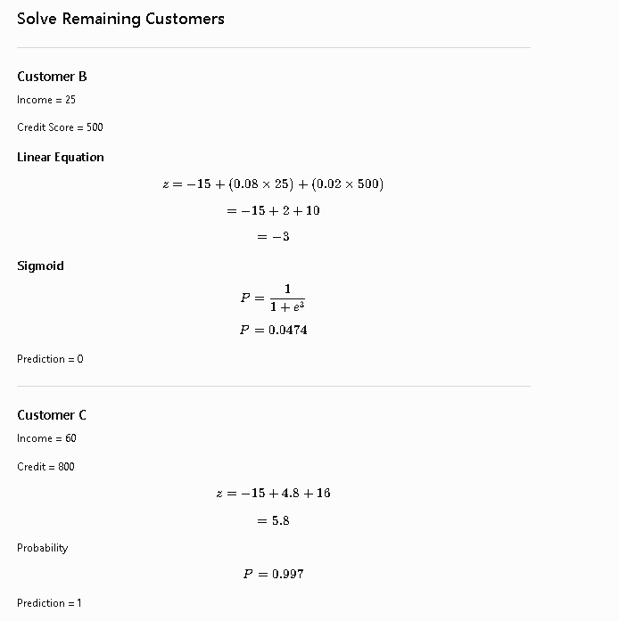

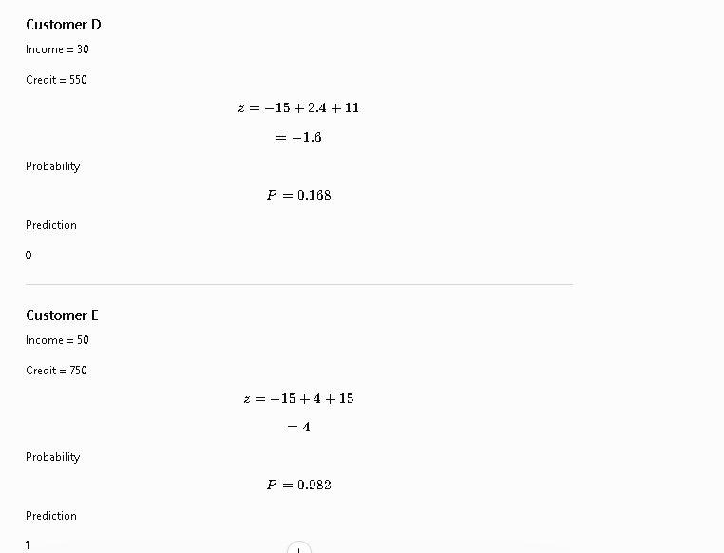

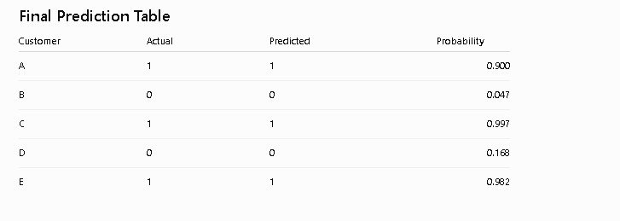

Confusion Matrix

A confusion matrix is a table used to evaluate the performance of a classification model. It compares the model's predicted labels with the actual labels.
For a binary classification problem (e.g., Spam vs. Not Spam), the confusion matrix looks like this:
Actual \ Predicted | Positive | Negative
Positive | True Positive (TP) | False Negative (FN)
Negative | False Positive (FP) | True Negative (TN)

What each term means
- True Positive (TP): The model correctly predicts the positive class.
  - Example: A spam email is correctly identified as spam.
- True Negative (TN): The model correctly predicts the negative class.
  - Example: A normal email is correctly identified as not spam.
- False Positive (FP): The model incorrectly predicts the positive class (also called a Type I error).
  - Example: A normal email is mistakenly marked as spam.
- False Negative (FN): The model incorrectly predicts the negative class (also called a Type II error).
  - Example: A spam email is mistakenly classified as normal.

Example
Suppose you tested a model on 100 emails:
Actual \ Predicted | Spam | Not Spam
Spam | 40 | 10
Not Spam | 5 | 45
From this matrix:
- TP = 40
- FN = 10
- FP = 5
- TN = 45

Metrics derived from the confusion matrix
Using the values above:
- Accuracy = (TP + TN) / (TP + TN + FP + FN)
= (40 + 45) / 100 = 85%
- Precision = TP / (TP + FP)
= 40 / (40 + 5) = 88.9%
  - Of all emails predicted as spam, how many were actually spam?
- Recall (Sensitivity) = TP / (TP + FN)
= 40 / (40 + 10) = 80%
  - Of all actual spam emails, how many did the model correctly detect?
- Specificity = TN / (TN + FP)
= 45 / (45 + 5) = 90%
  - Of all normal emails, how many were correctly identified?
- F1 Score = 2 × (Precision × Recall) / (Precision + Recall)
= 84.2%
  - A balance between precision and recall.

Why is it called a "confusion" matrix?
It shows where the model is getting confused—specifically, which classes it predicts correctly and which it misclassifies. This makes it more informative than accuracy alone, especially when the dataset is imbalanced.

Quick summary
Metric | Formula | Measures
Accuracy | (TP + TN) / Total | Overall correctness
Precision | TP / (TP + FP) | Correctness of positive predictions
Recall | TP / (TP + FN) | Ability to find all positive cases
Specificity | TN / (TN + FP) | Ability to identify negative cases
F1 Score | 2 × (Precision × Recall) / (Precision + Recall) | Balance between precision and recall

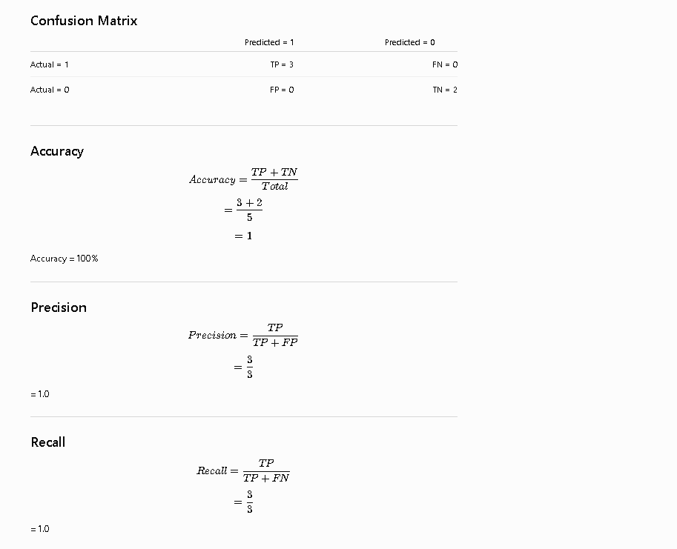

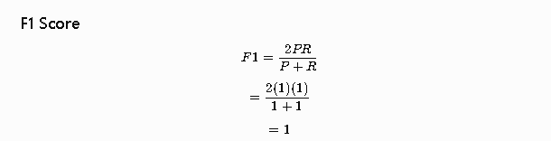

Python code

