Decision Tree
- Machine learning algorithm for both classification and regression tasks.
- Tree Structure
- Decision Nodes
- Leaf Nodes
- Splitting
- Entropy and ... (partially hidden, likely "Information Gain")
- Pruning
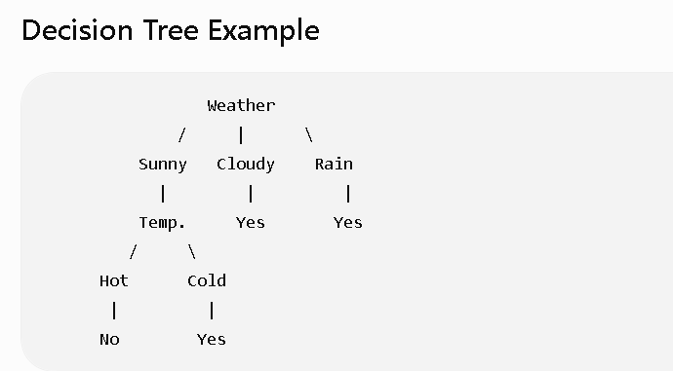

Entropy
Entropy means How much confusion is present in the data?
More confusion → Higher entropy.
Less confusion → Lower entropy.

Example 1
All students passed.
Pass
Pass
Pass
Pass
Confusion = 0
Entropy = 0

Example 2
Pass
Fail
Pass
Fail
Now we don't know.
Confusion is maximum.
Entropy is maximum.

Formula
Entropy=−Pyeslog⁡2(Pyes)−Pnolog⁡2(Pno)Entropy=-P_{yes}\log_2(P_{yes})-P_{no}\log_2(P_{no})Entropy=−Pyes​log2​(Pyes​)−Pno​log2​(Pno​)

Numerical Example
Suppose
10 students
8 Pass

2 Fail
Probability
P(Pass)=810=0.8P(Pass)=\frac{8}{10}=0.8P(Pass)=108​=0.8 P(Fail)=210=0.2P(Fail)=\frac{2}{10}=0.2P(Fail)=102​=0.2
Entropy
=−0.8log⁡2(0.8)−0.2log⁡2(0.2)=-0.8\log_2(0.8)-0.2\log_2(0.2)=−0.8log2​(0.8)−0.2log2​(0.2)
Using
log⁡2(0.8)=−0.322\log_2(0.8)=-0.322log2​(0.8)=−0.322 log⁡2(0.2)=−2.322\log_2(0.2)=-2.322log2​(0.2)=−2.322 Entropy=−(0.8)(−0.322)−(0.2)(−2.322)Entropy = -(0.8)(-0.322) -(0.2)(-2.322)Entropy=−(0.8)(−0.322)−(0.2)(−2.322) =0.2576+0.4644=0.2576+0.4644=0.2576+0.4644 =0.722=0.722=0.722
Higher entropy means the data is mixed.

8. Information Gain
Information Gain tells us which feature gives the best split by reducing entropy the most.

Formula
IG=Entropy(Before)−Entropy(After)IG = Entropy(Before)-Entropy(After)IG=Entropy(Before)−Entropy(After)

Example
Initial entropy
1
After splitting on Weather
0.2
Information Gain
1−0.2=0.8
This is a very good split.

Rule
Highest Information Gain = Best feature.

9. Pruning
Sometimes the tree becomes too big.
Weather

↓

Sunny

↓

Temperature

↓

Humidity

↓

Wind

↓

Pressure

↓

Month

↓

Play
This tree memorizes the training data instead of learning patterns. This is called Overfitting.
Pruning removes unnecessary branches.

Before Pruning
Weather

↓

Sunny

↓

Temp

↓

Humidity

↓

Wind

↓

Pressure

↓

Play

After Pruning
Weather

↓

Sunny

↓

Temperature

↓

Play
A smaller tree is usually faster and predicts better on new data.

Complete Example
Suppose we have this dataset:
Weather | Temperature | Play
Sunny | Hot | No
Sunny | Cold | Yes
Cloudy | Hot | Yes
Rain | Cold | Yes
Sunny | Hot | No
Rain | Hot | Yes
The Decision Tree becomes:
Weather
/ | \
Sunny Cloudy Rain
|
Temperature
/ \
Hot Cold
| |
No Yes
How it predicts:
Suppose a new day has:
- Weather = Sunny
- Temperature = Cold
The tree follows the path:
Weather = Sunny
↓
Temperature = Cold
↓
Prediction = Yes (Play)

Summary Table
Parameter | Simple Meaning | Example
Root Node | First question | Weather?
Decision Node | Intermediate question | Temperature?
Leaf Node | Final answer | Play = Yes
Splitting | Divide data into groups | Sunny, Rain, Cloudy
Entropy | Measure of confusion | Mixed Yes/No labels
Information Gain | Reduction in confusion after a split | Choose Weather because it reduces entropy the most
Pruning | Remove unnecessary branches | Simplify an overly complex tree
Classification | Predict categories | Spam/Not Spam
Regression | Predict continuous values | House Price = ₹45 Lakhs

Numerical Problem
The following dataset is given:

ID | Weather | Temperature | Humidity | Play Cricket
1 | Sunny | Hot | High | No
2 | Sunny | Hot | High | No
3 | Cloudy | Hot | High | Yes
4 | Rain | Mild | High | Yes
5 | Rain | Cool | Normal | Yes
6 | Rain | Cool | Normal | No
7 | Cloudy | Cool | Normal | Yes
8 | Sunny | Mild | High | No
9 | Sunny | Cool | Normal | Yes
10 | Rain | Mild | Normal | Yes

Task
- Calculate the entropy of the complete dataset.
- Calculate the Information Gain for:
  - Weather
  - Temperature
  - Humidity
- Choose the best root node.
- Draw the Decision Tree.

Step 1: Calculate Dataset Entropy
Count the target values.
Play = Yes = 6
Play = No = 4
Total = 10
P(Yes)=6/10=0.6
P(No)=4/10=0.4
Entropy formula
Entropy(S)=−P(Yes)log⁡(2(P(Yes))−P(No)log⁡(2(P(No))
Substitute the values
=−(0.6)log2​(0.6)−(0.4)log2​(0.4)
Using
log2(0.6)=−0.737
log2​(0.4)=−1.322
Therefore,
Entropy(S)=−(0.6)(−0.737)−(0.4)(−1.322) =0.442+0.529
Entropy(S)=0.971

Step 2: Split Dataset According to Weather
The Weather feature has three values:
- Sunny
- Cloudy
- Rain
Now separate the dataset.

Sunny Dataset
ID | Weather | Play
1 | Sunny | No
2 | Sunny | No
8 | Sunny | No
9 | Sunny | Yes
Count
Total = 4
Yes = 1
No = 3

Calculate Probabilities
P(Yes)=1/4=0.25
P(No)=3/4=0.75

Entropy Formula
Entropy(Sunny)=−(0.25)log⁡2(0.25)−(0.75)log2((0.75))
Using
log⁡2(0.25)=−2\log_2(0.25)=-2log2​(0.25)=−2 log⁡2(0.75)=−0.415\log_2(0.75)=-0.415log2​(0.75)=−0.415
Substitute
Entropy=−(0.25)(−2)−(0.75)(−0.415)
First multiplication
0.25×2=0.5
Second multiplication
0.75×0.415=0.311
Now add
0.5+0.3110.5+0.3110.5+0.311
Entropy(Sunny)=0.811​

Cloudy Dataset
ID | Weather | Play
3 | Cloudy | Yes
7 | Cloudy | Yes
Count
Total =2
Yes =2
No =0
Probability
P(Yes)= 1
P(No)= 0
Entropy
Entropy=−(1)log⁡2(1)−(0)log⁡2(0)Entropy = -(1)\log_2(1) - (0)\log_2(0)Entropy=−(1)log2​(1)−(0)log2​(0)
Since
log⁡2(1)=0\log_2(1)=0log2​(1)=0
Therefore
Entropy=0Entropy=0Entropy=0 Entropy(Cloudy)=0\boxed{Entropy(Cloudy)=0}Entropy(Cloudy)=0​
Reason: Since all examples belong to one class (Yes), there is no uncertainty.

Rain Dataset
ID | Weather | Play
4 | Rain | Yes
5 | Rain | Yes
6 | Rain | No
10 | Rain | Yes
Count
Total =4
Yes =3
No =1
Probability
P(Yes)=3/4=0.75
P(No)=1/4=0.25
Entropy Formula
Entropy(Rain)=−(0.75)log(2(0.75))−(0.25)lo(2(0.25))
Entropy(Rain)=0.811​

Step 3: Calculate Weighted Entropy
The weighted entropy is calculated using:
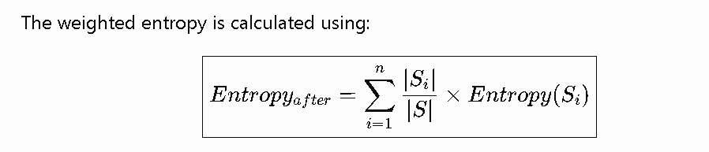

Where:
- ∣Si∣|S_i|∣Si​∣ = Number of records in each subset
- ∣S∣|S|∣S∣ = Total number of records
Substitute the values:
- Sunny = 4 records
- Cloudy = 2 records
- Rain = 4 records
Entropyafter​=4/10​(0.811)+2/10​(0)+4/10​(0.811)
Calculate each term:

Sunny contribution
410×0.811=0.4×0.811=0.3244

Cloudy contribution
210×0=0

Rain contribution
410×0.811=0.3244
Now add all contributions:
0.3244+0+0.3244=0.6488
Entropy_{after}=0.649

Step 4: Calculate Information Gain
The formula for Information Gain is:
IG(Attribute)=Entropy(Before)−Entropy(After)
Substitute the values:
- Parent Entropy = 0.971
- Weighted Entropy = 0.649
IG(Weather)=0.971−0.649
IG(Weather)=0.322

Final Summary
Quantity | Value
Parent Entropy | 0.971
Entropy (Sunny) | 0.811
Entropy (Cloudy) | 0.000
Entropy (Rain) | 0.811
Weighted Entropy | 0.649
Information Gain (Weather) | 0.322
​

