Ridge and Lasso Regression (Layman's Language)

Step 1: First Understand the Problem
Imagine you are a teacher trying to predict a student's final exam marks.
You collect the following information:
Student Information | Useful?
Hours Studied | ✅ Yes
Attendance | ✅ Yes
Previous Marks | ✅ Yes
Number of Friends | ❌ Maybe Not
Favorite Color | ❌ No
Shoe Size | ❌ No
Height | ❌ No
Now you build a machine learning model.
The model doesn't know which information is important.
It simply says,
"I'll use everything!"
So it starts giving importance to every feature.
For example
Hours Studied = Very Important
Attendance = Important
Favorite Color = Also Important??
Shoe Size = Important??
But does your shoe size affect your exam marks?
No.
This is where the problem starts.

Why is this a Problem?
Suppose there are 100 students.
The model tries very hard to fit every student perfectly.
It even starts learning random patterns.
Example
One student who wore a red shirt scored 95%.
The model thinks
"Red shirts help students score high."
Obviously, that's wrong.
The model is learning noise instead of the real pattern.
This is called Overfitting.

What is Overfitting?
Imagine a student preparing for an exam.

Student A
Memorizes all previous year's questions.
Scores 100% in practice tests.
But in the real exam, questions are different.
Fails.

Student B
Understands the concepts.
Can answer new questions.
Scores well everywhere.
Which student is better?
Student B.
Machine Learning is exactly the same.
We want our model to learn concepts, not memorize the training data.

So How Do We Stop the Model from Memorizing?
We tell the model:
"Don't become too complicated."
Think of it like a parent saying,
"Don't spend all your money."
The parent is putting a limit.
Similarly,
we put a limit on how large the model's coefficients can become.
This limit is called Regularization.

What are Coefficients?
Suppose your model predicts salary.
Salary =
1000 × Experience
+
500 × Education
+
5 × Height
+
2 × Shoe Size
The numbers
1000
500
5
2
are called coefficients.
They tell us how important each feature is.
Large coefficient = More importance.
Small coefficient = Less importance.

What Does Regularization Do?
Regularization tells the model:
"Don't make any feature too important unless it really deserves it."
It reduces unnecessary importance.
Think of it as a strict teacher who says,
"Only give marks where they are deserved."

Real-Life Example
Imagine you're packing a suitcase for a 3-day trip.
You have:
- 25 shirts
- 18 pants
- 10 shoes
- 7 jackets
Can you carry all of them?
No.
So you take only what you need.
Similarly,
Machine Learning doesn't need every feature.
Regularization helps the model carry only what's necessary.

Ridge Regression
Now let's understand Ridge.
Imagine your mother says,
"You can eat chocolate, but not too much."
She doesn't stop you completely.
She simply reduces the quantity.
This is exactly what Ridge does.

Suppose the model thinks
Experience = 100
Education = 90
Height = 70
Favorite Color = 50
Ridge says
Experience = 70
Education = 60
Height = 30
Favorite Color = 20
Notice something?
Every feature is still there.
Just less important.
Nothing is removed.

Simple Definition
Ridge Regression reduces the importance of all features, but it keeps every feature in the model.

Real-Life Example of Ridge
Suppose you're buying groceries.
Your budget is ₹2,000.
Your shopping list is:
- Rice
- Wheat
- Milk
- Fruits
- Chocolate
- Chips
- Juice
Your mother says,
"Buy everything, but spend less on unnecessary items."
You still buy chocolate.
Just fewer packets.
This is Ridge.
Nothing is removed.
Everything stays.

Lasso Regression
Now imagine your mother becomes stricter.
She says,
"Don't buy chocolates."
"Don't buy chips."
"Don't buy juice."
Only buy essentials.
Now your shopping list becomes
- Rice
- Wheat
- Milk
- Fruits
The unnecessary items are completely removed.
This is exactly what Lasso does.

Suppose the model has
Experience = 100
Education = 80
Height = 20
Favorite Color = 10
Shoe Size = 8
Lasso changes it to
Experience = 90
Education = 70
Height = 0
Favorite Color = 0
Shoe Size = 0
Notice something?
Some features disappear completely.

Simple Definition
Lasso Regression removes unimportant features from the model by making their coefficients exactly zero.

Another Real-World Example
Imagine you're hiring employees.
You receive information about candidates.
- Experience ✅
- Skills ✅
- Degree ✅
- Hair Color ❌
- Favorite Movie ❌
- Lucky Number ❌

Ridge
Says
"Let's keep all the information, but give less importance to the useless ones."

Lasso
Says
"Hair color doesn't matter."
"Favorite movie doesn't matter."
"Lucky number doesn't matter."
Removes them completely.

Ridge vs Lasso (Simple Comparison)
Ridge | Lasso
Keeps every feature | Removes useless features
Reduces importance | Removes importance completely
Good when most features are useful | Good when many features are useless
No feature selection | Performs feature selection

Easy Way to Remember

Ridge = Diet
You still eat everything.
Just eat less.
Nothing is removed.

Lasso = Cleaning Your Cupboard
You throw away clothes you never wear.
Only useful clothes remain.

Why Do Companies Use Ridge and Lasso?
Imagine Amazon wants to predict product sales.
They have 500 features.
Some are useful:
- Price
- Discount
- Rating
- Reviews
Some are useless:
- Product ID
- Warehouse Number
- Internal Code
If all 500 features are used equally, the model becomes complicated and may learn random patterns.
- Ridge reduces the influence of less useful features while keeping all of them.
- Lasso removes the features that add little or no value, making the model simpler and easier to understand.

A Simple Story to Remember Forever
Imagine you're carrying a school bag.
Inside are:
- Books
- Notebook
- Pen
- Lunch Box
- Cricket Bat
- Football
- Teddy Bear
The bag is too heavy.

Ridge's advice:
"Keep everything, but carry smaller or lighter versions if possible."

Lasso's advice:
"Remove the cricket bat, football, and teddy bear. You don't need them for school."
Both make your bag lighter.
The difference is:
- Ridge keeps everything but reduces the load.
- Lasso removes unnecessary items completely.

One-Line Interview Answers
What is Ridge Regression?
Ridge Regression is a regularization technique that reduces the importance of all features to prevent overfitting, but it keeps every feature in the model.
What is Lasso Regression?
Lasso Regression is a regularization technique that reduces the importance of features and can completely remove unimportant features by making their coefficients zero.

Memory Trick
Ridge = Reduce → Reduces all coefficients but keeps every feature.
Lasso = Leave Out → Leaves out (removes) unnecessary features by setting their coefficients to zero.
If you're learning Machine Learning for interviews or teaching, this simple intuition will make the mathematical formulas much easier to understand later.

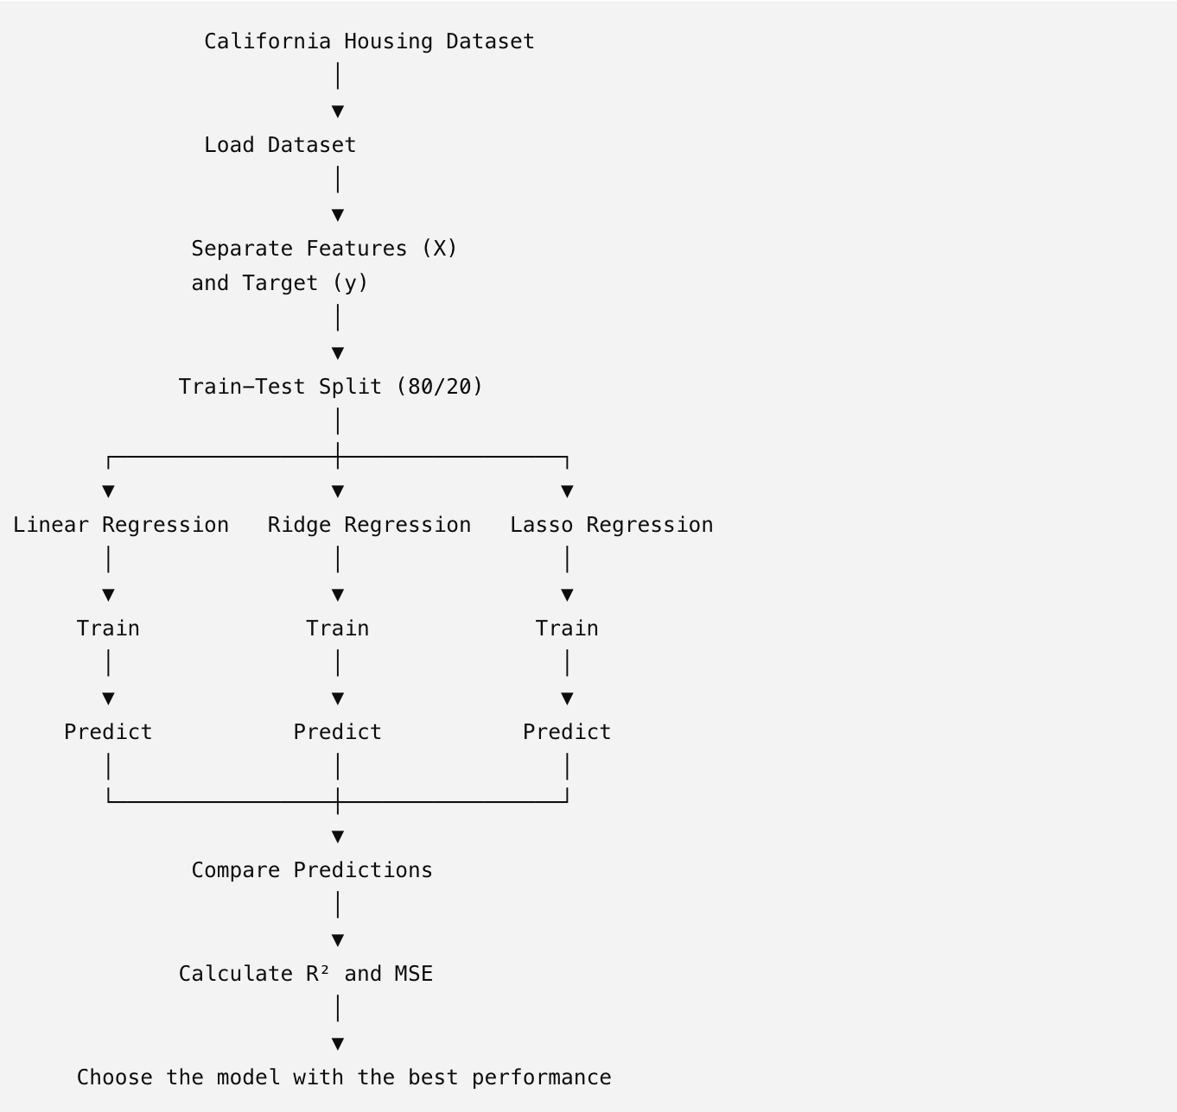

import pandas as pd
from sklearn.datasets import fetch_california_housing
from sklearn.model_selection import train_test_split
from sklearn.linear_model import LinearRegression, Ridge, Lasso
from sklearn.metrics import mean_squared_error, r2_score

# Load dataset
housing = fetch_california_housing()

X = pd.DataFrame(housing.data, columns=housing.feature_names)
y = housing.target

# Split dataset
X_train, X_test, y_train, y_test = train_test_split(
X, y, test_size=0.2, random_state=42
)

# Linear Regression
lr = LinearRegression()
lr.fit(X_train, y_train)
lr_pred = lr.predict(X_test)

# Ridge Regression
ridge = Ridge(alpha=1.0)
ridge.fit(X_train, y_train)
ridge_pred = ridge.predict(X_test)

# Lasso Regression
lasso = Lasso(alpha=0.1)
lasso.fit(X_train, y_train)
lasso_pred = lasso.predict(X_test)

# Evaluation
print("Linear Regression")
print("R2:", r2_score(y_test, lr_pred))
print("MSE:", mean_squared_error(y_test, lr_pred))

print("\nRidge Regression")
print("R2:", r2_score(y_test, ridge_pred))
print("MSE:", mean_squared_error(y_test, ridge_pred))

print("\nLasso Regression")
print("R2:", r2_score(y_test, lasso_pred))
print("MSE:", mean_squared_error(y_test, lasso_pred))

Step 1: Import Required Libraries
import pandas as pd

What is this?
This imports the Pandas library and gives it the short name pd.

Why do we need it?
Pandas is used for working with tables (DataFrames).
Example:
House Age | Income | Price
15 | 5.2 | 200000
10 | 6.1 | 250000
This table is called a DataFrame.

from sklearn.datasets import fetch_california_housing

What is this?
Imports the California Housing dataset from Scikit-Learn.

Why?
Instead of creating data manually, Scikit-Learn already provides this dataset.
It contains information about houses in California.
Features include
- Median Income
- House Age
- Number of Rooms
- Population
- Latitude
- Longitude
Target variable
House Price

from sklearn.model_selection import train_test_split

Why?
Machine Learning models should not learn and test on the same data.
We divide the data into
- Training Data
- Testing Data
This function performs that split.

from sklearn.linear_model import LinearRegression, Ridge, Lasso
This imports three regression algorithms.

LinearRegression
Simple Linear Regression without penalty.

Ridge
Regression with L2 Regularization.

Lasso
Regression with L1 Regularization.

from sklearn.metrics import mean_squared_error, r2_score
These are evaluation metrics.

mean_squared_error
Measures prediction error.
Smaller is better.

r2_score
Measures how well the model explains the data.
Closer to 1 is better.

Step 2: Load Dataset
housing = fetch_california_housing()

What happens?
Downloads (or loads) the California Housing dataset.
Think of it as
housing
│
├── data
├── target
├── feature_names
├── DESCR
It is like a dictionary containing multiple pieces of information.

Step 3: Create Feature DataFrame
X = pd.DataFrame(housing.data, columns=housing.feature_names)
Let's understand this carefully.

housing.data
Contains only the input variables.
Example
[
[8.3252,41,6.9841,1.02,322,2.55,37.88,-122.23],
[8.3014,21,6.2381,0.97,2401,2.10,37.86,-122.22]
]

housing.feature_names
Contains column names.
[
'MedInc',
'HouseAge',
'AveRooms',
'AveBedrms',
'Population',
'AveOccup',
'Latitude',
'Longitude'
]

pd.DataFrame(...)
Converts the raw array into a nice table.
Result
MedInc | HouseAge | AveRooms | Population | Latitude
Now it's easier to analyze.

Step 4: Target Variable
y = housing.target
The target variable is
House Price.
Example
[4.526, 3.585, 3.521, ...]

Now
X
contains input features.
y
contains output.
Machine Learning tries to learn
X -----> y

Step 5: Split Dataset
X_train, X_test, y_train, y_test = train_test_split(
X, y, test_size=0.2, random_state=42
)
This is one of the most important steps.

X
Features

y
Target

test_size=0.2
Means
20% data for testing
80% data for training
Suppose
1000 houses
800 → Training
200 → Testing

random_state=42
Controls randomness.
Without it
Every run gives different train/test data.
With
random_state=42
Every run produces the same split.
Useful for reproducibility.

Result
X_train
Training features
X_test
Testing features
y_train
Training prices
y_test
Actual testing prices

Step 6: Create Linear Regression Model
lr = LinearRegression()
Creates an empty Linear Regression model.
Think of it as
Student created
But hasn't learned anything yet.

Step 7: Train Model
lr.fit(X_train, y_train)
This is where learning happens.
The algorithm studies
House Features
↓
House Prices
It finds the best equation.
Something like
Price
=
2.5 × Income
+
0.3 × Rooms
−
0.2 × Population
+
Intercept
The coefficients are learned automatically.

Step 8: Prediction
lr_pred = lr.predict(X_test)
Now we give unseen houses.
The model predicts prices.
Example
Actual
$250000
Prediction
$245000

Step 9: Ridge Regression
ridge = Ridge(alpha=1.0)
Creates Ridge Regression.

alpha=1.0
Regularization strength.
Small alpha
Little penalty.
Large alpha
Strong penalty.
Penalty keeps coefficients smaller.

Training
ridge.fit(X_train, y_train)
Learns the relationship while controlling large coefficients.

Prediction
ridge_pred = ridge.predict(X_test)
Predicts prices.

Step 10: Lasso Regression
lasso = Lasso(alpha=0.1)
Creates Lasso Regression.
Difference
Lasso can make some coefficients exactly zero.

Training
lasso.fit(X_train, y_train)
Learns while selecting only important features.

Prediction
lasso_pred = lasso.predict(X_test)
Predicts prices.

Step 11: Print Heading
print("Linear Regression")
Only prints
Linear Regression

Step 12: Calculate R²

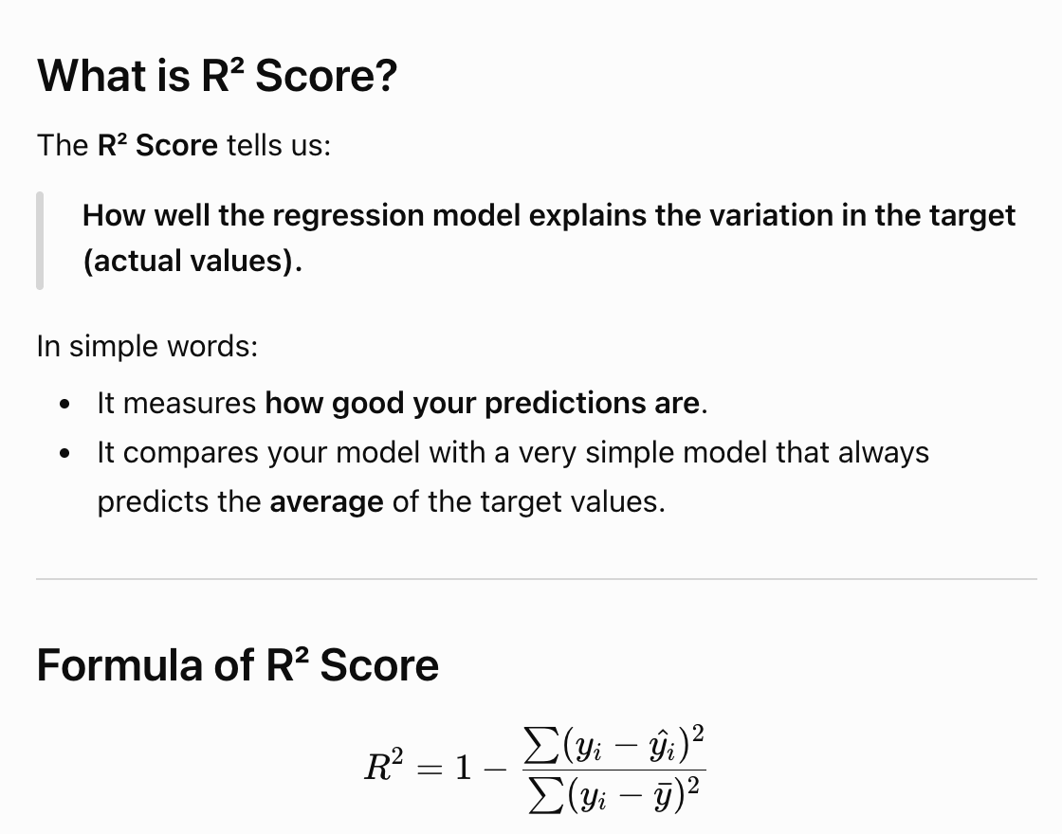

print("R2:", r2_score(y_test, lr_pred))
Compares
Actual prices
vs
Predicted prices
Suppose
Actual
200
250
300
Predicted
198
245
310
R² tells how well predictions match reality.
Example
R² = 0.82
Means
82% of the variation in house prices is explained by the model.

Step 13: Calculate MSE
print("MSE:", mean_squared_error(y_test, lr_pred))
Formula
$$MSE=\frac{∑(Actual-Predicted)^{2}}{n}$$
Example
Actual | Prediction | Error | Squared
100 | 90 | 10 | 100
200 | 190 | 10 | 100
300 | 320 | -20 | 400
Total
600
Average
600/3=200
Lower MSE is better.

The same evaluation is repeated for Ridge and Lasso:
print("\nRidge Regression")
print("R2:", r2_score(y_test, ridge_pred))
print("MSE:", mean_squared_error(y_test, ridge_pred))
and
print("\nLasso Regression")
print("R2:", r2_score(y_test, lasso_pred))
print("MSE:", mean_squared_error(y_test, lasso_pred))
This allows you to compare the performance of all three models on the same test data.

Expected Interview Questions
- Why do we split the dataset?
To train the model on one portion of the data and evaluate its performance on unseen data, which helps detect overfitting.
- What is the purpose of fit()?
It trains the model by learning the relationship between the input features (X_train) and the target (y_train).
- What does predict() do?
It uses the trained model to estimate the target values for new input data.
- What is the difference between Linear Regression, Ridge, and Lasso?
  - Linear Regression: No regularization.
  - Ridge Regression: Uses L2 regularization to shrink coefficients but keeps all features.
  - Lasso Regression: Uses L1 regularization and can reduce some coefficients to exactly zero, effectively performing feature selection.
- Why is random_state=42 used?
It ensures that the train-test split is reproducible, so you get the same split every time you run the code.
- What does alpha control in Ridge and Lasso?
It controls the strength of regularization. A larger alpha means a stronger penalty on large coefficients.
- How do you decide which model is better?
Compare metrics such as R² (higher is better) and MSE (lower is better) on the test dataset.

