Supervised Machine Learning
Regression is a supervised learning technique used to predict continuous numerical values by learning relationships between input variables (features) and an output variable (target). It helps understand how changes in one or more factors influence a measurable outcome and is widely used in forecasting, risk analysis, decision-making and trend estimation.

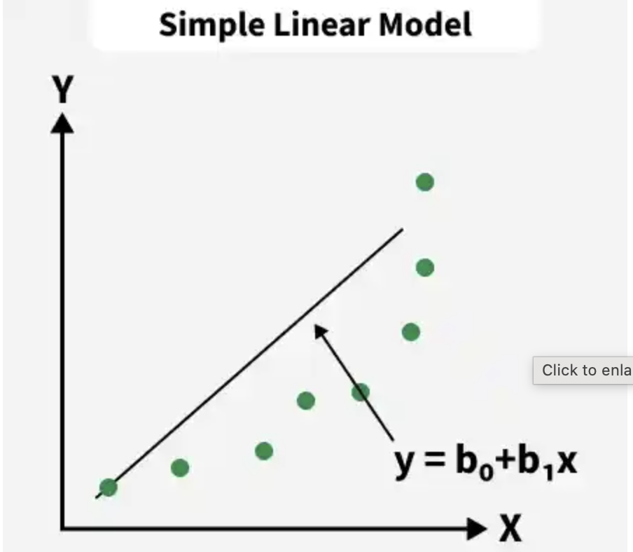

- Works with real valued output variables
- Helps to identify strengths and the type of relationships
- Supports both simple and complex predictive models.
- Used for tasks like price prediction, trend forecasting and risk scoring.

Types of Regression

1. Simple Linear Regression
Simple Linear Regression models the relationship between one independent variable and a continuous dependent variable by fitting a straight line that minimizes the sum of squared errors. It assumes a constant rate of change, meaning the output varies proportionally with the input.
- Application: Estimating house price from only its size
- Advantage: Highly interpretable due to its simple mathematical structure
- Disadvantage: Cannot capture curved or complex data patterns

2. Multiple Linear Regression
Multiple Linear Regression extends simple linear regression by incorporating multiple independent variables to predict a continuous outcome. Each predictor is assigned a coefficient that reflects its individual impact while holding other variables constant.
- Application: Predicting house prices using multiple factors like size, location, age and number of rooms
- Advantage: Captures the combined influence of many factors simultaneously
- Disadvantage: Performance drops in the presence of multicollinearity (features highly correlated with each other)

3. Polynomial Regression
Polynomial Regression models non-linear relationships by transforming input features into higher-degree polynomial terms (e.g x², x³). Although it models non-linear relationships in input features, it is linear in coefficients (parameters), which is why it is still considered a linear model.
- Application: Modelling curved growth trends like population increase or temperature variation
- Advantage: Effectively captures non-linear relationships without switching to non-linear algorithms
- Disadvantage: Higher-degree polynomials may lead to overfitting and unstable predictions

4. Ridge and Lasso Regression
Ridge and Lasso are regularized linear regression techniques that add penalty terms to limit large coefficients and reduce overfitting. Ridge (L2) shrinks coefficients smoothly, while Lasso (L1) can reduce some coefficients to zero, enabling feature selection.
- Application: Used in high-dimensional datasets like marketing attribution or gene expression data
- Advantage: Controls overfitting and improves generalization, especially with many predictors
- Disadvantage: Penalty terms make model interpretation less straightforward

5. Support Vector Regression (SVR)
Support Vector Regression applies the principles of Support Vector Machines to regression tasks. It fits a function within a defined margin (epsilon-tube) and penalizes errors only when predictions fall outside this boundary. Kernel functions allow SVR to model non-linear relationships.
- Application: Predicting continuous outcomes such as stock values or energy consumption
- Advantage: Works well with high-dimensional, complex datasets and non-linear patterns
- Disadvantage: Computationally intensive and requires careful tuning of kernels and parameters

6. Decision Tree Regression
Decision Tree Regression splits the data into hierarchical branches based on feature thresholds. Each internal node represents a decision question and leaf nodes represent predicted continuous values. It learns patterns by recursively partitioning the data to minimize prediction errors.
- Application: Predicting customer spending behavior based on demographic and financial features
- Advantage: Easy to visualize and understand decision logic
- Disadvantage: Easily overfits, especially when the tree becomes deep and complex

7. Random Forest Regression
Random Forest Regression is an ensemble method that builds multiple decision trees using different data samples and averages their predictions. This reduces the overfitting tendency of single trees and improves accuracy through diversity (bagging). Each tree captures a slightly different aspect of the data.
- Application: Sales forecasting, demand planning, churn prediction
- Advantage: High accuracy and robust performance even on noisy datasets
- Disadvantage: Acts as a black-box model, making interpretation difficult due to many trees

Regression Evaluation Metrics
Evaluation in machine learning measures the performance of a model. Here are some popular evaluation metrics for regression:
- Mean Absolute Error (MAE): The average absolute difference between the predicted and actual values of the target variable.
- Mean Squared Error (MSE): The average squared difference between the predicted and actual values of the target variable.
- Root Mean Squared Error (RMSE): Square root of the mean squared error.
- Huber Loss: A hybrid loss function that transitions from MAE to MSE for larger errors, providing balance between robustness and MSE’s sensitivity to outliers.
- R2 – Score: Higher values indicate better fit ranging from 0 to 1.

Implementing Linear Regression in Python
Here we apply linear regression to a housing dataset to predict house prices. The following Python code demonstrates how this model is implemented.

import pandas as pd

from sklearn import linear_model

from sklearn.model_selection import train_test_split

import matplotlib.pyplot as plt

df = pd.read_csv("Housing.csv")

Y = df['price']

X = df['lotsize']

X = X.to_numpy().reshape(len(X), 1)

Y = Y.to_numpy().reshape(len(Y), 1)

X_train, X_test, Y_train, Y_test = train_test_split(X, Y, test_size=0.2, random_state=42)

plt.scatter(X_test, Y_test, color='black')

plt.title('Test Data')

plt.xlabel('Size')

plt.ylabel('Price')

plt.xticks(())

plt.yticks(())

regr = linear_model.LinearRegression()

regr.fit(X_train, Y_train)

plt.plot(X_test, regr.predict(X_test), linewidth=3, color='red')

plt.savefig("regression_plot.png")

print("Plot saved as regression_plot.png")

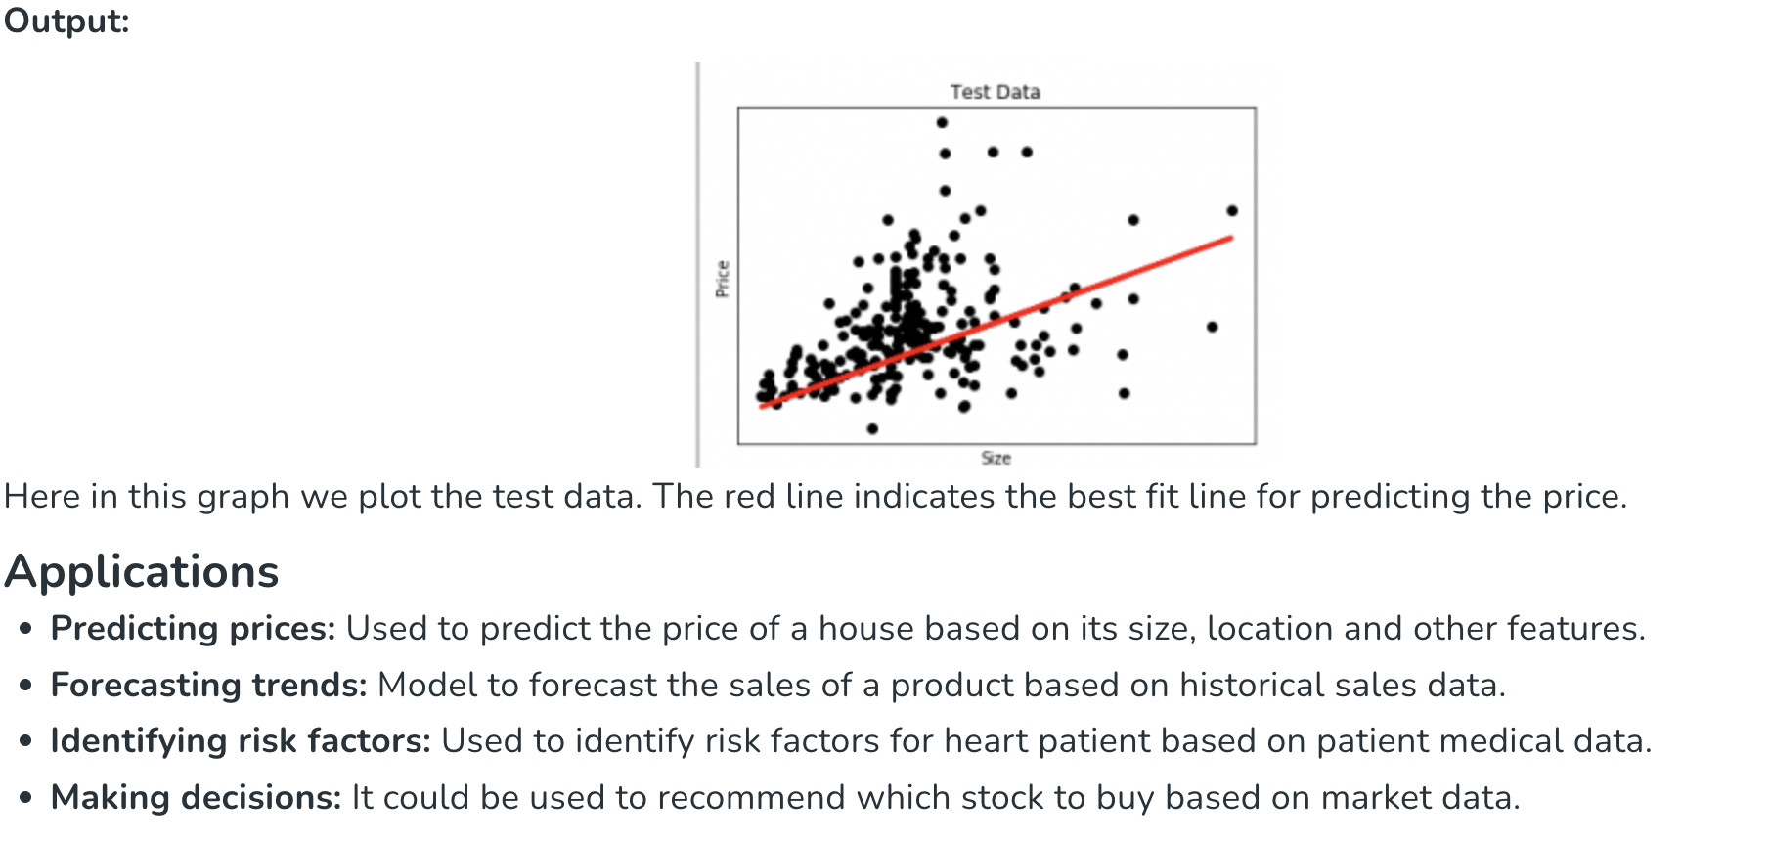

Linear Regression Problem Statement (Industry-Level Example)

Problem Statement
A coaching institute wants to predict a student's exam marks based on the number of hours studied.
Historical data:
Study Hours (X) | Marks (Y)
2 | 40
4 | 60
6 | 80
8 | 95
10 | 110
The institute wants to answer:
If a student studies 7 hours, what marks can be expected?
This is a perfect Linear Regression problem because:
- Input (Hours) is numerical
- Output (Marks) is numerical
- We want to predict a continuous value

Step 1: Visualize the Data
Plotting the data would look approximately like:
Marks
110 | *
100 |
90 | *
80 | *
70 |
60 | *
50 |
40 | *
--------------------------
2 4 6 8 10 Hours
As study hours increase, marks increase.
Therefore:
Positive Linear Relationship

Step 2: Linear Regression Equation
Linear Regression tries to fit a line:
$$y=mx+b$$
$$m$$
$$b$$
Which means:
$$y=mx+c$$
where:
- $y$= predicted marks
- $x$= study hours
- $m$= slope
- $c$= intercept

Step 3: Mathematical Solution
Dataset:
X | Y
2 | 40
4 | 60
6 | 80
8 | 95
10 | 110

Calculate Required Values

Sum of X
$$∑X=2+4+6+8+10 \\ ∑X=30$$

Sum of Y
$$∑Y=40+60+80+95+110 \\ ∑Y=385$$

Sum of XY
X | Y | XY
2 | 40 | 80
4 | 60 | 240
6 | 80 | 480
8 | 95 | 760
10 | 110 | 1100
$$∑XY=2660$$

Sum of X²
X | X²
2 | 4
4 | 16
6 | 36
8 | 64
10 | 100
$$∑X^{2}=220$$

Number of Observations
$$n=5$$

Step 4: Find Slope (m)
Formula:
$$m=\frac{n∑XY-(∑X)(∑Y)}{n∑X^{2}-(∑X)^{2}}$$
Substitute values:
$$m=\frac{5(2660)-30(385)}{5(220)-{30}^{2}} \\ m=\frac{13300-11550}{1100-900} \\ m=\frac{1750}{200} \\ m=8.75$$

Step 5: Find Intercept (c)
$$c=\frac{∑Y-m∑X}{n}$$
Substitute:
$$c=\frac{385-(8.75)(30)}{5} \\ c=\frac{122.5}{5} \\ c=24.5$$

Final Regression Equation
$$\boxed{y=8.75x+24.5}$$

Step 6: Predict Marks for 7 Hours
Substitute:
$$x=7 \\ y=(8.75)(7)+24.5 \\ y=61.25+24.5 \\ y=85.75$$

Final Answer
$$\boxed{85.75}$$
Expected Marks ≈ 86

Verification Using Python
from sklearn.linear_model import LinearRegression
import numpy as np
# Input Feature
X = np.array([[2],
[4],
[6],
[8],
[10]])
# Output Target
y = np.array([40, 60, 80, 95, 110])
# Create Model
model = LinearRegression()
# Train Model
model.fit(X, y)
# Predict for 7 hours
prediction = model.predict([[7]])
print("Predicted Marks =", prediction[0])
# Equation
print("Slope (m) =", model.coef_[0])
print("Intercept (c) =", model.intercept_)

Output
Predicted Marks = 85.75
Slope = 8.75
Intercept = 24.5

Complete Interview Discussion

Why Linear Regression?
Because:
- Input is numerical
- Output is numerical
- Continuous prediction required

What is X?
Feature (Independent Variable)
Study Hours

What is Y?
Target (Dependent Variable)
Marks

What does slope mean?
Slope = 8.75
Interpretation:
For every additional hour studied,
marks increase by approximately 8.75.

What does intercept mean?
Intercept = 24.5
Interpretation:
If a student studies 0 hours,
expected marks ≈ 24.5

Assignment Questions

Q1
Predict house price using:
Area | Price
1000 | 50
1500 | 70
2000 | 90
2500 | 110
3000 | 130
Find:
- Regression Equation
- Price for 2200 sqft

Q2
Predict salary using:
Experience | Salary
1 | 25
2 | 35
3 | 50
4 | 60
5 | 75
Find salary for 6 years.

Q3 (BITS Level)
A company records advertising spend and sales:
Advertising ($1000) | Sales ($1000)
1 | 15
2 | 25
3 | 35
4 | 45
5 | 60

