Appium

What is Appium??

**Appium** is an open-source automation mobile testing tool, which is used to test the application. It is developed and supported by **Sauce Labs** to automate native and hybrid mobile apps. It is a cross-platform mobile automation tool, which means that it allows the same test to be run on multiple platforms. Multiple devices can be easily tested by Appium in parallel.

It has **NO** dependency on Mobile device OS. Because APPIUM has framework or wrapper that translate[Selenium](https://www.guru99.com/selenium-tutorial.html)Webdriver commands into UIAutomation (iOS) or UIAutomator (Android) commands depending on the device type, not any OS type.

Appium supports all languages that have Selenium client libraries like- Java, Objective-C,[JavaScript](https://www.guru99.com/interactive-javascript-tutorials.html)with node.js, PHP, Ruby, Python,[C#,](https://www.guru99.com/c-sharp-tutorial.html)etc.

Advantages of Appium

* Appium is an open-source tool, which means it is freely available. It is easy to install.
* It allows the automated testing of hybrid, native, and web applications.
* Unlike other testing tools, you do not need to include any additional agents in your app to make Appium compatible with automation. It tests the same app, which is going to upload in App Store.
* An additional feature added to Appium. Now it would support desktop application testing for windows as well along with mobile application testing.
* Appium is a cross-platform, freely available mobile testing tool, which allows us the cross-platform mobile testing. This means you can test on multiple platforms (single API for both Android and IOS platforms).

Prerequisites to use Appium

* Install **Java** (JDK)
* Install **Android Studio**
* Install additional Android **SDK tools**
* Install **Appium GUI** file
* Install **Appium Inspector**
* Install **IDE** for Java(IntelliJ)

## Appium Installation on windows:

Setting up Appium is not only the installation of a single tool or setting up a few variables. A complete setup of Appium requires the installation of many other tools. Then Appium starts testing of an application. This tutorial mainly focuses on Appium setup for Android on Windows Operating system.

**Step 1** −Install & Setup Java . Java is used to write these automation test scripts. So, download the latest version of JDK and setup the environment variable.

* [Download the latest version of Java](https://www.oracle.com/in/java/technologies/javase-downloads.html)
* Setup Java Environment Variable.

**Step 2** – Download Android studio and download SDK tools

Go to https://developer.android.com/studio

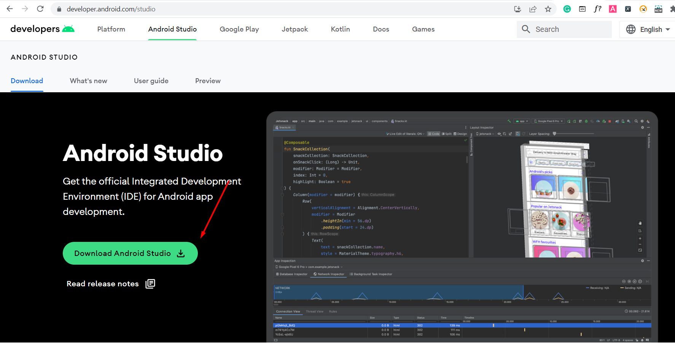

* Extract zip and install Android Studio
* Open Android studio and download SDK Tools
* Click on SDK manager  
  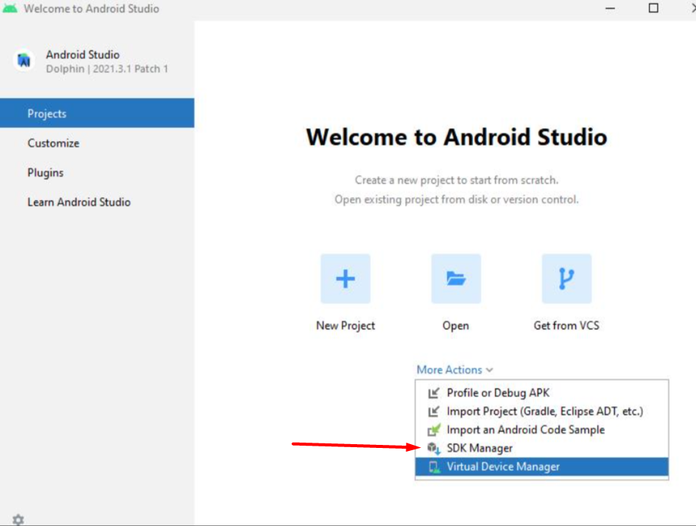
* Click on latest or at least one below Android version  
  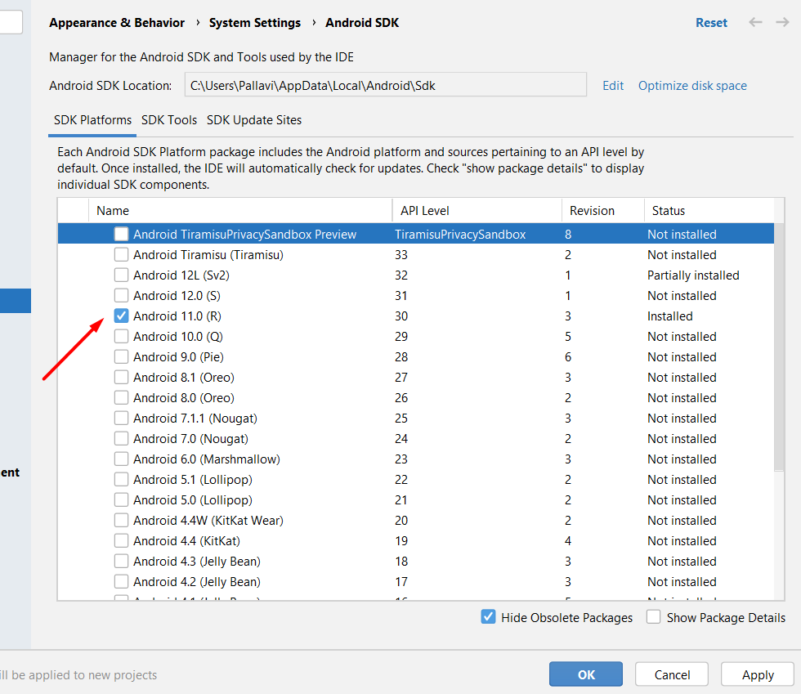
* Click on SDK Tools Tab and check below options  
  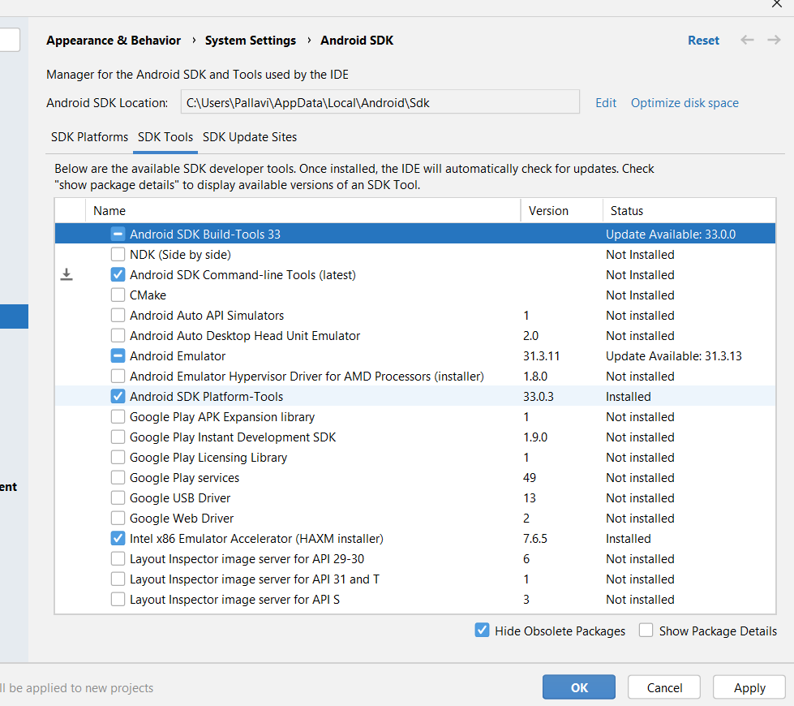
* Click on Apply and your SDK Tools will start to download.
* Set the Env Variable i.e. ANDROID_HOME= location of your sdk folder

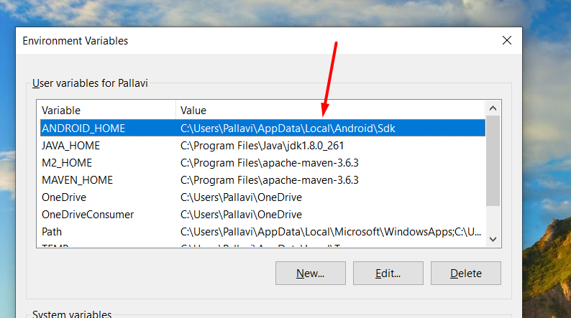

* Path= append the path of platform-tools folder

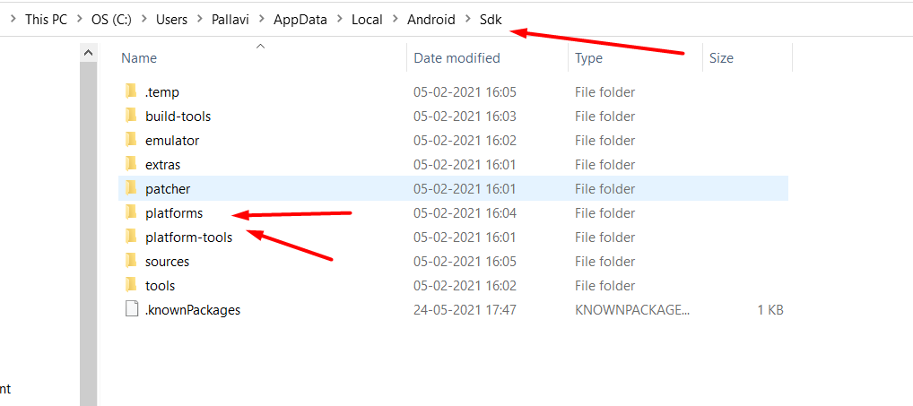

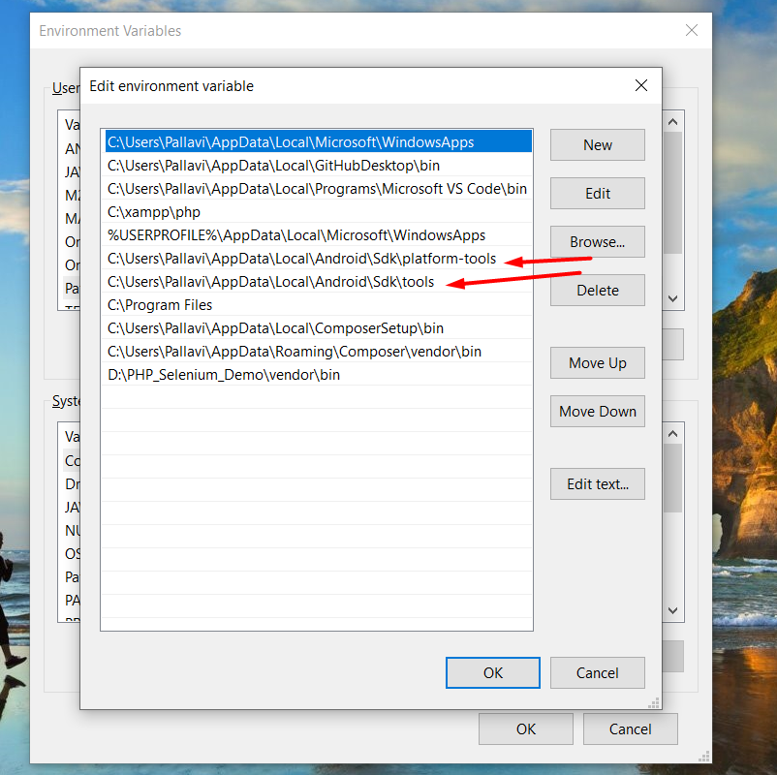

## Step 3 – Install Appium Server or GUI.

* Go to the following link <https://github.com/appium/appium-desktop/releases/tag/v1.22.3-4>
* Download latest exe file  
  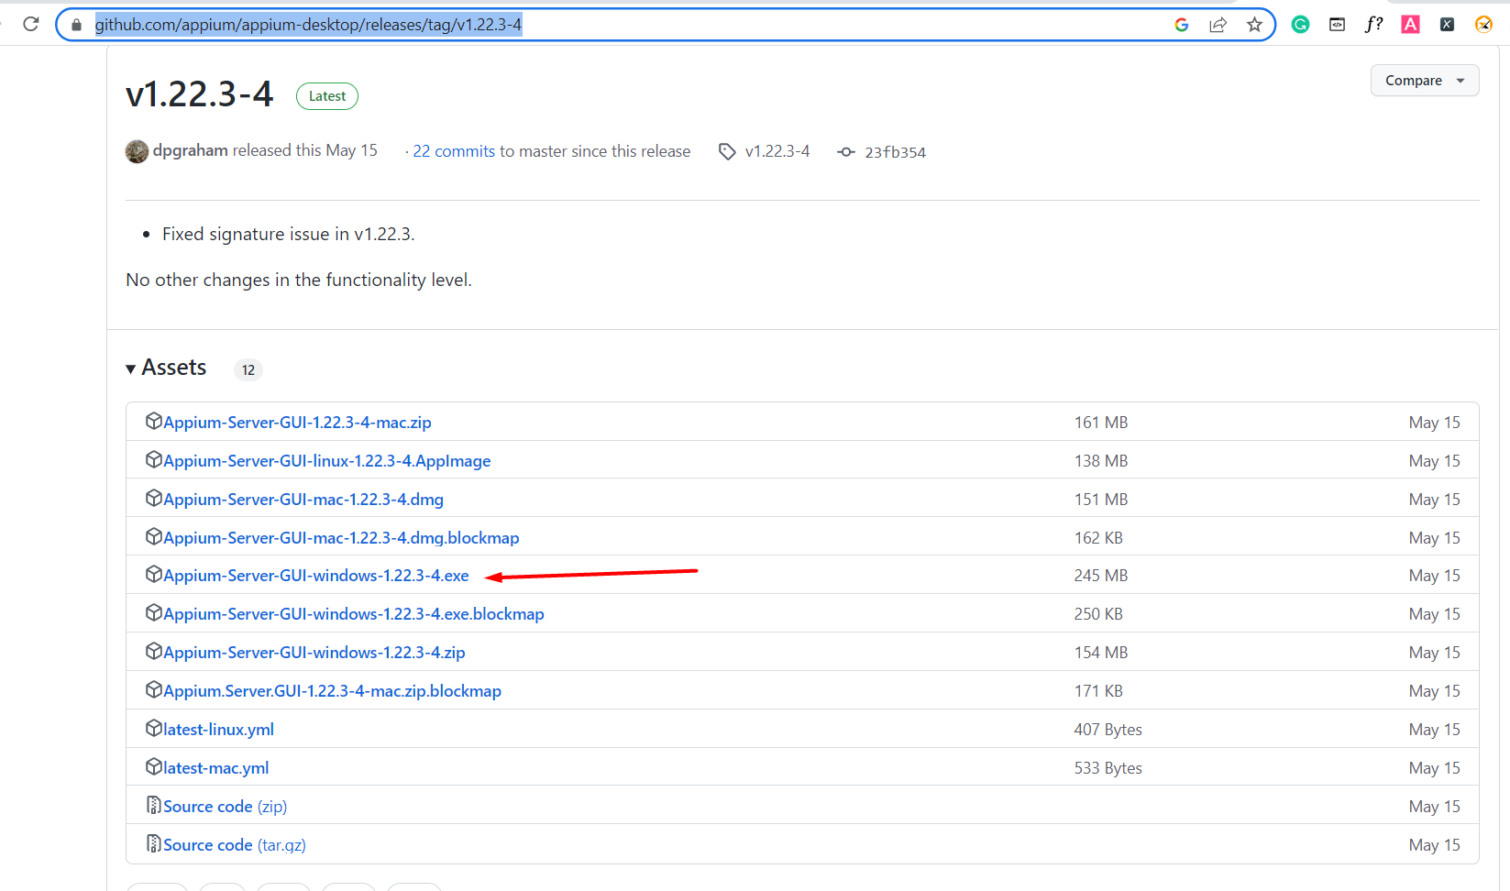
* After downloading the exe file, double click on the downloaded file to run.

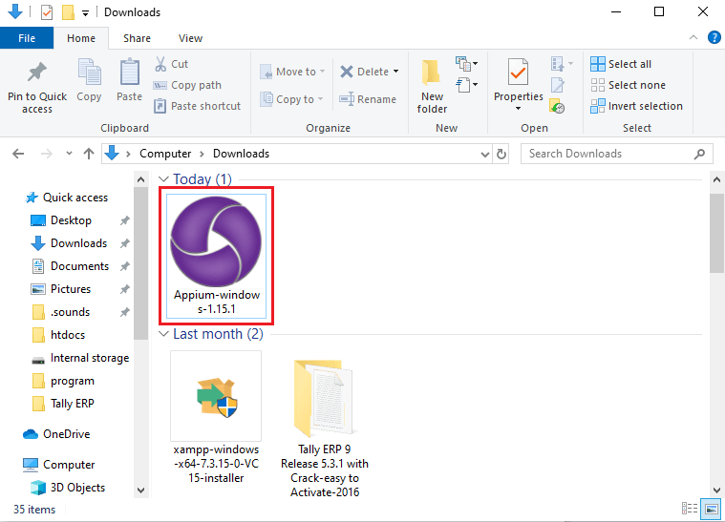

* Here, you need to choose the installation options. You can select all users, if you have multiple users on your system, otherwise select **only me** for the administrator of the system.

After choosing the installation option, click on the **install** button.

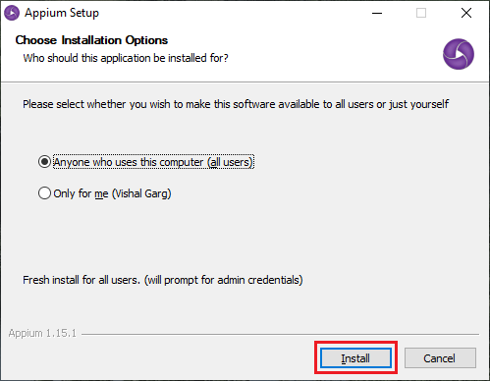

This will start the installation, which may take time to install.

* Now, After successful installation Appium Desktop UI will appear on the screen containing the default **Host** and **Port**, which can be changed.

Default Host - 0.0.0.0

Default Port - 4723

Click on the **Start Server** button and start Appium Server.

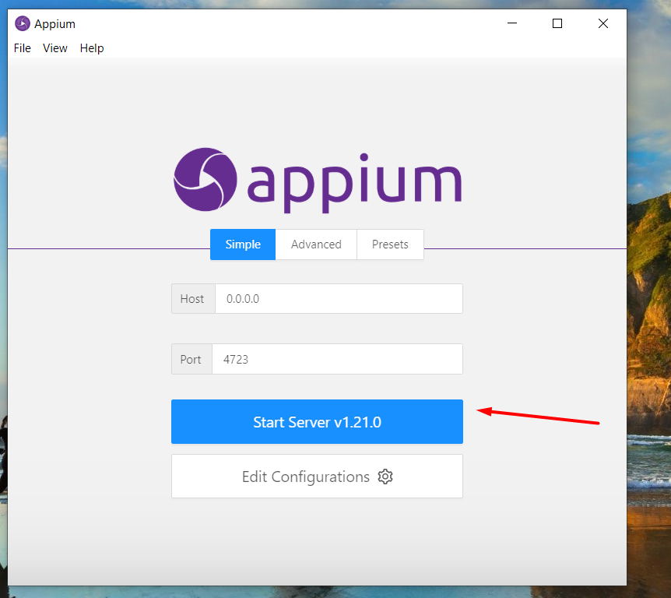

* A new server will launch on the Host and Port specified in previous step. You can see the message on the top of the screen that Server is running.

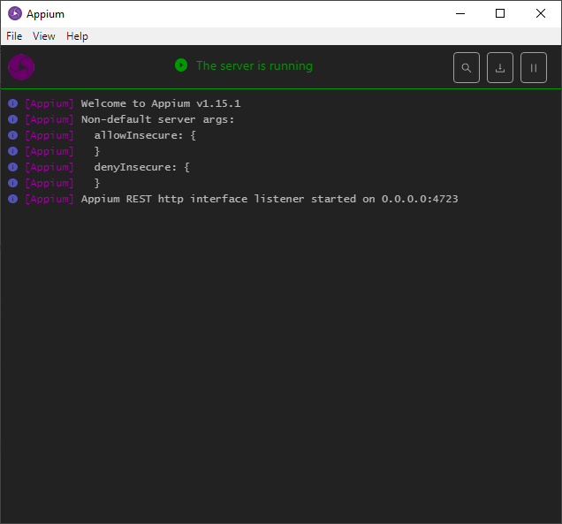

* Now download Appium inspector Go to the link <https://github.com/appium/appium-inspector/releases>
* Download exe file, Run and install Appium inspector

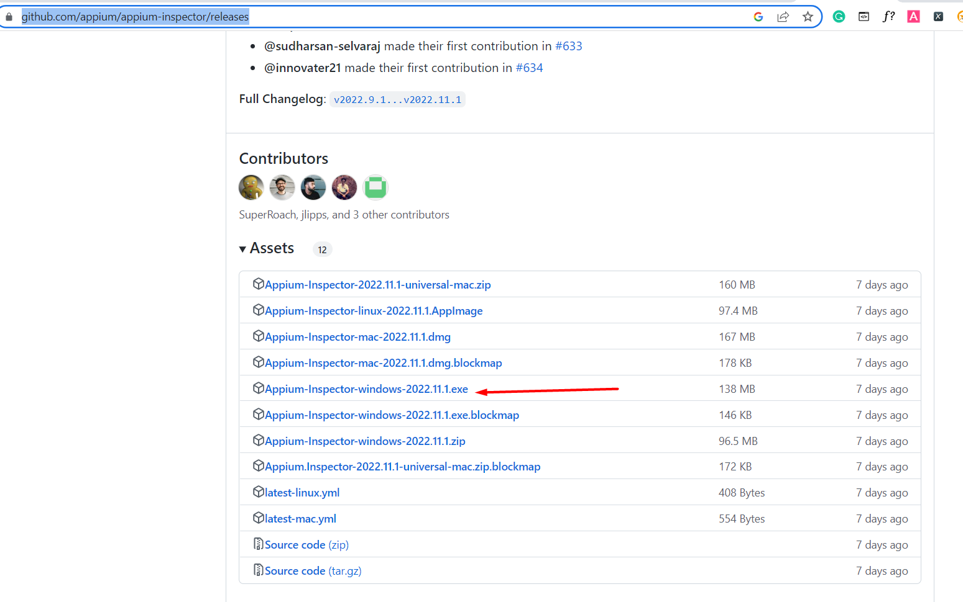

* Provide all desired capabilities here and Click on the **Start Session** button to start a new session.

**Step 4 :** Run command adb devices in commandline where adb = android debug bridge and Check your command run successfully without list of device at this step