# Technologies to be used

## Front-end web development

* HTML5
* CSS3
* JavaScript

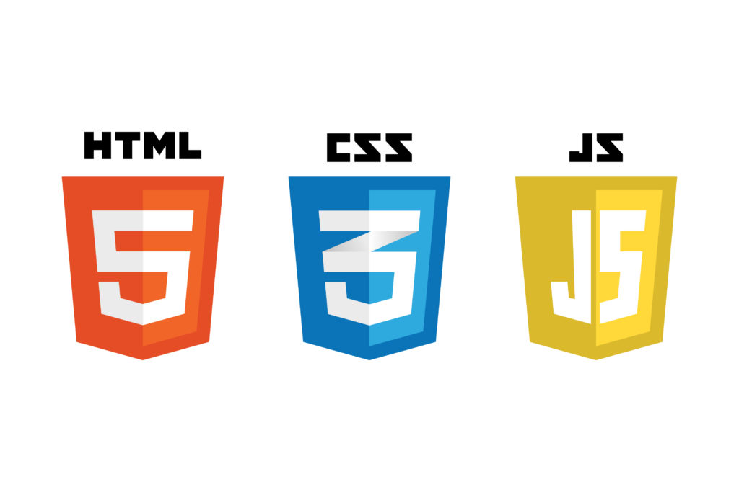

## Back-end development

* PHP



## 

## Database

* MySQL for main data storage
* [Redis for cache storage](https://redis.io/)

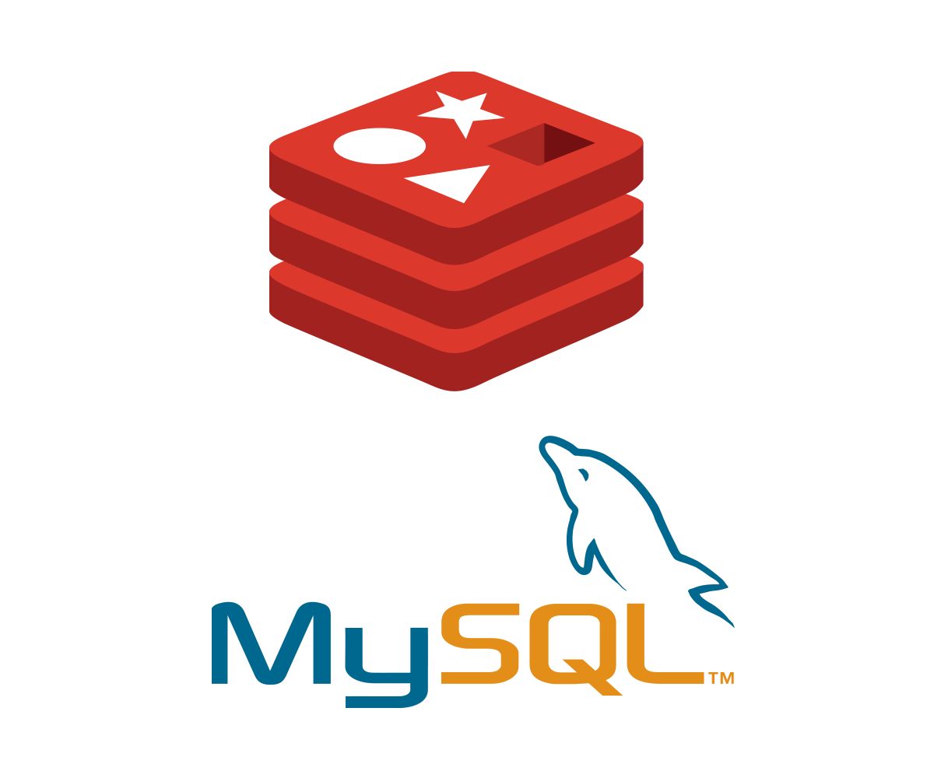

## IDE

* [Visual Studio Code](https://code.visualstudio.com/)
* [PhpStorm](https://www.jetbrains.com/phpstorm/)

 

## Development server

* [XAMPP](https://www.apachefriends.org/)



## Version control & collaboration

* [GitHub](https://www.github.com)



## Project management tool

* [Trello](https://www.trello.com)



## Diagram drawing tool

* [draw.io](https://app.diagrams.net)



## Storage for documents

* Google Drive



## Team meetings

* MS Teams

